Contents
Foreword 2
A4/ Inclusive Schools 3
Beneficiaries: 3
How to use this document 3
Recommendation: 4
Aim 4
Objectives 5
Desirable prerequisites and outcomes 5
Materials to be kept ready for the four-day training: 6
Competency Framework Alignment : Perspective building on Inclusive schools 8
Training Module Components 10
Outline of the general time plan of training module : 10
Guidelines for the trainers: 13
TRAINING GUIDE: Day 1 13
TRAINING GUIDE: Day 2 41
TRAINING GUIDE: Day 3 79
TRAINING GUIDE: Day 4 111
References for all four days 128
Competency Self-Assessment Rubric 130

Trainer’s / Facilitator’s Guide
Module: Inclusive School

Foreword
Diversity in terms of abilities to learn and to develop skills in the individuals is a natural phenomenon throughout the world. However, it has become common to generalize people with certain abilities as normal by the dominants and the remaining abilities are grouped as weaker section or as persons with disabilities. The attitude of ‘discrimination’ by the ‘dominant-normal’ is often driven by beliefs and assumptions rather than rationale. In this scenario, the dominant majority tries to fit ‘the-others’ into a common frame or isolate them from common society on the pretext of offering special treatment instead of creating an environment where everyone can be accommodated to participate in all activities in the society. As a result, discrimination creeps even into education as physical, political, and attitudinal barrier, depriving many children from enjoying their rights to education with other children and learn with dignity. These people face negative societal stigmas and discrimination based on the differences in their gender, and physical abilities that deprive them of their right to access education, employment and living full healthy lives. Hence, what happens is instead of ‘education-for-all’, often it turns out that it is ‘education- for-a-few’. This dominant practice is seen to instill a feeling of low self-esteem and stunted intellectual development. This sort of discrimination not only affects the individual but has a debilitating ripple effect on their family and even the nation as a whole. Several studies across the world are revealing that the solution to prevent discrimination is inclusion in education.
In this four-day training module for the Trainer of Trainers/ Master Trainers on Inclusive Schools for the Professional Development Members (PDM), the participants will gain insights into those barriers and the strategies to gradually remove the barriers to promote inclusion. In this workshop the participants will deliberate on the Universal Design for Learning and its significance in turning the formal schools into inclusive schools. This knowledge is hoped to enable the PDMs with practical strategies to support the schools and the stakeholders in the community to develop informed strategies and practices to ensure inclusion.
This trainer’s guide provides a detailed account of the day-wise and session-wise instructions to conduct the four-day training programme on Inclusive Schools. In this module, both in the power point presentations and the facilitator guide the information and pictures accessed from internet are exclusively used for educational purposes and as representation and no copyright infringement is intended. This module expects the participants and trainers to hone certain competencies to realise the aims of sustaining inclusive schools.

Note: Trainer of Trainer (MTOT)/ master trainers/ Facilitators (these terms have been used interchangeably but consistently mean the same) are drawn from pool of resource personnel serving as central professional development members (CPDM) and provincial professional development members (PPDM) or any other expert educationist: These are the new designations to the members in Professional Development Directorate. Earlier they were designated as Academic Supervisors at the central, provincial and district levels with specific roles and responsibilities.

A4/ Inclusive Schools
Date Developed | 31 July 2021
Expected User/s | Provincial Professional Development Members and District Professional Development Members
Length of Training | 4-days, 420 minutes (7-hours) per day including lunch and short breaks of 80 minutes

Beneficiaries:
This is the training for provincial professional development members (PPDM) and the district professional development members(DPDM).

How to use this document
This document is the trainers’ training guide for module/ training topic Inclusive Schools. This document highlights the prerequisite knowledge and skillsets that trainers need and the competencies that need to be developed to monitor inclusivity in schools while functioning as PDM at the provincial and district levels. This document features materials to be used, types of discussions and activities to be conducted. It also indicates additional readings that can be studied by trainers. This module includes the basics of principles of Inclusion and Inclusive schools to understand and develop strategies for practicing inclusion in detail. Trainers are expected to go through this document at least one week prior and prepare for the session that they will conduct. This document highlights materials required for training sessions, types of discussions and activities to be conducted.

Recommendation:

- Worksheets and handouts for participants: During training, the participant trainee PDM can be provided with session-wise worksheets or a compilation of all worksheets and handouts in a ‘work-book’ form with adequate space for the AS trainees to make personal notes. These worksheets should have prompts to guide self-reflection and participate in interaction during these four-days of interactive sessions.
- Interactive diaries: This is a notebook in which trainee AS will provide feedback to or seek clarifications about the training to the facilitators and in turn the facilitators will respond in writing. The facilitators provide prompts such as Did you enjoy the activities? What did you learn about in today’s training? What would you change about today’s training? And so on. Trainee AS will write their notes for the facilitators in the diaries and then these will be collected. The trainers/facilitators will respond to the diary entries by writing back, thus beginning a dialogue between the facilitators and the trainee supervisors.

- Important message for the Facilitator:
Facilitator must repeatedly tell the participants: “From today onwards whenever they find free time , in the next three days that is till the last days’ TLC , the participants need to spend time thinking and discussing about what is fair in education system?. How to achieve education for all? What ails Afghan education and what kinds of support do the Afghan education system need? They can also discuss things like these on what’s app/telegram so that a greater number of people can add their points of view. Facilitator must repeatedly caution the participants that no opinion or belief should be disregarded. It should not be taken offensively. However, they should discuss the rationale for either accepting or rejecting others point of view in a professional manner.

Structure of the document is described next. First, the aim, objectives, and the competency alignment with this module are presented. They highlight the key skills and takeaways for the participants from this training. Rest of the document explains training pertaining to each day, presentations of new ideas and skills, and reflection activities for participants. The last part on notes, has been intentionally left blank for training participants to take notes and make the training their own.

Aim
At the end of the training the professional development members (PDM) would be able to understand the meaning of diversity and the philosophy of inclusion in education by engaging in reflective exercises to internalize the concept of inclusion which in turn will enable them to promote and support inclusivity in schools since the overall goal (impact) of the project is that every child is enrolled in the school in the project target geographies and benefit from quality learning in a conducive environment.

Objectives
This ‘Inclusive Schools’ module covers the concepts of barriers to schooling, diversity (physical, socio-cultural, emotional) among learners, the differential ability and the major cognitive diversity (disabilities) prevalent in Afghanistan, the meaning and philosophy of inclusion in education with special focus on need for child protection, gender fair education for girls, the policy systems and practices to promote inclusion, models of inclusive schools and role of PDMs to support schools to promote inclusivity.

The participants will be able to:
- Learn about the general philosophy of inclusion in education.
- Understand the concepts of diversity, exclusion, inclusion, and inclusive schools.
- Gain foundational insights into the Universal Design for Learning with special focus on inclusive pedagogies and inclusive strategies in a classroom (detailed knowledge learnt from Pedagogy and classroom management module)
- Learn to discuss issues of diversity from multiple perspectives and strategies to realise inclusivity in schools.
- Learn about the need for self-assessment of their own competencies and skills to support inclusive schools.
- Engage in structured reflection

Desirable prerequisites and outcomes
It is desirable that the participants and the trainers to either already possess or develop certain competencies in them in order to realise the aims of sustaining inclusive schools.
Requirements
This training is designed to make the module inclusive and participants are offered experiential learning about the philosophy of inclusivity.
To bring in inclusivity right from day one of the training, it is desirable that on day one a WhatsApp /telegram group of all participants along with the facilitators and organizers are created. This will introduce them to comfort and transparency that can be brought in communication.
This e-group can also be used to make announcements, gather information, making collective decisions, make clarifications, to brainstorm, debate and discuss on various concepts etc.
Expectation from the master trainer of trainer/facilitator to conduct workshop for the Module: Inclusive Schools
General desirable prerequisites for the trainers before conducting this training:
- Being trainers, you need to exhibit a fair amount of expertise and familiarity with all the core and sub-competencies that is expected of from the participants, so that you are in a position to guide the participants to enrich their competencies.
• Awareness of the education sector plan, Afghanistan.
• Awareness of the competencies to be honed and subject them to continuous development at all levels.
• Practice the principles of inclusion in their day-to-day work and demonstrate it during the workshops.
• Have gone through the other modules with deeper understanding of the modules on pedagogy.
• Are convinced that all individuals have different abilities and styles of learning and hence there are diversities among learners.
- Believe that diversity is a natural phenomenon, inclusion is a response to diversity.
- Aware that most of the barriers to inclusion at both intra and international situations are due to exclusion and biases.
- Be convinced that the barriers can be mitigated or minimized in an incremental manner by simultaneously using both top down and bottom-up approaches.
- Knowledge of Universal Design for Learning (UDL) to promote inclusion.
- Be able to communicate the aspirations of MOE and the strategies of UDL to enthuse and motivate to the participants (DPDM and PPDM) in such a way that they in turn gradually overtime become competent enough to contribute to the implementation at the grassroot levels.
- Conduct activities and presentation to achieve the learning objectives of the participants.
- Skills of generating mind-maps/ concept maps with the participants in an interactive manner.
- Enable the participants to develop/use a checklist to identify and record the diversity acting as barrier to inclusion at the school level, develop the competency to facilitate TLC for skill transfer at the intra and interschool levels, facilitate schools towards sourcing and collecting resources for creating UDL classrooms, and develop the expertise of reporting the ground level situation to PPDMs.
- In addition to the above the Master trainers will enable the PPDMs to engage in consolidation of the reports from district level and provide resources for cross learning and skill transfer across the districts.
- Providing constructive feedback and guidance to the participants in the interactive diaries- a quality essential at all levels between the facilitator and the learner.

Materials to be kept ready for the four-day training:
General for all the days: ppt, markers, sketch pens, chart paper, chalk/colour powder for marking on the floor, interactive handouts (like worksheets) for participants, notebooks/plain sheets/folders, appropriate adhesives/thread to display the work, seating plans (mats/chairs/desks), adequate power supply, computer, overhead projector…(list varies according to the context and the need of the participants)
Set up a reading/Quiet corner: Where the reference reading materials and samples of teaching aids are kept in a manner which is accessible to all, on all the four days.(It could be an open shelf or a small bench on which the reading materials are placed)
Materials On Specific days:
Day 1: bangles (all same medium sized), a ball, chalk/ colour powder, a Ball, a bell, chart paper, markers, hand out
Day 2: paper slips, pencil, chart paper, ppt , pins, blue tac, adhesive tapes,
Day 3: post-it, Chart paper, marker pens
Day 4: bucket, paper balls,

Competency Framework Alignment : Perspective building on Inclusive schools
Sub-topic | Core Competency | Sub Competency
Prerequisite Competency *1  ( Cuts across entire Module/Training Topic)  *The prerequisite competencies are not covered during Inclusive school module. However, it is desirable that the participants are fairly competent in these when they come to the training program. | Education Expertise | Education Policy Development
 | Education Expertise | School Management
 | Education Expertise | Develop Self and Others
 | Education Expertise | Decision Making
 | Knowledge of education system, policies, rules, and norms | Knowledge and understanding of Afghanistan education law and procedures.
 | Knowledge of education system, policies, rules, and norms | Knowledge of National Education Strategic Plan
 | Knowledge of education system, policies, rules, and norms | Sound understanding of MOE education policies, SOPs, guidelines, and forms.
Perspectives of inclusion Part-1  Barriers to Inclusion in School and issues of child protection and Gender | Problem solving and decision making | Creative and Innovative Thinking
 | Problem solving and decision making | System & Strategic Thinking
 | Problem solving and decision making | Self-Awareness & Management
 | Problem solving and decision making | Social Awareness and Management
 | Problem solving and decision making | Active listening
 | Problem solving and decision making | Logical and Critical Communication
 | Problem solving and decision making | Analytical Skills
 | Problem solving and decision making | Negotiation Skills
 | Problem solving and decision making | Honesty and commitment to the profession.
Perspectives of inclusion Part 2  Exclusion in School: gender and child protection issues | Working effectively with others | Honesty and Integrity
 | Working effectively with others | Empathy
 | Working effectively with others | Adaptability
 | Working effectively with others | Flexibility
 | Working effectively with others | Active listening
 | Working effectively with others | Influencing
 | Working effectively with others | Teamwork
 | Working effectively with others | Effective oral communication
 | Working effectively with others | Building community relationship
 | Working effectively with others | Negotiation and conflict management
Perspectives of inclusion Part-3  Universal Design Learning (UDL) | Knowledge of teaching-learning methodologies | Knowledge of multiple teaching methods and instructional strategies to engage students in learning process effectively.
 | Knowledge of (inclusive) pedagogy | Knowledge of Pedagogical Approaches
 | Knowledge of (inclusive) pedagogy | Knowledge of learning and teaching processes
 | Knowledge of (inclusive) pedagogy | Knowledge of learning theories
 | Knowledge of (inclusive) pedagogy | Positive and conducive learning environment setting
 | Knowledge of (inclusive) pedagogy | Child Psychology
 | Knowledge of (inclusive) pedagogy | Impartiality and fairness
Perspectives of inclusion Part-4  Vision building: Sustaining inclusivity and Role of PDMs in promoting inclusive schools | Policy, systems, and practices to promote inclusion | Sound understanding of MOE education policies, SOPs, guidelines, and forms.
 | Policy, systems, and practices to promote inclusion | Motivation of school heads and the teachers
 | Policy, systems, and practices to promote inclusion | Effective communication with students and parents.
 | Policy, systems, and practices to promote inclusion | Impartiality and fairness
 | Policy, systems, and practices to promote inclusion | Facilitate cross-learning, adaptability to context, and collaboration within and across the schools
*1: The prerequisite competencies are not covered during Inclusive school module. However, it is desirable that the participants are fairly competent in these when they come to the training program.

Training Module Components

Day | Sub-topic | Concepts
Day 1 | Barriers to Inclusion in School and issues of child protection and Gender | Concept 1: Challenges to achieve academic, emotional, and social success of all children.
Day 2 | Exclusion in School: gender and child protection issues | Concept 2: Barriers due to exclusion: explicit and implicit biases - Prejudice, Stereotypes, Discrimination
Day 3 | Universal Design for Learning  UDL | Concept 3: UDL and Inclusive pedagogy  Concept 4: Diversity facilitates inclusivity
Day 4 | Vision building: Sustaining inclusivity and role of Professional Development Members in promoting inclusive schools | Concept 5: Equality of access- difference between integration and inclusion

Outline of the general time plan of training module :
Day | Sub-topic | Concepts | Pedagogy | Time ( adds up to 7 hours  including breaks)
Day # | Competency to be focused on
Day # | Sub-Topic name | Concept # | First activity on day 1:  *2a Self-assessment of competencies should be in every training module as the first and the last activity that participants engage in. It will serve as a measure of growth in participants competencies that the module is focusing on. | 90min
Day # | Sub-Topic name | Concept # | Icebreaker/ Community Building Activity/ Introductory presentations/ orientation /demonstration | 90min
Day # | Sub-Topic name | Concept # | Tea/ Coffee Break | 10 min
Day # | Sub-Topic name | Concept # | Interactive Group Work, Presentation, Discussions | 80 min
Day # | Sub-Topic name | Concept # | Lunch | 60 min
Day # | Sub-Topic name | Concept # | Activities/ presentation | 90 min
Day # | Sub-Topic name | Concept # | Tea/ Coffee Break | 10 min
Day # | Sub-Topic name | Concept # | Activity/presentation  Structured reflection for the day*3 | 80 min
 |  |  | *2b Final activity of final day should be participants engaging in the Self-assessment of competencies rubric to document their growth. | 80 min
*2a, *2b Self-Assessment: Competency Self-Assessment Rubric
Participants will be given a rubric to self-assess their capabilities in the above-mentioned competencies at the beginning and end of the training. The rubric form is in the end and multiple copies of this is to be made and each participant gets one in the beginning of Day -1 and is kept with the facilitator. and one on the last day. It is recommended that the facilitator go through the rubrics filled in on day-1 to get a sense of the competencies in the participants and efforts could be made to enhance their competencies over next four days. On the last day, the facilitator should recommend the participants to keep checking the development of their competencies at intervals and try to strengthen them over a period of time.
*3 Structured reflection is recommended on all the four days of training. To conclude the structured reflection session, participants and trainers will engage in an interactive diary session throughout the four days of training. Interactive dairy is a strategy to include the supervisors’ voice in the training. In interactive diary, the trainees get to give live feedback on the design of the training that they are undertaking by engaging in a dialogue with the trainer. Other than this, there are two rationales to include interactive diaries in this training. First, it will include supervisors’ voice in the training process. Second, it builds a transferable skill in the supervisors that they can use when they are working in the field with their supervisees. The facilitators will see trainees as valuable contributors in their development as supervisors, and for trainees get to actually comment on their training to make it their own.

Day | Sub-topic | Concepts | Pedagogy | Time
Day 1 | Core Competencies mapped: Problem solving and decision making
Day 1 | Barriers to Inclusion in School and issues of child protection and Gender | Concept 1: Challenges to achieve academic, emotional, and social success of all children. | Greeting and setting ground rules (common for all modules) and self-assessment of competency | 30 min
Day 1 |  |  | Community building welcome activity | 40 min
Day 1 |  |  | Understanding the aspirations of MOE towards inclusion | 10min
Day 1 |  |  | Overview of 4-day training, Instructions | 10 min
Day 1 |  |  | Short Break | 10 min
Day 1 |  |  | Presentation by facilitator : spot the barriers | 10min
Day 1 |  |  | Small group activity : brainstorm various kinds of barriers | 30min
Day 1 |  |  | Collective activity: Mind map exercise | 40min
Day 1 |  |  | Lunch | 60 min
Day 1 |  |  | Collective activity: Tell me? | 40 min
Day 1 |  |  | Paired activity: Brainstorm on examples of barriers in real life situation | 20min
Day 1 |  |  | Small group activity to consolidate the examples of barriers-preparation to identify indicators of barriers and presentation | 40 min
Day 1 |  |  | Short Break | 10 min
Day 1 |  |  | Part 1: Listening and interactive activity ( Trainer to have read the case story just narrate the case with voice modulation to participants.) | 40 min
Day 1 |  |  | Part 2: Discussion-Reading-Reflection: What barriers did the case story try to address?
Day 1 |  |  | Structured reflection for the day | 40 min

Guidelines for the trainers:
The following section contains details about each of the teaching aid required to conduct the training session as well as references for further reading.

TRAINING GUIDE: Day 1
Facilitator’s Objective for Day 1: Barriers to schooling
- Develop an understanding of the complexity of different barriers to education.(Mind-map will provide visual stimulus to the complexity)
- Help participants reflect on the challenges to achieve academic, emotional, and social success of all children because of the barriers.
- Using a checklist to observe and recording barriers to schooling and developing awareness of sorting the issues concerning barriers in terms of the levels at which it can be addressed.

Prerequisite knowledge/skills for Facilitator:

1. Familiar with different barriers to schooling in Afghan and in other developed and developing countries
2. Knowledge of various interventions, their strategies, and outcomes to promote inclusivity in Afghanistan
3. Communicate to the participants that the barriers can be controlled or minimized at various levels.
4. Help participants understand to segregate the issues of inclusion as ones which they can themselves address and the ones to be addressed at the central level .
5. Enable the participants to understand how to document ground level issues and report to higher levels
6. Knowledgeable about mind-maps. (For this module, to generate a mind-map during the workshop in an interactive mode while eliciting the barriers to education from the participants.

Day 1: Schedule

Concept 1: Challenges to achieve academic, emotional, and social success of all children.

On day one, begin the day with greeting (Trainer to choose a manner which is vibrant and inviting to the participants) and setting ground rules (common for all modules) and get the participants to fill out the form for self-assessment of competency.
Use slide 2
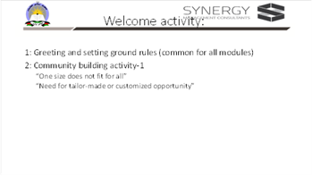

Objective of welcome activity:
- Community building exercise: Get participants to know each other.
- Take away message: Importance of need based flexible support : “One size does not fit for all”, “Need for tailor-made or customized opportunity.”

Note to facilitators /Trainer: Instructions to perform welcome and community building activity
Activity 1: Greeting and setting ground rules (common for all modules) and self-assessment of competency (30 min)
- Get all participants to settle. Set clear expectations on nature of participation and announce the non-negotiable ground rules to be adhered to. (These rules will preferably be common across all the days of training and across all the modules to ensure discipline, give clarity, to avoid chaos and for time management).
- Greet the participants as per the protocol. Get them to fill out the competency form.
Activity 2: Community building welcome activity (40 min)
- This ice breaker activity-‘bangle activity’ (can be done as an indoor or outdoor activity depending as per convenience) is aimed to help the participants experience exclusion. (Materials needed: medium sized bangles (alternately you many use finger rings, gloves, hoops, hair bands, paper rings etc. ) all same size enough to give one each for each participant, chalk to draw two concentric circles on the floor, one A3 sized chart paper and marker, adhesive or thread/nail to hang the chart paper). This activity has two parts-I and II.

PART-1 of the bangle activity

- Draw two large concentric circles on the floor such that the space inside innermost circle can hold about 20 people, about 30 participants in the space between the inner and outer most circle and about 40 people around the outermost circle. Ask all participants (PDC member) to keep their hands free and gather around the outer circumference of outer most circle. (Preferably drawn even before the participants arrive to the venue, and if possible, should be retained all through since they come handy for collective activities)
- Let them start calling out from #1 and each adjacent person calls out the next consecutive number aloud. Finally, the last number which is equal to the total number of participants in the activity to be marked as total number on the chart/blackboard
- Later ask them to turn to the neighbours such that they are in pairs facing each other. Next tell them that each pair are ‘best-partners’.
- Next instruct them to greet and introduce each other with two information. One their full names and another how they wish the world to recognize them as (the identity they wish to have). Also tell the participants that they need to remember their best-partner’s name and identity at least until the next day.
- Now tell them that you will begin the next activity. Explain the activity as follows: “here is a school enrolment drive, a lifetime opportunity to get admitted to the best of best schools with the best facilities irrespective of their differences. The selection procedure is very simple with just one criterion to be satisfied. If the candidates fulfill that, then they get admitted.
- Here are two circles with a gap in between.
- As you see, all of you are standing on the outside of outermost circle.
- At the end of the task, those who are occupying the space outermost the circle form group ten as they get 10 points, those found in-between the two circles form group one and they get one point and those in innermost circle form group zero and they get zero point.
- Tell the participants, “Now you will get one bangle each. Just pick it up and wait till I say what you need to do. (So, saying, distribute one bangle each to each participant.)
- Ask, “Did you all get one bangle?”, Try to insert it through your left /right hand. “Pass it through your hand so that it is around your wrist. You get 2 minutes”.
- At the end of two minutes, draw their attention towards you and ask them to do the next action. Give instruction “All of you whose bangles reached the wrist can enter the innermost circle, for those whose bangles just entered halfway of the palm say up to knuckles will enter the outer circle and stand in the space between inner and outer circles. If the bangle did not enter the hand, then they will remain where they are on the outside of outer circle.
- After the participants are distributed in different circles and settle, Now explain : The innermost circle represents the school with all facilities and admits those who fit into their stipulations. If the ring/bangle easily passes through their hand, then enter the innermost circle, The second situation represents schools with little or no resources and hence they have flexible criteria that, even if the bangle reached half-way they may enter the space between inner and outer circle. In the last case, if the bangle does not pass at all there is no entry into any school, and they stand where they are outside the outermost circle
- In the end count the number of participants in the different zones-group 10, group 1 and group 0 from the outermost to innermost regions of the circles and mark it on the chart. (Note: This activity is performed while all teachers are standing in a circle/ seated on chairs (similar to musical chair activity)
- Give each one a piece of plain white paper approximately the postcard size or 4” by 6” and a pin. Ask the participants to write the group to which they belong to and attach it to their dress near left or right shoulder.

PART-2 of the bangle activity

Facilitator to instruct all the participants to remain in the three groups – 0,1, and 10 when they return to their seats. Once the participants settle, continue the activity
- Make sure that the participants must remain in their new groups 0,1 and 10 with labelled slips attached to their dress and return to their seats.
- Begin by asking “How many of you do not have your best partner in the same group as you are in? Please raise your hands” . (Irrespective of the numbers, there will be some who are separated). How does this feel? How else would you have preferred to play this game?
- Tell them “Now let us reflect for a few minutes on this activity” and ask, “even though the criteria for entering innermost circle was same for all, all got equal opportunity, time and even bangles, but still why did it not provide equal results for all?”- (Their answers would probably convey that the bangles were either too small or that everyone’s hands are not of equal size. If not direct them to think in terms of the bangle)
- How would they feel if the same condition was ”only those who are in the inner circle will get increment in their salary?”. Let them discuss for two minutes in their groups and select one member from each group to volunteer and answer.
- Next engage in discussion with questions:
- Did this activity remind you of any personal experience when you were refused privileges in real life situation for not satisfying certain criteria?
- Have you come across real cases of such a discrimination in terms of gaining admission to schools?
- (Keep probing to brainstorm as to) Why is it so that students do not have equal access despite common rules and claims of equality for schooling?
Let a few participants share until the message that equal entry conditions does not necessarily ensure admission to desired school. Note the responses until a few barriers to access to school are elicited.

- Finally ask “just like the same size bangles did not fit each hand, how the situation would have been if there were different sized bangles?, and how it would have been if the participants had an opportunity to choose the size that fits them.”

- Facilitator can draw comparison of bangle to common rigid curriculum which leads to isolation like the way many did not enter inner most circle. The group number and scores are irrational but can leave deep scars. In this game how your best partners were separated. Attaching to some group and asking the students to remain there is also demoralizing. If multiple sized bangles were provided and opportunity to choose, probably each one of you could have entered innermost circle. This is called ‘tailor-made or customized opportunity’, since ‘one size does not fit for all’.
- Conclude the activity by announcing that each participant, “during short break, write a word, phrase or a sentence, poem, or draw to show how you felt and what went on in your minds? when the bangle fitted /did not fit your hands”.

- Facilitator: takes over to explain: Like fixed criteria set in the game, similar such eligibility criteria are set in the society that prevents all students gain access to schools. These are the barriers. But MOE in Afghanistan aspires to remove barriers and make flexible eligibility criteria. Let us understand what they are. (flash the next slide : Aspirations of MOE)

Activity 3: Understanding the aspirations of MOE towards inclusion-10 min
Slide 3
For Facilitators/MTOTs: 10 minutes
Allow the participants a minute to go through the slide.
Ask if any participant to (one to three) volunteer to read aloud. Pause after each sentence to stress on the key points, elicit questions and clarify what it means to the participants if required.)
Briefly draw the participant’s attention towards inclusion of all individuals and equitable access to schools which are inclusive, relevant and safe as aspired by MOE. You might even ask them to make a note of this in their handouts/notes that these are the aspirations of MOE and as professional development members they need to strive to help schools to meet these aspirations
“Increased equitable and inclusive access to relevant, safe, and quality learning opportunities for children, youth, and adults in Afghanistan, especially women and girls. Increased equitable availability of responsive, safe and conducive learning and skills training opportunities”.

Next tell the participants: Let’s see what we will be doing during this four-day workshop. So, saying, spend next 10 minutes with the following four slides: title slide (a few seconds), Overview of four-day training (2 minutes), Desirable learning outcomes (5-6 minutes), day 1 timetable (1 minute)

Activity : Overview of 4-day training, Instructions (10 min)
Trainers to spend a few minutes to walk through the participants about the four day’s workshop
Slide 4 (2min)
Slide 5 (2 min)
Note to Facilitator: (5-6 minutes)
Objective is to help participants understand what the desirable learning outcome in the participants are after participating in the four-day workshop:
- Clearly explain the commonalities and differences in the roles of PPDM and DPDM.
- In order to make it interactive, even before showing the slide, the trainer can ask what they think that they might learn in this workshop, get three to four responses and quickly move on to present the notes in this slide.

Slide 7:
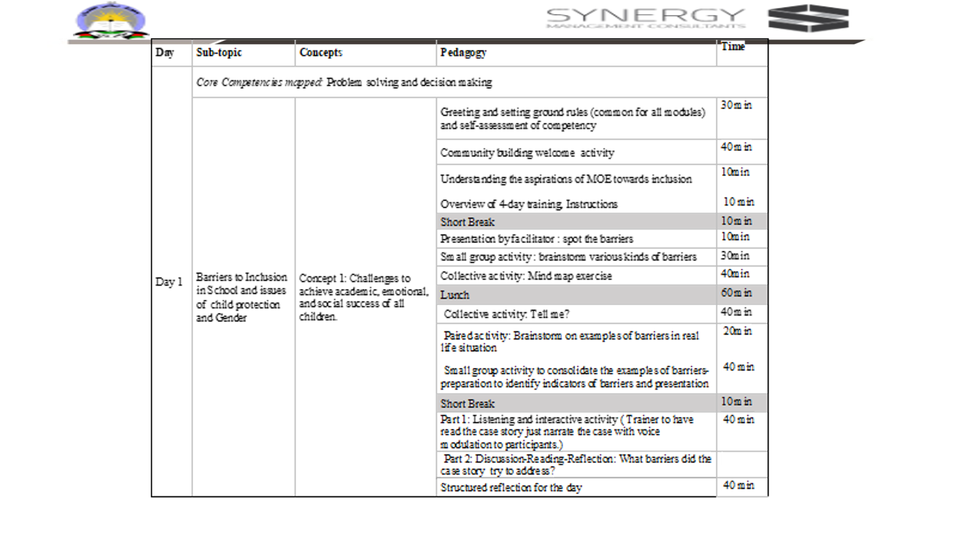
Note to Facilitator:
Address the participants and tell them that you will be sharing about what they will do in the next and the following three days.
Present the next three slides which is an introduction to overall plan for next four days sessions for setting expectations.
The facilitator makes a ppt presentation of the following three points:
- Overview of the workshop in the next four days
- Desirable learning outcome in the participants from the four-day workshop: Clearly explain the commonalities and differences in the roles of PPDM and DPDM.
- Quick walk through the timetable for Day-1
To Facilitator: Finally flash this slide of day 1 plan and conclude saying: In the next four days including today, we engage in understanding how these aspirations of MOE can be realised by establishing and supporting inclusive schools. (Instruct them that session continues after a ten-minute short break. Remind them about the chart paper in which they need to write or draw how they felt during bangles activity especially when they were isolated or separated from their best partners)
Tell the participants that all four days will have the same format. It will be day long workshops, 7 hours or 420 minutes. Out of this one-hour lunch break and 10 minutes each there will be two short breaks of ten minute each. One short break before lunch and the other after lunch break.
Morning the session begins with a general/thematic community building exercise followed by introductory or recap of previous day’s activity.
The day ends with structured reflection of the day. This is to simulate the TLCs facilitated by trainers. For this all participants are required to sit in a circle along with the facilitator. They must have their interactive diaries and their personal notes.
In the interactive diaries they may write to the facilitator. In the end the facilitator will collect their diaries and respond in writing to each one of them and return it the next day morning.
In the personal diaries the participants make notes from the discussion they carry out on the topic,

It is recommended that the Facilitator makes note of intangible feedback from participants various feelings such as happiness, disappointment etc. and use them as examples to draw their attention towards implications of barriers.

--------------------------------------------------------------------Tea/ Coffee Break-----------------------------------------------------------------------

Note to trainer of trainer /facilitator :
In the next 80 minutes until lunch break, there will be three activities: 1: First 10 minutes presentation by the facilitator, 2: then for 30 minutes small group activity and 3: last 40 minutes is a collective activity to develop a mind map .
1. Collective presentation: Make a brief PPT presentation to create a context to help the participants to recall the barriers in the school and community (3 minutes)
2. Small group activity: Make small groups of five each and facilitate discussion in small groups to ensure that the different types of barriers are brainstormed. Participants should be encouraged to note down the list of barriers in their worksheets.
3. Collective: Volunteers from group share their list of barriers, the facilitator makes a consolidated mind-map on a chart paper

Prerequisite for the facilitator: Facilitators should be informed about the kinds of barriers and evidence of barriers from national and international scenario and have the knowledge of developing a mind-map.

Materials required: Blackboard/ preferably chart paper with a few colored markers, ppt presentation, handouts/worksheets.

Activity: Presentation by facilitator : spot the barriers (10 min)
Use slides 8 to 14
1. Collective presentation: First recollect the bangle activity, then make a brief PPT presentation to create a context to help the participants to recall the barriers in the school and community and finally (10 minutes) .

How to conduct this session:
Step 1: (3 minutes) Recall the bangle activity. (Point to one or two statements or pictures on the chart paper used during bangle activity that shows disappointment).
Ask : How would it have been possible for all others to also enter the innermost circle ?
Ask: What was preventing everyone to enter innermost circle?
Answer to be arrived at: Size of the bangle : Tell the participants that in this activity size was a variable feature and, relying on only one size was the barrier for many. Similarly ask them to keep thinking of the reasons as to why many children do not enroll, or drop out in between, discontinue or even if they are in school lag in studies despite the availability of schools and school curriculum. (Probe to elicit responses indicating inaccessibility)

Step 2: (5 minutes): This step is done to set a context for the next activity. Begin PPT presentation of pictures. Ask the participants to observe each picture and think of inaccessibility in each case- Example: nature of inaccessibility, which children? what prevents some children from attending such schools? Pause in each slide and elicit at least 2-3 responses.

Slide 8:

Slide 9:

To Facilitators about slide 9:
In order to set the context, to think of barriers, spend less than a minute to draw the participant’s attention to the universal truth of the importance of education to alleviate poverty. Draw their attention to the UNESCO report about 99% not getting the crucial basic education. Then tell them that the next few slides will help them think of the reasons as to why most of the Afghans are not getting basic education ?
Slide 10:
To Facilitators about slide 10:
This slide no 10 is to be used to facilitate the participants to critically comment on the diversity in access to schools
Diversity in terms of availability: Tell the participants to look at the two pictures and comment on possible barriers to get education: Possible answers: school building-extreme difference: rich vs poor, urban vs rural, distance and access, transportation and so on.

Slide 11:

To Facilitators about slide 11:
Suggestion: Facilitator should ask questions to elicit the circumstances in which such schools have been created? What are various barriers if any in these schools?

Slide 12:

To Facilitators about slide 12:
For this slide facilitators to ask participants :What are barriers ? Who are affected? And what are its implications?

Slide 13:

To Facilitators about slide 13:
Prereading for facilitator: Barman, A. (2020). Education as an Instrument of Social Change in India. https://ir.nbu.ac.in/bitstream/123456789/4006/1/IJLJ%20-%20Vol.%2011%20No.%201%20%28Part%20III%29%20Article%20No%206.pdf
Facilitators to give an example of the influence of societal norms in other countries and ask what are the societal norms in Afghan, and ask questions such as what are the societal norms in Afghan? How is it influencing the education of girls, boys, differently abled etc? Ask “which practices are not fair for all children? ”“should some of these need to be improved?”,
Eg: In India: “In Indian culture the educational institutions are treated as the places of worship of learning. Education is considered as a lifelong process by which people learn new ways of action and thought. In India education is thought to change behavior which aim to improve the human living conditions”. Do you think education improves living condition? If yes, why some children cannot go to schools? What is Afghan’s belief about schools? What is Afghan’s belief about higher education of all children? Are there any barriers for higher education? And so on.
Facilitator: Use slide 14:
While showing the 14th slide the facilitator helps participants to keenly observe the alternate arrangements made by teachers in two classrooms.

In this slide draw participants attention towards the alternative arrangements made by the teachers and encourage participants comment about it. The facilitator may ask What alternative arrangements have the teachers made in these cases?
At the end of the PPT presentation, get all the participants to make small groups of five members in the same place wherever they are seated. Once they settle move on to the next activity.

Activity 2: Small group activity : To brainstorm various kinds of barriers (30 min)
At the end of the PPT presentation a small group activity in two parts is conducted for 30 minutes:
Objective: This activity helps participants to recall their experiences about the barriers that they know of or have experienced which prevents the children to attend school.
Materials required: PPT, chart paper large enough to draw a mindmap.
Facilitator:
Make small groups of five each and facilitate discussion in small groups to ensure that the different types of barriers are brainstormed. Participants should be encouraged to note down the list of barriers in their worksheets.
The trainer should go to each group, and facilitate brainstorming by asking them lead questions so that a variety of barriers are identified
.

Slide 15: To be preferably displayed after brainstorming and presentation of barriers. Participants can compare the barriers they brainstormed with this pre-prepared list of barriers and make necessary changes

A suggestion to the facilitator:
- A volunteer from each group shares the list of barriers which they have identified. Facilitator makes note of the issues /barriers using a few broad basic characteristics on a chart paper.
- If required (just in case the small group discussions are not able to work independently) this slide can be on while the participants discuss and list the barriers to schooling in the small groups.
- While the groups are discussing, the facilitator should preferably go to each small group and help them think of all possible barriers associated with the key words .
- If needed the facilitator can probe and ask questions to direct the thinking process

At the end of this exercise the facilitator should tell the participants that in the next session they would learn to put their list of barriers to schooling in the form of a mind map. The small groups are allowed to continue to be seated in their positions but get together to make a single group for the next activity.

Activity: Collective activity: Mind map exercise (40 min)
- Collective activity to develop a mind-map on barriers to schooling: Volunteers from group share their list of barriers, the facilitator makes a consolidated mind-map on a chart paper.

Materials required: Light coloured chart paper, a few coloured felt marker and felt pens. While the participants list the barriers, the trainer needs to develop a mind map using the participant listed barriers.

The mind map thus generated need to look like this sample mind map (exclusively presented here as a sample). This need to be preferably replaced with the mind map generated during discussion.

Slide16:Sample
.

Facilitator:
Preferable: this mind map on the slide is just for representation. It is desirable that the facilitator will take the picture of the mind map created in previous session and insert it here.
After the small group activity, the Facilitator flashes this slide while eliciting responses to develop a mind map. (Several samples are available on the web. Trainers need to take ideas and customize it to Afghan’s context.)
The mind map can be drawn on this slide/ on a chart paper or even on a blackboard. In the end this can be photographed or a fair copy is made in the notebook /handouts.
This session ends with the participants and facilitator together developing a mind map on barriers to schooling/education.
Facilitator will end the session by making required announcements, about lunch break formalities and the time to return after lunch.

Did You Know? Accessibility Organization for Afghan Disabled (AOAD) is a non-governmental organization established by persons with disabilities that is working as a peer-supporter and advocacy outlet in Kabul, Afghanistan

Conclude the session displaying the mind map chart in a place accessible to all.

---------------------------------------------------------------------------Lunch Break-----------------------------------------------------------------------
Concept 1: continued

On day one post lunch phase, four activities are proposed.
1:Tell me? Activity to recall real life examples of barriers that led to drop out of a student 20 min
2: Developing observation check list to document barriers to education in schools and community,
3: TLC to discuss the feasibility for reducing or mitigating the barriers
4: Part 1: Listening to a case study .Trainer to narrate the case with voice modulations (or can sketch or use ready visuals that is relevant to Afghan context to participants.). Part 2: Reading an excerpt from a journal article and discuss What barriers did the case story try to address?

Objective :
Introduction to reflecting, documenting and providing feedback.
Post warm up activity, the participants revisit their mind maps on barriers and think of real-life examples and record them in a tabular form to develop an observation checklist to record barriers to inclusion in schools.

Activity : Collective activity: Tell me? (20 min)

Facilitator led: Tell me? Activity. 20minutes
Facilitator’s notes :

“Tell me?” is the post lunch warm-up activity related to inclusive situation: 20 minutes.

Materials needed: a Ball, a bell, chart paper, markers
Facilitators will follow the following steps.
- Step 1: instruct the participants to gather in a large semi-circle (preferably facing the blackboard or the screen in the training hall).
- Step 2: Any two participants are asked to volunteer to be observers and reporters. (if they wish they can add to the mind-map created in the morning on a chart paper/ blackboard)
- Step 3: Instruction to participants:
- “Here is a ball and a bell”.
- “I will give you the ball”,
- when I start ringing the bell, you take the ball, keep passing the ball. No tossing / throwing. You need to walk up to the person you choose to give the ball, hand it over and stand in their place”,
- “Now that person will do the same thing, take the ball and give to any other person”,
- “Do not stop as long as the bell is ringing”, (Do this five times in quick succession so they are shuffled)
- Step 4: Okay, now I will add one more dimension to this. You will continue to pass the ball in the same way we did till now.
- As soon as I stop/ as soon as ringing is stopped, you take the ball and say in one sentence (or communicate in any other way: home language, action, write in words, draw a picture, ) one real-life example of any of the barrier to education.
- And there will be only ten rounds.
- So, the condition is, each time the real-life example told by others should not be repeated.
- In case if you cannot recollect any example immediately just say ‘pause’
- and the chance goes to the person standing on the left of your side.
- The person standing to the right side must answer the next question: To which type of barrier, does this belongs to?

- The volunteers may include (if it’s a new one) this on a chart paper having the mind-map generated prior to lunchbreak.
- The game ends when we have gathered 10 different real-life examples of barriers to education.

(To start the game the ball is handed over to any one participant. It must be passed on quickly to any other by walking up to that person, hand over the ball and stand in that person’s place. The one who receives the ball will now go to any other person, hands over the ball and takes that place. This goes on. While the handing over the ball is happening, the facilitator keeps ringing the bell. When it stops, the person in whose hand the ball is will share one real life example of a barrier to education and the person standing to his/her right will identify to which group of barriers it belongs to.)

Facilitator: Instruction for next activity:

“Thank you, friends. Did you enjoy? From this game we were able to hear 10 life realities about barriers to schooling. Don’t feel otherwise if you could not recollect any example or if you did not get a chance. In the next activity, you will be asked to think of maximum number of such examples . They are not only from your experience, but you may also even draw from any other source.

In the end ask participants to recall their best partner with whom they mutually introduced in the morning and to get back to their seats in pairs with their best partner for the next activity. For this they must keep their personal diary or worksheet , and a pen/pencil.
After the participants settle in pairs, move on to the next activity.

Slide 17: for Activity : Paired activity: Brainstorm on examples of barriers in real life situation (20 min)

After the participants settle in pairs, move on to the next activity.
Slide 17
Sample list for trainers: Slide 17 is to be mainly used as a cue for the facilitator. Such a list has to be generated during this session by conducting the following paired activity.

Suggestion: Briefly go through the slide 17 with participants and tell them: this is how they need to begin to think of looking at barriers from the four dimensions. While they are working in pairs depending on the need this slide can be kept on the screen or not. If participants are independently thinking there is no need to keep this slide on.

Facilitator: This is a paired activity. 20 minutes
Materials: PPT slide titled: Guiding questions to prepare the draft checklist of indicators for identifying barriers, charts for each pair, notebook / plain sheets of paper to make notes while discussion in pairs, pen/pencil/sketch pens etc

Objective of the activity: Create awareness about the indicators of barriers to schooling and to reflect on how to identify them in real situation. Preparing a checklist of indicators to find barriers to schooling in the schools and community.

Instruction to participants:
- This is an opportunity for you to work with your best partner for the next 20 minutes only.
- Keep your personal diary/work sheet, pen/pencil/sketch pens etc. ready
- Each pair of participants may refer to the mind-map on barriers prepared today in the pre-lunch session.
- Facilitator can take cues from the sample ppt slide 17 to ask leading questions to help the pairs to think of barriers from all four dimensions-attitudinal barriers, physical barriers, curricular and pedagogical barriers and the systemic barriers.
- Use the template of the table as in the ppt slide

Note: Slide 18 is purposefully left blank for the facilitators to generate their own questions since in depends on the participants requirements and the depth of details added in the mind-map which was developed collaboratively in the previous session.

Activity : Small group activity to consolidate the examples of barriers-preparation to identify indicators of barriers and presentation (40 min)
Note: Divide the time into 20min + 20 minutes. First 20 minutes for working in pairs and next 20 minutes to consolidate the points discussed in pairs.
Slide 19
Facilitator:
- Instruct the participants to think of all possible indicators of clues that help them identify the different kinds of barriers. (Below is just a sample of how you as a facilitator can get the participants to begin to think about indicators )
- Example of how to explain the table:
- “In this activity you will recall all the terms we used in the mind map on barriers to education.
- For each term just think where and how will this become evident in the society? The cues or the indicators
- Is it visible? Is it so subtle that it requires some other strategy to notice the biases?
- You may think of any quality of indicators which are positive, negative, neutral, graded, happy. sad…anything which you know of.
- Explain the table:
- On the left-hand vertical column. These are the larger causes for barriers which generally divide the society-Economic divide, Religious divide, Ethnic divide, Political divide, access to health care, Geographical, means of earning livelihood ”
- On the Horizontal, row one: you see the broad classification of types of barriers we arrived at when we created the mind-map such as: social, cultural, institutional, emotional, cognitive, physical, instructional, economic, gender, infrastructure and so on.
- Now see, in the first cell in second row you see the words Economic divide. and in rest of the cells in second row, an indicator is mentioned in relation to the barrier mentioned in the respective heading column. As you see they have been presented in a different colour just to draw your attention.
- This is just an example. Each cell can have multiple entries. (Read aloud the pairs while pointing)
- economic status-social barrier: education of parents,
- economic status-cultural barrier: early marriage,
- Economic status-institutional barrier: admission to better school/no admission to any school,
- economic status-emotional and cognitive barrier: quality of support to learning,
- economic status-physical and cognitive barrier: learner centric facilities matching the learning styles
- economic status-Instructional barrier: clarity in communication
- economic status-economic barrier: poor outfits, odd sets/broken or damaged educational accessories
- economic status-gender barrier: either early marriage or send them to international schools/study abroad
- economic status-infrastructure: ability to choose appropriate school
- Only a few common ones are filled since the specific indicators are contextual and only the PDMs can do it collectively with the help of different stakeholders
- This template is only to be used to practice thinking about looking for indicators of barriers to schooling.
- “It is not necessary that all the cells may get filled when you are working in pairs”
- You will get first 20 minutes to work in pairs.
- Presenting this the form of a table is just one way of brainstorming about indicators. You can think of any other way that is convenient to document this in your personal diaries/worksheets. You may use flowchart, pie-charts, mind maps, and so on
- So, your time starts now.
- While the paired team works, the facilitators will go to each group to provide need-based support.
At the end of 20 minutes, ask the participants to stop working and tell them that they will now make a larger group.

Slide 20
Used for indicator developing exercise.
This slide is a template in which the points which participants share are entered. Suggestion is . depending on the availability and convenience, the points shared by participants can be directly typed up into the slide or similar chart can be made

Facilitator:

Small group activity: indicator developing exercise:

Objective: To consolidate the examples of barriers and arrive at indicators to identify indicators of barriers

Materials: Personal notes, Chart paper, felt pens / markers

Instructions: Twostep process:

Step-1: 10 minutes
- (Depending on the number of pairs) Tell three to four / pairs to re-group themselves in such a way that there need to be total of 8 or 10 individuals in each group.
- Once they regroup, provide instruction to the group
- Each new group with 8-10 members should prepare a consolidated checklist of indicators to identify barriers .
- List all the indicators on the chart paper either in tabular or mind-map format.

Step -2: 10 minutes
- Each group should share their indicators of barriers to education. And display their presentation.
- Those willing to volunteer to be encouraged come forward to consolidate the presentations to make a common indicator checklist.
At the end of 40 minutes, instruct the participants to take a short break for 10 minutes

Note: Following this activity the participants get a 10-minute short break. Ask the participants to reassemble after 10 minutes.
Important instruction: Tell the participants to sit in one large circle or semi- circle when they return.
.

---------------------------------------------------------------------Tea/ Coffee Break----------------------------------------------------
Concept 1: continued

Activity 4: Part 1: Listening to a case study .Trainer to narrate the case with voice modulations (or can sketch or use ready visuals that is relevant to Afghan context to participants.)
Activity 4: Part 2: Reading an excerpt from a journal article (International Journal of Education and Psychological Research (IJEPR) Volume 6, Issue 2, June 2017) and discuss What barriers did the case story try to address?

Slide 21:
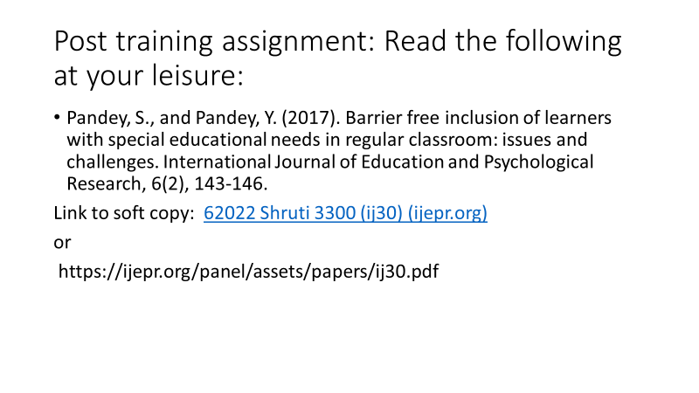
Objective: To get deeper insights and engage in discussion about the relevance of the concept of barriers to inclusivity in Afghan context.

Materials required:
1. Chart paper / black board to record the responses of participants both during part I and II of the activity.
2. Handout for participants to read – A section extracted from the following article : Reference: Pandey, S., and Pandey, Y. (2017). Barrier free inclusion of learners with special educational needs in regular classroom: issues and challenges. International Journal of Education and Psychological Research, 6(2), 143-146.

To facilitator: this activity has two parts:
Part 1: Listening and interactive activity ( Trainer to have read the following case story and just narrate the case with voice modulation to participants.)

Part 2: Discussion-Reading-Reflection: What barriers did the case story try to address?
Prerequisite: the facilitator should preferably read the case study and the entire recommended article prior to training and prepare a narration. In addition, the trainer might also choose any one or two of such studies conveying barriers to school education for gaining in-depth understanding about barriers to inclusive schooling.
After reading, to convert the content in the case study into a narration and narrate the scenes to participants. (If possible a few relatable picture clippings can be taken from the Afghan context and displayed as a slide to reduce verbal narration and make it more inclusive for people who prefer visual senses than auditory and for those who work with concrete objects than making meaning of abstract narrations).
Case story One: The case of Tasleem: (adapted and modified into a fiction for purposes of training about barriers from a journal article: http://www.teachersofindia.org/en/article/inclusive-education-issues-and-challenges )
The story of (Tasleem), as narrated by her mother, a housewife from a small town in a large country, illustrates the challenges in the implementation of inclusion due to barriers. Tasleem, 10, with polio was excited at the prospect of being admitted, after a long wait, to a ‘good’ school. However, on admission she faced two issues. She could not run or jump like the other girls nor was she able to even stand in the morning assembly. In addition to this, Tasleem was placed in class two along with children who were at least two year younger to her and was to remain there till she had gained mastery over the English alphabets. Tasleem had been misdiagnosed with mental retardation when she was 5. As she grew older, it became clearer that she had developmental coordination disorder, which made writing a huge challenge. She had an impressive fund of general knowledge, but with her dysgraphia, writing was near-impossible. The barriers she encountered were attitudinal: the school authorities just could not understand how a child would get through school without being able to write.

Later follow it up with guided discussion with facilitator about the following:
- Have you come across similar cases in your life? (Allow participants to briefly recollect similar or different cases for about 5 minutes only. This is just to help participants to discover the existence of visible and invisible barriers)
- What did the story/case-study/ intend to communicate?
- Was there any capture of barriers to schooling? Explain
- Is this story relevant to understand barriers to schooling?
- What more information could have been there in the story to communicate better?
- After brief discussion, distribute the handout. Allow 5 minutes to read. Continue guided discussion based on the eight key barriers mentioned in the reading.
- Finally end the session by asking if there were possibilities of alternative ideas which the school authorities and teachers could have used to help Fatima retain her excitement to come to school and learn along with other children?

Activity : Structured Reflection Session for – Day 1 (40 min)
Seating Plan: In a circle along with the facilitators
Materials required: personal diaries /notebooks, interactive diaries, writing instruments
Slide 22:
Lead/guide for structured reflection:
To Facilitator:
Every day ends with structured reflection of the day.
Objective:
This is to simulate the TLCs facilitated by trainers. For this all participants are required to sit in a circle along with the facilitator.
Materials: (If needed the ppt slide can be displayed)
Participants must have their pens, interactive diaries, and their personal notes.
In the interactive diaries they need write to the facilitator as feedback, seek clarification, share their points of view.
In the end the facilitator will collect their diaries and respond in writing to each one of them and return it the next day morning.
In the personal diaries the participants make notes from the discussion they carry out on the topic,

It is recommended that the Facilitator makes note of intangible feedback from participants various feelings such as happiness, disappointment etc. and use them as examples to draw their attention towards implications of barriers.
The following are some of the questions which can be kept on as a slide to facilitate the structured reflection session:
- What went well for you?
- Feedback for the facilitator’s presentation
- Which activity gave you insights?
- Which activity kept you engaged?
- Which aspect were difficult/easy?
- What was your experience in communicating? With facilitator/coparticipants
- What were your expectations for the day?
- What do you want to share or get clarification from the facilitator? What more are you expecting from tomorrow?
- Why are you satisfied/not satisfied?
- What is your takeaway?
Note: These questions need to be reworded, or more questions can be asked as per the need of the day and the group. It is important for the facilitator to listen actively and try to address the issues or convince the participants in the subsequent training days

Slide 23
At the end of the day, thank the participants. Remind them of the next days schedule, ground rules if any and assignments if any. Also you can either show the slide or just orally highlight the points about the competencies which the participants need to strive to improve in order to emerge as efficient professional development members. in the slide 25.

Space for trainers to make their own notes on this. Notes.

TRAINING GUIDE: Day 2
For Facilitator:

Objective-1 : Inclusive Schools-Exclusion as a barrier
- Communicate that some barriers are visible (explicit biases), and some are invisible(implicit biases).
- Mere integration is not inclusion
- The difference in strategies and outcomes when learner is considered problematic and when school is considered to be problematic.

Objective-2 : For facilitators to reach the following message to the participants:
- Barriers are a hindrance to inclusion.
- Introduce the terms bias and exclusion
- The dictionary meaning of Bias-Bias is a tendency to prefer one person or thing to another, and to favour that person or thing.
- Exclusion is defined as ‘the process through which individuals or groups are wholly or partially excluded from full participation in the society
- Exclusion is a type of barrier. Exclusion is either visible or invisible. They can be identified by noticing bias during verbal interactions, body language like facial and body expressions and in quality of need-based facilities provided.
- Exclusion is either explicit or implicit and are deeply ingrained in the beliefs of individuals.
- Implicit biases are often resorted to unconsciously. But recipient can feel that.
- Some can be controlled , and others need interventions to address
- Some barriers need time and can be got rid of gradually
- Prejudices leads to stereotyping. Later it results in discrimination

Prerequisite knowledge/skills for Facilitator:

1 Barriers are either visible or invisible
2.Exclusion is an invisible bias- generally happens due to social and cultural constructs
3. Familiar with different barriers in Afghan and in other developed and developing countries
4. Knowledge of various interventions, their strategies, and outcomes to promote inclusivity in Afghanistan
5. Able to communicate to the participants that the barriers can be controlled or minimized at various levels,.
6. Able to help participants understand to segregate the issues of inclusion as those at which they can themselves address and the issues which can be address at the central level .
7. Able to enable the participants to understand how to document and report ground level issues to higher levels

Recommended literature for facilitators for prereading:
- https://www.learningforjustice.org/professional-development/test-yourself-for-hidden-bias
- https://www.unicef.org/rosa/media/5491/file/Afghanistan%20%E2%80%93%20Education%20Equity%20Profile%20for%20Adolescent%20Girls.pdf
- https://www.unicef.org/education/inclusive-education Inclusive education | UNICEF
- What are some examples of implicit bias? – Mvorganizing.org

Day 2: Schedule
Day | Sub-topic | Concepts | Pedagogy | Time
Day 2 | Sub Competencies mapped: Problem solving and decision making
Day 2 | Exclusion in School: gender and child protection issues | Concept 2: Barriers due to Exclusion: Explicit and Implicit Biases  Prejudice, Stereotypes, Discrimination | Welcome and Community building activity | 30 min
Day 2 | Exclusion in School: gender and child protection issues |  | Review of day 1:indicators of barriers | 20 min
Day 2 | Exclusion in School: gender and child protection issues |  | Concept of Exclusion and Kinds of exclusion | 20 min
Day 2 | Exclusion in School: gender and child protection issues |  | Role play: visible and invisible bias | 20 min
Day 2 | Exclusion in School: gender and child protection issues |  | Short Break | 10 min
Day 2 | Exclusion in School: gender and child protection issues |  | Explicit and Implicit biases | 40 min
Day 2 | Exclusion in School: gender and child protection issues |  | Gender stereotypes- 1 and 2 | 40 min
Day 2 | Exclusion in School: gender and child protection issues |  | Lunch | 60 min
Day 2 | Exclusion in School: gender and child protection issues |  | Where is the problem? In Student or In School? | 40 min
Day 2 | Exclusion in School: gender and child protection issues |  | Inclusive Literacy Classroom | 40 min
Day 2 | Exclusion in School: gender and child protection issues |  | Interactive presentation on literacy in inclusive classroom | 10 min
Day 2 | Exclusion in School: gender and child protection issues |  | Short Break | 10 min
Day 2 | Exclusion in School: gender and child protection issues |  | Identifying indicators of inclusivity | 20 min
Day 2 | Exclusion in School: gender and child protection issues |  | Reading case study | 20 min
Day 2 | Exclusion in School: gender and child protection issues |  | Structured reflection for the day | 40 min

Concept 2: Exclusion in School: gender and child protection issues
Barriers due to Exclusion: Explicit and Implicit Biases-Prejudice, Stereotypes, Discrimination

Opening slide 1: Welcome (10 min)

Facilitator or Trainer: Following informal greeting , begin the day with a formal greeting.

Introduce the participants to the day’s schedule and move on to community building activity.

Slide 2: Day- 2 Schedule

Activity : Community building activity: What is Fair? (20 min)

Facilitator:
In this community building exercise: What is fair? The facilitators will use certain illustrations to prepare the participants to think from multiple perspectives on being fair for all.

Objective is to experience exclusion by the participants.

Materials: pen with each participant, chits of paper: on which names of animals are written (alternately pictures, miniatures, sounds of animals can be used), ppt slide with the picture.

Slide 3: Part I: Community building activity: What is Fair?

Part 1: Activity: (10min)
- Participants will gather around a circle: (Preferably outdoors or in a large space.)
- A circle , large enough to accommodate all participants to stand is drawn.
- All participants gather around the circle.
- One participant is chosen as teacher: The participant playing the role of a teacher gets the instruction cards to enact as teacher in a formal school.
- In the following order each participant calls out name of one animal-crow, monkey, penguin, elephant, fish.
- All the crows, monkeys, penguins, elephants and fish stand one beside the other forming a large circle
- In the paper on the top, you write the name of animal you called out and imagine that you are now that animal..
- Instruction by the participant playing the role of the teacher: “All the animals should do what the teacher asks you to do. If you cannot do, you have to come out of the circle and each time you cannot do, you will move two steps back away from the circle”. And each time you write on the paper I cannot ….….. . But, if you, can do what the teacher says you just enter the circle.
- The participants will now do as the teacher says. If they cannot, they move two steps back and write on the paper “ I cannot do…….”. If they can do, they enter the circle.
- All of you jump.
- All of you turn around in the same place where you are. (All can)
- All of you swim.
- All of you sing/ produce sound. (fishes go out)
- All of you stand on four legs (penguin and crow go out)
- All of you who have long nose (elephants stay on, monkeys move out)
- All of you eat with both hands. (Only monkeys move in, elephants move out)
- All of you turn your head 360 degrees. (Even monkey moves out)

- Observation is that gradually the number depletes until no one remains except the teacher. Some like the fishes would have gone far away from the circle. This teacher must now enact that he/she is totally confused and announce that no one is getting admitted to the school and hence they plan to close the school.
- .Ask participants: “read what you noted on your paper” observe that every statement begins with “I cannot……….. ”. Now pictorially draw an emoticon showing how you are feeling/ would feel if you were really a student in this school. After drawing, pin it/ stick it on the chart paper.

Conclusion of Part-I : Discussion and reflection about the activity is carried out.

For this first ask all the participants to get back to their seats. Give about a minute for them to settle. Now tell them : Let us share some thoughts on the activity we did just now.
Ask the participants to reflect on part 1 activity : Any one can volunteer to answer.
“Did this activity remind you of our education system in any way?”
“Why did the fishes never got any opportunity to reenter the circle?”
Gather about 5-6 points and move on to part II of this activity.

Slide 4: Part II: Community building activity: What is Fair? (10 min)

Part 2: Activity: After the part- I activity,

Draw the participant’s attention to the cartoon in the slide 4 above where the teacher is conducting a fair examination and is asking them to climb the tree for FAIR selection.
Tell them: this is a generally familiar picture on the slide. It depicts the fair examination criteria. Observe each and every detail in the picture.
Note : Let them observe the picture for one minute. At the end of one minute pause for a while and ask, “What went on in your mind when you were looking at the picture?”
Allow participants to share whatever they feel and do not interrupt in between or show any signs of agreement or disagreement. Just listen to what participants say.
In case if the participants do not begin to speak up, just to break the silence ask the following lead questions.
“What is happening in the picture? ”,
“Who will pass and who will fail in the examination?”
”The examiner calls it as a fair exam. But do you agree? Yes or no, give reason”

Finally ask: “So what would have been FAIR in this situation”. Were there any barriers in this school and if yes give specific examples?

Slide 5:
To be just displayed as part of concluding statement. Allow a few seconds for the participants to read the slogan in the slide- 5.

Important message for the Facilitator: This slide 5 is displayed as the takeaway message from the community building activity.
Facilitator to tell the participants: “From today onwards whenever they find free time , in the next three days that is till the last days’ TLC , the best partners need to spend time thinking and discussing about what is fair in education system?. They can also discuss this on what’s App/telegram so that a greater number of people can add their points of view. Facilitator must repeatedly caution the participants that no opinion or belief should be disregarded. It should not be taken offensively. However, they can discuss the rationale for either accepting of rejecting others point of view in a professional manner.

Important strategy: Throughout the activity, trainers should preferably facilitate the participants to feel comfortable and uninhibited. Let the participants feel free to add their opinion without the fear of being judged.

Activity : Review of day 1: Indicators of barriers to schooling (10 min)
Slide 6: (instead of this slide 6 it is desirable to use the pictures of mind-map and the indicators chart developed on day-1

To the Facilitator: Review of day 1: Barriers to schooling
Suggestion: Preferably insert a photo of the mind map generated on barriers to education on day 1)
Facilitator while leaving the above slide or the indicator chart developed by the participants, will ask the participants to recall what was done on the day 1, since morning. ( This is a collective activity. Just use various strategies to motivate each one to contribute)
Tell the participants: yesterday we identified certain barriers to education. Of these which are the barriers that can completely push the learner/ student out of the school? Recall the animal game we played just now. Participants are allowed adequate time to share their views.

Important board work/ chart work plan: Facilitator to draw two columns on a blackboard/chart paper to make note of all those reasons which lead to school dropouts on a chart paper in one column. The other column is left blank to use for the next activity

Activity : Concept of Exclusion and Kinds of exclusion (10 min)
Slide 7: (5 min)
Prerequisite knowledge for the facilitator to conduct this session:

- Facilitator should know the kinds of biases, prejudices and stereotypes existing in Afghan society.
- To be aware of the limitations of deficit model of integrative approach to education as against the inclusive model of education which accepts diversity to compliment learning styles.
- Awareness on which biases can be directly controlled and which can be addressed with interventions and corrective measures.
- To be able to communicate to the participants that to address exclusion, planning before implementation is necessary. It should not be a trial-and-error process.
- Addressing exclusion is a slow process as it involves creating awareness in all stakeholders in education about evaluation of one’s own strongly held beliefs against evolving society and self-realisation .
- Key competencies among others that helps realising our unconscious bias are empathy, belief in diversity as a resource, and diversity .

Objective for facilitators: To communicate the message and facilitate to develop deeper understanding about the following:

- Barriers are a hindrance to inclusion.
- Introduce the terms bias and exclusion
- The dictionary meaning of Bias-Bias is a tendency to prefer one person or thing to another, and to favour that person or thing.
- Exclusion is defined as ‘the process through which individuals or groups are wholly or partially excluded from full participation in the society
- Exclusion is a type of barrier. Exclusion is either visible or invisible. They can be identified by noticing bias during verbal interactions, body language like facial and body expressions and in quality of need-based facilities provided.
- Exclusion is either explicit or implicit and are deeply ingrained in the beliefs of individuals.
- Implicit biases are often resorted to unconsciously. But recipients can feel that.
- Some can be controlled , and others need interventions to address
- Some barriers need time and can be got rid of gradually
- Prejudices leads to stereotyping. Later it results in discrimination

How to go about?
While showing this slide, and the chart paper address the participants:

- (point to the two columns on a blackboard/chart paper on which you (facilitator) had made a note of all those reasons which participants had shared their points / factors which lead to school dropouts on a chart paper in one column. The other column on the right which is blank we will use in this activity). while pointing to the chart , say “Look here. these are factors that prevent children from continuing education, and many of them are likely to dropout.
- Now let us tick those which are biases. Bias means a tendency to prefer one person or thing to another, and to favour that person or thing
- Can you think which of these biases will be easily evident and which are the ones not visible? How do we know such children are excluded and discriminated?
- Facilitator to classify the factors as visible and non-visible while eliciting responses from the participants.(suggestion: in-front of the word mark V and N or any way to classify the terms indicating biases into visible and invisible biases )

Facilitator will introduce the term EXCLUSION.

This way of imposing impossible criteria and keeping students away from attending the school is a form of exclusion.

After this it will be Facilitator’s Presentation and activity: hence facilitator to pause for a while. Ask participants if they have any question. Then say, “let’s try to understand more about exclusion” Go to the next slide 8: Introduction to exclusion

Introduction to Exclusion: (40 minutes)
Make a brief power point presentation: about exclusion (four slide no: 8,9,10 and 11) (10-12 min)

Slide 8:

For Facilitator:

Tell the participants to read from the slide about : what is exclusion?
Then ask the following questions: Elicit collective response. Do you agree? Are there any points left out? Is there anything to be added to the above statement about exclusion? [Two to three responses would suffice.]

Slide 9:

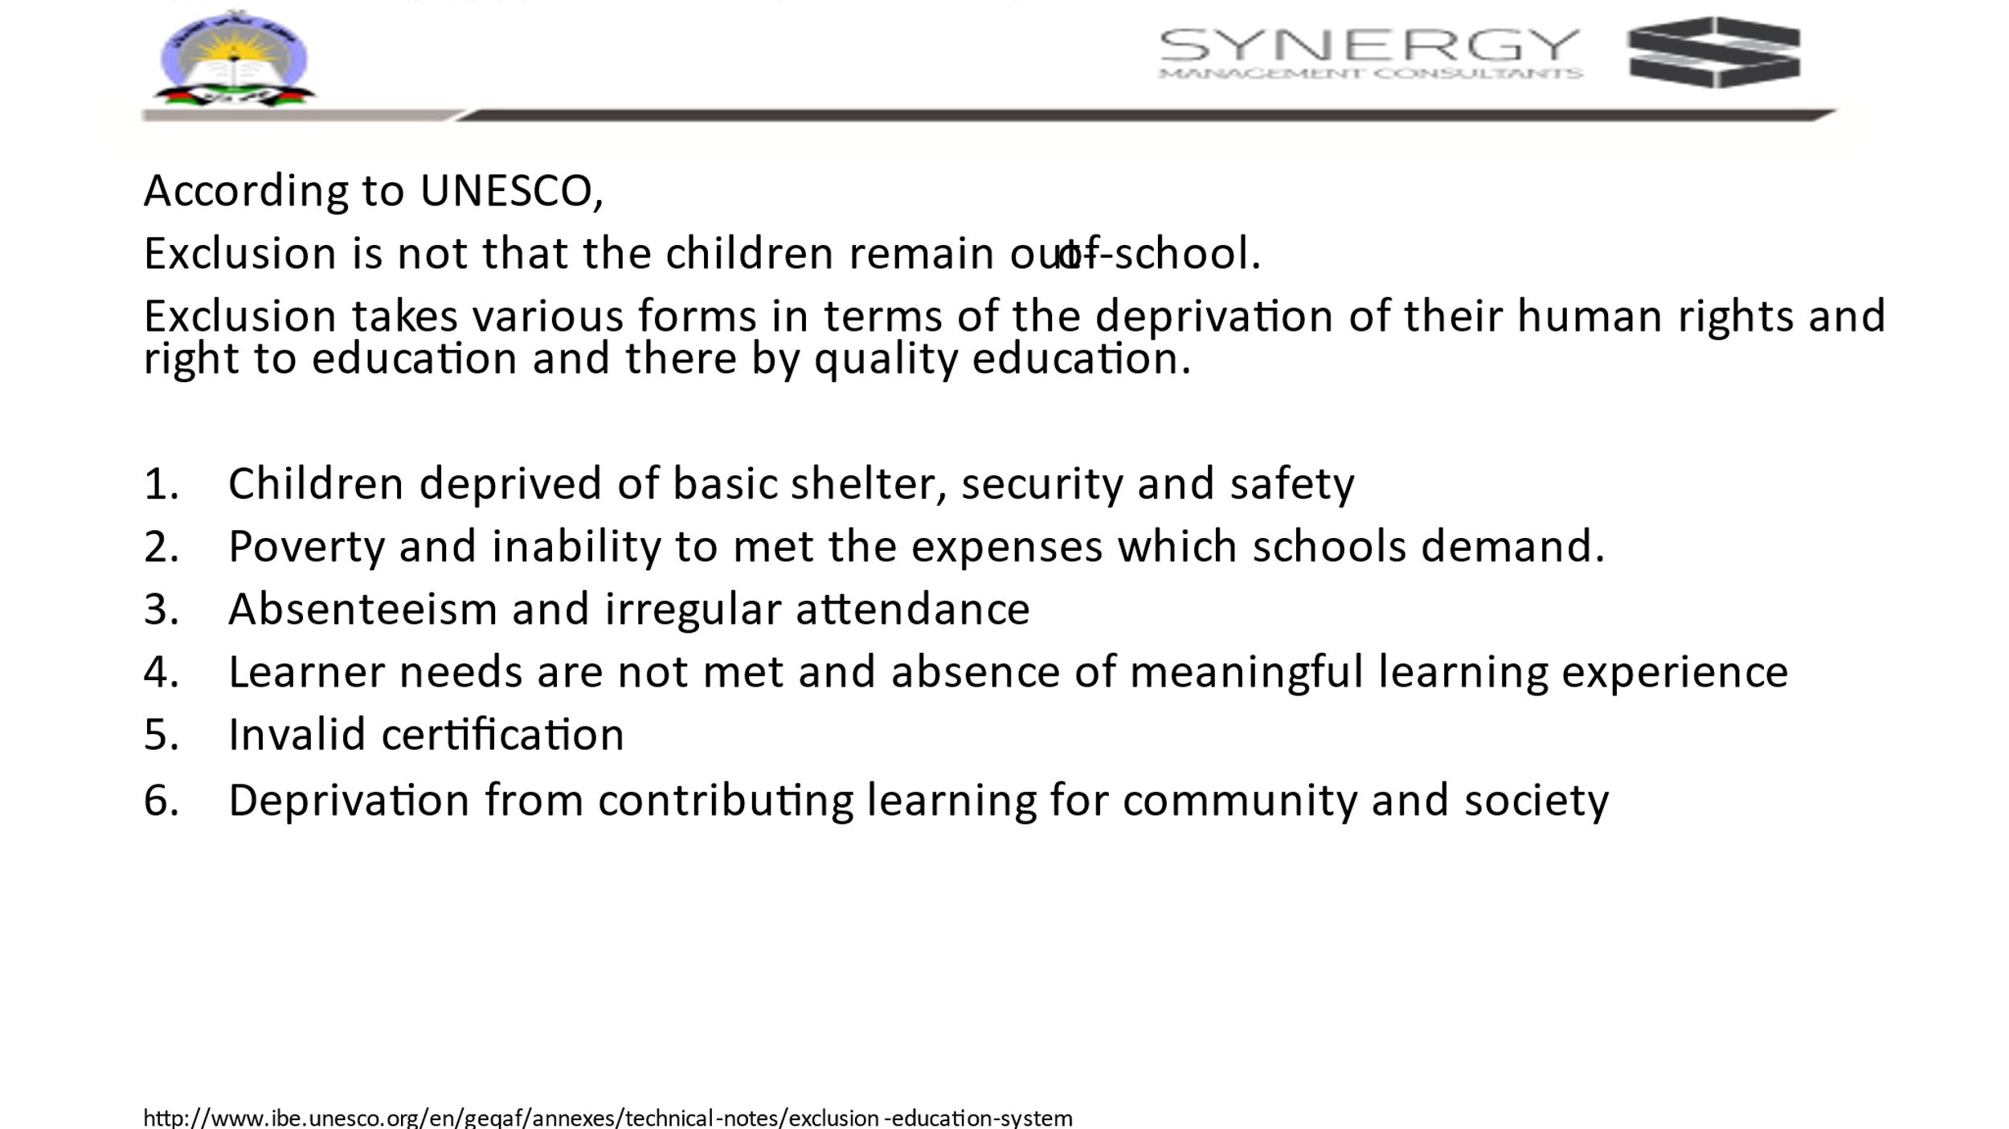

Facilitator:
Ask the participants: Read what is exclusion. Do you agree? Are there any points left out? Is there any thing to be added to the above statement about exclusion?
For each point the facilitator need to give specific examples:
1: home less, street children, slum dwellers, child labour are some of the examples of exclusion from getting good health care and safety of children
2: though there might be a good school they are excluded because they cannot pay the fees, they cannot afford the kind of dress or books and stationery prescribed by the school.
3: Inability to attend school regularly either because of distance or due to domestic demand at home like taking care of siblings, not safe for girls to travel long distances, seasonal migration.
4: Examples: teaching and learning process not meeting the learning needs of the learner; teaching and learning process not corresponding to the learning styles of the learner; the language of instruction and learning materials is not comprehensible; learner goes through negative and discouraging experiences at school or in the programme, e.g. discrimination, prejudice, bullying, violence.
- For example, some certifications are not recognised and this will be a waste since such learning does not lead to any gainful job opportunity or are eligible for higher education.

6. Learning is of little value because of the low status accorded either to the organisation where they studied or the subject itself is considered of little value. As result it results in limited work opportunities that correspond to the area of learning acquired, or limited work opportunities in general; discrimination in society on the basis of socially ascribed differences that disregards any learning acquired by the person.

Slide 10:
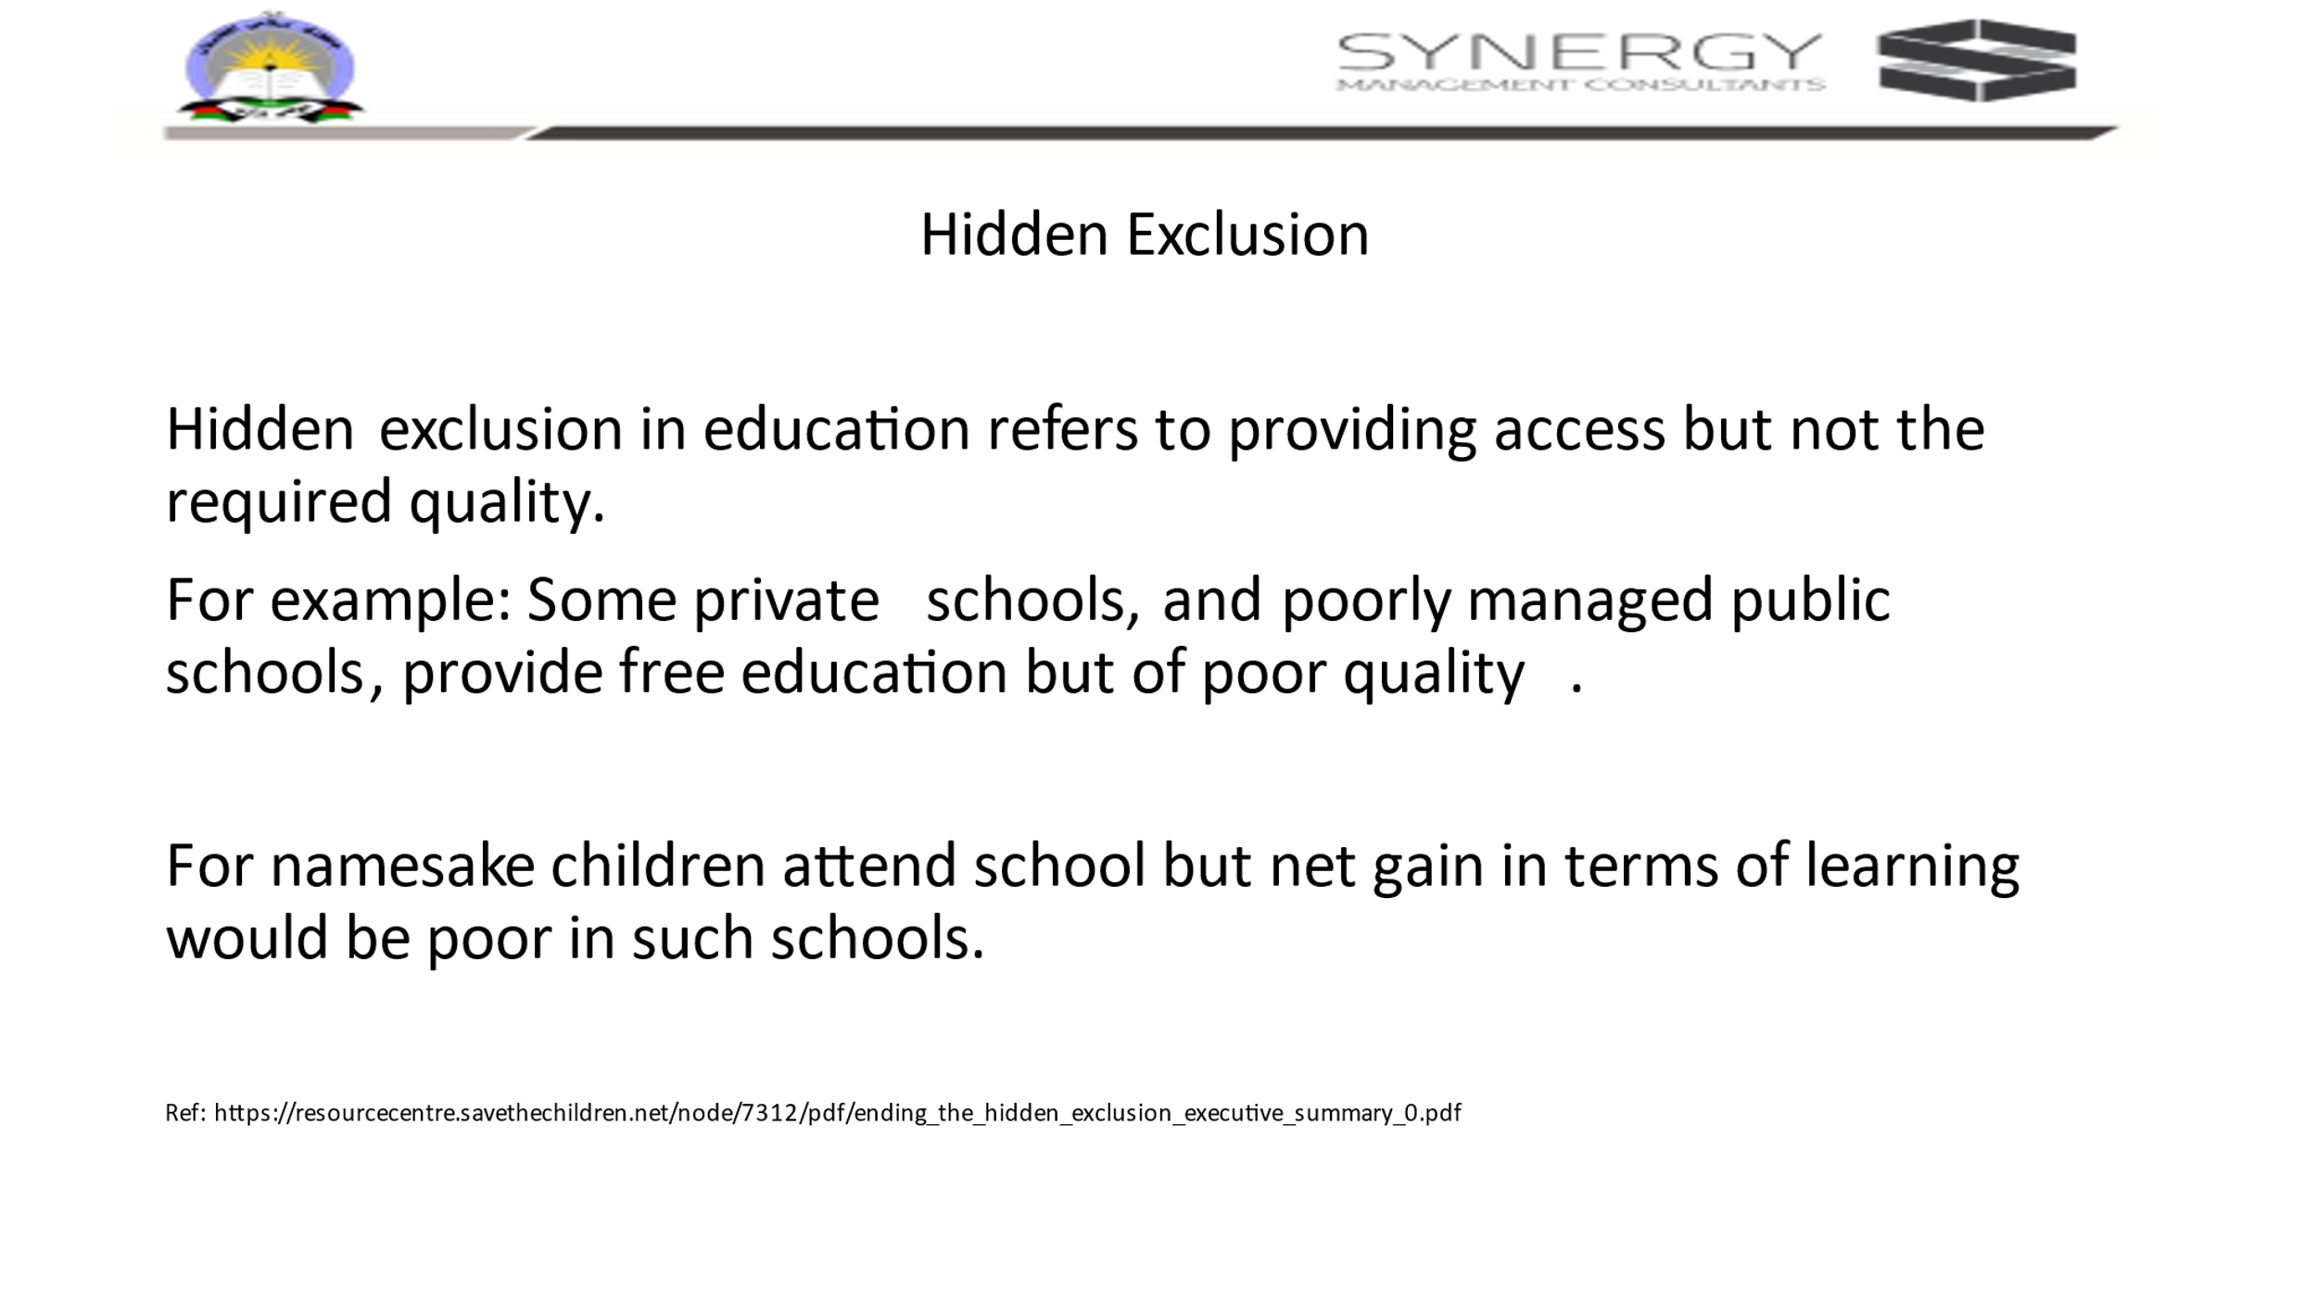

Facilitator: To ask participants to think of the possible reasons for poor quality of teaching and learning?
Possible reasons could be poor quality teachers, lack of resources, lack of toilets, … let participants list.

Slide 11:

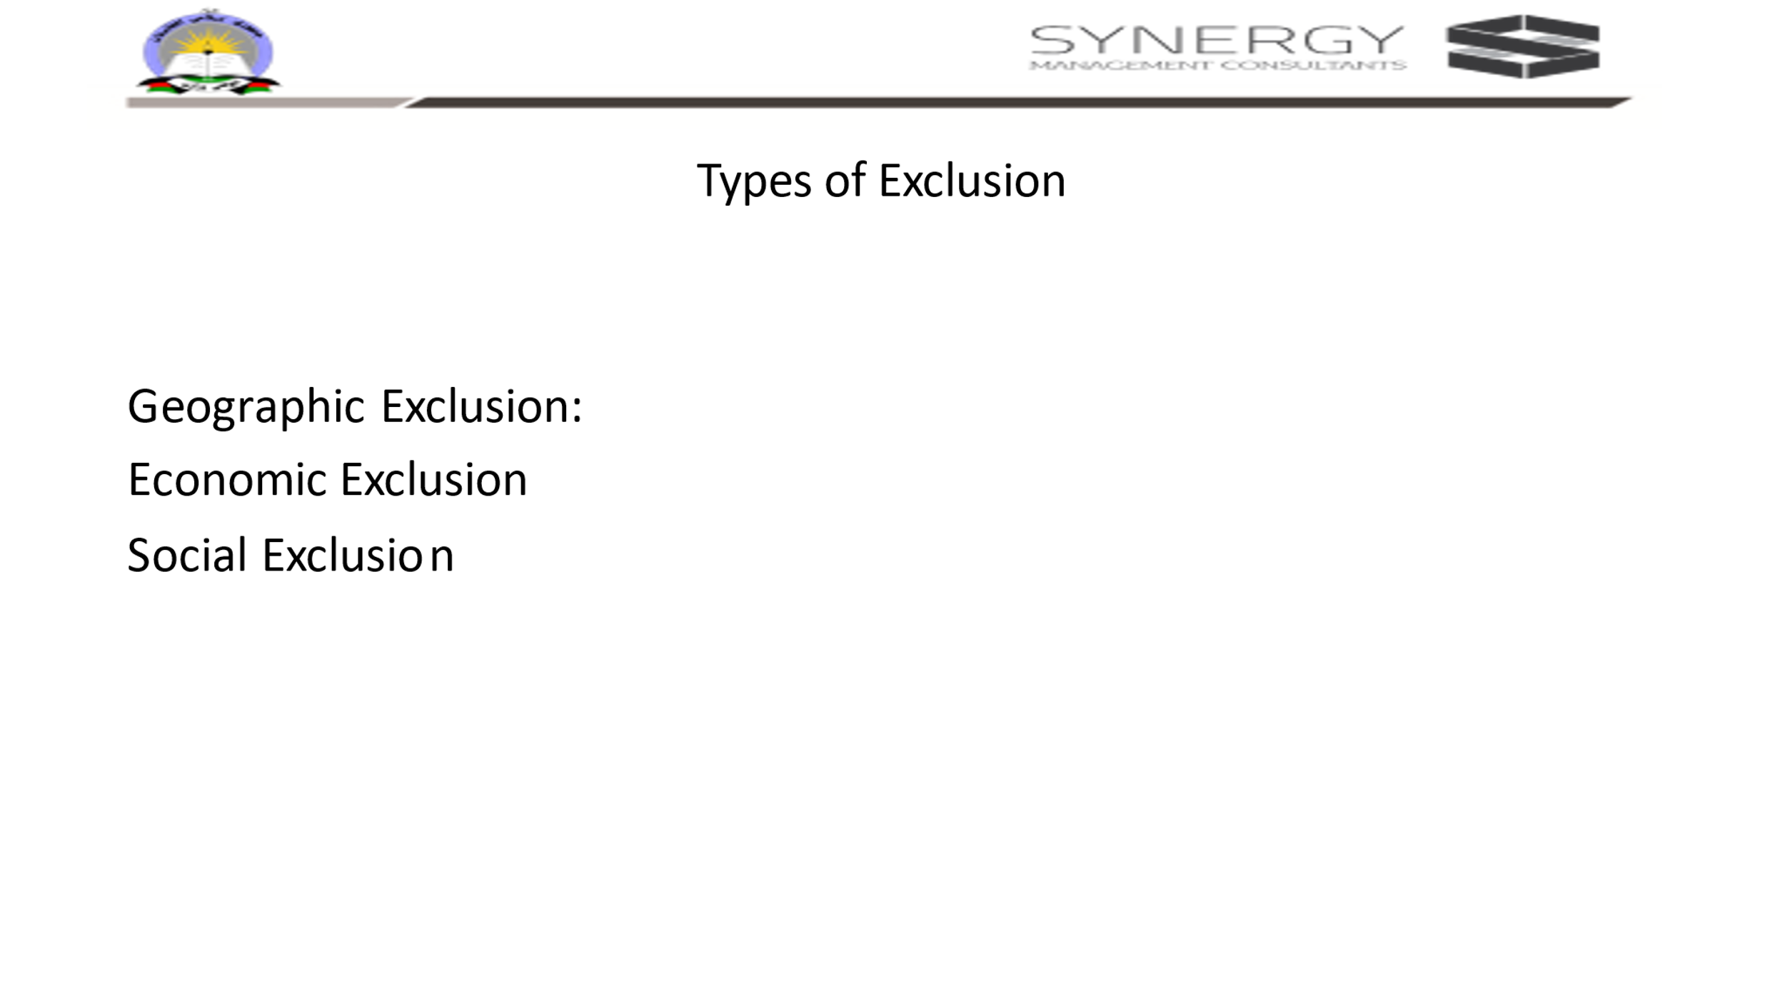

Facilitator: Provide examples of each of these types.
Geographic exclusion: remoteness, poor connectivity, difficult terrain, poor access to services, low agriculture or resource potential.
Economic exclusion: lack of access to labour market, lack of access to banking services
Social exclusion: Discrimination based on the basis of identity such as being man or woman, boy or girl, upper caste or lower caste, rich or poor. They suffer from multiple disadvantages.

Finally ask the participants what could be those disadvantages especially for children?
Open up for discussion and clarifications if any.

In the end tell the participants that : Till now we have heard about various problems that learners face and hence are deprived of education either due to barriers, biases, exclusion and so on. In the next 20 minutes form three groups and each group will get a theme and you need to plan and perform the role play. Some can direct the play, some can be dialogue writers, some can be actors and so on. One condition is every one in the team should contribute to some thing in the role paly.

Activity : Slide 12: (28-30 min)

Facilitator:
Role play: three themes
Theme 1: To think of bias inside a classroom where a teacher is partial to students who score well and rewards them. The others never get a chance to receive reward even once. How they feel?

Theme 2: Parents: they have a twin children-one boy and one girl. Gender discrimination in the family

Theme 3: A school. There is one blind, one deaf, one slow learner, and polio child along with other students. The kind teacher is fair to all. Conduct an activity such a way that all children are happy and are learning in the classroom.

How to conduct the activity?
- Tell the participants to form three groups: theme 1, theme 2, theme 3
- Without revealing what topic each team gets, distribute the three topics to the teams. (Write the themes on three chits, fold them and distribute it randomly)
- Tell them:” this is a collaborative exercise. You decide the plot, number of actors, task distribution etc. plan a five-minute-long skit and present
- While each team presents their skit, the other two will watch. In the end they one volunteer from each team gives feedback on the visible and invisible bias they could see.

Alternate Plan: Just in case the participants take more time to plan the skit, then tell the participants that after the short break the participants should present the role play

Slide 13:
After the skit presentations are over, ask the participants to be seated and in conclusion display the slide 13

Facilitator: PPT to explain the concept of exclusion
Definition of BIAS and EXCLUSION
- Bias-Bias is a tendency to prefer one person or thing to another, and to favour that person or thing. Bias could be based on gender, age, sexual orientation, gender identity, disability status, scholastic ability, and physical appearance such as height or weight.

- Exclusion is defined as ‘the process through which individuals or groups are wholly or partially excluded from full participation in the society

Ask the participants: From our discussion and skit presentations can you think of biases which a teacher can have inside a classroom and indicators to identify them and not it in their personal notes with examples
After this the participants take a short break.

--------------------------------------------------------------------Tea/ Coffee Break-----------------------------------------------------------------------

Facilitator: Once they return, ask the participants to be seated in a semi-circle.

Activity: Reading the pictures: Explicit and Implicit biases (40 min)
Slide: 14

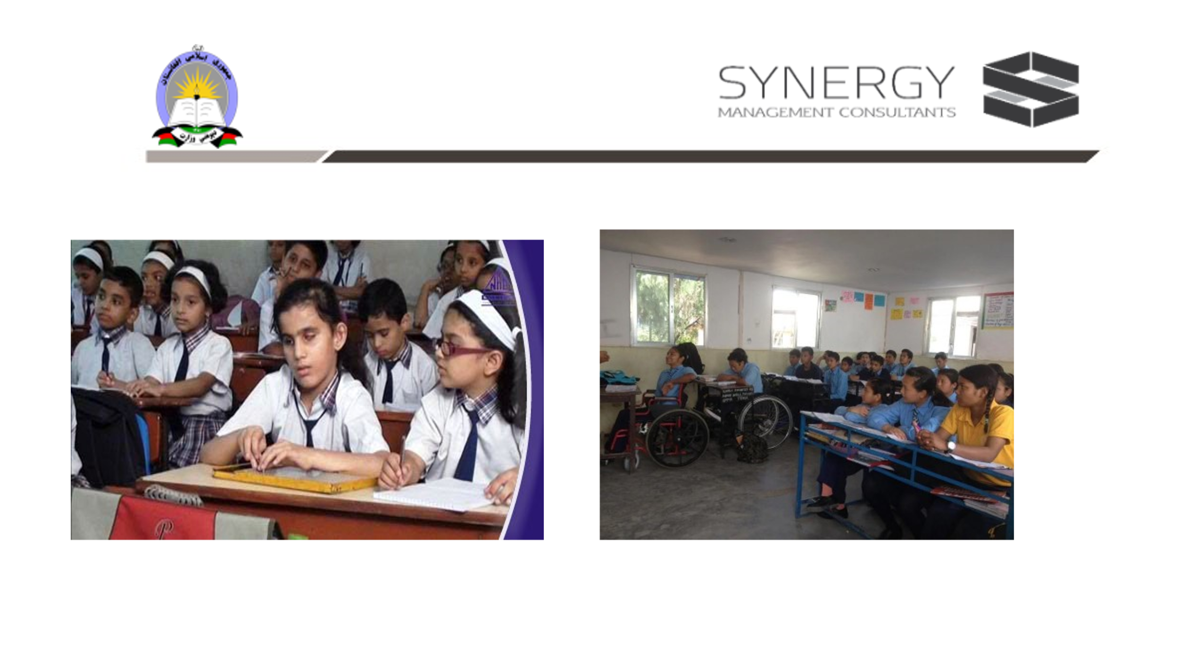

Facilitator : picture reading: Invisible barriers
Suggestion only: Prereading of a few blogs: What are some examples of implicit bias? – Mvorganizing.org
Activity: Reading the pictures:

Participants are asked to look at the two pictures in the slide. Keeping in mind the morning’s introductory activities, they need to think of all possible criteria that might ensue that, some of the students may remain outside the group?
Steps to conduct the activity: (Try to include the principles of UDL)
- All of you look at the picture on screen. Observe all the details.
- Make sure that all the participants can see the picture clearly. Those who want to have a closer look, you may come closer. (In fact, if the training venue has facilities for computers, some of the presentations can be shown on individual/shared computer, there can be opportunities to give feedback by messaging instantly and so on.)
- Ask any two participants to volunteer to read the pictures aloud. “Any two of you volunteer to read the picture. (Either choose one man and one lady/choose one PPDM and one DPDM/ one senior and one junior member and so on) “. Tell them: “come closer to the screen,.
Expectation/ facilitate participants to look at the first picture on the left from the perspective of both physical diversity, safety factors and gender.
Add the participant’s observations to the chart paper whenever new observations are made.

Conclude the activity by summing up telling the participants that bias is based on several factors such as gender, age, sexual orientation, gender identity, disability status, scholastic ability, and physical appearance such as height or weight.
Then move on to the next activity: Tell the participants that next we shall see how gender stereotyping as a bias lead to discrimination and exclusion of women.

Concept 2: Barriers due to Exclusion: Explicit and Implicit Biases-Prejudice, Stereotypes, Discrimination
Activity : “Gender Diversity-what it means to be a boy or a girl”, “Capabilities in learning and earning livelihood” : this is carried out in two parts.

Objective of this activity: to draw attention to prejudices and stereotypes in gender related issues and thereby help participants reflect on its unconscious practices of discrimination

Prerequisite knowledge for the facilitator: Facilitator should know the kinds of prejudices and stereotypes about men and women existing in Afghan society. They should also be aware of the statuses of several successful women both in Afghan society and in other parts of the world who have broken barriers of learning and means of livelihood.

Activity: Gender stereotypes- 1 and 2 (40 min)

Slide 15: Part I (20 min)

Activity part 1: (15 min)
Facilitator/Trainer: For this activity, the facilitator should divide the participants into three groups.

Materials required: Three chart papers and markers

Quick grouping:
Wherever the participants are seated, they call out “only men”, “only women” and “either or men and women” in a sequence. (Purpose: tendency is that familiar people are seated together. This is to shuffle them). After this tell them that they now form three groups- men, women, either men or women.
Each group will identify one leader for themselves who will be required to consolidate the groups work.
In their respective groups using the format displayed from slide 15, the members will list task which only men, only women and both can perform on a chart paper. After 3 minutes, the group leader lists the activities which are either entered in the table above or on a chart paper either by the facilitator or by group leaders.

Facilitator/Trainer: Once all the entries are made, the facilitator reads out the list under each column and asks if there are any changes to be made. This is done for all three columns. Discussion about each activity listed under only men and only women is to get a common consensus that the classification is final. If it contradicts, then the groups to decide if that activity can be moved to different column.

Outcome would be that most activities can be done by both with some ifs and buts. (Facilitators will tell the participants that we use this list to do the part 2 of this activity)

Alternate Suggestion to do the same activity: Get the participants to say in a sequence boy, girl, baby one after the other. Tell them that they form three groups: Men, Women. Either man/woman. All those who said boy will form men group, those who said girl will form women group and those who said baby will form either man/woman group. They should identify a leader for their group. Men and Women groups should list all activities which only men or women respectively can do in their groups . The third group ‘both’ to think of activities which both men and women can do. They write the activity on slips. Then the three-group leads will attach the slips on the wall/ write of a chart paper under respective columns designated for men, women and either man/woman. Then the three chart entries are compared, discussed and any differences are debated to try to arrive at some common consensus.

Slide 16: Part II: (15 min)

Activity part 2: (15 min)

Prerequisite knowledge for the facilitator: Facilitator should know the kinds of prejudices and stereotypes existing in Afghan society.
Outcome: This discussion will elicit the implicit prejudices and stereotypes

Caution: Nobody should take anyone’s words or opinions offensively. As soon as the activity is over, they should no longer treat themselves as opposition members. At the outset itself the facilitator must tell the participants that this is a fun game, and no one should take any opinion stated by their opposite partners in a defensive mode. Also, the opinion need not be specific to Afghan culture. It could be an international perspective. Facilitator should also indicate that the activity is purely meant as an exercise to learn to debate and negotiate in a professional manner, to arrive at consensus in order to take decisions, be able to debate with conviction and giving informed rationale, learn not to reason emotionally.

Objective of the activity: To help participants realise that the gender differentiation is socially ascribed and lead to discrimination. Being a man or woman is a natural diversity, like any other diversities among humans.

Take away message should be Men and Women are biologically different with specific needs, but this has nothing to do with gender neutral activities like schooling and higher education. Respecting each other’s differences and providing facilities to meet their needs is the spirit of inclusion.

Facilitator: After getting consensus for segregation of activities based on whether it is performed by either men or women or both, facilitator should choose six activities (three claiming only men, three claiming only women activities ) preferably pertaining to learning and education , the respective groups to give reasons or justify as to why they think that such an activity can be performed by only men/ only women ? The neutral group are free to challenge this assumption or can join any other group if they want to. The two groups should spend 10 minutes to prepare a debate. Then they seat opposite to each other and debate to justify their point of view. Irrespective of the outcome of the debate, the neutral group are given five minutes to justify why they consider some activities are gender neutral.

While the participants debate, the facilitators note the words used by all three teams to make their concluding remarks.
Facilitator should pick up the words indicating prejudices, stereotypes and discrimination in the participants’ responses and use them as exemplars to explain the definitions for stereotype, prejudice, and discrimination. Facilitator should convey the message that most of the reasons listed are diversities which are socially ascribed, and hence acts as barriers to inclusion. Being a man or woman is natural but justifying who and how one should be learning or get educated, where they should work are all socially ascribed. If we see the larger world, there are many women who have crossed these barriers and have proven time and again that educating women results in better economy of the family

Notes for facilitators: Definition of Terms: Prejudice, Stereotype, and discrimination
A stereotype is an exaggerated belief, image or distorted truth about a person or group—a generalization that allows for little or no individual differences or social variation. Stereotypes are based on images in mass media, or reputations passed on by parents, peers, and other members of society. Stereotypes can be positive or negative. Example: You are mathematics teacher’s son hence you must score cent percent, how can you run like boys?, You write neatly like girls, etc.

A prejudice is an opinion, prejudgment or attitude about a group or its individual members. A prejudice can be positive, but in our usage refers to a negative attitude. Prejudices are often accompanied by ignorance, fear, or hatred. Prejudices are formed by a complex psychological process that begins with attachment to a close circle of acquaintances or an "in-group" such as a family. Prejudice is often aimed at "out-groups.“ He is a tribal boy so cannot speak english,
All our children are from rural background so they cannot perform in a choir,

Discrimination is behavior that treats people unequally because of their group memberships. Discriminatory behavior, ranging from slights to hate crimes, often begins with negative stereotypes and prejudices.

(Source of the definitions : https://www.learningforjustice.org/professional-development/test-yourself-for-hidden-bias )

Slide 17: Activity Part III: (10 min)

Facilitator:
Prerequisite expectation from the facilitator or trainer: To know a few case studies of successful women who have achieved in terms of education in Afghanistan and in other countries abroad.

After the activity, display this slide 17. Pause for a minute or two. Then ask any one of the participants to volunteer to read aloud from the slide.
After reading, pick up each underlined word or phrase indicating barriers and ask if the participants agree. Encourage them to provide specific examples of the barriers due to exclusion.
Facilitator : to read out from the slide and ask the participants the following three questions for reflection and note it in their diaries?
Que 1: as professional development members what is their personal belief about education for all?
Que 2: what are the benefits of education of girls beyond primary level and encourage them to aim for higher education?
Que 3: Recollect and note down at least one example of a woman who has achieved because of education? ()

Repeat this message: Men and Women are biologically different with specific needs, but this has nothing to do with gender neutral activities like schooling and higher education. Respecting each other’s differences and providing facilities to meet their needs is the spirit of inclusion.
Further reading: https://www.unicef.org/rosa/media/5491/file/Afghanistan%20%E2%80%93%20Education%20Equity%20Profile%20for%20Adolescent%20Girls.pdf
Following facilitating the groups to make their points of view, the facilitators make a concluding remark and indicate which of the classification belonged to stereotypes, prejudices and discrimination. Ask the participants to reflect on this activity and relate them to their own life experiences in their families, amongst kith and kin and just recall the consequences of stereotyping in their mind. If they like ask them to share their points of view and experiences on the What App or Telegram group.

---------------------------------------------------------------------------Lunch Break-----------------------------------------------------------------------

Activity: Where is the problem? In Student or In School? (40 min)
To Facilitator: Use Slides 18, 19 and 20 for this.
Slide 18:
The Facilitator to display the slide and discuss how prejudices lead to stereotyping and believing that as the norm finally leads to discriminatory practices in the society.
Begin the discussion by asking what are the differences seen in children in terms of their developmental patterns and styles? What are the different ways in which children learn? Are schools and teachers indispensable for all those which children learn? What exactly is the role of a school in children’s education?
Then ask in what ways are the children subject to stereotypical classification ? Refer to prejudices and discrimination of children.
After presentation ask the participants to think about the following two questions whether children need to adapt to school or the school should accommodate the diversity in children.? And move on to next slide 19
Slide 19:
Facilitator to discuss the examples of kinds of diversity against each variable as an indicator of diversity among students. Let participants responses be recorded on this slide/ on a chart paper.
For example, for the variable economic class the diversity could be difference in occupation, income, social status, upper class, middle class, lower class, rich/poor,

After this exercise ask “despite these variables can we expect all children to fit into a school which expects uniform learning? Is it fair to group them as misfit?”
Ask them to think for a while on the possibility of providing what the child needs in the school instead of asking them to accommodate?

Slide 20:
Facilitator led session: Requires detailed explanation from the facilitator. The session can be made interactive by asking open ended questions
Objective:
To present the differences in the premise with which formal and inclusive schools try to provide education.
Show how diversity is treated.
Explanation:
A formal school views any deviation in a child’s learning styles to be problematic. These schools claim to teach normal children. They usually do not admit differently abled children. In fact, they prefer uniformity to such an extent, they shy away from encouraging multi-grade classrooms. As a result, formal school look at differences in children to be problematic. (Go through the 11 points on the left hand, side of the table.) Explain each phrase with an example.
- The child’s physical or cognitive differences are highlighted, or they simply attach a tag special child/ differently abled child, deaf, blind, and so on.
- The school tries to even out the differences ‘in the differently abled by providing some aids. For example, even while introducing these children are identified with the deficiency if any.
- The type of diversity is identified and are separated from main group. Teachers in such schools strongly believe in uniform learning. Though it is proven scientifically about multiple intelligences, in practice all children are expected to learn through a common method taught by the teachers. The effect of this on the child varies. The extent of deviation from the normal is assessed and evaluated.
- The schools try to bring them to mainstream if these students’ competencies are comparable and match the ‘normal’ students.
- In case if the difference in terms of diversity cannot be removed, such children drop out of the mainstream school.
- The pedagogy in formal classes follows a ‘one-size fits all’ model.
- Every child in a class is assumed to learn the same way and this is taken as a standard measure to measure their learning and the school decides the kind of treatment needed. Students are indeed seen as patients requiring medical intervention to make them normal.
- Even if such students are physically present in the same classroom, they are merely integrated and they do not get any opportunity to participate in any pedagogical activity.

On the other hand, the difficulties and discrimination faced by children to learn in a uniform manner when seen from the point of view of deficiency in the system, they try to accommodate all children. The teachers in such schools believe that every child can learn so that they can be educated enough to become responsible citizens.

Activity: Inclusive Literacy Classroom (40 min)
This session will have three kinds of activities. They are understanding the meaning of Inclusion, discussion about an Inclusive Literacy Classroom followed by a paired activity to imagine an inclusive literacy classroom by distinguishing it from a formal classroom – an imaginary real-life case.
This session is very important preparation for the day-3 training concept called the Universal Design for Learning
Slide 21: (5 min)

Facilitator: To ask the participants: “Observe the pictures and think of what it communicates about the situation inside a classroom? The circle represents school and coloured dots represent different children with different styles of learning”

Objective:

- Formal schools promote exclusion, segregation or mere integration
- But even integration is not inclusion.
- Beginning to brainstorm about the features of an inclusive classroom.

Presentation of the slide 21
Facilitator needs to explain each type of isolation of students with different learning styles, who do not fit into the normal group in the classroom. Draw participants attention towards the difference between exclusion, segregation and integration and share how inclusion is the best way to encourage learning in all students.

Activity: Inclusive literacy Classroom
Slide 22:
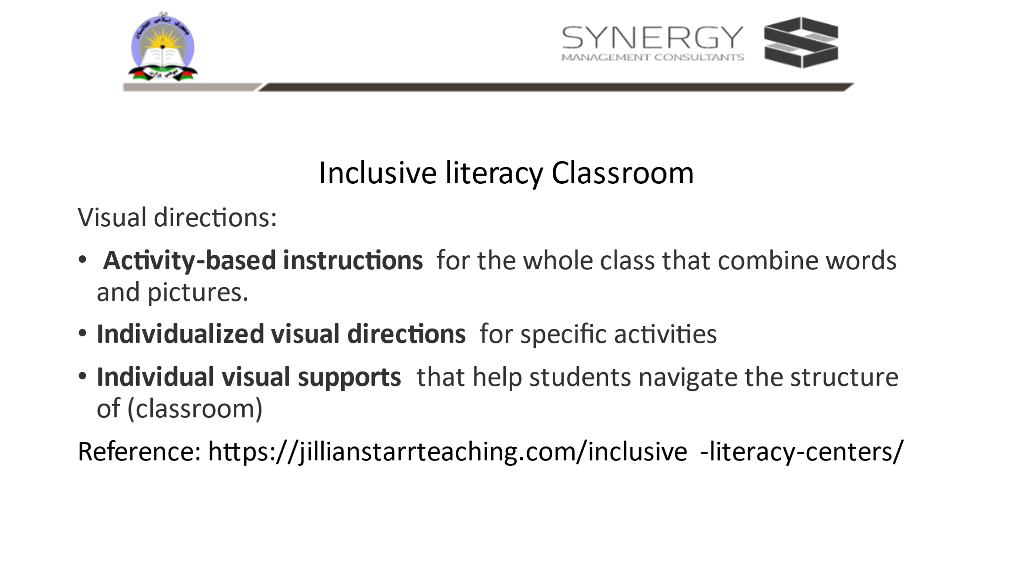
Next introduce the possibility of inclusive literacy in classroom.: (5-10 min)
Activity: This is a facilitator led discussion on inclusive literacy in the form of question and answer.
Seating: preferably in a circle along with the facilitator.

Prerequisite knowledge for the facilitator:
- Fair knowledge of inclusivity, inclusive pedagogy, inclusive classrooms from across the world- both from developed and developing countries , resource rich classrooms, multi-grade classrooms, UDL classrooms.
- The following article provides some insights into how one of the inclusive literacy classrooms looks like. Prereading of this before the training is recommended: https://jillianstarrteaching.com/inclusive-literacy-centers/

Initially the Facilitator begins the discussion with a series of questions. They will also answer if the participants do not respond. Facilitators should ensure to encourage participants to ask questions

Facilitator:
- What is an inclusive literacy classroom? – It supports students without singling them out and ensuring they feel empowered (and powerful) in the classroom.
- Which learners feel empowered in such classroom? Give example? – Every student feel empowered in such a classroom. It is especially empowering for students who have a different home language, or dialect, for those who are new to the medium of instruction used in school. Example a child who knows only Pashto but admitted to an english medium school.
- What do teachers think while planning in an inclusive literacy classroom? - inclusive literacy classroom is centered around the aim to support each and every child to learn meaningfully. So such teachers ask the following two questions: “Is my resource or lesson scaffolded in a way that supports ALL of the kids in my room?” and “How can I modify, challenge, and extend my content for those who need it/are ready?”.( https://jillianstarrteaching.com/inclusive-literacy-centers/)
- If the teacher has to cater to each learner, how many ways of individualized and inclusive support can be provided? Is it really possible for a single teacher to do this? – There are multiple ways of individualized and inclusive support which a teacher can learn. Such teachers draw support from other stakeholders like the parents, community members, school heads, colleagues, PDMs, education department, NGOs and so on who are also are preferably informed about the possibility of inclusion in school and in particular the possibility of an inclusive literacy classroom.
- What are the characteristic features of an inclusive literacy classroom?- There are many. One most important aspect of a functional classroom is the learners are clear about ground rules, they have clarity on their tasks, they can be independent with most of the task, the classroom is prepared with resources which are freely accessible to students and the class is normalized, calm and absence of chaos is evident. In such classroom every individual will be working at their own pace. The teacher makes sure that multiple scaffolds are available and presents them to students as per the learner’s needs. One strategy for example a teacher found the oral instructions worked fine for only a few. Others needed repeated reminders. So along with oral instructions, lot of visual instructions were added. Since every student by nature desire to be independent, they visual instructions made them to rely more on visual cues and their peers rather than only on the teacher. It gave them a feeling of being independent and empowered.
- What is this type of teaching called? -Inclusive pedagogy

In the end tell the participants that this is just a sample., and others also continue to ask questions or share their answers. The questions can be noted in the personal diary and answers can be found out from various sources. These should be preferably posted on what’s app / telegram groups to gather more knowledge and ideas.

Lastly tell the participants that they will work in pairs to think of an inclusive literacy classroom. Participants are free to choose their pairs for this 10-minute-long session

Materials required: Facilitator suggests participants to read online or provide a few hard copies of the reading material.

Activity: Interactive presentation on literacy in inclusive classroom (10 min)
Slide 23:
Objective: To get a glimpse of an inclusive classroom.

Paired activity:
To think what the children might experience in a formal classroom and in an inclusive classroom, and fill the table
Facilitator: Displays slide 23 and reads out aloud the case of Rafiq and Reshma. Then tell the participants: You take 5 minutes to work in pairs and think of all that you can do to scaffold the two children so that they feel empowered and independent in the new school.

In the case of Rafiq and Reshma, list out all possible strategies the school can do to help the children?
In the end each pair shares the strategies they thought of on a paper, reads them aloud taking turns and fixes it on to the chart paper or common display board.
Facilitator fills out the blank cells to make a consolidated table in the slide 23.

---------------------------------------------------------------------Tea/ Coffee Break----------------------------------------------------------------------
Concept 2: Barriers due to Exclusion: Explicit and Implicit Biases-Prejudice, Stereotypes, Discrimination

Activity: Identifying indicators of inclusivity: (20 min)
Slide : 24

Facilitator:
- Instruct the participants to think of all possible indicators of clues that help them identify the inclusive practices. (Below is just a sample of how you as a facilitator can get the participants to begin to think about indicators )
- In this activity the participants will think of the strategies used to address the barrier against the variables or diversity in school

- Example of how to explain the table: The horizontal rows list the barriers to schooling which you identified on day one. On the left column the type of diversity in a student is listed. Against each diversity and the barrier, think of what the indicator of inclusivity could be to address the barrier with respect to the diversity.
- For example, first row is filled as sample.
- The participants will work in small groups of three or four and try to fill the table and present at the end of the task

Materials: Notebook/ work sheets/ handouts, writing instrument, chart paper to consolidate all the points from all groups into one common chart for display

Activity: Reading case study (20 min)
This is preferably an individual activity
Slide 25:

Facilitator: https://www.unicef.org/afghanistan/stories/learning-today-inspiring-tomorrow
Preparation: (file name of soft copy provided in the resources folder: Learning today; inspiring tomorrow _ UNICEF Afghanistan) Either original english version or the translated version is used. A hard copy or soft copy is provided to all the participants before the session begins.
Instruction:
Facilitator will instruct the participants: “this is a reading activity. Reading can be done in three ways of their choice:
- Read silently all alone and make notes. Prepare in such a way that you can narrate this story to all.
- You can read in pairs : Two of can read together, silently/ share reading. Later you discuss the case study keeping in mind the last two days learning from the training.
- You can even read collectively- say a group of five. One person will read aloud. And others listen. They summarize orally, followed by critical discussion.

This story is later on used as the lead for TLC discussion. Based on day 1 discussion or barriers, day 2 discussion on inclusion, participants should discuss Royeda’s case, what were her circumstances to achieve, how she negotiated, gender issues in her family, support she received from her husband and so on. Can teachers like Royeda be increased in the community so that the shortage of women teachers can be improved?
Finally, the participants enter in the interactive diary what is their learning and belief about the possibility of sustaining inclusive school and join the structured reflection session

Activity : Structured Reflection Session for – Day 2 (40 min)
Seating Plan: In a circle along with the facilitators
Materials required: personal diaries /notebooks, interactive diaries, writing instruments
Slide 26:
Lead / guide for structured reflection:
To Facilitator:
Every day ends with structured reflection of the day.
Objective:
This is to simulate the TLCs facilitated by trainers. For this all participants are required to sit in a circle along with the facilitator.
Materials: (If needed the ppt slide can be displayed)
Participants must have their pens, interactive diaries, and their personal notes.
In the interactive diaries they need write to the facilitator as feedback, seek clarification, share their points of view.
In the end the facilitator will collect their diaries and respond in writing to each one of them and return it the next day morning.
In the personal diaries the participants make notes from the discussion they carry out on the topic,

It is recommended that the Facilitator makes note of intangible feedback from participants various feelings such as happiness, disappointment etc. and use them as examples to draw their attention towards implications of barriers.
The following are some of the questions which can be kept on as a slide to facilitate the structured reflection session:
- What went well for you?
- Feedback for the facilitator’s presentation
- Which activity gave you insights?
- Which activity kept you engaged?
- Which aspect were difficult/easy?
- What was your experience in communicating? With facilitator/coparticipants
- What were your expectations for the day?
- What do you want to share or get clarification from the facilitator? What more are you expecting from tomorrow?
- Why are you satisfied/not satisfied?
- What is your takeaway?
Note: These questions need to be reworded, or more questions can be asked as per the need of the day and the group. It is important for the facilitator to listen actively and try to address the issues or convince the participants in the subsequent training days

At the end of the day, thank the participants. Remind them of the next days schedule, ground rules if any and assignments if any. Display the last Slide.
Slide 27

References and Further Reading
Recommended literature for facilitators for prereading:
- https://www.learningforjustice.org/professional-development/test-yourself-for-hidden-bias
- https://www.unicef.org/rosa/media/5491/file/Afghanistan%20%E2%80%93%20Education%20Equity%20Profile%20for%20Adolescent%20Girls.pdf
- https://www.unicef.org/education/inclusive-education Inclusive education | UNICEF
- What are some examples of implicit bias? – Mvorganizing.org
- https://jillianstarrteaching.com/inclusive-literacy-centers/

Space for trainers to make their own notes on this.

TRAINING GUIDE: Day 3

For Facilitator:
Facilitator’s objective of the day
- Help participants understand that situation of diversity and principles of inclusion is universal, but strategies for inclusion is contextual (metaphor of grafting vs pollination)
- Introduce the concept of Universal Design for Learning
- UDL is introduced in an experiential manner

Prerequisite knowledge and skill for facilitators
- Conviction that everyone can learn and in particular the children.
- to look at school and school system as a barrier rather than the children’s diversity as a barrier
- Aware of various forms of exclusion
- Optimum knowledge about the concept of UDL
- Multiple strategies of instruction within the framework of multiple intelligences and the principles of inclusion
- Knowledge of gathering resources for UDL from multiple sources including resources from local community.
- What to notice and how to observe academic activities and how to provide constructive feedback. (for lesson planning, execution of planned lesson, usage of resources, peer learning during TLC etc. to name a few)
- How to document and report /gather information on inclusive schools
- Compile information of usage of UDL from multiple institutions-national and international sources
- Disseminate relevant strategies to sustain inclusion in schools in ones’ province /district and facilitate adaptation of strategies to local context in Afghan.
- Facilitate cross learning and skill transfer across teachers and schools during TLC

Prereading(recommended)
- https://www.cast.org/impact/universal-design-for-learning-udl (Readers are suggested to explore themselves)
- INCLUSIVE EDUCATION, TRAINING of TRAINERS MANUAL, Steps towards Afghan Girls’ Educational Success II, Aga Khan Foundation, Afghanistan, April 2018

Expected learning outcomes from participants
- Understand the difference between conventional and UDL frameworks of teaching
- Experience planning to teach using UDL framework
- Strategies of facilitating teachers to practice inclusion.
- Strategies to report the ground level situation to higher levels
- Recommended that even the PDMs read these two documents:
- https://www.cast.org/impact/universal-design-for-learning-udl
- INCLUSIVE EDUCATION, TRAINING of TRAINERS MANUAL, Steps towards Afghan Girls’ Educational Success II, Aga Khan Foundation, Afghanistan, April 2018

Day 3: Schedule
Day | Sub-topic | Concepts | Pedagogy | Time
Day 3 | Sub Competencies mapped: Working effectively with others
Day 3 | Universal Design for Learning  UDL | Concept 3: UDL and Inclusive pedagogy  Concept 4:Diversity facilitates inclusivity | Welcome, Review Day 2 | 30 min
Day 3 | Universal Design for Learning  UDL |  | community building activity: Find your partner | 40 min
Day 3 | Universal Design for Learning  UDL |  | Preliminary activity to understand practices of inclusivity | 20 min
Day 3 | Universal Design for Learning  UDL |  | Short Break | 10 min
Day 3 | Universal Design for Learning  UDL |  | How to practice inclusion? Thinking | 15 min
Day 3 | Universal Design for Learning  UDL |  | UDL at a glance: Reading two articles and analyzing its contextual relevance | 25 min
Day 3 | Universal Design for Learning  UDL |  | Facilitator led presentation about UDL and UDL lesson plan | 40 min
Day 3 | Universal Design for Learning  UDL |  | Lunch | 60 min
Day 3 | Universal Design for Learning  UDL |  | Practice preparing a lesson plan using UDL frameworks for indoor activity: Left group as Performers, develop a plan of an indoor activity and  others in right group –are Observers | 40 min
Day 3 | Universal Design for Learning  UDL |  | Presentation by performers (can be either formal talk/role play/mime/pictorial )  Presentation by observers: Reflect what to notice and how to give feedback | 30 min
Day 3 | Universal Design for Learning  UDL |  | Short Break | 10 min
Day 3 | Universal Design for Learning  UDL |  | Practice preparing a lesson plan using UDL frameworks for outdoor activity: Right-group as Performers, develop a plan of an activity and others in left group –become Observers | 40 min
Day 3 | Universal Design for Learning  UDL |  | presentation by performers (can be either formal talk/role play/role play/mime/pictorial )  Presentation by observers | 30 min
Day 3 | Universal Design for Learning  UDL |  | Structured reflection for the day | 40 min

Concept 3: Universal Design for Learning (UDL) and Inclusive pedagogy
Concept 4: Diversity facilitates inclusivity

Add details about the training here.

Activity : Welcome, Review of day 2 (30 min)
Slide 2: 5 min

Facilitators:
Begin the day greeting the participants and follow the protocols.
Later walk through the participants about the schedule for day 3.
Remind the ground rules, state the expectations and learning outcomes from the participants. Return the interactive diaries, share your responses to general information and common issues applicable to all. If it is participant specific, ask them to go through your feedback, and get back to you for further clarification if any .

Day 3 Expectations: participants will be exposed to principles of UDL and they experience on how to observe, facilitate and provide feedback to teachers.

Objectives:
- Understand what inclusive schools do to accommodate diversity in students.
- Understand the difference between conventional and UDL frameworks of teaching
- Experience planning to teach using UDL framework
- Strategies of facilitating teachers to practice inclusion.
- Strategies to report the ground level situation to higher levels

Slide 3: (2 min)
To the Facilitator: Help participants recall the learning from day one and two and the specific message for the PDMs from the two days’ workshop.
Further move on to the next slide to help them specifically recall the difference between viewing student diversity as a problem as against the deficiencies in the school itself

Slide 4: (23 min)
Facilitator led:

Objective:
To recall the difference between viewing student diversity as a problem as against the deficiencies in the school itself

How to do this activity?
Keep this slide on, and randomly select every fifth person in a circle (alternatively every person sitting of the right end of each row will read out the pair of points from two columns and say what they understand by it.
For example, the first points from both columns: child is labelled versus child’s need valued. Based on day 2 discussions, they need to explain What does this mean? What could be the problem in the first case.

Note: And they should pause for half a minute. In this period, any other participant is welcomed to seek clarification if any from their co-participant or add their observation /point of view.
This way 11 participants are randomly selected, and they share their understanding about what each pair mean.
Following this move on to community building activity.

Activity : Community building activity: Find your partner (40 min)

Slide 5:

Facilitators:
Community building activity: Finding resource persons:
Objective of the game:
Mutually complimenting the demand and supply of external support,

Material: Most preferable Post its (notepaper with sticky gum / paper slips/ in case post-its is not available, use chart and
markers/sketch pens .
Instruction: Activity in two parts:
Part 1
1.Get all participants to be seated in a circle with a pen in their hands and quick warm up claps. (Slow to fast then slow frequency)
2. Give each participant two blank pieces of paper (about the size of a post card) and Show the slide with two incomplete statements.
3.Now instruct them:
- Write your full name on one corner of both the papers
- Look at the slide. There are two incomplete statements. You will need to complete them. On one sheet write the first statement and on the other the second sentence.
- After writing, stick the chits on the flip charts separately under charts with the corresponding headings- “I need to know” and “I can offer”. For this you get 10 minutes . (The two flip charts can be of different colours and can be hung on opposite walls in the training venue)

Part 2
- After all of them stick and return to their seats, give them the next instruction
- You have to now look for a partner who wants to offer help for the aspect you want to know. Find them from the chart and become their partner for remaining two days.
- Use this opportunity to discuss what you need to know? Why?
- There can be more member partners in each group.
- Just in case suitable partner is not found, then both I need to know to, and I can offer can be stuck to the flip chart in the centre.
- Facilitator will help address this during break time.

Part 3: move on to next slide

Slide 6:

Facilitator
This activity is the continuation of the review activity. Tell the participants that they now have an opportunity to mutually help each other to wonder How the schools accommodate children with diversity?

Objective:
In this the participants will get an opportunity to make a guess about inclusive practices and suggest the alternative strategies which are not normally seen in formal schools.

Instruction:
The partners formed during community building exercise group together. The number of members in each group is likely to vary. In case the size of the group is more than six, they divide into more groups of three members.
Tell the participants to brainstorm how they accommodate all children against each point about what they do?
Conclude that activity by asking the participants to remember all that they discussed as it will be a valuable resource for themselves.

Activity : Preliminary activity to understand practices of inclusivity (20 min)

Slide 7:

Facilitator:
Knowledge of the existence of the following document: INCLUSIVE EDUCATION, TRAINING of TRAINERS MANUAL, Steps towards Afghan Girls’ Educational Success II, Aga Khan Foundation, Afghanistan, April 2018.

Facilitator: To show this slide, draw attention to the meaning of pluralism model and the phrase diversity is strength.

Ask the participants: “In the previous activity do you think that intuitively you applied pluralism model and accepted diversity a useful resource in your thinking. How many of you accept diversity as a strength? Please raise your hands.

Later for those who did not raise hands, select two or three among them and ask why you don’t agree?” Just record it and can be used in subsequent sessions if needed.

--------------------------------------------------------------------Tea/ Coffee Break-----------------------------------------------------------------------

Add details here
Activity : How to practice inclusion? Thinking (15 min)
Slides 8 to 14 are used here.
To the Facilitator:
Preferable seating arrangement: In a circular form till lunch time.
This is a reading activity : 15 minutes. The four slides (9 , 10, 12 and 13) are meant for the participants to read: they are excerpts from two sources:
1. Source: Ministry of Education, Islamic Republic of Afghanistan, and United Nations Children’s Fund (UNICEF), https://www.unicef.org/afghanistan/reports/global-initiative-out-school-children
2. N for nose: state of the education report for India 2019; children with disabilities - UNESCO Digital Library P(75)

The objective:

Participants who are now familiar with various barriers to schooling, get to know the major barriers in their own context from reliable sources of information.

Activity:

Brief reading: Ask the participants to first read either from their worksheets/ interactive diaries and if given printed handout otherwise they can read from the laptop or mobile phone.
Second, discuss in pairs about possible solution to prevent dropouts by making suitable modifications in the school and classroom.
Later spend 5 minutes for collective sharing of the outcome of their discussion.

There is a possibility that some of the participants discover that this paragraph is just an introduction, incomplete and the actual barriers and gaps are not found in this paragraph. That observation is indeed positive. Let the participants know that the link will be shared, and they may read the entire article/report in their leisure.
Alternately just in case no one notices, the facilitator can ask two direct questions :
- What does this report intend to identify?
- What are the barriers identified by the report?

Facilitate participants to think out of box on the possibilities to attract and retain children in school by addressing the barriers which are within their scope of addressing.

Slide 8: How to practice inclusion? (1 min)

To facilitators:
- One of the most important principles of inclusive education is that no two learners are alike, and so inclusive schools play great importance in creating opportunities for ALL students to learn and that they are assessed in a variety of ways to track individual self-development instead of assessing them in comparison with the development of the peers.
2. Teachers and inclusive classroom pedagogy :Observing and facilitating inclusiveness, give importance to cross learning across schools and provinces (note: Grafting vs cross pollination metaphor)
Facilitators will tell the participants that today they would be learning two concepts which are mutually inclusive and go hand in hand.

NOTE: From 9th slide to 14th the participants are encouraged to read through the texts recommended for guided reading and the complexity in terms of length of the text is increased gradually.
OBJECTIVE of GUIDED READING:
- It will have specific focus and learning objective for the reading session.
- Not only the readers decode the text, but they will also understand and interpret the text.
- Readers get an opportunity to engage with the text by critically evaluating it and reflecting on their responses to it by bringing prior knowledge to their understanding of the text.
- In guided reading, the readers can use their skills of inference, deduction, justification, and evaluation.

Slide 9 : Activity:
Brief reading: Ask the participants to first read either from their worksheets/ interactive diaries and if given printed handout otherwise they can read from the laptop or mobile phone.
Second, discuss in pairs about possible solution to prevent dropouts by making suitable modifications in the school and classroom.
Later spend 5 minutes for collective sharing of the outcome of their discussion.

There is a possibility that some of the participants discover that this paragraph is just an introduction, incomplete and the actual barriers and gaps are not found in this paragraph. That observation is indeed positive. Let the participants know that the link will be shared, and they may read the entire article/report in their leisure.
Alternately just in case no one notices, the facilitator can ask two direct questions :
- What does this report intend to identify?
- What are the barriers identified by the report?

Facilitate participants to think out of box on the possibilities to attract and retain children in school by addressing the barriers which are within their scope of addressing

Slide 9: First slide for reading

Slide 10:Second slide for reading
Note to facilitator:
- Any three participants will volunteer to read the three points in the slide above. After each point the facilitator pauses to discuss whether some of these issues can be resolved.
- Facilitator encourages the participants to ask questions and seek responses from each other.
- To reflect upon the following:
- Realise that not all problems be resolved all at once.
- List all the problems mentioned in this excerpt of UNICEF report. Are there any new issues which were not pointed in the last two days?
- To ponder which of these issues can be addressed with collective effort from parents, community, school management, teachers and PDM?
4. Conclude the activity by saying let us explore more about addressing such issues of dropouts. Here is short video about the strategies which can be used to address some of these issues.

Slide 11:

Slide 12: third slide for reading

Slide 13: Introducing the concept of UDL framework: 4th slide for reading

This is also a reading activity : 15 minutes. This is the fourth slide - meant for the participants to read: they are excerpts from two sources:
1. Source: Ministry of Education, Islamic Republic of Afghanistan, and United Nations Children’s Fund (UNICEF), https://www.unicef.org/afghanistan/reports/global-initiative-out-school-children
2. N for nose: state of the education report for India 2019; children with disabilities - UNESCO Digital Library P(75)

Slide 14: More about the concept of UDL framework: 5th slide : for reading
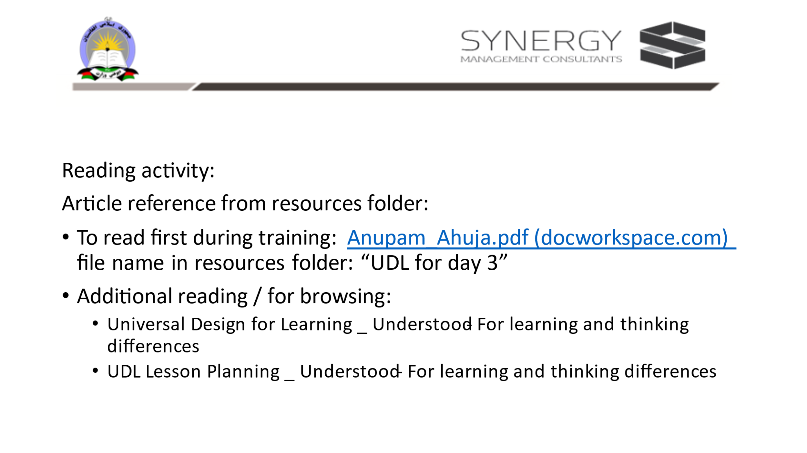

Objective:
1: Practice self-reading and discussing to understand new concepts with guidance.
2: Understanding the basic principles of UDL
Facilitator: Reading about UDL: Either everyone reads on their own or the facilitator reads aloud and explains.
(Just a suggestion: no need for translation, the facilitator can read aloud like a textbook and provide explanation while the participants follow the text or gives the gist of the message in the article either in the beginning or in the end if the participants can read on their own.)
Activity:
- Begin with a warmup activity: for shuffling and regrouping:
Get all participants to walk randomly inside a circle when the bell is ringing. When it stops, they must quickly form a circle. Repeat this five times. In the end, tell the participants to say left, right, left, right…one after the other. All those who said left will move to one side and those who said right will form another group.
2. Then they sit in their respective groups-left or right and read together: The articles in pdf are in the resources folder:
- To read first during training: Anupam_Ahuja.pdf (docworkspace.com) file name in resources folder: “UDL for day 3”
- Additional reading / for skimming:
  - Universal Design for Learning _ Understood - For learning and thinking differences
  - UDL Lesson Planning _ Understood - For learning and thinking differences
3. After reading the two groups are required to debate on what they agree and what they do not from the article. They need to also discuss why it is or it is not relevant to Afghan context.
4. Facilitator joins only when there is silence or misconceptions are discussed. Otherwise, the facilitator observes and records the participants’ understanding of UDL. These can be used as examples wherever relevant during the presentation.

Post reading session Activity : Facilitator led presentation about UDL and UDL lesson plan (40 min)
To the Facilitator: : (slide no 15 to 19) Is part of facilitator presentation of UDL . Post reading make a power point presentation about UDL (slide no 15 to 19)
Seating plan: Regular classroom form of semi-circular or in rows.
Slide 15

Slide 16:
To the Facilitator: Is part of facilitator presentation of UDL : (slide no 15 to 19)
Slide 17:
To the Facilitator: Is part of facilitator presentation of UDL : (slide no 15 to 19)
Continuing with the knowledge that integration is not inclusion, similarly, in inclusive pedagogy, instead of modification, accommodation is more beneficial to any child.
Objective:
To distinguish between Modification and Accommodation in inclusive pedagogy.

Slide 18: Self-explanatory picture communicating the need to remove barriers and accommodating rather than making modifications or providing uniform facilities to provide equal treatment for all.

To facilitator:
Let participants comment and say what they understand from the picture.
Is part of facilitator presentation of UDL : (slide no 15 to 19)

Activity:
Suggest to the participants to observe the picture carefully and try to define UDL instruction.
The first on the left depicts uniform instruction in formal or conventional classroom
The middle one depicts integration and modification type of instruction.
The last one denotes differentiate accommodation.
Tell participants they will learn about a UDL lesson plan

Slide 19:
To Facilitator: Post reading activity, reading this is the last slide of power point presentation about UDL: (slide no 15 to 19)

This is just for the participants to read, either facilitator can read or ask some participant to volunteer to read aloud. Pause and open up for discussion or clarification.

Pause for a while until participants have no more clarifications. Then tell them that in the next slide they will learn how to prepare a lesson plan based on the principles of UDL.

Slide 20:
To Facilitator: Presentation of a sample UDL lesson plan

Prerequisite knowledge preferable in a facilitator:

- Knowledge of OER
- Knowledge of teaching and learning resources
- Knowledge of the concept of resource center
- Importance of lesson plans, kinds of lesson plans, difference in the way novice and experienced teachers pan their lessons
- Knowledge of pedagogy: preferably to be thorough with the content of the 10-day pedagogy training
- Familiar with the curriculum and textbooks at all levels.
- The philosophy of UDL and its application in any classroom
- Informed of the barriers, exclusions, prejudices, discrimination that is prevailing in the society.
- Communicate the knowledge that no intervention however successful in some context, can be grafted on to existing programs in a different context. It has to be adapted to the prevailing context. This is the adaptive expertise which needs to be developed in all stakeholders in education preferably.
- The PDMs should be informed of multiple sources of resources and ingenuity to provide need-based scaffolding. This knowledge will help PDMs to conduct meaningful TLC and enable skill transfer across different people and the contexts.

Suggestion: The facilitator may want to use any recent formal lesson plan . The one given here is just representative.
Objective:
1. The participants will be able to distinguish formal traditional lesson plan from UDL lesson plans by considering potential barriers in the traditional lesson plans and to think of solutions that is appropriate to the context.

Presenting this to participants:
This will happen in five parts:
Part 1: collective, facilitator led presentation of the format of UDL lesson plan
Explaining the sample UDL lesson plan. (The participants will have this as a handout with them
Draw participants attention to the three columns. The second column considers potential barriers and based on this the entries in the third column are arrived with lots of thought on minimizing the barriers.
To also present what to keep in mind while preparing UDL lesson plan. Key planning questions for using the modules, units, and activities: ( get the ref: from the website: UNICEF_00_ToT Introductory Booklet_March_2015.pdf and in the resources folder: Linking Theory to Practice-ToT_Intro_Module-UNICEF )
What? What should be learnt? (Objectives)
Why? Why should it be learnt? (Purpose, Values)
Who? Who should be involved? (Commitment)
How? How should it be learnt? (Tools, Strategies)
Where? Where should it be learnt? (Enabling Environments)
When? When should it be learnt? (Planning coordinated actions in situations)

Part 2: Formation of two teams: Implementer team and Observer team.
Ask the participants to gather in a circle quickly within a minute. Then then in an order and succession one after the other they say implementer, observer,….
The one who says implementer takes two steps forward and sits in the center, and the ones who says observer just takes two steps backwards but stand there.
Now tell the groups to make two different circles in the same venue.
Facilitator will now give some instructions which are common to both teams and separate instructions for the individual team.

Instructions for all:

- In this activity we will be able experience the process of preparing an UDL lesson plan.
- In the first round all those who are in implementing team will prepare a lesson plan for any indoor activity. As a suggestion: the topic could be teaching a lesson in language/science/geography or narrating a story: lesson about a famous king, concept of pollution, concept of forms of land, any story –fiction/classic etc.
- The implementing team will have to democratically come to quickly choose the theme to prepare UDL lesson plan. Then within them they can make pairs and prepare draft and share to make a common plan. This will enrich in terms of brainstorming on multiple resources. Alternately they all can sit together, distribute the task of who make rough copies and fair copy on a chart.
- At the end of preparing lesson plan. They are expected to present it to all and are given 20 minutes for LP preparation and five minutes for presentation.
- The presentation can be explaining the three columns, or they can display the flip chart and present a role play the classroom scenario where the UDL practice is enacted. The choice is left to participants.
- While the implementation team is planning, the observer team OBSERVES. The objective of this observation is to stimulate the process and correct the process wherever needed in a participative manner. They should take care to not interfere and overpower in the decisions of the implementers. However, the observers will also make a presentation for 5 minutes to share constructive feedback to implementers to provide a critical evaluation of the entire process of developing an UDL lesson plan.
- After this participant break out for lunch. Facilitator must announce that post lunch the roles will reverse. The observers will become implementers and vice versa.

Part 3: UDL Lesson plan: template indoor activity

Part 4: UDL Lesson plan: template outdoor activity

Part 5:Conclusion: Participants sit and do personal quiet reflection. In their personal diaries they make following entries:
- list the difference between a usual lesson plan and a UDL lesson plan
- When they visit the school, what indicators do they think, which will reveal how much of UDL is seen in classroom activities?
- What is their take home learning today?

---------------------------------------------------------------------------Lunch Break-----------------------------------------------------------------------
Concept 3 and 4: continued

Activity : Practice preparing a lesson plan using UDL frameworks for indoor activity: Left-group as Performers, develop a plan of an indoor activity and others in right group –are Observers (40 min)
Slide 21:

To Facilitator:

Part 3: UDL Lesson plan: template indoor activity
- In the first round all those who are in implementing team will prepare a lesson plan for any indoor activity. As a suggestion: the topic could be teaching a lesson in language/science/geography or narrating a story: lesson about a famous king, concept of pollution, concept of forms of land, any story –fiction/classic etc.
- The implementing team will have to democratically come to quickly choose the theme to prepare UDL lesson plan. Then within them they can make pairs and prepare draft and share to make a common plan. This will enrich in terms of brainstorming on multiple resources. Alternately they all can sit together, distribute the task of who make rough copies and fair copy on a chart.
- At the end of preparing lesson plan. They are expected to present it to all and are given 20 minutes for LP preparation and five minutes for presentation.
- The presentation can be explaining the three columns, or they can display the flip chart and present a role play the classroom scenario where the UDL practice is enacted. The choice is left to participants.
- While the implementation team is planning, the observer team OBSERVES. The objective of this observation is to stimulate the process and correct the process wherever needed in a participative manner. They should take care to not interfere and overpower in the decisions of the implementers. However, the observers will also make a presentation for 5 minutes to share constructive feedback to implementers to provide a critical evaluation of the entire process of developing an UDL lesson plan.
- After this participants break out for lunch. Facilitator must announce that post lunch the roles will reverse. The observers will become implementers and vice versa.

Activity 2: Presentation by performers (can be formal talk/role play/mime/pictorial ). Presentation by observers: Reflect what to notice and how to give feedback (30 min)
- The presentation can be explaining the three columns, or they can display the flip chart and present a role play the classroom scenario where the UDL practice is enacted. The choice is left to participants.
- While the implementation team is planning, the observer team OBSERVES. The objective of this observation is to stimulate the process and correct the process wherever needed in a participative manner. They should take care to not interfere and overpower in the decisions of the implementers. However, the observers will also make a presentation for 5 minutes to share constructive feedback to implementers to provide a critical evaluation of the entire process of developing an UDL lesson plan.
- After this participants will have a short break. Facilitator must announce that post lunch the roles will reverse. The observers will become implementers and vice versa.

-----------------------------------------------------------------Tea/ Coffee Break----------------------------------------------------------------------

Concept 3 and 4: continued

Activity : Practice preparing a lesson plan using UDL frameworks for outdoor activity: Right-group as Performers, develop a plan of an activity and others in left group –become Observers (40 min)
Slide 22:

Part 4:
To the Facilitator: This is a collective activity for the two teams. This is for planning outdoor activity

Instructions:
1. Similar to what you did before lunch break
2. To make sure that both the teams experience being a performer and an observer.

Team 2 Performers: will use this template to discuss and develop a plan for outdoor activity using UDL principles.
Team 1 Observers : stimulate the process of planning and correct the process.

- As a suggestion: the topic could be teaching some game-volleyball/ sports-day preparation/annual day/regular morning assembly/and so on
- The implementing team will have to democratically come to quickly choose the theme to prepare UDL lesson plan. Then within them they can make pairs and prepare draft and share to make a common plan. This will enrich in terms of brainstorming on multiple resources. Alternately they all can sit together, distribute the task of who make rough copies and fair copy on a chart.
- At the end of preparing lesson plan. They are expected to present it to all and are given 20 minutes for LP preparation and five minutes for presentation.
- The presentation can be explaining the three columns, or they can display the flip chart and present a role play the classroom scenario where the UDL practice is enacted. The choice is left to participants.
- While the implementation team is planning, the observer team OBSERVES. The objective of this observation is to stimulate the process and correct the process wherever needed in a participative manner. They should take care to not interfere and overpower in the decisions of the implementers. However, the observers will also make a presentation for 5 minutes to share constructive feedback to implementers to provide a critical evaluation of the entire process of developing an UDL lesson plan.
- After this participant perform a warm up activity: Facilitator must announce that post the warm-up activity for three-minutes they will move on to do part -5 of this activity.

Activity 2: presentation by performers (can be formal talk/role play/role play/mime/pictorial )
Presentation by observers (30 min)
- The presentation can be explaining the three columns, or they can display the flip chart and present a role play the classroom scenario where the UDL practice is enacted. The choice is left to participants.
- While the implementation team is planning, the observer team OBSERVES. The objective of this observation is to stimulate the process and correct the process wherever needed in a participative manner. They should take care to not interfere and overpower in the decisions of the implementers. However, the observers will also make a presentation for 5 minutes to share constructive feedback to implementers to provide a critical evaluation of the entire process of developing an UDL lesson plan.
- After these participants perform a warmup activity: Facilitator must announce that post the warm-up activity for three-minutes they will move on to do part -5 of this activity.

Slide 23:
Part 5:Conclusion:
To Facilitator:
Step 1: After the outdoor activity planning and presentation, participants perform a warmup activity: Facilitator must announce that post the warm-up activity for three-minutes they will move on to do part -5 of this activity.
Step 2: Participants now need to sit and do personal quiet reflection. In their personal diaries they make following entries:
- list the difference between a usual lesson plan and a UDL lesson plan
- When they visit the school, what indicators do they think, which will reveal how much of UDL is seen in classroom activities?
- What is their take home learning today?

Step 3:
Objective: to facilitate the participants to begin to think and brainstorm on what can be included to achieve the Vision for Afghanistan which is equitable access to education. But how does UDL enable to materialize? UDL could be one of the many strategies.
To Facilitator: Recommended Prereading of the following excerpt and show the slide, ask participants to read in mind.
Did you know?
The National Education Plan (NESP) III 2017-2021 reports significant achievements since 2001 with regards to access and girls’ education. Since 2001, the number of children enrolled in General Education (grades 1-12) has risen by almost nine times, from 0.9 million (almost none of them girls) to 9.2 million with 39% girls. The number of schools has also increased from 3,400 to 16,400.
Despite these achievements, NESP III recognizes that there is still much to do with regards to equity, girls’ education and improving access and efficiency. Even with the increase in girls’ enrollment, many provinces have very low female students reported, with ranges as low as 14%. The availability of female teachers is also a challenge, with NESP III reporting an average of 33% nationwide, ranging from 74% in some provinces to as low as 1.8%.
Step 4:
Facilitator to close the day’s session with following message:
The Education Quality Reform in Afghanistan program (EQRA) aims to increase equitable access to primary and secondary education, particularly girls, with a focus on selected lagging provinces, and to improve learning conditions in Afghanistan through four program components:
      - Increasing equitable access to basic education, especially for girls in selected lagging provinces
      - Improving learning conditions
      - Strengthening education sector planning capacity and transparency
      - Technical assistance and capacity building.

Slide 24:
In the resources folder the article: Afghanistan_ Making schools accessible for children with physical disabilities in Afghanistan - Zero Project

Activity : Structured Reflection Session for – Day 3 (40 min)
Seating Plan: In a circle along with the facilitators
Materials required: personal diaries /notebooks, interactive diaries, writing instruments
Slide 25:
Lead / guide for structured reflection:
To Facilitator:
Every day ends with structured reflection of the day.
Objective:
This is to simulate the TLCs facilitated by trainers. For this all participants are required to sit in a circle along with the facilitator.
Materials: (If needed the ppt slide can be displayed)
Participants must have their pens, interactive diaries, and their personal notes.
In the interactive diaries they need write to the facilitator as feedback, seek clarification, share their points of view.
In the end the facilitator will collect their diaries and respond in writing to each one of them and return it the next day morning.
In the personal diaries the participants make notes from the discussion they carry out on the topic,

It is recommended that the Facilitator makes note of intangible feedback from participants various feelings such as happiness, disappointment etc. and use them as examples to draw their attention towards implications of barriers.
The following are some of the questions which can be kept on as a slide to facilitate the structured reflection session:
- What went well for you?
- Feedback for the facilitator’s presentation
- Which activity gave you insights?
- Which activity kept you engaged?
- Which aspect were difficult/easy?
- What was your experience in communicating? With facilitator/coparticipants
- What were your expectations for the day?
- What do you want to share or get clarification from the facilitator? What more are you expecting from tomorrow?
- Why are you satisfied/not satisfied?
- What is your takeaway?
Note: These questions need to be reworded, or more questions can be asked as per the need of the day and the group. It is important for the facilitator to listen actively and try to address the issues or convince the participants in the subsequent training days

Slide 26

Space for trainers to make their own notes on this. Notes/

TRAINING GUIDE: Day 4
Facilitator’s objective of the day:
To ensure that the PDM’s have understood the following at the end of the four-day training program:
- That inclusion is a principle and a response to diversity.
- Diversity is a natural phenomenon which is treated as a resource

Day 4: Schedule
Day | Sub-topic | Concepts | Pedagogy | Time
Day 4 | Sub Competencies mapped:
Day 4 | Vision building: Sustaining inclusivity and role of Professional Development Members in promoting inclusive schools | Concept 5: Equality of access- difference between integration and inclusion | Welcome and Community building activity | 30 min
Day 4 |  |  | Review of day 1, 2 and 3 | 30 min
Day 4 |  |  | Sustaining inclusive schools  Imagining an ideal inclusive school model | 45 min
Day 4 |  |  | Short Break | 10 min
Day 4 |  |  | Brief presentation on equality | 5min
Day 4 |  |  | Role of professional development members | 30min
Day 4 |  |  | Lunch | 60min
Day 4 |  |  | Presentation of two non-Afghan inclusive education check list. | 60min
Day 4 |  |  | Free reading activity | 30min
Day 4 |  |  | Short Break | 10 min
Day 4 |  |  | Structured reflection for the day | 45min
Day 4 |  |  | Recap of the training past 4 days and way forward | 10min
Day 4 |  |  | GDAS Competency Self-Assessment | 20min

Concept 5: : Equality of access- difference between integration and inclusion
Facilitator’s objective of the day:
To ensure that the PDM’s have understood the following at the end of the four-day training program:
- That inclusion is a principle and a response to diversity.
- Diversity is a natural phenomenon which is treated as a resource

Activity : Welcome and Community building activity (30 min)
Slide 1: opening slide
Facilitator or Trainer: Following informal greeting , begin the day with a formal greeting. Introduce the participants to the day’s schedule and move on to community building activity.

Slide 2: Day-4 plan

Slide 3: Community building activity: Team Game- Paper and Basket game
Facilitator: Paper and Basket game:
Objective:
The Paper and Basket game/ Teamwork game is a micro way to show how systemic issues affect individuals and how inclusive principles of collaboration help achieve target and enable more people win.
Materials: Basket/a Bucket, scrunched –up paper balls (as many as the participants are.)
Suggestion: This activity is best with 5-10 people. (If there are more keep a larger basket. And group them into two teams if there are 30 people. One group play while the others watch and provide constructive feedback after the game and provide ideas on how to help)

Instruction to participants:

We are all stakeholders in education and have common goals. We PDMs are part of a larger team doing tasks at varying levels of difficulty to achieve same goal. Play
Part 1: Aim: to throw the balls and get all paper balls in the basket

- Start with a basket in the middle of the room or against a wall
- Let the participants stand in a line about 10 feet away from the basket.
- Give everyone a sheet of old newspaper
- Tell them to scrunch it -up into a paper ball
- Later spread people out randomly, regardless of physicality or potential skillset. This is done by playing some instrumental music. While the music is on, the participants walk around the basket in various directions without touching anyone. As soon as the music stops, they must stand still where-ever they area and in which ever direction they are.
- Note: Let a few be very close to the basket and some far away (keep everyone within 10 feet of the basket but at all different angles)
- After they position themselves, explain that getting all the paper balls in the basket is the goal of the game. It’s not an individual game, but a team sport. The only problem - no one is allowed to help anyone else.
- Everyone has one shot to throw the paper ball in the basket without moving from their spot
- Count how many balls get in the basket, noting who succeeded and who didn’t

Part 2: Aim: to throw the balls and get all paper balls in the basket

After the activity, ask people to continue to stand where they are. Get them to talk about the following.
- how did you feel throwing the ball and with the result?
- Note what they say. The probable responses could be ,
some people felt fine
some people felt they needed more tries
Some wanted to be closer to the basket.
Some wanted to be farther away from the basket
- Remind people - the goal is to get all the balls in the basket. This is a team of individual contributors working towards common goals.

- Then tell, you will get two minutes to talk to your team and if anyone who failed the first time need help with ideas, tips, and tricks to get your ball in the basket are free to seek support orally from other team-mates. The condition is you continue to stand wherever you are in the same orientation and position,
- Keep everyone in the same positions but let them try again after talking through their issues and getting ideas from their team. This time also count the number of balls inside and outside the basket

Part 3: Aim: to throw the balls and get all paper balls in the basket

- Ask again how people felt - did talking help?
- Find out how many failed both times ? Give them a third chance and ask if the wish to move closer to the basket. If they accept, move them no more than half-way closer from where they were (e.g. if they were 10 steps away, move them to 5 steps away from the basket).
- Let everyone try again. And count the number of balls in the basket.
- It is likely that most of the balls can be put inside the basket.
Now explain:
- Part 1 of this activity shows how privilege works. Some people simply don’t have the same resources as others, and that affects their workplace performance.
- Part 2 shows how a team of individual contributors can still support and help each other. There’s a common team goal, so everyone succeeds when everyone is more able to complete their task.
- Part 3 shows how inclusive actions help the team do more. When someone needed an accommodation, they were (hopefully) more successful. Note that this didn’t take away from anyone else’s ability to be successful - and the team overall got more done with simple tweaks for individuals who needed them. Accommodation is one of the inclusive principles without compromising on expectations.

Activity : Review of day 1, 2 and 3: (30 min)
Slide 4:

Objective:
To assess whether the participants have fair understanding of the existence of barriers to education-physical, social and economical barriers. They have understood the meaning of exclusion due to stereotyping and discrimination. Lastly they have understood the principles of UDL. Use the following check list and ask orally if they have any queries / comments about the pointers in the check list.
- Believe that diversity is a natural phenomenon, inclusion is a response to diversity.
- Aware that most of the barriers to inclusion at both intra and international situations are due to exclusion and biases.
- Be convinced that the barriers can be mitigated or minimized in an incremental manner by simultaneously using both top down and bottom-up approaches.
- Knowledge of Universal Design for Learning (UDL) to promote inclusion.
- Be able to communicate the aspirations of MOE and the strategies of UDL to enthuse and each other and the other stakeholders in such a way that they in turn gradually overtime become competent enough to contribute to the implementation at the grassroot levels.
- Conduct activities and presentation to achieve the learning objectives.
- Skills of generating mind-maps/ concept maps for planning their activities and also facilitate the same in schools
- Can they now develop/use a checklist to identify and record the diversity acting as barrier to inclusion at the school level, develop the competency to facilitate TLC for skill transfer at the intra and interschool levels, facilitate schools towards sourcing and collecting resources for creating UDL classrooms, and develop the expertise of reporting the ground level situation to PDMs in higher offices.
- Know the need for accessing resources for cross learning and skill transfer across the schools and provinces .
- Providing constructive feedback and guidance to the teachers or community members - a quality essential at all levels between the facilitator and the learner.

Activity: Sustaining inclusive schools : Imagining an ideal inclusive school model (45 min)
Slide 5:
Facilitator:
Make five teams. Let the participants call out team 1, 2, 3,4 and 5.

Materials: chart paper, colours, paints, craft paper etc

Activity: 30minutes to plan + 15 minutes for presentation

Each team can sit wherever they want and come up with a model which is an ideal inclusive school with no barriers at all or all barriers are fixed .

In the end each group share the model of their dream school for 3 minutes each.
Display their ideal school plan.

--------------------------------------------------------------------Tea/ Coffee Break-----------------------------------------------------------------------

Activity: Brief presentation on equality of educational opportunity(5 min)

Slide 6:
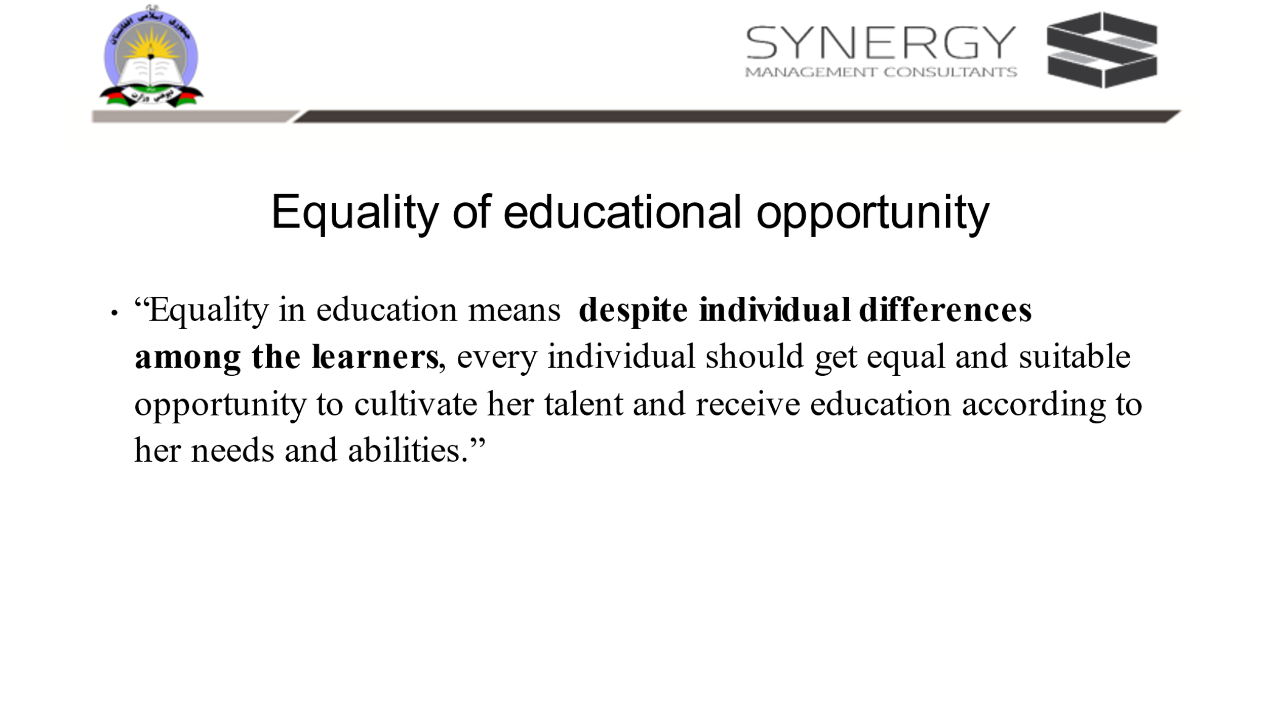

When the participants return, ask the participants to think whether they had thought of equality of educational opportunity in their model schools.
Ask what is equality?
Elicit responses and note it on the chart paper or blackboard. Lastly you give your definition.
“Equality in education means despite individual differences among the learners, every individual should get equal and suitable opportunity to cultivate her talent and receive education according to her needs and abilities.”
Then ask: Do they want to make changes to their model, just in case if anything is left out which could prevent equality of educational opportunity. Once the response from participants is complete, tell them that next you move on to discuss the role of PDMs in inclusive schooling

Activity: Role of professional development members
Slide 7:
Facilitator led presentation of the slide. Getting consensus from the participants
Facilitator should ask the participants to share the following and also note it in their personal diaries.
- How do they plan to observe a classroom and provide feedback?
- What is the role of PPDMs in regular observation? How is it different from what DDMS would do?
- What do they understand by being pragmatic?
- What is their expectation from school heads to support teachers ?

---------------------------------------------------------------------------Lunch Break-----------------------------------------------------------------------
Concept 5: continued

Activity: Presentation of two non-Afghan inclusive education check list (60 min)
Slide 8

Facilitator
The following two links are samples of consolidated checklist which shall be used for giving the participants an idea on how different countries monitor inclusivity in their contexts.
It is recommended that eventually the PDM will develop indigenous checklist to monitor inclusivity.
Requirement:
If the participants are comfortable in using softcopies, the links may be accessed during training program. Or else sections of this document will need to be printed and used for training purpose

Reference 1: https://www.heartland.edu/documents/heip/faculty/QualityInclusivePracticesChecklist.pdf
Reference 2: Index 2002 complete_05 (eenet.org.uk)

Files in resources folder:
Quality Inclusive Practices Checklist for day 4, and
Index 2002 complete_05 for Day 4

Slide 9

To Facilitator:
For purposes of discussion, a sample extract for the checklists is used in this slide.
The format is used for discussion during last day of the training:
It is recommended that eventually the PDM will develop indigenous checklist to monitor inclusivity.

For facilitator’s use, along with the links for check lists* from two different contexts, to prompt the participants, the following check list from handbook of inclusion education, Central Board of Secondary Education, India (p:27-28) is given here.

School Policies and Administrative Support

Does the school: Yes/ No
• have inclusive practices in its a vision and mission statements?
• have barriers that prevent the school from being fully inclusive?
• have school administrators, principal, teachers, and students who understand the importance of inclusive education?
• have any special people working as teacher or staff?
School Environment Yes/No
• have a welcoming, healthy, and clean environment?
• have a clean, safe drinking water supply accessible to all children?
• have separate toilets (for girls and boys as well as juniors and seniors) with special facilities for disabled children?
• have facilities that are accessible for students with disabilities e.g. ramp, railing, lifts, special arrangements in library and laboratory and play field etc.?
• have staff from different backgrounds –men and women, different
languages (ethnic groups)?
Teacher’s Skills, Knowledge and Attitudes Yes/ No
• have teachers who can explain the meaning of inclusive and learning-friendly education?
• have teachers who believe all children can learn including children
with disabilities, ethnic minority groups, girls, poor etc.?
• have teachers who can identify unhealthy students and advise
families to access medical care?
• have teachers who understand students having individual learning
needs and can adapt lesson plans and activities to meet the needs
of all students with diverse backgrounds and abilities?
• have teachers who use a variety of teaching and learning materials
to help students learn?

Teacher Development Yes/ No
• have the teachers have attended training on Inclusive Education and ILFE (Inclusive Learning Friendly Environment) classrooms?
• have the teachers attended training on developing teaching and learning materials related to ILFE?
• Can the teachers visit model ILFE schools?

Students Yes/ No
• Do all school-age children in the community attend school regularly?
• Do all students have textbooks and learning materials to meet their learning needs?
• Do all students actively participate and contribute to activities in the classroom?
• Do children with disabilities have an Individual Education Plan (IEP) and regular monitor student progress?
• Is there regular follow up in case of shortage /irregularity in attendance?

Academic Content and Assessment Yes/ No
• Are locally available resources utilized for easy/learning support?
• Does the curriculum promote attitudes such as respect, tolerance, and knowledge about one’s own and others’ cultural backgrounds?
• Does the curriculum allow for different teaching methods, such as discussion and role-play, to meet different learning rates and styles, particularly for children with disabilities?
• Does the school provide all concessions in scheme of studies and internal school-based assessments as stipulated by CBSE

*Source (ILFE Self-Assessment Checklist (adapted from UNESCO toolkit)

Requirement:
If the participants are comfortable in using soft copies, the links may be accessed during training program. Or else sections of this document will need to be printed and used for training purpose

Slide 10

It is recommended that the participants get enough time to go through each and every point in the sample checklist to get a clear sense of what are the indicators of inclusive classrooms.

Conclusion of this activity ends with two questions:
Facilitator to ask the participants
      - if there are any points relevant to Afghanistan?
      - In their experience what are the unique aspects which are needed for Afghanistan context in order to make it more inclusive.

Activity: Free reading activity (30min)
Objective : To propose the importance of reading as a source of gathering resources which is essential for PDMs to facilitate inclusive practices in schools and community
Materials: preferably most the recommended additional readings are made available in hard copies and are kept in a reading corner in the training venue on day -1 itself. Alternatively, this reading corner is set up on day 4 and participants are given half an hour each prior to and post the second short break.

---------------------------------------------------------------Tea/ Coffee Break--------------------------------------------------------------------
Concept 5: continued
Activity : Structured Reflection Session for – Day 4 (40 min)
Seating Plan: In a circle along with the facilitators
Materials required: personal diaries /notebooks, interactive diaries, writing instruments
To facilitators:
1: This form which the participants are familiar (filled the first day) is distributed. Ask the participants to write their full names and then fill the form.
2: Then they need to self-evaluate their competencies and return the forms to the facilitator.
3: Suggestion: The participant’s first and last day forms can be entered in a spread sheet, so that the participants may periodically return to this form to assess themselves and work on further developing their competencies.
Slide 11: Lead / guide for structured reflection:

To Facilitator:
Every day ends with structured reflection of the day.
Objective:
This is to simulate the TLCs facilitated by trainers. For this all participants are required to sit in a circle along with the facilitator.
Materials: (If needed the ppt slide can be displayed)
Participants must have their pens, interactive diaries and their personal notes.
In the interactive diaries they need write to the facilitator as a feedback, seek clarification, share their points of view.
Today being the last day, the facilitator could provide oral general feedback or if the participant needs a one on one feedback, based on mutual convenience it can be provided after the session .
In the personal diaries the participants make notes from the discussion they carry out on the topic,

It is recommended that the Facilitator makes note of intangible feedback from participants various feelings such as happiness, disappointment etc. and use them as examples to draw their attention towards implications of barriers.
The following are some of the questions which can be kept on as a slide to facilitate the structured reflection session:
- What went well for you?
- Feedback for the facilitator’s presentation
- Which activity gave you insights?
- Which activity kept you engaged?
- Which aspect were difficult/easy?
- What was your experience in communicating? With facilitator/coparticipants
- What were your expectations for the day?
- What do you want to share or get clarification from the facilitator? What more are you expecting from tomorrow?
- Why are you satisfied/not satisfied?
- What is your takeaway?
Note: These questions need to be reworded, or more questions can be asked as per the need of the day and the group. It is important for the facilitator to listen actively and try to address the issues or convince the participants in the subsequent training days

Slide 12: Self-competency assessment rubric

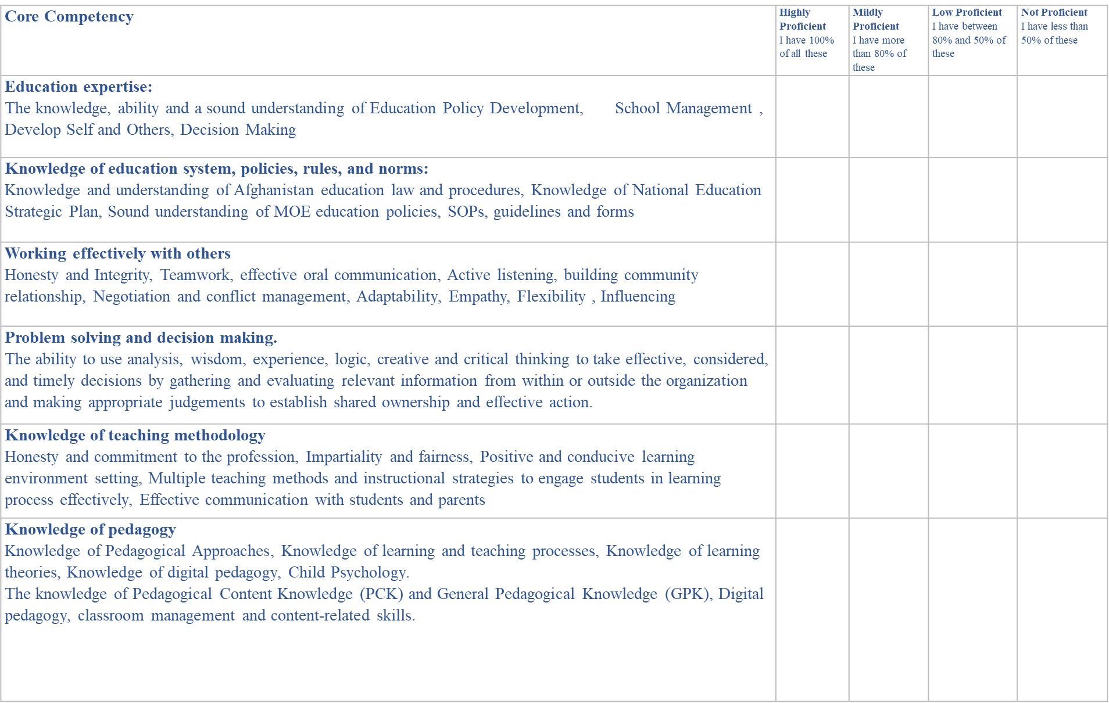
To facilitators:
1: This form which the participants are familiar (filled the first day) is distributed. Ask the participants to write their full names and then fill the form.
2: Then they need to self-evaluate their competencies and return the forms to the facilitator.
3: Suggestion: The participant’s first and last day forms can be entered in a spread sheet, so that the participants may periodically return to this form to assess themselves and work on further developing their competencies.

Slide 13:

Activity: Recap of the training past 4 days and way forward (10 min)
Facilitators can invite any four volunteers to share their experience of the last 4-days’ workshop for 2 minutes each
Facilitator to provide inputs on way forward.
After this distribute the copies of competency self-assessment forms. Let the participants know that it is the same form which they had filled it on day 1.
Suggest them to observe if they found any difference in the competency levels. Also suggest that they can use this form to periodically assess their own competencies using this format.

Space for trainers to make their own notes on this.

References for all four days
Note: These are also the recommended literature for facilitators for prereading for Inclusive Schools module. The soft copies of most of these are provided in the resources folder.
- https://www.learningforjustice.org/professional-development/test-yourself-for-hidden-bias
- https://www.unicef.org/rosa/media/5491/file/Afghanistan%20%E2%80%93%20Education%20Equity%20Profile%20for%20Adolescent%20Girls.pdf
- INCLUSIVE EDUCATION, TRAINING of TRAINERS MANUAL, Steps towards Afghan Girls’ Educational Success II, Aga Khan Foundation, Afghanistan, April 2018
- https://www.unicef.org/education/inclusive-education Inclusive education | UNICEF
- https://www.globalpartnership.org/sites/default/files/education-sector-plan-afghnistan-2017-2021.pdf
- https://www.concernusa.org/story/barriers-to-education-around-the-world/
- https://www.concernusa.org/story/girls-education-in-afghanistan/
- https://www.eenet.org.uk/resources/docs/Inclusion%20in%20Action%20METHODOLOGY.pdf
- https://www.unicef.org/education
- https://www.globalpartnership.org/where-we-work/Afghanistan
- https://www.unicef.org/reports/UNICEF-education-strategy-2019-2030
- www.teachingtolerance.org
- https://www.cast.org/impact/universal-design-for-learning-udl
- CAST: About Universal Design for Learning
- https://www.texthelp.com/resources/universal-design-for-learning/
- https://www.unicef.org/afghanistan/stories/learning-today-inspiring-tomorrow (must keep a soft or hard copy ready for day two reading session)
- Online blog by Morin, A. (2018). Universal Design for Learning (UDL): What You Need to Know.
- Additional reading by Ralabate, P. K. (2011). Universal Design for Learning: Meeting the Needs of All Students. The ASHA Leader.
- Document by Booth, T., & Ainscow, M. (2002). Index for Inclusion- Developing learning and participation in schools. Centre for Studies on Inclusive Education. [Note: read pp 13-37
- N for nose: state of the education report for India 2019; children with disabilities - UNESCO Digital Library P(75)

Space for trainers to make their own notes on this.

Competency Self-Assessment Rubric
Please self-assess your capabilities for each of the following core competencies:
Name: Designation: Date :
Core Competency | Highly Proficient | Mildly Proficient | Low Proficient | Not Proficient
Core Competency | Have most these | have 75%of these. | Have 50% of these | Many are new and yet to be gained
Education Expertise: Knowledge of the Education Policy Development, School Management, Develop Self and Others, Decision Making
Knowledge of education system, policies, rules, and norms: Familiar with the Knowledge and understanding of Afghanistan education law and procedures, Knowledge of National Education Strategic Plan, Sound understanding of MOE education policies, SOPs, guidelines, and forms.
Problem solving and decision making: Creative and Innovative Thinking, System & Strategic Thinking, Self-Awareness & Management, Social Awareness and Management
Active listening, Logical and Critical Communication, Analytical Skills, Negotiation Skills
Honesty and commitment to the profession.
Working effectively with others: Honesty and Integrity, Empathy, Adaptability, Flexibility
Active listening, Influencing, Teamwork, Effective oral communication, Building community relationship, Negotiation, and conflict management
Knowledge of teaching-learning methodologies: Knowledge of multiple teaching methods and instructional strategies to engage students in learning process effectively.
Knowledge of (inclusive) pedagogy: Knowledge of Pedagogical Approaches, Knowledge of learning and teaching processes, Knowledge of learning theories, Positive and conducive learning environment setting, Child Psychology Impartiality and fairness
Which of these competencies I will acquire/improve before next self-evaluation

