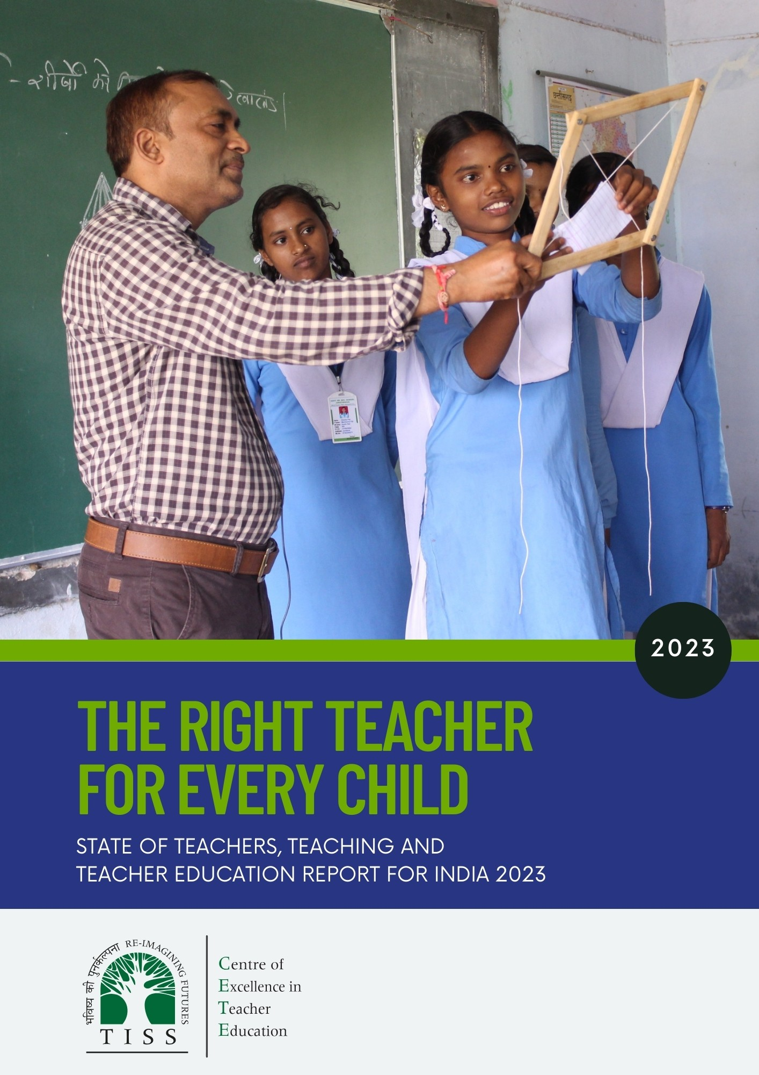
The Right Teacher for Every Child

C


The Centre of Excellence in Teacher Education (https://bit.ly/cetewebsite) is an Independent Centre at the Tata Institute of Social Sciences, Mumbai, established with seed grants from the Pandit Madan Mohan Malaviya National Mission
on Teachers and Teaching, Government of India, and the Tata Trusts, and with the Tata Trusts as founding partner. The Centre's overarching focus and agenda is innovation and improvement in teacher education, school and higher education pedagogy and curriculum, and is aligned with the United Nation's Sustainable Development Goal 4: "to ensure inclusive and equitable quality education and promote lifelong learning opportunities for all", and Goal 4c
in particular "by 2030 to substantially increase the supply of qualified teachers" The Centre envisages its role as a catalyst for transformation in teacher education through academic programmes, field action programmes, research, collaborations, and advocacy. The State of Teachers Teaching and Teacher Education is a Biennial State of the Sector Report produced by CETE.

Acknowledgements
The SOTTTER-23 research team is grateful to the SOTTTER-23 editorial board–Prof. Dinesh Saklani, Director NCERT; Mr Harshit Mishra, Niti Ayog; Prof. Amita Chudgar, Michigan State University; Dr Nidhi Gulati, Institute of Home Economics, University of Delhi; Ms Amrita Patwardhan, Tata Trusts; and Dr Carlos Vargas Tames. Teacher Task Force, UNESCO– provided invaluable perspectives on the analysis and reporting. Prof. Archana Mehendale reviewed this report and gave valuable feedback. Dr Indumathi and Ms Aditi Desai anchored the study until May 2023 and August 2023. Yusuf Sayed and Emon Nandi guided the approach to the sample design. Mr Shivkumar (Kalike) for extending support.
Special thanks to the state of cials for providing the required eld assistance in their respective states: Smt. M. Radha Reddy, Director SCERT Telangana; Dr Nirada Devi, Director, SCERT, Assam; Mr Narayan Konwar, (IAS) Secretary to the Govt of Assam, Department of School Education; Dr Reshmi Prabha, Joint Director (DIET) Raipur; Dr Nishi Bhambri, Joint Director SCERT, Chhattisgarh, Raipur; Mr Alok K Sharma, Director SCERT, Chhattisgarh; Pradip Kumar Chaubey, Deputy Director, JCERT, Jharkhand; Mr Manjunath Sadpi, TE Cell DSERT Director, Bangalore; Shri Ranjit Singh Deol (Secretary) Department of Education Government of Maharashtra; Mr Jaspreet Talwar, IAS Principal Secretary School Education Punjab; Dr Maninder Singh Sarkaria, Director SCERT, Punjab; DEOs of (Senior Secondary and Elementary Education), Moga, Mohali and Firozpur Districts of Punjab; N. R. Murali, Joint Commissioner (Academics), Kendriya Vidyalaya Sangathan, New Delhi; Mr Nilesh Patil, BEO, Nandurbar Tehsil, Nandurbar; Mr Dhirsing Tedya Valvi, BEO, Shahada Tehsil, Nandurbar; Ms Karuna Vakati, IAS, Telangana.

Authors
- Padma M. Sarangapani
- Jyoti Bawane
- Kamlesh Goyal
- Mythili Ramchand with
- Aishwarya Rathish
- Anitha Bellappa
- Arpitha Jayaram K.

Citation
CETE (2023). The Right Teacher for Every Child. State of Teachers Teaching and Teacher Education for India Report 2023. Tata Institute of Social Sciences, Mumbai.


This document is released under a Creative Commons Attribution-ShareAlike 4.0 International licence.
Download Here: https://bit.ly/CETE_PPP Any questions, suggestions or queries may be sent to us at: chair.cete@tiss.edu
Design and layout
Ramesh Khade
Cover page photo:
Dilip Kumar Sahu, Government School Teacher, Chhattisgarh with students
Photo Credits:
Shiva Thorat

THE RIGHT TEACHER FOR EVERY CHILD
State of Teachers, Teaching and Teacher Education Report for India 2023

Editorial Board
Dinesh Prasad Saklani, Director, National Council for Educational Research and Training
Harshit Mishra, Deputy Adviser (Education) Niti Ayog, Government of India
Amita Chudgar, Professor, Michigan State University
Nidhi Gulati, Professor, Institute of Home Economics, University of Delhi
Amrita Patwardhan, Head Education, Tata Trusts
Carlos Vargas Tames, Chief of Section, Section of Teacher Development, UNESCO

Team
Lead Research
Padma M. Sarangapani, Jyoti Bawane, Kamlesh Goyal, Mythili Ramchand, Aishwarya Rathish, Anitha Bellappa, Arpitha Jayaram K.

Research Support
Indumathi S, Aditi Desai, Mohammad Aslam, Rutuja Warthi, Srijana Siri, Sunita Vishwas, Aditi Desai, Emaya Kannamma, Geetha M, Pragya Singh, Sudheer Reddy.

Administrative Support
Tushar Vaity, Vijay Jathore, Gayathri Moily, Sudheer Reddy.

Overall Field Survey Coordination
Jyoti Bawane, Aditi Desai, Anitha Bellappa, Indumathi S, and Kamlesh Goyal.

Sampling Design
Kamlesh Goyal, Indumathi S, Rutuja Warthi, Surendra Balerao, Padma Sarangapani, Mythili Ramachandran, Emon Nandi.

Field Research
Assam: Sayed Kazi (lead), Susmita Sarma, Farheen Jia, Jolly Kazi, Abhishek Phukan.

Bihar: Anil Kumar and Harshvardan Kumar (lead), Rajnish Raj, Anand Kumar, Shalini Ghazal, Gaurav Kumar Singh, Rakesh Kumar Singh, Varun Kumar Gupta, Rekha Kumar.

Chhattisgarh: Amitabh Anand (lead), Sanjeeva Singh, Shweta Pal.

Karnataka: Indumathi Sundararaman and Anitha Bellappa (lead), Dhananjay Chittapur,
Mahesh D.K, Girish Harakamani Krishnappa N, Pavan Kalyan DG, Ravikumar, Mareppa, Anjanayya, Ashwinirani, Ayamma, Sharanu, Allaouddin, Lingappa, Neelaya, Ashok, Shivaraj, Raju, Anjappa.

Maharashtra: Jyoti Bawane and Aditi Desai (lead), S.S. Shinde, Sandeep D Bhadane, Anil Khadare, Rupali Pagare, Girish Pramodi Behere, Vinay Lautre, Kishore Bethekar, Aarti Bhavna Shahare, Riya Wasnik, Vaishnavi Humane, Kiruthiga M P.

Mizoram: B. Lalmuanawma (lead), Jake Tlau (Jacob Lalrinawma), Dindin Zote (Vanlaldinpuia).

Punjab: Kamlesh Goyal (lead) Amritpal Singh, Richa Sharma, Harjinder Singh, Harpreet Singh, Jitendra Kumar Pal, Kuldeep Singh.

Telangana: Sreeramulu G (lead) Karthik S. (co lead), V.V. Satyanarayana M, Thalari Pavan Kumar, Prasanth Kumar Munnang, Konderapu Mohana Rao, Kolapuri Chandrasheka, Nagula Ramesh, Raju Sambari, Swamy Jadala, Moola Reddy, Arshad Khan.

Contents

- Introduction 1
- Teachers in India: An overview 3
- Providing the right teacher in each class: Are there shortages? Where? What kind? 7
- Gender balance in the teaching workforce 14
- Working conditions of teachers with a focus on teachers in private schools 19
- Regional concerns: Rural regions, the North East 25
- Teacher supply: What is the quality of the supply? Is the supply adequate? 27
- Key observations and recommendations 30

Abbreviations

BEd | Bachelor of Education
BElEd | Bachelor of Elementary Education
CTE | College of Teacher Education
CUET | Common University Entrance Test
DEd | Diploma in Education
DElEd | Diploma in Elementary Education
DIET | District Institute for Education and Training
DISE | District Information System for Education
DNH&DD | Dadra Nagar Haveli & Daman Diu-Union Territory
ECCE | Early Childhood Care and Education
HM | Head Mister/Mistress
IASE | Institute of Advanced Studies in Education
ICT | Information and Communication Technology
INR | Indian National Rupee
ITEP | Integrated Teacher Education Programme
JNV | Jawahar Navodaya Vidyalaya
KV | Kendriya Vidyalaya
NCTE | National Council for Teacher Education
NTA | National Testing Agency
OBC | Other Backward Classes
PF | Provident Fund
PLFS | Periodic Labour Force Survey
PMMMNMTT | Pandit Madan Mohan Malaviya National Mission on Teachers and Teaching
PSTE | Pre- Service Teacher Education
PT/PET | Physical Education Teachers
PTR | Pupil Teacher Ratio
PWD | Persons with Disability
RTE | Right of Children to Free and Compulsory Education Act, (2009)
SC | Scheduled Caste
SOTTTER | State of Teachers, Teaching and Teacher Education Report
SSA | Samagra Shiksha Abhiyan
ST | Scheduled Tribe
TEI | Teacher Education Institution
TET | Teacher Eligibility Test
TGT | Trained Graduate Teacher
UDISE+ | Unified District Information System for Education Plus

The Right Teacher for Every Child

Introduction
1

- Press Information Bu- reau, dt 5 September 2023. https://pib.gov.in/ PressReleaseIframe- Page.as px?PRID%3D19 54967&sa=D&source=- docs&ust=1704534 516666145&usg= AOvVaw2ZygUZwX
_6AKCzTYdsfH7a
- (Civil Appeal @ SLP (C) No.20743 of 2021 Devesh Sharma vs Union of India)
- Press Information Bureau 2023 and NTA Public Notice. dt 26 June, 2023. https:// www.pib.gov.in/ PressReleseDetailm. aspx?PRID=1904184 and https://cdnasb. samarth.ac.in/ncet- site-admin23/pn/ Press+Release+for+- declaration+of+Re- sult+of+NCET+2023. pdf accessed on 1/12/2023. ecla- ration+of+Re- sult+of+NCET+2023. pdf accessed on 1/12/2023.
The year 2022-23 has seen many significant developments relating to and affecting the teaching profession in India.

  - The Union Budget 2023 included the announcement that the Pandit Madan Mohan Malaviya National Mission on Teachers and Teaching (PMMMNMTT) scheme would be continued. On September 5th 2023, Teachers’ Day, the scheme unveiled was limited to faculty development in higher education institutions1. The Union Finance Minister also announced during her budget speech, the creation of 38,800 new positions for teachers and support staff in Tribal Schools (The Hindu, 2023, February 1).
  - Several states across the country announced large numbers of recruitments in the years 2022-23: up to 1.7 lakh in Bihar and between 30-40 thousand in each of the states of Gujarat, Maharashtra, Odisha, Rajasthan, Tamil Nadu, Chhattisgarh, and Karnataka.
  - Hon’ble Supreme Court of India ruled that the BEd degree holders cannot be regarded as fulfilling eligibility for primary school teachers, nullifying the NCTE notification permitting those with BEd degrees to be employed as primary school teachers, and restricting eligibility to those with DElEd/BElEd and equivalent degrees2.
  - The National Council of Teacher Education finalised the National Professional Standards for Teachers—the final document is yet to be released.
  - A new four-year Integrated Teacher Education Programme (ITEP) was announced in 2022-23 and during the academic session starting in 2023-24, 57 institutions received permission to launch the programme. 42 institutions started the programme in the academic session 2023-24 with a total of 3,950 approved intake (Secondary: 3,400, Middle: 150, Preparatory: 350, Foundational: 50)3. Admissions to the programme was conducted through the Common University Entrance Test (CUET), and a total of 10136 (6613 female and 3523 male) candidates appeared for the test4.
  - UNESCO’s Global Education Monitoring Report (2023) on Technology noted that AI assisted teaching does no better than traditional teaching and that teachers and learners need to be included in formulating policy on use of ICT for monitoring, teaching and assessment.

In the backdrop of these national and international developments, this second report5 on the State of Teachers, Teaching and Teacher Education for India 2023 (SOTTTER 2023) focuses on issues concerning the teaching profession and teacher preparation in India. The report is based on eight background research papers that used primary and secondary data6 including UDISE+ 2021-22, Periodic Labour Force Survey 2021-22, the SOTTTER 23 Survey of schools and teacher education institutions carried out in Eight States, and TET data from One State A.

The analyses examine the demographic profile of teachers in different sectors, the working conditions of teachers, and the availability and supply of teachers in general, and specifically of qualified teachers, in the system. Comparisons are made between states, between urban and rural locations and between the government and private sectors.
The full reports are available on the CETE website. https://bit.ly/SoTTTER-by-CETE
- Teachers in India in 2021-22: the picture from UDISE+
- Teachers in India: A snapshot from the Periodic labour Force Survey 2021-22.
- Public and Private Sector Contract Teachers in India: An Analytical Research Paper.
- Quality of Pre-service Teacher Education and Teacher Supply in India: An analysis of TET data from one state.
- Status of School Teachers in Eight States: A report based on primary data.
- Status of Preservice Teacher Education in Eight States: A report based on primary data from teacher education faculty and student teachers.
- Teacher Supply Demand: A review of Literature.
- Teaching Occupation in the News: An analysis of news coverage in Indian National English Newspapers January-December 2023.
Box 1: SOTTTER-23 Background Research Papers and Reports

1

CETE (2023)

A special focus of this report is on teacher deployment and availability drawing from three normative ideals. Firstly, the desirability of the teaching workforce to have a demographic (gender and social) profile similar to the student population is well accepted. This holds special significance in the case of students from socio-cultural and linguistically marginal groups and for girls.

Secondly, depending on the stage of schooling (student age group) and school subjects, different types of professional qualifications and academic qualifications are required of teachers. The Right to Education Act (RTE) specifically mandates physical education, music and craft be a part of the
school curriculum. Vocational Education subjects are now being introduced into secondary and senior secondary schools. Students with special needs require teachers who have received professional education in teaching children with special needs, also decreed by the Hon’ble Supreme Court of India in its 2021 ruling7.

Finally, pupil-teacher ratio (PTR) norms guide the size of classrooms, so as to enable meaningful pedagogical transaction and attention to all students. Teacher availability to meet all these requirements is a function of the overall supply–availability of preservice institutions and choices and aspirations of students on the one hand, and timely recruitment and conducive recruitment terms in the government and private sectors on the other. Deployment of teachers, especially to remote and difficult regions is another important concern.

Analyses of teacher profiles, working conditions and teacher supply are presented and discussed in detail in the background papers. These are drawn upon to highlight issues in the report.

This report begins with an overview of the current status of teachers in India. Following this, five themes are discussed: teacher availability at schools, gender balance in the teaching workforce, working conditions of teachers in private schools, regional disparities, and quality of teacher supply. It concludes with key observations and recommendations.

- NTA Press Release. dt 25 August, 2023. https://cdnasb. samarth.ac.in/ncet- site-admin23/pn/ Press+Release+for+- declaration+of+Re- sult+of+NCET+2023. pdf. accessed on 1/12/2023.
- The UNESCO (2021) Report ‘No Teacher No Class’ with its focus on the status of teachers and teacher education, authored by the CETE team
is taken as our first
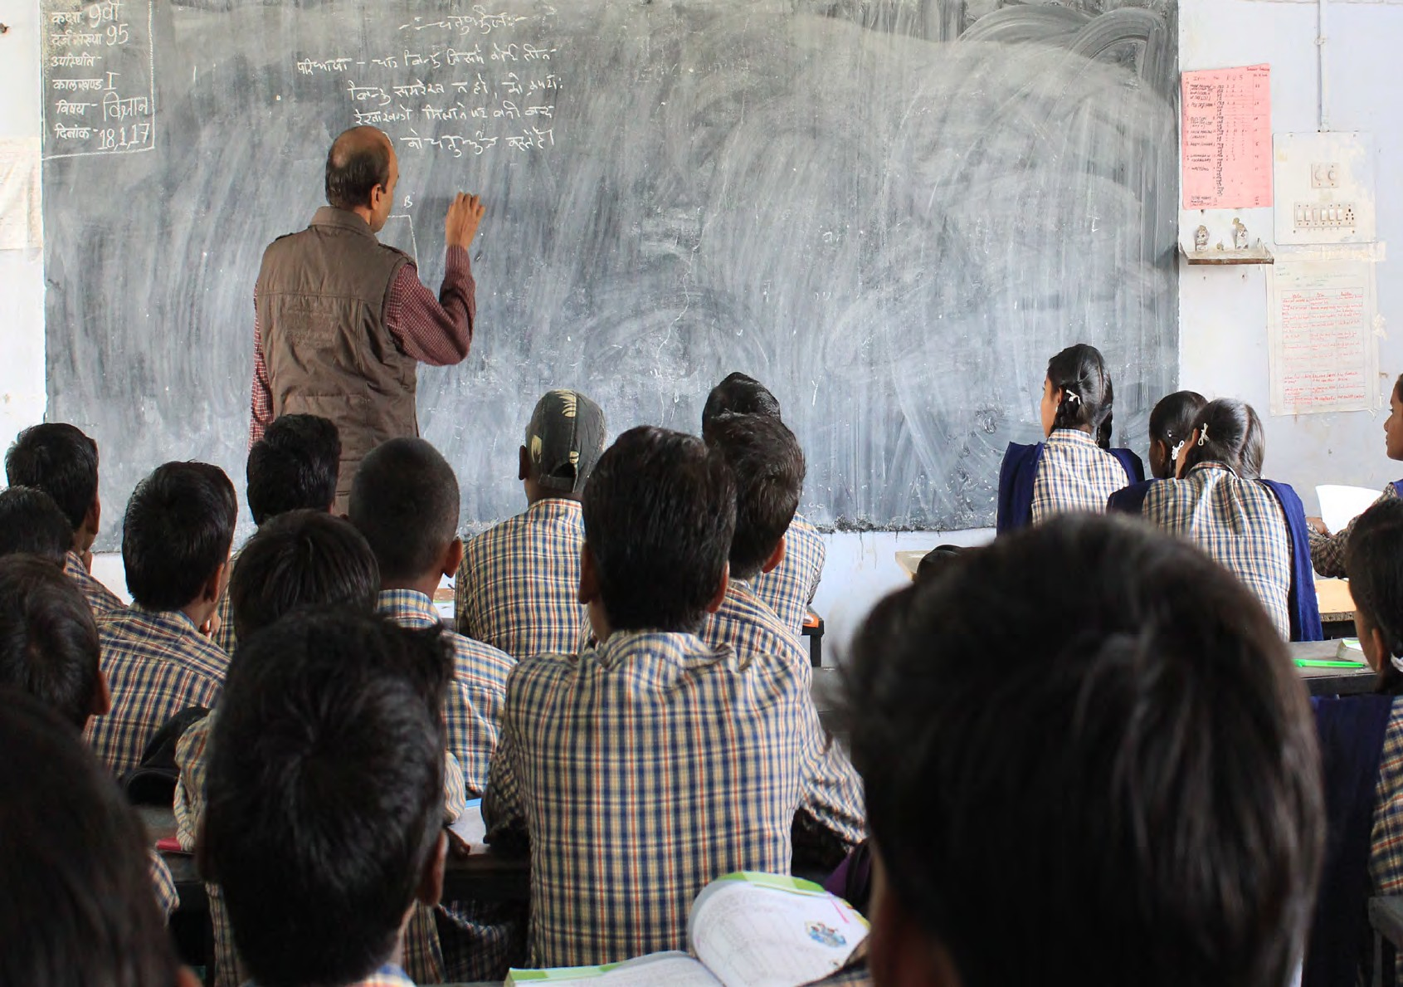
State of Teachers, Teaching and Teacher Education for India Report.
- Analyses and figures quoted in the report are primarily from UDISE+ 2021-22 data set analysis carried out by the CETE team (Background paper 1). Other data sets analysed and used in this report include Periodic Labour Force Data Set (PLFS 2021-2022; Background paper 2);
SOTTTER-2023 Survey
of eight states: Assam, Bihar, Chhattisgarh, Karnataka, Maharashtra, Mizoram, Punjab and Telangana (SOTTTER-2023-survey Background papers 5&6); SOTTTER 23-TET
analysis (Background
paper 4), and are cited where relevant.
- rajneesh-kumar- pandey-vs-union- of-india-ll-2021-
sc-602--403113.pdf
(livelaw.in)

2

The Right Teacher for Every Child

Teachers in India: An overview
2

he education system8 in India (UDISE+ 2021-22 data) has a total of 14,89,115 schools and 95,07,123 teachers catering to
T
25,57,40,623 students, from grades I to XII, (i.e. Primary, Upper Primary, Secondary and Higher/Senior Secondary grades; Table 1).

82.92% of all schools are in rural areas with 69.71% of all students and 70.09% of all teachers. The all- India average size of the school is 178 students; the rural school size is 150 and the urban school size is 316. The overall Pupil Teacher Ratio (PTR) at the national level across all schools is 28:1 (same for rural and urban).

Primary/ elementary schools, have 51% of teachers and about 50% of the student enrollment. Composite schools employ about 27% of teachers and have about
27% of student enrollment. Middle/ secondary and senior secondary schools employ 22% of teachers and have 25% of student enrollment.
Table 1
National average number of Schools (*), Teachers and Enrollment (**)

 | Schools | Teachers | Students
Total | 1,489,115 | 9,507,123 | 265,235,830
% rural of total | 82.92% | 70.09% | 69.71%
Government | 65.70% | 49.25% | 51.68%
% of govt in rural | 91.97% | 85.44% | 84.53%
Government (other) | 3.31% | 2.11% | 2.33%
Government Aided (***) | 5.54% | 8.38% | 10.19%
Private | 22.55% | 37.24% | 33.28%
% of private in rural | 60.70% | 52.22% | 50.92%
Madarsa (recognized) | 1.34% | 0.99% | 1.01%
Unrecognized | 1.91% | 2.03% | 1.51%
Note (*) UDISE classification of school by management type are grouped into Government, Government (other), Government aided, Private and Madrasa (recognised) and unrecognised.
(**) Data is restricted to grades I to XII. It excludes preschool data.
(***) States with a significant proportion of school, teachers and students in aided schools include Goa (68% teachers), Kerala (42 % teachers) and Maharashtra (38%).
Source: Authors based on data from UDISE+ 2021-22

The average size of an elementary school is enrolment of 115, for composite schools it is 518 and for secondary/senior secondary schools, it is 267. The all India PTR in elementary schools is 26:1, 28:1 for composite schools and 31:1 for secondary/senior secondary schools.

The average size of a government school is 140 and of a private school is 263. Overall rural schools are smaller at 150 compared to urban schools which have an average size of 316. Elementary and
composite private schools whether in rural or urban areas have larger enrollments than government schools. Only secondary/senior secondary government schools tend to be larger than private schools.

The overall share of teachers in a state is generally commensurate with the overall proportion of students in that state (Table 2). Uttar Pradesh has 16% of all teachers, followed by Maharashtra (8%), Rajasthan (8%), Tamil Nadu (6%), West Bengal (6%), Bihar (6%), Madhya Pradesh (6%).
Table 2
State wise share of Teachers and Students (as percentage of total teachers/students)
Share of Teachers | Schools
More than 9% | Uttar Pradesh (teacher: 15%; student: 18%)
7.1% - 9% | Rajasthan (7%; 6%), Maharashtra (7%; 8%)
5.1% - 7% | Tamil Nadu (5%; 4.7%), West Bengal (6%; 6%), Bihar (6%; 10%), Madhya Pradesh (6%; 6%)
3.1% - 5% | Andhra Pradesh (3.3%; 3.1%), Telangana (3.3%; 2.64%), Odisha (3.4%; 2.9%), Assam  (3.7%; 2.7%), Gujarat (3.9%; 4.4%), Karnataka (4.5%; 4.4%)
1.1% - 3% | Himachal Pradesh (1%; 0.5%), Uttarakhand (1.3%; 0.9%), Delhi (1.5%; 1.6%), J&K  (1.7%; 0.9%), Jharkhand (2.2%; 3.0%), Haryana (2.5%; 2.2%), Punjab (2.7%; 2%),  Chhattisgarh (2.7%; 2.2%), Kerala (2.8%; 2.2%)
Less than 1% | Lakshadweep (0.01%; 0.01%), DNH & DD(*) (0.05%; 0.05%) Ladakh (0.06%; 0.02%),  Andaman and Nicobar Islands (0.06%; 0.03%), Chandigarh (0.1%; 0.1%),  Puducherry (0.1%; 0.09%), Sikkim (0.1%; 0.05%), Goa (0.1%; 0.1%), Mizoram (0.2%;  0.1%), Arunachal Pradesh (0.2%; 0.1%), Nagaland (0.3%; 0.1%), Tripura (0.3%; 0.2%),  Manipur (0.4%; 0.2%), Meghalaya (0.5%; 0.3%)

- These figures are aggregated across all 28 States and 8 Union Territories.

Note (*) Dadra Nagar Haveli & Daman Diu-Union Territory
Source: Authors based on data from UDISE+ 2021-22

3

CETE (2023)

The percentage of teachers working in rural areas is 80% or above in several states, namely Assam (87%), Bihar (84%), Himachal Pradesh (88%), Ladakh (86%, Lakshadweep (100%), Meghalaya (86%),
Odisha (84%), Sikkim (83%), Tripura (81%) and Uttar Pradesh (81%) (Figure 1).

Figure 1
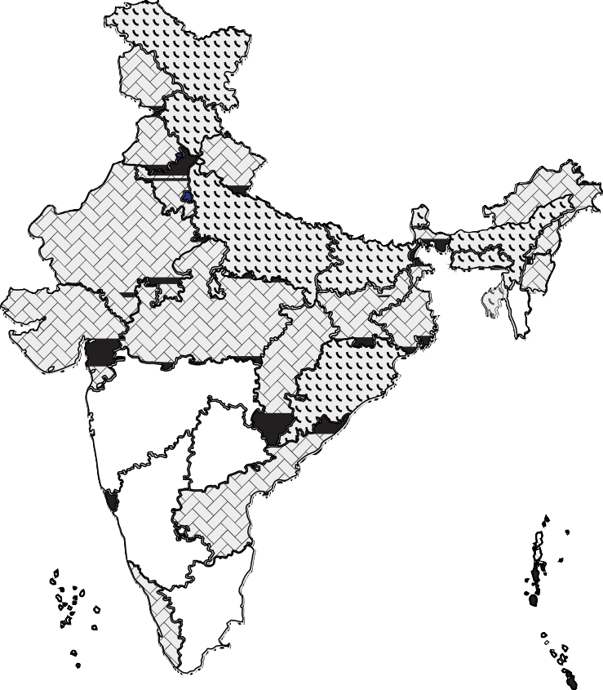
Proportion of Teachers working in Schools located in Rural Areas

More than 80% teachers 60-80% teachers
40-60% teachers
0-40% teachers
Source: Authors based on data from UDISE+ 2021-22

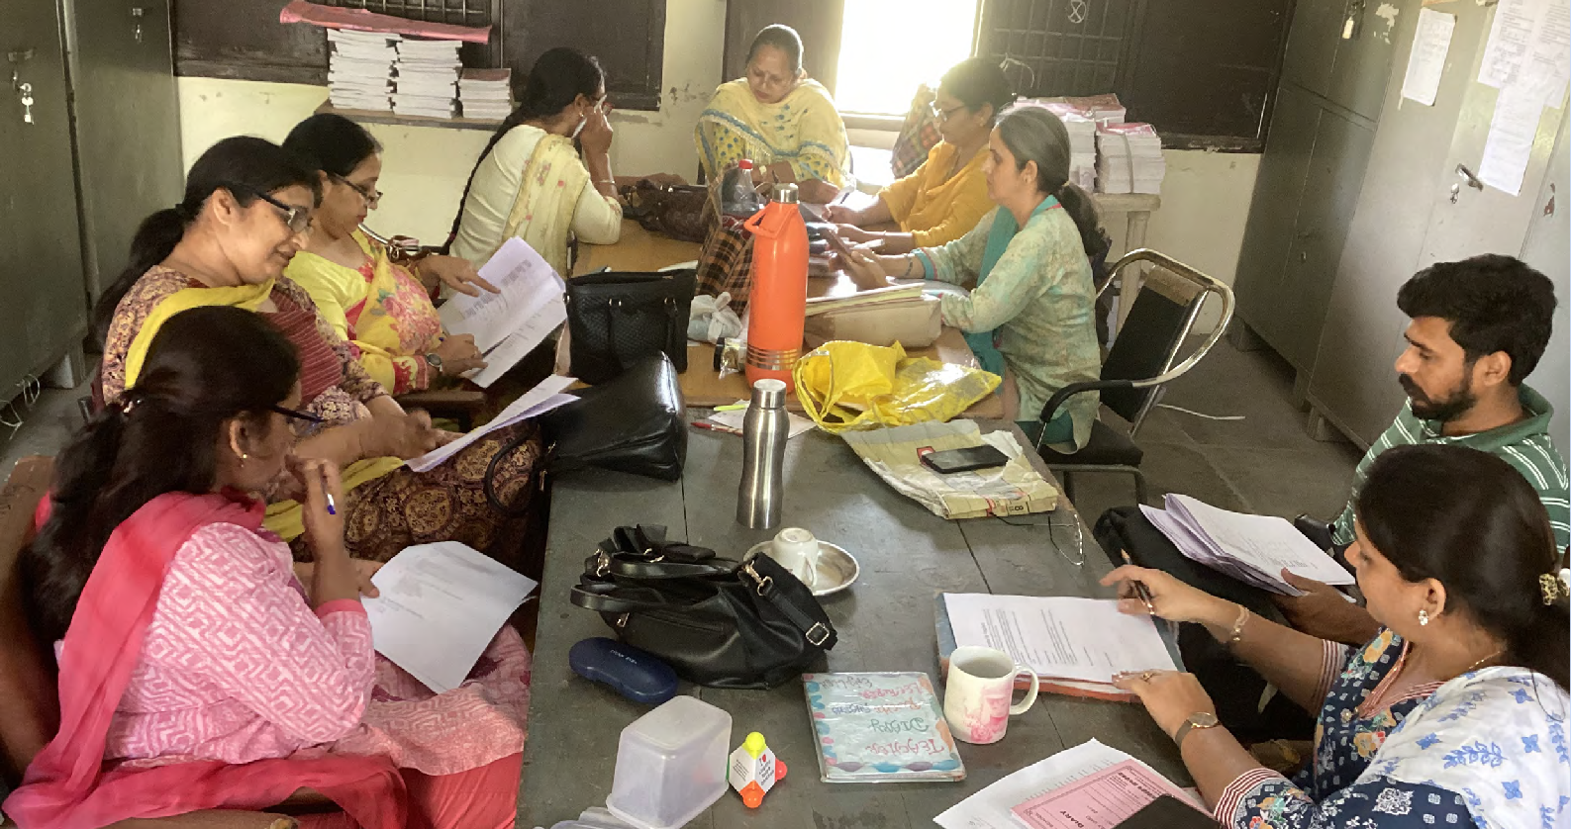
4

The Right Teacher for Every Child

11% of Government school teachers are contractually employed. Regions and states with high levels of contract government teachers include the North Eastern States (between 24% in Assam and 69% in Meghalaya), Jharkhand (54%), and Dadra Nagar Haveli and Daman Diu (Union Territory henceforth DNH&DD: 47%). 90% of these contractual appointments are in rural schools. Contractual
teaching workforce in government and aided schools are more feminised as compared to the level of feminisation in the overall teacher workforce. Bihar, Madhya Pradesh and Delhi significantly reduced the number of contractual teachers between 2013-2014 and 2021-22, by approximately 15-17%, while Mizoram, DNH&DD, Assam and Meghalaya significantly increased the proportion of contractual teachers. In the case of Madhya Pradesh and Bihar, this change was possible as contractual teachers’ term was extended until the age of retirement and they are now being identified as ‘regular’ rather than ‘contractual’ in UDISE+. However, they are not considered employees of the state nor are their employment terms defined and managed by the Cadre and Recruitment authority of these States. Effectively a new category of teachers paid by the state and working in government schools, but not counted as state employees has been created. The cases of Meghalaya and DNH&DD indicate the effect of and continued dependence on Sarva Siksha Abhiyan/Samagra Siksha (Central Scheme) funding to employ teachers contractually. Considerations of the fiscal demands of recruitment, legal cases pending resolution on previous appointments, and local political considerations have come in the way of these states recruiting teachers (this is discussed in depth in Background paper 3).

Gender, social category, persons with disability (PWD), age9

Overall women make up 51% of the workforce: 44% of the government teacher workforce and 63% of the private teacher workforce.

Table 3
Proportion of Teachers in Govt and Private Schools based on their Social Category
Social Category | As per 2011 census/estimates (all India) and NSSO 2011-12 | UDISE+ (2021-22)
Social Category | As per 2011 census/estimates (all India) and NSSO 2011-12 | Overall | Government | Private
General | 30.77%** | 41.54% | 34.72% | 50.91%
OBC | 44%* | 38.36% | 38.80% | 36.64%
Scheduled Castes (SC) | 16.63% (Census 2011) | 12.46% | 15.42% | 8.93%
Scheduled Tribes (ST) | 8.60% (Census 2011) | 7.64% | 9.99% | 3.51%
(*) Estimate as per NSSO as reported in Report No. 563: Empowerment and Unemployment Situation among Social Group, 2011-12 (Annexure-XIV)
(**) General is estimated as 100%-%SC-%ST-%OBC (NSSO estimate see above)
Source: Authors based on data from UDISE+ 2021-22

- Data and analysis of teachers’ age is based on PLFS 2021-22 data
- Data of
Government and Private are provided as they are the largest sectors employing most teachers.
Other than these
teachers may be also employed in aided schools,
other government schools (run by Central or state societies), Madarsas and unrecognised private schools. See table 1 above.
42% of all teachers are from the general social category, compared to 12%, 8% and 38% from the Scheduled Caste, Scheduled Tribe, and Other Backward Classes communities respectively (Table 3). While overall their proportion is reasonably proportionate to their representation in the population (as per Census 2011), teachers from SC and ST communities are mostly employed in Government schools, and they have low representation in private schools (61% of SC teachers are in government schools; 27% are in private schools; 64% ST teachers are in government schools, 17% are in private schools)10.

Comparing the overall gender proportions category wise, a larger proportion of women are found in the general category (women 58% vs men 42%) and the proportion in OBC is almost equal at 49% women and 51% men. Among SC and ST, the overall proportion of men is much higher than that of women (57-58% vs 43-42%).
This is likely a reflection of caste differences in overall education levels and employment
opportunities. The proportion of women varies by level of school, rural-urban location, school management and subject area. A detailed discussion on feminisation is included in this report.
The median age of the total workforce is 38 (Figure 2). There are marked differences based on management and level, and type of teacher. Early Childhood Care and Education (ECCE) teachers are the oldest group with a median age of 42, followed by secondary teachers with a median age of 40 and primary teachers with a median age of 39. This tells us that teachers are
mostly middle-aged and are likely to be married, have children and ageing parents. This would have implications for their financial needs and obligations, and could also have implications
for their openness to job transfers to remote locations. Inservice teacher education also needs to take into account this age profile in its design and approach. Approximately, 10% of the workforce will need to be replaced in the next five years, and approximately 15 % after every five years.

5

CETE (2023)

The government teacher workforce is older than the private teacher workforce, overall and within sectors. i.e. the workforce is skewed
towards older teachers in the case of government and towards younger teachers in the case of private. The age difference is between 6 to 8

Figure 2
Age profile of all teachers (ECCE, Primary and Secondary)

years. This may be indicative of the fact that the first job of qualified teachers tends to
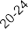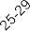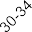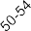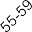be in the private sector and they move into government jobs at a later age, based on when recruitments are announced and possibly also repeated attempts until the age limit for entry is reached. We see a larger proportion overall of teachers in the 20-24 and 24-29 age groups in the private sector as compared with the

government sector. If we assume that in general almost all those acquiring professional teaching qualifications aspire to government jobs and remain in teaching11, it would seem that the wait
time between professional qualification and Age Profile of Private sector teachers
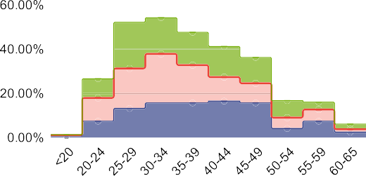successfully securing a government job is 5 to 7 years. And during this time, they are working in

the private sector.

Rural private school primary and secondary teachers have the lowest median age of 32 years, with the women median age as low as 30 years. ECCE workers in urban areas, secondary school teachers in urban areas tend to be among the oldest with a median age of 43-44 years.
Generally, the median age of women is 3 to 4 years less than men. This indicates that among

- Some states specify maximum age limit for government employment recruitment, up to 36-40 years (e.g. Delhi, Kerala). Some States (e.g. UP) do not specify any upper age limit. Minimum age is usually 20-21 year.
younger workforce more women rather than men are entering into the profession overall. A growing trend of feminisation over the last ten years is also visible with 62% secondary school teachers and 73% primary school teachers in the age group of 20-24 being women. In the age group of 45 years upwards the balance is in favour of men. The feminisation of government
teacher workforce seems to be taking place over the last five years, feminisation of private teacher workforce began at-least 20-30 years ago.

UDISE+ gathers information on teachers with disabilities; recruitment in government service reserves jobs for persons with disabilities. 2.62% government school teachers (56% men), 1.19% teachers in aided schools and 2.21% teachers
in private schools (37% men) are persons with disabilities. As per SOTTTER- 23 survey, 9% (n=38) of the schools reported having teachers with disabilities (Government -28, Private-5).

Age Profile of Government sector teachers
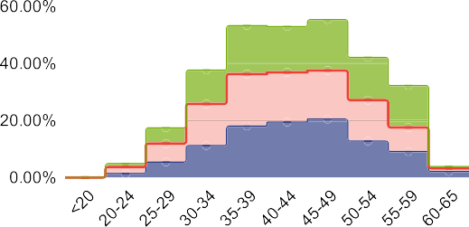

Median age (in years):
ECCE Overall: 42; Govt: 43; Private: 39;
Primary Overall: 39; Govt: 42; Private: 34
Secondary Overall: 40; Govt: 44; Private: 35

Source: Authors analysis based on Periodic Labour Force Survey, 2021-22

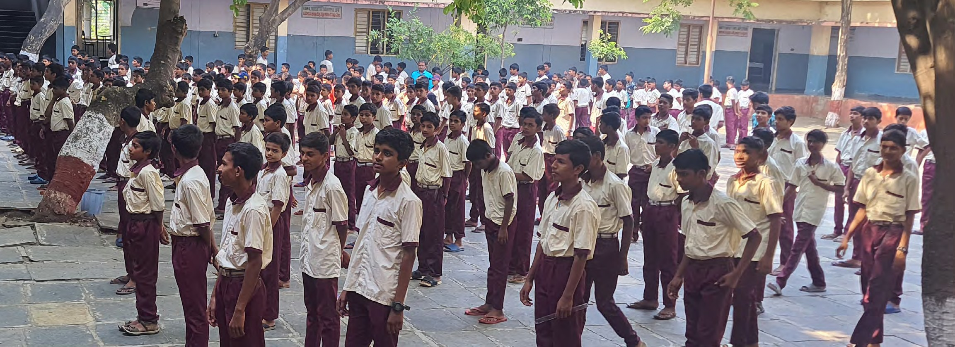

6

The Right Teacher for Every Child

Providing the right teacher in each class: Are there shortages? Where? What kind?
3
T
he Right of Children to Free and Compulsory Education Act, (2009) mandates PTR at the school level of 30:1 for Grades 1 to 5 and 35:1 for grades 6-8. The Act requires that each school employ professionally qualified teachers: DElEd (or equivalent) for primary grades and graduate teachers with BEd (or equivalent) for middle grades. Each school is expected to have a
minimum of 2 teachers. Additionally, middle schools are expected to have one teacher for each subject and appoint instructors for physical education, music and art. The Hon’ble Supreme Court ruled in 2021 that special educators must be appointed in schools12. Are the right teachers teaching children, according to their level and subject requirement? Does teacher deployment ensure that the norms prescribed by the Right to Education Act are met in terms of the relevant professional qualification, subject specialisation and prescribed PTR norms? Do we have a surplus of teachers in the system or are there shortages?

National and state level average PTRs
PTRs calculated at the national, state or for any type of school group is indicative of overall availability of teachers. The national PTR average for all schools is 28:1. The PTR for rural schools is 28:1 and for urban schools 29:1. Overall for primary schools the PTR is 26:1, for upper primary it is 19:1, for secondary it is 18:1 and for higher secondary 27:1. Overall government school PTR is 28:1 while for private schools it is 26:1.
In our primary data survey of eight states, the average PTR for government schools was found to be 31:1 and for private schools was 21:1. There is considerable variation in PTR of the government sector from state to state, varying from 6:1 (Ladakh) to 57:1 (Bihar). 16 states have PTRs less than 20:1 and 5 have PTR greater than 30:1. The PTRs of private school sector, varies from state to state between 12:1 to 45:1 with most having PTRs between 20 and 30. A pattern noted is that where government school PTRs are low, private school PTRs tend to be higher, and where government PTRs are higher, private school PTRs are lower (Table 4, Figure 4).

Table 4
States across Government School PTR range
PTR range | States with govt school PTR in range | Notes
7:1-10:1 | Sikkim, Nagaland, Ladakh, Andaman and Nicobar | Private schools in these states have higher PTRs, 12:1 (Sikkim) >PTR > 20:1 (Nagaland)
11:1 to 20:1 | Arunachal Pradesh, Goa, Himachal Pradesh, J&K, Kerala,  Lakshadweep, Manipur, Maharashtra, Mizoram, Puducherry, Tripura, Uttarakhand | PTRs in private schools are generally comparable, with exception of Goa, Maharashtra and Uttarakhand where it is higher.
21:1 to 29:1 | Andhra Pradesh, Assam, Chhattisgarh, DNH and DD, Gujarat, Haryana, Karnataka, Madhya Pradesh, Meghalaya, Odisha, Punjab, Rajasthan, Tamil Nadu, Telangana, West Bengal | PTRs in private schools are comparable, with exception of Assam and Odisha where it is much lower.
30:1 to 40:1 | Chandigarh, Delhi, Uttar Pradesh | PTRs in private schools are much lower in Chandigarh and Delhi and comparable in Uttar Pradesh
41:1 to 57:1 | Jharkhand, Bihar | In Bihar, Govt Secondary and Composite schools have PTRs >80:1
Source: Authors based on data from UDISE+ 2021-22

- See footnote 7

7

CETE (2023)

Figure 3
State Wise Comparison of PTR

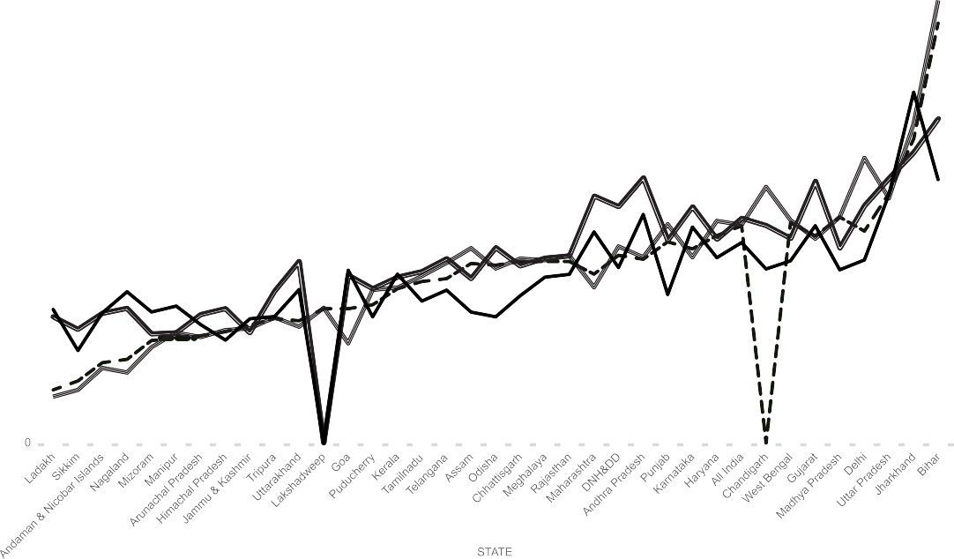

Source: Authors based on data from UDISE+ 2021-22

School level PTRs13

The RTE norms require PTRs to be calculated and maintained at the school level. At the school level, having PTR of 35:1 is an indicator that the school has a teacher requirement and a PTR less than 30:1 is an indicator of possibility of teacher surplus in that school.

24% of all schools in the country have PTR
>35:1; this means that they most likely have a shortage of teachers. 66% of these schools are government schools and 20% are private schools. 81% of schools with PTR >35:1 are in rural areas.
These rural schools constitute 23% of all the rural
PTR are in urban areas. States with 20% or more private schools with teacher requirement include Andhra Pradesh (23%), Bihar (29%), Gujarat (28%),
Jharkhand (46%), Karnataka (26%), Maharashtra (27%), Uttar Pradesh (30%), and West Bengal (21%).

9.5% of government schools are single teacher schools (Table 5). 91% of all single teacher schools are primary schools. The states
with higher percentage of single teacher government schools suggest that the reasons are varied: supply of qualified teachers, delays

- School-level PTR is calculated based on school level enrollment / total number of teachers for each school. This section is based on the PTRs calculated for each school in the UDISE+ 2021-22 data base, based
on which schools
were categorised for analysis As per the RTE, meeting teacher requirements at
the upper primary/
middle level are more complex and PTR<30 does not necessarily mean excess teachers
as they may be
needed to meet the RTE norm. This analysis is a first level attempt to arrive at estimates of requirements and surpluses.
schools in the country. 67% of all schools have PTR <30:1. 65% of these schools are government schools. Of the schools with PTR <30:1, 83% are in rural areas. These rural schools constitute 68% of all the rural schools in the country. Rural schools seem to be simultaneously more difficult to staff (leading to lower PTRs than desirable) or small, yet requiring teachers to fulfil RTE mandated teacher requirements. This could lead to both high and low PTR.

States where 20% or more government schools have teacher requirements (i.e. % of govt. schools with school level PTR>35:1) include Assam (22%), Bihar (70%), Chandigarh (33%), Delhi (50%),
Haryana (24%), Jharkhand (49%), Karnataka
(20%), Madhya Pradesh (26%), Rajasthan
(22%), Uttar Pradesh (30%), Uttarakhand (25%) and West Bengal (24%). While most of the requirement is in rural areas, (overall, of all government schools having a teacher
requirement, 90% are located in rural areas), in more urbanised and developed states such as Karnataka, Kerala, Maharashtra, Goa and Gujarat, Tamil Nadu and Telangana, and also DNH&DD, about 25-30% government schools with high
in recruitment, difficulties in rationalising deployment and difficult to staff areas (rural- remote, hilly). In case of the North East, it is both a lack of adequate teacher supply (overall shortage of qualified teachers) along with difficult terrain affecting posting. The same is arguably the case with Jharkhand. Himachal and Uttarakhand likely experience difficulties in staffing remote schools. Telangana, Andhra Pradesh, Karnataka and Goa have adequate supply of qualified teachers but may have experienced recruitment and deployment related problems.

8

The Right Teacher for Every Child

Table 5
Proportion of Single Teacher Government Schools in States of India
Range | % of government schools that are single teacher schools
0-4.9% | Andaman & Nicobar (1%), Nagaland (1.4%), Mizoram (2%), Gujarat (3%), Sikkim (3%), Uttar Pradesh (4%), Kerala (4%), Ladakh (4%), Dadra & Nagar Haveli, Chandigarh, Lakshadweep, Puducherry, Delhi (0%),
5-9.9% (National  average: 9.5%) | West Bengal (5%), Assam (5%), Haryana (5.6%), Manipur (6%), Bihar (7%), Odisha (7%),  Meghalaya (7%), Tripura (7%), Tamil Nadu (8%)
10-14.9% | Jammu & Kashmir (10%), Chhattisgarh (11%), Rajasthan (11%), Punjab (13%), Madhya  Pradesh (13%), Karnataka (14%)
15-19.9% | Telangana (18%), Jharkhand (19%),
20-24.9% | Himachal Pradesh (20%), Uttarakhand (21%), Andhra Pradesh (23%)
>25% | Arunachal Pradesh (26%), Goa (29%)
Source: Authors based on data from UDISE+ 2021-22

- See footnote 2

Qualifications
83% of all teachers are graduates, 90% have some form of professional qualification, and 10% are without any professional qualification. 4% of all government teachers and 16% of private school teachers have no professional qualification. 69% of teachers with no professional qualifications are working in rural areas. 61% work in private schools and 21% in government schools.

States with a higher proportion of teachers without any professional qualification include the North Eastern States of Manipur (24%), Assam (34%), Nagaland (39%), Meghalaya (37%), Tripura (26%) and Sikkim (24%). Other states with high proportion of teachers without professional qualification include Jammu Kashmir (23%) and Ladakh (25%), Jharkhand (14%), Uttar Pradesh
(15%), Arunachal Pradesh (15%), Bihar (15%) and
Madhya Pradesh (11%).

States with relatively higher proportion of teachers without professional qualification in urban areas include Gujarat (70%), Karnataka (67%), Maharashtra (65%) and Telangana (80%). This may also reflect concentration of such teachers in the private sector in these states. The private sector emerged as the major employer of unqualified teachers in most states: DNH&DD (83% of all unqualified teachers), Gujarat
(98%), Haryana (82%), Madhya Pradesh (89%),
Maharashtra (87%), Puducherry (97%), Punjab
(89%), Rajasthan (90%), Telangana (83%). In a few states, a large proportion of the unqualified teachers group was in the government sector: Jharkhand (77%) and Tripura (79%).

Overall, 9.85% of teachers teaching at the primary level, 8.89% of teachers teaching at the upper primary level and 6% teaching at the secondary level have no professional qualifications at all.
At the primary teaching level, about 35% of the workforce of unrecognised schools and 41%
of madarsas have no professionally qualified teachers.

The matter of having the appropriate professional qualification is more complex. The RTE and NCTE have defined professional qualifications required by teachers for different
levels of the school system. The requirement that DElEd and equivalent degrees such as BElEd or BTC are the only valid professional qualification

for primary school teaching was recently reasserted in 2023, by the Hon’ble High Court of Rajasthan and the Hon’ble Supreme Court,
which set aside other professional qualifications such as BEd to be valid for this level14.

Overall, only 45.72% of teachers teaching primary grades have the appropriate professional qualification of a DElEd or BElEd or equivalent degree (Table 6). 60.5% of government school teachers and 68% of aided school teachers and 66.45% of teachers working in government schools of the social welfare, tribal welfare
and labour department have the appropriate qualification. An additional overall 30.44% of teachers teaching primary grades have BEd or equivalent degrees. A large proportion of
primary school teachers teaching in schools run by government societies such as the KVs, i.e. about 55%, have BEd degrees and only 24% have the appropriate qualification of DElEd. Private recognised schools tend to employ BEd rather than DElEd to teach in primary classes. 43%
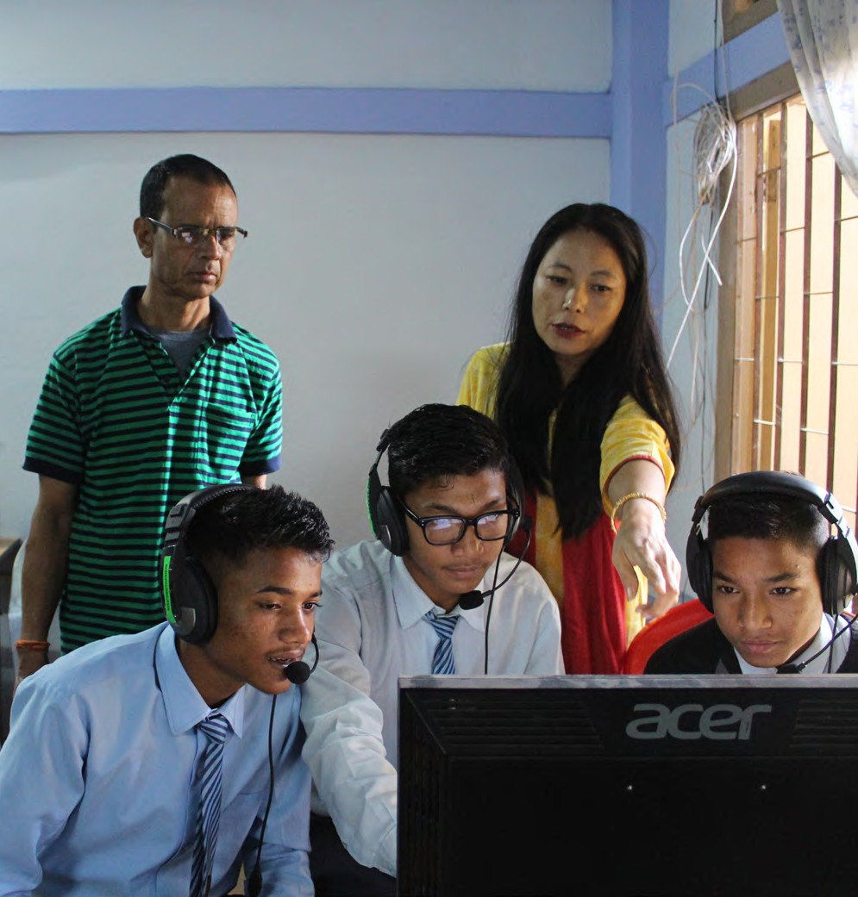of their teachers have BEd and only 22% have DElEd.

9

CETE (2023)

Table 6
Availability of Appropriate Professional Qualifications (All India, teacher data categorised for School type by Management types and School type by level
School Type by Level and Management | Proportion of teachers with relevant qualification |  |  |  | Distribution of teachers with without qualification (none) across management types
School Type by Level and Management | DEd or Equivalent | BEd or equivalent (including MEd) | Diploma/degree in special education | None
A. Primary School for which professional qualification is DElEd/DEd/BElEd
Government schools | 60% | 24% | 1.0% | 4% | 21%
Government aided | 68% | 21% | 2.2% | 3% | 1.2%
Private unaided recognised | 22% | 42% | 2.2% | 17% | 62%
Unrecognized | 28% | 16% | 2.3% | 36% | 8%
Madarsa (recog + unrecog) | 15% | 22% | 1.7% | 41% | 7%
Govt other (Generally English medium) | 24% | 56% | 2.9% | 2.9% | 0.1%
Govt other (for socially marginalised groups) | 66% | 17% | 1.3% | 4.3% | 0.7%
Total | 46% | 30% | 1.5% | 10% | 100%
B. Upper Primary for which profesional qualification is BEd
Government schools | 31% | 58% | 1.1% | 3.2% | 14%
Government aided | 30% | 60% | 1.2% | 3.8% | 2.6%
Private unaided recognised | 15% | 58% | 1.9% | 13% | 70%
Unrecognized | 24% | 23% | 2.2% | 34% | 9%
Madarsa (recog + unrecog) | 15% | 21% | 1.3% | 43% | 4.2%
Govt other (Generally English medium) | 7% | 76% | 2.7% | 3.1% | 0.2%
Govt other (for socially marginalised groups) | 25% | 64% | 1.1% | 1.3% | 0.2%
Total | 22% | 57% | 1.5% | 9% | 100%
C. Secondary school for which professional qualification is BEd
Government schools | 7% | 83% | 0.7% | 4.1% | 28%
Government aided | 6% | 84% | 0.9% | 4.5% | 11%
Private unaided recognised | 7% | 73% | 1.6% | 9% | 55%
Unrecognized | 10% | 28% | 2.1% | 48% | 3.1%
Madarsa (recog + unrecog) | 10% | 27% | 1.5% | 37% | 1.8%
Govt other (Generally English medium) | 2.2% | 84% | 1.6% | 2.5% | 0.7%
Govt other (for socially marginalised groups) | 13% | 78% | 1.3% | 1.3% | 0.4%
Total | 7% | 79% | 1.1% | 6% | 100%
Source: Authors based on data from UDISE+ 2021-22

10

The Right Teacher for Every Child

The appropriate professional qualification for upper primary grades is BEd or BElEd. About 57% of teachers in the system teaching in the upper primary level are appropriately qualified with BEd. (Government, aided and government schools of the social, tribal and labour departments, as well as in private recognised schools, all have the same proportion). 75% of teachers teaching middle school
grades in the government society run schools such as Kendriya Vidyalayas, and the Jawahar Navodaya Vidyalayas also have the appropriate qualification. 22% of upper primary level school teachers have DElEd or BElEd professional degrees.

The appropriate professional qualification for teaching in secondary schools is also BEd. 79% of teachers in the system teaching at this level have BEd degrees: Government (83%), aided (84%). 73% of teachers are in private recognised schools and 78% of teachers are in schools run by the social, tribal and labour departments.

The SOTTTER 23 survey also provides a worm’s eye view of the availability of appropriately qualified teachers for various levels of school (Table 7). Data from 81 schools and 817 teachers of these schools was mapped onto the levels in the schools. Although this is a small sample, the analysis is provided to illustrate the specific issue of ascertaining whether appropriate teachers are being employed/ deployed/available. In the surveyed schools, only 22% of the teachers in Primary schools had DEd or equivalent degrees. 58% of primary level teachers were BEd degree holders–working mostly in aided schools (90%) or Central Government Society run English medium schools (72%). The largest proportion of teachers with no professional qualifications (53%) were found to be mostly working in private primary schools. Of the 153 teachers with no professional qualifications, 14% worked in primary schools, 34% in composite schools and 50% in middle and secondary schools. Most of the
teachers without professional qualifications were employed in the private sector (62%: 5% in primary + 24% in composite + 33% in middle and high), followed by government schools (29%: 8% primary + 7% composite + 14% middle & secondary).

Table 7
Professional qualification of teachers by teaching level and school type
Level type | Management type | Schools |  | Teachers
Level type | Management type | Total | Proportion | Total | DEd or Eq | BEd or Eq | No Prof.  Qualifications
 |  | N | % | N | % | % | %
Primary Only | All | 24 | 14% | 180 | 22% | 58% | 12%
(grades I-V) | Aided | 4 | 1% | 40 | 8% | 90% | 3%
(grades I-V) | Government | 16 | 8% | 118 | 27% | 52% | 11%
(grades I-V) | Government Others | 1 | 0% | 7 | 14% | 71% | 0%
(grades I-V) | Private | 3 | 5% | 15 | 27% | 20% | 53%
Elementary | All | 6 | 2% | 68 | 50% | 38% | 4%
(grades I-VII/VIII) | Government | 4 | 0% | 52 | 50% | 44% | 0%
(grades I-VII/VIII) | Private | 2 | 2% | 16 | 50% | 19% | 19%
Composite |  | 17 | 34% | 181 | 22% | 38% | 29%
(grades I-X or I to XII) | Aided | 7 | 3% | 59 | 19% | 61% | 8%
(grades I-X or I to XII) | Government | 5 | 7% | 52 | 17% | 46% | 19%
(grades I-X or I to XII) | Private | 5 | 24% | 70 | 27% | 13% | 53%
Middle/Secondary |  | 34 | 50% | 388 | 22% | 53% | 20%
(grades VI-X/XII) | Aided | 11 | 3% | 80 | 60% | 33% | 5%
(grades VI-X/XII) | Government | 19 | 14% | 218 | 12% | 70% | 10%
(grades VI-X/XII) | Government Others | 1 | 0% | 10 | 50% | 20% | 0%
(grades VI-X/XII) | Private | 3 | 33% | 80 | 5% | 29% | 64%
Grand Total |  | 81 | 100% | 817 | 24% | 49% | 19%
Note: (*) data on qualifications such as physical education, special education, nursery teaher training and various diplomas not analysed.
Source: SOTTTER-2023 Survey

11

CETE (2023)

Table 8  Teacher’s undergraduate academic subject specialisation and subjects they teach (middle school and above) |  | Proportion of total | Breakup based on  Under Graduate subject specialisation
 | Level of match between school teaching subject and Under Graduate (UG) specialsiation | Proportion of total | Science without mathematics | Physical Science with mathematics | Social Science with mathematics | Social Science and Language | Commerce | Other professional degree | No Information/ Not applicable
A. All teachers (Govt and Private) | All Government school N=991
A. All teachers (Govt and Private) | Proportion of teachers |  | 20% | 14% | 2% | 54% | 5% | 1% | 4%
A. All teachers (Govt and Private) | All subjects (primary or secondary) | 4% | 1% |  | 5% | 5% | 10% | 20%
A. All teachers (Govt and Private) | UG subjects and teaching subjects do not match | 16% | 32% | 5% |  | 15% | 6%
A. All teachers (Govt and Private) | Teaching language (regional or English) | 4% | 9% | 4% | 10% | 0% | 24% | 50%
A. All teachers (Govt and Private) | Teaching one related subject & other subjects | 2% | 9% |  |  |  | 6%
A. All teachers (Govt and Private) | UG subjects and teaching subjects match | 70% | 49% | 90% | 85% | 79% | 54%
A. All teachers (Govt and Private) | All Private school teachers N-746
A. All teachers (Govt and Private) | Proportion of teachers |  | 14% | 15% | 1% | 53% | 10% | 1% | 5%
A. All teachers (Govt and Private) | All subjects (primary or secondary) | 6% | 2% | 3% | 13% | 6% | 11% | 11%
A. All teachers (Govt and Private) | UG subjects and teaching subjects do not match | 14% | 15% | 4% |  | 19% | 5%
A. All teachers (Govt and Private) | Teaching language (regional or English) | 5% | 10% | 5% | 25% |  | 18% | 22%
A. All teachers (Govt and Private) | Teaching one related subject & other subjects | 3% | 21% |  |  |  | 3%
A. All teachers (Govt and Private) | UG subjects and teaching subjects match | 68% | 52% | 88% | 63% | 75% | 63%
B. All Rural Teachers (Govt and private) | Rural Government school teachers N=501
B. All Rural Teachers (Govt and private) | Proportion of teachers |  | 15% | 14% | 3% | 59% | 3% | 1% | 5%
B. All Rural Teachers (Govt and private) | All subjects (primary or secondary) | 6% | 1% |  | 8% | 7% | 12% | 25%
B. All Rural Teachers (Govt and private) | UG subjects and teaching subjects do not match | 15% | 26% | 1% |  | 18% | 6%
B. All Rural Teachers (Govt and private) | Teaching language (regional or English) | 3% | 8% | 4% | 8% |  | 29% | 25%
B. All Rural Teachers (Govt and private) | Teaching one related subject & other subjects | 2% | 11% |  | 0% |  | 12%
B. All Rural Teachers (Govt and private) | UG subjects and teaching subjects match | 69% | 54% | 93% | 85% | 74% | 41%
B. All Rural Teachers (Govt and private) | Rural Pirvate school teachers N=206
B. All Rural Teachers (Govt and private) | Proportion of teachers |  | 14% | 15% | 0% | 53% | 9% | 2% | 6%
B. All Rural Teachers (Govt and private) | All subjects (primary or secondary) | 7% | 3% | 3% |  | 8% | 13%
B. All Rural Teachers (Govt and private) | UG subjects and teaching subjects do not match | 13% | 14% | 3% |  | 18% | 9%
B. All Rural Teachers (Govt and private) | Teaching language (regional or English) | 6% | 8% | 5% |  |  | 35% | 33%
B. All Rural Teachers (Govt and private) | Teaching one related subject & other subjects | 4% | 28%
B. All Rural Teachers (Govt and private) | UG subjects and teaching subjects match | 63% | 47% | 89% |  | 73% | 43%
Teacher’s undergraduate academic subject specialisation do not match teaching subjects Teacher’s undergraduate academic subject specialisation match teaching subjects
Source: SOTTTER-2023 Survey

For teachers teaching in middle and secondary schools, their under graduate subject specialisation and the subjects they were teaching were compared for match (Table 8). Overall, about 68-70% teachers in government and private schools were teaching subjects in middle and high school where they had relevant undergraduate specialisations (Table 8). Science teachers without mathematics were teaching mathematics (41% Government and 35% private). About 15-16% social science teachers were teaching science subjects. 4-5% teachers were teaching all subjects in both government and private schools. 5% teachers with backgrounds in commerce or science or mathematics were involved with language teaching. In 55% of cases in government schools and 50% cases in private schools, mathematics was being taught by a teacher who had not studied mathematics in their undergraduation. The scenario in rural school taken alone was fairly similar; about 69% government school teachers were teaching subjects in which they had specialisation, as compared to about 63% of private school teachers.

12

The Right Teacher for Every Child

With regards to providing teachers for Physical Education, Music Education and Art Education (Table 9), private schools were better off as compared to government schools. Urban schools are also better off in terms of providing full time teachers for these subject areas:
42% of schools surveyed reported having at least one child with disability. 29% schools reported having a teacher with some training/ orientation to teach children with disabilities. 52% private and government schools said they did not need a special educator. 22% private schools compared with 8% government schools said they had a special educator. 14% government school teachers and 21% private school teachers reported having received some training or certification in special education.

Table 9
Teachers for physical education, art education and music education

 | Physical Education |  | Art Education |  | Music Education
 | Full time | Part time | Full time | Part time | Full time | Part time
Government | 30% | 6% | 19% | 1% | 11% | 1%
Private | 53% | 11% | 40% | 17% | 25% | 14%
Rural | 34% | 5% | 22% | 6% | 12% | 5%
Urban | 40% | 9% | 32% | 6% | 17% | 5%
Source: SOTTTER-2023 Survey

Teachers requirements15

- Based on SOTTTER 23 survey data
61% schools, i.e. (261 schools heads out of 422) reported that they had a teacher requirement or unfilled vacancies (Table 10). 41% of all schools (176 school heads) also provided details of this
requirement providing numbers. The total estimated requirement was 702 teachers for 176 schools, an average of 4 teachers per school reporting a requirement. 65% of the schools reporting such requirements/vacancies were government schools: 69% of rural schools and 54% of urban schools. In comparison, 32% of private schools reported having a teacher requirement (35% rural and 29% urban). The States with higher proportion of government schools reporting requirement were Bihar (82%), Telangana (63%) and Punjab and Karnataka (63%). 127 schools provided details of the subject teacher requirement they had. Across all schools, the highest requirement reported was for Mathematics and Science (35%) followed by English (31%) and the regional language (30%). 15-16% reported requirements for Physical Education and Music/Art teachers.

Table 10
(A) State wise | Government |  |  | Private
Rural Urban Total Rural Urban Total
 | % yes | % yes | % yes | % yes | % yes | % yes
Assam | 70% | 50% | 59% | 20% | 43% | 33%
Bihar | 84% | 75% | 82% | 13% | 0% | 8%
Chhattisgarh | 60% | 45% | 55% | 67% | 60% | 64%
Karnataka | 63% | 63% | 63% | 50% | 57% | 55%
Maharashtra | 86% | 15% | 40% | 33% | 0% | 21%
Mizoram | 56% | 60% | 58% | 25% | 27% | 27%
Punjab | 65% | 58% | 63% | 29% | 11% | 19%
Telangana | 100% | 62% | 67% | 33% | 30% | 31%

School heads reporting ‘Yes’ to teachers requirement/unfilled vacancy
(response rate 92%)

(B) Overall | Rural | Urban | Total
All Government Schools | 69% | 54% | 62%
All Private Schools | 35% | 29% | 32%
All Aided Schools | 56% | 57% | 57%
All Government Other Schools | 33% | 20% | 25%
Grand Total | 59% | 47% | 53%

(C) Overall schools requirement reported | Rural | Urban | Total
Total requirement reported across all school types and states | 343 | 359 | 702
Number of schools saying 'Yes' to requirement and providing numbers | 93 | 83 | 176
Average teacher requirement reported by school saying 'Yes' | 3.7 | 4.3 | 4.0
Overall average teacher requirement (total teacher requirement reported (number)/total number of schools reporting Y or N (schools saying Y to requirement but not providing numbers have left out) | 1.9 | 1.8 | 1.9

(D) Only government schools requirement reported | Rural | Urban | Total
Total requirement reported in all government schools | 257 | 174 | 431
Number of schools saying 'Yes' to requirement and providing numbers | 67 | 49 | 116
Average teacher requirement reported by school saying 'Yes' | 3.8 | 3.6 | 3.7
Overall average teacher requirement (total teacher requirement reported (number)/total number of schools reporting Y or N (schools saying Y to requirement but not providing numbers have left out) | 1.4 | 0.9 | 1.1
Source: SOTTTER-2023 Survey

13

CETE (2023)

Gender balance in the teaching workforce16
4

ll India, about 51% of school teachers are women. However, there are significant differences indicative of sectoral and management and rural-
A
urban, interstate and social category-wise imbalances of marked feminisation as well as lack of women representation.

State-to-state variation in the proportion of women teachers in the workforce is considerable (Figure 4). States and Union Territories with a high proportion of women
teachers (>=70%) include Chandigarh (81%), Delhi
(74%), Goa (81%), Kerala (79%), Puducherry (75%), Punjab (75%), and Tamil Nadu (75%). States and Union Territories with a low proportion of women teachers (<= 40%) include Bihar (40%), Jharkhand (40%), Rajasthan (40%), and Tripura (35%).

Women teachers tend to be concentrated in urban areas. 67% of all teachers in urban areas are women compared to 44% in rural areas. Women teachers also tend to be concentrated in private schools. Overall, only
44% of government school teachers are women, whereas 63% of teachers in private schools are
Figure 4

women. There is considerable interstate variation in the extent of feminisation in the private sector vs government sector teacher workforce. 73% of teachers in private schools in urban areas are women.

Except the private sector, across all other school types the proportion of men exceeds that of women by 11-28% points. (11% in Government and government aided, and government
other English Medium; 24% in social welfare department schools; 25%; in madrasas; 28% in tribal welfare).

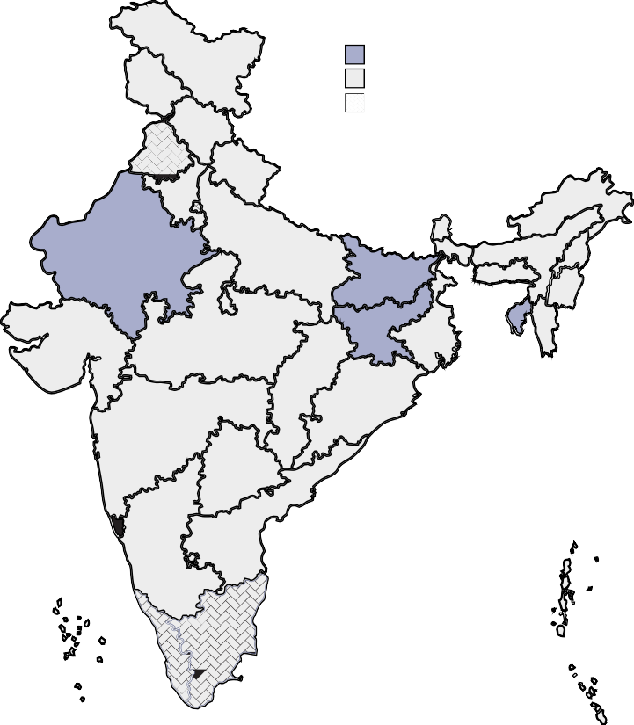State/ UT wise feminization in teaching

States/ UTs with <= 40% of women teachers States/ UTs with 40-70% of women teachers States/ UTs with >= 70% of women teachers

- The analysis of this section is based on SOTTTER-2023 background paper
1, 2, 5 and 6, drawing on UDISE Data, PLFS data and the SOTTTER 23 survey of eight states data

Source: Authors based on data from UDISE+ 2021/22

14

The Right Teacher for Every Child

Table 11
Proportion of women and male teachers in Government and Government aided schools
 | Overall |  |  | Contractual
 | Female % | Male % | Total N | Female % | % | Total N
Government | 44% | 56% | 46,81,968 | 55% | 45% | 518111
Govt (I-V and I-VIII) | 45% | 55% | 29,75,247 | 55% | 45% | 367401
Aided | 45% | 55% | 796631 | 59% | 41% | 47507
Aided (I-V and I-VIII) | 64% | 36% | 185551 | 80% | 20% | 11786
Tribal Welfare | 36% | 64% | 127320 | 42% | 58% | 12763
Tribal (I-V and I-VIII) | 35% | 65% | 72045 | 41% | 59% | 4639
Source: Authors, based on analysis of data from UDISE+ 2021-22

The contractual workforce (Table 11) in all government sector and aided schools is more feminised than the overall workforce: at approximately 55-59% women to 45-41% men. Across all the government and aided school types contractual workforce is more feminised compared to the overall workforce (11% points more than in the overall workforce). Tribal welfare school contractual workforce is still mostly male (lower proportion).

Table 12
Proportion of women to men teachers in government and private employment, sector- wise government, private and overall.

 | Government |  | Private/ Non Government
Type of teacher | Female | Male | Female | Male
Overall | 48% | 52% | 58% | 42%
ECCE teacher | 86% | 14% | 79% | 21%
Primary teacher | 39% | 61% | 63% | 37%
Secondary teacher | 36% | 64% | 50% | 50%
(small sample)
Special Education teacher | 46% | 54% | 53% | 47%
Vocational Education teacher | 22% | 78% | 48% | 52%
Music, Art, Drama teacher | 100% | 0% | 39% | 61%
Physical Education teacher | 8% | 92% | 19% | 81%
Source: Authors, analysis based on PLFS, 2021-22

Periodic Labour Force data gives an idea of gender balance across other teaching sectors (Table 12) and across age groups (Table 13). The most feminised teaching sector is early childhood education (85%). The least feminised teaching sectors are vocational education (33%) and physical education (16%). There is a lower proportion of women to men in the government sector and a higher proportion of women to men in the private sector in primary and secondary teaching.

Private primary school teaching is highly feminised across all teacher age groups (Table 12), while there is more gender balance in secondary private school teaching (Table 13). A very recent trend is the marked feminisation in Government school teaching also. The older government workforce is predominantly male. Private school teaching is highly feminised in the States of Goa, Kerala, Delhi and Chandigarh where more than 90% of the workforce is women.

15

CETE (2023)

Table 13
Proportion of women (to total) in the respective age bracket of the workforce: government, private and overall.
 | Primary teachers |  |  | Secondary teachers
Age Bracket | Govt. | Pvt/ NonGovt. | Total | Govt. | Pvt/ NonGovt. | Total
20-24 | 69% | 75% | 73% | 67% | 62% | 62%
25-29 | 41% | 64% | 54% | 41% | 53% | 50%
30-34 | 41% | 67% | 52% | 40% | 41% | 40%
35-39 | 38% | 64% | 46% | 37% | 53% | 44%
40-44 | 37% | 58% | 42% | 35% | 54% | 43%
45-49 | 36% | 61% | 41% | 27% | 49% | 34%
50-54 | 36% | 60% | 39% | 41% | 54% | 45%
55-59 | 38% | 38% | 38% | 34% | 40% | 35%
60-65 | 64% | 75% | 68% | 40% | 29% | 32%
>65 | 0% | 33% | 33% | 0% | 0% | 0%
Source: Authors, analysis based on PLFS, 2021-22

Table 14
Proportion of women among school heads and teachers: Statewise, school management wise and rural
Management |  | Aided | Government | Private | Government Others | Overall | All Rural Schools
 | HM | 50% | 45% | 25% | ss(*) | 39% | 24%
Assam | Teachers | 55% | 57% | 63% | 91% | 60%
 | HM | ss | 39% | 58% | ss | 45% | 36%
Bihar | Teachers | 93% | 43% | 47% | 67% | 49%
 | HM | 67% | 45% | 43% | ss | 49% | 41%
Chhattisgarh | Teachers | 73% | 62% | 68% | ss | 67%
 | HM | 36% | 29% | 27% | ss | 31% | 15%
Karnataka | Teachers | 53% | 65% | 73% | 61% | 64%
 | HM | 53% | 40% | 29% | ss | 42% | 27%
Maharashtra | Teachers | 47% | 50% | 60% | 44% | 51%
 | HM | 9% | 42% | 20% | ss | 29% | 25%
Mizoram | Teachers | 53% | 52% | 69% | - | 59%
 | HM | 57% | 44% | 50% | ss | 47% | 31%
Punjab | Teachers | 95% | 71% | 89% | - | 80%
 | HM | 80% | 33% | 46% | ss | 44% | 44%
Telangana | Teachers | 90% | 63% | 86% | 44% | 72%
 | HM | 49% | 40% | 37% | 50% | 41% | 30%
Grand Total | Teachers | 65% | 61% | 71% | 58% | 65%
Note: (*) ss: small sample hence disregarded;
Source: SOTTTER-2023 Survey

The SOTTTER 23 survey provides the picture of gender balance in school leadership (Table 14). Overall, at 41% (30% in rural) women HMs are 20% point less than the proportion of women teachers in the workforce. Even though private school teaching is highly feminised (71% women), management
of private schools is very male dominated (only 37% women). In government schools also, school heads are more likely to be male.

16

The Right Teacher for Every Child

Overall, the proportion of women ST and SC teachers in secondary schools is low. The proportion of teachers from Scheduled Caste (SC), Scheduled Tribe (ST) communities in private employment is low compared to government schools. Private school teachers are predominantly in urban areas (about 62%, compared to about 41% of government school teachers (PLFS, 2021-22).

Differentials in pay structure is taken up in the section discussing working conditions of teachers in private schools.
The social category wise profiles of government and government aided schools are reasonably similar to each other. The proportion of male SC and ST teachers is greater than the proportion of women SC, ST teachers by almost 20-30% indicative of lower levels of women’s education in these communities. The overall social category profile of private unaided schools and government other (English medium) are fairly similar to each other. These schools generally have a higher proportion of teachers from general categories (51% to 56%) and much lower representation of teachers from tribal groups (4-6%).

The proportion of ST teachers in schools run by Welfare departments (social, tribal and labour) is highest at 44%, in comparison, their proportion in Private unaided schools is lowest at 4%. Teachers from scheduled caste communities represent overall 12% and are more or less evenly distributed among all school types (between 9% and 15%).
Box 2: Social category profiles of teachers in schools of different management types

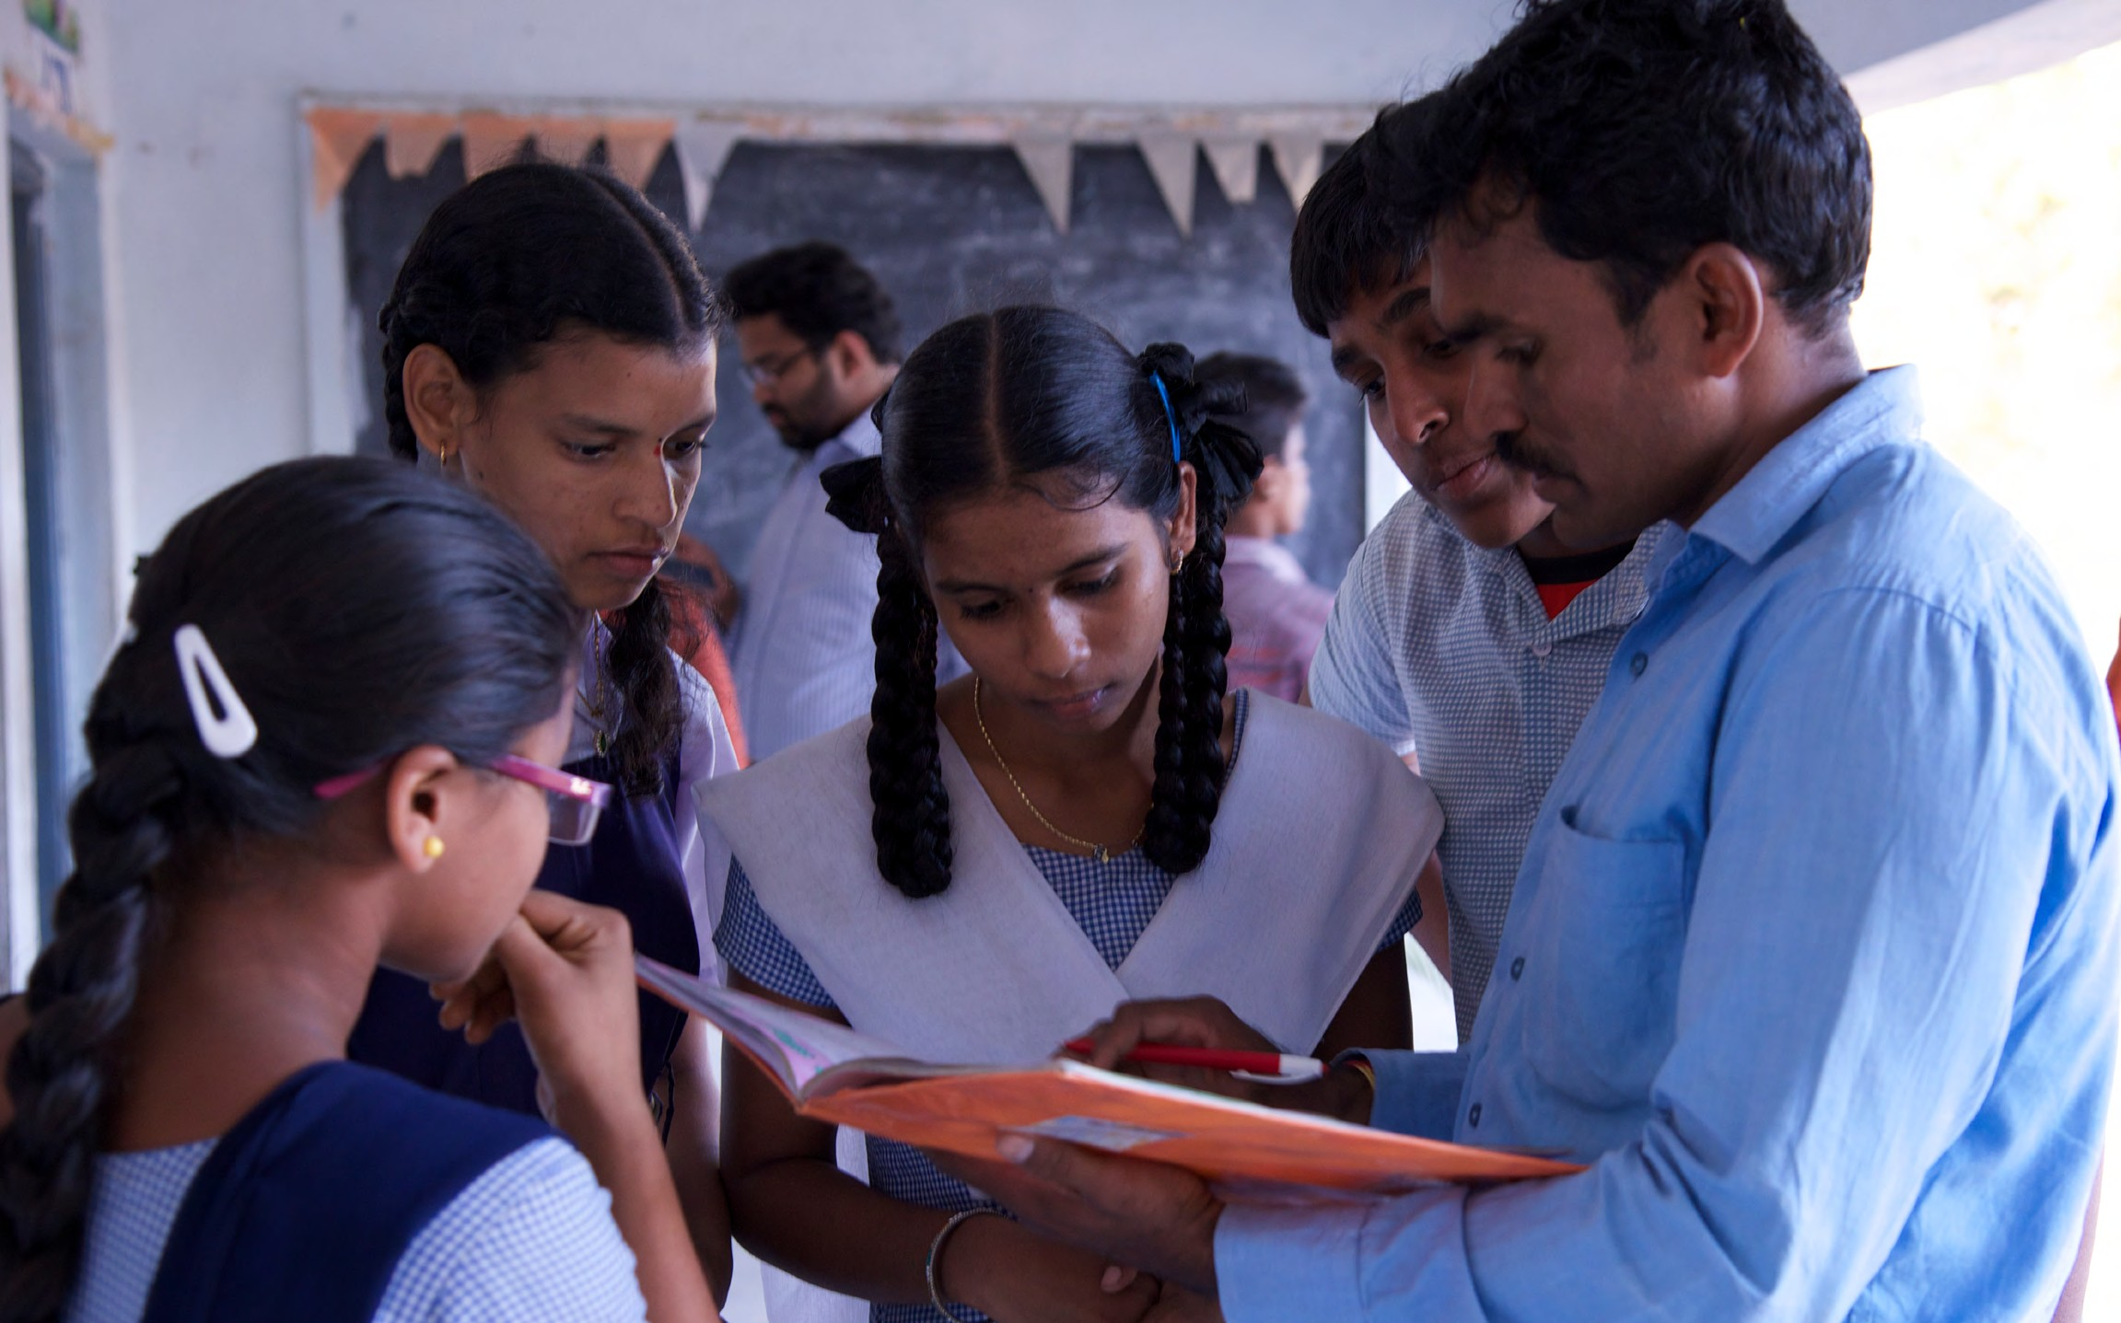

17

CETE (2023)

Feminisation in teacher supply

In the SOTTTER 23 survey, 73% of BEd sample and 65% of the DElEd sample were women. In case of ST students, the overall proportion was 52% women in BEd and 63% women in DElEd. 70% of the physical education respondents were men. A trend also seen from PLFS data.

Several faculties of teacher education institutions have noticed an increasing number of married women enrolling for the programme. In BEd, 30% of women and 15% of men and in DElEd 16% women and 5% men were married. The overall mean age of BEd Students was 26, and for DEd was 23. The mean age of the married students in these programmes was about five years more at 31 and 28 respectively. Married students differed from their unmarried counterparts in their reasons for
selecting to pursue teaching as a career and joining the PSTE programme in three aspects: 18% married women as opposed to 11 % of unmarried students said that teaching was convenient for women, and 38% as opposed to 20% said they selected the programme
as they are able to manage studies and requirements of their home. Only 70% of married students hoped and expected to secure government employment as opposed to 88% of unmarried students (Table 15).

Table 15
Reasons for selecting teaching as a career/ joining PSTE

 | Married students | Unmarried students
Reasons for selecting Teaching/ joining PSTE
Shifted career | 10% | 9%
Family and peer suggested | 15% | 17%
Had convenient work schedule | 72% | 73%
Can balance responsibilities of home and work | 80% | 80%
Can manage studies and home | 38% | 20%
Like to work with children | 82% | 83%
Convenient for women | 18% | 11%
Hope to work in Government school | 70% | 88%
Salary expectations
Less than 10,000 | 3% | 3%
10,000- 20,000 | 13% | 13%
20,000 - 30,000 | 24% | 20%
30,000- 40,000 | 27% | 26%
More than 40,000 | 34% | 37%
Source: Authors, analysis based on SOTTTER-2023 Survey

In terms of gender differences in teacher supply, based on TET-State A data (Table 16), 65% of all applicants for primary school teaching were women, and 61% of all qualifying candidates were women. The proportion of women among applicants for science and mathematics and social science teaching (secondary/TGT) was similar, with 67% and 64% applicants and 61% qualifying candidates being women. However, while the overall female to male ratio in qualifying candidates is 1.5:1 for primary school teachers and 1.4:1 for middle/secondary school subject teachers, the ratios for SC/ST/PWD group is 1.2:1 and 1.2:1 respectively. This indicates that fewer women from SC/ST/PWD groups are appearing for and qualifying to become teachers. Overall, the proportion of men qualifying as opposed to women was higher in both General and BC categories by 4% points in Paper 1 (i.e. for primary school teaching/DEd) and 8% points in paper 2 (i.e. for secondary school teaching BEd).
Table 16
Proportion of women to men appearing and qualifying in TET social category wise

 | GENERAL | BC | SC/ST/PWD | Total
Paper 1
Appeared: female to male ratio | 3.9:1 | 2.1:1 | 1.3:1 | 1.9:1
Qualifying-female:male | 2.8:1 | 1.8:1 | 1.3:1 | 1.6:1
Pass percentage (women) % | 9% | 26% | 46% | 30%
Pass percentage (men) % | 12% | 30% | 46% | 36%
Pass percentage overall % | 10% | 27% | 46% | 32%
Paper 2
Candidates applying female:male | 3.7:1 | 2:1 | 1:1 | 1.8:1
Qualifying female:male | 2.4:1 | 1.6:1 | 1.2:1 | 1.4:1
Pass percentage (women) % | 15% | 40% | 70% | 45%
Pass percentage (men) % | 23% | 49% | 71% | 56%
Pass percentage overall % | 17% | 43% | 71% | 49%
Source: SOTTTER-TET-data-from State A

18

The Right Teacher for Every Child

Working conditions of teachers with a focus on teachers in private schools
5

ut of all teachers in India, 49.25% work in government schools, 37.24% work in private schools and 8.38% work in government aided schools. That is, for every 10 teachers working in government schools, there are 7.6 working in private schools. Considering that most knowledge about private school teachers remains anecdotal and sparse, we bring focus on
O
their working conditions.

There is considerable variation between states in the proportion of teachers working in the government vs the private sector (Figure 5). States where 50% or more teachers are in private school employment include Karnataka, Punjab, Uttar Pradesh, Uttarakhand, Haryana, Madhya Pradesh, Tamil Nadu, Telangana, and Puducherry.

Figure 5
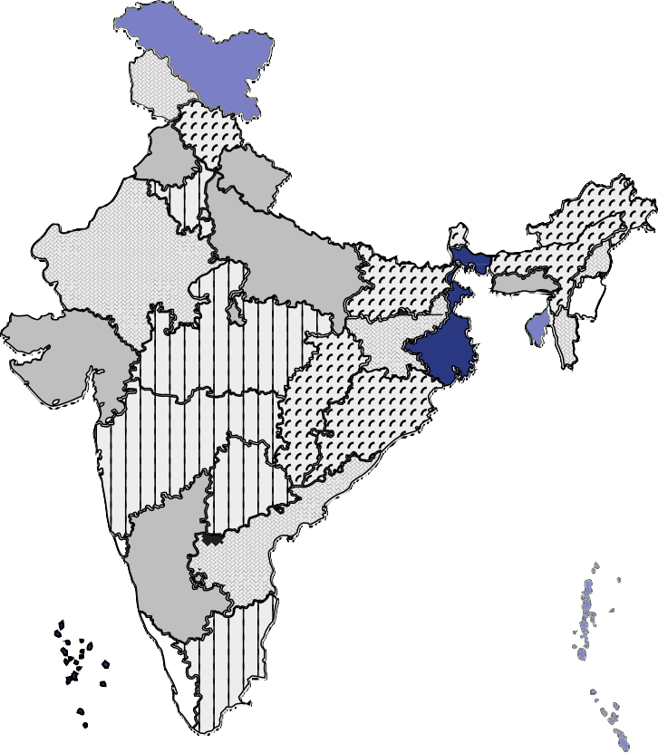
Proportion of Teachers in Government Schools Employment

Source: Authors, based on data from UDISE+ 2021-22

Between 100% and 80% in government schools
80-70% in government schools 70-60% in government schools 60-50% in government schools 50-40% in government schools
40%-30% in government schools 30%-20% in government schools

Source: SOTTTER 23 survey and analysis of PLFS 2021-22
40% of teachers currently working in government schools reported to have been working as teacher prior to recruitment into government service most likely in private schools. The wait time between acquiring professional qualification and securing a government job for those who succeeded was approximately 7 years. Between their first employment and securing a government job, the average wait time was 2.74 years.
Box 3: Wait time to secure a (government) teaching job

19

CETE (2023)

In all areas of Basic amenities of service conditions there has been improvement between 2018-19 and 2021-22, (Figure 6). However, a persisting area of concern is that only 63% schools (58% in Rural areas) report having all classrooms in good condition. 72% schools report having ramps: 83% government schools and only 49% private schools.

Availability of ICT provisioning improvements are marginally better (5% to 5.52%). Availability of internet has improved (19% to 34%.). Classrooms conditions have dipped slightly (65% to 63%), and markedly lower visits by academic supervisors (73% to 58%).

Figure 6
Changes in Basic Amenities from 2018-19 to 2021-22
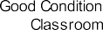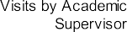

Source: Authors based on data from UDISE+ 2018-19 and 2021-22

Of the schools covered in the SOTTTER-23 survey, 91% of private schools (80% rural and 100% urban) and 87% government schools (86% rural and 87% urban) functioned in pucca buildings. 98% private schools and 95% government schools had clean premises. 96% private schools and 87% government schools were located in areas which were clean. 86% private schools and 77% government schools had boundary walls. Only 46% of private schools and 33% of government schools visited had functional toilets for their staff.

More staff support was available in private schools including Librarians, Computer Lab Assistants and Clerical and Cleaning staff. The government schools have the lowest proportion of non-teaching staff, except the cooking staff (Table 17).

Both government and private schools had limited teaching learning resources (25%), while more private schools had libraries (44% vs 35%) and Computer labs (46% vs 28%). 76% of private school vs 38% government schools reported having internet access in the school.
Table 17
Infrastructure and Working Conditions of Teachers

 | Government | Private
Playground | 40% | 36%
Library | 35% | 44%
Librarian | 8% | 39%
Computer Lab | 28% | 46%
Computer Lab Assistant | 10% | 52%
Internet Access | 38% | 76%
Staff Room | 38% | 53%
Functional Toilet for Staff | 33% | 46%
Teaching Learning Materials | 26% | 25%
Staff for clerical work | 20% | 67%
Cleaning staff | 39% | 86%
CCTV installed in school | 38% | 56%
Source: SOTTTER-23 Primary Data

20

The Right Teacher for Every Child

Professional work conditions
In general PTRs in private schools were more favourable at 21:1 while in government schools the average PTR as 31:1. In terms of workload of teaching, and responsibilities for cultural activities, etc. (Table 18), private and govt. school teachers reported similar views. A larger proportion of government schools had multigrade classes
(38% vs 19%) and reported that higher PTRs were a problem (23% vs 10%). They reported having problems with student attendance (33% vs 18%). A higher percentage of private schools reported having difficulties with slow learners (41% vs 27%). The average periods per
week taught by government and private school teachers was almost the same at 28 for private and 27 for government (Figure 8). Government school teachers reported having an average of 7 substitution periods per week, in comparison to an average of 5 for private school teachers (Figure 7). With regards responsibilities for co-curricular and other activities, government and private school teachers both reported having responsibility for PT (32% govt, 29% private) and for cultural events (59%
Govt, 59% Pvt).

With regards administrative responsibilities, close to 40% government teachers as opposed to about 18-20% private school teachers felt they have a high workload: (maintaining data: 49% govt.,38% pvt; mid-day meal/nutrition: 30% govt, 8% pvt; other responsibilities: 40% govt, 30% pvt). 59% of private schools reported problems with fee collection.
Figure 7

Table 18
Proportion of schools reporting teaching learning conditions

Teaching learning Conditions | Govt. | Pvt.
Multigraded classrooms | 38% | 19%
High PTR | 23% | 10%
PTR | 31:1 | 21:1
Motivating slow learners | 27% | 41%
Unsupportive Parents | 41% | 27%
Student attendance issues | 33% | 18%
student lack of motivation | 20% | 18%
Retaining teaching a problem | 15% | 22%
Fee collection is a problem | 6% | 59%
Shrinking enrolment | 20% | 21%
Lack of Teacher motivation | 22% | 28%
Lack of student motivation | 41% | 30%
Problem of student attendance | 45% | 28%
Parental illiteracy | 62% | 44%
Source: SOTTTER-23 Primary Data

Average number of substitution periods per week

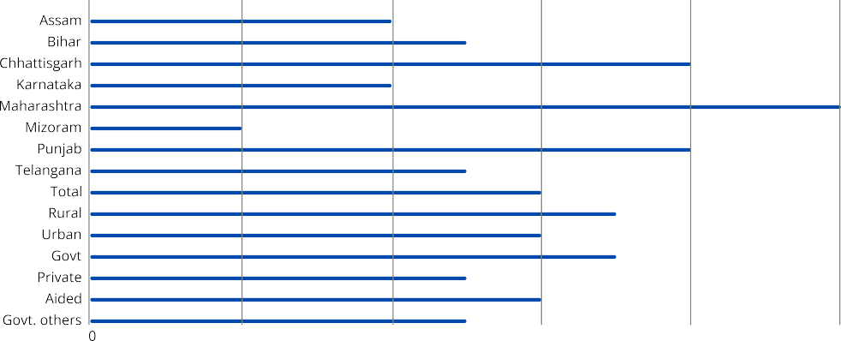10
4
5
8
4
2
8
5
6
7
6
7
5
6
5

Figure 8
Average number of periods taught per week

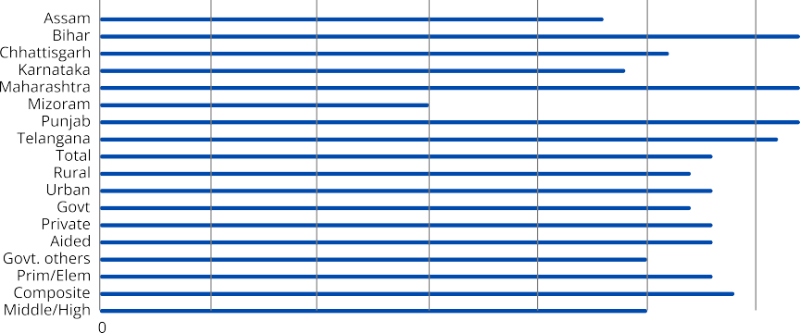32
23
26
24
15
31
27

27
25
28
28
28
28

28
25
29

32

32

Source: SOTTTER 2023 Survey

21

CETE (2023)

Professional agency, collegiality and work-life balance

About 40% of private and government school teachers strongly agreed with the statement that they had control over their lesson planning. Between 68% and 70% felt they were often supported by
their school heads and colleagues at work. 60% of government school teachers and 52% of private school teachers felt they received support from SMC and parents. 82% of government schools and 63% of private schools said they had been visited by Government Education Department officials after COVID pandemic (Table 19).

Private and government school teachers were similar in terms of experiencing stress in their work (24% and 25%). About 17-19% in both groups felt their job impacted on their mental and physical health negatively. About 24-26% felt they had too many lessons to teach, about 22-25%
felt they had too much correction work. 44% government and 18% private school teachers felt they had too much administrative work. 15% government and 18% private school teachers reported feeling intimidated by their students.

Private school teachers mostly lived closer to their schools and travelled between 14 minutes (Mizoram) and 25 minutes (Assam) to reach their
Table 19
Proportion of Schools Reporting Visits by Educational Officials

Sr |  | Govt. | Pvt.
Sr | N 240 107
1 | Visits by Education officials
 | NI | 9% | 10%
 | Never | 6% | 11%
 | More than 4 years ago | 0% | 3%
 | 2 to 3 years ago | 3% | 13%
 | 1-2 years | 2% | 8%
 | Last year | 56% | 33%
 | 6 months | 24% | 21%
2 | Having a PTA/SMC | 90% | 76%
3 | Have teachers issues come up in the PTA/SMC (Yes) | 59% | 1%
4 | Installation of CCTV (Yes) | 38% | 56%
Source: SOTTTER 2023 Survey

schools. In comparison, most government school teachers travelled about half an hour or more to reach their schools. 28% government school teachers and 25% private school teachers felt stressed by the amount of travel they needed to do.

40% private school teachers and 23% government school teachers felt they were not paid well. 20% of private school teachers and 7% of government school teachers said they had lost their job during COVID. 85% government school teachers and 52% private school teachers said they did not suffer any pay cut during COVID.

38% of government teachers and 25% of private school teachers said they were part of teacher networks–i.e. mostly professional groups. 38% of government school teachers and 12% of private school teachers were part of teacher unions.

Employment terms17

According to the PLFS 2021-22, about 24% of teachers working in government ECCE centres and primary and secondary schools and more than 50% of teachers in private/non-government schools report
that they are working without written contracts. Only about 6% to 24% of teachers in private schools report having written contracts of duration three years or more. The proportion of women with no written contracts in government schools is higher than that of men: 30% vs 24% in ECCE, 32% vs 19% Primary teachers and 28% vs 21% secondary school teachers. In the private sector the proportions are almost the same for men and women without any written contract. However, in the case of ‘having written contract for three years or more’, the proportion is only 21% women vs 30% men.

In case of younger teachers, a large proportion of ECCE young teachers have no contract (43.24%), a larger proportion of young women teachers in private sector schools report having no written contracts (50%primary and 64% secondary). This is indicative of vulnerabilities and casualisation of employment of younger women in the private sector.

Private school teachers in all sectors receive lower salaries: ECCE teachers: 66% lower than government
teachers’ salary (INR 7,665 vs INR 11,394); Primary teachers: 36% lower than government teachers’ salary (INR

- This section is based on PLFS 2021-22 data analysis, reported in SOTTTER Background Paper No.2
11,086 vs INR 31,225) and Secondary teachers: 35% of government teachers’ salary (INR 13,412 vs INR 38,282) (Table 20).

Teachers with no written contract receive the lowest salaries. In the case of private school employment, it is about 50-60% lower than a private teacher with a contract of three years or more. In the case of government employment, this is about 75% lower than the salary of a government teacher with contract of more than 3 years.
Private school primary and secondary teachers earned about 35% the salary of government teachers, long contract private school teachers earned about 45- 50% the salary of a government teacher.

22

The Right Teacher for Every Child

Comparable salaries were earned by men and women in private secondary schools. Women earned between 75-85% of the salaries of men in government primary and secondary schools–this may be an indication of the overall younger women workforce in government schools, bringing the overall average salary down for women.

Women in private sector employment earn proportionately lower compared to men in the private sector. There is less gender difference in pay seen in teachers below 30 years (Table 20). Also, young women and men in private sector employment are the least paid, earning only between 35 and 40% of their government counterparts. Secondary school women teachers in rural non-government employment earn about 64% lesser salary of their government counterparts. Non-government rural
to urban teachers mean wage is comparable (Primary teacher) or slightly lower (Early Childhood and General Secondary and physical education teachers) (Table 21).

In general, the average wages do increase with the age of the teacher. Private school teachers’ starting salaries are lower and the increase is about INR 1700 every 5 years. The increase in case of government primary and secondary teachers is steady at about INR 4000 every 5 years. However, salaries of ECCE teachers remain fairly flat throughout their career. Average starting salaries in the sector for teachers less than 25 years entering into the profession are low at about INR 10,000 to INR 15,000.

Table 20  Monthly salary comparisons based on contract type, between government and private, gender and sector-wise | ECCE teacher |  | Primary teacher |  | Secondary teacher
 | Govt. | Pvt/ NonGovt. | Govt. | Pvt/ NonGovt. | Govt. | Pvt/ NonGovt.
Overall
Average salary received by a teacher (in INR)(*) | 11,394 | 7,665 | 31,255 | 11,086 | 38,282 | 13,412
Average salary received by regular (govt)/ teacher with contract>3yr (Pvt) | 12,594 | 11,627 | 34,100 | 19,072 | 41,494 | 22,168
Proportion of the salary of regular/3 year contract teacher received by teachers with out contract | 80% | 67% | 75% | 52% | 77% | 60%
Proportion of salary of govt school teacher received by pvt school teacher both with contracts>3 yrs |  | 92% |  | 56% |  | 53%
Proportion of govt teacher salary received by pvt school teacher |  | 67% |  | 35% |  | 35%
Women
Proportion of salary of govt school teacher received by pvt school teacher both with contracts>3 yrs |  | 96% |  | 46% |  | 53%
Proportion of govt teacher salary received by pvt school teacher |  | 80% |  | 34% |  | 36%
Proportion of male teacher salary received by woman | 21% | 44% | 77% | 61% | 88% | 91%
Men
Proportion of salary of govt school teacher received by pvt school teacher both with contracts>3 yrs |  | 79% |  | 70% |  | 55%
Proportion of govt teacher salary received by pvt school teacher |  | 39% |  | 43% |  | 35%
Women < 30 years
Proportion of salary of govt school teacher received by pvt school teacher both with contracts>3 yrs |  | 247% |  | 112% |  | 73%
Proportion of govt teacher salary received by pvt school teacher |  | 91% |  | 33% |  | 42%
Proportion of male teacher salary received by woman | 84% | 68% | 92% | 67% | 76% | 98%
Men < 30 years
Proportion of salary of govt school teacher received by pvt school teacher both with contracts>3 yrs |  |  |  | 94% |  | 57%
Proportion of govt teacher salary received by pvt school teacher |  | 89% |  | 46% |  | 33%
Note: (*) Salaries reported are averages. Maximum salaries of government teachers in PLFS was INR 1,10,000 (primary) and INR 1,43,000 (secondary). About 12% government primary teachers and 24% government secondary teachers PLFS sample receive more than INR 50,000 (most about 50 years age group).
Source: Authors analysis based on PLFS 2021-22

23

CETE (2023)

Table 21
Rural-Urban Differential wages between women and men, and government, non-government teachers
 | Early Childhood Education | Primary School | General Secondary School | Small Sample
 |  |  |  | Special Education | Vocational Education (sec) | Physical Education | Music, Art, Drama
Average rural government teacher wage (in INR) | 8,139 | 27,680 | 35,700 | 41,736 | 11,066 | 39,949 | ss
Average urban government teacher wage (in INR) | 14,181 | 38,681 | 43,344 | 21,281 | 33,622 | 36,210 | ss
Rural: non government teachers' wage as proportion of government teacher wage | 106% | 52% | 43% | 11% | 59% | 34% | -
Rural: women non government teachers' wage as proportion of government teacher wage | 100% | 45% | 64% | 12% | ss | ss | -
Urban: non government teachers' wage as proportion of government teacher wage | 70% | 39% | 45% | 79% | 104% | 47% | -
Non government rural teachers' wage as proportion of urban teachers wage | 86% | 96% | 79% | 26% | 19% | 80% | -
ss: Very small sample hence not reported
Source: Authors analysis based on PLFS 2021-22

Between 57% and 52% of those employed in non-government/private sector are not eligible for any benefits (Table 22). Only 12% primary teachers and 16% secondary school teachers in private/non- government teaching jobs receive full benefits of pension, PF, gratuity, health and maternity leave. These are the best paid among private school teachers, reporting salaries between INR 30,000 and 33,000 which is about 70-77% of the salary of government school teachers. About 22-25% of private sector jobs pay is reasonably comparable with the pay (about 60-70%) and benefits of government teachers. An additional 13 to 14% of private school primary and secondary teachers receive some benefits; PF, gratuity etc.

In comparison, between 55% to 63% of government primary and secondary school teachers receive all benefits of pension, PF, gratuity, health care and maternity benefits in full. An additional 25% receive some of possible benefits.

A small proportion of ECCE teacher (approximately 40%) receives all or some benefits in addition to their salary. Within the government sector, 61% primary teachers and 70% secondary teachers report receiving health-related benefits. Only 27% of early childhood education workers receive health benefits even though the nature of their work is field intensive and front line involving direct engagement. 49% of ECCE teachers working with the government report not being eligible for any benefits. The proportion of government primary and secondary teachers reporting not being
eligible for any benefits is 15% and 10% respectively. This may be reflective of short-term contractually employed staff working in government schools.

Table 22
Benefits(*) sector-wise, comparing government and private teachers
 | ECCE teacher |  | Primary teacher |  | Secondary teacher
 | Govt. | Pvt/NonGovt. | Govt. | Pvt/NonGovt. | Govt. | Pvt/NonGovt.
No Information | 3.2% | 20% | 4.0% | 16% | 1.5% | 19%
Most/All | 22% | 11% | 55% | 12% | 63% | 16%
Some | 20% | 16% | 25% | 14% | 24% | 13%
Only health & maternity | 5% | 2.5% | 0.6% | 1.2% | 0.7% | 1.0%
Not Eligible | 50% | 51% | 15% | 57% | 10% | 52%
(*) PLFS collects information on a range of benefits: Pension, Provident Fund (PF), gratuity, health benefits, maternity leave.
Source: Authors analysis based on PLFS 2021-22

24

The Right Teacher for Every Child

Regional concerns:
6
Rural regions, the North East

he rural teacher workforce profile is indicative of challenges faced in deploying teacher to work in rural areas. The demographic profile of rural teachers is skewed with a lower proportion of women (only 44% of teachers in rural areas are women). The teaching workforce is also younger (Primary: 38yrs vs 40yrs; secondary: 39yrs vs 42yrs; private: 32yrs vs 36yrs; govt 40yrs
T
vs 44yrs); generally, teachers with less experience are posted in/recruited/available in rural areas. It is likely that older and experienced teachers move to urban areas, as concerns of their personal life requirements become more significant. 69% of all teachers without professional qualifications are in rural schools; 90% of government contractual teachers are working in rural schools. 90% of single
teacher schools are also located in rural areas. High PTRs and low PTRs are also found in rural areas. This suggests the possibility of larger numbers of small schools which nevertheless try to deploy teachers for all classes and subject areas. There may also be schools where there are inadequate teachers–with vacancies remaining unfilled, and unmet teacher requirements. 23% of rural schools have a PTR >35:1. This means they have a teacher requirement. (81% of all schools with PTR >35:1 are in rural areas).

Overall teachers in rural areas are worse off than their urban counterparts in terms of basic amenities (Table 23). They are also worse off in terms of their professional work environment (Table 24).

Details from selected aspirational districts provide a more in-depth understanding of teacher availability and working and professional conditions of teachers.
Most of these districts are found to have a large proportion of rural schools (90% or more), far higher than the state average: Darrang in Assam (96%), Muzaffarpur in Bihar (92%), Bastar in Chhattisgarh (93%), and Nandurbar in Maharashtra (90%). These districts have higher incidence of government single teacher schools compared to the state average: 33% in Bastar, 29% and 28% in Dhubri, Assam, 13% in Firozpur, 19% in
Jayashankar Bhupalapally. They also have lower proportion of women teachers: (between 20-30% below state average).
They have poorer basic amenities, (39% girls’ toilets in Moga, 45% in Jayashankar Bhupalapally). Professional working conditions are generally commensurable with the state levels, except for access to ICT and Internet which is generally lower.

Table 23
Availability of basic amenities in schools

Basic amenities in School | Overall | Rural | Urban
Classrooms in good condition | 63% | 58% | 83%
Availability of ramps | 72% | 74% | 63%
Availability of ramps and handrails | 50% | 51% | 42%
Accessible by roads in all weather conditions | 89% | 88% | 93%
Functional drinking water facilities | 96% | 96% | 97%
Availability of functional boys’ toilets | 91% | 91% | 92%
Availability of functional girls’ toilets | 94% | 94% | 96%
Availability of working electricity | 87% | 85% | 96%
Source: Authors based on data from UDISE+ 2021-22

Table 24
Professional working conditions in schools

Professional working conditions in school | Overall | Rural | Urban
Availability of libraries | 77% | 76% | 81%
Availability of computing devices (laptops or desktops) | 32% | 27% | 55%
Access to internet | 34% | 29% | 58%
Visits by academic supervisors | 58% | 63% | 34%
Source: Authors based on data from UDISE+ 2021-22

25

CETE (2023)

The North East and Himalayan states
The North East States of Assam, Arunachal Pradesh, Nagaland, Manipur, Mizoram, Tripura, Meghalaya and Sikkim, share similar conditions indicative of problems associated with adequate (quality) teacher supply, along with problems of small schools and of deploying teachers in hilly and remote regions.
These States and Himalayan states of Himachal, J&K and Ladakh have low PTRs between 10:1 to about 16:1. They have a higher proportion of teachers without any professional qualification include the North Eastern States of Manipur (24%), Assam (34%), Nagaland (39%), Meghalaya (37%), Tripura (26%) and Sikkim (24%), Jammu Kashmir (23%) and Ladakh (25%), Arunachal Pradesh (15%). A very high proportion of contractual teachers is also noted: (Meghalaya (69%), Arunachal Pradesh (53%), Mizoram (37%), Sikkim (37%) Assam (24%) and Tripura (19%).

Basic Amenities and disability access in these states is far below the national average (Box 4). Professional working conditions are suboptimal in these states. Access to computing devices and internet in schools is low (Mizoram 8%, Assam (12%).

Box 4: Basic Amenities: States of Concern
North Eastern States:
- North Eastern States have lower basic amenities in schools–affecting students and also service conditions for teachers in several aspects:
- Access by Road: Meghalaya 63%; Arunachal Pradesh 72%
- Drinking Water Facilities: Meghalaya 46%; Nagaland 60%; Arunachal Pradesh 68%; Tripura 75%
- Functional Toilets for boys and girls: Arunachal Pradesh 67% & 69%; Meghalaya 73% & 70% Manipur 75% & 75%; Nagaland 76% & 77%; Tripura 72% & 74%; Assam 76% & 82%
- Electricity: Meghalaya 25%; Arunachal Pradesh 53%; Manipur 54%; Tripura 55%; Nagaland 67%
- Good Condition Classroom: Assam 29%; Arunachal Pradesh 31%; Tripura 32%; Meghalaya34%; Nagaland 35%; Manipur 40%; Mizoram 40%; Sikkim 45%
- Disability Access: Arunachal Pradesh 25%; Sikkim 29%; Meghalaya 30%; Nagaland 38%; Mizoram 44%, Manipur 50%; Tripura 63%; Assam 69%
Other states of concern:
- Access by Road: Uttarakhand 63%; Jammu & Kashmir 79%; Jharkhand 76%
- Drinking Water Facilities: Telangana 86%
- Functional Toilets for boys and girls: Telangana 68% & 78%; Jammu & Kashmir 79% & 82%
- Electricity: Jammu & Kashmir 73%; Madhya Pradesh 75%; Odisha 77%; Uttar Pradesh 81%
- Good Condition Classroom: Ladakh 33%; West Bengal 43%; Andaman & Nicobar 47%, Jammu & Kashmir 49%;
- Disability Access: Jammu & Kashmir 39%; Andhra Pradesh 54%; Goa 61%; Uttarakhand 62%; Andaman & Nicobar 63%; Jharkhand & Uttar Pradesh 64%; Puducherry & Rajasthan 65%
Source: Authors based on data from UDISE+ 2021-22

Other state specific concerns
Bihar has a very high state average PTR of 53:1. Bihar and Jharkhand also have a very low proportion of women in the teaching workforce (less than 40%; this is also the case in Rajasthan and Tripura). States with higher levels of teachers without professional qualifications includes Jharkhand (14%), Uttar Pradesh (15%), (15%), Bihar (15%) and Madhya Pradesh (11%). High levels of contract teachers are found in Jharkhand (54%), DNH&DD (47%), Chandigarh (35%) and Uttar Pradesh (25%). States with a
high proportion of single teacher schools include Goa (29%), Arunachal Pradesh (26%), Andhra Pradesh (23%), Uttarakhand (21%), Himachal Pradesh (20%), Jharkhand (19%) and Telangana (18%).

26

The Right Teacher for Every Child

Teacher supply: What is the quality of the supply? Is the supply adequate18?
7

oncerns regarding the quality of teacher education is the subject of recent policy including the National Education Policy, 2020. Poor quality in the sector is widely attributed to the proliferation of self-financed colleges which account of over 93% of pre-service teacher education. Concerns are also expressed regarding quality of teachers, and the policy calls for
C
ways to attract talent into the profession. Based on analysis of Teacher Eligibility Test (TET) data from one State and the SOTTTER 23 survey we examine evidence on teacher supply.

Quality of teacher education institutions
TET data from one state: A19 were analysed to examine the quality of teacher supply and Pre- Service Teacher Education providers of that State. Private self-financed institutions accounted for approximately 90 % of all applicants.

The proportion of candidates qualifying in the TET and their average marks were used as proxies for quality. Students from Government institutions (DIETs, IASEs and CTEs, aided colleges) out-
perform self-financed institutions in terms of proportion of applicants qualifying the TET (Table 25). In the primary teacher TET exam, 59% of candidates from DIETs as opposed to 31% from self-financed institutions qualified in TET. The proportion of qualifying candidates across all social categories was higher by 30% points in DIETs as compared to Self-financed colleges and institutes. In the secondary subject teacher exam, the proportion of students qualifying from IASEs, CTEs and Aided institutions was higher than the proportion of students qualifying from self-financed colleges by 20 % points. (Science and Math: 78% vs 57%; Social Sciences 57% vs 37%).

Table 25
Institution type wise comparison of proportion of successful candidates and performance (mean marks & Standard Deviation)
Rank Order | Primary teacher |  |  | Subject Teachers (TGT)
Rank Order |  |  |  |  | Science/ Mathematics |  | Social Sciences
Rank Order |  | PAQ* | Marks** |  | PAQ | Marks | PAQ | Marks
1 | DIETs | 59% | 86 (12) | IASEs & CTEs | 78% | 88 (11) | 57% | 84 (12)
2 | University Distance TE programmes | 49% | 80 (11) | Aided Institutions | 73% | 86 (10) | 55% | 82 (10)
3 | Aided Institutions | 39% | 79 (11) | University Distance TE programmes | 69% | 88 (12) | 52% | 83 (13)
 | State overall | 32% | 78 (11) | State overall | 58% | 82 (11) | 38% | 78 (11)
4 | Self Financed | 31% | 77 (11) | Self Financed | 57% | 82 (11) | 37% | 78 (11)

- The discussion in this section of the report is based on analysis of TET
data from one state (see SOTTTER-2023
background paper No. 4 for full report).

- The State is anonymised and referred to as ‘A’ The analysis is based on data provided from this state. TET and CTET data offer the possibility of such rigorous analysis and if carried out could provide a comprehensive
pan India picture of
teacher supply, and institutional quality

- For this analysis, the PSTE institution of each candidate was identified
and categorised. Analysis was then carried
out Institution wise, based on total number of
applicants and total number qualifying.

Note: *PAQ - Proportion of applicants qualifying %, ** Mean (standards deviation); Maximum 150.
Source: Authors, based on analysis of SOTTTER-23-TET data-from-State A

In terms of overall institutional quality as reflected in the proportion of applicants from each institution who qualify, DIETs, IASEs, CTEs and government aided and government Universities perform better than self-financed colleges20 (Table 26). In each of the DIETs and CTEs and IASEs, (i.e. all) 50% or more of the applicants passed in the TET. In comparison, for primary school teacher TET, in only 7% of self-financed institutions, more than 50% students passed. The quality of DEd Self financed colleges, programmes and candidates is a concern. In 72% of the self-financed colleges in this sector, only 40% or less candidates appearing for the test passed.

In primary school TET, 59% of students from DIETs and CTEs qualify with a mean score of 86/150 as opposed to 31% from self-financed colleges with a mean score of 77/150.

27

CETE (2023)

In science and mathematics secondary school TET, 78% students from IASE and CTEs and 73% from aided institutions qualify with a mean score of 88/150, as compared with 54% from self-financed colleges, with a mean score of 82/150.
In Social Sciences, 57% of students from IASEs and CTEs and 55% from Aided institutions qualify with a mean score of 84/150, as opposed to 37% students from self-financed colleges, with a mean score of 78/150.

A small but significant proportion of Self-Financed colleges seem to be more effective in enabling their students to qualify in TET, particularly in the BEd
space. The factors that enable these self- financed institutions to succeed where most others fail, can be studied so that regulation and policy on self-financed institutions in the sector can be better informed.

Table 26
Summary of overall performance of institutions

 | Applicants Qualifying
 | More than 50% | More than 60%
Paper 2 (Science and Social Science Teaching)
CTEs and IASEs (approx 5) | 100% | 100%
Self financed (approx 400) | 45% | 13%
Govt aided and govt other (approx 20) | 72%
Paper 1 (Primary School Teaching)
DIETs (approx 10) | 100% | 57%
Self Financed (approx 500) | 7% | 1%
Govt aided and govt other (approx 20) | 60%
Source: Authors, based on SOTTTER-TET-data-from-State A

Performance on TET
Overall quality of teachers with DEd/DElEd professional qualification (i.e. Primary school teaching) and teachers with BEd (Social Science) is low with only 32% and 38% of such professionally qualified graduates passing the TET. The overall quality of science-mathematics teachers is better with 58% of them qualifying the TET. Comparing the overall performance of candidates qualifying in the TET to those who do not qualify, the difference in the mean score is about 15% for Primary school teachers and Social Science teachers, and about 11% for science teachers. In the case of mathematics, the difference is about 17%.

Only a small percentage (approx. 15% of qualifying candidates) secured more than 60% in the test (about 1.5% scores above 70%). Among primary teachers, there seems to be a poor level of
mathematics content knowledge; a large proportion of those qualifying to become teachers do not have adequate mathematics knowledge as reflected in the mean marks of 46% in that component. This is also true in the case of secondary Science-Mathematics teachers (mean marks in mathematics content knowledge 50%). It may be desirable for the test to include a component wise cut off/ qualifying mark, in addition to the overall qualifying mark, to ensure subject competence in qualifying candidates. The difference in performance in regional language proficiency is largest for primary school teachers (20% difference). These low levels of proficiency as measured in this test raises a flag concerning those who are acquiring qualification to teach without having adequate language or mathematics proficiency.

A very large percentage of teachers qualify with between 40 and 50% marks, and this is of concern. Curricular reforms are essential to put into place to ensure that knowledge gaps leading to this poor performance are addressed during preservice. Deploying teachers with poor levels of content and pedagogic knowledge have implications for the system’s ability to address quality education for vulnerable and socially marginalised groups.

Teacher supply
Going by the data of state A, overall supply of teachers by specialisation of school level and subject areas from Pre- Service Teacher Education (PSTE) in State A is uneven (Table 27). The ratio of
supply of Primary teachers to Math Science subject teachers and Social Science Language subject teachers is approximately 10:8:5. There is an even more serious concern of quality considering that a large proportion of those qualifying the TET score 50% or less on the test. There seems to be an undersupply of Social Science and Regional Language teachers in State A.

Table 27
Ratio of teacher supply for different school requirements (level and subject) in State A
 | Primary : Science-Mathematics : Social Science
Teacher supply | 10 : 8 : 5
Quality teacher supply (those who secure > 60% on the TET test) | 10 : 12 : 4.5
Ratio of supply to quality | 10 : 1.6 :: 10: 2.4 :: 10: 1.6
Source: Authors, based on TET Paper 1 and Paper 2 data of a State A

28

The Right Teacher for Every Child

SOTTTER 23 survey collected data on the pedagogy subject choices of 1400 PSTE students21. 31% were pursuing DElEd (or its equivalent) which qualifies them for primary school teaching. 1.5% were enrolled in special education courses, 3% in physical education courses. 1.29% were enrolled in BEd specialising in Music and Art. Close to 60% of the surveyed students were pursuing BEd degrees.

Pedagogic specialisations which were most prominent were mathematics and physics (31%), Social Sciences and Language (31%), followed by Biological Science (18%). 11% were specialising in English Pedagogy and 6% were specialising in Commerce Pedagogy.

Proportion of women enrolled in Biology (overall women 14%, men 7%) and Special Education was more (overall women 2% men 0.4%). Male dominated subject areas were Physical Education (overall men 7%, women 1.4%), followed by BEd Mathematics and Physics pedagogy: (overall men 23% vs women 20%). In BEd Social Science and Language Pedagogy (Overall women 22%, men 16%). Gender balance was seen in English (about 7% each).

- This section is based on data gathered through the SOTTTER-2023 survey in eight states. The full report can be found in SOTTTER-2023 background papers and reports No 6.
- Rehabilitation Council of India 2023. List of Approved
Institutions., List of RCI approved Institutes
(rehabcouncil.nic.in)
- National council for Teacher Education (2022) Annual Report. Annual Report 2021-2022 (ncte.gov.in)
- See footnote 7
Box 5: Status of Teacher Education in Special Education, ECCE, Art and Physical Education
Special Education22: The approved intake for special education is 53087 across DElEd (Spl Ed), BEd (Spl Ed), and MEd (Spl Ed)., with different specialisation in each disability. Rajasthan
institutions have a total intake of 15190 followed by Uttar Pradesh 8371. The North Eastern states have between 70-110 seats each, Jammu & Kashmir has 75, Puducherry has none.
ECCE, Art and Physical Education23: 204 institutions offer NCTE approved Diploma in pre- primary education with a total intake of 11430 seats. 978 institutions offer NCTE approved DPEd., BPEd. and MPEd. in Physical Education, with a total intake of 64,770. There are 18 Institutions offering Diploma in performing arts education and 10 for visual arts education, with a total intake of 1550 seats.
To understand the state of these sectors of teacher education, eight sector experts were interviewed. Their insights are summarised below:
  - Special Education: Earlier special education teacher preparation was mostly in the distance education mode. It is desirable for all Universities to introduce a department of special education. The demand for PSTE in special education has been going up since about 2012, but it continues to have more girls than boys coming in; it seems that now employment opportunities are improving, especially with the CBSE mandating schools to have special educators and the 2021 Supreme Court24 ruling.
  - Art Education: NCF 2005 created a space for art education by recognising it as a curricular area-earlier it was treated as co-curricular. There is no system in place for the preparation of art teachers-only a few diploma courses are being offered; mostly artists work as art educators, but they need to have inputs in pedagogy. In the few programmes that there are, the sector mostly had students from economically weaker sections, but this is now changing. The RTE was misinterpreted that regular teachers need not be appointed for art education and that guest teachers will do; this ended art education in some states as they stopped hiring art teachers. Similar to physical education the sector needs a directorate for art education.
  - Physical Education: A range of courses from certificate and diploma to BEd and also post graduate diploma are being offered. The demand for such courses has gone up considerably in the last decade. In society, perception regarding career in sports has
changed. Earlier the sector drew mainly boys from rural and lower socio economic groups, but now urban youth are also applying. In addition to jobs in private and government schools, there are also opportunities in the fitness industry. Overall in society there is more awareness about the need for physical fitness. Compulsory daily PE must be a part of the curriculum.
  - ECCE: Not much is currently happening in ECCE teacher education: a range of diplomas and certificates from 2 months to a year are available mostly in the private sector.
There is no regulation at all. But overall there is a decline in institutes for training-even Anganwadi training centres and private sector is closing down. The North East and Eastern states have hardly any institutions. Students tend to come from lower socio economic backgrounds, mostly women, as women are preferred for employment as Anganwadi workers which comes under women and child welfare. These jobs have not yet opened
up in the government sector. Private sector schools seem to prefer BEd. ECCE needs professionalisation; a regulatory system needs to be in place, along with specific budgetary allocation to strengthen the sector. If it is integrated in elementary it may get diluted, a separate cadre will be preferable.

Source: SOTTTER 23 interviews with key respondents

29

CETE (2023)

Key observations and recommendations
8

- The availability of teachers with appropriate qualifications in the system in the primary level is inadequate.
Overall only about 46% of teachers teaching in primary grades having the DElEd or BElEd or equivalent qualifications. The scenario in government and aided schools is better, but in private schools only about a fifth of primary school teachers have the right professional qualification.
The private sector prefers to employ BEd graduates. In the light of the recent Hon’ble Supreme court ruling on this matter, these anomalies will need to be addressed through innovative programmes to enable BEd holders wanting to teach in primary schools to receive the appropriate continuous professional development and certification. Similarly teachers with DElEd qualification wanting to teach in higher grades should also have appropriate CPD and certification. BEd with specialisation for primary school teaching should also be available as an option for those looking for a career shift to teaching.

- There are teacher shortages and requirements in subjects such as mathematics, science and English, and higher shortages in physical education, music and art, and special education.
In middle and secondary schools, overall at about 70%, the scenario is reasonably balanced in terms of teachers teaching subjects that they have studied in their undergraduate level.
However in the case of mathematics, in almost half the cases in both government and private schools, teachers who have not studied mathematics in their undergraduate are found
to be teaching this subject. The highest subject requirement reported is for Mathematics, Science and English in government and private schools. Availability of art and music teachers in government schools, and rural schools (government and private) is low, and of physical education teachers is only marginally better. Overall low availability of special education teachers is a concern.
TET data of one state indicates that supply and quality of language teachers and social science teachers is a concern in that State.

- Rural areas and the North Eastern States face teacher shortages along with poorer working conditions for teachers.
Teacher availability and teacher working conditions in rural schools and the North Eastern part of India is a matter of concern. High and low PTRs and higher proportion of Single Teacher School in rural schools are indicative of difficulties being faced in deploying teachers and of small schools. It is also indicative of poor supply of qualified teachers in these regions. Greater decentralisation of teacher management, and incentivising teachers to work in backward and rural areas is required. Innovations and investments in teacher preparation programmes that cater to rural teaching contexts, and strengthening initial teacher education in the North East are also required.

- Gender imbalances are noted with high proportion of male teachers in the sectors of rural government teaching, in tribal welfare schools, in the states of Bihar, Jharkhand, Rajasthan and Tripura and in physical education, and high proportion of women teachers in ECCE, and in private schools. There is noticeable feminisation visible in the younger teacher cohort.
Gender balance of the teaching profession is desirable as ideally the demography of the teaching workforce should reflect the demography of the population. There are very few sectors within teaching which show gender balance.
The overall lower presence of women teachers from SC and ST groups and lack of women teachers for physical education is a concern and specific initiatives especially in the form of scholarships, will be needed to boost their enrolment in programmes.
Overall, a growing feminisation in the teaching profession is noticeable particularly with younger teachers and in teacher supply. This could be on account of a general increase in women entering and completing higher education, as well as cultural perceptions guiding career choices for women in general and married women in particular towards teaching. This situation seems to favour private schools, looking for a workforce willing to work for lower pay and employment conditions. Young unmarried women are willing to work for lower salaries at school near their homes. From the 1980s, policy has favoured employing women in teaching, guided by the belief that for ECCE/Anganwadi work women are better suited, and in order to support girls’ enrolment; yielding positive results. As teaching employment opportunities are growing in the private sector, the wait time for government employment is long, and securing government jobs is unpredictable, there is an indication that teaching is being perceived as
a smaller second income. Feminisation in employment sectors is often related with lower pay scales, lowering of status, and increased casualisation. The sector as a whole (private and

30

The Right Teacher for Every Child

government) needs to offer and sustain robust and attractive employment terms and career options and pathways with adequate remunerative compensation for men and women. The evidence of this will be seen if there is greater gender balance across all sectors and regions.

- The Private Sector is a major employer of teachers. Greater attention needs to be paid to the employment terms of teachers in this sector.
The private school sector is both a significant employer of teachers and is also the sector in which most teachers will find their first employment. (the ratio of government to private sector teachers is currently 10:7). More attention needs to be paid to teachers in this sector. Working conditions of teachers in private schools are equal or better than government schools, with more time available for teaching and less time being devoted to administration as compared to government teachers. However, employment terms are far worse and a source of stress.
High levels of distress during COVID in the form of loss of pay and jobs was reported by private school teachers. More over their concerns are not well represented by Teacher Unions.

- All teachers need to receive health benefits. Employment terms of ECCE workers need to be improved.
A large proportion of even government teachers are not provided with health benefits. This is a concern as school teachers are front line workers and exposed to health hazards routinely. A high proportion of teachers in many contexts are also women. Health and maternity benefits are essential for this workforce.
The absence of regularisation, fair employment terms and health benefits for ECCE teachers is a matter of concern. With recent policy requiring integration of early childhood years into the school system, the role and positioning of ECCE teachers will require review.

- Graduates from state and state funded pre-service teacher education institutions are more likely to clear the TET examination. State and state funded institutions are more effective and efficient than self-financed colleges.
The overall low percentage of candidates qualifying TET is more indicative of the poor state of self-financed teacher education rather than the overall state of the sector. The state must strengthen and extend funding to non-state providers or improve its own preservice teacher education sector or both.

- Quality of DEd/DElEd students is a concern. Subject knowledge in particular knowledge of mathematics must be enhanced during Pre Service Teacher Education.
Special efforts are needed to extend state supported high quality PSTE in the DEd/DElEd space. It is disappointing to see that most of the ITEP programmes announced this year cater to secondary teacher preparation, with only 100 seats for preparatory phase. This is the sector where ITEP could potentially have made most impact. This should be increased with more state supported programmes, including ITEP, but also BEd more innovative programmes to prepare teachers for the preparatory phase.

- The presence of those shifting careers and older aspirants in BEd programmes is significant and growing.
The addition of older and experienced aspirants to the teaching profession should be supported as they bring varied experiences into the space of the school. 2-year and part time BEd programmes for all stages of school and specialisations (special education, physical education, music education, etc.), catering to this group, and to others deciding to enter the profession at later stages of higher education, should be retained.

- There are insufficient institutions preparing teachers for physical education, art education, music education and for special education.
Innovative programmes are required to facilitate teacher professional development for these areas, in collaboration with institutes of performing arts, creative arts, design and music. Strong impetus to regularise school appointments in these sectors of the curriculum are also required, to attract more aspirants to this sector. The supply of teachers able to work with children with special needs and inclusive classrooms is also not adequate. More coordination is required between the NCTE and the RCI to ensure both specialist special educators as well as inclusive teachers are prepared in the system.

- UDISE+ and PLFS are valuable data bases enabling powerful insights to be generated regarding the status of teachers in the system and the teaching workforce.
UDISE data set can be strengthened to enable questions of teacher availability and quality to be analysed. Data must be gathered and provided systematic information on the availability of subject teachers at the school level and map their qualifications (academic and professional) to the level and the subjects, teachers teach. Data on teachers for physical education, art, and
music education (all mandated by the RTE) as well as on special educators (as per the Supreme Court ruling) needs to be gathered systematically. The data field ‘employment terms’ needs better operationalisation and categorisation so that guest teachers and different forms of employment emerging in the state and non-state are captured. The availability of data on early childhood sector needs to be systematically and comprehensively included in UDISE. Better validation of data of private schools needs to be put into place.

31

CETE (2023)

PLFS is unique in providing insights into the teacher workforce. PLFS insights can be strengthened if information on professional qualifications in teaching is added as a data point. Teaching is among the largest regular employment forms available, with high gender relevance. There is also a proliferation of self-financed teacher education colleges catering to hopes to secure government employment. There is likely to be a large qualified unemployed teaching workforce. Hence the value in obtaining this information. Information on disability could be added.

- The Teacher Eligibility Test (TET) being conducted by all states and the centre is an invaluable database to understand the quality and supply of the teacher workforce as well as the quality of institutions.
More systematic information capture, as well as making data available for analyses would greatly strengthen understanding of this sector and provide evidence to guide policy.

32

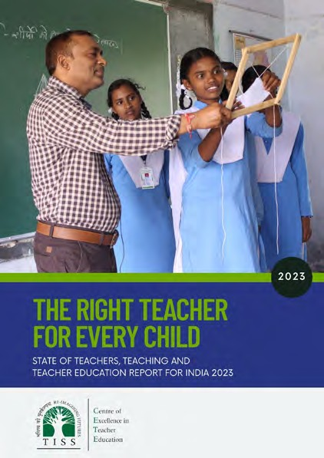State of Teachers Teaching and Teacher Education for India Report

2023

https://bit.ly/SoTTTERbyCETE
The Right Teacher for Every Child
CETE (2023). The Right Teacher for Every Child. State of Teachers Teaching and Teacher Education for India Report 2023. Tata Institute of Social Sciences, Mumbai.
Background papers
- CETE (2023). Teachers in India in 2021-22: The picture from UDISE+. Background paper 1: State of Teachers, Teaching and Teaching Education Report 2023.
- CETE (2023). Teachers in India: A snapshot from the Periodic Labour Force Survey. Background paper 2: State of Teachers, Teaching and Teaching Education Report 2023.
- CETE (2023). Public and Private Sector Contract Teachers in India: An analytical research paper. Background paper 3. State of Teacher, Teaching and Teacher Education Report 2023.
- CETE (2023). Quality of Pre-service Teacher Education and Teacher Supply in India: An analysis of TET data from one state. Background paper 4: State of Teachers, Teaching and Teaching Education Report 2023.
- CETE (2023). Status of teachers in the workforce in eight states: A report based on SOTTTER 23 Survey. Background research report 5: State of Teachers, Teaching and Teaching Education Report 2023.
- CETE (2023). Status of teacher educators and student teachers in eight states: A report based on SOTTTER 23 Survey. Background research report 6: State of Teachers, Teaching and Teaching Education Report 2023.
- CETE (2023). Teacher supply demand: A review of literature. Background paper 7: State of Teachers, Teaching and Teaching Education Report 2023.
- CETE (2023). News coverage in Indian Print Media on Teachers and Teacher Education January-December 2023. Background research report 8: State of Teachers, Teaching and Teaching Education Report 2023.

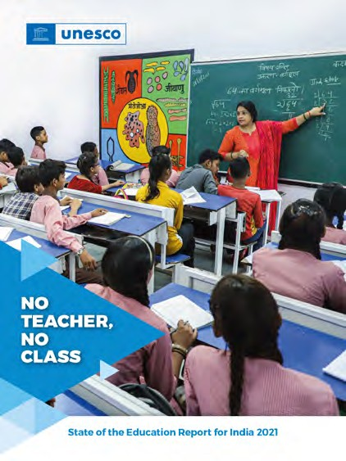2021

No Teacher, No Class
State of the Education Report for India.
UNESCO (2021). No teacher, no class: State of the education report for India. UNESCO: New Delhi. available at https://unesdoc.unesco.org/ark:/48223/ pf0000379115.locale=en

https://bit.ly/NTNC_CETE



Centre for Excellence in Teacher Education
Tata Institute of Social Sciences V.N.Purav Marg, Deonar, Mumbai - 400088, India Phone: +91 - 22- 25525002/3/4

