

Public and Private Sector Contract Teachers in India: An Analytical Research Paper
Background paper 3:
State of Teachers, Teaching and Teaching Education Report 2023
CETE 2023
This paper was commissioned by the UNESCO Teacher Task Force in 2023 as a background paper to the first report on teachers. This paper also serves as the third background paper to the State of Teacher Teaching and Teacher Education Report 2023.
Citation: CETE. (2023). Public and private sector contract teachers in India: An analytical research paper. Background paper 3: State of Teacher, Teaching and Teacher Education Report 2023.
Authors: Padma M. Sarangapani (Lead Author), with Aishwarya Rathish, Arpitha Jayaram, Aditi Desai, Kamlesh Goyal, Jyoti Bawane, Mythili Ramchand, and Anitha Bellappa

Abstract
This paper presents the situation of contract teachers in India, tracing its origins in large scale efforts of expanding elementary education in the 1980s, to present times. The paper examines definitions and changing rationale for the introduction and persistence of contract teacher schemes. It analyses UDISE data to profile the situation in Indian states and union territories and the demographic profile of contract teachers vs regular teachers. Private school contract teachers are profiled using primary data from two states and their characteristics and remuneration and benefits are compared with government teachers. Feminisation and social composition is analyzed. The process of renegotiating unequal terms of employment are noted, evidence of efficacy and challenges of the contractual teachers is examined through secondary literature.
Keywords: contract teachers, India, states, private schools, government schools, employment terms.

Acknowledgements
We gratefully acknowledge the assistance we received from teachers, school heads and department officials of the States of Telangana and Maharashtra. Rashmi Sharma (IAS) and Vimala Ramachandran generously shared insights from their research and experience. Mr. Atul Dayanak, Dr. Rashmi Sukla, Mr. Jatin Goyal, Dr. David, Mr. Manjunath,and Ms. Revathi Reddy and several others, enabled us to understand the details of their respective states and drew our attention to important websites and aspects of their particular contexts. Thanks To Dr. Amita Chudgar, and Dr. Peter Wallet, UNESCO, Teacher Task Force for enabling this study to take place at a time when this team was also engaged with a landscape mapping of teachers and the teaching workforce in India. This paper draws from and contributes to the State of Teachers, Teaching and Teacher Education Report for India currently under preparation at the Centre of Excellence in Teacher Education, Tata Institute of Social Sciences. The team acknowledges the insights and assistance received from the SOTTTER team and field work teams for the field data included in the preparation of this report.


The Centre of Excellence in Teacher Education (https://bit.ly/cetewebsite) is an Independent Centre at the Tata Institute of Social Sciences, Mumbai, established with seed grants from the Pandit Madan Mohan Malaviya National Mission on Teachers and Teaching, Government of India, and the Tata Trusts, and with the Tata Trusts as founding partner. The Centre's overarching focus and agenda is innovation and improvement in teacher education, school and higher education pedagogy and curriculum, and is aligned with the United Nation's Sustainable Development Goal 4: "to ensure inclusive and equitable quality education and promote lifelong learning opportunities for all", and Goal 4c in particular "by 2030 to substantially increase the supply of qualified teachers" The Centre envisages its role as a catalyst for transformation in teacher education through academic programmes, field action programmes, research, collaborations, and advocacy. The State of Teachers Teaching and Teacher Education is a Biennial State of the Sector Report produced by CETE.


State of Teachers Teaching and Teacher Education for India Report
Background Papers
- CETE (2023). Teachers in India in 2021-22: The picture from UDISE+. Background paper 1: State of Teachers, Teaching and Teaching Education Report 2023.
- CETE (2023). Teachers in India: A snapshot from the Periodic Labour Force Survey. Background paper 2: State of Teachers, Teaching and Teaching Education Report 2023.
- CETE (2023). Public and private sector contract teachers in India: An analytical research paper. Background paper 3. State of Teacher, Teaching and Teacher Education Report 2023.
- CETE (2023). Quality of pre-service teacher education and teacher supply in India: An analysis of TET data from one state. Background paper 4: State of Teachers, Teaching and Teaching Education Report 2023.
- CETE (2023). Status of teachers in the workforce in eight states: A report based on SOTTTER 23 Survey. Background research report 5: State of Teachers, Teaching and Teaching Education Report 2023.
- CETE (2023). Status of teacher educators and student teachers in eight states: A report based on SOTTTER 23 Survey. Background research report 6: State of Teachers, Teaching and Teaching Education Report 2023.
- CETE (2023). Teacher supply demand: A review of literature. Background paper 7: State of Teachers, Teaching and Teaching Education Report 2023.
- CETE (2023). News coverage in Indian print media on teachers and teacher education January-December 2023. Background research report 8: State of Teachers, Teaching and Teaching Education Report 2023.
https://bit.ly/SoTTTER-by-CETE



This document is released under a Creative Commons Attribution-ShareAlike 4.0 International licence. Download Here: https://bit.ly/SoTTTER-by-CETE
Any questions, suggestions or queries may be sent to us at: chair.cete@tiss.edu

Contents

Abstract 1
Acknowledgements 1
Contents 2
List of tables and figures 3
Abbreviations 3
1. Introduction 4
2. Emergence of contract teachers 6
3. Definitions in the literature 7
3.1 Regular and contract teachers 7
3.2 Part time and guest teacher 9
3.3 Private school teachers 10
4. Context in India and government rationale for contract teachers 11
5. Government contract teachers: National and State status and trends as per UDISE 2021-22 13
5.1 Extent of government contract teachers in 2021-22 13
5.2 Rurality and single teacher schools 15
5.3 Districts with high proportion of contract teachers 15
5.4 Feminisation 16
5.5 Professional qualification 17
5.6 Levels of contract teachers and fiscal considerations in States 17
5.7 Changes between 2013-14 and 2021-22 18
6. Recruitment Norms and terms of employment 22
6.1 Recruitment qualifications for contract teachers 22
6.2 Terms and employment pathways 25
6.3 Short term appointments against teacher vacancies 26
7. Contract teachers in government aided schools 29
8. Trends in the private sector 30
8.1 From UDISE+ 31
8.2 From literature 32
Analysis of primary data from Maharashtra and Telangana 33
8.3 Sample 33
8.4 Characteristics of teachers 33
8.5 Educational levels 36
8.6 Wages and sources of livelihood compared (Table 8.8) 38
9. Social dialogue 38
10. Claims and counterclaims 41
11. Conclusions and recommendations 42
References 44

List of Tables
Table 1.1 Total schools and teaching workforce by management type and in rural areas
Table 1.2 Overall proportion of teachers employed in different types of school managements
Table 3.1 Comparison of key regular vs contractual appointments of teachers
Table 4.1 Key phases of policy and landscape
Table 5.1 States ranked by extent of contractual teachers in government employment as per UDISE+
Table 5.2 Districts with high proportion of contract teachers
Table 5.3 Proportion of women and male teaches in government and government aided schools
Table 5.4 Changes in extent of government contract teachers between 2013-14 and 2021-22
Table 6.1 Recruitment and employment terms in selected states
Table 6.2 State/UT wise sanctioned position and vacant posts for primary government school teachers
during 2018-19
Table 7.1 Proportion of contract teachers in aided schools for select states
Table 8.1 Proportion of the teacher workforce in private schools
Table 8.2 Proportion of women in government vs private unaided school workforce
Table 8.3 States that have least and most feminized private school workforce
Table 8.4 Sample of schools and teachers who responded to the survey
Table 8.5 Contract vs regular in private and government schools by gender, social category and age
Table 8.6 Private and government school teachers by gender, age and duration of contract
Table 8.7 Education of teachers from private and government schools
Table 8.8 Wages and sources of livelihood of teachers from private and government schools

List of Figures
Figure 5.1 Scatter plot of state % allocation of budget to education (2022-23) and % of government
contract teachers (2021-22)
Figure 5.2 State wise changes in extent of contractual teacher in government teacher workforce

Abbreviations
CTE College for Teacher Education
DDNHD Daman Diu Nagar Haveli Dadra (Union territory)
D.El.Ed Diploma in Elementary Education
DIET District Institutes of Education and Training
DISE District Information System for Education
DPEP District Primary Education Project
EGS Education Guarantee Scheme
INR Indian Rupee
NCTE National Council of Teacher Education
NEP National EducationPolicy
NPE National Policy on Education
PF Provident Fund
PLFS Periodic Labour Force Survey
RTE Right to Education Act
SDMC School Development and Monitoring Committee
SOTTTER State of Teachers, Teaching and TEacher Education Report (for India)
SSA Sarva Shiksha Abhiyan
TET Teacher Eligibility Test
UDISE+ Unified District Information System for Education plus
UEE Universal Elementary Education
UNDP United Nations Development Programme

Introduction
Education has by and large been a state subject in the Federal organization and division of sectors. Education was included on the concurrent list in 1976 enabling the Central government to also legislate it; however, matters of school education and teacher appointments have traditionally been and continue to be largely state subjects governed by State government policy and budgets. There were interstate variations seen on teacher qualifications and recruitment methods and policies–largely a result of historical development of the sector both pre-independence and post-independence. In addition to government schools run by the Commissioners of Public Instruction (Department of Education) in a given state, there are also schools that are privately managed but receiving government aid (for teacher salaries)-commonly called aided schools, private self financed schools (which may receive some state subsidies for land, and taxes), Madarsa schools run by Islamic communities, and schools run by societies set up the Central or State government such as tribal welfare, Army, Railway, Navodaya residential schools and ‘Kendriya Vidyalayas, etc (government other). Since 2011, the Unified District Information System for Education plus (UDISE+, earlier called DISE) maintains school wise information of all schools in the country. Table 1.1 provides an overview of the types of schools classified by management type, and proportion of schools located in rural areas.

Table 1.1 Total schools and teaching workforce by management type and in rural areas
School type (*) |  | Total | %  of school type | %  share of enrolment | %  schools in rural areas | %  share of all rural schools | Teaching workforce | % share
Government | Total | 978,290 | 66% | 52% |  |  | 4,681,968 | 49%
Government | Rural | 899,748 |  | 85% | 92% | 73% | 4,000,478 | 85%
Government (other) | Total | 44,096 | 3% | 2% |  |  | 200,478 | 2%
Government (other) | Rural | 40,822 |  | 75% | 93% | 3% | 151,807 | 76%
Government Aided | Total | 82,480 | 6% | 10% |  |  | 796,631 | 8%
Government Aided | Rural | 55,411 |  | 54% | 67% | 4% | 459,565 | 58%
Private | Total | 335,844 | 23% | 33% |  |  | 3,540,647 | 37%
Private | Rural | 203,852 |  | 51%2 | 61% | 17% | 1,848,924 | 52%
Madrasas (recognized) | Total | 19,965 | 1% | 1% |  |  | 94,277 | 1%
Madrasas (recognized) | Rural | 13,391 |  | 72%8 | 67% | 1% | 63,528 | 67%
Unrecognized | Total | 28,440 | 2% | 1.5% |  |  | 193,122 | 2%
Unrecognized | Rural | 21,564 |  | 72%9 | 76% | 2% | 139,534 | 72%
Total | Total | 1,489,115 |  | 265,235,830 |  |  | 9,507,123
Total | Rural | 1,234,788 |  | 184,886,952 | 83% |  | 6,663,836 | 70%
 |  |  | 100% |  |  | 100%
Source: Analysis authors based on UDISE+ 21/22;
Note: *Government : Department of Education, Local Body and Other State Govt. Managed
Government (other): Tribal Welfare Department, Minority Affairs Department, Social Welfare Department, Ministry of Labour, Kendriya Vidyalaya, Jawahar Navodaya Vidyalaya, Sainik School, Railway School, Central Tibetan School and Other Central Govt./PSU Schools.
Government Aided, Private, Madrasas (recognized) and Unrecognized schools

Note: ‘Schools’ enumerated in table 1.1 and discussed in policy in this report refers almost exclusively to schools with grades I to XII.I. Pre-schools are a part of many private schools, or exist as standalone institutions, but the enrollment and teachers of these pre-school grades, and these institutions (standalone or otherwise) are not included or counted in the table above. The Pre-school sector is (a) not a formal part of the Department of Education, (b) there are no requirements of recognition for this sector (c) the preschool is not covered by the Right to Education (RtE) act (d)There is no systematic data gathered about the preschool sector. The senior secondary grades (XI and XII) are covered and enumerated by UDISE+. Data on other sectors of senior secondary grades such as vocational streams is not maintained and enumerated systematically, as these institutions are also administered by different agencies. Hence the senior secondary is also not the focus of the report. This report focuses primarily on teachers in schools with enrollments from Grade I to Grade XII.

As can be seen, the largest number of schools are government schools (66%; State government managed) followed by private schools (23%). In terms of total enrolment however, government schools account for 52% and private schools account for 33% (see Table 1.1). The large proportion of government schools are therefore small size, with an average enrolment of about 140 and mostly located in rural areas (73%). Government schools tend to be separated into primary, middle and secondary and various combinations of the levels–with primary and secondary schools typically managed by different bodies/directorates of government. In comparison only 17% of Private schools are in rural areas. Private schools tend to be mostly composite (i.e. going from pre-school to grade X or XII), with an average school enrolment size of 263.

The total teaching workforce is 9,507,123 out of which 49% are in government schools and 37% are in private unaided schools, with 8% in aided schools (for ratio, see Table 1.2). 85% of the government school teacher workforce is in rural areas in comparison with 52% of the Private school teacher workforce and 58% of the aided school workforce. The private unaided sector is therefore significant as an employer of teachers.

Table 1.2 Overall ratios of teachers employed in different types of school managements compared to government teachers
Government | Private unaided | Government aided | Others
10 : | 7.6 : | 1.7 : | 1
Source: Authors based on data from UDISE 2021-22, CETE 2023.

A radical growth of access to schooling, with a view to achieve Universal Elementary Education (UEE) was undertaken after the National Policy on Education 1986 (NPE-1986), which called for expanded access and inclusion through multiple means including opening of new schools and state support for the development of non-formal education to be run by State and non state partners, to be supported by District Institutes of Education and Training (DIET). This indigenous model of expansion of access to education received further support and expansion to many more states in the 1980s, when the Central government became involved in channelising multilateral international funding to state governments, beginning with projects such as Andhra Pradesh Primary Education Project (1989-96), Bihar Education Project, Lok Jumbish (1992-2003), and the District Primary Education Project (DPEP-1994-2001(approx), in seven states), and United Nations Development Programme(UNDP) supported Mahila Samakhya–targeting girls and rural areas. This process was expanded to all states and all districts, when the Sarva Siksha Abhiyan (SSA) was launched in 2001-02 with multilateral funding. These central government projects were run on ‘mission mode’ through separate societies set up for this purpose. These societies, headed by officers from the Indian Administrative Service (IAS), were outside the Education Departments of the States, and constituted a ‘parallel body’ from State to District, to Block and Cluster (see Sarangapani and Vasavi, 2003). Following the NPE ‘86 norm that there must be a primary school within 1 km distance of any child’s habitation, where necessary, additional ‘schools’ were added. This resulted in massive expansion of ‘schools’; alongside, guidelines also required that every school must have at least one woman teacher, with a view to engender greater enrolment of girls into school (see UNESCO 2021:36). The Right to Education Act (henceforth RtE) 2009, brought in focus on requisite school infrastructure, maintaining teacher pupil ratios at 1:30 in primary grades and 1:35 in middle school grades, ensuring teacher specialization requirements are met at the school level, and mandating teacher qualifications for all elementary schools between grades 1 and 8. Since 2018-19 the UDISE system which was established in about 2009 is maintained by the Government of India as UDISE+ with comprehensive annual data on all schools, under all types of managements, with information on enrolment, infrastructure and teachers.

Emergence of Contract Teachers
The emergence of ‘contract’ teachers within the Government schooling system in India can be traced to the period of the National Education Policy 1986, followed by the early international aid supported large scale programmes of the 1980s which sought to extend access to schooling, beginning with Siksha Karmi (funded by SIDA) in the State of Rajasthan. Siksha Karmi was inspired by the work of Tilonia to increase access to education employing local youth and sought to replicate this model by involving local community youth to work in non-formal education centers (Ramchandran, personal communication). The model focussed on community mobilization involving community teacher volunteer, to provide access to areas of Rajasthan where government appointed teachers were not available or unwilling to work, given the remoteness of these locations. The ‘non-formal education’ model which had NPE 1986 sanctioned, introduced such volunteers as a cost effective way to provide access in difficult to serve remote areas of underdeveloped states. The model worked outside the formal system and was administered by an independent society set up for this purpose (GONGO). The success of Siksha Karmi in the non formal sector inspired its adoption in the formal education system, beginning with Himachal Pradesh and spreading to Madhya Pradesh, where ‘volunteer teachers’ who were paid low stipends were appointed to run centers names variously as ‘Education Guarantee Schools’ etc., to spread education and provide a school within one-kilometer radius of each child, in a bid to universalise elementary education.

Earlier referred to in the literature as ‘para teachers’ (see for example Govinda and Josephine, 2005), akin to paramedics, and signaling personnel with lower qualification and competence to address localized and basic level of service provision, ‘para-teachers’ employed in the Lok Jumbish programme of Rajasthan had qualifications as low as class V pass, in comparison to a primary school teacher of the state at this time who was expected to have completed grade XII and also acquired a professional qualifications of 1 or two year length. Known variously as Siksha Karmi (in Rajasthan, Orissa, Himachal Pradesh), and guruji (Madhya Pradesh), Vidya Volunteer (Andhra Pradesh), employing teachers on short contracts at lower salaries than ‘regular’ teachers came to be a standard feature of the Centrally sponsored schemes: Mahila Samakhya (started in 1988, soon after the NPE 1986), District Primary Education Project (1994-2001) and Sarva Siksha Abhiyan (2001-2010) and adopted and used widely in several states in India.

Definitions in the Literature

3.1 Regular and contract teachers
- Para teacher: “teachers recruited by the community (though not always) on a contractual basis and on a fixed honorarium to meet the demand of basic education” (Pandey, 2006)
- “Teachers on ‘short-term’ contracts on low salaries, with no service benefits or job security, who are used to fill positions that should be filled by personnel (teachers) in standard and long-term employment” (Ramachandran et al 2020:9).
- Contract teachers’ as an umbrella term, including volunteers, parents, community members, student teachers, recent trainees fulfilling national services obligations, expatriate teachers, retired teachers (Chudgar, 2017).
- “Appointed on contract and/or on terms and conditions which are different from the regular cadre of teachers in the state" (National Council for Applied Economic Research, 2008).
- A teacher who is on a fixed-term rather than a permanent contract. We further define a contract teacher as a government employee, rather than a community-paid teacher (Kingdon at al, 2013:8).
- “Contract teachers have renewable contracts and do not have professional training unlike regular teachers. Their salaries are generally a fraction of the salary of regular teachers who are civil servants. They are given performance-based contracts.” (Goyal and Pandey, 2011: 2).
As suggested in the literature, features defining ‘contract teachers’ includes (i) the contractual and short, fixed term nature of appointment, (ii) appointment not by the state recruitment body, but by a ‘local’ body, (iii) having low salary and (iv) having limited or no benefits.
The category of ‘Contract Teacher’ in the government school education sector, can be best understood with reference to the category ‘Regular Teacher’ (see Table 3.1).

‘Regular’ teachers are those whose employment is as per the cadre created, financed and administered by the respective state department of personnel (state subordinate and ministerial services), for the respective board of school education/commissioner of public instruction for employment as teacher in government schools of the State, based on approvals of the finance department/commissions of the state. These are ‘permanent’ positions in the sense that after recruitment, the person continues in the position until retirement unless dismissed earlier for various reasons. The terms of such ‘regular’ positions are governed by the prevalent state service and pay commissions which oversee matters such as pay fixation, annual increments, leave, health coverage and pension and gratuity. The salaries and pensions of such teachers are part of the recurring budget of the State. They may thus be considered as part of ‘civil services’ of the State. In contrast, 'contract teachers’ are those with a short time period of employment, ranging from a few months to a few years, thus constituting temporary forms of employment. The budgets for such employment may come from the regular teacher salary budget in case the appointments are against a vacancy created in the event of retirement or demise of an existing employee, or from other budgets sources in case such employment is to meet demands of additional teacher requirements, etc. Varied recruitment practices are followed in ‘contract employment’ and the terms of service of such ‘contract teachers’ also vary widely, although by and large people occupying these positions tend to be paid less than regular teachers and also enjoy fewer rights and benefits in comparison with ‘regular teachers’.

Table 3.1 Comparison of key regular vs contractual appointments of teachers
 | Regular | Contractual
Tenure | ‘Tenured’ until retirement or dismissal from service | Short fixed term, ranging from a few months to a few years. Renewable, but renewal is discretionary. (Contract may also be up to age ‘60’ also, as in the case of Bihar, but not counted as government employee; e.g. not eligible for ‘compassionate’ employment of the dependent family member in the government sector in case of the demise of the teacher during tenure.
Cadre | State cadre, and government employee, with recruitment at State or District level, transferable. | Panchayat (village council) cadre with recruitment at District level. Not accepted as ‘government employee’; may/maynot be transferable.
Remuneration and terms fixation authority | Salary fixed as per state pay commission and revised from time to time by pay commission. | Salary fixed by departmental circulars and revised from time to time based on political negotiation.
Benefits | Benefits, leave and retirement pension as defined by the state service commission for civil servants | May have limited or no benefits, limited leave benefits and no retirement benefits. Vacation pay, may/may not be provided.
Ease of revising cadre rules | Governed by cadre rules and service conditions. Cadre is stable, revisions are more difficult and require cabinet approval. | Governed by department circulars and more flexible and ad hoc.
Source: Authors with inputs from Rashmi Sharam Shukla (personal interview, 2023)
When such ‘contract’ staff were first introduced in large numbers into the government school sector they were not referred to as ‘teachers’ but using a variety of other terms such as Shiksha Karmi (Education Worker), Shiksha Mitra (Education Friend), Vidya Volunteer (Andhra Pradesh) which suggested a subsidiary, helper or assistant position. This began in a large scale with the introduction of Siksha Karmis in Lok Jumbish, Rajasthan, and Mahila Samakhya, with eligibility for employment to these positions being lower academic qualifications, no professional qualification than that of a regular teachers, and receiving lower monthly pay, frequently no vacation pay, and having no benefits. However, having the same responsibilities, tasks and working hours of a regular teacher. Following the RTE Act 2009, the minimum qualifications of teachers are fixed. Further salaries, although still lower than ‘regular teachers’ have been revised several times through agitations, strikes and political negotiations by contract teachers, in all states.

3.2 Part time and guest teacher
Two other categories are identified based on UDISE and fieldwork carried out as a part of SOTTTER 23 which are not found in research literature: ‘ part time’ and ‘guest teacher’. A category used in data gathering system in UDISE which is not reflected in the literature is ‘part time’. UDISE requires that teachers’ employment type be identified as ‘regular’, ‘contractual’ or ‘part time’ (UDISE+ Data Capture Form 2020: 12), where part time applies to “ Part-time instructors for Arts, Health and Physical Education positioned as per RTE norms for upper primary section” (p10). The 2021 Data Capture Form includes the term ‘guest teacher’along with part time: parttime/guest teacher in its instructions for filling up s.no 7 for Nature of appointment. ‘Part time’ there fore refers to ‘teaching staff’ of the school, appointed to teach part time–hence not regular; possibly therefore holding a contract, or hired and deployed by an ‘outsourcing agency’ contracted by government, or paid at the school level based on classes taught. UDISE+ intends that this term be used to designate teachers whose requirement is mandated by the Right to Education (GoI , 2009) for subjects of Art, Health and physical education. With reference to vacancies arising on account of retirement or death of staff, which are meant to be filled through recruitment, State governments permit teachers to be engaged to meet the teaching work load requirement. These are meant to be short term forms of employment. The qualifications of such teachers is equivalent to that of teachers except that they may not be required to have qualified the Teacher Eligibility Test (TET). These teachers are referred to as ‘Guest Teachers’, and may be recruited directly by the school (e.g. Karnataka), or through a state system (e.g. in Madhya Pradesh) or through an ‘outsourcing agency’ contracted by government (e.g. in Bihar) (and hence employees of the agency and not the state or the school). Frequently these are teachers on very low salaries, and may be paid on a ‘per class’ basis, as is the practice in tertiary education, where faculty may be engaged to teach and be paid on a per class basis. Little is known about this group of teachers and there is limited and no systematic knowledge about the extent of their presence in the government school systems of states.
Admittedly when vacancies arise on account of teachers being transferred or delays in posting, or retiring or their demise, schools needs ways of addressing teacher requirements as stop gap measures until recruitment and deployment is managed. ‘Guest teachers’ are meant to be flexible short term teaching staff for schools. Such ‘guest teachers’ are also found in schools run by the tribal and social welfare departments. They are supposed to be temporary ways filling vacancies until recruitment is made possible. However in effect, they seem to persist and continue for several years, extending upto even a decade for various state and local specific reasons. The numbers of such teachers in the system at any given point of time, may also fairly large, constituting upto 10% of teachers. Arguably, as is seen and discussed n the case of faculty in the tertiary education space, ‘guest’ and ‘ part time’ teachers are indicative of casualisation in teaching.
“Guest Teacher” means a person engaged for the purpose of teaching in Government schools against vacant posts on a temporary basis on a honorarium. Contract teachers in comparison are short term or long appointments as teachers, with salaries being paid from various sources such as Samagra or local body budgets.
Part time teachers are accounted for an documented in UDISE, but the overall numbers are very low except for Delhi (18% of teaching workforce). Guest teachers are not recorded, and are hence entirely invisible in the data on schools and teachers in India. When asked state officials responding saying there is no category for such teachers, and hence this data is not picked in UDISE+. A full treatment of ‘non regular’ teachers in the teaching workforce would require that adequate attention be paid to these forms of employment. This is unfortunately beyond the scope of this report, primarily as secondary data capture is limited or absent and hence would require extensive primary data gathering. To the extent possible, practice pertaining to guest teacher employment are discussed in section 6 of this report.

3.3 Private school teachers
Employment in the private school education sector is akin to the terms of a contract government teacher. Virtually all private school teachers with very few exceptions may be considered as contract teachers. This report by and large discusses only government contract teachers,and comments on teachers employed in private schools where relevant. Section 6 of the report discusses the status of teachers employed in private schools.

These emerging features complicate our understanding of what ‘contract teachers’ in the Indian education system space, designate and what their presence in the school system signifies. ‘Contract teacher’ as a category of government, vs ‘contract teachers’ as an analytical category.

Context in India and Government rationale for Contract Teachers
Key phases of national policy and schemes are presented in Table 4.1 drawing attention to aspects of provisioning, exceptions, and regulation that have shaped the teaching workforce recruitment and qualification landscape. Notable are (1) entry of funding through DPEP and SSA missions, enabling states to effectively stop recruiting into the state teacher cadre and instead employ large numbers of teachers, contractually. (2) the contrary pulls of teacher qualifications in elementary school, with the RTE mandate on the one hand, and the large scale recruitment of unqualified teachers in some states in a bid to meet the RTE norms of teacher availability.
Table 4.1 Key Phases of Policy and Landscape
1980s  (NPE ‘86) | Policy recognition for and state funding for ‘Non Formal Education’ Centres to increase access to basic education.  At the same time, District Institutes of Education and Training (DIETs) was introduced in all districts and primary school teachers’ pre-service education qualification was made a 2 year Diploma in Elementary Education (D.El.Ed.) to increase supply of qualified primary teachers. Teacher qualifications are decided by States and vary widely. E.g. for primary teacher appointment: West Bengal required only eighth grade pass, whereas Karnataka required completion of senior secondary and one year professional training.
Pre and District Primary Education Project (DPEP)  1983-1998 | Spread of non formal education centers. Creation of curriculum and ‘teacher’ capacity building to conduct classes. Model of employing local youth and community involvement in increasing access. Introduction of models such as ‘alternate schooling’ (with extensive support of NGOs) and education guarantee scheme. Many states stopped or reduced their own cadre recruitment, and began employing contractual teachers with funding from DPEP and later Sarva Shiksha Abhiyan (SSA).  The National Council of Teacher Education was notified in 1993 to regulate teacher education quality and mandate teacher qualifications (academic and professional) for different levels of school and subjects of school. Pre-school teacher education and teacher qualification however remains outside the fold of NCTE regulation.
Sarva Shiksha Abhiyan (SSA)  1998-2010 | This was setup in a mission mode to meet the growth of the government schooling system. Government funding for ‘SSA schools’ to increase access, with local employment of ‘teachers’ involving lowering of qualifications and disregard for professional qualification. Emphasis shifts to ‘inservice teacher education’ to improve quality of classroom teaching. System achieves close to Universal Elementary Education.
Post Right to Education (RtE) (govt)  2009 | Recognition and requirement of professional qualification to become a teacher is mandated. States with teachers without relevant qualification given time to complete teacher education to acquire qualification.
Growth of private sector  2010 onwards | Increasing comparisons between private school teachers and government school teachers on parameters of ‘efficiency’, ‘value for money’, and salaries–framed within ‘New Public Management’ accountability with focus on learning outcome.
Developments in States from the 1980s onwards enable us to trace shifting rationale and considerations in the emergence and continuation of various schemes to employ teachers contractually, and with differing qualifications and terms of employment.
- Finding teachers to work in remote and tribal areas. Himachal Pradesh had introduced ‘Volunteer Teacher Scheme’ in 1984 to improve the situation in single- teacher schools in remote areas. Later Shiksha Karmi (Rajasthan) was initiated 1987 onwards with relaxed qualifications in order to find people willing to live and work in remote and inaccessible areas (Ramchandran, Bhattacharjea and Sheshagiri 2009:6).
- Move towards decentralization, greater accountability to local authority, and mobilizing community/youth involvement as a solution for teacher shortage. In Andhra Pradesh the trend of deploying para teachers in regular schools started with the objective of achieving UEE for “imparting quality education; mobilizing community participation; Assisting existing teachers in school management; and to address adverse teacher-pupil ratio” (Govinda and Josephine 2004:15). (Terway and Steiner Khamsi 217:216).
- Providing a second teacher in single teacher schools: In Uttar Pradesh it was “to provide a second teacher in single teacher schools; and to provide an additional teacher in schools with adverse pupil teacher ratio” (Govinda and Josephine 2004:15).
- Cost effective interim measure to meet fiscal pressures: Schemes like ‘Guruji’ of Madhya Pradesh, ‘Vidhya Sahayak’ of Gujarat and ‘Shikshan Sevaks’ of Maharashtra considered the appointment of para-teachers as an interim measure to meet the financial paucity of the state. (Pandey, 2006).
- Meeting teacher shortages and fiscal pressures consequent to sudden large expansion of number of schools and enrolments, in early 1990s (Ramachandran et al 2020:9, (De Koning 2013:92).
- Means of ensuring teachers’ accountability for improving learning outcomes with the assumption that teachers who are hired locally and directly by the school will be held more accountable to the community and to performance (De Koning 2013:92).
We notice that the 1980s was the phase of indigenous mission of universalising elementary education, the core rationale drawn upon by states was the need to staff schools in remote areas, and to look at local youth involvement, and community involvement in staffing and running schools. In this phase the Indian Administration System was being reformed to develop decentralized ‘panchayati raj’ structures, devolving greater responsibility and involvement to district and subdistrict local self government institutions with elected representatives. This phase in the states found policy support in the NPE 86 which formally articulated non-formal education as an interim achievable way of universalising education. These systems however were under the oversight of state institutions at the District level in the form of the DIET which was supposed to supervise, monitor and support such under qualified, contractually and locally employed youth.
In the 1990s, the rationale shifts towards cost efficiency needed to staff a ballooning expansion of the system, in the face of both fiscal limitations in states. Short term funding was being provided through internationally aided/loan supported missions, to employ contractual teachers to staff ‘schools.’ In this period, arguments began to emerge on the additional work efficiencies of such contractual staff–greater accountability, value for money etc. Many states in the North stopped recruitment into the State cadres at this time, effectively dismantling the professional teacher cadre of the state, and also enabling lowering of academic and professional qualifications. Studies claimed evidence that such ‘contractual accountable teachers’ were more cost effective and efficient in meeting basic education learning outcomes; they also laid ground for arguments for favoring in-service over pre-service teacher education, arguing that there is no evidence of gains in teaching quality from pre-service teacher education. This may only have the effect of inflating salaries of teachers claiming to be professionals, and having professional qualifications.
By the 2010s, the arguments seem to have overall shifted in terms of favoring practices of the private sector (especially low fee paying schools), with claims that insecurity of tenure and tight oversight leads to greater efficiencies of teaching as well as reduction of teacher absenteeism, while considerably lowering costs.
Counting teachers among ‘frontline functionaries’--a group that includes police constables, primary health workers and panchayat workers, Rashmi Sharma (2023) notes a similar approach of the state towards all of these sectors post 1990s, in terms of attempting to curtail costs while expanding delivery of services. She notes both absence of policy and policy shifts across all of these sectors. She notes the authoritarian work ethos,limited voice of the sector within the government system, and no firm policy for professionalization. Understanding the approach towards teachers of Indian Government and Indian states, would benefit from this wider contextualisation and intersectoral understanding vis a vis front line workers of the public delivery system.

Government Contract Teachers: National and State status and trends as per UDISE 2021-22

5.1 Extent of government contract teachers in 2021-22
The pan India picture from UDISE 21/22+ shows that India has a total of 9,507,123 teachers across 36 states and Union territories (Refer Table 1.1). All together, about 5,679,077 teachers work in schools of state government education departments (4681968) or schools to whom government provides aid (796631), or schools run by societies set up by Central or State government or government sector including army, railways, etc (200478). Of these, 585698 are ‘contractual’ (518111 in government schools run by state education departments + 20080 by ‘quasi government societies' + 47507 by government aided schools). Nationally, the percentage of teachers in ‘other government’ is only about 2% and in government aided is about (8%) (Refer Table 1.1).

11% of government school teachers are contractually employed as per UDISE 2021-22 (refer Table 5.1). There are 9 states and Union Territories in which between 25% and 69% of the government school teachers are contractual. These include North Eastern States of Meghalaya (69%), Arunachal Pradesh (53%), Mizoram (37%), Sikkim (37%) and Assam (24%), Eastern State of Jharkhand (54%), the Northern State of UP (25%) and the Union Territories of Dadra & Nagar Haveli and Daman (47%) and Chandigarh (35%). In 16 states the level of contract teachers in government is very low ( 6% or less). Explanations of persistence, and large proportion of contract teachers in some states is taken up in section 5.7.

Table 5.1: States ranked by % government contract teachers teaching grades I-XII as per UDISE+ 21/22
Region | PGI | State | % of contract govt to total govt | Total teachers | Total teachers in Rural Schools | Total teachers in govt schools | % of teachers in govt schools
S-UT | 851 | Lakshadweep | 0.0% | 806 | 806 | 775 | 96%
E | 773 | Bihar | 0.05% | 582876 | 490913 | 395189 | 68%
N | 771 | Madhya Pradesh | 0.1% | 601208 | 388780 | 233190 | 39%
W | 903 | Gujarat | 0.2% | 378118 | 249160 | 185185 | 49%
S | 862 | Karnataka | 0.3% | 431386 | 246055 | 189346 | 44%
N | 834 | Jammu & Kashmir | 0.4% | 167106 | 127430 | 97116 | 58%
S | 855 | Tamil Nadu | 0.8% | 569920 | 315845 | 219879 | 39%
W | 903 | Rajasthan | 1.0% | 724525 | 541515 | 383068 | 53%
W | 928 | Maharashtra | 1.0% | 748589 | 423150 | 232553 | 31%
N | 844 | Ladakh | 1.9% | 6155 | 5301 | 4361 | 71%
N | 719 | Uttarakhand | 1.9% | 123212 | 84615 | 57282 | 46%
W | 843 | Chhattisgarh | 2.2% | 260782 | 196639 | 176448 | 68%
S | 897 | Puducherry | 3.6% | 12355 | 5736 | 4524 | 37%
N | 899 | Delhi | 4.2% | 151600 | 3935 | 80846 | 53%
S | 902 | Andhra Pradesh | 5.0% | 320724 | 226196 | 178805 | 56%
S | 928 | Kerala | 5.9% | 268473 | 200211 | 74671 | 28%
NE | 741 | Manipur | 9.4% | 42684 | 32868 | 12184 | 29%
 |  | All India | 11% | 9507123 | 6663836 | 4681968 | 49%
S | 754 | Telangana | 11% | 320894 | 140628 | 127732 | 40%
NE | 728 | Nagaland | 13% | 31402 | 20814 | 18726 | 60%
N | 928 | Punjab | 13% | 257134 | 162591 | 118713 | 46%
N | 869 | Himachal Pradesh | 13% | 100137 |  | 66039 | 66%
S-UT | 853 | Andaman & Nicobar Islands | 14% | 5281 | 3595 | 4043 | 77%
N | 865 | Haryana | 15% | 237594 | 144890 | 92120 | 39%
E | 877 | Odisha | 16% | 331336 | 277394 | 200077 | 60%
W | 795 | Goa | 16% | 13836 | 9099 | 2860 | 21%
E | 866 | West Bengal | 18% | 581687 | 462312 | 471748 | 81%
NE | 834 | Tripura | 19% | 36433 | 29469 | 27559 | 76%
NE | 848 | Assam | 24% | 352944 | 306838 | 217563 | 62%
N | 851 | Uttar Pradesh | 25% | 1507828 | 1218336 | 624874 | 41%
N-UT | 927 | Chandigarh | 35% | 9345 | 0 | 4615 | 49%
NE | 765 | Mizoram | 37% | 23366 | 13358 | 13357 | 57%
NE | 751 | Sikkim | 37% | 13613 | 11349 | 9504 | 70%
W-UT | 857 | Dadra & Nagar Haveli and Daman & Diu | 47% | 4489 | 3227 | 2745 | 61%
NE | 669 | Arunachal Pradesh | 53% | 23707 | 18354 | 15722 | 66%
E | 841 | Jharkhand | 54% | 210418 | 167148 | 116000 | 55%
NE | 716 | Meghalaya | 69% | 55160 | 47175 | 22549 | 41%
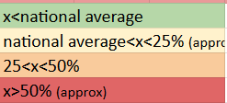 |  |  | Region of State: N: North; S:South;E: East;NE:North East; W: West; UT: Union Territory; PGI: Performance Grading Index grades 2022 round: (accessed from Niti Aayog/MHRD website)

5.2 Rurality and single teacher schools
Nationally, as noted already,11% of teachers in government schools are contractual.
16% of government primary school teachers are contractual, indicating that proportionally more posts in primary schools have been filled by contractual teachers. In the states of Arunachal Pradesh (61%), Jharkhand (77%) and Meghalaya (53%), more than 50% of the contractual teachers are in primary schools.
Almost all the contractual appointments i.e. 90% are in rural schools: 4,68,820 of the total 5,18,111 teachers.
This could be indicative of difficulties in staffing rural schools in general–a large proportion of government schools are rural. States with high proportion of of contractual teachers in primary schools mentioned above are also states with overall high vacancies of teachers ( see section 5.6). States in the East and North East of India in general have inadequate professionally qualified teachers and are more dependent on Central funding from Samagra for teacher salaries–leading to contractual appointments. The total number of government schools staffed with only contract teachers was 48,272 (5%). Most of these schools are in the states of Assam (4516; 10%), Jharkhand (16652; 47%), Meghalaya (5117; 66%), West Bengal (14,019; 17%). The total number of single teacher schools with a contract teacher was 11,934. A large proportion of these single teacher schools staffed with contract teachers are in West Bengal (2429), Jharkhand (5234).

5.3 Districts with high proportion of contract teachers
While recruitment is conducted centrally, in most states, teachers are appointed to a district cadre and are managed at the district level, or a group of districts forming a ‘region’. Analysis of the occurrence of contractualisation of government teachers at the district level shows (see Table 5.2) that in states with about 25% contractualisation at the state level, the problem is localized to some districts having a high percentage of contractual teachers. In six states with very high proportion of contract teachers like Mizoram, Sikkim, Meghalaya, Arunachal Pradesh (all in the North East of India) Jharkhand and the Union Territory of Dadra and Nagar Haveli and Daman & Diu (DNHDD), all Districts of the state faced the problem, indicating that the problem is at a pan-state and not localized to some districts. This could be indicative of overall state policy affecting general regular recruitment resulting in favoring contractual staffing of schools, versus states where there may be more localized issues affecting school staffing.

Table 5.2 Districts with high proportion of contract teachers
 | State | Overall % of government teachers on contract | Total number of districts | Number of districts with contract teachers in government> 30% | District with maximum contract teachers in govt | % of govt teachers on contract
N | Haryana | 15% | 22 | 1 | Nuh | 32%
E | Odisha | 16% | 30 | 0 | Mayurbhanj | 19%
UT | Goa | 16% | 2 | 0 | North Goa | 16%
E | West Bengal | 18% | 24 | 1 | Murshidabad | 27%
NE | Tripura | 19% | 8 | 1 | Dhalai | 33%
NE | Assam | 24% | 35 | 10 | Cachar | 35%
N | Uttar Pradesh | 25% | 75 | 6 | Hardoi | 31%
N | Chandigarh | 35% | 1 | 1 | Chandigarh | 35%
NE | Mizoram | 37% | 11 | 10 | Data of doubtful validity
NE | Sikkim | 37% | 6 | 5
UT | Dadra & Nagar Haveli and Daman & Diu | 47% | 3 | 3
NE | Arunachal Pradesh | 53% | 26 | 25 | Papum Pare | 62%
E | Jharkhand | 54% | 24 | 24 | Giridih | 65%
NE | Meghalaya | 69% | 11 | 11 | East Khasi Hills | 75%
Source: Authors analysis of UDISE+ 2021/22
Key: 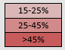

5.4 Feminisation
Overall, in the government and government-aided workforce (see Table 5.3), the proportion of male teachers to females is about 55% to 45%. In elementary schools the proportion is the same, while in elementary aided schools, there is a much higher proportion of women teachers. Tribal schools have been examined for feminisation as these are more remote schools and located in areas with lower literacy levels. Here the proportion of male teachers in the overall work force is considerably higher at 64% to only 36% women. Across all these school types we note that the contractual workforce is more feminized compared to the overall workforce. 55% of government contractual teachers are women (overall and in elementary schools). 59% of aided school contractual teachers are women, and up to 80% of aided elementary school teachers are women. In tribal welfare schools contractual teaching is more feminized with 41-42% being women as compared to 35-36% of the overall tribal school teacher workforce.
UDISE does not enable more disaggregated analysis of feminization of contractual teaching–with reference to schools in rural areas.

Table 5.3 Proportion of women and male teaches in government and government aided schools
 | Overall |  |  | Contractual
 | Female | Male | Total | Female | Male | Total
Government | 2,071,826 | 2,610,142 | 4,681,968 | 282544 | 235567 | 518111
 | 44% | 56% |  | 55% | 45%
Govt (I-V and I-VIII) | 1,332,020 | 1,643,227 | 2,975,247 | 201811 | 165590 | 367401
 | 45% | 55% |  | 55% | 45%
Aided | 355267 | 441364 | 796631 | 27931 | 19576 | 47507
 | 45% | 55% |  | 59% | 41%
Aided (I-V and I-VIII) | 119680 | 65871 | 185551 | 9466 | 2320 | 11786
 | 64% | 36% |  | 80% | 20%
Tribal Welfare | 45697 | 81623 | 127320 | 5353 | 7410 | 12763
 | 36% | 64% |  | 42% | 58%
Tribal (I-V and I-VIII) | 25023 | 47022 | 72045 | 1915 | 2724 | 4639
 | 35% | 65% |  | 41% | 59%
Source: Authors based on analysis of data from UDISE+ 2021/22

5.5 Professional qualification
Between 2011 and 2014-15, a large proportion of teacher who were contractually employed did not have qualifications commensurable to the requirements as mandated in the RTE Act (as notified by the NCTE): between 41 and 45%; subsequently the proportion decreased following massive interventions in the main states which had employed large numbers of unqualified teachers including Madhya Pradesh, Odisha, Bihar, and states in the North East. These states were provided with a window within which they were expected to achieve RTE specified norms of posting trained qualified teachers in school. The 2017-18 UDISE+ reported that about 30% of government school contractual teachers did not have professional qualifications. The publicly available UDISE+ database did not allow us to analyze and report figures for 2021-22. (The figures and trends reported here are based on Ramchandran et al 2020).

5.6 Levels of contract teachers and fiscal considerations in states
In order to examine if the extent of government contractual teachers in each state can be understood in terms of the state’s budget allocation to education, each state’s data on the the extent of contractualisation found in 2020-21 UDISE_ and its budget allocation for education was plotted in the scatter graph shows in Figure 5.1. We should expect to see higher levels of contractual teaches in states with low budget allocations to education. We find that of the three states which report very high levels of contract teachers, Jharkhand and Meghalaya have average budget allocations at the level of the national average of 14-15%; Arunachal Pradesh has a much lower budget allocation. Out of the 31 states for which information was available, 36% of States with budgets allocation to education more than 14.8% (average state allocation) had levels of contractual teachers higher than the national average of 11%. 50% of states with budget allocations to education less than the average state spending of 14.8% (PRS Legislative Research 2023) had levels of contractual teachers higher than the national average. Fiscal considerations do seem to be important, however, the presence of contractual teachers in the state does appear to be more complex and mediated by a number of other factors as is found in some selected cases discussed in section 5.7.

Figure 5.1 Scatter plot of state % allocation of budget to education (2022-23) and % of government contract teachers (2021-22)
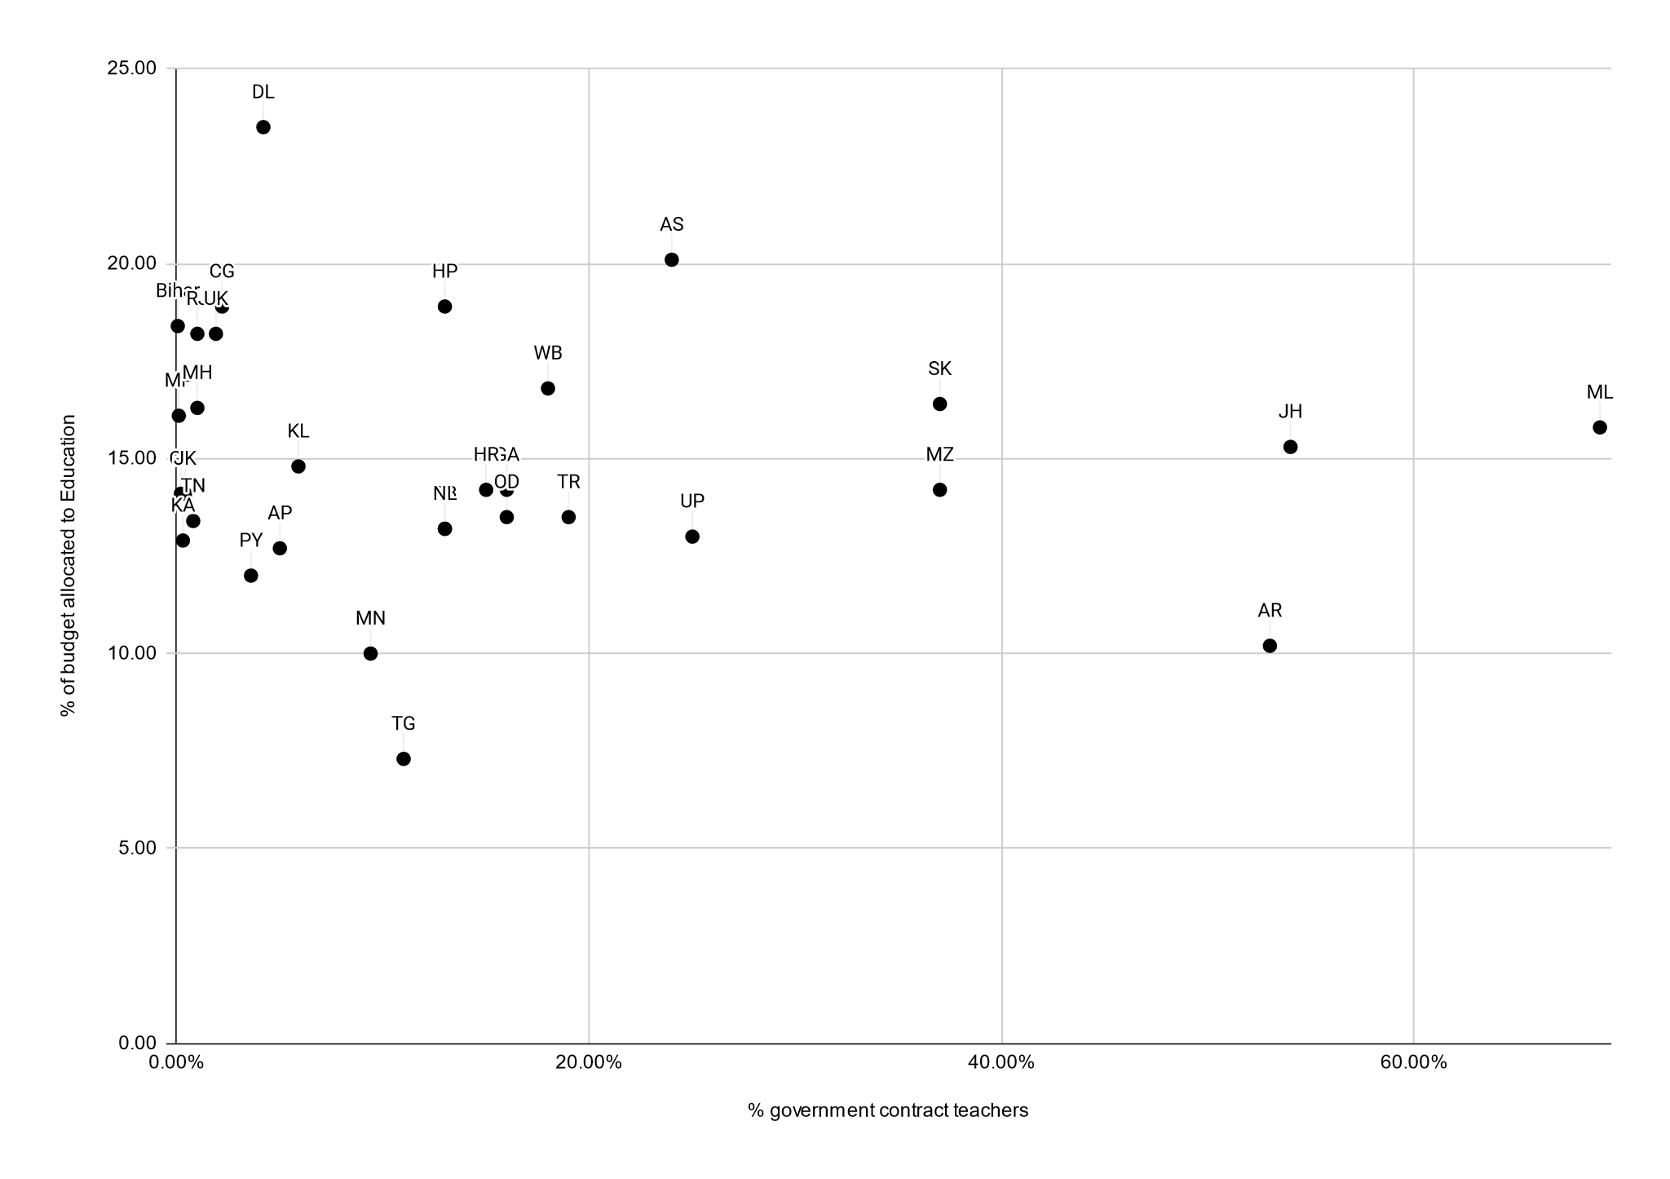
Key: Delhi (DL), Assam (AS), Chhattisgarh (CG), Himachal Pradesh (HP), Bihar (BR), Rajasthan (RJ), Uttarakhand (UK), West Bengal (WB), Sikkim (SK), Maharashtra (MH), Madhya Pradesh (MP), Meghalaya (ML), Jharkhand (JH), Kerala (KL), Goa (GA), Haryana (HR), Mizoram (MZ), Gujarat (GJ), Jammu and Kashmir (JK), Odisha (OR), Tripura (TR), Tamil Nadu (TN), Nagaland (NL), Punjab (PB), Uttar Pradesh (UP), Karnataka (KA), Andhra Pradesh (AP), Puducherry (PY), Arunachal Pradesh (AR), Manipur (MN), Telangana (TG).
Source: authors analysis based on data on % budget allocation to education https://prsindia.org/budgets/states/policy/state-of-state-finances-2022-23; figure 38 (national average 14.8%), accessed on 24th October 2023, and data on % of contractual teachers from USDIE 2021-22 (national average 11%; table 5.1 this report)

5.7 Changes between 2013-14 and 2021-22
Examining state wise trends in the extent of contractual teachers in the government schooling system over the last eight years reveals important considerations that have informed policy on contract teachers, recruitment and reporting. Figure 5.2 provides the extent of contract teachers in government schools as reported in UDISE+ at three points of time: 2013-14, 2017-18 and 2021-22 (4 years gaps). Changes between these three data points are computed and presented in the table 5.4.

Figure 5.2 State wise changes in extent of contractual teacher in government teacher workforce between 2013 and 2022 (States rank ordered from lowest to highest level of contractualisation in 2021-22).
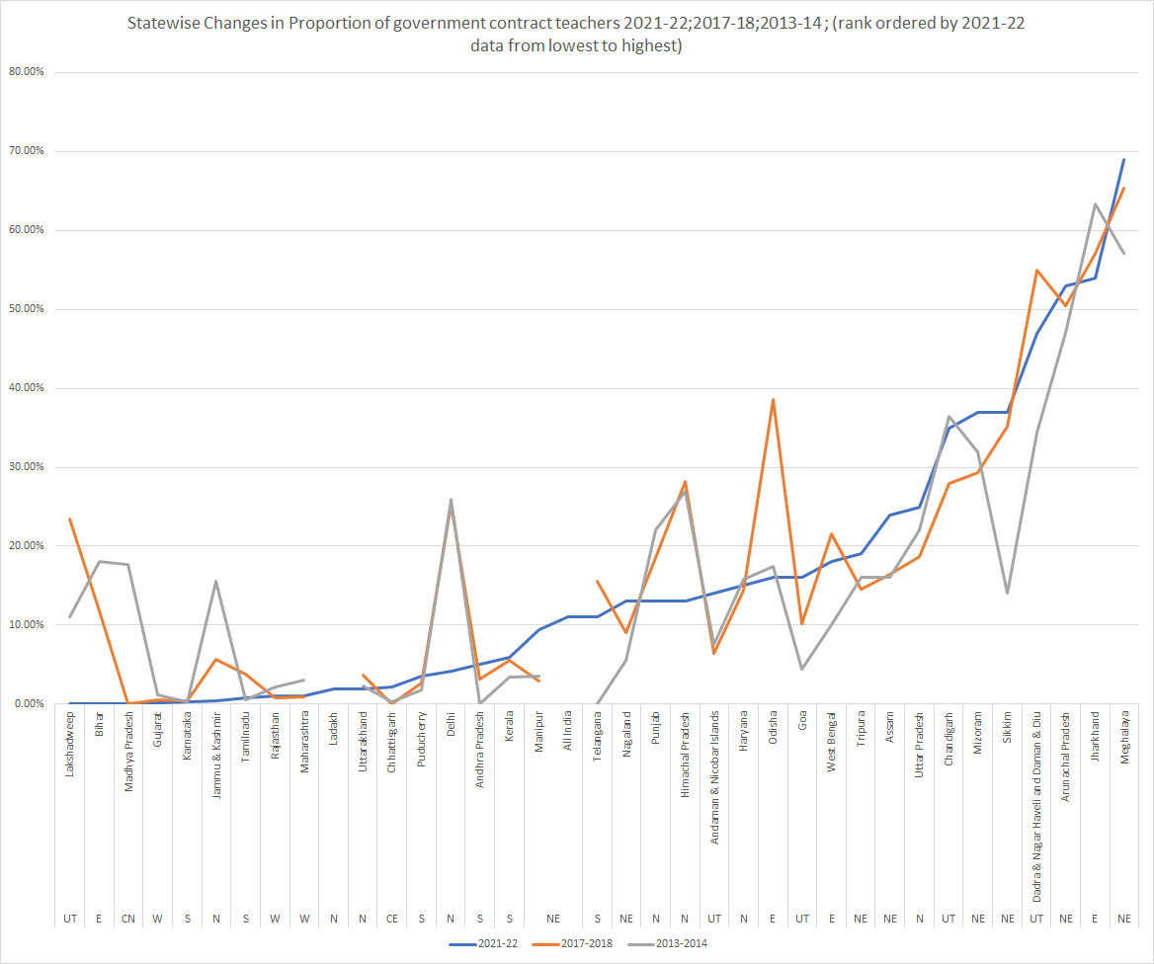
Source: Authors based on analysis of Data from UDISE+ 2021-22 and Ramachandran et al (2020)

Six states are identified as having seen significant shifts or showing significant patterns in terms of increase or decrease in the contractual labor force in the eight year period: Bihar, Madhya Pradesh, Delhi are notable for significant reduction in contractual teachers in the workforce, from between 17% and 25% in 2013-2014 to 0.1% - 4.2% in 2021-22. Mizoram, DNHDD, Assam and Meghalaya stand out for a significantly increased proportion of contractual teachers . Interviews with key informants from some of these states enable us to have an understanding of the changes behind the shifts noted.

Table 5.4 Changes in extent of government contract teachers between 2013-14 and 2021-22
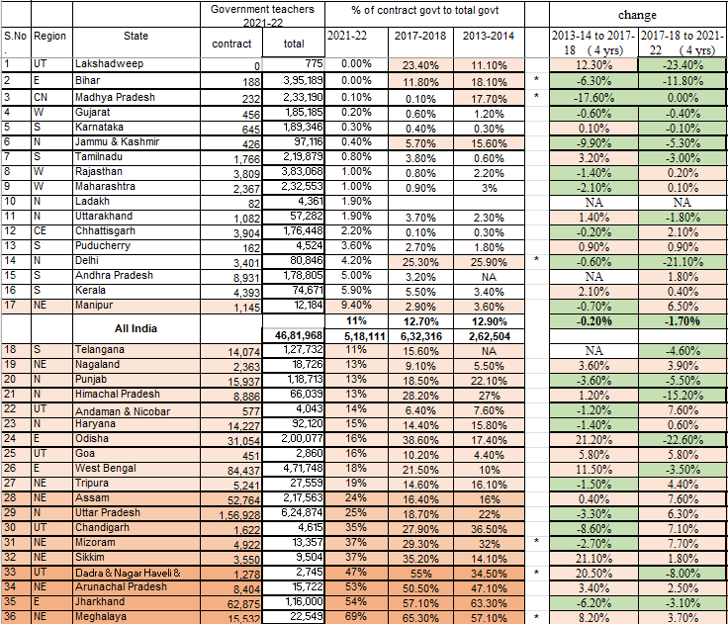
Source: Authors based on analysis of data from UDISE 21-22 and data from Ramchandran et al 2020

Significant lowering in proportion of contract teachers: Madhya Pradesh and Bihar
Madhya Pradesh: The state had a high proportion of contractual teachers at around the time of the RTE enactment. These teachers had entered into the system through various schemes of the government including notably the ‘Education Guarantee Scheme (EGS)’ during the DPEP period. The state had a cadre of regular teachers who were appointed through the state service commission, however was unable to expand recruitment for fiscal limitations. Teachers were introduced as ‘local panchayat’ teachers employed at considerably lower salaries and through local selection processes at the block level. This was the time of empowering the ‘Panchayati Raj’ system. Through a series of strikes and lobbying, these contract teachers were able to have their salaries revised. The rules governing the appointment over the decade were notified from time to time, but more flexibly changed at the Department level. Benefits of leave, vacation pay and medical cover was extended to contract teachers. The state also undertook massive training of untrained teachers at its DIETs and CTEs. In 2016 through political pressure, a new Siksha cadre was notified. While these are ostensibly ‘Panchayat’ employees, this cadres is ‘managed’ at the state level under the Department of Education. The salary of these teachers is lower than the earlier cadre, beginning at about 40,000 INR per month and going up to about 60,000 INR per month. Recruitment to this cadre is centrally administered. The State has a very limited number of teachers who are still not qualified and hence continue to be ‘contractual. To replace teachers who have retired, or following delays in recruitment, the system manages ‘guest teacher’ system (portal: Madhya Pradesh Guest Faculty Portal). These positions are very short term pending recruitment and currently number about 20,000 (website: https://gfms.mp.gov.in/). These teachers are not captured and reported in UDISE+.

Bihar: Prior to 2006: appointment of teachers took place at the panchayat level as a part of Panchayati Raj. Qualifications were not examined at the time of appointment, nor was there any examination based recruitment. It was a political move and resulted in large-scale disregard of quality considerations in contractual teacher appointments. These contractual appointments were for 3-years and did not offer any benefits to the appointees. In 2006, with a view to check the problem of poor quality, an examination was introduced and teachers were allowed to continue provided they passed the examination ‘Dakshata Pariksha’. The growth of these positions was with funding received from SSA. From 2010 onwards as and when they passed the examination, teachers were given contracts up to the age of 60. These exams have been held two or three times since then. They also receive limited benefits governed by different rules—but they are not regarded as government employees. They cannot expect any compassionate grounds appointment of relatives in case of demise during tenure, for example. The Supreme Court has recently ordered that the state should make efforts to provide professional development to enable the remaining few teachers to also qualify for this long contractual appointment. So technically speaking they do not receive the same salary as a teacher appointed through the Bihar Public Service Commission (BPSC), and they are not government teachers—they are ‘contractual’. The state has now decided that going forward all recruitment will be through the BPSC. Currently, teachers who were appointed through the BPSC and those who are on contracts until 60 years are counted as ‘regular’ teachers. Guest teachers who are in the system for defined short periods to fill vacancies until recruitment and posting, are not counted in UDISE+.
Significant Increase in Proportion of Government Contract Teachers: Meghalaya and DNHDD
Meghalaya: When SSA was introduced into the state to support the expansion of access to schools, a large number of private schools became ‘SSA funded’ and the government was supposed to take over these schools. However they have continued to be effectively managed privately even though they are on paper considered government schools. These are small schools which are not viable, often with just two or three teachers and under local and private control. The appointments in these schools are contractual—there is resistance to ‘regularize’ these positions or allow them to be filled through State recruitment. Under SSA Meghalaya also started a large number of ‘EGS’ centers with volunteer teachers—these were converted into schools later. Teachers in these schools are mostly unqualified. There is a related problem of not having sufficient qualified teachers for the system.
Dadra and Nagar Haveli and Daman and Diu (DNHDD; Union Territory): SSA/SA has supported the creation of a large number of contractual positions in the State. Being a Union Territory, as there is no requirement of a state contribution to be made to the SSA budget, there is adequate resource support for these contractual appointments. These appointments are far easier to make as compared to regular appointments which involve the service commission. When recruitment is announced there is frequently a lot of litigation around it. Moreover, until recently set aside by the High Court, in the public service exams, locals receive an advantage of up to 20 marks, which is now not possible. Following this, there is greater reluctance to announce formal recruitment and risk non locals getting the teacher jobs—contractual appointments on the other hand are mostly local. Another problem arises because of the complexity of having four mediums of instruction (Gujarati, Marathi, Hindi and English) and having to recruit subject teachers and follow the reservation roster—on account of this, suitable candidates are not found to fill posts. The need for teachers who can teach in English medium schools has now emerged as a new concern.

Recruitment Norms and Terms of Employment

6.1 Recruitment qualifications for contract teachers
The literature documenting the details of recruitment norms and employment terms of Contract Teachers in government schools provides us with details of practices in 10 states (see Table 6.1). The first noticeable point on recruitment eligibility qualifications, both at the time these practices were initiated in the late 1990s and early 2000s recruitment and as a key change post the RTE (i.e., after 2010) is with regards professional qualification. In the pre RTE contract teacher appointments, in all states, academic qualifications were retained at the level of the regular teachers, but professional qualifications were not mandated. Only in states of Andhra Pradesh, academic qualification was reduced to Secondary school from senior secondary requirement, for teachers in rural and tribal areas. And in Rajasthan, where ‘Shiksha Karmi’ reduced the academic qualification to eighth class pass while recruiting its community ‘teachers’. In the case of Andhra Pradesh and Madhya Pradesh, we find mention in the literature of short training before placement and annual refresher trainings (between 7 days and 2 weeks). Shiksha Karmi training is notable–for its lengthy pre -service induction training (37 days) and long annual refreshers (40 days per year).

Studies post 2009, i.e post the RTE, note that the same academic and professional qualification of the regular teacher are required from the contractual teacher as well.

Table 6.1 Recruitment and employment terms in selected states
Sl No | State and Sources | Pre/ Post RtE | Academic Qualification | Professional Qualification | Prof. Dev Provided | Terms
1 | Andhra Pradesh; Dayaram 2002; EdCIL 2009 | Pre RtE | Sr Secondary and reduced to secondary in low literacy areas. | Not mandated | 7 days preservice training and 15 days per year inservice | INR 1000-1500 per month (consolidated) with a contract of 10 months. Not considered as a govt. employee; not entitled to any leave; deployed mainly in rural areas; non transferable; could be removed without notice.
2 | Bihar; EdCIL 2009 | Pre RtE | Sr Secondary | Not mandated |  | Long contract up to retirement, but not considered govt. employees; 16 days casual leave per year and 90 days maternity leave for women; non transferable but trained teacher could avail 2 transfers in career; no allowances for house or transport or medical; no promotions; trained teacher INR 5000 and untrained INR 4000
3 | Chhattisgarh; EdCIL 2009 | Pre RtE | Sr. Secondary for Primary school; graduation for secondary school | Not mandated
4 | Gujarat; EdCIL 2009 | Pre RtE | Sr Sec | PTC |  | Apt for 5 years, if found satisfactory, then absorbed into regular payscale in the system against vacancy; if not within 5 years, then on completion of 5 years they are absorbed into system on regular payscale. (Advantage of earlier absorption based on performance). Initial pay, Rs 2500 per month (honorarium).
5 | Jammu and Kashmir; EdCIL 2009; Authors (from Govt Order 2000) | Pre RtE | Sr Sec and Graduate for 3rd teacher. | Not mandated |  | (2000 govt order) apt for 5 years, and on satisfactory completion eligible for appointment as 'general line teacher' in the department. 2 system: Rs 1500-2000 for primary teacher and Rs 4500 for contract teacher.
6 | Kerala; Terway and Steiner-Khamsi 2017 | Post RtE | same as regular teacher | with relevant prof qualification of regular teacher; but no requirement of TET |  | Rs 8000 vs Rs 17000 for regular teacher
7.1 | Madhya Pradesh; Dayaram 2002; Govinda and Josephine 2004 | Pre RtE | Sr Sec | Not mandated | 12 days/20 days initial TT followed by 12/14 days per year of INSET | No performance evaluation; between INR 2500 (for primary teacher) and Rs 4500 (for sec teacher) per month; duration of contract for 1 year, and extendable to 3 years; renewal of contracts up to age of 62.
7.2 | EdCIL 2009 | Pre RtE | Sr Sec (Primary T); Graduation (for secondary T); Masters (for Sr. Sec T) | Not mandated (for primary T)/ DElEd for Middle or Secondary T/BEd for Sr. Sec T
7.3 | Terway and Steiner-Khamsi 2017/ Beteille and Ramchandran 2016 | Post RtE | same as regular teachers | Same as regular teachers and TET |  | Teachers enrolled in Prof Dev course- entitled to paid leave to study; increment of 15% after a period of 3 years.
8.1 | Rajasthan; Shiksha Karmi Project (1980s) reported in Govinda and Josephine 2004 | Pre RtE | 8 years of schooling | Not mandated | PST 37 days (45 days for teachers from remote areas); 40 days per year refresher | Appointment reviewed and renewed each year, and made permanent after 8 years. Consolidated pay of INR 1800 per month. Non permanent govt employees.
8.2 | Rajasthan  EdCIL 2009; Ramchandran and Beteille 2016 | Pre RtE | Sr Sec | Certificaye in Teaching |  | 10 days casual leave each year; can be terminated after show case for leave without permission of more than 7 days in a row, and terminated if leave without permission exceeds 15 days. not transferable, but achieved through political pressure; regularization of 23000 teachers around 2016, but without parity in pay scales (post RtE).
9 | Odisha |  |  |  |  | Indirect recruitment/ regularized after six years as contract teacher
10 | Uttar Pradesh; EdCIL 2009 | Pre RtE | Sr Secondary (and 18-35 years), resident of gram panchayat | Not mandated |  | Appointed for grades I and II. Consolidated pay of Rs 3000 per month; Village Education Committee involved in selection. Contract for 10 months and renewable; VEC can remove with a 2/3 majority.
Source: Based on review of literature as cited from pre and post RTE Act

6.2 Terms and employment pathways
Pay: Literature notes the low pay of consolidated nature of contractual teachers. In the case of Andhra Pradesh, Uttar Pradesh and Rajasthan, literature notes the ease of terminating appointments of contractual teachers, with/without notice. These states also indicate oversight at the village/panchayat level of these appointments, and their involvement in regular release of salary.
Leave and benefits: In most states, contract teachers having limited or no leave is noted. No equivalence with government employment, even in cases of long contract until the age of retirement, and not having allowances permissible to government employees, such as travel, housing, is noted (Bihar) Other benefits are not mentioned. Some states equivalence in leave policy, including casual leave and 90 days maternity leave for women is noted (Bihar)
Pathways: In states of Gujarat, a pathway, starting from contractual employment leading to regularization is noted, with the change taking place earlier in case of higher quality performance. So also in Rajasthan (after 8 years of contractual service) and Odisha (after 6 years), and Jammu Kashmir’s 2000 government order (after 5 years). However, becoming regularized may not always mean pay equal to ‘government employee’. These jobs even when they are ‘regular’ are not considered ‘government employment’. They may also not be transferable.

6.3 Short term appointments against teacher vacancies
Data pertaining to teacher vacancies in the government school system is available only at state level and is often not publicly accessible. To some extent this data is reported in the minutes of Programme Approval Board (PAB) of Samagra, Government of India. Data in Table 6.2 below was compiled and provided by Government of India, in response to a question in the Rajya Sabha (Upper House of the Central Government of India), of vacancies in primary schools in the year 2018-2019. As indicated by the percentage of vacant positions, the all India vacancy was close to 20% and more than 30% in the states of Bihar, Daman Diu, Jharkhan and Uttar Pradesh. Understanding the status of these vacancies today, how long such vacancies may have persisted, if and how State governments address such vacancies, possibly indicative of unmet teacher requirements/shortages at school level would require considerable primary data gathering effort which are outside the scope of this paper. In order to get a sense of what the situation and practices may be, we selectively contacted and interviewed key informants in some states. The section on notes provides a sense of some of the prevailing practices on appointing contract teachers.

Table 6.2 State/UT wise sanctioned position and vacant posts for primary government school teachers during 2018-19
Sl. No. | State/UT | Sanctioned Posts | In Position | Vacant Posts | % Vacant Posts | Notes on select states  2023(*)
1 | Andaman & Nicobar Islands | 3,169 | 2,690 | 479 | 15.12%
2 | Andhra Pradesh | 1,48,785 | 1,34,108 | 14,677 | 9.86%
3 | Arunachal Pradesh | 14,245 | 13,567 | 678 | 4.76%
4 | Assam | 1,82,439 | 1,57,250 | 25,189 | 13.81%
5 | Bihar | 5,92,541 | 3,88,607 | 2,03,934 | 34.42% | Two kinds of guest teachers, one hired by the government (Rs. 1000 per day, per class) and the other by outsourcing (Rs. 250 in rural areas and Rs. 290 in urban areas, per day, per class). They are appointed at the school level and their tenure could be extended till the age of retirement. Qualification (for a senior secondary teacher) post graduate in the concerned subject with B.Ed and TET however, for teachers recruited by outsourcing, TET is not mandatory but an experience of 3 years is desirable.
6 | Chandigarh | 4,284 | 3,852 | 432 | 10.08%
7 | Chhattisgarh | 1,96,806 | 1,58,290 | 38,516 | 19.57% | No practice of appointing guest teachers.
8 | Dadra & Nagar Haveli | 1,804 | 1,643 | 161 | 8.92%
9 | Daman & Diu | 601 | 385 | 216 | 35.94%
10 | Delhi | 49,286 | 42,483 | 6,803 | 13.80% | 18% of all teachers in Delhi are ‘part time’ as per UDISE+ 2021-22
11 | Goa | 2,216 | 2,216 | - | 0.00%
12 | Gujarat | 2,17,106 | 2,13,067 | 4,039 | 1.86%
13 | Haryana | 65,446 | 50,074 | 15,372 | 23.49% | Guest teachers once appointed continue to teach in schools against vacant posts.These posts are also filled up by partnerships with NGOs, volunteers in rural areas or by retired teachers. They get an emolument of Rs. 30,000 to 42,000 p.m. Recently contractual teachers are being appointed by Haryana Rojgar Kaushal Scheme. However they would only be appointed for the contract period and might not get regularized.
14 | Himachal Pradesh | 45,997 | 44,002 | 1,995 | 4.34%
15 | Jammu & Kashmir | 1,01,301 | 94,232 | 7,069 | 6.98%
16 | Jharkhand | 1,91,679 | 1,11,869 | 79,810 | 41.64%
17 | Karnataka | 2,03,824 | 1,89,332 | 14,492 | 7.11% | Guest teacher salary: 25% of the regular government teacher. They are appointed by the school development and monitoring committee (SDMC).
18 | Kerala | 1,26,382 | 1,25,011 | 1,371 | 1.08%
19 | Ladakh | NA | NA | NA | NA
20 | Lakshadweep | 731 | 681 | 50 | 6.84%
21 | Madhya Pradesh | 3,63,099 | 2,96,576 | 66,523 | 18.32% | Appointments are managed through Guest Faculty Portal. As per the portal on 25th October 2023, there were about 66,255 teachers working as guest teachers.
22 | Maharashtra | 3,24,801 | 3,04,053 | 20,748 | 6.39% | Contract teachers (Shikshan Sevak) get an emolument of Rs. 6000 per month (raised from the previously fixed honorarium of about Rs. 2500 p.m.) with a probationary period of 3 years and are later regularized. The government recently started appointing retired teachers as ‘guest’ teachers with a honorarium of Rs. 20,000 p.m. given the scarcity of teachers. These teachers are appointed by the Zilla Parishad for a period of 11 months.
23 | Manipur | 16,167 | 15,801 | 366 | 2.26%
24 | Meghalaya | 22,632 | 21,756 | 876 | 3.87%
25 | Mizoram | 2,228 | 2,193 | 35 | 1.57% | There are two kinds of contractual teachers in the state, one, appointed by the state govt. dept. and the other under the Samagra Shiksha scheme. Their eligibility conditions are the same as a regular teacher. Both get a fixed honorarium. About 10% of DoE appointed teachers have a chance of getting regularized after a period of 5 years but the teachers appointed by Samagra Shiksha (with a fixed honorarium of 25,000 p.m. and additional 10% T.A) are not regularized. There is no practice of appointing guest teachers in the state.
26 | Nagaland | 17,330 | 17,013 | 317 | 1.83%
27 | Odisha | 2,29,006 | 2,29,006 | - | 0.00%
28 | Puducherry | 3,705 | 3,040 | 665 | 17.95%
29 | Punjab | 75,805 | 68,218 | 7,587 | 10.01%
30 | Rajasthan | 3,14,271 | 2,77,683 | 36,588 | 11.64%
31 | Sikkim | 8,573 | 8,573 | - | 0.00%
32 | Tamil Nadu | 1,47,913 | 1,41,902 | 6,011 | 4.06%
33 | Telangana | 72,702 | 68,918 | 3,784 | 5.20% | There is no practice of appointing guest teachers. The system has surplus teachers and they are redeployed.
34 | Tripura | 35,091 | 30,655 | 4,436 | 12.64%
35 | Uttar Pradesh | 8,79,691 | 4,94,114 | 3,85,577 | 43.83%
36 | Uttarakhand | 46,053 | 39,048 | 7,005 | 15.21%
37 | West Bengal | 4,54,860 | 3,88,466 | 66,394 | 14.60%
Total |  | 51,62,569 | 41,40,374 | 10,22,195 | 19.80%
Source: RAJYA SABHA SESSION - 251 STARRED QUESTION NO. 274; Source: AWP&B-2018-19, Information provided by the State/UTs (Updated as on September 2021). Retrieved from: https://karnataka.data.gov.in/resource/stateut-wise-sanctioned-position-and-vacant-posts-primary-teachers-during-2018-19-ministry on 25-10-2023
(*) Based on interviews with key informants from selected states to understand practices to meet teacher requirements arising out of vacancies-with a focus to understand matters of ‘guest teachers’ and other appointments of an interim nature, pending fresh recruitment. Interviews conducted in October 2023.

As can be seen the pay for guest teachers and the terms of their engagement vary widely from state to state. They may be paid as low as Rs 200-300 per class they take; they may be employed through an outsourcing agency, their appointments and deployment may be transparent, taking place through a state portal, or be left to the school; states may decide not to fill up vacancies by appointing guest teachers; they may earn a fixed monthly honorarium up to about 25% of the salary of a regular teacher. They are expected to have the same qualification as regular teachers, but may not be required to have TET qualification. This sampling of the ground situation pertaining to ‘guest teachers’ within the government school system suggests varied levels of casualisation in teaching.

Contract Teachers in Government Aided Schools
In the colonial period, the British government gave ‘grants in aid’ to schools established by trusts and societies, often run by christian missions. This policy of giving ‘government aid’ to managements continued post independence also, extending to many other community based societies. This aid is mainly in the form of support for teachers salaries and benefits to students. Teachers supported through government aid meet the same norms as in the case of government teachers, they enjoy the same salaries and benefits as government recruits. Students in aided schools are entitled to various government schemes and benefits such as mid day meal, free uniforms and textbooks for students from reserved categories, etc. (Jain, 2018). From about the 1980s, most state governments, with the exception of Goa, Kerala and Maharashtra, began discontinuing giving aid, or not supporting new recruitment after teachers retired. The total percentage of aided schools and enrolment in aided institutions has been shrinking ( Bashir, 2003; this trend continues to date), with the exception of the states of Goa, Kerala and Maharashtra in as noted in our analysis of UDISE 2021-22 data (see below). The continued large proportion of aided schools in these three states could be attributed to the political influence of the church and managements of these schools, enabling them to be successful in retaining state support.

All India, the extent of government aided schools stands at 8% (UDISE 2021/22). Only three states have a significant proportion of teachers in aided schools. These are Goa (68%), Kerala (43%) and Maharashtra (38%). In all these three states, the level of contractualization is relatively low (<4% in Kerala and Maharashtra and at 9%in Goa). In Goa up to 16% of the main government teacher workforce is contractual, suggesting that in general aided schools have been more successful in ensuring timely recruitment of teachers. So also in the state of Gujarat, where 12% of the workforce is in aided schools, only 1% of aided school teachers are contractually employed vs close to 25% of teachers in government schools. This suggests that in general the aided schools as a block in these states are more effectively able to manage to ensure timely teacher recruitment.

Although accounting for a small overall proportion of teachers/schools, the proportion of aided school teachers who are on contract is high in the states of Telangana (52%), Punjab (38%) and Mizoram (71%). In all these states, the States have adopted a policy of not replacing the aided school teacher on retirement, compelling the managements of these schools to contractually employ teachers in their place. As can be seen from the table 7.1 below, the level of contractual teachers in aided schools in these states is far higher than the level of contractual teachers in the government schools. These contractual teachers, employed by non government managements are comparable to teachers in private schools.

Table 7.1: I. Proportion of contract teachers in govt aided schools for select states with a high proportion of aided school teachers. II. States with high proportion of contract teachers in govt aided schools
 |  | Proportion of teachers in aided schools | Proportion of teachers in aided schools  on contract | Proportion of teachers  in the govt. schools  on contract
I | States with large proportion of teachers in aided schools
1 | Goa | 68% | 9% | 16%
2 | Kerala | 43% | 4% | 6%
3 | Maharashtra | 38% | 3% | 1%
4 | Tamil Nadu | 14% | 7% | 1%
5 | Gujarat | 12% | 1% | .25%
II | States with high proportion of contractual appointments in aided schools
1 | Mizoram | 8% | 71% | 37%
2 | Telangana | 1% | 52% | 11%
3 | Punjab | 2% | 38% | 13%
4 | Haryana | .1% | 83% | 15%
Source: Authors analysis based on UDISE+ 2021-22

Trends in the Private Sector
The entire private sector teacher workforce must be treated as essentially contractual in character, unless there is strong evidence to the contrary. To date we have limited or no disaggregated and detailed understanding of the type of contracts in this sector. While UDISE+ gathers information under the heading ‘contractual’ in the case of private schools, where ‘regular’ is not well defined, the validity of the data gathered under this head is not established. We use UDISE+ for the limited purpose of understanding the overall distribution of teachers in this sector: gender, type of school they work in (primary, composite etc) and rural/urban location. We draw on limited secondary literature existing in this sector and finally, we examine the sector of private school teachers through primary data gathered from 2 states: Maharashtra and Telangana.

8.1 From UDISE+
Currently the private school sector in India employs 37% of teachers all India (Grade 1 to 12, excluding preschool). Fourteen states have a fairly high proportion of the teacher workforce in the private sector (>41%), and in the four states of Haryana, Puducherry, Punjab and Telangana they account for more than 50% of the teacher workforce in the respective state (see table 8.1). The tables that follow are based on analysis of UDISE+.
Table 8.1 Proportion of the teacher workforce in private schools
0-20% | Goa (14%), Jharkhand (16%), Lakshadweep (0%), Tripura (17%), West Bengal (16%)
21-40%  All India average: 37% | Andhra Pradesh (38%), Arunachal Pradesh, Assam (25%), Bihar (19%), Chhattisgarh (30%), DNHDD (31%), Gujrat, Himachal (37%), Kerala (25%), Ladakh (26%). Maharashtra (29%),Meghalaya (22%), Mizoram (32%), nagaland (39%), Odisha (24%), Sikkim (26%)
41-60% | Chandigarh (41%), Delhi (41%), Haryana (58%), Jammu Kashmir (41%), Karnataka (44%), Madhya pradesh (48%), Manipur (49%), Puducherry (55%), Punjab (51%), Rajasthan (45%), Tamil Nadu (45%), Telangana (55%), Uttarakhand (46%), Uttar Pradesh (47%)
Source: Authors analysis based on UDISE+2021-22 data
A larger proportion of the private school workforce comprises women (63% as opposed to 44% in government schools) (see Table 8.2). Reflecting the largely urban character of private schools, we find that only 45% of teachers in private schools in rural areas are women in comparison to 80% of government school teachers in rural areas are women.

Table 8.2 Proportion of women in government vs private unaided school workforce in India teaching grades I-XII
 | Government | Private unaided
Total workforce | 4,681,968 | 3,540,647
% of the workforce in the school type who are women | 44.25% | 63.05%
% of total women workforce in each school type | 42% | 45%
% of total workforce in rural areas | 85% | 52%
% of women teachers in rural schools of the school type | 80% | 45%
Source: Authors analysis based on UDISE+ 2021-22
Overall, across all states barring Bihar, Sikkim and Uttarakhand the private school workforce in all states has a large proportion of women (>50%); the largely urban states/union territories of Chandigarh, Delhi, DHN&DD have over 82% of private school teachers are women. Punjab, Tamil Nadu and Kerala also have a very high proportion of women teachers in private schools (refer Table 8.3).

Table 8.3 States that have least and most feminized private school workforce
< 50% | Bihar (41%); Sikkim (47%); Uttarakhand (46%)
>75% | Andaman and Nicobar (81%); Chandigarh (92%); DHDD(82%); Delhi (88%); Goa (92%); Haryana (75%); Himachal Pradesh (76%); Kerala (90%); Puducherry (79%); Punjab (86%); Tamil Nadu (85%)
Source: Authors analysis based on UDISE+ 2021-22

The largely feminized character of private schools in most states is also indicative of the lower employment conditions and poorer employment terms we are likely to find in these states. This may be fuelled by demand for jobs with a larger number of educated women available for employment, enabling private school managements to lower employment terms and working conditions in these states.

8.2 From literature
In a study conducted in rural Andhra Pradesh it was found that “the age and gender profile of private school teachers are similar to those of contract teachers (younger and more likely to be female than regular teachers). Private school teachers have higher levels of general education, but even lower levels of teacher training than contract teachers. They live much closer to the school and are more likely to be from the same village relative to regular teachers (though less so than contract teachers). Further the salaries of private school teachers are even lower than those of contract teachers (Muralidharan and Sundaraman 2013:20).

Based on the 2011-2012 National Sampling Survey’s (NSS) 68th round “Employment and Unemployment” data from India, it was found that “private school teachers in India earn about half of what public school teachers earn in rural and urban areas, respectively. Their benefits are fewer. A small fraction of private school teachers receive a pension (30 %), gratuities (20 %) and health care benefits (20 %). Further, private teachers are also more likely to seek additional and alternative work and to do so more frequently compared to public teachers” (Chudgar and Sakamoto 2021:5). Analysis of the PLFS data 2018 round shows that “contractual appointments – especially in the private sector – frequently do not cover vacation periods” (UNESCO 2021:53). Moreover it was found that 42 % teachers report having no contracts and 45% have contracts of 3 years or more’, and “the overall proportion of teachers in private schools who report working with no job contract is alarmingly high at 69 per cent” (UNESCO 2021:54). Up to 57% to 61% of private school teachers report having no benefits, only 11% report having all benefits and PF as compared to 49% of government teachers (UNESCO 2021:59). A 2021 study conducted during COVID on the impact of school closure on private schools noted that 65% teachers in private schools reported that their salary had been put on hold (CSF, 2021).
Analysis of Primary Data from Maharashtra and Telangana
Data were gathered at the teacher level from teachers in private, aided and government schools (including ‘government other’; i.e. schools run by Tribal Welfare Department) from 2 districts each. A total of 506 respondents responded to a survey that was administered in March-April 2023. The findings of the survey are reported and discussed.

8.3 Sample
A total of 506 teachers, 176 from 34 schools in Maharashtra and 330 from 43 schools in Telangana participated in the survey. 57% of the sample in Maharashtra and 34% of the sample in Telangana were employed in private unaided schools. 21% of government school teachers in Maharashtra and 35% of government school teachers in Telangana said they had contractual appointments of less than 3 years. From those working in private schools, 42% in Maharashtra and 88% in Telangana said they had short contracts of less than 3 years. About half of the private school teachers in Maharashtra and only about 10% of private school teachers in Telangana had long contracts of more than 3 years in their schools. Others had short contracts. The sample details are provided in Table 8.4
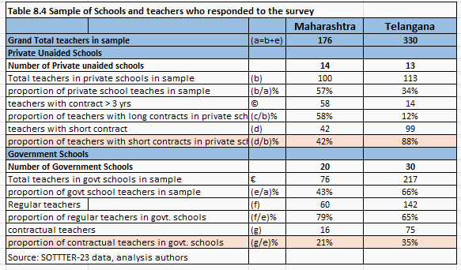

8.4 Characteristics of teachers
comparison between regular and contractual teachers of government and private schools (Table 8.5 and 8.6)

There is a much greater proportion of women in short contracts in private schools and contractually employed in government schools.
In Maharashtra Government schools, women make up 56% of contract teachers vs 48% of regular teachers. In Telangana women make up 76% of contractual teachers vs 59% of regular teachers.
In Maharashtra Private schools, women make up 67% of teachers on short contracts vs. 55% of teachers on long contracts. In Telangana Private schools, women make up 87% of teachers on short contracts vs 71% of teachers on long contracts.

There is almost double the proportion of teachers from other backward classes (OBC) communities and about one fourth the proportion of teachers from scheduled tribe (ST) communities in private schools as compared with government schools.
In Maharashtra Private schools compared with Government schools, overall, there is a much higher proportion of OBCs (52% vs 26%) and lower proportion of STs (4% vs 20%). A similar pattern is seen in Telangana (OBC: 57% vs 35% and ST: 5% vs 29%). Ie teachers from Scheduled Tribe communities are well represented in government schools (20-29%), and have very limited representation in private schools (4 to 5%). This may indicate that government policy of representation of these groups ensures their representation in government schools and in the absence of such policy in private schools, they are less likely to be employed. It may also be on account of the noted private school preference for women teachers and lower educational levels of women from ST communities.

There is evidence of a larger proportion of younger women employed in the private sector and more so in the private sector on short contracts, as compared with teachers in the government sector. This is more pronounced in Telangana, where in the 20-30 year age group was represented by 19% of women and no men. In the 20-30 age bracket, there are more teachers in private schools (21% in Maharashtra and 19% in Telangana) as compared with in government schools (10% in Maharashtra and 6% in Telangana). In all cases this age group is significantly feminized with women in this age group ranging from 71% in private schools in Maharashtra to 100% in private schools in Telangana.

The overall large extent of feminisation seen in this age group may also indicate that overall the profession is trending towards greater feminisation. It is found that 88% of the 20-30 years age group work force comprises women, while in the remaining age brackets it is between 60 and 67%. The oldest age group of 50-60 years is 56% women. This seems to confirm the observation that there is a marked feminisation in teaching on the whole across both states.

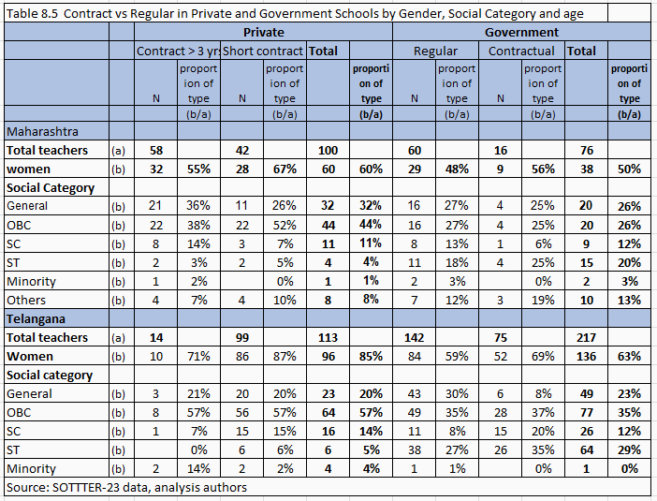
OBC: Other Backward Classes; SC: Scheduled Castes; ST: Scheduled Tribes; Minority: Muslims, Sikhs, Christians, Buddhists, Jain and Zorastrians (Parsis)
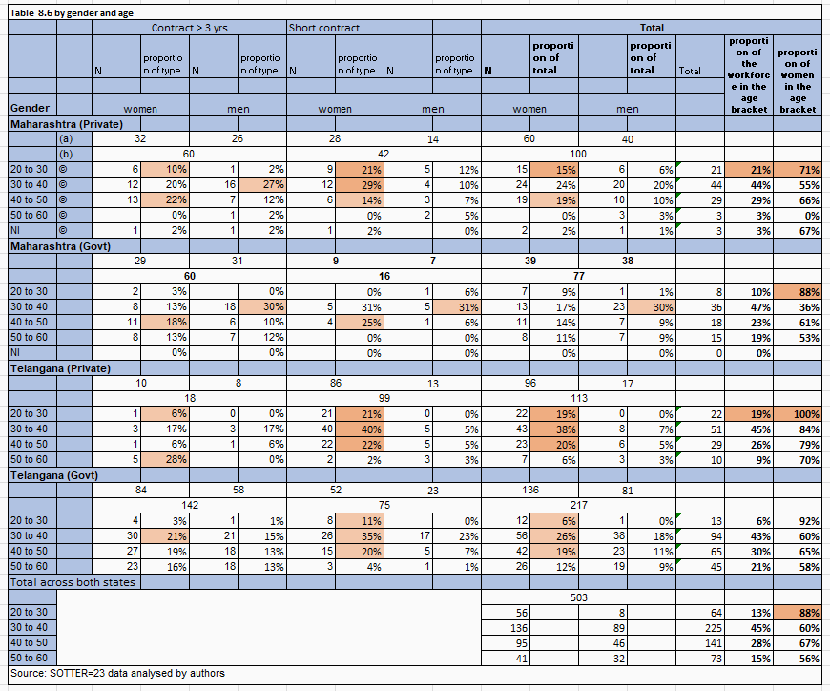

8.5 Educational levels
In Maharashtra, similar educational profiles were noted between teachers in private and government schools: a larger proportion of teachers in both groups had post graduate qualifications (63% in private and 57%in government), and about two fifths having undergraduate degrees (about 34%). A large proportion of short term contractual teachers (67%) have postgraduate qualifications. This may be indicative of overall over supply of post graduate teachers in the labor market.
Telangana Government teachers are on the whole far more qualified as compared to teachers in private schools, with overall 79% having Post Graduate (PG) degrees (compared with 41%in private) (see Table 8.7). 54% of private school teachers had Undergraduate (UG) degrees. Within private schools, we note differences in Telangana with a larger proportion of short term teachers having UG qualification (56% of Short term contracts, vs 43% of long term contracts). In the case of Government schools however, we note that a higher proportion of contractual teachers have PG qualification (85% of contractual vs 75% of regular teachers). This may indicate that the private school sector may be actively prefering to employ lower academic qualifications in its teachers, and also that lower qualified persons are more likely to find employment as teachers in private schools.
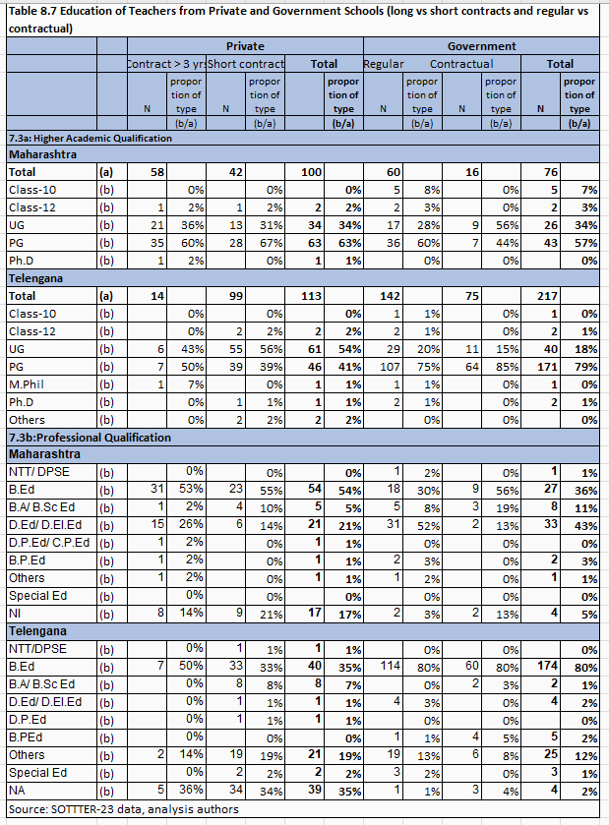
UG: Undergraduate; PG: Postgraduate; M.Phil: Master in Philosophy; Ph.D: Doctor of Philosophy; NTT/DPSE: Nursery Teacher Training/ Diploma in Pre School Education; B.Ed: Bachelor of Education; B.A/B.Sc.Ed: Bachelor of Arts/ Bachelor of Arts Education; D.Ed/D.El.Ed: Diploma in Education/ Diploma in Elementary Education; D.P.Ed/C.P.Ed: Diploma in Physical Education/ Certificate in Physical Education; B.P.Ed: Bachelor in Physical Education; NI/NA: No Information

8.6 Wages and Sources of Livelihood compared (Table 8.8)
Teachers on short term contracts in private schools earned the least. Overall 35% were in this pay bracket of less than Rs 10,000. This was followed by teachers from both government contractual and private short term contract teachers who most earned in the bracket of Rs 10,000 to Rs 20,000 ( 44% of all short term contract private school teachers, and 56% of contract government teachers). Telangana contract teachers working in private schools were likely to be paid the lowest salaries.
Of the total of 506 teachers surveyed, 15% received less than Rs 10,000 per month, 30% received between Rs 10,0001 and 20,000 per month, and about 40% received over Rs 40,000 per month. Of teachers earning less than Rs 10,000 per month, all were in the private sector, and 85% of these teachers were on short contracts. Among teachers earning between Rs 10,000 and Rs 20,000 per month, the largest proportion came from government contractual teachers (34%) and Private short term contract teachers (45%). 36% of private school teachers on longer term contracts earned between Rs 10,000 and Rs 20,000. And about 37% earned between Rs 20,000 and Rs 40,000. 87% of teachers with salaries above Rs 40,000 were those with regular government employment.

In the case of Private Schools, 13% of teachers in Maharashtra and 55% of teachers in Telangana were paid less than Rs 10,000 per month. 51% teachers in Maharashtra, and 38% of teachers in Telangana were paid between Rs 10,000-Rs 20,000 per month. Most of these teachers had short term contracts. About 4% of teachers in both states received higher salaries of more than Rs 40,000. Most of these teachers held longer contracts in their schools.

Vacation pay: 73-75%Contractually employed teachers in Government schools of Maharashtra and Telangana reported not being paid salary during vacations. Among Private school teachers, 30% from Maharashtra, and 48% from Telangana said they may or did not receive salary during vacations. Only 25% of teachers from Private schools of Maharashtra and Telangana said they conducted extra classes for students in their locality after school hours before or after school. Between 86 and 88% in both states said they did not do any additional work to earn additional income.

Social Dialogue
Contract teachers working in Government schools have over the years, in respective states, been able to come together to lobby for their service conditions. Key concerns have included equal pay for equal work, regularization, securing transfer, extension of contracts, against arbitrary termination of contract, etc. They have employed various means including going on strike, unionizing, taking matters to court, political channels to apply pressure and lobby to improve service conditions and seek redress for grievances. While there are differences between states on the details of how contract teachers have acted in unison to improve their own working conditions, by and large the two most common routes that have led to reform include (a) the legal route—resulting in court orders and (b) political route—through exerting pressure by striking, or teacher unions, or lobbying (Beteille and Ramachandran 2016:45; Ramachandran, Das, Nigam & Shandilya 2020:69). The latter has on the whole brought better results.
Announcements in the newspapers on ‘regularization’ of contract teachers in some states before the elections indicates that their interests reflect those of a sizable electorate in most states (e.g. reports on Bihar, PTI 2020; ABP News Bureau).

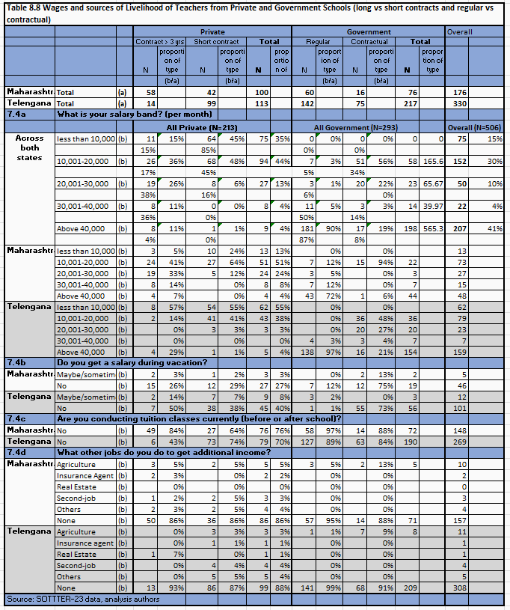
The legal route has brought limited success, as “In most instances, the High Courts (in Karnataka, Rajasthan, and Uttar Pradesh) did not interfere with the state education departments’ decisions, especially in situations where the contract teacher had been originally appointed for a temporary post. A common theme running through many of these judgments was the notion that, unlike regular teachers, teachers appointed on an ad hoc basis were not governed by any set of rules regarding their appointments or benefits and, therefore, decisions on these teachers were left largely to the executive decisions of the respective state governments” (Ramachandran et al. 2018:163). However, following the Right to Education Act, the Rajasthan High Court in 2014 ordered the government to do away with the system of contract teachers (Ramachandran et al. 2018:164). Since then new contractual appointments have not taken place. The Supreme court also criticized the Government of Haryana for failing to recruit regular teachers and instead relying on ‘guest teachers’ (Beteille and Ramachandran 206:45). The state of Rajasthan is currently gearing up for election and the Chief Minister recently announced recruitment of over 50,000 teachers. Haryana, also going to the polls has announced the recruitment of 16959 school teachers. While courts have not paved the way for contractual teachers to be regularized, they have favored fair treatment as seen in the case of Jharkhand where the Supreme Court ruled that contract teachers should not be penalized by loss of benefits for failure of the state to provide them with mandatory training in time. In 2013 in West Bengal, the High Court held that the pay of so-called part time teachers should be equalized with that of full time teachers if they are asked to do the same quantum of work (Ramachandran, Das, Nigam & Shandilya 2020:47). The success of the Political route can be seen in the case of Madhya Pradesh and in Bihar.
Madhya Pradesh, one of the first states to abandon hiring regular teachers in 1998 in favor of contract teachers, saw complaints from teacher- applicants stating that the new recruitment policy violated the fundamental rights enunciated in the Article 16 of the Constitution emphasizing the principle of equality of opportunity for all citizens. Since the contract teacher recruitment procedure aimed to hire local candidates from the panchayat catchment area, it violated a citizen’s fundamental rights. These applicants demanded expanding the catchment area for recruitment. Shortly thereafter, contract teachers in Madhya Pradesh formed their own union and began agitating for better service conditions, followed by a demand for regular jobs with wages equal to those of other (regular) teachers. There were periodic struggles, and right until 2008, close to 38,000 gurujis (a category of contract teachers) demanded regularization. The state government eventually redesigned the policy, making concessions on local recruitment and qualifications. In 2013 there was another major agitation for equal pay for equal work. Schools across the state remained closed for 12 days. Eventually, the government agreed to increase the pay scale of adhyapaks (formerly contract teachers, now on permanent contracts, but being paid considerably less than permanent teachers hired prior to 1998) and agreed to bring it in line with permanent teachers from the pre-1998 era within four years’ (Beteille and Ramachandran 2016:45). The state modified its teacher cadre by introducing a contract period of three years – before they are confirmed (Ramachandran, Das, Nigam & Shandilya 2020:69).
It has been noted that contract teachers tend to have fewer of the characteristics that would lend them a socially powerful status compared to regular teachers, resulting in increased local accountability for the former. They are more likely to be female, from low caste, less experienced and less likely to be trained (Goyal and Pandey, 2011:9). However, we find that while it is true that contract teachers are more likely to be female, younger and have less training, their social caste is likely to be higher than that of regular teachers. They are more likely to succeed in renegotiating their terms through political means.
The concerns of teachers in Private schools remain invisible. The only time their vulnerable condition received media attention was during COVID when teachers losing their jobs and having to resort to manual labor or return to family occupations such as vegetable selling, was widely reported in the media. There are no unions or associations representing private school teachers.

Claims and Counterclaims
Concerning comparative efficiency
On one side are researchers with findings favoring contract teachers as being more efficient, and cost effective. This includes Muralidharan and Sundararaman (2013), Kingdon, Aslam, Rawal and Das (2013). Muralidharan and Sundararama(2013) find that in spite of being five times more expensive than contract teachers, regular teachers are not more effective–thus raising questions on the relevance and need of teacher professional qualification, and favoring keeping teachers more vulnerable to job loss. Goyal and Pandey (2011) found contract teachers to be making more effort compared with regular teachers, and this likely explains higher student outcomes. They also found that contract teachers in their first year of tenure made more effort as compared to contract teachers in their second year of tenure. Kingdon ad Rao (2010) and Muralidharan and Sundaraman note that contract teachers do have lower levels of absenteeism. This is contradicted by Shukla (2018) who notes that no differences have been noted.

On the other side are researcher who find evidence more inconclusive and dissatisfaction among stakeholders on the viability of expanding the system through contractually employed teachers (de Koning 2013), Goyal and Pandey (2011) study could also be taken to indicate that after a year, working at the same level, but at lower pay affects motivation of contract teachers. They also note that in the absence of accountability structures, their work can be extremely slack, dull and ineffective . This point is reiterated by Beteille and Ramchandran (2016), who note that in the absence of regularization, motivation to continue to work is affected. Shukla (2018) notes that no difference in student performance is noted (grade 3 and 5), but also notes that contract teachers tend to be placed in more socio-economic disadvantaged areas.

Sustainability
Clarence, Devassy, Jena, et al., (2021) note that the para teachers’ ability to remain proactive and engaged is dependent on proactive leadership in the school, maintaining a sense of commitment among teachers. Kumari (2018) notes that there were no differences in performance between regular and contract teachers in Delhi , however contract teachers seemed demotivated and had longer working hours in school. She also notes that contract teachers seem to be more burdened. As noted by Goyal and Pandey (2013), while initially contract teachers seem to be more efficient, this is affected with more years in service without the hope of regularization materializing. Not being employees of the state and being directly answerable to Village Education Committees also leads to their feeling vulnerable to local politics (Govinda and Josephine, 2005).

Overtime, with consistent political pressure from contract teacher groups, states have been forced to move in the direction of creating a new ‘cadre’ at lower salaries, and equalizing all other aspects of recruitment, including qualifications, tenure, and leave and benefits–with the exception of pension and ambiguousness vis a vis transfer policies. Some states, Maharashtra, Rajasthan, have resorted to initially employing the teacher contractually, but regularizing them after 3 to 5 years of work. There is no evidence that this is anything but a way to cut costs for a few years of service, as there is no evidence that this is used to screen out unsatisfactory teachers.

Conclusions and recommendations
The emergence of the Contract Teachers within government schools in India traces back to the National Education Policy 1986 beginning with Siksha Karmi in the State of Rajasthan. While at the start this was promoted as a way of staffing schools with local community youth in remote areas, and universalising access in remote and tribal areas of states, the scheme soon evolved into employing lower qualified staff at lower salaries as a way to meet the growth in teacher requirement in states which experienced a surge in enrolment in the 1990s onwards. International aid channeled to states by the centre created the conditions for the spread of this scheme and the virtual cessation of recruitment of regular teachers. This led to the growth of literature around the core tension around claims that contract teachers are more cost effective and value for money as compared to government teachers, and that professional qualification has the effect of inflating salaries without any gain in teaching quality. Nevertheless, initially the qualifications of such teachers was lower than that of ‘regular teachers’, particularly after the Right to Education Act 2009, states have in a time bound way, sought to improve professional qualifications of all teachers and recruit teachers fulfilling the RTE mandated qualifications. Overall, the level of contract teachers in the system has decreased over time, from 13% in 2013-14 to 11% in 2022-23. In nine states, the level of contractual teachers is fairly high (almost 24% or higher). A consideration leading to this is overall lower budget allocations to education, but this is not the only reason. Local political considerations and local interest, which do not favour regular recruitment, non availability of qualified teachers to recruit as in the case of the North East, and availability of central sponsored schemes providing support for teacher appointment, thus reducing the burden on the state, are also contributing reasons for the persistence of contractual teachers in the system. In two states which show marked decrease in contractual teachers: Madhya Pradesh and Bihar, this is because of the change in contract, which was earlier two to three years and was subsequently extended until retirement age–and receiving benefits, however, at lower salaries, not being considered a government employee. Thus these forms of invisible contract, quasi-regular teachers seems to be persisting in the system mostly on account of fiscal constraints in states.

90% of contract teachers are in rural areas. Also contract teachers tend to be women.
Rurality and Single Teachers summary: 16% of government primary school teachers are contractual, almost all the contractual appointments i.e. 90% are in rural schools.
Contractual workforce is more feminized compared to the overall workforce.

Trends from Private Schools: Our analysis shows that currently the private school sector in India employs 37% of teachers all India (Grade 1 to 12, excluding preschool). Fourteen states have a fairly high proportion of the teacher workforce in the private sector (>41%). A larger proportion of the private school workforce comprises women (63% as opposed to 44% in government schools). Reflecting the largely urban character of private schools, we find that only 45% of teachers in private schools in rural areas are women in comparison to 80% of government school teachers in rural areas are women. A large proportion of private school teachers tend to have short contracts of less than 3 years. In the course of primary data collection, many reported having only oral or no contracts. Private school teachers tend to have a larger proportion of ‘OBC’ (Mid level and often politically more powerful castes) as compared to government schools, and also have very limited teachers from Scheduled tribe communities. There is almost double the proportion of teachers from OBC communities and about one fourth the proportion of teachers from ST communities in private schools as compared with government schools. Contract teachers are more likely to be female, younger and have less training, and their social caste is likely to be higher than that of regular teachers.

Teachers on short term contracts in private schools earned the least. Overall 35% were in this pay bracket. This was followed by teachers from both government contractual and private short term contract teachers who most earned in the bracket of Rs 10,000 to Rs 20,000. Teachers in both private and government schools report having no medical insurance coverage, and limited or no benefits such as a gratuity, PF etc.
Contract teachers in government schools seem to be active in political dialogue and renegotiating the terms of their employment towards better pay and more benefits. However, there are few cases of succeeding in regularisation. The evidence on their value in the system in terms of higher quality teaching or better learning outcome results is mixed. While often results appear to favour contract teachers in initial periods, there is doubt regarding this effect continuing with time.
Research is beginning to draw attention to issues of motivation and ability to stay engaged with work, in a scenario where regularisation is elusive and different pay for same work becomes less acceptable with time.
The changing nomenclatures and definitions are rendering contractualisation or rather cessation of permanent teacher cadre as civil servant in states–the entry of ‘guest teacher’ as stop gap measures to fill vacancies against sanctioned posts is not well captured by DISE. Reports from the ground indicate that such guest teachers may be continuing in the system for many years as there is no recruitment taking place. This group is completely invisible in DISE which does not have a category for guest teachers and hence they go uncounted. This is an invisible form of casualisation of the teaching workforce, falling even below contract teachers, with wide ranging vulnerabilities experienced by such teachers who are effectively on daily wage/per class taken type of honoraria and wages.
The growth of the private school sector in which all teachers are effectively contractual needs more attention and data to understand the sector and the condition of teachers in this sector.
Teacher motivation and quality will be affected in the long run if states continue with a policy of having regular and contract teachers are two different levels of pay, doing the same work, and persisting casualisation in the form of guest teachers. The political ramifications of this has played out in several states which have now been forced to radically revise the terms of contractual teachers making them at par with regular teachers or create new cadres, or cease with contractual teachers completely. In states where this has not yet been possible, local political and economic conditions and the effects of central funding which favours appointment of contract teachers seems to be key. Schemes that link pathways from contractual into regular teacher with quality of performance have been notional at best, with no evidence that they actually lead to any ‘filtering’.
Informants note that by and large there are long periods with no recruitments, a tendency to announce massive recruitments in years when the state is due for elections, persistence of contractual employment, growth of teaching jobs in only the private sector. These circumstances have led contractual teachers in the government system to frequently resort to political measures to improve their working status, and has led to increased politicization of the teaching work force having to resort to political ways of ensuring jobs and job related working conditions. Overall it would seem that having contract teachers within the system of government employment favours teachers as being politically active.
The NEP 2020 of India seems to favour the continuation of short term contractual teacher employment as a stepping stone to ‘tenure’ based on performance. This seems to be aligned to the growing popularity of NPM logic and claims regarding efficiency with regards the workforce. While it does recognise the need to improve working conditions, the NEP 2020 does not recognise issues of teachers’ wages and benefits for teachers (see Sarangapani and Chandran, 2021). Sharma’s (2023) analysis of frontline workers points out that the issues concerning contractual teachers will benefit from comparative analysis with frontline workers in other sectors.

References
ABP News Bureau. (2020, October 30). Why the issue of ‘contractual teachers’ in Bihar is a major election issue? ABP Live. https://news.abplive.com/news/india/bihar-elections-2020-issue-of-contractual-teachers-in-bihar-is-a-major-election-issue-1375782
Bashir, Sajitha. (2003). A policy note on the grant-in-aid system in Indian education : main issues and options for reform (English). South Asia Human Development Sector report ; no. 3 Washington, D.C. : World Bank Group. http://documents.worldbank.org/curated/en/693701468282301322/A-policy-note-on-the-grant-in-aid-system-in-Indian-education-main-issues-and-options-for-reform accessed on 26 October 2023.
Beteille, T. and Ramachandran, V. (2016). Contact teachers in India. Economic and Political Weekly 51(25), 40-47.
Central Square Foundation. (2021). Impact of COVID-19 on teaching- learning in private schools. https://www.centralsquarefoundation.org/CSF%20Report-Impact%20of%20COVID19%20on%20private%20schools_July%202021%20Final%20.pdf
Chandra, M. (2015). The implications of contract teaching in India: A review. Policy Futures in Education, 13(2), 247–259.
Chudgar, A., Muralidharan, K., & Honeyman, C. (2017, September 20). Contract teachers: Effective policy solution or inadequate response to deeper problems? International Institute for Educational Planning, UNESCO. https://learningportal.iiep.unesco.org/en/blog/contract-teachers-effective-policy-solution-or-inadequate-response-to-deeper-problems
Chudgar, A. & Sakamoto, J. (2021). Similar work, different pay? Private school teacher working conditions in India. International Journal of Educational Development. https://doi.org/10.1016/j.ijedudev.2021.102478
Clarence, M., Devassy, V.P., Jena, L.K. et al. (2021). The effect of servant leadership on ad hoc schoolteachers’ affective commitment and psychological well-being: The mediating role of psychological capital. International Review of Education 67, 305–331. https://doi.org/10.1007/s11159-020-09856-9.
Clarence, M., Viju P. D., Jena, L. K., & George, T. S. (2021). Predictors of Positive Psychological Capital: An Attempt Among the Teacher Communities in Rural Jharkhand, India. Management and Labour Studies, 46(2), 139–160.
de Koning, M. (2013). Contract teacher policy in India: Debates on education quality and teachers' professional status. In A. Verger, H. Altinyelken, & M. de Koning (Eds.), Global managerial education reforms and teachers. Emerging policies, controversies and issues in developing contexts (pp.91-108). Brussels: Education International Research Institute.
Department of School Education and Literacy. (2023). UDISE+. Ministry of Education. Government of India. https://dashboard.udiseplus.gov.in/#/reportDashboard/sReport
EdCIL. (2009). Deployment and professional competence of para- teachers: Abridged report. New Delhi: EdCIL (India) Limited.
Ministry of Human Resource Development. (1986). National policy on education. Government of India. New Delhi.
Ministry of Education, Government of India: (2020) National Education Policy, New Delhi.
Government of India. (2009). Right to Free and Compulsory Education Act 2009 (Right to Education Act). New Delhi, MHRD.
Govinda, R, & Josephine, Y. (2005). Para-teachers in India: a review. Contemporary Education Dialogue, 2(2), 193-224.
Goyal, S., & Pandey, P. (2011). Contract teachers in India. Washington, DC: The World Bank.
Jain, M. (2018). “Public, private and education in India: a historical overview. In School Education in India: Market, State and Quality. Edited by M. Jain, A. Mehendale, R. Mukhopadhyay, PMSarangapani and C. Winch, New Delhi: Routledge: 31-66.
Kingdon, G., Aslam, M., Rawal, S., & Das, S. (2013). Are contract teachers and para teachers a cost effective intervention to address teacher shortage and improve learning outcomes? Education in Pakistan’s Punjab: Outcomes and Interventions, 47. London, UK: University of London, Institute of Education.
Kingdon, G. and Sipahimalani-Rao, V. (2010). Para-Teachers in India: Status and Impact. Economic and Political Weekly, 45(12), 59–67.
Kumari, J. (2018). Analysis of work and employment conditions of contractual teachers in India. NMIMS Journal of Economics and Public Policy.
Muralidharan, K., & Sundararaman, V. (2013). Contract Teachers: Experimental Evidence from India. National Bureau of Economic Research. doi:10.3386/w19440
Pandey, S. (2006). Para-teacher scheme and quality education for all in India: Policy perspectives and challenges for school effectiveness. Journal of Education for Teaching, 32(3), 319-334.
PRS Legislative Research. (2023). State of State Finances 2022-23. https://prsindia.org/budgets/states/policy/state-of-state-finances-2022-23 accessed on 23rd October 2023.
Ramachandran, V., Beteille, T., Linden, T., Dey, S., Goyal, S. & Chatterjee, P. G. (2018). Getting the right teachers into the right schools. World Bank Group.
Ramachandran, V., Bhattacharjea, S., and Sheshagiri, K M. (2008). Primary school teachers: the twists and turns of everyday practice. Technical Report. Educational Resource Unit, New Delhi.
Ramachandran, V., Das, D., Nigam, G. and Shandilya, A. (2020). Contract teachers in India. Recent trends and current status. Azim Premji University.
Ramachandran, V. (2009). What is “para” about some teachers? New Delhi: Education Research Unit.
Ramachandran, V & Sethi, H. (2001). Rajasthan Shiksha Karmi Project: An Overall appraisal. SIDA.
Sarangapani P.M. and Chandran, M. (2020). Whither the teaching profession? Inspecting some silences of the NEP 2020. The Bastion.September 26,2020. https://thebastion.co.in/politics-and/whither-the-teaching-profession-inspecting-some-silences-in-the-nep-2020/
Sarangapnai, P.M. and Vasavi, A.R. (2003). Aided programmes or guided policies? DPEP in Karnataka. Economic and Political Weekly, 38(32), 3401-3408.
Shukla, A. (2018, August 2). Contract teachers in India: A historical review. Medium. https://anuraag-shukla.medium.com/para-teachers-in-india-a-review-77e8d12216cb
Sharma, R. (2023). Frontline functionaries in India: the absent policy. State Capacity Initiative Working Paper No. 2023-8. New Delhi Centre for Policy Research.
Terway, A. & Steiner-Khamsi, G. (2017). Comparing Contract Teacher Policies in Two States of India: Reception and Translation of the Global Teacher Accountability Reform. In M. Akiba & G. K. LeTendre (Eds.), International Handbook of Teacher Quality and Policy (pp. 204-217). Routledge
UNESCO. (2021). No Teacher No Class: State of the Education in India Report 2021. New Delhi: UNESCO Regional Office.
(authors: Sarangapnai, P.M., Thirumalai, B., Ramchand, M., Kumar, R. and Ramanathan, A.). https://unesdoc.unesco.org/ark:/48223/pf0000379115.locale=en
Verger, A., Altinyelken, H. K., & de Koning, M. (Eds.). (2013). Global managerial education reforms and teachers. Emerging policies, controversies and issues in developing contexts. Brussels: Education International Research Institute.

Elite pan-India Central Administrative Services.
The National Council of Teacher Education (NCTE) is the statutory authority identified by the Government of India to prescribe qualifications of teachers as required by the RtE. Accordingly NCTE has notified qualifications (a) teachers for grade I to V: Grade 12+ 2 year Diploma in Elementary Education (DElEd) and (b) teachers for VI-VIII: Undergraduate degree in a school subject + Bachelor of Education (BEd). The National Council of Teacher Education also mandates qualifications for secondary (i.e. classes 9 and 10) and Senior Secondary (i.e., grades 11 and 12), but these mandates do not have the same authority as teachers for the grades that are directly covered by the Right to Education Act.).
Data Capture Form for United District Information System for Education Plus (UDISE+) dated 30th September 2020. https://udiseplus.gov.in/assets/img/dcf2021/DCF6-8.pdf; Section 3: teaching and non teaching (pp9-12).
Information about part time and guest teachers in this sectionis based on personal interviews with key informants in states, carried out between July and September 2023, and in the course of SOTTTER 23 study. These two categories are of importance in understanding the changing dynamics of the teacher workforce employment terms and conditions. However this report is limited to the formal category of ‘contract teachers’ and does not do justice in terms of providing understanding of the teacher workforce who are employed in these ways.
https://www.pmhelpline.com/rajasthan-reet-3rd-grade-teacher-recruitment/news paper
https://sarkariresultz.in/haryana-teacher-vacancy/

