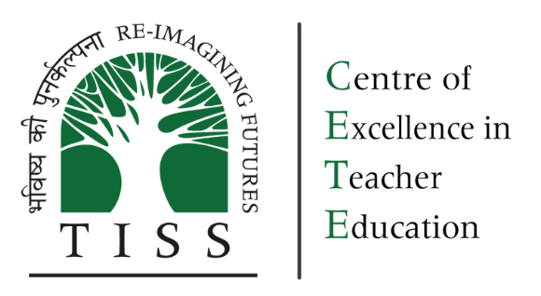

Teachers in India in 2021-22: The picture from UDISE+

Background Paper 1:
State of Teachers, Teaching and Teaching Education Report for India 2023
CETE 2023
Citation: CETE. (2023). Teachers in India in 2021-22: The picture from UDISE+. Background paper 1: State of Teachers, Teaching and Teaching Education Report 2023.
Authors: Padma M. Sarangapani, Kamlesh Goyal, Mythili Ramchand, Jyoti Bawane
Research Assistance: Aishwarya Rathish, Arpitha Jayaram, Anitha Bellappa, Rutuja Warthi, Aditi Desai (until August 2021)

Abstract: Based on publicly available data from the UDISE+2021-22 academic cycle, this paper analyses and presents data on teachers in the Indian school system. The analysis is organised at the all-India level and state-wise and disaggregates and compares teachers based on gender and social category, the location of the school they work in rural/urban, and the type of school by level and management. It profiles teachers by their demography and qualifications. Teachers’ working conditions are examined based on the basic amenities and professional working conditions. Finally, the availability of teachers is examined using PTRs, the incidence of single-teacher schools and the availability of qualified teachers. Variations between states emerge as important to note. Certain states, including the North East, Himalayan states, and the states of Jharkhand, Bihar, Telangana and Andhra Pradesh are states of concern on various parameters including basic amenities, teacher qualification, single-teacher schools and adverse PTRs. While there is overall gender parity, in some states teaching is highly feminised, and in a few, it is very male-dominated. In some states, the majority of the teaching workforce is in the private sector. Teachers from Scheduled Caste and Scheduled Tribe communities are found to be underrepresented in the private school workforce.
Keywords: teacher workforce, interstate variation, working conditions, feminisation, government-private comparison
Acknowledgements: The SOTTTER 23 editorial board–Prof. Saklani, Director NCERT, Mr Harshit Mishra, Niti Ayog, Prof. Amita Chudgar, Professor, Michigan State University, Dr Nidhi Gulati, Institute of Home Economics, University of Delhi, Ms. Amrita Patwardhan, Tata Trusts, and Dr Carlos Vargas Tames Teacher Task Force, UNESCO–provided invaluable perspectives on the analysis and reporting.

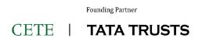
The Centre of Excellence in Teacher Education (https://bit.ly/cetewebsite) is an Independent Centre at the Tata Institute of Social Sciences, Mumbai, established with seed grants from the Pandit Madan Mohan Malaviya National Mission on Teachers and Teaching, Government of India, and the Tata Trusts, and with the Tata Trusts as founding partner. The Centre's overarching focus and agenda is innovation and improvement in teacher education, school and higher education pedagogy and curriculum, and is aligned with the United Nation's Sustainable Development Goal 4: "to ensure inclusive and equitable quality education and promote lifelong learning opportunities for all", and Goal 4c in particular "by 2030 to substantially increase the supply of qualified teachers" The Centre envisages its role as a catalyst for transformation in teacher education through academic programmes, field action programmes, research, collaborations, and advocacy. The State of Teachers Teaching and Teacher Education is a Biennial State of the Sector Report produced by CETE.

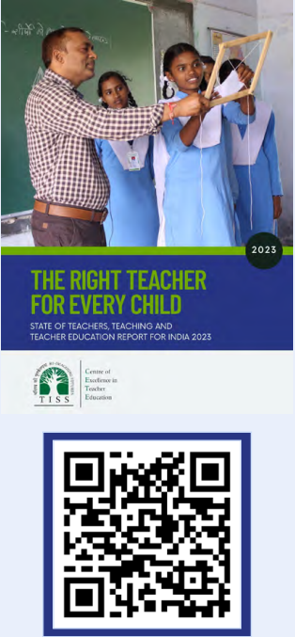
State of Teachers Teaching and Teacher Education for India Report
Background Papers
- CETE (2023). Teachers in India in 2021-22: The picture from UDISE+. Background paper 1: State of Teachers, Teaching and Teaching Education Report 2023.
- CETE (2023). Teachers in India: A snapshot from the Periodic Labour Force Survey. Background paper 2: State of Teachers, Teaching and Teaching Education Report 2023.
- CETE (2023). Public and private sector contract teachers in India: An analytical research paper. Background paper 3. State of Teacher, Teaching and Teacher Education Report 2023.
- CETE (2023). Quality of pre-service teacher education and teacher supply in India: An analysis of TET data from one state. Background paper 4: State of Teachers, Teaching and Teaching Education Report 2023.
- CETE (2023). Status of teachers in the workforce in eight states: A report based on SOTTTER 23 Survey. Background research report 5: State of Teachers, Teaching and Teaching Education Report 2023.
- CETE (2023). Status of teacher educators and student teachers in eight states: A report based on SOTTTER 23 Survey. Background research report 6: State of Teachers, Teaching and Teaching Education Report 2023.
- CETE (2023). Teacher supply demand: A review of the literature. Background paper 7: State of Teachers, Teaching and Teaching Education Report 2023.
- CETE (2023). News coverage in Indian print media on teachers and teacher education January-December 2023. Background research report 8: State of Teachers, Teaching and Teaching Education Report 2023.
https://bit.ly/SoTTTER-by-CETE



This document is released under a Creative Commons Attribution-ShareAlike 4.0 International licence. Download Here: https://bit.ly/SoTTTER-by-CETE
Any questions, suggestions or queries may be sent to us at: chair.cete@tiss.edu
Contents

List of Tables 3
List of Figures 3
1. Introduction the picture from UDISE+ 4
1.1 What is UDISE? 5
1.2. An overview from UDISE 2021-22 6
2. What kinds of teachers and where are they? 10
2.1 What kinds of teachers: 10
2.2 Where are our teachers? 11
2.3 Who are our teachers? 15
2.3.1 Gender 16
2.3.2 Social groups 17
2.3.3 Gender and Social Group by School type (by management) 18
2.3.5 Teacher qualifications 19
3. What is the service environment? 20
3.1 Basic amenities 20
3.2 Professional work environment 22
3.3 Employment terms 24
3.4 Service Environment in Aspirational districts: 25
3.5 Changes between 2018-19 and 2021-22 27
4. Teacher availability and deployment 28
4.1 PTRs 30
4.2 PTR at school level 33
4.1 Single-teacher schools 34
4.3 Level of Professional Qualifications of Teachers 35
5. Summary of Key Findings 37

List of Tables
Table 1.1 National Average Number of Schools, Teachers and Enrollment
Table 1.2 Average school size and PTR for Government and Private Schools (all India) by
local and by school type (elementary, composite, secondary and senior
secondary)
Table 2.1 State wise share of teachers
Table 2.2 Proportion of Teachers in different School Management Types and Urban & Rural
Areas
Table 2.3 State wise Proportion of Teachers Employed in Government Schools
Table 2.4 States with varied proportion of Women Workforce in Private Sector Schools
Table 2.5 Proportion of Teachers in Government and Private Schools based on their Social
Category
Table 2.6 Social Category of Teachers by School Management Type (Summary Table)
Table 3.1 Basic Amenities: States of Concern
Table 4.1 Minimum Qualifications Required for Teaching various Levels
Table 4.2 States across PTR range
Table 4.3 Proportion of Single Teacher Government schools in various States
Table 4.4 Availability of Appropriate Professional Qualifications (All India, teacher data
categorized for School type by Management types and School Type by Level)

List of Figures
Figure 2.1 Proportion of Teachers working in Schools located in Rural Areas
Figure 2.2 Proportion of Teachers in Government School Employment
Figure 3.1 Changes in Basic Amenities from 2018-19 to 2021-22
Figure 4.1 State Wise Comparison of PTR

List of Tables in Annexure

(Annexure Link: https://www.tiss.edu/uploads/files/SOTTTER-23_BP1-ANNEX_UDISE-Data-Tables.xlsx)
Table A1 All India: Schools, Student Enrollment, Teachers, Mean School Size, Pupil-Teacher Ratio
Table A2 All India: Schools, Student Enrollment, Teachers, Mean School Size, Pupil-Teacher Ratio
Table B State-Wise Distribution of Schools, Teachers, Single Teacher Schools
Table C State-wise teacher profile: Social Profile and Professional Qualifications
Table D School Infrastructure
Table E Aspirational Districts in Eight States of SoTTTER Survey
Table F Availability of Appropriate Professional Qualifications-All India
Table G State wise PTR
Table H Govt-Contract Teachers
Table I Part-Time Teachers
Table J Contract Teachers in Govt Schools
Table K Summary of Social Category
Table L Summary of PTR and Overall School
Table M No. of Teachers by School Type and Rural
Table N PWD Teachers

Abbreviations
BEd Bachelor in Education
BElEd Bachelor in Elementary Education
DElEd Diploma in Elementary Education
BTC Basic Training Certificate
DNH&DD Dadra and Nagar Haveli and Daman and Diu
ECCE Early Childhood Care and Education
ICT Information and Communication Technology
KV Kendriya Vidyalaya
MEd Master in Education
NCTE National Council for Teacher Education
NEP National Education Policy
OBC Other Backward Classes
PGT Post Graduate Teacher
PLFS Periodic Labour Force Survey
PRT Primary Teacher
PTR Pupil Teacher Ratio
RTE Right to Education Act
SC Scheduled Caste
ST Scheduled Tribes
TGT Trained Graduate Teacher
UDISE Unified District Information System for Education
UNESCO United Nations Educational, Scientific and Cultural Organization

1. Introduction: The picture from UDISE+
The 2021 Report No Teacher No Class (UNESCO 2021) provided a status and overview of teachers, the teaching profession and teacher education in India, drawing on UDISE+ data (2018-19 cycle), PLFS (2018-19) and literature. This 2023 report on the Status of Teachers, Teaching and Teacher Education in India provides an update on the teaching workforce in the schooling system and examines changes in the last three years.
The 2021 report noted that overall, for every 10 teachers employed in government schools, there are 7 employed in private self-financed schools–differences in the terms of employment and working conditions were significant. We noted that while about 50% overall were women teachers, there was significant feminisation in private schools. The 2021 report noted that there was a requirement for teachers in many schools (over 1 million). We also noted that there are likely to be shortages of qualified teachers at specific school levels–particularly the early childhood education level, as well as in school subjects such as music, and physical education and to address the special needs of children (UNESCO, 2021:7).
In the federal structure of the Indian Union, Education is on the concurrent list, but by and large, managed by States. State Departments of Education and Local bodies directly fund and manage schools. Additionally, State governments also give aid to private not-for-profit societies and trusts that manage schools, largely to meet teacher salary costs. Private not-for-profit societies and trusts may also manage and run schools through school fees collected from students or via philanthropy (private schools). Communities may run Madarsas (Madarsas which are recognised) and additionally, many schools function which are not recognised.
In this chapter, we profile teachers in the system based on data from UDISE+ (2021-22 cycle).
We start with providing a broad overview of the education system in terms of schools, student enrollment and teachers, all-India and key state-wise features by rurality, school type by levels, and school type by management. The chapter then focuses on the analysis of UDISE, at all India and state-wise levels. We begin with the distribution of teachers in the system, state-wise, management-wise, rurality and by level. We then examine teacher characteristics–gender, social category and PWD and their qualifications. We then move on to examining the service conditions of teachers: their working conditions.
The background paper is organised to answer the following four questions:
- What kinds of teachers and where are they?
- Who are our teachers?
- What are their working conditions?
- What is their availability and deployment?

1.1 What is UDISE?
Unified District Information System for Education (UDISE) initiated in 2012-13 by the Ministry of Education, integrates the District Information System for Education (DISE) for elementary education and the School Education Management Information System (SEMIS) for secondary education as a management information system on school education. The information under UDISE is collected from each school once a year which cannot be updated on a real-time basis. In 2018-19, the UDISE+ app was launched, with the mandate to collect details at the school level pertaining to details of the school type, management, teachers, students, infrastructure and resources, whether recognized or unrecognised, imparting formal education from Pre-primary to XII. Schools that are onboarded successfully on the platform are provided with a UDISE Code, which acts as a national-level unique identifier. UDISE+ has the school as the unit of data collection and the district as the unit of data distribution.
UDISE 2021-22 which is the data on which this report is based, captured information in 12 sections, all of which were mandatory for schools to fill (GoI, 2021). The revised form applicable from the 2023-24 cycle onwards is re-organised into four broad sections with subsections (totalling eight subsections). This report primarily draws on the sections:

Section 1: School Profile (location, medium of instruction, management, etc)
Section 2: School Infrastructure/Physical Facilities
Section 3: Teaching and Non-Teaching Staff
Section 4: Student details: Enrolments and Repeaters
The UDISE data system is fairly consistent in the fields on which it captures information year on year, with improvements being made to enable the system to reflect field realities and support analysis and policy. This report is based on data from UDISE 2021-22 and uses the categories and fields that were defined in the 2020 data capture form.
Section 3 of UDISE+ for Teaching and Non-Teaching Staff has 39 items. Selected items from this set are discussed below as they provide us with how UDISE categorises teachers and the types of analyses and understanding possible there-on.
At the school level, it captures the types of non-teaching staff and their count as well as teaching staff in position and their count. Item 3.2 requires the number of Teaching Staff In-Position to be reported categorised as (i)Teaching staff (Regular teachers) and (ii) Teaching staff (Non-regular Teachers, i.e., contract, part-time, para teacher etc.)
Individual teacher-wise data is gathered using a total of 36 items (3.3 to 3.39).
- Teacher type requires teachers to identify themselves as head teacher, acting head teacher, teacher, instructor positioned as per RtE, Principal, vice Principal and Lecturer.
- Nature of appointment: teachers are categorised as regular, contract part-time/guest
- Their highest Professional qualification and highest academic qualification are reported.
- The level for which the teacher is appointed is optional (item 11), and teachers may identify themselves as PRT (primary teacher); TGT (trained graduate teacher: subject teacher for middle and secondary school) and PGT (Post Graduate teacher–subject specialist teachers for senior secondary school).
- Classes taught (item 12), Subjects appointed for (item 13), and subjects taught (item 14a,b) are noted teacher-wise.
Section 3 gathers extensive individual teacher information invaluable to analyse for such a report which seeks to not only profile teachers but also answer the question if all schools have adequate numbers of appropriately qualified teachers. However, publicly limited information is provided as microdata for analysis–restricted to teacher gender, social category, classes taught, academic qualifications and professional qualifications.

1.2. An overview from UDISE 2021-22
The system in 2021-22 has a total of 14,89,115 schools and 95,07,123 teachers catering to 25,57,40,623 students, from grades I to XII, (ie Primary, Upper Primary, Secondary and Higher/Senior Secondary grades). These figures are aggregated across all 28 States and 8 Union Territories.
By management type (Ref Table A appendix): 65.70% of all schools are managed directly by the government, either the state department of education or local bodies. They employ 49.52% of all teachers and cater to 53.60% of all students. This is followed by schools run by private not-for-profit societies and trusts accounting for 22.5% of all schools, employing 37.24% of all teachers and catering to 34.52% of all students. Schools receiving government aid account for 5.54% of all schools employ 8.38% of teachers and 11.19% of student enrolment. The remaining 6.21% of schools include those run by various societies of the Central government (e.g. Kendriya Vidyalaya Sangathan etc: 2.96%), Madrasas (1.34%) and unrecognised schools(1.91%), employing about 5.13% of teachers and with 4.85% of student enrolment.
School size and PTR: 82.92% of all schools are in rural areas with 69.71% of all students and 70.09% of all teachers (Table 1.1). The all-India average size of the school is 178 students; the rural school size is 150 and the Urban school size is 316. The overall PTR at the national level across all schools is 28:1. It is 28:1 for rural and urban schools.
51% of teachers teach in primary/elementary schools, with about 50% of the student enrollment. Composite schools employ about 27% of teachers and have about 27% of student enrollment. Middle/secondary and senior secondary schools employ 22% of teachers and have 25% of student enrollment. The average size of an elementary school is an enrolment of 115, 518 for composite schools and 267 for secondary senior secondary schools. The all-India PTR in elementary schools is 26:1, 28:1 for composite schools and 31:1 for secondary/senior secondary schools.
Table 1.1 National Average Number of Schools, Teachers and Enrollment
 | Schools | Teachers | Students
Total | 1,489,115 | 9,507,123 | 265,235,830
% Rural of total | 82.92% | 70.09% | 69.71%
Government | 65.70% | 49.25% | 51.68%
% of govt rural | 91.97% | 85.44% | 84.53%
Government (other) | 3.31% | 2.11% | 2.33%
Government Aided | 5.54% | 8.38% | 10.19%
Private | 22.55% | 37.24% | 33.28%
% of private rural | 60.70% | 52.22% | 50.92%
Madrasas (recognized) | 1.34% | 0.99% | 1.01%
Unrecognized | 1.91% | 2.03% | 1.51%
Source: Authors based on data from UDISE+ 2021-22
Comparison of 2018-19 and 2021-22 data shows a 4% decrease in the number of schools overall from 1,551,000 to 1,489,115 whereas number of teachers have increased slightly by 1%. While the number of teachers in the government remains more or less the same at 50% from 2018-19, there is a 2% increase in the number of teachers in private schools.
The average size of a government school is 140 and of a private school is 263. Overall rural schools are smaller at 150 compared to urban schools which have an average size of 316. Elementary and Composite Private schools average size whether in rural or urban areas have larger enrollments than government schools. Only secondary/senior secondary government schools tend to be larger than private schools (see Table 1.2).
Table 1.2 Average school size and PTR for Government and Private Schools (all India) by local and by school type (elementary,composite, secondary and senior secondary)
 |  | By location |  | By school type/levels(***)
 | Total | Rural | Urban | Elementary | Composite | Secondary/Senior Secondary
Average School size(*)
Average overall school size | 178 | 150 | 316 | 115 | 518 | 267
Average govt school size | 140 | 129 | 270 | 105 | 460 | 265
Average pvt school size | 263 | 221 | 328 | 156 | 530 | 240
Pupil Teacher Ratio(**)
Average PTR | 28 | 28 | 28 | 26 | 28 | 31
Average govt school PTR | 29 | 29 | 31 | 28 | 32 | 30
Average Pvt school PTR | 25 | 24 | 26 | 22 | 25 | 32
Note: (*)Average school size: total students /total schools; (**)average PTR: total students/total teachers
(***)Elementary: I to V or I to VII/VIII; Composite: I to X/XII; Secondary/senior secondary: VI toX/ XII, VI to VIII, IX to X/XII, XI to XII)
Source: Authors based on data from UDISE+ 2021-22

Statewise (Ref Table G in appendix): There is considerable variation in the sizes of States in India–with regards to both geographic area as well as population. This in turn is reflected in the numbers of schools and school enrolment. Overall the State of Uttar Pradesh is the largest with a total of 2.6 lakh schools, followed by Madhya Pradesh (1.15 lakh), Maharashtra (1.1 lakh) and Rajasthan (1.06 lakh), all in the Western Region. The number of schools in the state could reflect either population size, geographic spread, leading to small-sized schools spread for access, or state policy on composite vs level-wise schools and overall establishment of schools from the point of view of access.
By share of total enrollment and schools and total enrollment, Uttar Pradesh is by far the largest State, with 18.29% of all students studying in 2.58 lakh schools. Followed by Bihar with 10.58% of all students, Maharashtra (8.63%), Rajasthan (6.72%), West Bengal (6.71%) and Madhya Pradesh (6.03%).
Rurality: On average, 82.92% of schools in India are in rural areas, with an enrolment of 70.11% of all students. Most states have more than 70% of schools located in rural areas. States reporting a lower proportion of schools in rural areas include Delhi (4.02% school and enrolment share of 2.22%), Puducherry (55.98% and enrolment share of 42.92%), Mizoram (65.07% and enrolment share of 51.10%) and Telangana (66.26%; enrolment share of 42.85%). Other states with about 50% or fewer students in rural areas include Maharashtra (50.28%), Andaman and Nicobar Islands ( 57.94%), Nagaland (50.25%) and Tamil Nadu (52.92%). This pattern broadly follows overall trends of urbanisation in the country (as per Census 2011 data).

Management type: 65% of schools are run by Government. With regards share of enrolment, overall 53.60% of students are enrolled in Government schools, 34.52% in private schools and 10.57% are enrolled in aided schools.There is considerable variation between states. The proportion is less than 50% in the states of Manipur (41.5%), Delhi (48.19%), Kerala (30.23%) and Chandigarh (49.97%). 22.55% of schools nationally are Privately managed (self-financed). States with a significant proportion of Privately run schools (30% or more) include Chandigarh (32.62%; 36% of enrollment), Delhi (46.02%; 38% of enrollment), Haryana (34.82%;57% of enrollment), Puducherry (38.18%; 58% enrollment), Rajasthan (32.4%; 44% enrollment), Uttar Pradesh (37.90%; 45% enrollment). Other states with high levels of enrollment in private schools include Andhra Pradesh ( 41%), Telangana 52%, Gujarat (36%), Himachal Pradesh ( 53%), Karnataka (43%), Ladhakh (60%), all the North Eastern States (Although aided schools are on the decline in general, and the national average is only about 5.54%, with many state governments discontinuing the practice of grants-in-aid, States with a high proportion of aided schools include Goa (36.89%), Kerala (44.23%), Maharashtra (21.93%), Meghalaya (28.58%) and Tamil Nadu (14.15%).

Compositeness: Schools differ in terms of the levels or classes that are offered in the same institution. Typically the government system has been graded and pyramidal, with a large number of primary schools established to enable access within 1 km of a habitation, feeding into a middle school to be established within 3 km of a habitation, in turn feeding into secondary and senior secondary schools located in larger villages and towns. Preschool has been outside of this system, established as a balwadi (ECCE centre) or anganwadis (maternal care and early childhood centre), within habitations. These different levels are managed and administered by different parts of the education department, and in the case of the ECCE, by a different department: the women and child care department. In contrast, most private schools have tended to be ‘composite’ offering admissions at pre-school (Nursery/Kindergarten) all the way up to class X or XII (public examination stages). School recognition however is generally provided separately for the primary/elementary level and the secondary/senior secondary level.

With the Right to Education covering the age group 6 years to 14 years, there has been pressure to upgrade all primary schools into elementary schools, but this system varies from State to State. Some states prefer to group middle and secondary schools together as these involve subject specialist teachers with BEd (i.e. TGT), while primary schools require generalist teachers with DElEd (PRT). In the system, overall, 74% of schools are elementary, 16.67% of schools have middle to secondary/senior secondary levels, and 9.29% of schools are composite. Within government schools, 82% are primary/elementary schools with 62% of government student enrolment, and only 3.6% are composite with a 12% share of the government student enrollment. In comparison, among private schools, 57% of primary/elementary with a share of 34% of students enrolled in private schools, and 24% are composite with close to 50% share of all students in private schools.

States where government schools also tend to be composite are Chandigarh (72% of government schools), Puducherry (38.86%), Rajasthan (28.67%), Delhi (27.12%) and the North Eastern States of Sikkim, Manipur, Nagaland, and Tripura where between 20 and 22% of schools are composite. These are also states with a high level of private providers (with the exception of Tripura).

2. What kinds of teachers and where are they?
UDISE+ captures information on the grade level teaching for which the teacher is deployed and categorises this into pre-primary (2 years of preschool), primary (classes 1,2,3,4,5), middle/upper primary (classes 6,7,8), secondary (classes 9,10) and higher/senior secondary (classes 11,12), and various combinations, based on the structure of the school and the teaching allocation (preprimary and primary; upper primary and secondary etc). It does not provide information on subject teachers, although the Right to Education Act (GOI, 2009) recognises primary generalist teachers, music teachers, physical education teachers, and middle school subject teachers for mathematics, languages, social science and science. UDISE+ category of part-time teachers is supposed to be used to count part-time instructors for RTE subjects. The RTE also recognises ‘headteacher’. This information is collected. However, it is not reported in tables for analysis.

2.1 What kinds of teachers
According to UDISE+ 2021-22, there are 95,07,123 million teachers in 1.48 million Indian schools. Approximately,
- 41% of teachers teach in primary school,
- 30% are in upper primary schools,
- 19% are in secondary schools and
- 9% are in higher/senior secondary schools.

2.2 Where are our teachers?
State-wise distribution: The overall proportionate share of teachers in a state is generally commensurate with the overall proportion of students in that state. Table 2.1 shows Uttar Pradesh has 16% of all teachers, followed by Maharashtra (8%), Rajasthan (8%), Tamil Nadu (6%), West Bengal (6%), Bihar (6%), Madhya Pradesh (6%).
Table 2.1 State wise share of teachers
More than 9% teachers | Uttar Pradesh (15.86%)
7.1% - 9% teachers | Rajasthan (7.62%), Maharashtra (7.87%)
5.1% - 7% teachers | Tamil Nadu (5.99), West Bengal (6.12%), Bihar (6.13%), Madhya Pradesh (6.32)
3.1% - 5% teachers | Andhra Pradesh (3.37%), Telangana (3.38%), Odisha (3.49%), Assam (3.71%), Gujarat (3.98%), Karnataka (4.54%)
1.1% - 3% teachers | Himachal Pradesh (1.05%), Uttarakhand (1.30%), Delhi (1.59%), J&K (1.76%), Jharkhand (2.21%), Haryana (2.50%), Punjab (2.70%), Chhattisgarh (2.74%), Kerala (2.82%)
Less than 1% teachers | Lakshadweep (0.01%), DNH&DD (0.05%), Ladakh (0.06%), Andaman and Nicobar Islands (0.06%), Chandigarh (0.10%), Puducherry (0.13%), Sikkim (0.14%), Goa (0.15%), Mizoram (0.25%), Arunachal Pradesh (0.25%), Nagaland (0.33%), Tripura (0.38%), Manipur (0.45%), Meghalaya (0.58%)
Source: Authors based on data from UDISE+ 2021/22
The gross mean PTR at an all students and all teachers level across all types of schools (ie 255740623 students and 9,507,123 teachers) is approximately 27:1. There is considerable variation between states. States with much higher PTRs than this national average are Bihar (47:1) and those with much lower gross PTR include the North Eastern of Arunachal Pradesh (15:1), Himachal Pradesh (14:1); Jammu Kashmir ( 16:1); Ladakh (10:1); Lakshadweep (17:1); Manipur ( 16:1); Mizoram (13:1); Nagaland Sikkim, Tripura; and Himalayan States and Uttarakhand the two island Union Territories of Andaman and Nicobar (14:1).
Table 2.2 Proportion of Teachers in different School Management Types and Urban & Rural Areas
 |  | Rural | Urban
Government |  | 85% | 15%
Private |  | 52% | 48%
Government Aided |  | 58% | 42%
Government Other |  | 76% | 24%
Source: Authors based on data from UDISE+ 2021/22
Rurality: Overall 70% of teachers are working in schools located in rural areas. States with a relatively lower proportion of teachers in rural areas include Delhi (3%), Puducherry (46%), and Telangana(44%), followed by Tamil Nadu (55%) and Maharashtra and Karnataka (57%). Relative to the overall urbanisation of States in India, overall as per the Census 2011, 31.15% of India’s population was in Urban areas. Commensurable with this statistic, we find 29.89 % of students in urban vs 70.11% in rural areas and the proportion of teachers in urban at 30%. (see Table 2.2)
Out of 1.48 million schools, 83% are located in rural areas and employ 70% of all teachers. The percentage of teachers working in rural areas is 80 or above in several states, namely Assam (87%), Bihar (84%), Himachal Pradesh (88%), Ladakh (86%, Lakshadweep (100%), Meghalaya (86%), Odisha (84%), Sikkim (83%), Tripura (81%) and Uttar Pradesh (81%). (see Figure 2.1)
Figure 2.1 Proportion of Teachers Working in Schools Located in Rural Areas
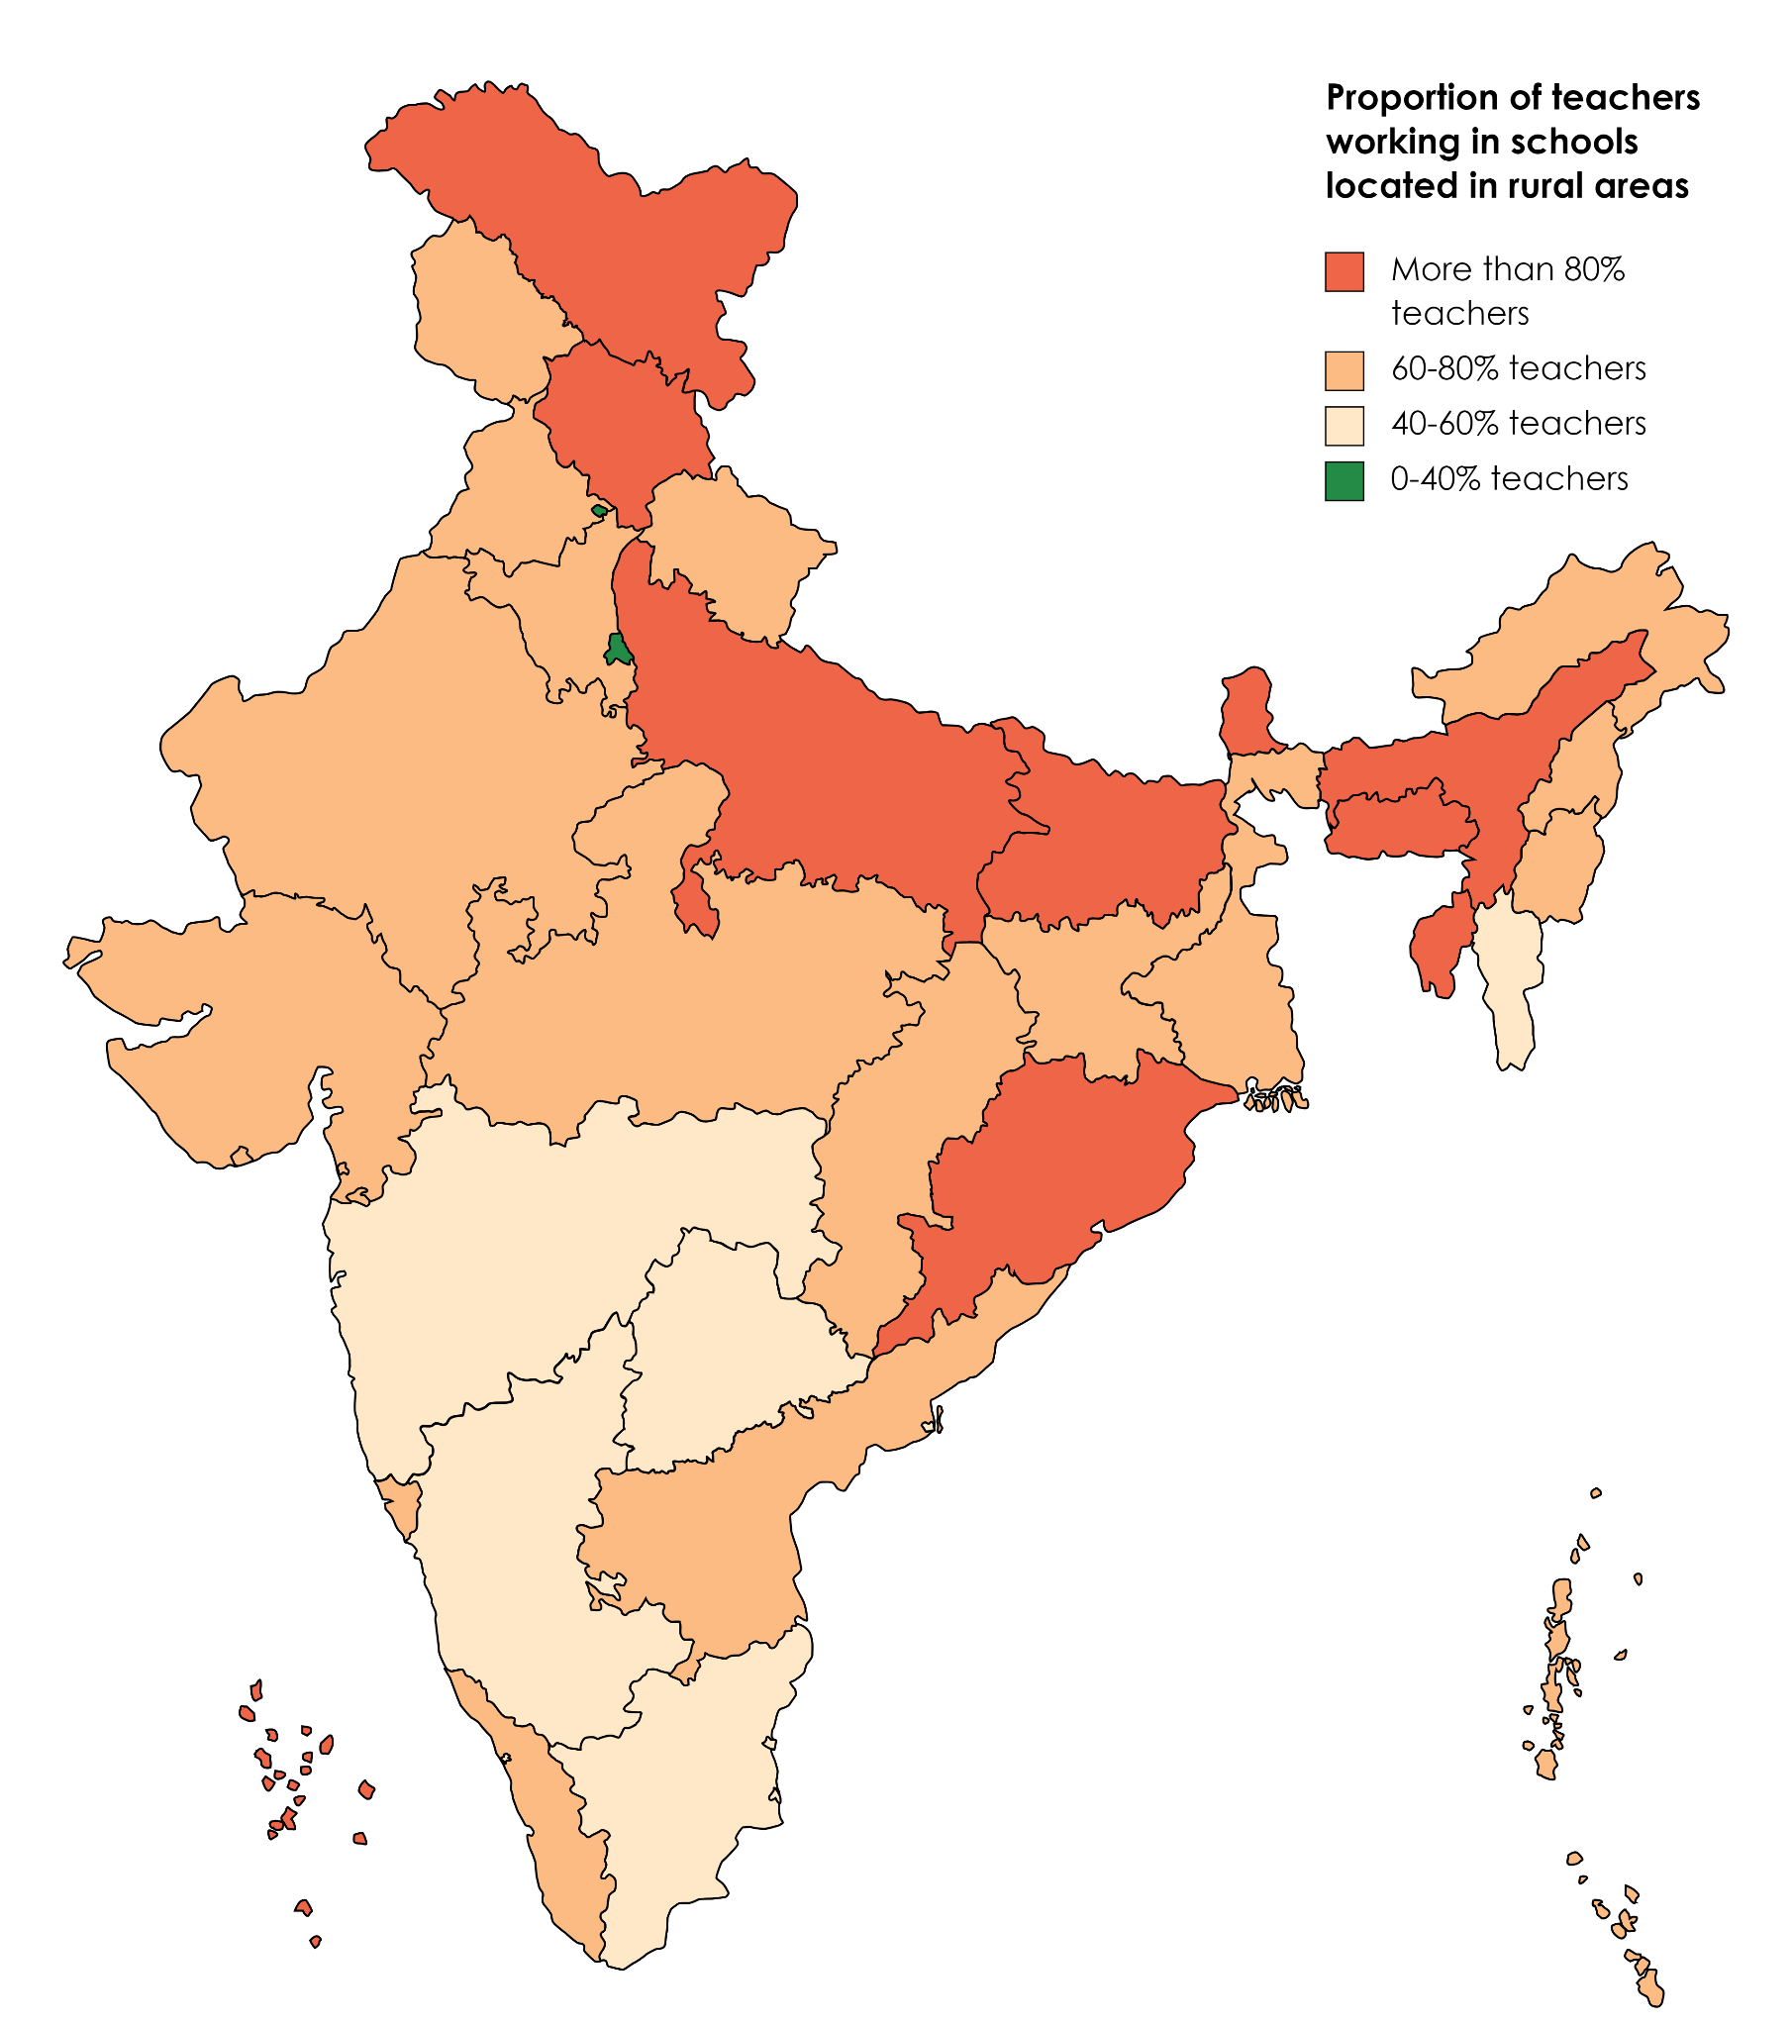
Source: Authors based on data from UDISE+ 2021/22
School Management type: Overall 49.25% of teachers work in Government schools, followed by 37.24% work in Private schools, and 8.38% in Government Aided schools. This means that for every 10 teachers employed in government schools, there are 7.6 working in private schools and 1.7 working in aided schools. The figures for 2018-19 were 60% government school teachers, 26% private school teachers and about 7% private aided schools.
There is considerable variation between states on the proportion of teachers working in government schools vs private schools and aided schools. These signal state-specific trends and policies shaping workforce deployment. States in which the teaching workforce is now primarily in the private sector include nine states Karnataka, Punjab, Uttar Pradesh, Uttarakhand, Haryana, Madhya Pradesh, Puducherry, Tamil Nadu, and Telangana. (see Table 2.3 and Figure 2.2)
Table 2.3 State wise Proportion of Teachers Employed in Government Schools
Proportion of teachers in government school employment | States | Notes
Between 100% and 80% in government schools | Lakshadweep (96.15%), WestBengal (81.10%)
80-70% in government schools | Andaman and Nicobar Islands (76.56%), Ladakh (70.85%), Tripura (75.64%)
70-60% in government schools | Arunachal Pradesh (66.32%), Assam (61.64%), Bihar (67.80%), Chhattisgarh (67.66%), Himachal Pradesh (65.95%), Odisha (60.38%), DNHDD (61.15%), Sikkim (69.82%)
60-50% in government schools | Andhra Pradesh (55.75%), Jammu and Kashmir (58.12%), Jharkhand (55.13%), Rajasthan (52.87%), Delhi (53.33%), Mizoram (57.16%), Nagaland (59.63%)
50-40% in government schools | Karnataka (43.89%), Punjab (46.17%), Uttar Pradesh (41.44%), Uttarakhand (46.49%), Meghalaya (40.88%) | Meghalaya (32.01% in aided schools)
40%-30% in government schools | Haryana (38.77%), Madhya Pradesh (38.79%), Maharashtra (31,07%), Tamil Nadu (38.58%), Telangana (39.81%), Puducherry (36.62%) | Maharashtra: 38.31% in aided schools, Tamil Nadu (13.74% in aided schools)
20-30% in government scho0ls | Kerala (27.81), Manipur (28.54%), Goa (20.67%) | Kerala (32% in aided schools); Goa (63.79% in aided schools. Manipur (13% in other and 13% in aided)
Source: Authors based on data from UDISE+ 2021/22

Figure 2.2 Proportion of Teachers in Government School Employment
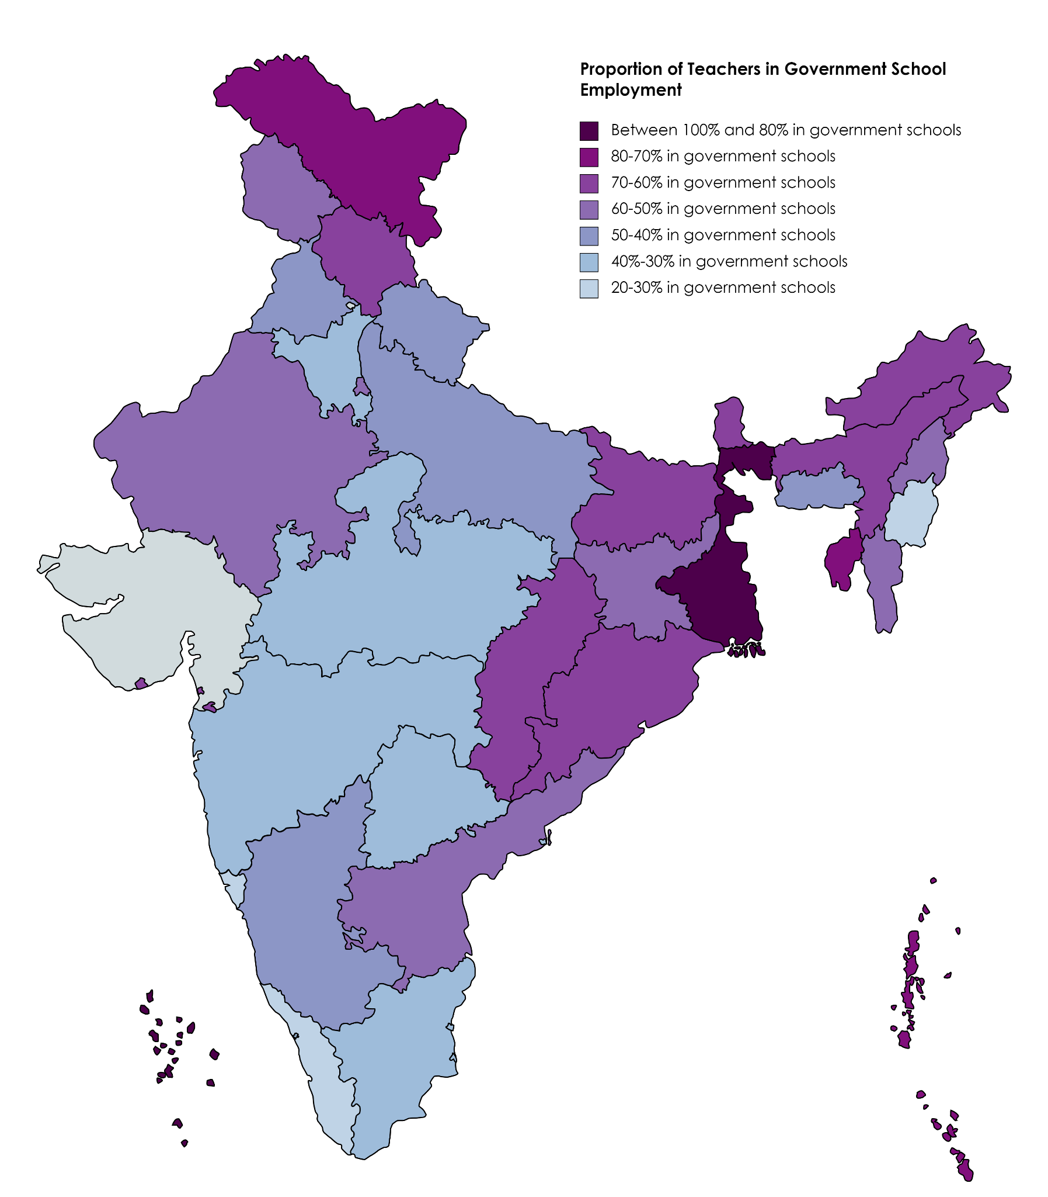
Source: Authors based on data from UDISE+ 2021/22
By school Level Type: overall 50.86% of teachers work in elementary schools, followed by 26.88 % in composite schools and 22.26% in middle/secondary and senior secondary schools.

2.3 Who are our teachers?
A group of teachers whose demographic profile represents the population profile ensures that there is adequate representation reflecting the diversity of the school population in the school. From considerations of both ‘representation’ where students are able to ‘identify’ with the school via the identities of their teachers, cultural requirements, girls and boys and students with disabilities, to have appropriate role models as well as safety, and finally the practical requirement of teaching-learning with knowledge of the local languages, contexts and culture of the students.

2.3.1 Gender
All India, about 51% of school teachers are women. State-to-state variation in the proportion of women teachers in the workforce is considerable. States and union territories with a high proportion of women teachers (>=70%) include Chandigarh (81%), Delhi (74%), Goa (81%), Kerala (79%), Puducherry (75%), Punjab (75%), and Tamil Nadu (75%). States and union territories with a low proportion of women teachers (<= 40%) include Bihar (40%), Jharkhand (40%), Rajasthan (40%), and Tripura (35%).
Women teachers tend to be concentrated in urban areas. 67% of all teachers in urban areas are women compared to 44% in rural areas.
Women teachers also tend to be concentrated in private schools.(see Table 2.4) Overall, only 44% of government school teachers are women, whereas 63% of teachers in private schools are women; ie the proportion of women in the private school workforce is 19% points more than the proportion of women in the government school workforce. There is again considerable interstate variation in the extent of feminisation in the private sector vs the government sector teacher workforce. Also, 73% of teachers in private schools in urban areas are women.
Table 2.4 States with Varied Proportion of Women Workforce in Private Sector Schools
Comparable proportion | Bihar (diff 1.25%); Manipur (diff 4.62%); Uttar Pradesh (-2.7%)
Much higher proportion of women in private vs govt section (.20% points) | Chhattisgarh (31%)
Proportion of women workforce of the private sector is more than 90% | Chandigarh (91%); Delhi ( 88%); Goa (91%); Kerala (90.18%)
Proportion of women in private sector workforce is less than 60% | Andhra Pradesh, Assam, Bihar, Manipur, Mizoram, Rajasthan, Tripura, Uttar Pradesh, Jharkhand, West Bengal, Odisha
Source: Authors based on data from UDISE+ 2021/22
These trends could be understood as arising from disparate socio-economic phenomena at play in States: Overall employment opportunities or development in the state, leading to men occupying jobs that are white coloured but otherwise low status and poorly renumerative; relatively lower or higher level of women’s education, patriarchy, or a combination of all of these. Whether a higher level of men in the private school teaching sector leads to relatively better working conditions and better pay is worth examining.
By school type (based on levels), women teachers comprise 60% of composite school teachers, 51% of elementary school teachers and 41% of middle/secondary/Sr. Secondary school teachers are women. This indicates an overall skewness that could be attributed to the feminisation of teaching in the private sector and secondary and sr. secondary teaching being more male-dominated and lacking adequate women. Close to 80% of women government school teachers are in rural areas as opposed to 45% of women private school teachers.

2.3.2 Social groups
Table 2.5 Proportion of Teachers in Government and Private Schools based on their Social Category
Social Category | As per 2011 census/estimates (all India) and NSSO 2011-12 | UDISE+ (2021-22)
Social Category | As per 2011 census/estimates (all India) and NSSO 2011-12 | Overall | Government | Private
General | 30.77%** | 41.54% | 34.72% | 50.91%
OBC | 44%* | 38.36% | 38.80% | 36.64%
SC | 16.63% (Census 2011) | 12.46% | 15.42% | 8.93%
ST | 8.60% (Census 2011) | 7.64% | 9.99% | 3.51%
(*)Estimate as per NSSO as reported in Report No. 563: Empowerment and Unemployment Situation among Social Group, 2011-12 (Annexure-XIV)
(**)General is estimated as 100%-%SC-%ST-%OBC (NSSO estimate see above)
Source: Authors based on data from UDISE+ 2021/22
42% of all teachers are from the general social category, compared to 12%, 8% and 38% from the Scheduled Caste (SC), Scheduled Tribes (ST), and Other Backward Classes (OBC) communities respectively. 61% of all teachers from the Scheduled Caste communities work in government schools and 27% work in private schools. 64% of all teachers from the Scheduled Tribe communities work in government schools, and 17% in private schools. 50% of all teachers from the Other Backward Classes communities work in government schools, and 36% in private schools (see Table 2.5).
Gender differences among general teachers in the private sector are noted, with close to 68% being women and only 32% being men. Overall, comparing the gender proportions category-wise, a larger proportion of women are found in the general category ( 58% vs 42%) and the proportion in OBC is almost equal at 49% women and 51% men. Among SC and ST, the overall proportion of men is much higher than that of women ( 43-42% vs 57-58%). This is likely a reflection of caste differences in overall education levels and employment opportunities.
There is considerable variation in the relative representation of teachers from SC, ST and OBC castes particularly in private schools, between states.
States: In terms of inter-state variations, states with an overall higher proportion of teachers from the SC communities (>15%) include Andhra Pradesh (18.78%), Himachal Pradesh (15.99%), Punjab (17.25%), Tamil Nadu (15.67%), Tripura (15.89%), and West Bengal (20.74%).
States with a higher proportion of teachers from the ST communities (>15%) include firstly states from the North East: Arunachal Pradesh (72.64%), Meghalaya (87.91%), Mizoram (97.33%), Nagaland (90.82%), Sikkim (41.76%), Manipur (40.02%) and Ladakh (92.46%), Lakshadweep (94.67%), followed by States in the Easter and Central belt: Telangana (33.33%), Chhattisgarh (26.55%), Dadra Nagar and Haveli and Daman and Diu (32.17%), Jharkhand (21.22%), Assam (15.54%).
States with a higher proportion of teachers from the OBC communities (>20%) include Andaman and Nicobar Islands (29.27%), Andhra Pradesh (44.66%), Assam (30.54%), Bihar (50.42%), Chhattisgarh (38.32%), Gujarat (32.01%), Haryana (20.88%), Jharkhand (44%), Karnataka (65.76%), Kerala (47.76%), Madhya Pradesh (35.38%), Maharashtra (32.46%), Manipur (20.59%), Odisha (43.2%), Puducherry (75.58%), Rajasthan (42.29%), Sikkim (43.9%), Tamilnadu (74.06%), Telangana (44.71%), and Uttar Pradesh (41.85%).

2.3.3 Gender and Social Group by School Type (by management)
Based on the figures from Table 2.6 across all school types except the private sector, the proportion of male teachers is higher by about 11% points (Government and government aided, and government other ‘English Medium). The proportion of men exceeds women in welfare department schools by 24% points and Madarsas by 25% points. Only in the case of private unaided schools, the proportion of women teachers exceed that of men: by 26% points in private unaided recognised schools and by 8% points in private unrecognised schools.
The social category-wise profiles of government and government-aided schools are reasonably similar. The proportion of male SC and ST teachers is greater than the proportion of women SC, and ST teachers by almost 20-30% indicative of lower levels of women’s education in these communities. The overall social category profile of private unaided schools and government other (English medium) schools is mostly similar, with better higher representation of men in the latter. These schools generally have a higher proportion of teachers from general categories ( 51% to 56%) and much lower representation of teachers from tribal groups (4-6%).
The proportion of ST teachers in schools run by Welfare departments (social, tribal and labour) is highest at 44%, in comparison, their proportion in Private unaided schools is lowest at 4%. Teachers from scheduled caste communities represent an overall 12% and are more or less evenly distributed among all school types (between 9% and 15%).

Table 2.6: Social Category of Teachers by School Management Type
 | Total Teachers | General |  | SC |  | ST |  | OBC
School Management |  | F | M | F | M | F | M | F | M | Total Female | Total Male
Overall | 9,507,123
* gender proportion |  | 58% | 42% | 43% | 57% | 42% | 58% | 49% | 51% | 51% | 49%
* % of category in school type |  | 42% |  | 12% |  | 8% |  | 38%
Government School | 4,665,203
* gender proportion |  | 49% | 51% | 39% | 61% | 38% | 62% | 44% | 56% | 44% | 56%
* % of category in school type |  | 35% |  | 16% |  | 10% |  | 39%
Government Aided | 796,631
* gender proportion |  | 46% | 54% | 34% | 66% | 43% | 57% | 45% | 55% | 45% | 55%
* % of category in school type |  | 43% |  | 9% |  | 7% |  | 41%
Private Unaided (Recognized) | 3,540,647
* gender proportion |  | 68% | 32% | 53% | 47% | 59% | 41% | 59% | 41% | 63% | 37%
* % of category in school type |  | 51% |  | 9% |  | 4% |  | 37%
Unrecognized | 175,264
* gender proportion |  | 56% | 44% | 49% | 51% | 59% | 41% | 51% | 49% | 54% | 46%
Madarsa | 112,135
* gender proportion |  | 40% | 60% | 35% | 65% | 39% | 61% | 36% | 64% | 38% | 62%
* % of category in school type |  | 45% |  | 3% |  | 0% |  | 52%
Government Other (Generally English Medium) | 74,973
* gender proportion |  | 48% | 52% | 37% | 63% | 43% | 57% | 39% | 61% | 44% | 56%
* % of category in school type |  | 56% |  | 14% |  | 6% |  | 25%
Welfare Departments(Social, Tribal, Labour) | 142,270
* gender proportion |  | 43% | 57% | 42% | 58% | 34% | 66% | 39% | 61% | 38% | 62%
* % of category in school type |  | 15% |  | 15% |  | 40% |  | 29%
% of category in TWD school type | *127,320 | 15% |  | 14% |  | 44% |  | 27% |  | 36% | 64%
Source: Analysis authors based on UDISE 2021-22 data

2.3.4 Teacher qualifications
Overall, 83% of teachers are graduates or postgraduates and 90% of teachers have some form of professional qualification, including a Diploma, B.El.Ed, B.Ed, M.Ed, or other qualification. Thus, 10% of all teachers have no professional qualification at all. Of the group of teachers with no professional qualification, 69% work in rural areas and 31% in urban areas. Among all teachers without professional qualifications, 21% work in government schools and 61% in private schools. 4% of all government school teachers have no professional qualification compared to 16% of all private school teachers.
States reporting having only qualified teachers include Delhi, the Union Territories of Andaman and Nicobar Islands and Lakshadweep. 16 states and union territories have 90% or more teachers who are professionally qualified.
States with a higher proportion of teachers without any professional qualification include the North Eastern States of Manipur (24%), Assam (34%), Nagaland (39%), Meghalaya (37%), Tripura (26%) and Sikkim (24%). Other states with a high proportion of teachers without professional qualification include Jammu Kashmir (23%) and Ladakh (25%), Jharkhand (14%), Uttar Pradesh (15%), Arunachal Pradesh (15%), Bihar (15%) and Madhya Pradesh (11%).
States with a relatively higher proportion of teachers without professional qualifications in urban areas include Gujarat (70%), Karnataka (67%), Maharashtra (65%) and Telangana (80%). This may also reflect the concentration of such teachers in the private sector in these states. The proportion of unqualified teachers in private sector employment was particularly high in the states of DNH&DD (83% in private sector), Gujarat (98%), Haryana (82%), Madhya Pradesh (89%), Maharashtra (87%), Puducherry (97%), Punjab (89%), Rajasthan (90%), Telangana (83%). States with a higher proportion of unqualified teachers in government sector employment include Chandigarh (70% of teachers without professional qualification), Jharkhand (77%) and Tripura (79%).

3. What is the service environment?
NEP 2020 notes the importance of providing a supportive service environment to enable teachers to do their job effectively. In this section, UDISE+ data is used to examine the availability of infrastructure and teaching/learning resources in schools, including basic amenities, basic professional requirements, as well as academic leadership and support for teachers. The UDISE+ data which is generally used as a metric of inputs to students, also serves as an indicator of teachers.

3.1 Basic amenities
In terms of access to basic amenities, wide variations exist between states, as well as between urban-rural areas. This section provides an overview of the availability of basic amenities including accessible roads, functional girls' and boys’ toilets, working electricity, classrooms in good conditions, and ramps and handrails in schools in India. (see Table 3.1)
Conditions of classrooms are the area of most concern: Only 63% of all schools - 58% of all rural schools and 83% of all urban schools - report having all classrooms in ‘good condition.’ States reported having less than 60% of schools with all classrooms in good condition including Andaman and Nicobar Islands (47%), Arunachal Pradesh (31%), Assam (29%), Bihar (59%), Chhattisgarh (59.7%), Himachal Pradesh (58%), Jammu and Kashmir (49%), Ladakh (33%), Manipur (40%), Meghalaya (34%), Mizoram (40%), Nagaland (35%), Odisha (59%), Sikkim (45%), Tripura (32%), Uttarakhand (55%) and West Bengal (43%).
Ramps and handrails: 72% of all schools (74% rural and 63% urban) report having ramps, and 50% of all schools (51% rural and 42% urban) report having both ramps and handrails. 59% of all government schools have both ramps and handrails as compared with 32% of all private schools. 83% of all government schools and only 49% of all private schools have at least ramps.
In terms of inter-state variations, states and union territories with a higher proportion of schools with ramps and handrails include Assam (62%), Chhattisgarh (61%), Dadra and Nagar Haveli and Daman and Diu (88%), Delhi (100%), Himachal Pradesh (65%), Kerala (61%), Lakshadweep (76%), Maharashtra (79%), Odisha (69%) and Punjab (85%).
States and union territories with a lower proportion of schools with ramps and handrails include Andaman and Nicobar Islands (35%), Andhra Pradesh (36%), Arunachal Pradesh (18%), Bihar (38%), Jammu and Kashmir (15%), Jharkhand (37%), Ladakh (31%), Madhya Pradesh (38%), Manipur (36%), Meghalaya (21%), Mizoram (19%), Nagaland (16%), Sikkim (20%), Telangana (32%) and Tripura (35%).
Road access: Overall, 89% of all schools - 88% of all rural schools and 93% of all urban schools - are accessible by roads in all weather conditions. Between 97% and 100% of schools are accessible by road in Chandigarh, Dadra and Nagar Haveli, Daman and Diu, Delhi, Goa, Gujarat, Haryana, Kerala, Maharashtra, Odisha, Puducherry, and Punjab. In hilly or mountainous states and union territories, the proportion drops to as low as 63% in Meghalaya.
Drinking water and toilets: 96% of all schools report having functional drinking water facilities which includes 96% of all rural schools and 97% of all urban schools.

Table 3.1 Basic Amenities: States of Concern
North Eastern States have lower basic amenities in schools–affecting students and also service conditions for teachers in several aspects:
- Access by Road: Meghalaya-63%; Arunachal Pradesh- 72%
- Drinking Water Facilities: Meghalaya-46%; Nagaland-60%; Arunchal Pradesh-68%; Tripura-75%
- Functional Toilets for boys and girls: Arunachal Pradesh-67% & 69%; Meghalaya-73% & 70% Manipur-75% & 75%; Nagaland-76% & 77%; Tripura- 72% & 74%; Assam - 76% & 82%)
- Electricity: Meghalaya-25%; Arunachal Pradesh-53%; Manipur-54%; Tripura-55%; Nagaland-67%
- Good Condition Classroom: Assam-29%; Arunchal Pradesh-31%; Tripura-32%; Meghalaya34%; Nagaland-35%; Manipur-40%; Mizoram-40%; Sikkim-45%
- Disability Access: Arunachal Pradesh- 25%; Sikkim-29%; Meghalaya-30%; Nagaland-38%; Mizoram-44%, Manipur-50%; Tripura-63%; Assam-69%
Other states of concern:
- Access by Road: Uttarakhand-63%; Jammu & Kashmir-79%; Jharkhand-76%
- Drinking Water Facilities: Telangana-86%
- Functional Toilets for boys and girls: Telangana- 68%&78%; Jammu & Kashmir-79%&82%
- Electricity: Jammu & Kashmir-73%; Madhya Pradesh-75%; Odisha-77%; Uttar Pradesh-81%
- Good Condition Classroom: Ladakh-33%; West Bengal-43%; Andaman&Nicobar-47%, Jammu&Kashmir- 49%;
- Disability Access: Jammu & Kashmir-39%; Andhra Pradesh-54%; Goa-61%; Uttarakhand-62%;
- Andaman & Nicobar-63%; Jharkhand & Uttar Pradesh-64%; Puducherry & Rajasthan-65%
Source: Authors based on data from UDISE+ 2021-22
Boys’ toilets are available in 91% of all schools: 91% of schools in rural areas and 92% of schools in urban areas have functional boys’ toilets. States with fewer than 75% of schools with functional boys’ toilets include Arunachal Pradesh (67%), Manipur (74.8%), Meghalaya (73%), Telangana (68%), and Tripura (72%). Overall, 94% of all schools report having functional girls’ toilets - with 94% of rural schools and 96% of urban schools having functional girls’ toilets. States with fewer than 75% of schools with functional girls’ toilets include Arunachal Pradesh (69%), Meghalaya (70%), and Tripura (74.5%).
Electricity: Overall, 87% of all schools in the country report having working electricity which includes 85% of rural schools and 96% of urban schools. States with low levels of electrification i.e. fewer than 75% of schools having access to working electricity include Arunachal Pradesh (53.8%), Jammu and Kashmir (72.9%), Madhya Pradesh (74.8%), Manipur (54.5%), Meghalaya (24.7%), Nagaland (67.1%), and Tripura (55%). The proportion of rural schools in these states having working electricity is even lower. On the other hand, states reporting 100% electrification include Chandigarh, Dadra and Nagar Haveli, Daman and Diu, Delhi, Goa, Gujarat, Lakshadweep, Puducherry, Punjab and Tamil Nadu.

3.2 Professional work environment
The availability and quality of teaching-learning materials play a major role in teacher motivation and satisfaction. This section provides an overview of the availability of textbooks, libraries, computing devices, internet, and the prevalence of visits by academic supervisors in schools in India.
Libraries and teaching-learning resources: Overall, 77% of all schools - 76% of rural schools and 81% of urban schools - have libraries. However, inter-state variations are huge when it comes to the prevalence of libraries. States and union territories with fewer than 50% of schools having libraries include Arunachal Pradesh (30%), Bihar (40%), Jammu and Kashmir (42%), Manipur (22%), Meghalaya (12.4%) and Tripura (26%). On the other hand, 100% of schools in Delhi and Lakshadweep report having libraries, with states and union territories such as Andaman and Nicobar Islands (97%), Chandigarh (96%), Chhattisgarh (96%), Dadra and Nagar Haveli and Daman and Diu (98%), Goa (97%), Kerala (95%) and Puducherry (99.6%) having a high proportion of schools with libraries.
Availability of computing devices, internet and ICT labs: With an increase in the provision of professional and academic resources, and professional development for teachers being provided online, the availability of computing devices and the Internet play a key role in the professional working conditions of teachers. Similarly, school administrative work increasingly requires access to computing devices and the Internet. The COVID-19 pandemic also provided an impetus to the use of ICT for teaching and learning; thus further increasing the importance of having a robust ICT infrastructure in schools.
Overall, the availability of computing devices (laptops or desktops) in schools remains quite low at 32%. This includes 27% of all rural schools and 55% of all urban schools. States and union territories with a higher prevalence of computing devices include Chandigarh (99%), Delhi (100%), Kerala (96%), Lakshadweep (95%), Puducherry (90%) and Punjab (91%). On the other hand, states and union territories with very low access to computing devices in schools include Assam (10%), Bihar (9%), Madhya Pradesh (19%), Meghalaya (13%), Odisha (18%), Uttar Pradesh (14%), and West Bengal (17%).
Access to the Internet is low in schools across India. Overall, only 34% of schools - 29% rural and 58% urban schools - report having access to the Internet. However, this still signifies an increase in internet access compared to a figure of 19% in 2018-19. States and union territories with particularly low availability of Internet include Assam (12%), Bihar (11%), Mizoram (8%) and Odisha (15%). States and union territories with relatively better levels of internet access include Andaman and Nicobar Islands (45%), Andhra Pradesh (56%), Chandigarh (99%), Dadra and Nagar Haveli and Daman and Diu (57%), Delhi (100%), Goa (58%), Gujarat (92%), Haryana (51%), Kerala (95%), Ladakh (43%), Lakshadweep (97%), Maharashtra (48%), Nagaland (51%), Puducherry (98%), Punjab (59%) and Rajasthan (60%).
In terms of availability of ICT labs, 82,223 schools report having ICT labs which include 60,894 schools in rural areas and 21,329 schools in urban areas. While this includes schools across management type, UDISE+ primarily attempts to capture data on ICT labs for government and government-aided schools. Hence, percentages have not been reported for this metric.
Receipt of free textbooks: Students in elementary government schools are entitled to free textbooks. However, data on the receipt of free textbooks is not readily available in the UDISE 2021-22 dataset.
Visits by academic supervisors: Overall, 58% of schools (63% of rural and 34% of urban schools) report visits by academic supervisors such as block and cluster resource persons and district academic inspectors. 89% of these schools were reported in government schools; on the other hand, no private school reports visits by academic supervisors. 79% of all government schools report at least one visit by an academic supervisor.
Lower coverage of supervision visits is reported in the states and union territories of Bihar (35%), Himachal Pradesh (48%), Jammu and Kashmir (42%), Ladakh (38%), Uttar Pradesh (43%), and Uttarakhand (39%).
On the other hand, higher coverage of supervision visits is reported in the states and union territories of Andaman and Nicobar Islands (74%), Andhra Pradesh (73%), Assam (73%), Chhattisgarh (82%), Dadra and Nagar Haveli and Daman and Diu (79%), Goa (80%), Jharkhand (73%), Kerala (75%), Lakshadweep (97%), Maharashtra (76%) and Tamilnadu (76%).

3.3 Employment terms
UDISE provides information on the ‘nature of appointment’ of teachers, and notes: “The appointment of a teacher may be on a regular basis, on contract, or as part-time/guest teacher’. Field interaction suggests that the definition of these categories varies contextually–from state to state as well as between government and non-government/private managements. Moreover, both field data and PLFS indicate that there are teachers in the system with no formal contract–and are likely employed based on verbal agreement on terms between employer and teacher. Given this, the picture from UDISE+ on employment terms/appointment types is very limited. To some extent, we are able to make sense of government schools where at least the term ‘regular’ is used to indicate employment until retirement–although based on interactions with states, this does not mean that the teacher is a government servant–their contracts may be for the entire period until retirement, but not carrying any extensive benefits of being a government employee. A detailed analysis is provided in the background paper on contract teachers. We limit our observations here to some basic details only.

The overall level of contractual teachers in government is about 11%. 19 states and union territories have contact teachers more than 11%, with high levels being seen in the Northeastern states of Tripura (19%), Assam (24%), Mizoram (37%), Arunachal Pradesh (53%), Meghalaya (69%), and Sikkim (37%). High levels are also seen in Chandigarh (35%, Uttar Pradesh (25%) DNH&DD (47%) and Jharkhand (54%). Delhi has a higher percentage of ‘part-time teachers’ at 18%.

16% of government primary school teachers are contractual, indicating that proportionally more posts in primary schools have been filled by contractual teachers. In the states of Arunachal Pradesh (61%), Jharkhand (77%) and Meghalaya (53%), more than 50% of the contractual teachers are in primary schools.

Almost all the contractual appointments i.e. 90% are in rural schools: 4,68,820 of the total 5,18,111 teachers.
Overall nationally only 1% of teachers are part-time teachers. Delhi stands out in part-time teacher recruitment from other states by having 14% of the state’s teacher workforce being part-time teachers and 72% of them are women. Out of all the government teachers in the state, 25% of them are recruited as part-time teachers.

UDISE+ data does collect the information on gender and age of teachers, but this is not available for analysis.

3.4 Service Environment in Aspirational Districts
To better understand the challenges faced by teachers in districts with low human development indices in the country, certain aspirational districts have been selected for in-depth analysis through both primary data collection and secondary data sources in the states of Assam, Bihar, Chhattisgarh, Karnataka, Maharashtra, Punjab, Telangana and Mizoram.
Schools
In general, all selected aspirational districts have a high proportion of rural schools. For context, 80% of all schools in the country are situated in rural areas. Aspirational districts with a high proportion of rural schools include Darrang in Assam (96%), Muzaffarpur in Bihar (92%), Bastar in Chhattisgarh (93%), and Nandurbar in Maharashtra (90%). In all of these cases, the aspirational districts have a higher proportion of rural schools compared to their respective states.
In these selected districts, the proportion of government schools is found to be similar to the overall proportion of government schools in the state. Some exceptions include Bastar (93%) compared with 86% for Chhattisgarh, Nandurbar (69%) compared with 59% in Maharashtra, and Jayashankar Bhupalapally (83%) compared with 64% for Telangana. In terms of private schools, both Nandurbar with 8% and Gadchiroli with 7% have a significantly lower proportion of private schools compared with 18% for Maharashtra. Similarly, both Jayashankar Bhupalapally with 14% and Bhadradri Kothagudem with 14% have a lower proportion of private schools compared with 28% for Telangana.
Teachers
Some of the aspirational districts have a higher percentage of single-teacher schools compared to the state. For example, Purnia has 12% of all schools as single-teacher compared with a figure of 6% for Bihar. Bastar with 33% compared with 10% for Chhattisgarh, Gadchiroli with 13% compared with 5% for Maharashtra, Firozpur with 13% compared with 9% for Punjab, Jayashankar Bhupalapally with 19% and Bhadradri Kothagudem with 17% compared with 15% for Telangana are other examples.
The percentage of women teachers in these aspirational districts is lower than the national figure of 51% with the notable exception of Korba in Chhattisgarh (52%), Moga (73%) and Firozpur (69%) in Punjab, Bhadradri Kothagudem in Telangana (53%) and Kolasib in Mizoram (51%). On the other hand, the proportion is as low as 29% in Dhubri in Assam, 29% in Nandurbar and 28% in Gadchiroli in Maharashtra.
The proportion of teachers with a graduate or postgraduate and above academic qualifications in these aspirational districts is commensurate with the overall proportion in their respective states. Similarly, professional qualifications are also commensurate with the figures of the state.
The proportion of contract teachers varies across states. For example, Darrang in Assam has 33% of all teachers as contractual, as compared with the state figure of 20%. In other states, the proportion of contract teachers in these aspirational districts is commensurate with the overall percentage of contract teachers in the state.
Working conditions: Basic amenities
In terms of accessibility, schools in these aspirational districts compare well with the overall accessibility of schools in their respective states. With the exception of Jayashankar Bhupalpally in Telangana (84%), aspirational districts fare well in terms of the provision of functional drinking water, with at least 90% of all schools in these districts having access to functional drinking water.
The selected aspirational districts fare poorly with respect to the provisioning of functional boys’ and girls’ toilets. Only 36% of schools in Jayashankar Bhupalpally and Bhadradri Kothagudem in Telangana have functional boys’ toilets. The figures are worse for girls’ toilets, with 39% for Moga in Punjab, 45% for Jayashankar Bhupalpally and Bhadradri Kothagudem in Telangana having functional girls’ toilets.
Access to working electricity is broadly lower than state figures in these aspirational districts. For example, Dhubri (64%) in Assam (75%), Nandurbar (61%) and Gadchiroli (65%) in Maharashtra (86%) have significantly lower access to electricity than the overall state.
While comparable to the figures for their respective states, the percentage of schools with all classrooms in good condition is quite low in these aspirational districts. The figures are particularly low for Darrang (30%) and Dhubri (32%) in Assam and Mamit (35%) and Kolasib (39%) in Mizoram.
While the availability of ramps and handrails in these aspirational districts is also broadly comparable to the overall situation in the state, Muzaffarpur (21%) in Bihar (38%) and Raichur (44%) in Karnataka (59%) show a significant difference.
In general, the provision of basic amenities in aspirational districts is not adequate and contributes to less-than-optimal working conditions for teachers in these places.
Working conditions: Professional
By and large, the availability of libraries in these aspirational districts is commensurate with the overall situation in the state. However, Dhubri (47%) in Assam (73%), Muzaffarpur (26%) in Bihar (40%) and Yadgir (77%) in Karnataka (95%) show a significant difference.
With the exception of Kolasib in Mizoram, these aspirational districts have significantly lower availability of computing devices compared with their respective states. With the exception of Darrang in Assam, lower levels of internet provisioning are reported in these aspirational districts as compared with the states. Visits by inspectors and academic supervisors are at the same level as the respective states, which are generally overall high all over India.

3.5 Changes between 2018-19 and 2021-22
Overall: In general, in all areas of basic amenities aspects of service conditions, there has been improvement between 2018-19 and 2021-22, as reported in UDISE. ICT provisioning improvements are marginally better ( 5% to 5.52%): This is surprising considering that after COVID one expected to see a spurt of investments in ICT infrastructure in schools. Availability of the internet has improved (19% to 34%.). Classroom conditions have dipped slightly (65% to 63%), and markedly lower visits by academic supervisors (73% to 58%). (see Figure 3.1)

Figure 3.1 Changes in Basic Amenities from 2018-19 to 2021-22
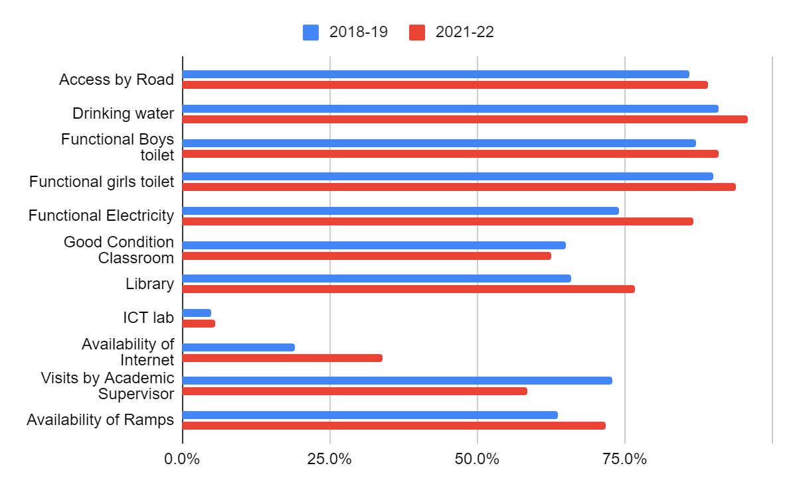
Source: Authors based on data from UDISE+ 2021-22

4. Teacher availability and deployment
While Section 3 of UDISE gathers several fields of information at the individual teacher level which are of immense value in understanding teacher availability and deployment, only a limited data set is publicly available for analysis on teacher availability and deployment. Dimensions that enable an overarching understanding of this issue include the following:
(i) Overall availability in terms of the adequacy of the number of teachers at the school. Pupil-teacher ratios are a proxy for teacher adequacy–illuminating different aspects of the question of availability depending on the level at which PTR is computed: with the school as a unit, or by overall schools, schools by level, schools by management type, by district, by state or by urban-rural. Schools enabling different degrees of Norms governing this are derived from the Right to Education Act (GoI, 2009). Factors affecting either excess or shortage of teachers relate to recruitment (lack of), availability, and deployment and transfers of teachers.
(ii) Overall availability of teachers with appropriate qualifications–both appropriate/relevant academic qualification and professional qualification–which differs based on whether the teacher is a primary school teacher, a secondary subject teacher (TGT) or a senior secondary teacher (PGT). This can be assessed in DISE data by examining whether teachers have the minimum appropriate academic qualification and professional qualifications. Having teachers who lack appropriate academic and professional qualifications when analysed across levels, management types, rural-urban differences, etc. are indicative of practices that may be still prevalent, (in)ability to regulate effectively, cost-saving measures, perceptions regarding the importance of professional qualifications, educational characteristics of the workforce locally, and availability of appropriately qualified workforce.
(iii) Needless to say, teacher recruitment and deployment need to ensure that the right kinds of teachers are deployed in individual schools so that the various components of the curriculum are taught by teachers who have the right qualifications for the subject.

Table 4.1 Minimum Qualifications Required for Teaching various Levels #
Level | Nature of preparation: generalist/speacialist and specializations | Entry level academic qualification (basic) | Teacher education programme
Early Childhood Care and Education/Nursery/Pre school* | Pre-Primary/Anganwadi  (Generalist- language, mathematics/ early literacy, numeracy) | Secondary or senior secondary | Nursery teacher
Primary School | I,II,III,IV,V  (Generalist- language, mathematics and environmental studies) | Senior secondary | DElEd, or BElEd
Middle School | VI,VII,VIII  Subject teacher (trained graduate teacher) | Graduate degree (BA/BSc) in one or two specific academic subjects:  Languages: One of the modern Indian languages)  English  Mathematics  Science: Physics and/or Chemistry  Biology (botany/ zoology), etc.  Social Science: History and/or Geography, Economics, etc. | B.Ed/ B.Sc.B.Ed/ B.A.B.Ed/ M.Sc.Ed
Secondary School | IX,X  Subject teacher (trained/ post graduate teacher)  Minimum specialisation required for middle and secondary levels  Regional languages  English  Mathematics  Science  Social Science |  | B.Ed/ B.Sc.B.Ed/ B.A.B.Ed/ M.Sc.Ed
Senior Secondary School | XI, XII  Subject teacher (post graduate teacher) | Post Graduate degree (MA/MSc)  Regional languages (compulsory)  English (compulsory)  Electives:  Mathematics  Physics  Chemistry  Biology  Computer Sciences  History  Geography, Economics etc. | B.Ed/ B.Sc.B.Ed/ B.A.B.Ed/ M.Sc.Ed
 | Physical Education (P.Ed.) | Undergraduate in physical education | C.P.Ed., D.P.Ed., B.P.Ed
 | Art/Music Education*  Visual Arts (V.A.) | Undergraduate in V.A. | B.V.A.Ed
 | Vocational Education** | No information | No information
Special Educator | Generalist with specialized knowledge of inclusion | Undergraduate | B.Ed (Spl Ed)
* NCTE has regulations for this qualification however, the sector is not regulated by them.
** Regulator’s status unclear
# With the introduction of ITEP from 2023 has been accompanied by circulars that indicate that this matrix is about to undergo significant changes.
Source: NCTE and RCI websites and UNESCO ‘No Teacher No Class’ 2021 Report.
This level of analysis should be possible based on UDISE data captured in section 3, however, as this data is not made available for public use, we are unable to comment on this through UDISE.

4.1 PTRs
4.1.1 Overall
The national PTR average for all schools is 28:1. The PTR for rural schools is 28:1 and for urban schools 29:1. Overall for primary schools the PTR is 26:1, for upper primary it is 19:1, for secondary it is 18:1 and for higher secondary 27:1. Overall government PTR is 28:1 while for private schools it is 26:1.
Between States, there is considerable variation with regard to PTRs. The trend seems to be that where Government school PTRs are low, Private school PTRs tend to be higher, and where govt PTRs are higher, private school PTRs are lower. Overall, the PTR at the state level for private schools varies between 12:1 and 45:1 with most having PTRs between 20 and 30. In comparison, the PTRs of government schools vary widely between 6:1 and 57:1, with 16 states having PTRs< 20:1 and 5 with PTR> 30:1 (see Table 4.2 and Figure 4.1).
Table 4.2 States across PTR range
7:1-10:1 | Sikkim, Nagaland, Ladakh, Andaman and Nicobar | Private schools in these states have higher PTRs, 12:1(Sikkim)>PTR>20:1(Nagaland)
11:1 to 20:1 | Arunachal Pradesh, Goa, Himachal, J&K, Kerala, Lakshadweep, Manipur, Maharashtra, Mizoram, Puducherry, Tripura, Uttarakhand | PTRs in private schools are generally comparable, with exception of Goa, Maharashtra and Uttarakhand where it is higher.
21:1 to 29:1 | Andhra Pradesh, Assam, Chhattisgarh, DNHDD, Gujarat, Haryana, Karnataka, Madhya Pradesh, Meghalaya, Odisha, Punjab, Rajasthan, Tamil Nadu, Telangana, West Bengal | PTRs in private schools are comparable, with exception of Assam and Odisha where it is much lower.
30:1 to 40:1 | Chandigarh, Delhi Uttar Pradesh | PTRs in private schools are much lower in Chandigarh and Delhi and comparable in UP
41:1  57:1 | Jharkhand  Bihar | In Bihar, Govt Secondary and Composite schools have PTRs> 80:1
Source: Authors based on data from UDISE+ 2021-22

Figure 4.1 Statewise Comparison of PTR
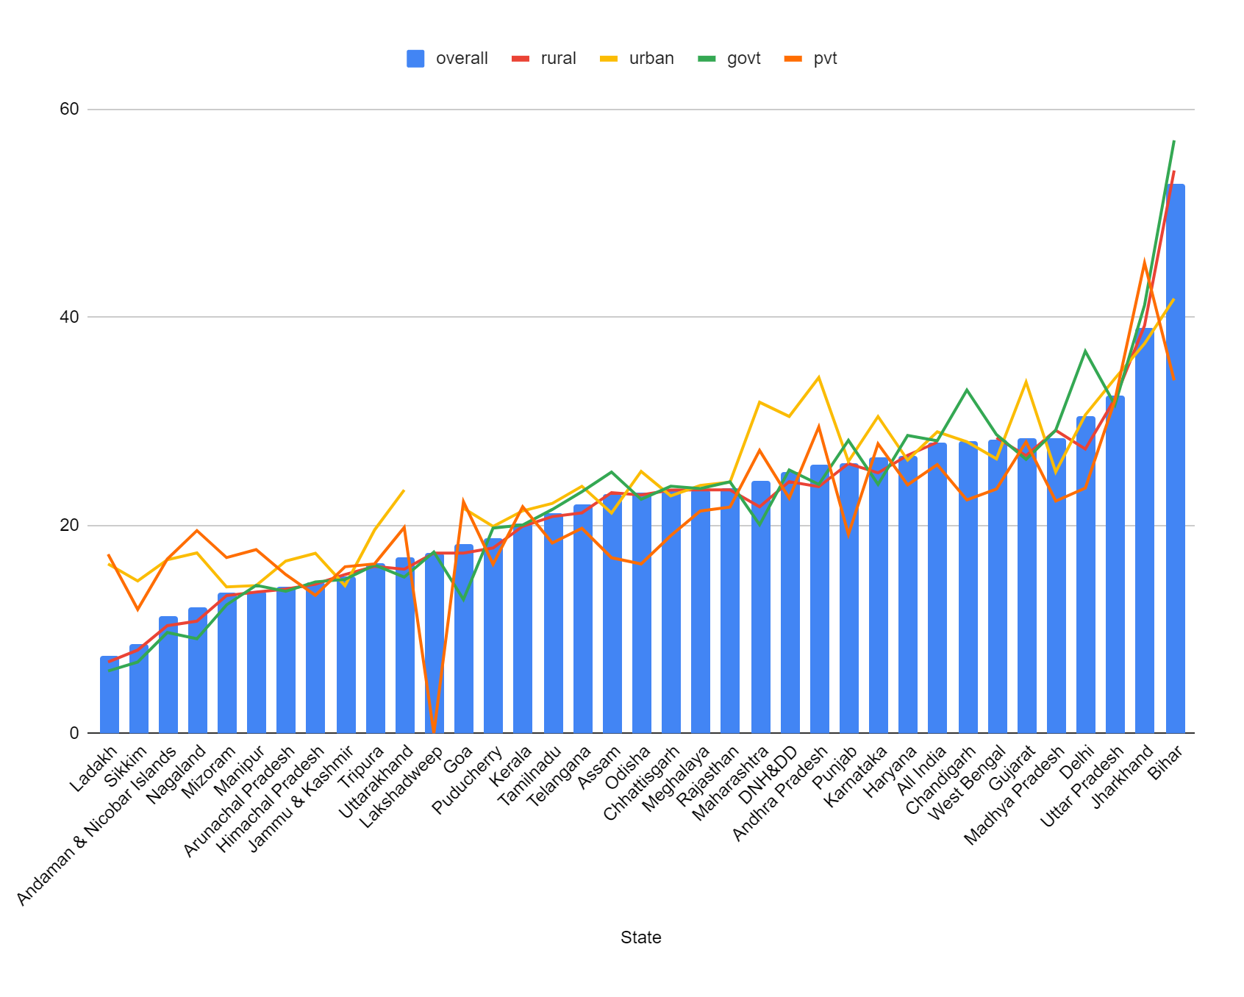
Source: Authors based on data from UDISE+ 2021-22
School size and compositeness have an effect on overall teacher management. The more composite a school is, the more the overall teacher availability and the more access students will have at every level to specialized teachers for academic subjects, a variety of languages, as well as physical education, art, music, work education, etc. Teachers enjoy the benefits of being part of a robust professional community. The provision of school heads for higher grades and larger schools also brings in academic and administrative leadership and the increased likelihood of academic planning and supervision.
About 9% of all schools in India are composite, employing 27% of all teachers. 11% of all government school teachers work in composite schools, as compared to 48% in private schools, and 29% in government-aided schools.
The average PTR of composite government schools is 1:36 as compared with an average PTR of 1:27 for elementary government schools and 1:32 for secondary government schools. For context, the average PTR of composite private schools is 27 and composite government-aided schools is 34.
The average school size for primary-only schools is 80, and for government primary schools is 74, with the government primary schools in rural areas having an average school size of 70. For context, the average school size for elementary schools is 115, for composite schools is 518, and for middle to senior secondary schools is 267.

4.2 PTR at School Level
According to the Right to Education Act the Pupil-Teacher Ratio, norms are defined for each individual school. They are expected to be PTR of 30:1 for grades 1 to grade 5 (primary) and 35:1 for grades 6 to grade 8 (middle school/upper primary). The act also specifies full-time subject teachers for grades 6 to 8 and part-time teachers for art, physical and work education.
UDISE captures data pertaining to available teachers in each school. However, sanctioned posts for each school are not reported, and hence teacher requirement-related information is inferred from the number of teachers in a school. In order to estimate the requirement of teachers, a PTR of 35:1 is used.
A School-level PTR>1:35 is taken as indicative that there is likely to be a teacher requirement in that school. By the same measure, a school-level PTR<1:30 is taken as indicative that there may be an excess of teachers in that school.
24% of all schools in the country have PTR>1:35; this means that they have a teacher requirement. 66% of these schools are government schools and 20% are private schools. 81% of schools with PTR>35 are in rural areas. These rural schools constitute 23% of all the rural schools in the country.
67% of all schools have PTR<1:30. 65% of them are government schools. Out of these, 83% are in rural areas. These rural schools constitute 68% of all the rural schools in the country. Rather than being a rural-urban difference, having lower PTRs and higher PTRs both seem to be a rural phenomenon.
66% of schools with PTR>1:35 are government schools, and 20% are private schools. 24% of all government schools in the country have PTR>1:35, and 2% of all private schools in the country have PTR>1:35.
Of all schools with PTR>1:35, 59% are government schools in rural areas, and 7% are government schools in urban areas. 51% are elementary government schools, 4% are composite government schools, and 11% are government secondary schools. 20% are private schools and 8% are government aided schools.
The average school size of schools with a PTR between 1:30-1:35 is 178. The average school size for schools in rural areas with a PTR between 1:30-1:35 is 150, and 316 in urban areas, 140 in government schools, 263 in private schools, and 328 in government-aided schools.
States with 20% or more government schools with teacher requirements include Assam (22%), Bihar (70%), Chandigarh (33%), Delhi (50%), Haryana (24%), Jharkhand (49%), Karnataka (20%), Madhya Pradesh (26%), Rajasthan (22%), Uttar Pradesh (30%), Uttarakhand (25%) and West Bengal (24%). While most of the requirement is in rural areas, (overall govt school requirement in rural is 90%), in more urbanised and developed states such as Karnataka, Kerala, Maharashtra, Goa and Gujarat, Tamil Nadu and Telangana, and also DNHDD, about 25%-30% government schools with high PTR are in Urban areas. States with 20% or more Private schools with teacher requirements include Andhra Pradesh (23%), Bihar (29%), Gujarat (28%), Jharkhand (46%), Karnataka (26%), Maharashtra (27%), Uttar Pradesh (30%), and West Bengal (21%).

4.3 Single-teacher schools
Overall, 9.5% of government schools are single-teacher schools. 91% of all single-teacher schools are primary schools. (see Table 4.3)
The group of states with a higher percentage of single-teacher government schools suggest that the reasons are varied: supply of qualified teachers, delays in recruitment, difficulties in rationalizing deployment and difficult-to-staff areas (rural-remote, hilly). (i) In the North East, it is both a lack of adequate teacher supply (overall shortage of qualified teachers) along with difficult terrain affecting posting. The same is arguably the case with Jharkhand. Himachal and Uttarakhand likely experience difficulties in staffing remote schools. Telangana, Andhra Pradesh, Karnataka and Goa have adequate supply of qualified teachers but may have recruitment and deployment-related problems.
Table 4.3 Proportion of Single Teacher Government schools in various States
 | % of government schools that are single teacher schools
0-4.9% | Andaman & Nicobar (1%), Nagaland (1.4%), Mizoram (2%), Gujarat (3%), Sikkim (3%), Uttar Pradesh (4%), Kerala (4%), Ladakh (4%), Dadra & Nagar Haveli, Chandigarh, Lakshadweep, Puducherry, Delhi (0%).
5-9.9% (National average: 9.5%) | West Bengal (5%), Assam (5%), Haryana (5.6%), Manipur (6%), Bihar (7%), Odisha (7%), Meghalaya (7%), Tripura (7%), Tamil Nadu (8%)
10-14.9% | Jammu&Kashmir (10%), Chhattisgarh (11%), Rajasthan (11%), Punjab (13%), Madhya Pradesh (13%), Karnataka (14%)
15-19.9% | Telangana (18%), Jharkhand (19%),
20-24.9% | Himachal Pradesh (20%), Uttarakhand (21%), Andhra Pradesh (23%)
>25% | Arunachal Pradesh (26%), Goa (29%)
Source: Authors based on data from UDISE+ 2021-22

4.4 Level of Professional Qualifications of Teachers
An analysis of professional qualifications of teachers teaching at different levels of the school system.
The RTE and NCTE have defined professional qualifications required by teachers for different levels of the school system. The requirement that DElEd and equivalent degrees such as BElEd or BTC are the only valid professional qualification for primary school teaching was recently reasserted by the High Court of Rajasthan and the Supreme Court, which set aside other professional qualifications such as BEd to be valid for this level. In order to closely examine professional qualifications held by teachers teaching a primary and, upper-primary/middle or High School, data regarding teachers reported from categories such as Primary + upper primary etc were set aside. We examined data pertaining to professional qualification, for ‘primary only’ teachers, ‘upper primary only’ teachers and ‘ ‘secondary only teachers’, disaggregated for school management type.

Table 4.4 Availability of Appropriate Professional Qualifications (All India, teacher data categorised for School type by Management types and School Type by Level)
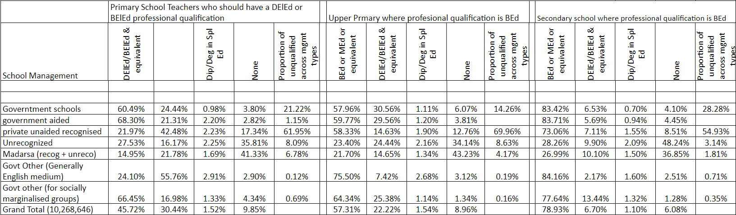
Source: Authors based on data from UDISE+ 2021-22

Primary Teaching/Schools: Overall only 45.72% of teachers teaching primary grades have the appropriate professional qualification of a DElEd or BElEd or equivalent degree. 60.5% of government school teachers 68% of aided school teachers and 66.45% of teachers working in government schools of the social welfare, tribal welfare and labour departments have the appropriate qualification. An additional overall 30.44% of teachers teaching primary grades have BEd or equivalent degrees (MEd is taken as equivalent as the person would have already acquired a BEd). A large proportion of primary school teachers teaching in schools run by government societies such as the KVs, ie about 55% have BEd degrees and only 24% have the appropriate qualification of DElEd. Private recognised schools tend to employ BEd rather than DElEd to teach in primary classes. 43% of their teachers have BEd and only 22% have DElEd.
Upper Primary Teaching: The appropriate professional qualification for upper primary grades is BEd. About 57% of teachers in the system teaching in the upper primary level are appropriately qualified. This is the proportion in the government, aided and Government schools of the social, tribal and labour departments, as well as in private recognised schools. 75% of Teachers teaching middle school grades in government society-run schools such as KVs, and JNVs also have the appropriate qualification. Another 22% of teachers in the system have DElEd or BElEd professional degrees.

Secondary School Teaching: The appropriate professional qualification is BEd. 79% of teachers in the system teaching at this level have BEd degrees: Government (83%), aided (84%), Government run societies (84%), as well as 73% of teachers in private recognised schools and 78% of teachers in schools run by the social, tribal and labour departments.

Unrecognised and Madarsas (recognised or unrecognised): Overall, these groups of schools are least likely to employ professionally qualified teachers, and also least likely to have teachers with the appropriate qualifications for the grades they are teaching.

In Madarsa schools, at the primary teaching level, about 15% of teachers had appropriate qualifications, and 22% of teachers in primary grades had BEd. Unrecognised schools employed about 27.5% of teachers with DElEd/BElEd in primary school teaching and about 16% of teachers with BEd. This could be a reflection of the available labour force and the type of school functioning.

At the upper primary level, in Madarsa schools, 21% had BEd qualifications; At the secondary level, 27% had BEd. 23% of teachers in unrecognised schools had BEd qualifications; 28% had BEd at the secondary level.

Teachers without any professional qualifications: Overall 9.85% of teachers teaching at the primary level, 8.89% of teachers teaching at the upper primary level and 6% teaching at the secondary level had no professional qualifications at all. At the primary teaching level, about 35% of the workforce of unrecognised schools and 41% of Madarsa schools had no professionally qualified teachers. 70% of all such teachers were in the private sector (recognised and unrecognised). At the upper primary level, 34% of the teachers in unrecognised schools and 43% of the teachers in Madarsa schools do not have professional qualifications. At the secondary level, the proportion is again high with 48% of teachers in unrecognised schools and 37% of teachers in Madarsa schools without professional qualifications. 12% at the upper primary and 8% at the secondary level in private schools do not have professional qualifications.

Overall the government societies run schools are patterned more like private recognised schools in terms of preference for BEd over DEd. This may also be a reflection of English as the medium of instruction and the employer's perception that BEd holders are more competent in communication in English. With Government schools, social, tribal and labour department schools tending to be in the regional medium of instruction, these schools are similar to each other in adhering to government norms on recruitment and finding it acceptable to employ DEd professional degree holders.

5. Summary of key findings
- The Indian school system (grades I to XII) has about 95,07,123 teachers in 1.48 million schools. Approximately 51% teach in primary classes, 30% in upper primary/middle, 19% are secondary teachers and 9% are senior secondary school teachers.
- 16% of all teachers are in the state of UP, followed by Maharashtra, Rajasthan (8%), and Tamil Nadu, Madhya Pradesh, West Bengal and Bihar (6%). The gross PTR are the national level is 27:1 but there is considerable interstate variation, with Bihar having a high PTR of 47:1 The North Eastern states and Himalayan states of Sikkim, Himachal, J&K and Ladhak have low PTRs between 10:1 to about 16:1.
- Overall about 35% of teachers are all of India are employed in private schools. There is considerable variation between states. States and UTs where the proportion of government teachers is very high include West Bengal, North East and Himalayan states, Bihar, Chhattisgarh and Odisha. States with a very high proportion of teachers in private schools include Tamil Nadu, Madhya Pradesh, Haryana, Telangana and Manipur. The States of Goa, Maharashtra and Kerala have a high proportion of teachers in aided schools.
- A larger proportion of teachers in private schools and aided schools (48-42%) are in urban areas compared to teachers in government schools (15%) proportions in urban areas compared to government schools.
- Overall, 51% of the workforce is women, but there is a considerable interstate variation with the states and union territories of Chandigarh, Delhi, Goa, Kerala, Punjab, Puducherry and Tamil Nadu having more than 75% women teaching workforce. States with a very low proportion of women in the workforce are Bihar, Jharkhand, Rajasthan and Tripura (40% or less). Women tend to be in urban areas (67% of the urban teacher workforce), but only 44% of the rural teacher workforce. 73% of urban private school teachers are women.
- The representation of teachers from SC and ST communities is lower in private sector schools. Government ‘English medium’ schools run by Government societies tend to have a social profile of teachers similar to that of private schools, with a very low representation of ST teachers.
- About 10% of teachers do not have any professional qualification. 69% of these teachers work in rural areas. 61% of these teachers are in private schools. 16% of private school teachers and 4% of government school teachers do not have professional qualifications. States with a very high proportion of teachers without professional qualifications include the North East, Jharkhand, J&K, Ladakh, UP, Bihar and Madhya Pradesh.
- North Eastern States, Himalayan States, Jharkhand, Bihar, Telangana and Andhra Pradesh lag in ensuring basic amenities and professional working conditions for teachers. With regards to basic amenities in schools, of most concern is the state of classrooms: only 63% of schools report having all classrooms in good condition (58% rural and 83% urban). States in the NE, Himalayan states, Bihar and pinball have less than 60% in good condition. Provisioning of ramps has improved, but it is still only 49% of private schools–North Eastern States, Jharkhand, Bihar, Telangana and Andhra Pradesh have a low proportion of schools with facilities for people with disabilities.
- 11% of government teachers overall, and 16% of government primary school teachers are contractual. States with very high levels of contractual appointments are Arunachal Pradesh, Jharkhand, Meghalaya and DNH&DD. About 90% of all contractual appointments are in rural areas.
- The national PTR average for all schools is 28:1. The PTR for rural schools is 28:1 and for urban schools 29:1. Overall for primary schools the PTR is 26:1, for upper primary it is 19:1, for secondary it is 18:1 and for higher secondary 27:1. Overall government PTR is 28:1 while for private schools it is 26:1
The trend seems to be that where Government school PTRs are low, Private school PTRs tend to be higher, and where govt PTRs are higher, private school PTRs are lower. Overall, the PTR at the state level for private schools varies between 12:1 and 45:1 with most having PTRs between 20 and 30. In comparison the PTRs of government schools vary widely between 6:1 and 57:1, with 16 states having PTRs< 20:1 and 5 with PTR> 30:1
24% of all schools in the country have PTR>1:35; this means that they have a teacher requirement. 66% of these schools are government schools and 20% are private schools. 81% of schools with PTR>35 are in rural areas. These rural schools constitute 23% of all the rural schools in the country.
67% of all schools have PTR<1:30. 65% of them are government schools. Out of these, 83% are in rural areas. These rural schools constitute 68% of all the rural schools in the country. Rather than being a rural-urban difference, having lower PTRs and higher PTRs both seem to be a rural phenomenon.
- Overall 9.5% of schools are single-teacher schools. States With a high proportion of single-teacher schools include Telangana, Jharkhand, Himachal Pradesh, Uttarakhand, Andhra Pradesh, Arunachal Pradesh and Goa.
- Overall only 46% of teachers teaching primary grades have the appropriate professional qualification. In government and government-aided schools the proportion is about 60-68% having the appropriate qualifications, and an additional 30% have BEd. Private schools and KVs tend to have more BEd-qualified teachers in primary school with about 43% of their teachers having BEd, and only 22% have DElEd/BElEd. At the secondary level, overall 79% of teachers in the system have the appropriate qualification of BEd. This is about 83% of government and aided school teachers at the secondary level and only about 73% of secondary level teachers in the private sector. About 10% of primary and middle school teachers and 6% of secondary school teachers have no professional qualification. 70% of all teachers with no professional qualifications are in the private sector.

The professional qualifications are categorised as 1. Diploma certificate: No. Of Teacher whose Highest Professional Qualification is a Diploma or certificate in basic teacher training of a duration not less than two years, 2. Bachelor_of_ee: No. Of Teacher whose Highest Professional Qualification is Bachelor of Elementary Education(B.EI.Ed), 3. BEd_Equivalent: No. Of Teacher whose Highest Professional Qualification is B.ED or Equivalent, 4. MEd_Equivalent: No. Of Teacher whose Highest Professional Qualification is M.ED or Equivalent, 5. Other: No. Of Teacher whose Highest Professional Qualification is Others, 6. None: No. Of Teacher whose Highest Professional Qualification is None, 7. Diploma_special_Edu: No. Of Teacher whose Highest Professional Qualification is a Diploma / Degree in Special Education, and 8. Pursuing_rpc: No. Of Teacher whose Highest Professional Qualification is Pursuing any Relevant Professional Course. In this analysis, the term ‘teachers with no professional qualification’ implies a sum of teachers in the ‘None’ category i.e. category 6 from the above list.
This includes all schools who have reported at least one academic inspection or visit by CRC coordinator or visit by Block Level Officer (BRC/CEO) or District/State Level Officers in UDISE+.
This data is reported from the UDISE+ microdata and includes only schools that have reported availability of libraries. There is a minor discrepancy between these numbers and those reported in the UDISE+ dashboard.
We have disregarded information pertaining to pre primary teachers captured in DISE as this information may not be reliable or complete.
The figure of 25,57,40,623 is as per DISE data of students enrolled from Grades I until Grade XII. This excludes students enrolled in pre-primary schools/grades.
Until 2019 Jammu and Kashmir was administered as a state by the Government of India however, with the abrogation of the Article 370 it was reorganized into two union territories- Jammu and Kashmir in the west and Ladakh in the east.
Note on teacher counts in UDISE 2021-22: UDISE gathers information and categorises teachers according to the levels they teach from pre-primary until Higher Secondary. I.e., 2 years of preschool and 12 grades of school. UDISE 2021-22 does not include ‘guest teachers’, ie teachers who are on an ad-hoc appointment against a substantive post; this option is available along with part-time teachers from the 2023-24 cycle onwards. These numbers are not easily available but could be up to 10 to 15% of the government and government-other workforce deployed in a state. All India UDISE count of teachers made on the basis of gender or social category, or any other data point that is gathered at the individual teacher level yields the number 9,507,123 for teachers teaching primary to higher secondary grades. Ie excluding pre-primary grades. When teacher data is organised based on examining grades that teachers teach, the total count goes up to 11,32,3929. This is because when teacher information is organised according to the levels they are teaching in a school, there are likely to be overlaps–the same teacher may be deployed in primary or upper primary; or between upper primary and secondary and so on, thus leading to double counting of such teachers. This number therefore is not representative of the total number of teachers. This number has been used when estimates are to be made when teacher characteristics are examined at school-type by level. We find school-type by level provides many combinations such as preschool only, pre+primary school, primary only, primary+upper primary, etc. Based on the requirement of the analysis, such categorise into which DISE classifies and counts teacher data have been aggregated or left out. Details of these choices are explained in each table. Although these tables may represent a partial picture as they are based on a selection of teachers, they still provide a reasonable picture of the situation on the ground.
GoI (2021) Data Capture Form for UDISE+ Academic Year 2021-22; reference date 30th September 2021; GoI (2023) UDISE+ Data Capture Form for Academic year 2023-24.
The Pupil-Teacher Ratios (PTR) mentioned in this section are based on the CETE research team’s calculations of PTRs at the school level. To estimate the school-level PTR, the total enrollment in each school was divided by the total number of teachers in the same school. Any state or national averages reported below are based on the mean of the school-level PTRs in a given category.
For purposes of data analysis, we have used the following categorisation of schools: By level 1. Elementary: a. Primary only with grades 1 to 5 (UDISE+ code: 1) and b. Upper Primary with grades 1 to 8 (UDISE+ code: 2), 2. Composite: a. Higher Secondary with grades 1 to 12 (UDISE+ code: 3), b. Secondary/Sr. Sec. with grades 1 to 10 (UDISE+ code: 6), and 3. Secondary/Senior Secondary: a. Upper Primary only with grades 6 to 8 (UDISE+ code: 4), b. Higher Secondary with grades 6 to 12 (UDISE+ code: 5), c. Secondary/Sr. Sec. with grades 6 to 10 (UDISE+ code: 7), d. Secondary/Sr. Sec. only with grades 9 & 10 (UDISE+ code: 8), e. Higher Secondary with grades 9 to 12 (UDISE+ code: 10) and f. Hr. Sec. /Jr. College only with grades 11 & 12 (UDISE+ code: 11). By management type 1. Government: a. Department of Education (UDISE+ code: 1), b. Local Body (UDISE+ code: 3), c. Other State Govt. Managed (UDISE+ code: 6), 2. Government (other): a. Tribal Welfare Department (UDISE+ code: 2), b. Minority Affairs Dept. (UDISE+ code: 7), c. Social Welfare Department (UDISE+ code: 90), d. Ministry of Labour (UDISE+ code: 91), e. Kendriya Vidyalaya (UDISE+ code: 92), f. Jawahar Navodaya Vidyalaya (UDISE+ code: 93), g. Sainik School (UDISE+ code: 94), h. Railway School (UDISE+ code: 95), i. Central Tibetan School (UDISE+ code: 96), j. Other Central Govt./PSU Schools (UDISE+ code: 101), 3. Government Aided: Government Aided (UDISE+ code: 4), 4. Private: Private Unaided (Recognized) (UDISE+ code: 5), 5. Madrasas (recognized): Madarsa Private and Aided (Recognized) (UDISE+ code: 97), and 5. Unrecognized: a. Unrecognized (UDISE+ code: 8) and b. Madarsa Unrecognized (UDISE+ code: 98).

