
Teachers in India: A Snapshot from the Periodic Labour Force Survey 2021-22

Background paper 2:
State of Teachers, Teaching and Teaching Education Report for India 2023
CETE 2023
Citation: CETE. (2023). Teachers in India: A snapshot from the Periodic Labour Force Survey. Background paper 2: State of Teachers, Teaching and Teaching Education Report 2023.
Authors: Padma M. Sarangapani, Kamlesh Goyal, Mythili Ramchand, Jyoti Bawane
Research Assistance: Mohammad Aslam, Anitha Bellappa, Aishwarya Rathish, Arpitha Jayaram, Rutuja Warthi

Abstract: Data from the Periodic Labour Force Survey 2021-22 were analysed to identify teachers and aspects of the teaching labour force by the level of the school where they are teaching (early childhood care and education, primary, secondary); government vs private sector; urban vs rural; and gender. A demographic profile of the workforce by gender, social category and age is presented in the paper. From the analysis, the feminisation of the teaching profession has been noted to be different based on sector and region. Wages and benefits of teachers in government and private sector are found to be very disparate. Women teachers from SC and ST communities are found to be very low in secondary schools. Almost 50% of teachers in private schools are working without contracts.

Keywords: Demography, Feminisation of Teaching, Teacher Wages and Benefits in the Private Sector, ECCE workers.

Acknowledgements: The SOTTTER 23 editorial board–Prof. Saklani, Director NCERT, Mr Harshit Mishra, Niti Ayog, Prof. Amita Chudgar, Professor, Michigan State University, Dr Nidhi Gulati, Institute of Home Economics, University of Delhi, Ms Amrita Patwardhan, Tata Trusts, and Dr. Carlos Vargas Tames Teacher Task Force, UNESCO–provided invaluable perspectives on the analysis and reporting.


The Centre of Excellence in Teacher Education (https://bit.ly/cetewebsite) is an Independent Centre at the Tata Institute of Social Sciences, Mumbai, established with seed grants from the Pandit Madan Mohan Malaviya National Mission on Teachers and Teaching, Government of India, and the Tata Trusts, and with the Tata Trusts as founding partner. The Centre's overarching focus and agenda is innovation and improvement in teacher education, school and higher education pedagogy and curriculum, and is aligned with the United Nation's Sustainable Development Goal 4: "to ensure inclusive and equitable quality education and promote lifelong learning opportunities for all", and Goal 4c in particular "by 2030 to substantially increase the supply of qualified teachers" The Centre envisages its role as a catalyst for transformation in teacher education through academic programmes, field action programmes, research, collaborations, and advocacy. The State of Teachers Teaching and Teacher Education is a Biennial State of the Sector Report produced by CETE.



State of Teachers Teaching and Teacher Education for India Report
Background Papers
- CETE (2023). Teachers in India in 2021-22: The picture from UDISE+. Background paper 1: State of Teachers, Teaching and Teaching Education Report 2023.
- CETE (2023). Teachers in India: A snapshot from the Periodic Labour Force Survey. Background paper 2: State of Teachers, Teaching and Teaching Education Report 2023.
- CETE (2023). Public and private sector contract teachers in India: An analytical research paper. Background paper 3. State of Teacher, Teaching and Teacher Education Report 2023.
- CETE (2023). Quality of pre-service teacher education and teacher supply in India: An analysis of TET data from one state. Background paper 4: State of Teachers, Teaching and Teaching Education Report 2023.
- CETE (2023). Status of teachers in the workforce in eight states: A report based on SOTTTER 23 Survey. Background research report 5: State of Teachers, Teaching and Teaching Education Report 2023.
- CETE (2023). Status of teacher educators and student teachers in eight states: A report based on SOTTTER 23 Survey. Background research report 6: State of Teachers, Teaching and Teaching Education Report 2023.
- CETE (2023). Teacher supply demand: A review of literature. Background paper 7: State of Teachers, Teaching and Teaching Education Report 2023.
- CETE (2023). News coverage in Indian print media on teachers and teacher education January-December 2023. Background research report 8: State of Teachers, Teaching and Teaching Education Report 2023.
https://bit.ly/SoTTTER-by-CETE



This document is released under a Creative Commons Attribution-ShareAlike 4.0 International licence. Download Here: https://bit.ly/SoTTTER-by-CETE
Any questions, suggestions or queries may be sent to us at: chair.cete@tiss.edu

Contents 3
List of Tables 4
List of Figures 4
Abbreviations 4
1. Introduction 5
2. Types of teachers and rurality of the teacher workforce 6
3. Demographic profile of teachers' labour force 6
3.1 Gender 6
3.2 Age 7
3.3 Social Category 8
3.4 Gender, social category and rurality 8
4. Type of employment: Government and non-government/ private sector 8
4.1 Teacher type 9
4.2 Gender 9
4.3 Age 10
4.4 Social Category 11
4.5 Rurality 12
4.6 Rurality x Gender; Rurality x Age 12
4.7 Gender x Age x Rurality 13
5. Terms of employment: Contract, wages, benefits 15
5.1 Contracts 15
5.2 Wages 15
5.3 Benefits 19
6. Summary and Conclusions 20

List of Tables
Table 1.1 NIC codes used to identify teachers sector-wise
Table 1.2 Codes used to identify and classify enterprise type
Table 3.1 Age profile of teachers sector-wise
Table 4.1 Proportion of women to men teachers in government and private employment,
sector-wise
Table 4.2 Median age of govt and private school teachers sector-wise
Table 4.3 Teachers' social group in government vs private schools, sector-wise
Table 4.4 Proportion of Rural to Urban teachers in government and private employment sector-
wise
Table 4.5 Proportion of men and women in rural and urban locations in government and private
employment sector-wise
Table 4.6 Median age of govt and private school teachers in rural and urban locations sector-wise
Table 4.7 Median age of government and private school teachers by gender and rural-urban
location, sector-wise
Table 4.8 Proportion of women in the respective age bracket of the workforce: Sector-wise
Table 4.9 Proportion of women in the respective age bracket of the workforce: Government,
private and overall, sector-wise
Table 5.1 Proportion of teachers with contracts and related average salary, sector-wise,
government-private employment type, gender-wise and less than 30 years
Table 5.2 Salary comparisons based on contract type, between government and private and
gender, sector-wise
Table 5.3 Differential wages between women and men, rural-urban and government,
non-government teachers
Table 5.4 Benefits: Sector-wise, comparing government and private teachers

List of Figures
Figure 3.1 Proportionate distribution of men and women teachers across sectors
Figure 3.2 Age profile of teachers as per PLFS 2021- 22
Figure 3.3 Age profile of all teachers (ECCE, Primary and Secondary)
Figure 4.1 Age profile of all teachers (ECCE, Primary and Secondary)
Figure 4.2 The presence of SC and ST teachers in the private sector is lower compared to the
government sector
Figure 5.1 Changes in wages with age/years of experience

Abbreviations
BEd Bachelor in Education
ECCE Early Childhood Care and Education
INR Indian National Rupee
OBC Other Backward Classes
PF Provident Fund
PLFS Periodic Labour Force Survey
SC Scheduled Caste
SOTTTER State of Teacher, Teaching and Teacher Education Report
ST Scheduled Tribes
UDISE Unified District Information System for Education
UG Under Graduate
UNESCO United Nations Educational, Scientific and Cultural Organization

1. Introduction
Details of the employment status of the teaching workforce in India are limited to what is captured in UDISE+. UDISE+ provides a reasonable understanding of primary school and secondary school teachers. However, sectors and levels such as early childhood education, vocational education, music, art physical education, and special education teacher workforce-related data are not well captured in UDISE+. Hence, the importance of the Periodic Labour Force Survey Data (PLFS) which enables some understanding of teachers working in these sectors. The PLFS is invaluable in providing an understanding of employment conditions of teachers–in both different sectors as well as in government and non-government sectors. It also enables aspects of the teacher workforce to be examined from the points of view of their gender, age, social category and location (urban and rural). In UNESCO 2021, we examined aspects of the teacher workforce using PLFS 2018-2019 data. As a part of SOTTTER-23 background papers, this paper examines aspects of the teacher labour force using the 2021-22 data set.
Note on categorisation in the following two tables, 1.1 and 1.2.:

Table 1.1 NIC codes used to identify teachers sector-wise
Industry Type | NIC code
Teachers Sector wise
Early Childhood Education | 85101
Primary School | 85102
General Secondary School | 85211
Special education | 85104+85213+85222
vocational education (sec) | 85221
Physical Education | 85410
Music, Art, Drama | 85420
Education Related, non-teaching employment (identified but not analysed)
Academic tutoring services | 85491
Educational support services | 85500
Source: Authors analysis based on PLFS 2021-22

Table 1.2 Codes used to identify and classify enterprise type
Government | Government/local body-05, Public Sector Enterprises-06, Autonomous Bodies- 07,
Non-Government/Private | Public/Private limited company-08, Co-operative societies-10,
Non-Government/Private | trust/other non-profit institutions -11, employer’s households(i.e., private households employing maid, servant, watchman, cook, etc.) -12, others -19
Source: Authors analysis based on PLFS 2021-22

2. Types of teachers and rurality of the teacher workforce
Teachers represent 1.86% of the total labour force. The PLFS identifies seven kinds of teachers. Primary teachers constitute the largest proportion of all teachers at 46% followed by Secondary school teachers at 32%. The third largest category is early childhood education teachers, perhaps anganwadi workers at 18%. Sectors, where a very small percentage (total 4.3%) is employed, include special educators (1.08%), vocational education teachers (1.61%), physical education teachers (1.08%) and music, art and drama teachers (0.54%).
In comparison to the total labour force where 72% is located in rural areas, 51% of the total teacher workforce and 48% of the primary and secondary teacher workforce is in rural locations. Around 71% of the ECCE workforce is in rural locations, followed by 55% of primary school teachers. 38-40% of general secondary school teachers, vocational education and special education school teachers are in rural areas. Only 23% of physical education teachers and music, art, and drama teachers are in rural locations

Table 2.1 Types of Teachers and Rurality of the Teacher Workforce
 |  |  |  | Gender | Distribution by social group |  |  |  | Location |  | Nature of employment
Teachers by Industry type (NIC Code) | % of the total labour force | % of type of teacher to the total teacher labour force | Median age | % women teachers in the respective teacher type | Scheduled Tribes | Scheduled Castes | Other Backward Castes | Others | proportion of workforce in rural locations | Proportion of women teachers working in rural locations | worked as regular wage/salaried employee (total: 31, 71, 72) | self employed (total:11,12,21,61,62)
All Teachers
A. Early Childhood Education (85101) | 0.34% | 18.28% | 43 | 91% | 14% | 24% | 35% | 27% | 81% | 82% | 98% | 2%
B. Primary School teacher (85102) | 0.86% | 46.24% | 40 | 49% | 13% | 16% | 38% | 33% | 63% | 54% | 96% | 4%
C. General Secondary School (85211) | 0.59% | 31.72% | 40 | 43% | 10% | 14% | 39% | 36% | 49% | 36% | 92% | 8%
D. Special education teachers (85104;213;222) | 0.02% | 1.08% | 33 | 48% | 1% | 44% | 27% | 27% | 56% | 64% | 87% | 13%
E. Vocational education (sec) (85221) | 0.03% | 1.61% | 29 | 38% | 1% | 12% | 34% | 54% | 63% | 67% | 93% | 7%
F. Physical Education (85410) | 0.02% | 1.08% | 30 | 20% | 1% | 24% | 36% | 38% | 31% | 0% | 68% | 32%
G. Music, Art, Drama (85420) | 0.01% | 0.54% | 25 | 68% | 0% | 4% | 16% | 80% | 26% | 32% | 33% | 67%
Total 'school teachers' (primary+general secondary: B+C) |  | 78% | 40 | 46% | 12% | 15% | 38% | 34% | 57% | 47% | 94% | 6%
Total teachers (A+B+C+D+E+F+G) | 1.86% |  | 41 | 54% | 12% | 17% | 38% | 34% | 62% | 53% | 95% | 6%
Total labour force |  |  | 38 | 26% | 11% | 20% | 45% | 24% | 72% |  | 22% | 52%
All India Demography as per census 2011 (source *) |  |  |  |  | 9% | 17%
Teachers by Enterprise type
Government
All Teachers(A,B,,D,E,F,G) |  |  |  | 53% | 15 | 19 | 36 | 30
All School Teachers (Primary+ Secondary) |  |  |  | 41% | 16 | 16 | 37 | 31
Primary School Teacher |  |  |  | 43% | 15 | 18 | 35 | 31
Gen secondary School Teacher |  |  |  | 36% | 16 | 13 | 39 | 32
Non Government/ Private
All Teachers (A+B+C+D+E+F+G) |  |  |  | 57% | 5 | 14 | 40 | 40
All School Teachers (Primary+ Secondary) |  |  |  | 56% | 5 | 14 | 41 | 40
Primary School Teacher |  |  |  | 61% | 7 | 13 | 42 | 38
Gen secondary School Teacher |  |  |  | 51% | 3 | 15 | 40 | 41
Note: Data is based on current weekly status. *Under nature of employment, the categories: 'self-employed as a helper (12% of the total labour force); 'worked as casual labour in public works other than MGNREG' (1% of the total labour force) and 'Sought for work or available for work' (6.08% of the total labour force) were left out as the % for teachers was '0'; ** Census of India 2011 http://censusmp.nic.in/censusmp/Data/PCA_DATA/008%20-%20Chapter%20-%206%20-%20ST%20.pdf; employed as regular wage/salaried employee: 31: 71: 72; self-employed (11: 12: 21: 61: 62: )
Source: Analysis authors based on data from PLFS 2021-22; (*)

3. Demographic profile of teachers' labour force

3.1 Gender
About 51% of all teachers and 45% of primary and secondary school teachers are women, this is much larger in proportion in comparison to the total labour force where women are about 26%. The most feminised teaching sector is early childhood education (85%) and the least is vocational education (33% and physical education 16%). Special education is 50%, followed by primary school teaching at 46% and general secondary and music, art and drama at 42%.
Figure 3.1 Proportionate distribution of men and women teachers across sectors
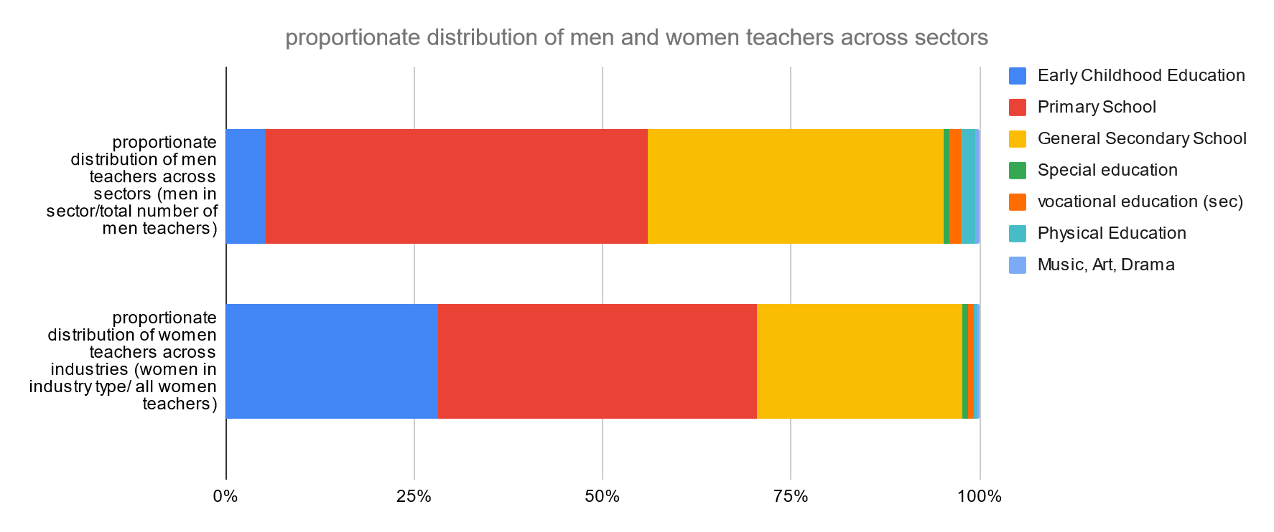
Source: Authors analysis based on PLFS 2021-22

Around 90% of men and 70% of women teachers are employed in primary and secondary schools, Another 5% of men teachers and 28% of women teachers are ECCE teachers (see Figure 3.1).

3.2 Age
The median age of the total workforce is 38, in comparison, the median age of the total teaching workforce is slightly higher at about 40. The ECCE teachers are the oldest age group with a median age of 42 followed by secondary teachers at 40 and primary teachers are 39. In comparison, teachers of other streams are young with a median age between 29 and 33. Teachers of music, art and drama are the youngest with a median age of 25 (see Figures 3.2 and 3.3).

Figure 3.2 Age Profile of teachers as per PLFS 2021- 22
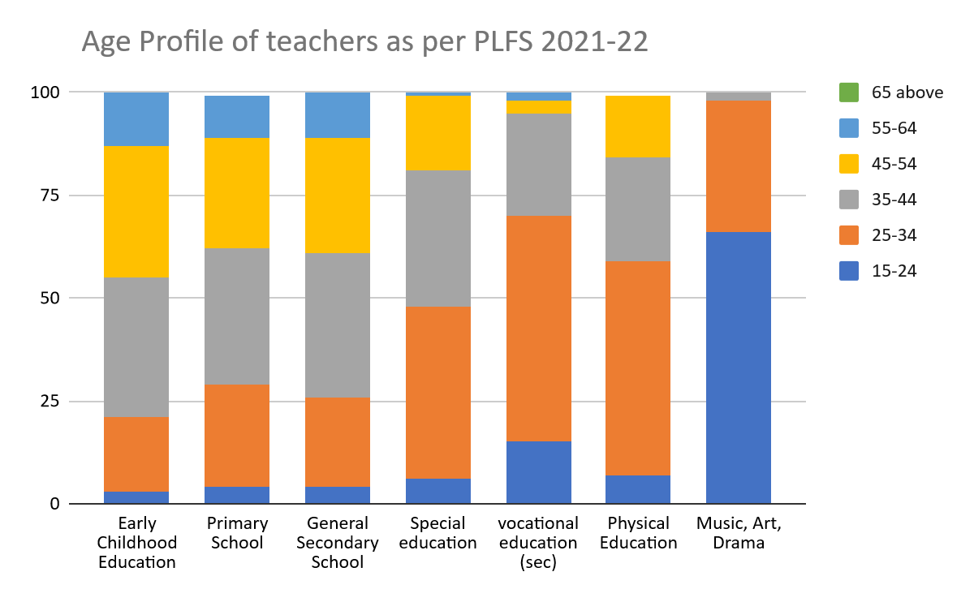
Source: Authors analysis based on PLFS 2021-22

Table 3.1 Age profile of teachers sector-wise
 | ECCE teacher | Primary teachers | Secondary teachers | Total | Replacement period
Age Bracket
<20 | 0.14% | 0.11% | 0.07% | 0.10%
20-24 | 2.46% | 4.96% | 4.56% | 4.38%
25-29 | 6.79% | 10.24% | 12.40% | 10.37%
30-34 | 11.99% | 17.07% | 13.89% | 15.08%
35-39 | 17.63% | 17.87% | 16.06% | 17.20%
40-44 | 18.93% | 15.31% | 15.09% | 15.87%
45-49 | 19.65% | 14.40% | 15.09% | 15.57%
50-54 | 11.27% | 11.31% | 11.73% | 11.44% | 2030-2034
55-59 | 8.82% | 7.41% | 9.63% | 8.42% | 2025-2029
60-65 | 2.17% | 1.17% | 1.42% | 1.43% | 2021-2025
>65 | 0.14% | 0.16% | 0.07% | 0.13%
Source: Authors analysis based on PLFS 2021-22
About 8.42% of teachers are expected to be replaced in the next five years and an additional 11.44 % of teachers in the next 10 years, overall (see Table 3.1).

Figure 3.3 Age profile of all teachers (ECCE, Primary and Secondary)
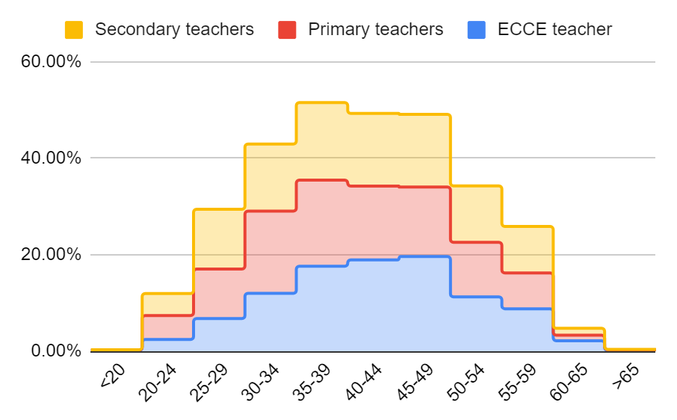
Source: Authors analysis based on PLFS 2021-22

3.3 Social Category
Among all teachers, the representation of scheduled tribes is 24% and scheduled castes is about 14%. The proportion of SC teachers is approximately the same as the Indian demography – however, of ST teachers is higher relative to the population. There is a significant representation of ST teachers in the early childhood and primary education sectors. Overall, ST and SC teacher representation in secondary school teaching is lower.
The proportion of women ST and SC teachers is lower in ECCE, primary and secondary school teaching, compared to the representation of women from OBC and Other social categories. This is likely a reflection of the educational achievement of women from SC, and ST communities.

3.4 Gender, Social Category and Rurality
Out of the total women teacher workforce, 45% of them work in rural areas and only 36% of the primary and secondary women teaching workforce are in rural areas. In comparison, 57% of the male workforce and 57% of the primary and secondary men teaching workforce are in rural areas. Only 25% of women secondary school teachers are in rural areas. Although based on an overall small sample, the complete absence of women physical education teachers in rural areas is to be noted.
The representation of women school teachers from SC and ST groups in rural areas is relatively high (32% ST, 15% SC) and their representation in urban locations is relatively low (12% ST, 10% SC). Women school teachers in urban areas tend to be disproportionately more from other social categories, compared to their overall representation in the workforce (44%).

4. Type of employment: Government and non-government/ private sector
Overall, 94% of all teachers, and 95% of school teachers are in regular/ wage employment as opposed to only 22% of the overall labour force. In ECCE 97%, primary and general secondary, the level is about 95%, and special and vocational education is 97% and 86%. Lower levels of regular employment/ higher proportion of self-employment are noted in physical education (80%) and music, art and drama teachers (32%).
The proportion of women who are regular wage/salaried is slightly lower for primary school teachers (93% vs 98%), and almost the same across all teachers. The proportion of regular wage/salaried women rural school teachers compared to men in rural areas is slightly lower by about 3 to 4% points.
Regular wage/salaried teachers from special education, vocational education, physical education and music, art and drama are older between 34.5 and 37 years.
Given that the teaching workforce is overwhelmingly ‘regular waged’, the analysis going forward is primarily restricted to this group; data for government and non-government/private sector is for the regular wage/salary group only.

4.1 Teacher type
The overall proportion of teachers employed in government institutions is 65% for all teachers. 85% of ECCE teachers, 68% of primary teachers, and 55% of secondary teachers are employed in government sector.
Among all, about 56% of vocational education teachers are in government employment, compared with 40% of special education, 30% of physical education and only 5% of music, art and drama teachers.

4.2 Gender
There is a lower proportion of women to men in the government sector higher proportion of women to men in the private sector in primary and secondary teaching (see Table 4.1). Although based on a small sample, there is a low proportion of women physical education teachers, and a low proportion of women vocational education teachers in government.
Table 4.1 Proportion of women to men teachers in government and private employment, sector-wise
 | Government |  | Private/NonGovernmant
Type of teacher | Female | Male | Female | Male
Overall | 47.99% | 52.01% | 57.52% | 42.48%
ECCE teacher | 86.16% | 13.84% | 78.51% | 21.49%
Primary teacher | 38.75% | 61.25% | 63.49% | 36.51%
Secondary teacher | 35.95% | 64.05% | 50.25% | 49.75%
(small sample)
Special Education teacher | 46.15% | 53.85% | 52.63% | 47.37%
Vocational Education teacher | 22.22% | 77.78% | 47.62% | 52.38%
Music, Art, Drama teacher | 100.00% | 0.00% | 38.89% | 61.11%
Physical Education teacher | 7.69% | 92.31% | 19.35% | 80.65%
Source: Authors analysis based on PLFS 2021-22

4.3 Age
The government teacher workforce is older than the private teacher workforce, overall and within sectors i.e., the workforce is skewed towards older teachers in the case of government and towards younger teachers in the case of private (see Figure 4.1). This may be indicative of the fact that the first job of qualified teachers tends to be in the private sector and government jobs in general become available at later ages. We see a larger proportion overall of teachers in the 20-24 and 24-29 age groups in the private sector as compared with the government sector if all teachers in private sector jobs aspire to government jobs and remain in teaching, it would seem that the wait time between professional qualification to obtain a government job is 5 to 7 years, during which time they are working in the private sector.
The minimum age by which a primary teacher completing 12 years of schooling and 2 years of professional qualification would get a job is 19-20 years. In the case of a secondary school teacher, it would be about 23-24 years (12 years of schooling followed by 3 years of UG and 2 years of BEd, after 2014).
Figure 4.1 Age profile of all teachers (ECCE, Primary and Secondary)
Age profile of Government sector teachers | Age profile of Private sector teachers
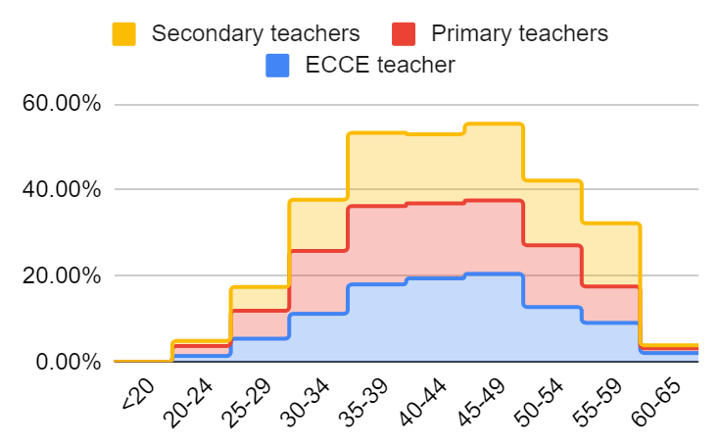 | 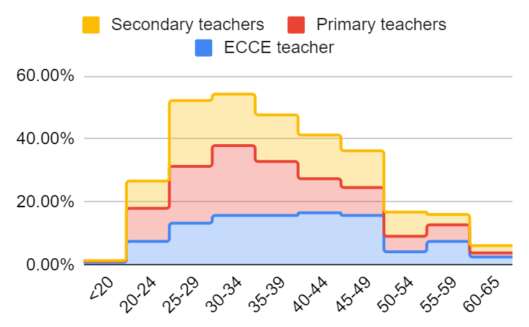
Source: Authors analysis based on PLFS 2021-22

Table 4.2 Median age of govt and private school teachers sector wise
Type of teacher | Overall Govt | Overall Pvt | Overall
ECCE teacher | 43 | 39 | 42
Primary teacher | 42 | 34 | 39
Secondary teacher | 44 | 35 | 40
Overall | 42 | 35 | 40
Source: Authors analysis based on PLFS 2021-22
The median age of government school teachers is about 6 to 7 years more than the median age of a private sector school teacher (see Table 4.2).
The median age of government school teachers is about 6 to 7 years more than the median age of a private sector school teacher (see Table 4.2).

4.4 Social Category
The presence of SC, and ST teachers in the private sector is much lower compared to the government sector by 10-15%, while general category teachers in the private sector are higher by about 10% points. The representation of general category teachers is highest at the secondary school level (see Figure 4.2 and Table 4.3).
Figure 4.2 Social categories of teacher by level and section (Govt vs private)
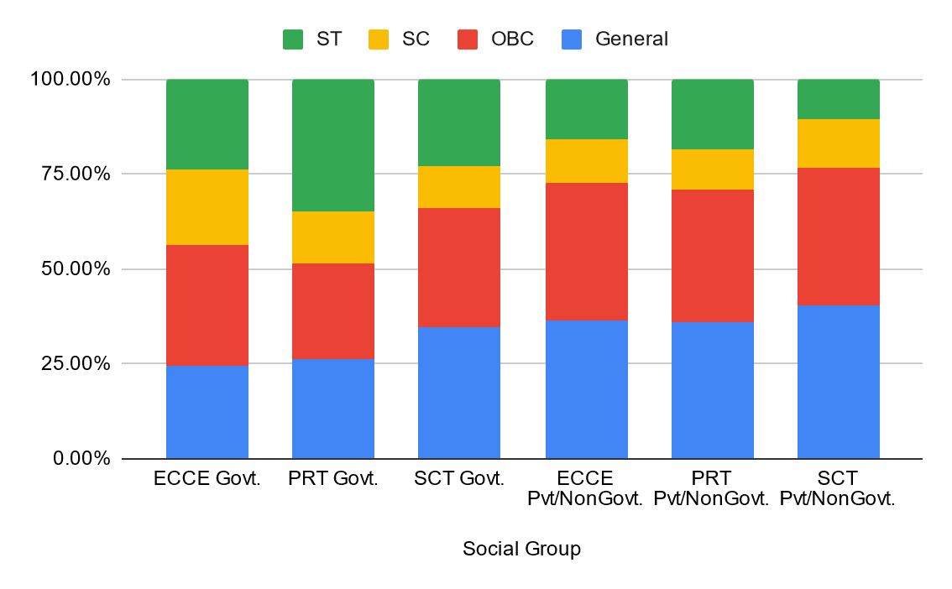
Source: Authors analysis based on PLFS 2021-22

Table 4.3 Teachers' social group in government vs private schools, sector-wise
 | Government |  |  | Private/Non-Government
Social Group | ECCE teacher | Primary teacher | Secondary teacher | ECCE teacher | Primary teacher | Secondary teacher
General | 24.52% | 26.36% | 34.59% | 36.36% | 35.86% | 40.23%
OBC | 31.87% | 25.10% | 31.49% | 36.36% | 34.87% | 36.39%
SC | 19.79% | 13.89% | 10.95% | 11.57% | 11.02% | 12.85%
ST | 23.82% | 34.65% | 22.97% | 15.70% | 18.26% | 10.52%
Source: Authors analysis based on PLFS 2021-22

4.5 Rurality
Private teachers are predominantly in urban areas, while government school teachers are predominantly in rural areas. Primary government teachers are more in rural areas, while secondary govt teachers are more in urban areas (see Table 4.4).

Table 4.4 Proportion of rural to urban teachers in government and private employment sector wise
 | Government |  | Private/Non-Government
Type of teacher | Rural | Urban | Rural | Urban
Grand Total | 58.59% | 41.41% | 38.04% | 61.96%
ECCE teacher | 75.66% | 24.34% | 47.11% | 52.89%
Primary teacher | 61.33% | 38.67% | 42.60% | 57.40%
Secondary teacher | 42.57% | 57.43% | 32.89% | 67.11%
(small sample)
Special Education teacher | 46.15% | 53.85% | 36.84% | 63.16%
Vocational Education teacher | 22.22% | 77.78% | 57.14% | 42.86%
Music, Art, Drama teacher | 0.00% | 100.00% | 16.67% | 83.33%
Physical Education teacher | 46.15% | 53.85% | 12.90% | 87.10%
Source: Authors analysis based on PLFS 2021-22
The ratio of rural to urban teachers in government was higher than the proportion in non-government/private. In the sectors of ECCE, the ratio was 7:1 for the government and 2.2:1 for the non-government sector. In primary school, the government ratio for rural to urban was 3:1 and in the case of private it was 1.3:1. In other sectors the ratio of rural to urban was the same across government and non-government/private institutions. Rural areas had a larger proportion of government as opposed to private/non-government employed teachers: 87% of ECCE workers, 75% of primary school teachers, 77% of physical education teachers, 53-60% of secondary, vocational and special education teachers in rural areas were in government employment.

4.6 Rurality x Gender; Rurality x Age
ECCE teaching, on the whole, is highly feminised in both rural and urban locations, more in government and less in private (see Table 4.5). This may be on account of government policy favouring women Anganwadi workers and men in more supervisory positions across both government and private.
Table 4.5 Proportion of men and women in rural and urban locations in govt and private employment
 |  | Govt. |  | Pvt/NonGovt.
Type of teacher | Gender | Rural | Urban | Rural | Urban
ECCE teacher | Female | 85.88% | 87.05% | 77.19% | 79.69%
 | Male | 14.12% | 12.95% | 22.81% | 20.31%
Primary teacher | Female | 32.18% | 49.18% | 51.35% | 72.49%
 | Male | 67.82% | 50.82% | 48.65% | 27.51%
Secondary teacher | Female | 20.63% | 47.29% | 38.07% | 56.22%
 | Male | 79.37% | 52.71% | 61.93% | 43.78%
Source: Authors analysis based on PLFS 2021-22
Rural primary government teaching is skewed in favour of men, and urban primary teaching is highly feminised. Urban government and rural private are gender balanced.
Secondary government rural teaching is highly skewed in favour of men, rural private secondary teaching is also skewed in favour of men, while urban secondary teaching is moderately feminised. In general, with the exception of the ECCE sector, all rural government teaching is skewed in favour of men, and urban teaching is more gender-balanced. Urban private school teaching is feminised (see Table 4.5).
Table 4.6 Median age of Govt and Private School Teachers in Rural and Urban Locations Sector-wise
 | Govt. |  |  | Pvt/NonGovt. |  |  | Overall
Type of teacher | Rural | Urban | Overall Govt | Rural | Urban | Overall Pvt
ECCE teacher | 43 | 44 | 43 | 38 | 39 | 39 | 42
Primary teacher | 40 | 43 | 42 | 32 | 35 | 34 | 39
Secondary teacher | 42 | 45 | 44 | 32 | 36.5 | 35 | 40
Overall | 42 | 44 | 42 | 32 | 36 | 35 | 40
Source: Authors analysis based on PLFS 2021-22
Overall government school teachers have a median age of 42 to 44 and are eight to nine years older than private school teachers who have a median age of 34 to 39 (see Table 4.6).
ECCE workers in rural and urban areas with a median age of 43 and 44, and government urban primary and secondary teachers with a median age of 43 and 45, are among the oldest in the group. Government school teachers in urban locations with a median age of 43 to 45 tend to be almost 8 to 10 years older than private school teachers in urban locations (see Table 4.6).

4.7 Gender x Age x Rurality
Overall, in primary and secondary teaching, the median age of women is lower than that of men. In the case of the private rural sector the difference is 3 to 5 years, indicating that there are more younger women as compared to men–this may be reflective of the willingness of younger women in rural areas to work for lower wages. The older men in government schools in urban areas may indicate their ability to migrate to urban areas via transfer, the lower median age of women teachers may also be an indication of increasing feminisation over time (see Table 4.7).
Table 4.7 Median Age of Govt and Private School Teachers by Gender and Rural-Urban Location, Sector-wise
 |  | Govt. |  |  | Pvt/NonGovt. |  |  | Overall
Median age |  | Rural | Urban | Overall Govt | Rural | Urban | Overall Pvt | Overall
ECCE teacher | Female | 42 | 44 | 43 | 40.5 | 39 | 39 | 42
 | Male | 43 | 46.5 | 43 | 32 | 39 | 37 | 43
ECCE teacher Total |  | 43 | 44 | 43 | 38 | 39 | 39 | 42
Primary teacher | Female | 40 | 42 | 41 | 30 | 35 | 33 | 37
 | Male | 41 | 44 | 42 | 35 | 36 | 35 | 40.5
Primary teacher Total |  | 40 | 43 | 42 | 32 | 35 | 34 | 39
Secondary teacher | Female | 39 | 43 | 42 | 30 | 36.5 | 35 | 39
 | Male | 42 | 46 | 45 | 32.5 | 36.5 | 35 | 42
Secondary teacher Total |  | 42 | 45 | 44 | 32 | 36.5 | 35 | 40
Grand Total |  | 42 | 44 | 42 | 32 | 36 | 35 | 40
Source: Authors analysis based on PLFS 2021-22
The trend of feminisation of the teaching workforce over the last ten years is visible: with primary teaching having become feminised over the last 10-15 years and secondary teaching becoming feminised over the last 5 to 10 years.
Table 4.8 Proportion of women in the respective age bracket of the workforce: Sector-wise
 | ECCE teacher | Primary teachers | Secondary teacher
Age Bracket |  |  | Total
<20 |  | 100.00% | 0.00%
20-24 | 88.24% | 73.12% | 62.30%
25-29 | 89.36% | 54.17% | 50.00%
30-34 | 80.72% | 51.88% | 40.32%
35-39 | 87.70% | 46.27% | 43.72%
40-44 | 80.15% | 41.81% | 43.07%
45-49 | 86.03% | 40.74% | 34.16%
50-54 | 84.62% | 39.15% | 44.59%
55-59 | 85.25% | 38.13% | 34.88%
60-65 | 100.00% | 68.18% | 31.58%
>65 |  | 33.33% | 0.00%
Source: Authors analysis based on PLFS 2021-22

Table 4.9 Proportion of women in the respective age bracket of the workforce: Government, private and overall, sector-wise
 | Primary teachers |  |  | Secondary teacher
Age Bracket | Govt. | Pvt/NonGovt. | Total | Govt. | Pvt/NonGovt. | Total
<20 | 0.00% | 100.00% | 100.00% | 0.00% | 0.00% | 0.00%
20-24 | 68.97% | 75.00% | 73.12% | 66.67% | 61.54% | 62.30%
25-29 | 41.46% | 63.64% | 54.17% | 41.46% | 52.80% | 50.00%
30-34 | 40.54% | 67.41% | 51.88% | 39.77% | 40.82% | 40.32%
35-39 | 38.10% | 64.42% | 46.27% | 37.30% | 52.81% | 43.72%
40-44 | 37.10% | 57.58% | 41.81% | 35.29% | 54.22% | 43.07%
45-49 | 35.65% | 61.11% | 40.74% | 26.52% | 48.57% | 34.16%
50-54 | 35.71% | 60.00% | 39.15% | 40.54% | 54.35% | 44.59%
55-59 | 38.32% | 37.50% | 38.13% | 33.94% | 40.00% | 34.88%
60-65 | 64.29% | 75.00% | 68.18% | 40.00% | 28.57% | 31.58%
>65 | 0.00% | 33.33% | 33.33% | 0.00% | 0.00% | 0.00%
Source: Authors analysis based on PLFS 2021-22
There seems to be a sharp and sudden feminisation of government primary and secondary school teaching in the last five years, while private primary school teaching has been feminised for a long time, and private secondary school teaching is becoming more feminised over the last 5 to 10 years. This could be indicative of larger numbers of educated women entering into the teaching workforce, with higher qualifications. It could also reflect a growth spurt in low-fee-paying private schools which prefer to employ women at lower wages.

5. Terms of employment: Contract, wages, benefits

5.1 Contracts
About 24% of teachers working in government ECCE centres and primary and secondary schools and more than 50% of teachers in private/non-government schools report that they are working without written contracts. Only about 6% to 24% of teachers in private schools report having written contracts for more than three years. the proportion of women with no written contracts in government schools is higher than that of men: 30% vs 24% in ECCE, 32% vs 19% in primary teachers and 28% vs 21% in secondary school teachers. In the private sector, the proportions are almost the same for men and women without any written contract. However, in the case of ‘having written contract for three years or more’, the proportion is only 21% women vs 30% men. In the case of younger teachers, a large proportion of ECCE young teachers have no contract (43.24%), and a larger proportion of young women teachers in private sector schools report having no written contracts (50% primary and 64% secondary). This is indicative of vulnerabilities and casualisation of employment of women in the private sector.

5.2 Wages
In absolute terms, teachers in the government sector ECCE reported an average monthly salary of INR 11,394, primary teachers INR 31,255 and secondary teachers INR 38,282. private school teachers in all sectors reported lower salaries: 66% of government teacher salary at INR 7,665 for ECCE, primary teachers: 36% of government teacher’s salary amounting to INR 11,086 and secondary teachers: 35% of government teachers salary, amounting to INR 13,412 (see Table 5.1).

Table 5.1 Proportion of teachers with contracts and related average salary, sector-wise, govt-private employment type, gender-wise and less than 30 years
 |  | Proportion |  |  |  |  |  |  | Average Salary (monthly in INR)
 |  | ECCE teacher |  | Primary teacher |  | Secondary teacher |  |  | ECCE teacher |  | Primary teacher |  | Secondary teacher
 |  | Govt. | Pvt | Govt. | Pvt | Govt. | Pvt |  | Govt. | Pvt | Govt. | Pvt | Govt. | Pvt
All Teachers
 | NI |  | 15.70% | 0.00% | 12.66% | 0.00% | 13.36%
No written contract |  | 29.60% | 49.59% | 24.15% | 52.30% | 24.72% | 54.26% |  | 10,047 | 7,748 | 25,674 | 9,934 | 31,796 | 13,281
Written contract<3yr |  | 6.83% | 8.26% | 4.34% | 11.02% | 4.12% | 26.38% |  | 6,064 | 9,047 | 15,479 | 11,522 | 17,719 | 13,126
Wri. contract > 3yrs |  | 63.57% | 26.45% | 71.51% | 24.01% | 76.28% | 6.01% |  | 12,594 | 11,627 | 34,100 | 19,072 | 41,494 | 22,168
Overall |  |  |  |  |  |  |  |  | 11,394 | 7,665 | 31,255 | 11,086 | 38,282 | 13,412
By Gender
Female | NI | 0.00% | 14.74% | 0.00% | 14.51% | 0.00% | 12.96%
No written contract |  | 30.49% | 48.42% | 32.18% | 52.59% | 27.82% | 56.81% |  | 6,703 | 6,145 | 20,079 | 8,857 | 28,114 | 12,728
Written contract<3yr |  | 7.72% | 9.47% | 6.72% | 12.44% | 5.64% | 11.30% |  | 5,961 | 9,274 | 13,384 | 11,271 | 17,567 | 13,885
Wri. contract > 3yrs |  | 61.79% | 27.37% | 61.10% | 20.47% | 66.54% | 18.94% |  | 8,145 | 7,848 | 31,034 | 14,169 | 39,577 | 21,021
All female |  |  |  |  |  |  |  |  | 7,537 | 6,002 | 26,323 | 8,959 | 35,147 | 12,793
Male | NI | 0.00% | 19.23% | 0.00% | 9.46% |  | 13.76%
No written contract |  | 24.05% | 53.85% | 19.07% | 51.80% | 21.10% | 51.68% |  | 36,447 | 13,014 | 31,646 | 11,835 | 34,520 | 13,895
Written contract<3yr |  | 1.27% | 3.85% | 2.84% | 8.56% | 2.95% | 12.08% |  | 10000 | 7000 | 18622 | 12158 | 17882 | 12408
Wri. contract > 3yrs |  | 74.68% | 23.08% | 78.09% | 30.18% | 75.95% | 22.48% |  | 35,516 | 28,000 | 35,621 | 24,853 | 42,436 | 23,144
All male |  |  |  |  |  |  |  |  | 35,417 | 13,738 | 34,379 | 14,785 | 40,041 | 14,038
overall |  |  |  |  |  |  |  |  | 11,394 | 7,665 | 31,255 | 11,086 | 38,282 | 13,412
Teachers in age bracket upto 29 years
Female | NI | 0.00% | 23.81% | 0.00% | 19.17% | 0.00% | 17.35%
No written contract |  | 43.24% | 28.57% | 38.89% | 50.00% | 26.09% | 64.29% |  | 8,138 | 4,750 | 13,583 | 7,430 | 12,033 | 10,783
Written contract<3yr |  | 8.11% | 23.81% | 11.11% | 17.50% | 26.09% | 11.22% |  | 4167 | 10300 | 9083 | 10190 | 13250 | 9727
Wri. contract > 3yrs |  | 48.65% | 23.81% | 50.00% | 13.33% | 47.83% | 7.14% |  | 7,644 | 6,972 | 26,887 | 8,813 | 29,674 | 12,343
all female |  |  |  |  |  |  |  |  | 7,575 | 5,470 | 19,735 | 6,673 | 20,787 | 8,905
Male | NI |  |  | 0.00% | 10.71% |  | 22.50%
No written contract |  | insufficient sample |  | 21.05% | 64.29% | 18.52% | 48.75% |  | insufficient sample |  | 11,329 | 8,697 | 22,000 | 11,079
Written contract<3yr |  |  |  | 14.04% | 14.29% | 14.81% | 16.25% |  |  |  | 17125 | 12500 | 19997 | 9162
Wri. contract > 3yrs |  |  |  | 64.91% | 10.71% | 66.67% | 12.50% |  |  |  | 25,674 | 24,083 | 30,275 | 17,250
All male |  |  |  |  |  |  |  |  | 9,000 | 8,040 | 21,454 | 9,957 | 27,220 | 9,046
Overall |  |  |  |  |  |  |  |  | 7,648 | 5,964 | 20,618 | 7,718 | 24,261 | 8,969
Source: Authors based on PLFS 2021-22

Table 5.2 Salary comparisons based on contract type, between government and private and gender, sector-wise
 | ECCE teacher |  | Primary teacher |  | Secondary teacher
 | Govt. | Pvt/NonGovt. | Govt. | Pvt/NonGovt. | Govt. | Pvt/NonGovt.
Overall
Proportion of the salary of 3 year contract teacher received by teachers with out contract | 79.78% | 66.64% | 75.29% | 52.09% | 76.63% | 59.91%
Proportion of salary of govt school teacher received by pvt school teacher both with contracts>3 yrs |  | 92.32% |  | 55.93% |  | 53.42%
Proportion of govt teacher salary received by pvt school teacher |  | 67.27% |  | 35.47% |  | 35.04%
Women
Proportion of salary of govt school teacher received by pvt school teacher both with contracts>3 yrs |  | 96.36% |  | 45.66% |  | 53.11%
Proportion of govt teacher salary received by pvt school teacher |  | 79.64% |  | 34.04% |  | 36.40%
Proportion of male teacher salary received by woman | 21.28% | 43.69% | 76.57% | 60.60% | 87.78% | 91.13%
Men
Proportion of salary of govt school teacher received by pvt school teacher both with contracts>3 yrs |  | 78.84% |  | 69.77% |  | 54.54%
Proportion of govt teacher salary received by pvt school teacher |  | 38.79% |  | 43.00% |  | 35.06%
Teachers < 30 years
Women
Proportion of salary of govt school teacher received by pvt school teacher both with contracts>3 yrs |  | 247.20% |  | 112.19% |  | 73.41%
Proportion of govt teacher salary received by pvt school teacher |  | 91.21% |  | 32.78% |  | 41.60%
Proportion of male teacher salary received by woman | 84.17% | 68.03% | 91.99% | 67.02% | 76.37% | 98.44%
Men
Proportion of salary of govt school teacher received by pvt school teacher both with contracts>3 yrs |  |  |  | 93.81% |  | 56.98%
Proportion of govt teacher salary received by pvt school teacher |  | 89.33% |  | 46.41% |  | 33.23%
Source: Authors analysis based on PLFS 2021-22

Teachers with no written contract received the lowest salaries. In the case of government employment, this was about 75% of the salary of a government teacher with a contract of more than 3 years. In the case of private school employment, it was about 50-60% of teachers with a contract of three years or more.

In the ECCE sector where salaries are already low at approximately comparable wages were seen in the case of government and private sector women teachers with long contacts. The latter receives about 92-96 % of the pay of the former (average salary of INR 12,500 in government vs INR 11,400 in private).

While in general, private school primary and secondary teachers earned about 35% of the salary of government teachers, long-contract private school teachers earned between 45 and 50% of the salary of a government teacher.

Comparable salaries were earned by men and women in private secondary schools. Women earned between 75-85% of the salaries of men in government primary and secondary schools–this may be an indication of the overall younger women workforce in government schools, bringing the overall average salary down for women.

Women in private sector employment earn proportionately lower compared to men in the private sector. There is less gender difference in pay seen in teachers below 30 years. Also, young women and women in private sector employment are paid the least, earning only between 35 and 40% of their government counterparts (see Table 5.2).

Table 5.3 Differential wages between women and men, rural, urban and government, non-government teachers
 | ECCE | Primary School | General Secondary School | Special Education | Vocational Education (Secondary) | Physical Education | Music, Art, Drama
Rural non-government teachers' wage as a proportion of government teacher wage | 106% | 52% | 43% | 11% | 59% | 34%
Rural women non- government teachers' wage as a proportion of government teacher wage | 100% | 45% | 64% | 12%
Urban non-government teachers' wage as a proportion of government teacher wage | 70% | 39% | 45% | 79% | 104% | 47%
Non-government rural teachers' wage as a proportion of urban teachers wage | 86% | 96% | 79% | 26% | 19% | 80% | 106%
Source: PLFS 2020-21 data analysis authors
Secondary school women teachers in rural non-government employment earn about 64% of the salary of their government counterparts. Non-government rural teachers mean wages are comparable (primary teachers) or slightly lower (Early childhood and general secondary and physical education teachers).
Change in wages with age/years of experience: In general average wages do increase with the age of the teacher (see Figure 5.1). The increase in the case of government primary and secondary teachers is steady at about INR 4000 every 5 years. In comparison, private school teachers starting salaries are lower and the increase is about INR 1700 every 5 years. However, the salaries of ECCE teachers remain fairly flat throughout their careers. Average starting salaries in the sector for teachers less than 25 years old entering into the profession are quite low at about INR 10,000 to INR 15,000.
Figure 5.1 Change in wages with age/years of experience
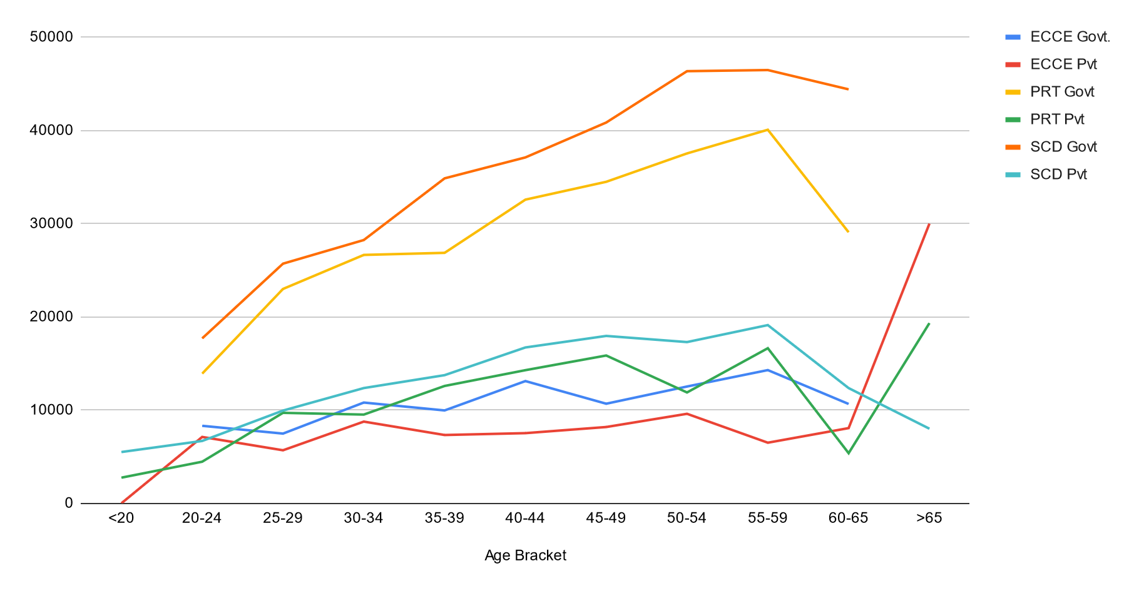
Source: PLFS 2020-21 data analysis authors

5.3 Benefits
Between 55% to 63% of government primary and secondary school teachers receive all benefits of pension, gratuity, health care and maternity benefits in full. An additional 25% receive some subset of benefits. A very small proportion of ECCE teacher (approximately 40%) receives all or some benefits in addition to their salary. Within the government sector, 61% of primary teachers and 70% of secondary teachers report receiving health-related benefits. Only 27% of early childhood education workers receive health benefits even though their’s is a field job based within the community and their work is of a fairly ‘front line’ nature. 49% of ECCE teachers working with the government report not being eligible for any benefits. The proportion of government primary and secondary teachers reporting not being eligible for any benefits is 15% and 10% respectively. This may be reflective of short-term contractually employed staff working in government schools (see Table 5.4).

Table 5.4 Benefits: sector wise, comparing government and private teachers
 | ECCE teacher |  | Primary teacher |  | Secondary teacher
 | Govt. | Pvt/NonGovt. | Govt. | Pvt/NonGovt. | Govt. | Pvt/NonGovt.
NI | 3.15% | 19.83% | 4.03% | 15.95% | 1.49% | 18.53%
Most/all | 22.24% | 10.74% | 55.09% | 12.01% | 63.24% | 15.69%
Some | 19.61% | 15.70% | 25.02% | 14.31% | 24.19% | 13.19%
Only health & maternity | 5.08% | 2.48% | 0.63% | 1.15% | 0.68% | 1.00%
Not Eligible | 49.91% | 51.24% | 15.23% | 56.58% | 10.41% | 51.59%
Source: PLFS 2020-21 data analysis authors

Between 57 and 52% of those employed in non-government/private sector are not eligible for any benefits. Only 12% of primary teachers and 16% of secondary school teachers in private/non-government teaching jobs receive full benefits of pension, PF, gratuity, health and maternity leave. These are the best paid among private school teachers, reporting salaries between INR 30,000 and 33,00 which is about 70-77% of the salary of government school teachers. About 22-25% of private sector jobs pay is reasonably comparable with the pay (about 60-70%) and benefits of government teachers. An additional 13 to 14% of private school primary and secondary teachers receive some benefits; PF, gratuity, etc.

6. Summary and Conclusions
- Overall, the profession appears to have a gender balance with 51% of all teachers and 45% of primary and secondary teachers being women. However, there are marked differences in the gender balance depending on location, level of teaching and management type, with some sectors being highly feminised and some being more male-dominated. In government primary and secondary teaching the proportion of women to men is approximately 40:60. In the private sector, in primary teaching the ratio of women to men is 65:35 and in secondary school teaching it is about 50:50. Although the sample size is small, physical education is dominated by men and the ration is about 10-20: 90-80.
ECCE is highly feminised, with over 85% of the workforce being women. Only 36% of primary and secondary women teachers are in rural areas. Only 25% of secondary school women teachers are in rural areas.
Government rural teaching primary and secondary is male dominated with between 67-70% being men. In comparison, urban private school primary teaching is highly feminised with close to 72% of the workforce being women. there is greater gender parity in government urban primary and secondary teaching and rural private primary teaching, rural private secondary teaching is male-dominated at 60%.
- The median age of the total workforce is 38. there are marked differences based on management, level, and type of teacher. ECCE teachers are the oldest group with a median age of 43, followed by secondary teachers with a median age of 40 and primary teachers with a median age of 39. This tells us that teachers are mostly in their midlife, and are likely to be married, have children and have ageing parents. Approximately, 10% of the workforce will need to be replaced in the next five years, and approximately 15 % every five years following this. Across all sectors, the median age of government teachers is roughly 6 to 8 years more than the median age of teachers in the private sector.
Rural private school primary and secondary teachers have the lowest median age of 32, with the women median age as low as 30. ECCE workers in urban areas and secondary school teachers in urban areas tend to be among the oldest with a median age of 43-44 years.
Generally, the median age of women is 3 to 4 years less than men. This indicates that more young women rather than men are entering into the profession overall. A growing trend of feminisation over the last ten years is also visible with 62% of secondary school teachers and 73% of primary school teachers in the age group of 20-24 being women. In the age group of 45 years upwards the balance is in favour of men. Government school teaching feminisation seems to be taking place over the last five years, private school teaching feminisation is at least 20-30 years old.
- Overall the proportion of women ST and SC teachers in secondary schools is low. The proportion of teachers from SC and ST communities in private employment is low compared to government schools. Private school teachers are predominantly in urban areas about 62%, compared to about 41% of government school teachers.
- About 24% of ECCE teachers in government and more than 50% of teachers in private schools report they are working without any written contract. Only 6-24% of teachers in private schools say they have written contracts for more than 3 years; A large proportion of young women in primary and secondary private schools (50% primary and 64% secondary) say they are working without written contracts. In absolute terms, the average salary of the ECCE teacher is about INR11,000, about INR 31,000 for a primary school teacher and about INR 40,000 for a secondary school teacher. Private ECCE teachers earn about 65% of a government ECCE worker and privately employed primary or secondary school teachers earn only about 35% of a government teacher. At the primary school level, in government and private, women teachers earn about 60-75% of that of a male teacher’s salary. In the case of secondary school, the salaries are comparable. In secondary school, men's and women's salaries in private schools seem to be comparable, while in primary school women earn about 60% of the salary of men. Teachers with no written contract receive lower salaries.
Between 55-63% of government teachers receive all benefits, and an additional 25% receive some. Only 21% of ECCE workers report receiving health benefits. Between 52-57% of teachers in the non-government/private sector do not receive any benefits. Only 12% of primary and 16% of secondary school teachers in the private sector report receiving all benefits–their salary is also comparable to that of government teachers (about 75% of govt teacher salaries).
References
UNESCO. (2021). No Teacher No Class: State of the Education in India Report 2021. New Delhi: UNESCO Regional Office.
(Authors: Sarangapnai, P.M., Thirumalai, B., Ramchand, M., Kumar, R. and Ramanathan, A.). https://unesdoc.unesco.org/ark:/48223/pf0000379115.locale=en

Periodic Labour Force Survey. (2020-21). Ministry of Statistics and Programme Implementation. Government of India.

