FIELDWORK SUMMARY
TEMPLATE

DIET NAME: GORAKHPUR DIVISION: GORAKHPUR

FIELD TEAM: ANAND KUMAR & RAJNISH RAJ

DATES OF VISIT: 12 Dec. TO 16 Dec. DURATION: 5 days

NOTE: Please add only your observations, do this as a group activity. You may add your reflections for your FA report; this document is only for observations. Please add Photos wherever relevant in the different sections.
- OBSERVATIONS DIETS (12-12-2022) FIRST DAY

- DIET Infrastructure

Gorakhpur diet is located in the middle of the city and due to being in the middle of the city, the effect of the city is clearly visible on its infrastructure, first of all, I would like to tell that due to the lack of boundary around them, a road has been made in their area which Divides the diet into two parts and the access of the animal which is always grazing and the access of other persons inside the compound is very easy. This diet is being operated at three different places, in which academic work is done at one place, studies are conducted at the other and the third is used as a storehouse. The first academic building is a one-storey building, which has a principal's room, a senior faculty room, a library, a vice principal's room, a staff room and a faculty room. There was also a bathroom which was in good condition. The principal room and the vice principal room were very nice. There was very little space in the faculty room, which all the faculty were complaining about. And faculty were saying that the table is also very small. Due to we can't do our job well. Apart from this, there is another building on this campus which is 2 floors. It has a meeting room on the ground floor with a seating capacity of 50 people. And the answer copy and question paper were kept on the floor above. A total of 2 bathrooms were on the ground floor which was in good condition. The second is another building which is a very old building. The oldest building there was built in 1904. There are five building which was used as a hostel in past but now some are used as a store room and in some building, people are living. These all buildings are not in good condition. The third building, where studies were going on has a total of 5 rooms. One room was for the girls' classroom, one room is for the boys' classroom, one room was for the computer lab and one room was for the course lab the other was locked which was used for the need of class, programme, activity, seminars etc. The condition of the bathroom was not good. Due to being a very old house, everyone was worried about safety like theft by thieves and the infrastructure here. A few days ago there was some relief due to the presence of boundary walls. Still, there remains a danger in the computer lab room during the time of water because it is impossible to keep it safe from both water and dust. There is a particular room for the library and only old books were there. Sports facilities are available there. Badminton, volleyball and many games are played by students and teachers. There is no ICT lab.

- Teaching Learning Resources

E-books of all the papers of deled are available on the website of Uttar Pradesh SCERT, which children read online or photocopy of that papers. Some had a guide of other publications available in the market, after reading which they give the direct exam. In the classroom, many pictures which were made by the child were pasted on the walls but while talking to the child it was found that it was not made by him. It is already installed. There were blackboards in all the classrooms on which the teachers were teaching them when I asked if there is any digital resources or not then they told me that we have 3 projectors which we use as per our requirement.

- D.El.Ed Class Observation

When we went on the first day, all the students were present. After the assembly, all the boys went to their class and the girls to their class. On the first day, during the diet observation itself, we got a chance to spend some time in the class, where I showed that there is a teacher in the boys' class, but all the students(boys) were busy with different work, they were doing what they had to do, but when I went to the girls class, There was a madam who was teaching them and all the girls were studying. After that, being on a field visit for 2 days, we reached DIET after 2 days where we came to know that the all students are not coming at all. On finding out, it was found that the child's exam is due from 19, and they are not coming.

- D.El Ed Student-teacher Interactions

After interacting with the students and teachers, the aspirations of both were almost the same. Both spoke about the building facility in the first voice, and after that, they spoke about the updated classroom. There should be at least one digital classroom. Electric wiring should be good in the class. A hostel facility and canteen facility should be provided. A security guard should be arranged. If we are told about the goals, along with studies, we keep the child doing quizzes, presentations and different activities from time to time and they are also made to prepare for the CTET exam.

- Workshops / Inservice Training Observed

Any seminar and training issued by SCERT is conducted at the diet level. DIET does not conduct any training for the teachers at its level district.

- NGOs Presence

As I say about computer lab presence, that is provided by the Humana NGO whose motto is people to people India. This NGO is working in different fields like education, environment etc. so for education, NETT ( necessary teacher training) do work. There is an app on the NETT on the play store. And also a website, named Humana ( https://humana-india.org/). A total of 9 people are working in diet Gorakhpur under this NGO. and a total of 50 computers are provided in this diet by Humana. And also they have all the online resources which are important for the deled students on the Humana website. It has free access and an unlimited download option. It has been working there since 2013. And at that time there was a shortage of teachers, so he used to go to the class and teach the children.

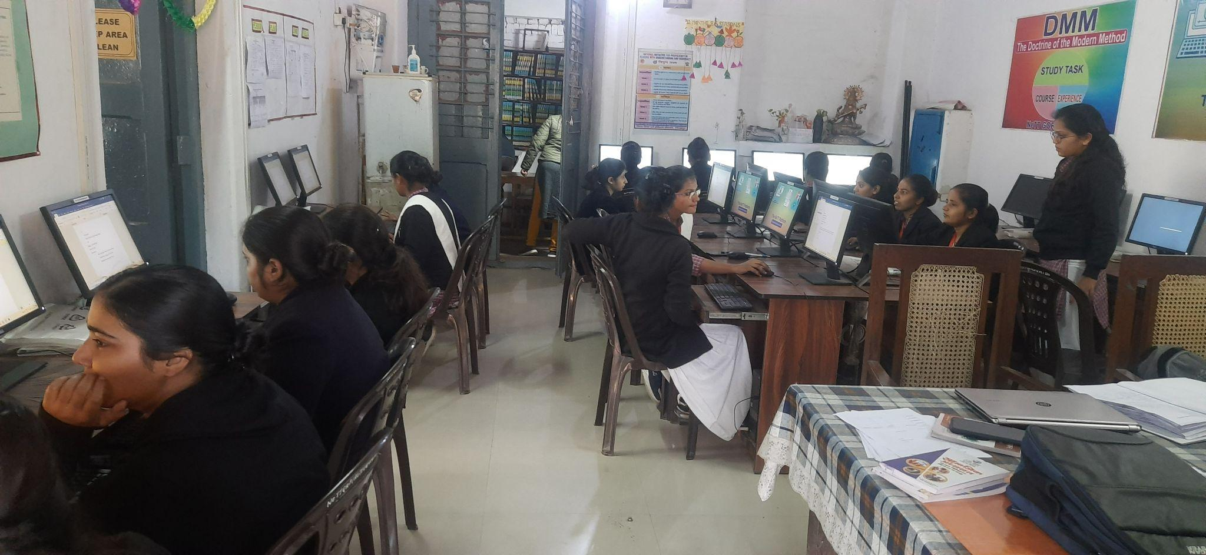

- Other Observations

In the assembly, at first, Pray was done, then the oath, then Suvichar, then news, then today's history, then pt was done and lastly, it was finished by singing the national anthem.

B. OBSERVATIONS SCHOOLS ( 13-12-2022) SECOND DAY

- School Type

(Upper Primary) → Pre Secondary School Chhapiya, Block-Piprauli, Gorakhpur (Class 6 to 8) [ UDISE CODE:- 09580107501 ]
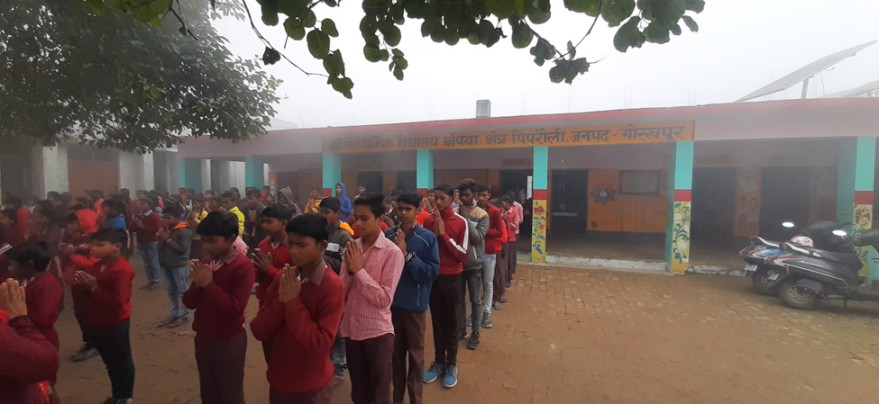
- School Location /Surroundings

(Rural) → This is located in a village. This is 10km from DIET Gorakhpur. There is a road on one side and one side is a field and the remaining sides have private buildings. Also, the BRC office was near this school.

- Infrastructure

There are only four big rooms and 2 small rooms there. Which are the principal office and a staff room. And of the 4 big rooms, 3 rooms are classrooms and one room is used for a science-based lab which is provided by care India NGO. there is also a small place for a playground.

- 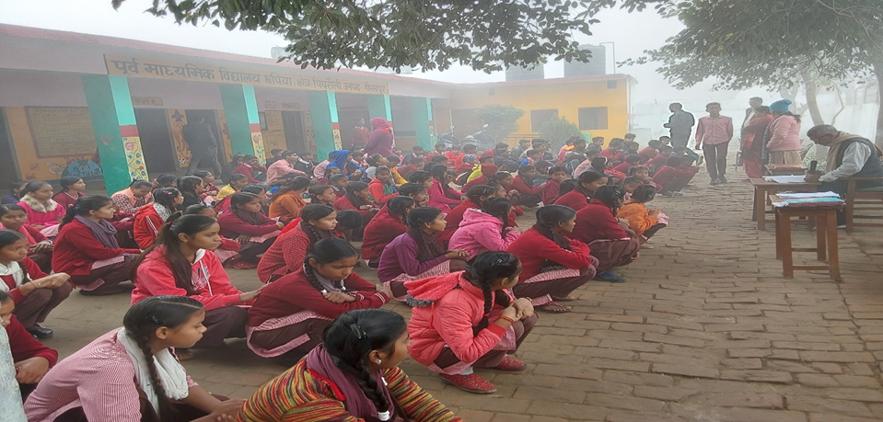

- No available drinking water. Students used to handpump water for drinking.
- No special ICT Lab
- Only 2 Toilets room is available (1 for Boys & 1 for girls)
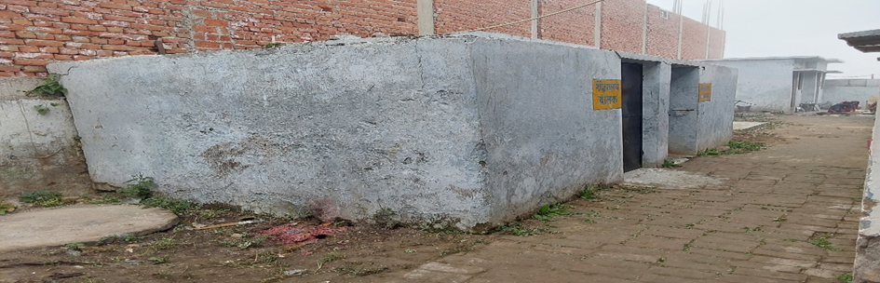
- No Facilities for special needs students/students with disabilities

- Teaching Learning Resources

A room has been developed as a Teacher Resource Lab. Science-based materials are available in this room. which is very useful for students. Also, we saw many student made science-based projects in which all students used useless material from our daily life.
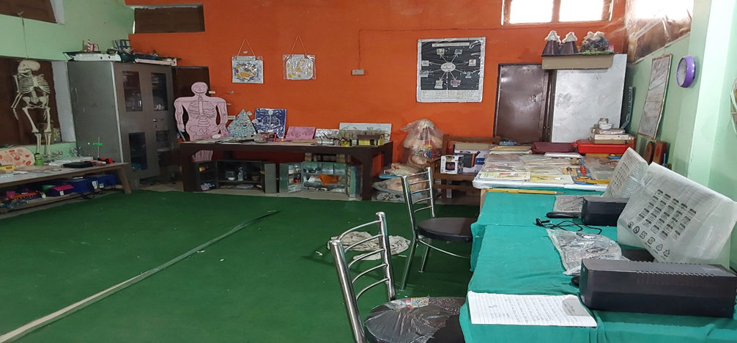

- NGOs Presence-

This lab is developed with the help of the Care India NGO. Care India NGO primarily provides two computer systems in this school.

- Class Observation

The total number of students is 228 ( Boys- 112, Girls-116 ). The total number of present students is 141. The number of minority students is 51. I observe a class and I found that madam was teaching geography. The chapter is about continents, oceans, islands, seas, canals etc. and I saw there she was teaching without any lesson plan or map. And they used the ocean in the explanation of the continent. And when I stayed for a long time, she said to the children that now Sir will teach, Then I taught about a balanced diet.

- Other Observations

In assembly, I found here that They recite the Gayatri Mantra after prayer.

INTERVIEW SUMMARY STAKEHOLDERS ( BEO & ARP) SECOND DAY

- Interviewee - ( BEO )

I interviewed a BEO of Piprauli. His name was Vijay kumar Ojha.

- Job/Role as described by Interviewee

His role as BEO, is to coordinate with ARP, DIET mentor and principal of that block. If any scheme is run by the SCERT then he has to also monitor it at the block level. He has to visit 10 schools in a month. He works under BSA officers.

- Opinions/issues expressed by the interview

During the talk, the main point where he focuses on the presentation of students in their class. He told me that we have taken out an awareness rally to increase attendance in class. And also he focuses on the presence of the private school. Because when a government school children getting good in the study then they this school and they went to private school.

- Nature of Interactions with DIET /DIET Faculty

He interacted with ARP directly in CRC meetings and in a monthly meeting, with all the diet faculty. BSA, BEO, SRG, ARP and the principal of the school meet together online but I think it is just for formality. There isn't any effect of it on education level.

- Interviewee - ( ARP)

I interviewed three ARP of the Piprauli block. two name was anil kumar Tiwari, ramji tiwari.

- Job/Role as described by Interviewee

At the block level, there are academic resource persons (ARP). total no. of ARP is 5. It is subject-wise. The role of ARP at the block level is he has to visit 2 schools per day and help teachers with their academic problems like how to teach, and how to use TLM material. And also see the progress which is run by the government. like when we have visit the school everywhere I got to see NIPUN Bharat. Poster and related to the resources provided to students and they were busy with them. And also ARP is involved mostly behind it because they have a target to achieve it by Dec. 2023.

- Opinions/issues expressed by the interviewee

During talking with them, they have lots of problems. At first, they mention that Our training does not happen from time to time. And instead of working, we have more problems. He said that if we want to fly a plane, we should give an airport and not a field. He said that we do not have updated resources. When we go to school, due to a lack of teachers and lack of resources, the entire load falls on us. Where we take the entire class, but now in this school, due to the next visit after months, we do not get updated with the performance of the school and the class. And sometimes we have to face difficulty due to the absence of a teacher related to the subject. He also told us about his travel allowance that we get 2500 rupees for oil, but due to the increase in inflation, it goes to less and we have to spend from our pocket.

- Nature of Interactions with DIET /DIET Faculty

As I said A mentor has been provided by DIET in each block. They have to visit 10 schools in a month, during that they also go to CRC where they also have to attend meetings where they get a chance to meet ARP, also during school visits, they get to meet by chance then they interact. So when I asked ARP for interaction with the diet then they told us that it is not fixed and I have no mobile no. of my mentor because if we need anything I interact with our BEO-related. So I think there is no direct interaction of ARP with diet.

C.OBSERVATIONS SCHOOLS ( 14-12-2022) THIRD DAY (VISIT TWO SCHOOLS)

- School Type (Composite) (FIRST SCHOOL)

Composite school Punda, Block-Pali, Gorakhpur (Class 1 to 8)
[ UDISE CODE:- 09581302602 ]

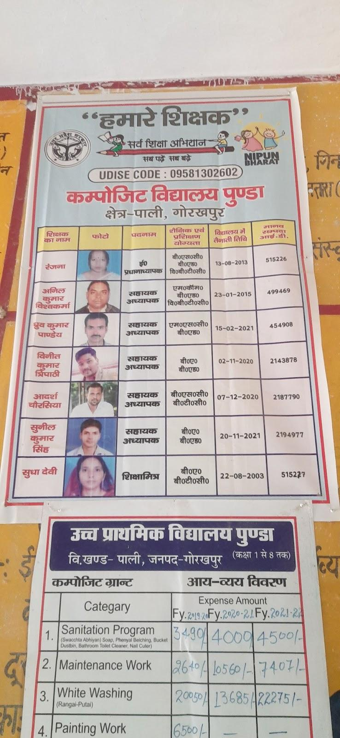

- School Location /Surroundings

This school is located in a village area (rural). This is 30 km from DIET Gorakhpur. This school and area are entirely submerged in water during the rainy season.

- Infrastructure (Staffroom, Classroom, Playground, Drinking Water, ICT Lab, Toilets, Facilities for special needs students/students with disabilities)

The School is divided into two parts. One part is on the left side of the road and another part is on the right side of the road. On the right side building, there is a total of 5 rooms, of which two rooms are fully damaged and two-room were good where the combined class of 7th and 8th is running. And on the left side of the road, there are 5 rooms and two small rooms. One room is occupied for the mid-day meal. And in the remains, one room is for ANGAN WADI and the remaining three rooms, are used for classes from 1st to 6th, which is running in combined mode. So here they are facing with lack of classrooms. They do have not any staff room. And also the classroom is not well because the classroom and the roof are inundated with water and there is a flood almost every year. There is no playground. All students are using handpumps for drinking water. No ICT lab in this school. The school has a toilet facility, but it is not in use yet. These students use the public toilet outside the school.

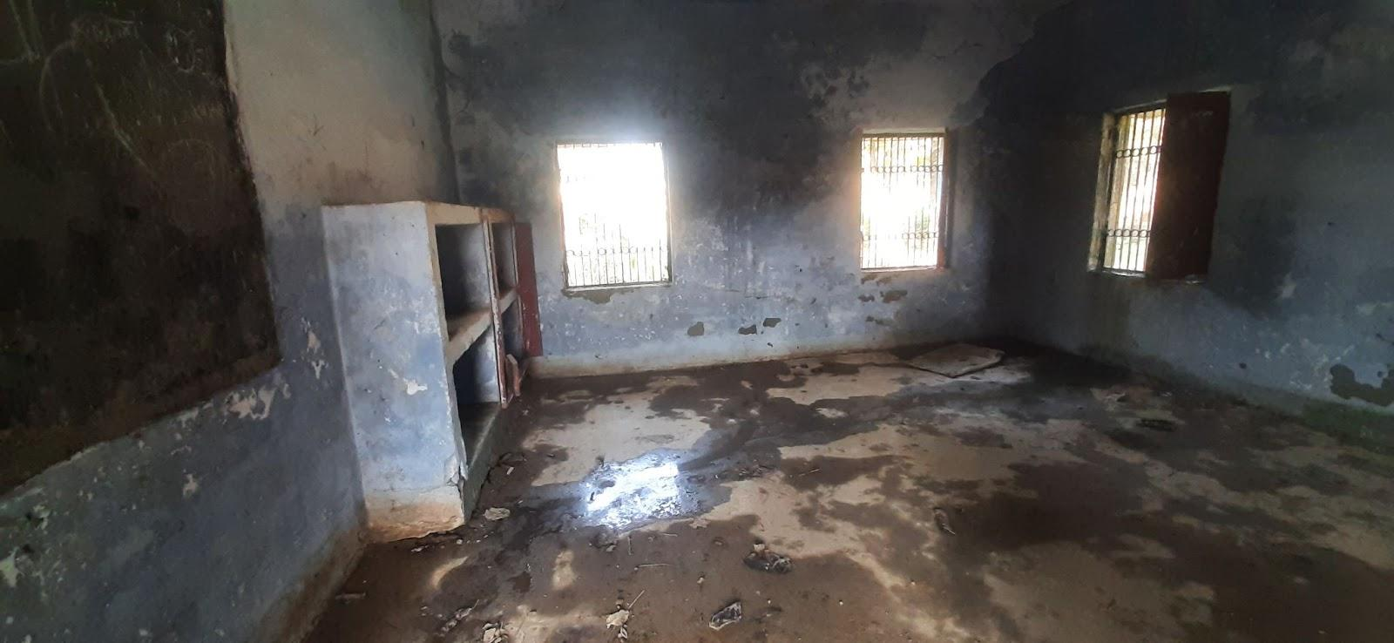

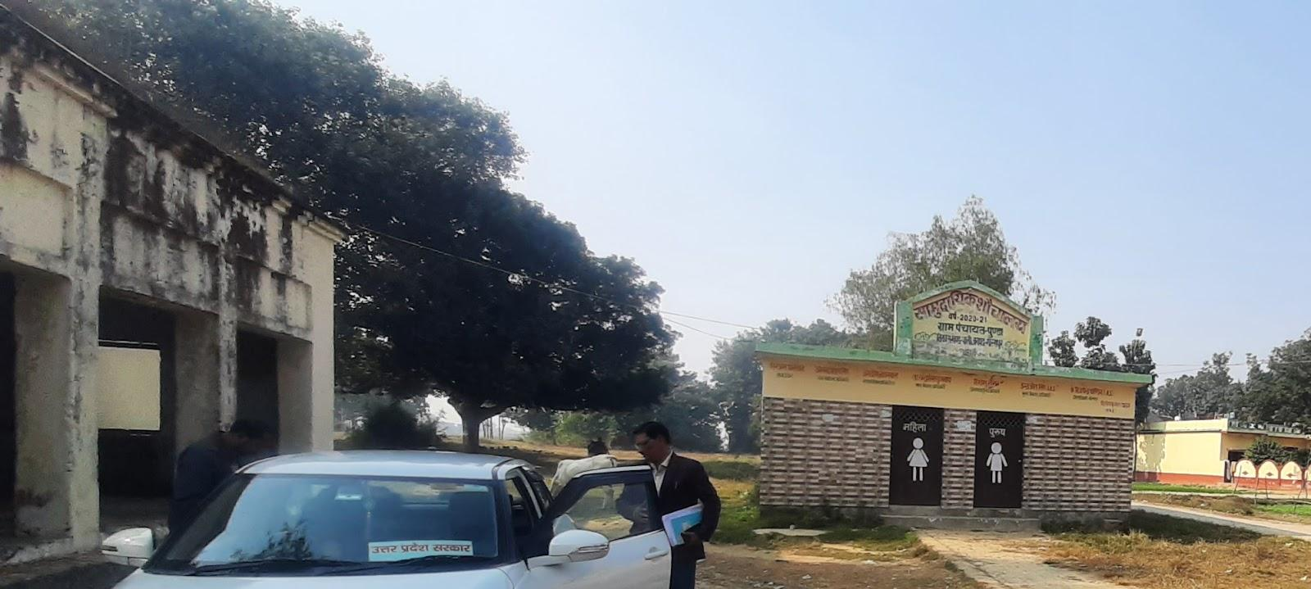

- Teaching Learning Resources

On the left side of the building of the school, each room wall has posters. TLM are also present there but on the right side building, there is nothing like posters and displays. Children were reading the book published by Uttar Pradesh for book

- Class Observation

When we go to class 8, there we saw that the class was running by merging both classes 7 & 8. Then I go to the Anganwadi where I saw the class 1 student and Anganwadi student class conduct merged. Then when I went to Anganwadi, I saw that class 1 and the Anganwadi class were running together.

- Interaction with headteacher/teacher

Here we got to see one more thing that here the head teacher was busy taking his class, so during this time we got a chance to observe his class, but due to external work, he requested me to teach, after which he started teaching. Vitamins were being studied in the class, so I started asking, then all the children answered well, some of the thieves. And they were really understanding too.

- NGOs Presence

No NGOs work in this school.

- Other Observations

When I reached the assembly has over and all the students in their class. One thing I want to say is that there is a student with 100% PWD. They are brought daily from home by a teacher of the same and then reach home. The child was not stable in his class as long as he was there. Sometimes he used to play the drum and sometimes he was playing with the globe. In this way, I felt that he was disturbing others, so I asked the teacher about his studies, and then he said that he did not want to come to school two years ago, and even when he used to come, he used to cry and beat others. Was but now he stays in school all day. A lot has changed in this. Now I am slowly bringing them to read

- School Type (primary school) (SECOND SCHOOL)

It is a Primary School in Kusmha Khurd, Pali, Gorakhpur [English Medium Class 1 to 5, UDISE CODE:- 09581307801 ]

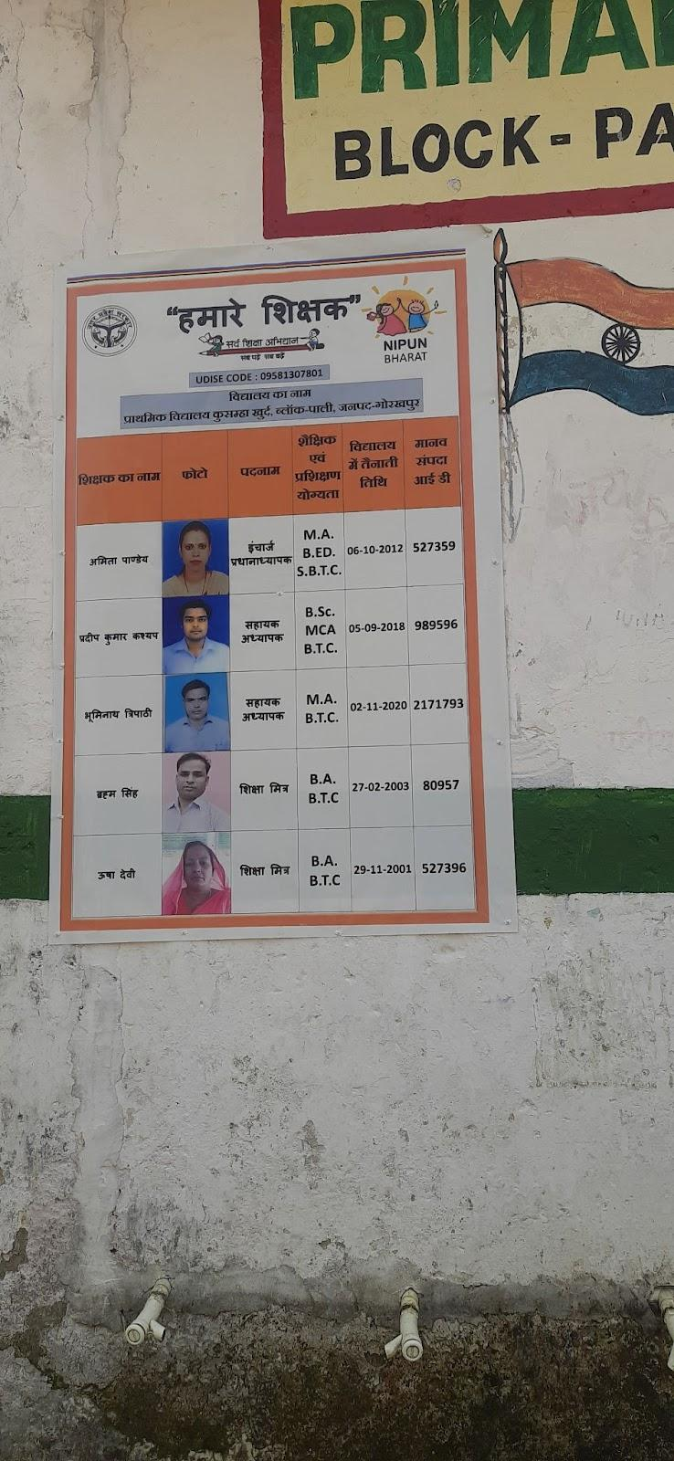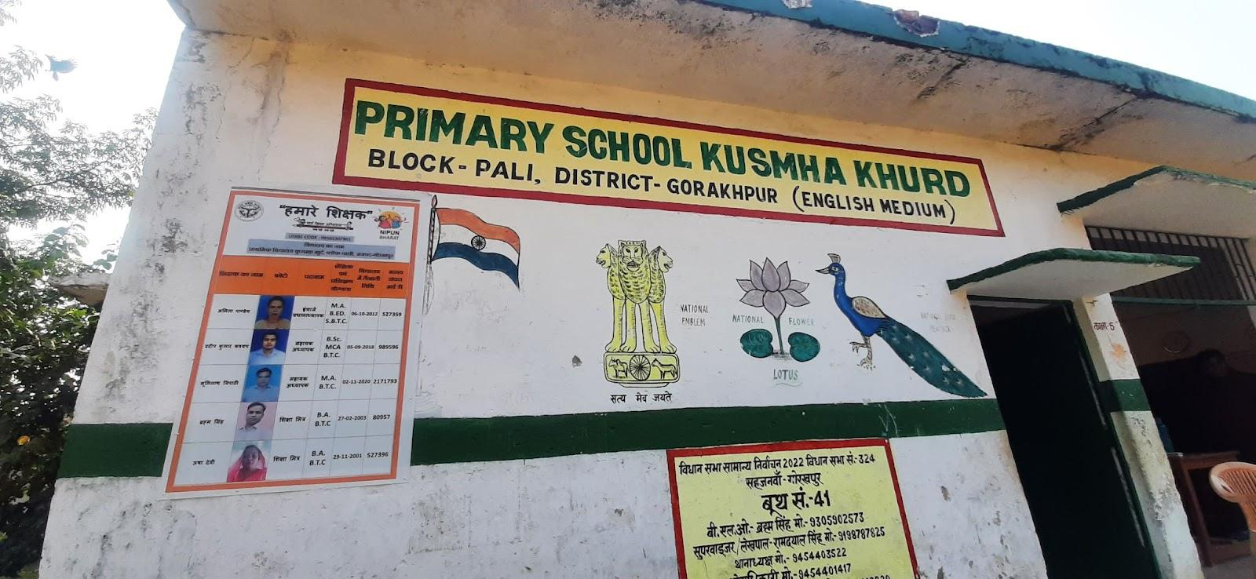

- School Location /Surroundings

(Rural or Urban) → This is located in a village. This is 35km from DIET Gorakhpur. This school and area are also entirely submerged in water during the rainy season.

- Infrastructure

There is a total of five rooms of which one room is for the mid-day meals and remains four rooms are for classes 1 to 5. There is a big playground in this school. Some classes were going on in the open ground when we reached there. There is the availability of a good drinking water facility. They do have not an ICT lab or library. There is no toilets or other facilities for special need students. There is a ramp to go to class available there. So there is a need for some classrooms in this school.

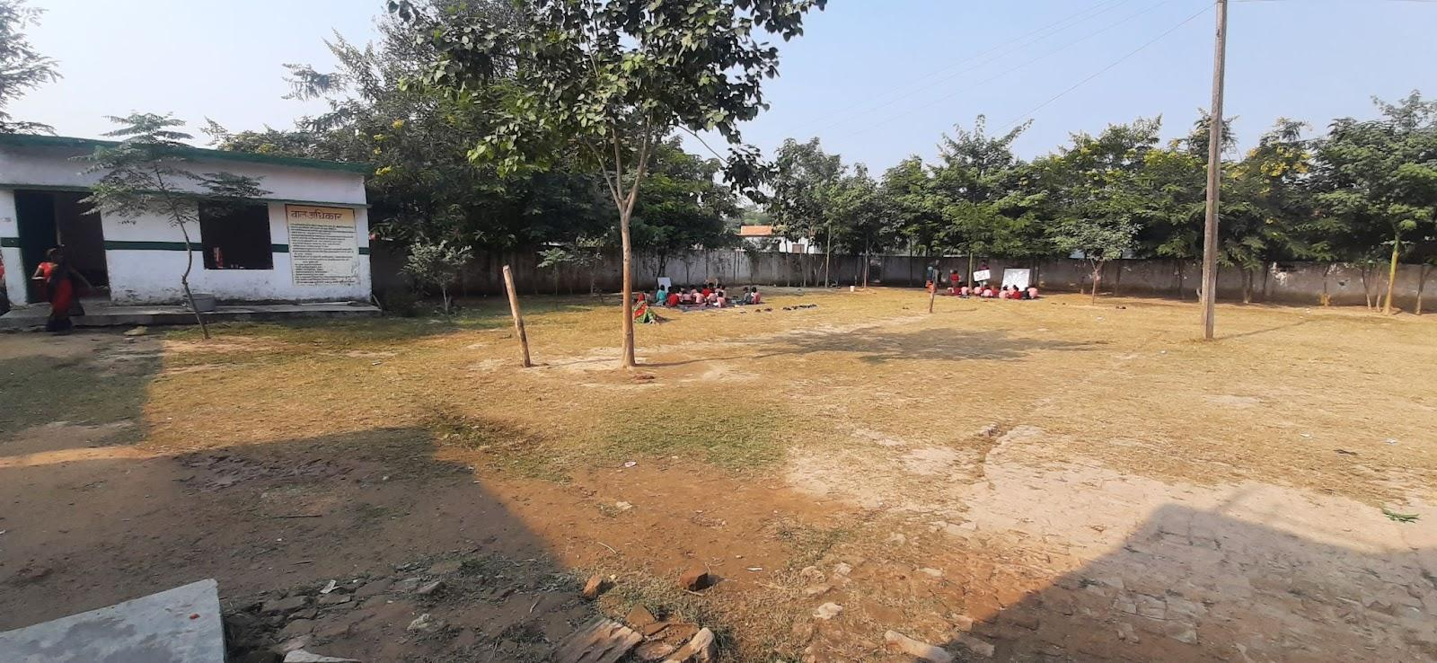
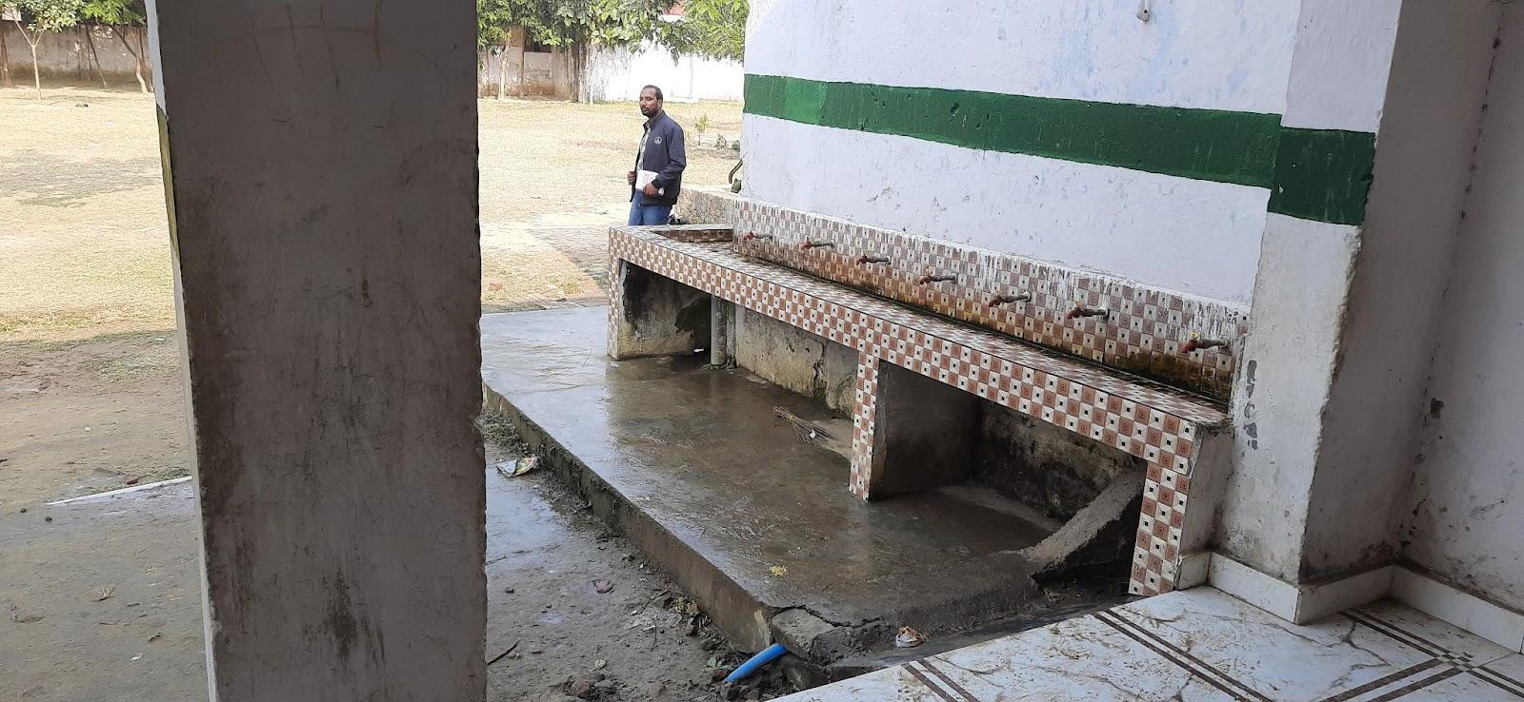

- Teaching Learning Resources

There are no available books, posters, or displays, but their available Teacher Learning Materials. This school's teacher is good. The teacher's extra work for non-active students. State government books are used there. And all teacher was focused on NIPUN BHARAT. As long as we stayed there, we saw all the classes being studied and conducted under Nipun Bharat.

- Class Observation

I went to class 5 then I give L.C.M and they can not solve it. All students were sitting on the floor. A wall blackboard is there. There is lots of poster in the class. And all students read for NIPUN BHARAT material which is provided by the teachers.

- Interaction with headteacher/teacher

Same Here we got to see that here the head teacher was busy taking his class, when I entered their class she asked me Who are you and for what purpose have you come to school then I told her our work then she said let us know if there's a problem during school observation. She was supported. She said that we need benches for our classroom. If there is a need, I will contact BO. We can't get in touch with Diet. If she needs anything, she talks to the direct block. There are three teachers and two para-teacher at the school. In the school, some teachers are also required. If he needs anything, he talks to the direct block. This school's mentor is Vinay Sir. But he only comes to school once a month. As a teacher, she faces many problems when students are absent. Then the student is back to study. Then many problems face both students and teachers.

- NGOs Presence

No NGOs work in this school.

- Other Observations

I reached this school after lunchtime so I could not see the assembly. But here special Navodaya preparation is done by a teacher for free. he calls all the children and studies them at home too. When I asked about the result, he told that no result has come yet, but we are working in a good way so that the results come and once the results start coming, then I don't think that anyone will be able to stop these children again.

D. INTERVIEW SUMMARY ( Junior Lecturer) 15-12-2022 FOURTH DAY

- Interviewee (FIRST JUNIOR LECTURE)

Sahebe alam anshari (Junior Lecturer )

- Institutional Identity and Focus:

He was Urdu Lecturer and was appointed as Junior Lecturer on 1st July 2020. Looking at their work, apart from teaching in DIET, they have to participate in DIET seminars and meetings and training as coordinators. He has assigned a block as a mentor of this block. Where he has to interact with BEO and ARP and also see their intern students who are doing their internship in that block. And also interact with 10 schools five days a month. The administrative work of this lecturer means that he has to be present at the meeting held in BRC. in the school where the students of DIET are doing internships, he goes for one or two days a month. He also said that I am not independent to do any work here. I have to follow as my principal said and also most of the work is fixed by SCERT from time to time SCERT does many activities and training at the diet level and I have to just participate in it. He suggests some points which are
- Urdu teacher is not calling for training till now.
- There is no Urdu-based syllabus.
- At block-level meetings, there is not any effect of it. It should be improved.
- There is no promotion guideline.
- There should be a suggestion register in every school. On which we could see the progress of school problems.
- There is no clear guideline regarding research

- Systemic location and relation to other institutions:

Mostly the diet is governed by the guideline set by SCERT and in this, our job is to follow the above orders. And we have to participate in the meeting in BRC at the block level where we meet with BEO and ARP to review the ongoing work plan at the block level and talk to each other about the problems happening at the school level during studies and discuss their diagnosis. But the bonding of these mentors with ARP & BO is not so good. In terms of the meeting, these meetings are sometimes called on DIET, and ARP avoids coming here.

- Financial Aspects:

He said that There is no financial aspect to the infrastructure. Resources, staff and faculty positions and for other facilities.

- Development of Faculty and Staff:

He is working as a junior faculty. As a responsibility, his work is to implement the program decided by SCERT in DIET and assist in the works of DIET. Visiting 10 schools in his block in a month and meeting the students doing internships and discussing the experiences and challenges faced while teaching them and giving suggestions. As a faculty in Gorakhpur DIET, some posts of Senior Faculty are vacant and some guards are needed. The method of reinstatement is done by UPPSC for lectures and the reinstatement of all other employees is done by UPSSC. There is a principal and a vice principal in this diet. The total number of lecture posts is 17 which is fulfilling. And there is 7 senior lecture post and only 4 seat is full. And one senior lecturer is working as a principal and the other is working as a vice principal of the diet.

- DIET functions and Activities:

The work of DIET is as training for in-service and pre-service teachers and students. For their training, work is assigned to them for in-service, from time to time by SCERT with Guideline, which is their responsibility to implement. For the pre-service, they have also fixed guidelines for their teaching and they have to follow them. Besides it, they do some other activities among the students. For presentations, group work, quizzes and speech competitions among them etc. as a resources centre, I think there is not any special facility there. They do have not any lab, or ICT lab, and also I can say that there is no proper library. So it is not in best as a resource centre. They do have not enough rooms for any meetings at the district level. And also no faculty who are involved in any material development and making some other TLM, resources materials in this diet.

- Collaborations and Partnerships:

For collaboration with another institute, then there is NASHTRA SHALA in Gorakhpur. DIET Gorakhpur keeps visiting its Pre-Service students from time to time for NASHTRA SHALA and students also told us about it. Besides, there is no collaboration with another university.

- COVID-19 Impact:

He was not present during covid period.
- Interviewee (SECOND JUNIOR LECTURE)

Ajay Mishra (Junior Lecturer). He joined as a lecturer in 2018 in diet

- Institutional Identity and Focus:

He was an English Lecturer and was appointed as Junior Lecturer in 2018. He has also the same work as I mentioned in the previous interview with the junior lecturer. He is also Looking at their work, apart from teaching in DIET, they have to participate in DIET seminars and meetings and training as coordinators. He has assigned a block as a mentor of this block. Where he has to interact with BEO and ARP and also see their intern students who are doing their internship in that block. And also interact with 10 schools five days a month. The administrative work of this lecturer means that he has to be present at the meeting held in BRC. in the school where the students of DIET are doing internships, he goes for one or two days a month.

Apart from it, he told us that he does some activities in their class like slogan writing which is based on the academic calendar like all the JAYANTI and festivals. Student participates in this activity and shares their different idea about it in their words. He told us that he did 6 months online course in online mode from TISS. he told us some suggestions which are
- all the ARP should be TLM toolbox.
- He also mentioned that all subject-based labs should be available in the diet.
- There should be fixed methodology development for all subjects.
- Diet follow only SCERT guideline. We are not independent so I need some budget and independence at the diet level to do some work at the district level.

- Systemic location and relation to other institutions:

It is the same as I say in before the interview.

- Financial Aspects:

It is the same as I say in before the interview.

- Development of Faculty and Staff:

It is the same as I say in before the interview.

- DIET functions and Activities:

It is the same as I say in before the interview.

- Collaborations and Partnerships:

It is the same as I say in before the interview.

- COVID-19 Impact:

During COVID 1 period, He conducted online classes. By talking to the children on the phone, they were solving their problems and giving suggestions.

INTERVIEW SUMMARY STAKEHOLDERS ( SRG ) 15-12-2022 FOURTH DAY

- Interviewee - ( SRG )

I interview all the SRGs of the Gorakhpur diet. His name was Ramesh kumar Pandey, Rajiv kumar rai and Rakesh kumar dubey.

- Job/Role as described by the Interviewee

Role of SRG is to Analyse the data recorded on the Prerna app and give suggestions and help in making action plans for himself or ARP. Regular review of all 35 points and orientation of all collaborators and stakeholders to develop the motivational block. Total 21 blocks are in Gorakhpur janpad. So these three SRGs are divided among 7 blocks equally. They are a direct online meeting with the DG sir once a month.

- Opinions/issues expressed by the interviewee

During a talk with them some issue also raises which are
- ARP are not well. And good teachers do not want to be ARP.
- Outer body only provided math and science tool kit. Whereas school has need of all subject based toolkit.
- In all the schools, we get to see that the teachers are not motivated, due to which we have to face a lot of problems. Need to work again on this type of problem
- Online training is not good. So face to face to training is good for us.
- We work hard academically but when administratively someone comes, they see BS deficiency and not our hard work.
- Not exact people come for a road map.
- Those teachers who are not in the field are also giving training.
- There should be a model school in the Janpad. And it will be better if it will be in the diet. By this, we have a proper aim and an experimental lab where we can do any experiment related to education. It will education resources hub in every JANPAD.

- Nature of Interactions with DIET /DIET Faculty

There is a meeting at the last of the month in which the principal of DIET and BSA, all SRG parts participate in it. Apart from this, whenever SRG is needed, he visits the diet and when the diet is also needed, he contacts SRG and he presents the next day.
E. INTERVIEW SUMMARY ( Principal / Sr Lecturer / Junior Lecturer) 16-12-2022 FIFTH DAY

- Interviewee -- Principal (PRINCIPAL)

Jay Prakash is the principal of diet Gorakhpur.

- Institutional Identity and Focus:

He is a senior lecturer at diet Gorakhpur and now he is assigned as principal of diet Gorakhpur. He has lots of work. Because as a diet principal, he is the chairperson of many academic programmes. The work at the diet level is assigned to them by the SCERT, and the responsibility of implementation rests entirely on them. From the budget to the training of these in-service and pre-service, it is up to them to implement seminars and activities properly. From time to time, if needed, they are assigned other work at the district level apart from education. Be it teacher reinstatement or any program related to education, all go to them.

- Systemic location and relation to other institutions:

He is connected with SCERT and BRC. There is a meeting once a month with BRC in which BSA, BEO, SRG, ARP, all the faculty of diet and all head teachers of the school are present in this meeting. in which the plan of action is discussed. And for the SCERT level, he can talk directly to the director of SCERT but mostly he talks with JDSA, SCERT.

- Financial Aspects:

If any work is given through SCERT, then the funds are fixed and sent from above. From time to time they are also asked what do you need for the development of their institute. Make a list and send it, then send it and according to the same list, money is sent for some work after fixing the money according to the work.

- Development of Faculty and Staff:

Almost all the posts in DIET are filled now but they told me about some staff shortages like the need for 2 guards. A library assistant is required and a computer operator is required in our diet.

- DIET functions and Activities:

Apart from teaching the children of Pre-Service, DIET also monitors all the primary schools. Each faculty is given a block, which monitors the studies, takes resources and helps with the teacher's problems. And also conduct all the activities and seminars which are given by SCERT.

- Collaborations and Partnerships:

For collaboration with another institute, then there is NASHTRA SHALA in Gorakhpur. DIET Gorakhpur keeps visiting its Pre-Service students from time to time for NASHTRA SHALA and students also told us about it. Besides, there is no collaboration with another university. In this diet, there is a Pavana ngo, who provides a computer lab with their faculty who are a total of 9 persons. And expect there to be no collaboration and partnerships with other institutions.

- COVID-19 Impact:

During the covid period, he has given instruction from SCERT in online mode. Which is related to the academic part. The meeting with BSA and BRC is in online mode and they are connected very well during this period. And at the school level, there are Mohala classes which are done during this period also.

- Interviewee -- Sr Lecturer FIRST SENIOR LECTURE

Her name was Amrit. She is the third senior lecturer there. She is 52 years old. She did M. Sc. in home science and M.ed. she is at first joined as a teacher in GIC in 2001 then in 2005 she came to diet and then she still doing their job in the diet.

- Institutional Identity and Focus:

She sees all the activities and programmes related to their course. Apart from teaching, he looks after the work related to these services. For example, when there is an exam or evaluation work, she looks at it. Their main work is to collect related material from the local committee and provide online training. All this is decided by the SCERT, which is responsible for implementing it at the diet level.

- Systemic location and relation to other institutions:

It is the same as I said for the principal sir.

- Financial Aspects:

she said also that There is no financial aspect to the infrastructure. Resources, staff and faculty positions and for other facilities.

- Development of Faculty and Staff:

She also said that now all the staff are present in the DIET but a computer teacher is required. Computer as a subject is also present in deled's syllabus.

- DIET functions and Activities:

It is the same as I said for the principal sir.

- Collaborations and Partnerships:

She also mentions NASHTRA SHALA. The student recently visit it so all faculty are mentioning it.

- COVID-19 Impact: [ Overall impact of lockdown and pandemic-related issues]

She has to face more problems during this time. But after some days, as SCERT ordered, all meetings are going online. Then she has easy access to all of these and also she was start teaching in online mode. And also interact with the principal and BRC and the teacher at the school level. She also taught Mohala classes during pandemic 19.

- Interviewee -- Sr Lecturer (SECOND SENIOR LECTURE)

His name was D. K. Singh. He 4th senior lecturer there.

- Institutional Identity and Focus:

According to him, there is a lot of work that needs to do in the diet. He told us that we have no proper planning at the diet level. We do any work only according to SCERT. Which is good. Each Janpad has different difficulties, that no one knows better than us. And the research committee does have not such type of idea so for any planning SCERT should also take our advice.

- Systemic location and relation to other institutions:

It is the same as I said for the principal sir

- Financial Aspects:

he said also that There is no financial aspect to the infrastructure. Resources, staff and faculty positions and for other facilities.

- Development of Faculty and Staff:

He said that all seat of the faculty mentor is fulfilled. Here also the need for some staff is very essential. Also, a cycle stand and a staff for the stand are needed. He told me about the hostel facility for students and also for teachers who came for training in diet. And as ma’am mentioned above the need of staff, sir also demand same.

- DIET functions and Activities:

It is the same as I said for the principal sir.

- Collaborations and Partnerships:

It is the same as I said for the principal sir.

- COVID-19 Impact:

During the pandemic, he did all the teaching work and meetings in online mode. Also, he was involved in Mohala's classes.

- Interviewee (ASSISTANT TEACHER)

Jay Prakash Ojha (Assistant Teacher)

- Institutional Identity and Focus:

Educational Qualification:- B.Sc, LT- Licence in Teaching ( equal to B.ed), BTCM, and M.ed. He joins to Diet in 2004. But his teaching experience is as a teacher from February 1987.

Professional development → whatever model is ready at the state level, they remain attached to it, not only at the state level but also at the national level. He had worked with Pariyojna and SCERT in the previous two years. Three models were developed here: Aadharshila, Dhayanakarshan, and Sikshansangrah.
He also contributed to the writing and editing of the "Teacher Handbook" which was developed here.
About 100 videos have been made in collaboration with the Diksha app which is running now.

- Systemic location and relation to other institutions:

No role of BRC in Pre-service teacher training. SCERT only give curriculum and instruction.

- Financial Aspects:

He said that There is no financial aspect to the infrastructure. Resources, staff and faculty positions and for other facilities.

- Development of Faculty and Staff:

Almost all the posts in DIET are filled now but they told me about some staff shortages like the need for 2 guards. A library assistant is required and a computer operator is required in our diet.

- DIET functions and Activities:

Under the pre-service, the curriculum which is prescribed by SCERT, that class runs. He has an internship for one month and then there is an exam. Now ICT competition was happening here.

- Collaborations and Partnerships:

It is the same as the principal told us.

- COVID-19 Impact:

During COVID, Diet used to take online classes. He used WhatsApp, Facebook, Google Meet, and other apps.

