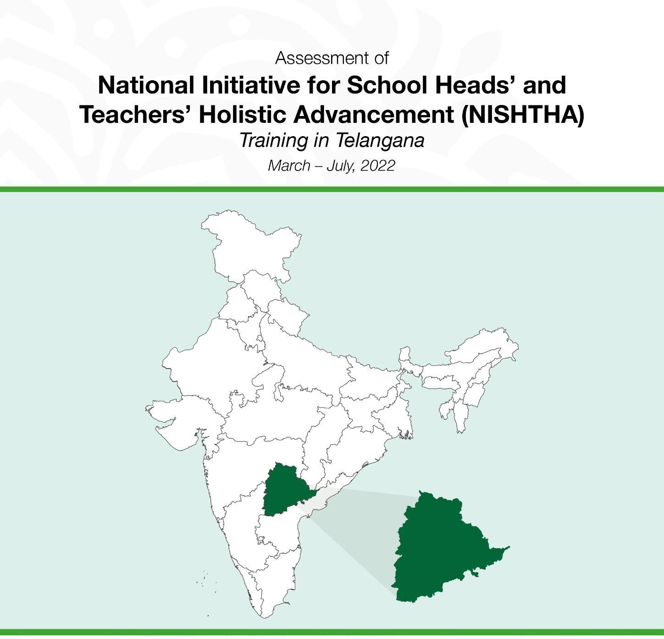

Conducted by
Centre of Excellence in Teacher Education,
Tata Institute of Social Sciences, Mumbai
Commissioned by
State Council of Educational Research and Training, Telangana, Hyderabad


CETE/2022/Nov/RP/1
The Centre of Excellence in Teacher Education (CETE) at the Tata Institute of Social Sciences, Mumbai (bit.ly/cetewebsite), aims to enable Right to Quality Education for all children in India by helping teachers respond to diverse and changing needs. Built around the central premise that professional qualified teachers can create lasting impact, the centre focuses on empowering teachers, improving professional development standards, supporting the teacher education ecosystem, and advocating the strengthening of policy on teaching and teacher education. Research at the centre is on the themes of quality in teaching, policy and scaling innovations, inclusion, curriculum and pedagogy, and EdTech. Academic teaching programmes include B.Ed.-M.Ed., M.A. Education, doctoral research, short term programmes through blended learning, and online offerings to enhance capabilities of teachers and teacher education faculty (www.tissx.tiss.edu). Key field action projects are focused on improving inclusive teaching-learning at schools and employing technology thoughtfully in professional development of teachers. The Connected Learning Initiative (www.tiss.clix.edu), was awarded the UNESCO King Hamad Prize for the Use of ICTs in Education in 2018. CETE received seed support from the Pandit Madan Mohan Malaviya National Mission on Teachers and Teaching, Government of India, and TATA TRUSTS.

© TISS, 2022
Citation: Ramanathan, A., Thirumalai, B., Singh, A., Subramanian, K., Chawla, S. & Roy, A. (2022). Assessment of National Initiatives for School Heads’ and Teachers’ Holistic Advancement (NISHTHA) Training in Telangana. CETE, TISS.
Except where otherwise noted, this content is licensed  under a Creative Commons Attribution4.0 International license  Report is available for download at  http://bit.ly/cetewebsite,  Any questions, suggestions or queries  may be sent to us at: chair.cete@tiss.edu  Centre for Excellence in Teacher Education (CETE)  Tata Institute of Social Sciences (TISS)  V.N.Purav Marg, Deonar,  Mumbai - 400088, India  chair.cete@tiss.edu  http://bit.ly/cetewebsite  Phone: +91 - 22- 25525002/3/4 | Authoring and Research  Dr. Anusha Ramanathan Asst Prof, CETE, TISS, Mumbai  Dr. Bindu Tirumalai, Asst Prof, CETE, TISS, Mumbai  Dr. Ajay Kumar Singh, Associate Prof, IGNOU, New Delhi  Mr. Karthik Subramanian, Consultant, CETE, TISS, Mumbai  Ms. Swati Chawla, Independent Consultant  Ms. Arundhati Roy, Independent Consultant  Field Investigators and Research & Translation Support  Mr. Arshad Khan, CETE, TISS, Mumbai  Mr. Moola Ramanakar Reddy, CETE, TISS, Mumbai  Mr. Raju Sambari, CETE, TISS, Mumbai  Mr. Ramesh Nagula, CETE, TISS, Mumbai  Mr. Swamy Jadala, CETE, TISS, Mumbai  Cover Page Design:  Mr Ramesh Khade, CETE, TISS  Design and Formatting:  Mr. Karthik Subramanian, Consultant, CETE, TISS, Mumbai  Ms. Nikhat Nasrin, CETE, TISS Mumbai  Mr. Sudheer Reddy, CETE, TISS Mumbai

Acknowledgements
Schools heads, Teachers, Key Resource Persons and State Resource Persons (Leadership) in schools visited in 10 districts of Telangana engaged with us generously during the in-person interviews and classroom observations. We are grateful to all of them.

We gratefully acknowledge the facilitation support received from the District Educational Officers of and ELEC Mentors in all districts of Telangana.

We are grateful to Smt. Radha Reddy, Director, SCERT, Telangana for overseeing and ensuring the smooth conduct of the study. We have immensely benefited from the constant guidance and support provided by Dr. P. Revathi Reddy, HoD, Education Technology & Planning, SCERT, Telangana and her team of faculty members - Smt. J.Krishna. Nagamani, Sri G. Srinivas Reddy, Sri. P. Bhoomaiah, Sri B. Ashok Reddy and Smt. Sarada. We gratefully acknowledge their contributions.

We would also like to thank Prof. Amarendra P. Behera of NCERT for his time and insights on design aspects of NISHTHA.

We would like to thank our Centre Chair, Prof Padma Sarangapani, for encouraging us and giving valuable feedback on the data reporting.

We would also like to thank the CETE administration staff for the support they have extended and Mr. Ramesh Khade for the design of the cover page and the NISHTHA summarized report and Ms. Nikhat Nasrin and Mr. Sudheer Reddy for helping with formatting.

Table of Contents
Abbreviations 8
List of Figures 12
List of Tables 15
1. Background 18
1.1. NISHTHA in Telangana & this study: 21
2. Objectives 23
3. Methodology 23
3.1. Conceptual Frame 23
3.2. Literature review 24
3.3. Review of NISHTHA documents 24
3.4. NCERT Consultations 24
3.5. SCERT Consultations 24
3.6. Review of NISHTHA Modules 24
3.7. Sampling methodology for Face-to-Face Interviews 24
3.8. Classroom Observations 26
3.9. Sampling Methodology for Online Survey 26
3.10. Online Tool 28
3.11. Survey Administration 28
3.12. Data Analysis 30
3.13. Face-to-Face Interviews & CROs 30
3.14. Online Survey Participants’ Profile 30
3.15. District-wise contribution: 31
3.16. Phase-wise contribution: 31
3.17. Participation from Rural & Urban Schools 32
3.18. Gender: 32
3.18.1. Teachers: 32
3.18.2. School Heads: 33
3.18.3. KRPs & SRPLs: 33
3.19. Age 33
3.20. School Management: 34
3.21. Designations 34
3.22. Qualifications 35
3.23. Teaching Grades 35
3.24. Teaching Experience 35
4. Design 37
5. Content Analysis 39
5.1. Abstract of Content Coverage in NISHTHA Courses: 39
5.2. Review/Analysis of Course Content 70
5.3. Detailed Review of Specific Modules 71
6. Key findings on Process 79
6.1. Month and Duration of Trainings 79
6.2. Teacher – KRP ratio 82
6.3. Notice about training 83
6.4. Training Guidelines 84
6.5. Mode of Receiving information or instructions about the Training 85
6.6. Learning navigation of Online Platform 86
6.7. Level of Comfort in Online Navigation 87
6.8. Devices used for training 87
6.9. Internet Connectivity 88
6.10. Number of hours spent to complete an online course 89
6.11. Sharing of Weblinks or QR Code (Phase-2 & Phase-3) 90
6.12. When were courses completed? 90
6.13. Problems faced during the trainings: 91
6.14. Support required by HMs and Teachers 93
6.15. Who supported Head Teachers and Teachers? 94
6.16. Follow-ups regarding course completion 95
7. Key findings on modules 96
7.1. Foundational Literacy & Numeracy 96
7.2. Competencies 99
7.3. Learning Outcomes 100
7.4. Assessments for holistic development 101
7.5. Subject Pedagogies 101
7.5.1. Pedagogy of EVS 101
7.5.2. Pedagogy of Mathematics 102
7.5.3. Pedagogy of Language 102
7.5.4. Pedagogy of Science 102
7.5.5. Pedagogy of Social Science 102
7.5.6. School Leadership 103
7.5.7. Curriculum and Inclusive Classrooms 104
7.5.8. Initiatives of School Education 105
7.5.9. Guidance and Counseling/ Personal Social Skills 106
7.5.10. Art Integrated Learning 107
7.5.11. Pre- School Education 108
7.5.12. Integrating Gender Concerns: 108
7.5.13. Revisiting NISHTHA Material 109
7.5.14. Testing Higher Order Skills 110
7.5.15. Reflecting on Teaching-Learning Processes 111
7.5.16. Vocational Education 111
7.5.17. Toy based Pedagogy 111
7.5.18. School Safety and Security 112
7.5.20. NISHTHA/DIKSHA App. 114
7.5.21. Overall aspects of the training programme 114
7.6. Inter-sector and inter-school management analysis 116
7.7. Comparison of responses across modules 119
8. Key aspects of Significance Tests 124
8.1. Inputs and Outputs 124
8.2. Hypotheses 125
8.3. Phase-wise effectiveness of inputs 125
8.3.1. Effectiveness of inputs within phases of intervention: 125
8.4. Effectiveness of intervention across Districts 134
9. Conclusions & Recommendations on Design 143
10. Conclusions & Recommendations on Content: 145
11. Conclusions & Recommendations on Training Delivery 146
12. Conclusions & Recommendations on Implementation of training gains 149
References: 151

Abbreviations
ANOVA | Analysis of Variance
App | Application
B.Ed | Bachelors in Education
BRC | Block Resource Centre
CBSE | Central Board of Secondary Education
CETE | Centre of Excellence in Teacher Education
COP | Community of Practice
CPD | Continuous Professional Development
CRC | Cluster Resource Centre
CRO | Classroom Observation
CWSN | Children With Special Needs
DEO | District Education Officer
DIET | District Institute of Education and Training
DIKSHA | Digital Infrastructure for Knowledge Sharing
ELEC | English Language Enrichment Course
ET | Education Technology
EVS | Environmental Science
F2F | Face-to-face
FLN | Foundational Literacy and Numeracy
GHS | Government High School
GPS | Government Primary School
GUPS | Government Upper Primary School
HM | Head Master
HoD | Head of Department
ICT | Information and Communication Technology
KGBV | Kasturba Gandhi Balika Vidyalaya
KRP | Key Resource Person
LFL | Low Female Literacy
LMS | Learning Management System
LO | Learning Outcome
M.Ed | Masters in Education
MEO | Mandal Education Officer
MoE | Ministry of Education
MPPS | Mandal Parishad Primary School
MPUPS | Mandal Parishad Upper Primary School
NCERT | National Council of Educational Research and Training
NCSL | National Centre for School Leadership
NEP | National Education Policy
NIEPA | National Institute of Educational Planning and Administration
NISHTHA | National Initiative for School Heads’ and Teachers’ Holistic Advancement
NRG | National Resource Group
NRP | National Resource Person
PC | Personal Computer
PGT | Post Graduate Teachers
QR Code | Quick Response Code
SA | School Assistant
SCERT | State Council of Educational Research and Training
SGT | Secondary Grade Teacher
SPD | State Project Director
SRPL | State Resource Person (Leadership)
TGT | Trained Graduate Teachers
TISS | Tata Institute of Social Sciences
TPD | Teacher Professional Development
TSMS | Telangana State Model School
UDISE+ | Unified District Information System for Education Plus
UDL | Universal Design for Learning
UT | Union Territory
ZPHS | Zilla Parishad High School

List of Figures

Figure No. | Figure | Page
1 | NISHTHA Modalities | 18
2 | Excerpts from NISHTHA Primer on Key Features of the program | 19
3 | NCERT’s Envisaged Model for Scaling NISHTHA | 21
4 | District wise percentage of participants in online survey | 31
5 | Phase wise percentage of participants in online survey | 31
6 | Proportion of Rural and Urban Schools in online survey | 32
7 | Gender break-up of online survey participants | 32
8 | Age break-up of online survey participants | 33
9 | School Management break-up of online survey participants | 34
10 | Designation break-up of online survey participants | 34
11 | Teaching Experience break-up of online survey participants | 35
12 | NISHTHA Coverage in Telangana | 81
13 | KRP/SRPL to Participant Ratio: | 82
14 | Dissemination of guidelines | 84
15 | Mode of receiving information | 85
16 | Using DIKSHA | 86
17 | Learning navigation of online platform | 86
18 | Comfort in online navigation | 87
19 | Devices used for online training | 88
20A | Speed of internet connectivity | 89
20B | Timing of disseminating weblink/QR codes | 90
21 | Support required in Phase 1.0. | 92
22 | Problems faced during online training | 92
23 | Support required in Phases 2.0. & 3.0. | 93
24 | Issue resolution time | 94
25 | Who provided support | 95
26 | Understanding NIPUN BHARAT | 96
27 | FLN Assessments | 97
28 | On following pre-defined Learning Outcomes & Competencies | 98
29 | Assessments for competency based education | 100
30 | Understanding Learning Outcomes | 100
31 | Assessments for holistic development | 101
32 | On Subject Pedagogies | 102
33 | Usefulness of School Leadership Concepts & Applications | 103
34 | On pedagogical leadership | 103
35 | On enabling learning by CWSN | 104
36 | Universal Design for Learning | 104
37 | On school education initiatives | 105
38 | On school safety | 106
39 | On art integrated learning | 107
40 | On integrating gender with subject teaching | 108
41 | Re-visiting course material (2.0.) | 110
42 | Re-visiting course material (3.0.) | 110
43 | On vocational education | 111
44 | On School safety and security | 112
45 | Feedback on Training Aspects | 115

List of Tables
Table No. | Table | Page
1 | Target Coverage of NISHTHA in Telangana | 21
2 | Clusters for Face-to-Face Interviews & Classroom Observations | 25
3 | Phase and stakeholder wise list of questionnaires | 28
4 | Online Survey Targets | 29
5 | Abstract of Grade-Level Wise Interviews & Classroom Observations | 30
6 | Abstract of Number of Responses Received in Online Survey | 30
7 | Objectives of NISHTHA | 39
8 | Abstract of Content in NISHTHA 1.0. | 40
9 | Abstract of Content in NISHTHA 2.0. | 51
10 | Abstract of Content in NISHTHA 3.0. | 60
11 | Content Analysis of Module 1 of NISHTHA 1.0 | 71
12 | Content Analysis of Module 6 of NISHTHA 1.0 | 72
13 | Content Analysis of Module 9 of NISHTHA 1.0 | 73
14 | Content Analysis of Module 13 of NISHTHA 1.0 | 74
15 | Content Analysis of Module 5 of NISHTHA 2.0. | 75
16 | Content Analysis of Module 9 of NISHTHA 3.0. | 76
17 | Content Analysis of Module 12 of NISHTHA 3.0. | 77
18 | Rollout plan of NISHTHA 2.0. | 80
19 | On Training Material | 113
20 | School Management & Sectoral Break-up of Usefulness of Training | 117
21 | Comparison of responses across modules | 119
22 | List of inputs and outputs for significance tests across 3 phases of intervention | 124
23 | Variation in outputs by the delay in receiving notice about course | 127-133
24 | Variation in outputs by delay in receiving guideline about course | 127-133
25 | Variation in outputs by delay in receiving QR codes | 127-133
26 | Variation in outputs by number of different modes of receiving information | 127-133
27 | Variation in intervention output by follow-up in Phase 1 | 127-133
28 | Variation in intervention output by follow-up in Phases 2& 3 | 127-133
29 | Variation in outputs by variation in internet connectivity | 127-133
30 | Correlation between various inputs and outputs of NISHTHA across phases | 134
31 | Effectiveness of inputs at the level of districts | 135

Chapter 1: Introduction

Background
In keeping with the recommendation of NEP 2020, that every teacher and head teacher is expected to participate in at least 50 hours of Continuous Professional Development (CPD) opportunities every year for their own professional development, driven by their own interests and that CPD opportunities shall, in particular, systematically cover the latest pedagogies regarding foundational literacy and numeracy, formative and adaptive assessment of learning outcomes, competency-based learning, and related pedagogies, such as experiential learning, arts-integrated, sports-integrated, and storytelling-based approaches, etc., NCERT under the aegis of Ministry of Education (MoE), Department of School Education and Literacy (DSE&L), Government of India, in collaboration with States / UTs and autonomous bodies under MoE, MoD and MoTA (Central Board of Secondary Education, Kendriya Vidya Sangathan, Navodaya Vidyalaya Samithi, Central Tibetan School Administration, Atomic Energy Education Society, Sainik School, Council for Indian School Certificate Examinations Ekalavya Model Residential Schools - National Education Society for Tribal Students etc.) had introduced National Initiative for School Heads' and Teachers' Holistic Advancement (NISHTHA) integrated training programme for different stages of school education - Teachers, Head Teachers/Principals and other stakeholders in Educational Management and Administration as part of Samagra Shiksha in 2019-20.
Figure 1: NISHTHA Modalities
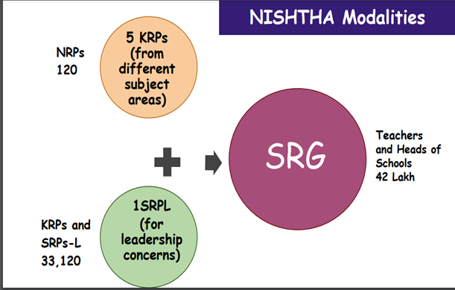
NISHTHA aims to build capacities of approximately 42 lakh participants spread across elementary-level teachers and Heads of Schools in all Government schools, faculty members of State Councils of Educational Research and Training (SCERTs), District Institutes of Education and Training (DIETs), as well as officials and Resource Persons from Block Resource Centres (BRCs) and Cluster Resource Centres (CRCs) in all States and Union Territories.
Source:https://itpd.ncert.gov.in/mod/page/view.php?id=504
The National Council of Educational Research and Training (NCERT), National Institute of Educational Planning and Administration (NIEPA), Kendriya Vidyalaya Sangathan (KVS), Navodaya Vidyalaya Samiti (NVS), Central Board of Secondary Education (CBSE), Non­ Government Organisations and UNICEF identified 120 National Resource Persons as part of the programme. It was envisaged that the NRPs will in turn train 33,120 Key Resource Persons (KRPs) and State Resource Persons (SRPs) identified by the State and UTs, who were to, in-turn directly conduct training to all teachers and heads of schools.
In order to stimulate and nurture critical thinking in students, handle a variety of circumstances, and serve as primary counsellors, this training seeks to motivate and empower instructors. It was aimed that the participants would be instructed in and be given the opportunity to hone their skills in a variety of areas including learning outcomes, competency-based learning and testing, learner-centred pedagogy, school safety and security, personal-social skills, inclusive education, information and communication technology (ICT) in teaching and learning including artificial intelligence, health and well-being including yoga, and initiatives in school education such as libraries, eco clubs, youth clubs, kitchen gardens etc.
Figure 2: Excerpts from NISHTHA Primer on Key Features of the program
.
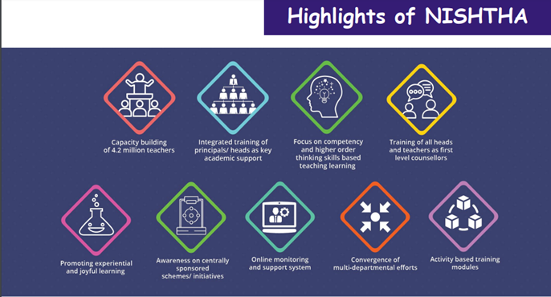
Source: NCERT Primer
With a view to equipping school heads with requisite knowledge, skills and attitudes to help teachers academically in the school while also exercising their administrative leadership, aspects pertaining to school leadership were included in the programme, which were designed by National Centre for School Leadership (NCSL) of NIEPA.
The main expected outcomes from NISHTHA were:
- Improvement in learning outcomes of the students.
- Creation of an enabling and enriching inclusive classroom environment
- Teachers are trained as first-level counselors to be alert and responsive to the social, emotional, and psychological needs of students.
- Teachers are trained to use Art as pedagogy leading to increased creativity and innovation among students.
- Teachers are trained to develop and strengthen the personal-social qualities of students for their holistic development.
- Creation of a healthy and safe school environment.
- Integration of ICT in teaching-learning and assessment.
- Developing stress-free School Based Assessment focused on the development of learning competencies.
- Teachers adopt Activity Based Learning and move away from rote learning to competency-based learning.
- Teachers and School Heads become aware of new initiatives in school education.
- Transformation of the heads of schools for providing academic and administrative leadership in the schools for fostering new initiatives.
Figure 3: NCERT’s Envisaged Model for Scaling NISHTHA
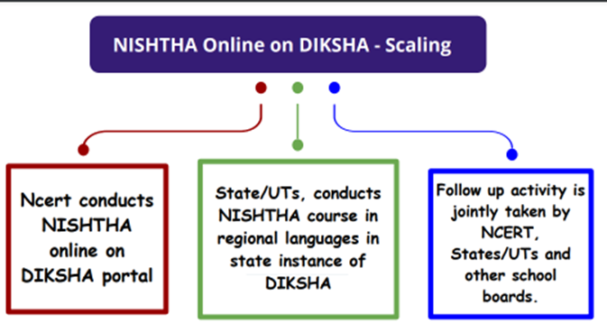
Image Source: NCERT Primer

1.1. NISHTHA in Telangana & this study:
NISHTHA has been implemented across all districts of Telangana, with the SCERT as the nodal agency. Following is the summary of NISHTHA’s target coverage[1] in Telangana:
Table 1: Target Coverage of NISHTHA in Telangana
 | Phase | Teacher categories covered | Period of training | Target No. of Teachers to be trained | Mode of Training
1 | NISHTHA 1.0 | 1st to 8th Classes - SGTs & S.As | November 2019 to January 2020 | 94,547 | Face-to-face
2 | NISHTHA 2.0 | 6th to 12th classes – Sas | August, 2020 to December, 2020 | 67,724 | Online
3 | NISHTHA 3.0 | 1st to 5th classes (SGTs) | October 2021 to March 2022 | 56,462 | Online
This study has been undertaken by Centre of Excellence in Teacher Education (CETE), Tata Institute of Social Sciences (TISS) based on the request from SCERT vide their Lr. Rc.No.126/Plg/SCERT/2019, dt. 15.02.2022 of Director, SCERT, Telangana.
This is the report of the study and the remainder of it is structured as follows. Chapter 2 discusses the objectives, methodology and presents the profile of the participant teachers and school heads in the online survey conducted as part of this study; chapter 3 presents the analysis of the design architecture of the program and the content analysis of NISHTHA modules; key findings on the training delivery processes are discussed in chapters 4, which is followed by a discussion in chapter 5 on perceived utility of NISHTHA modules as reported by teachers, school heads, KRPs and SRPLs in the online survey; chapter 6 discusses the insights from significance tests conducted as part of this study; chapter 7 presents the score card of the program in Telangana and chapter 8 concludes the report by discussing key conclusions and recommendations.

Chapter 2: Objectives & Methodology

About the chapter
This chapter presents the objectives of the study, discusses the methodology using which the objectives have been operationalized and presents the detailed profile of participants of the online survey conducted as part of this study.

Objectives
The following were the objectives of the study:
- To review the design of the overall architecture of NISHTHA.
- To review the content of NISHTHA modules and ascertain the extent of their compliance with the objectives and principles envisaged during the design of NISHTHA and identify areas for further improvement.
- To identify the areas in which the training delivery has been effective as also those in which there has been room for further improvement.
- To identify and enumerate the areas of teacher practice benefitted/strengthened by NISHTHA and recommend areas for further improvement.

Methodology

Conceptual Frame
Since NISHTHA is an ‘in-service’ training situated in the continuum of capacity enhancement programmes attended by the teachers and school heads over time, it is highly likely that the teachers and school heads may have had prior exposure to / experience in implementing certain of the concepts and applications covered in NISHTHA. An acknowledgement of this ‘prior’ exposure/experience of teachers and school heads has informed the research design of this study in general and the face-to-face interview/online survey tools in particular, with the module-related-questions in them pivoting around the extent to which the training has been able to add value to them, in relation to such prior exposure/experience.
In operationalizing the objectives of the study, data and insights have been sourced from multiple channels, as discussed in this section.

Literature review
Relevant literature pertaining to teacher professional development has been reviewed in the run up to developing the tools for data collection. Detailed bibliography, given at the end of the report, may be referred to for specifics of the literature consulted.

Review of NISHTHA documents
Guidelines, Standard Operating Procedure documents, Primers etc. pertaining to NISHTHA have been reviewed.

NCERT Consultations
Members of the study team met with Prof. Amarendra P. Behera of NCERT on 05/04/2022. Prof. Behera was a member of the core team which designed NISHTHA. Aspects pertaining to the context and design of NISHTHA were discussed in this meeting.

SCERT Consultations
Multiple consultations were held with Dr. P. Revathi Reddy, HoD, ET & Planning Departments, SCERT, Telangana and her team to understand various aspects of implementing NISHTHA in the State.

Review of NISHTHA Modules
A cross-section of NISHTHA modules have been reviewed from the viewpoint of assessing the extent to which they aid in the achievement of the stated learning objectives. Specific attention has been given to reviewing the structure of the modules, the knowledge & skills they seek to impart and key pedagogical aspects, while also identifying certain gaps meriting further action.

Sampling methodology for Face-to-Face Interviews
Telangana originally had 10 districts, which have been re-organized into 33 districts after State bifurcation. In order to ensure representation of stakeholders from all parts of the state, the 33 districts of the state were divided into 10 clusters, with all the re-organized districts of each original district forming a cluster, as follows:

Table 2: Clusters for Face-to-Face Interviews & Classroom Observations
S. No. | Cluster Name | Districts in the cluster
1 | Adilabad | - Adilabad, (2) Komaram Bheem Asifabad, (3) Nirmal,  (4) Mancherial
2 | Nizamabad | (5) Nizamabad, (6) Kamareddy
3 | Medak | (7) Medak, (8) Sangareddy, (9) Siddipet
4 | Ranga Reddy | (10) Ranga Reddy, (11) Vikarabad, (12) Medchal-Malkajgiri
5 | Hyderabad | (13) Hyderabad
6 | Mahbubnagar | (14) Mahbubnagar, (15) Wanaparthy, (16) Nagarkurnool, (17) Jogulamba Gadwal, (18)Narayanpet
7 | Karimnagar | (19) Karimnagar, (20) Jagitial, (21) Pedapalle, (22) Rajanna Sircilla
8 | Warangal | (23) Warangal, (24) Hanumakonda, (25) Mulugu,  (26) Jayashankar Bhupalapally, (27) Jangoan,  (28) Mahbubabad
9 | Nalgonda | (29) Nalgonda, (30) Yadadri Bhuvanagiri, (31) Suryapet,
10 | Khammam | (32) Khammam, (33) Bhadradri Kothagudem
From each cluster, one district was selected at random for the conduct of face-to-face interviews. These interviews were conducted between 11th April, 2022 and 21st April, 2022. in the districts of: Nirmal (Adilabad cluster), Kamareddy (Nizamabad cluster), Siddipet (Medak cluster), Medchal-Malkajgiri (Ranga Reddy cluster), Hyderabad (Hyderabad cluster), Wanaparthy (Mahbubnagar cluster), Rajanna Sircilla (Karimnagar cluster), Warangal (Warangal cluster), Nalgonda (Nalgonda cluster) and Khammam (Khammam cluster).
Within each of the aforelisted districts, in-depth in-person interviews were conducted with teachers, school heads, KRPs and SRPLs to understand their perspectives about and feedback on NISHTHA. In all, 50 stakeholders were interviewed, spread across NISHTHA 1.0., 2.0. & 3.0. District-wise coverage of different stakeholders and school managements is given at Annexure. These interviews were audio-recorded for detailed analysis. The interview questionnaires are at Annexure.

Classroom Observations
10 classroom observations (CRO) were conducted in these districts, with a view to understanding the implementation of desirable pedagogic practices, especially those advocated by NISHTHA and to understand the extent to which the implementation of these practices may have a relation with the observed teachers having undergone NISHTHA. The CRO tool used in this study is at Annexure.

Sampling Methodology for Online Survey
The following datasets formed the basis of sampling methodology for the online survey:
a) NISHTHA 1.0. was conducted in Telangana in batches between October, 2019 and February, 2020 in the face-to-face mode, with each batch undergoing the training for 5 days. There were 18 courses cumulatively for teachers and school heads in this phase which were sought to be covered in the 5-day-schedule of the programme. Course-wise-assessments were not part of this phase and as such, all the teachers and school heads attending the 5-day programme are deemed to have completed NISHTHA 1.0. training. Therefore, the number of teachers and school heads who attended this training was considered the sampling frame and this data, disaggregated district-wise, was sourced from SCERT, Telangana.
b) NISHTHA 2.0. and 3.0. were conducted in Telangana between August 2021 and May 2022 in the online mode. Unlike NISHTHA 1.0., the 2.0. and 3.0. versions of the training programme, introduced during the Covid lockdown phase, had multiple courses and the teachers and school heads were expected to enroll themselves in and undergo these courses, securing a minimum of 70% in the course-wise-assessments in order to be eligible for course-certification. The 2.0. and 3.0. phases therefore had 3 types of participants viz. (a) enrolled, (b) completed and (c) certified. We note that set ‘c’ is a subset of ‘b’, which in turn is a subset of ‘a’. For the purposes of the online survey, the ‘completed’ set of teachers and school heads was considered as the sampling frame, for, this set uniquely had the advantage of being able to reflect not merely on the experiences of enrolment and course completion but also on the challenges one may have encountered in certification (since this set of teachers and school heads have completed the course but have not been certified). For NISHTHA 2.0. and 3.0., the ‘completed’ set of data, disaggregated district wise and course wise, was sourced from SCERT, Telangana. Since this data was available only at the course level, and not as a composite (of all courses) for NISHTHA 2.0. or NISHTHA 3.0., the district average of ‘completed’ figures for all the courses respectively for NISHTHA 2.0. and 3.0. was considered as the sampling frame.
c) To understand the differences in responses, if any, of teachers and school heads from different school types (school management), data of district wise number of schools was sourced from UDISE 2019-20 and mapped to the 8 types of school managements in fold of public education in Telangana viz.
- Government Primary School (GPS) & Mandal Parishad Primary School (MPPS) in the primary sector,
- Government Upper Primary School (GUPS) & Mandal Parishad Upper Primary School (MPUPS) in the upper primary sector and
- Government High School (GHS), Zilla Parishad High School (ZPHS), Telangana State Model Schools (TSMS) and Kasturba Gandhi Balika Vidyalaya (KGBV) in the secondary sector.
The output of this step was the district wise, school management wise, number of schools. Based on this, the proportion of different school-managements was arrived at for each district.
d) Assuming a response rate of 60% and with a view to getting about 5% sample of targeted population, district-wise targets were stipulated at the rate of 8.5% of the targeted population (viz. those who have attended the training, in the case of NISHTHA 1.0. and those who have ‘completed’ the courses in the case of NISHTHA 2.0. and 3.0.).
e) The district wise targets were further distributed among the 8 school managements, in the proportion of their presence in the district.
f) Within each school management, the target was further sub-divided between the teachers and the school heads in the ratio of 9:1.

Online Tool
The online surveys were conducted using google forms. There were separate questionnaires for NISHTHA 1.0., 2.0. And 3.0. and within each of these phases, there were separate questionnaires for Teachers, School Heads, KRPs, SRPLs. The survey participants were required to choose one of these four stakeholder categories (i.e. the capacity in which they were participating in the survey) and had the choice of participating in the survey in either English or Telugu.
Thus, there were 17 questionnaires in all, used in the study, as listed below. As mentioned earlier, the questionnaires of face-to-face interviews are at Annexure, along with those of online survey.
Table 3: Phase and stakeholder wise list of questionnaires
Phase | Stakeholder | Mode
NISHTHA 1.0. | Teacher | 1. F2F interview
NISHTHA 1.0. | Teacher | 2. Online Survey
NISHTHA 1.0. | School Head | 3. F2F interview
NISHTHA 1.0. | School Head | 4. Online Survey
NISHTHA 1.0. | KRP | 5. F2F interview
NISHTHA 1.0. | KRP | 6. Online Survey
NISHTHA 1.0. | SRPL | 7. F2F interview
NISHTHA 1.0. | SRPL | 8. Online Survey
NISHTHA 2.0. | Teacher | 10. F2F interview
NISHTHA 2.0. | Teacher | 11. Online Survey
NISHTHA 2.0. | School Head | 12. F2F interview
NISHTHA 2.0. | School Head | 13. Online Survey
NISHTHA 3.0. | Teacher | 14. F2F interview
NISHTHA 3.0. | Teacher | 15. Online Survey
NISHTHA 3.0. | School Head | 16. F2F interview
NISHTHA 3.0. | School Head | 17. Online Survey

Survey Administration
For online survey of NISHTHA 1.0., the district-wise, school management wise targets were stipulated by SCERT vide Proceedings No. Rc.Plg/SCERT/2019, dt. 08.04.22. (Annexure)
The disaggregated targets, district, and channel-wise are at Annexure. Based on these instructions, the DEOs in turn identified and issued instructions to the schools/teachers/school heads for the participation in the survey. The responses for online survey were received between 14/04/2022 and 26/05/2022.
While for NISHTHA 1.0., the responses were mobilized by the DEOs, with reference to the online survey of NISHTHA 2.0. and 3.0., two channels were used to elicit responses of teachers and school heads viz. (a) DEO channel, through which responses were elicited from teachers and school heads who have participated in online survey of NISHTHA 1.0. and (b) ELEC Mentors channel, through which responses were elicited from teachers and school heads who did NOT participate in the online survey of NISHTHA 1.0.
Based on the methodology discussed above, the targets were stipulated separately for both these channels and instructions were issued to DEOs and ELEC Mentors vide Procg No. Rc. No. 126/Plg/SCERT/2019, dt 06.05.2022 (Annexure).
Overall targets were as follows:
Table 4: Online Survey Targets
Phase | Channel | Teachers | School Heads | KRPs | SRPLs
1.0. | DEO Channel | 7,127 | 798 | 132 | 33
2.0. | DEO Channel | 1,833 | 173 | N.A. | N.A.
2.0. | ELEC Channel | 2,984 | 359 | N.A. | N.A.
2.0. | 2.0. Sub total | 4,817 | 532 | N.A. | N.A
3.0. | DEO Channel | 963 | 92 | N.A. | N.A.
3.0. | ELEC Channel | 1,182 | 136 | N.A. | N.A.
3.0. | 3.0. Sub total | 2,145 | 228 | N.A. | N.A.

Data Analysis
The analysis of the online survey data has been carried out using STATA. Besides generating various frequency tables, correlation between key parameters have been tested to answer questions like (1) how effectively have various inputs been in terms of output generation, (2) which inputs was most effective and (3) what is the scope of improvement for future intervention etc. Tests were applied for "association" and "difference between groups". Test of association include pearson correlation (mostly) and Mann-Whitney and Kruskal Wallis (sometimes). To test between group differences, t-test, ANOVA has been applied. Individuals who opted for a specific likert scale as their response have been clubbed together into a specific group.

Face-to-Face Interviews & CROs
The abstract of the in-person interviews and classroom observations in the 10 districts is as follows:
Grade-wise summary of participants in the Face-to-Face interviews and CROs is given below. It was ensured that participants from all 3 phases of NISHTHA and all school managements (viz. GPS, MPPS, GUPS, MPUPS, GHS, ZPHS, TSMS and KGBV) are covered.
Table 5: Abstract of Grade-Level Wise Interviews & Classroom Observations
Grade level | Grade | No. of CROs | No. of Interviews
Primary | 1st to 5th grade | 2 | 10 Teachers, 2 HMs | 7 KRPs and  3 SRPs (Leadership)
Upper Primary | 6th to 8th grade | 4 | 10 Teachers, 6 HMs | 7 KRPs and  3 SRPs (Leadership)
Secondary | 9th to 10th grade | 4 | 10 Teachers, 2 HMs | 7 KRPs and  3 SRPs (Leadership)

Online Survey Participants’ Profile
The online survey of all 3 phases of NISHTHA elicited responses from 16,015 participants. The break-up of the same is as follows:
Table 6: Abstract of Number of Responses Received in Online Survey
NISHTHA Phase | Teachers | School Heads | KRPs | SRPLs
1.0. | 7,569 | 818 | 187 | 51
2.0. | 2,684 | 349 | N.A. | N.A.
3.0. | 3,555 | 802 | N.A. | N.A.
Total | 13,808 | 1,969 | 187 | 51
Figure 4: District wise percentage of participants in online survey

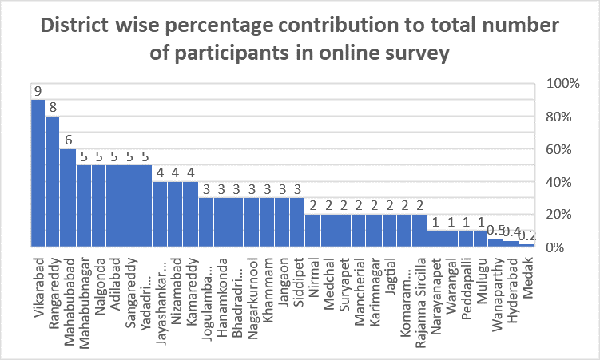
District-wise contribution:
Vikarabad and Ranga Reddy contributed the highest number of participants to the online survey, with a percentage share of 9% and 8% of the total respectively. The least contributions have come from the districts of Medak (0.2%), Hyderabad (0.4%) and Wanaparthy (0.5%) of the total. The district-wise, phase-wise number of participants in the online survey is at Annexure.
Figure 5: Phase wise percentage of participants in
online survey

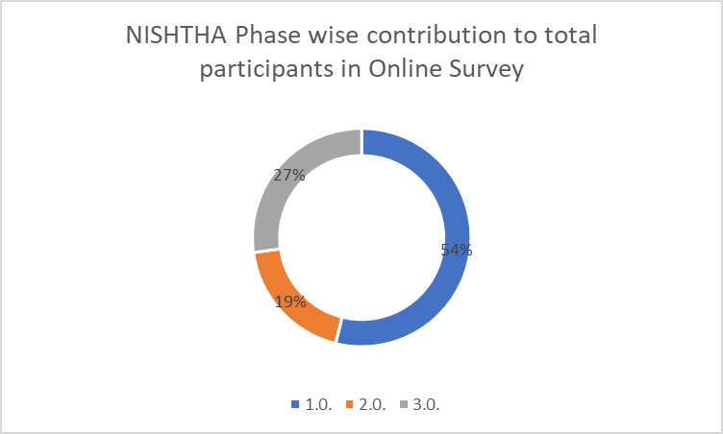
Phase-wise contribution:
Of the total participants, 54% were from Phase 1.0., 27% from 3.0. and 19% from 2.0.

Participation from Rural & Urban Schools
For the purpose of this study, GPS, GUPS, GHS and TSMS have been considered as constituting urban schools, while MPPS, MPUPS, ZPHS and TSMS as constituting rural schools. Overall, 69% of online survey participants are from rural schools and 31% from urban schools.
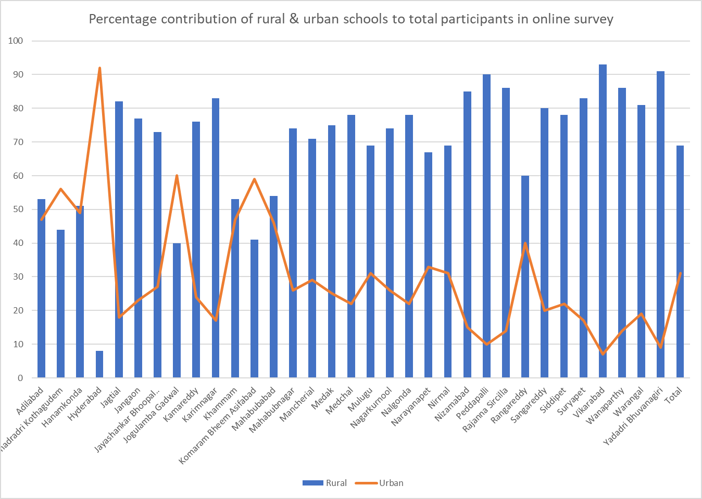
Figure 6: Proportion of Rural and Urban Schools in online survey

Vikarabad, Yadadri Bhuvanagiri and Peddapalli have the highest intra-district rural contribution, with 93%, 91% & 90% respectively of their participants being from rural schools while Jogulamba Gadwal, Komarambheem Asifabad & Bhadradri Kothagudem have the highest intra-district urban contribution, with 60%, 59% & 56% respectively of their participants being from urban schools.
Figure 7: Gender break-up of online survey participants

Gender:

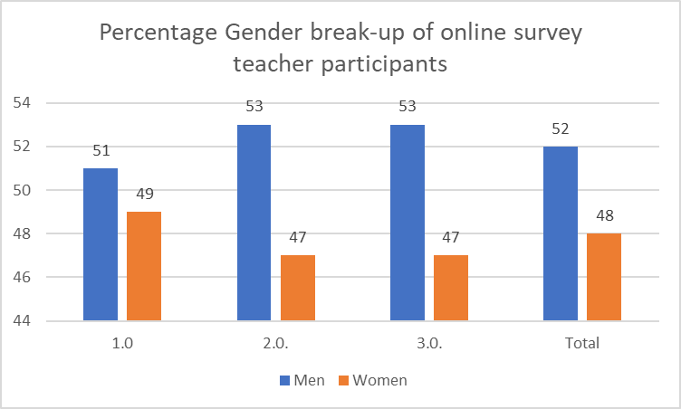
Teachers:
48% of the teacher participants were women and 52%, men. Five teacher participants have opted for ‘Other’ as their gender and 3 participants have preferred not to disclose their gender. The gender ratio of the survey participants is broadly consistent across the 3 phases of NISHTHA (Women: Men:: 49:51 (for 1.0.), 47:53 (for 2.0.) & 47:53 (for 3.0.)).

School Heads:
Women’s participation in the School Heads/LFL HM category is significantly lower at 36% overall and at 34%, 32% and 41% in online survey of NISHTHA 1.0., 2.0. & 3.0 respectively.

KRPs & SRPLs:
The gender break-up of KRPs and SRPLs is overwhelmingly skewed in favor of men - only 6% of KRPs and 14% SRPLs are women. The tables giving gender break-up across NISHTHA phases and across stakeholders is at Annexure.

Age
Figure 8: Age break-up of survey participants
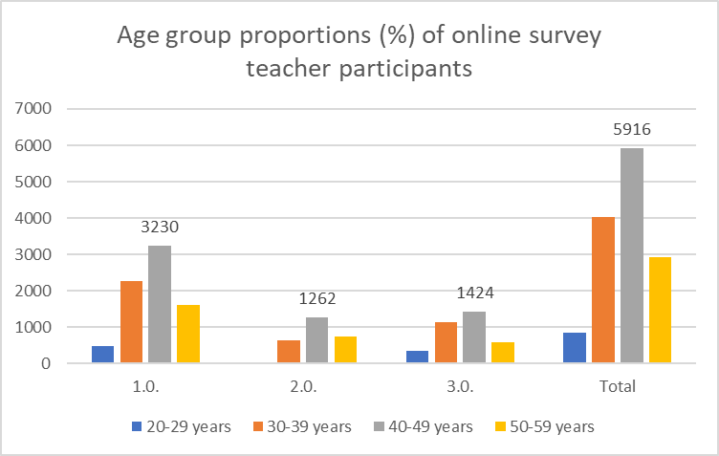
43% of the teacher participants are in the age group of 40 to 49 years, 29% in the 30 to 39 age group and 21% in the 50 to 59 age group.
43% head participants are in the age group of 50 to 59 years, 36% in 40 to 49 years age group and 17% in the 30 to 39 years age group. There are phase-wise variations in this regard. 80% of KRPs and 93% of SRPLs are 40 years and above. The detailed tables in this regard can be found at Annexure.

School Management:
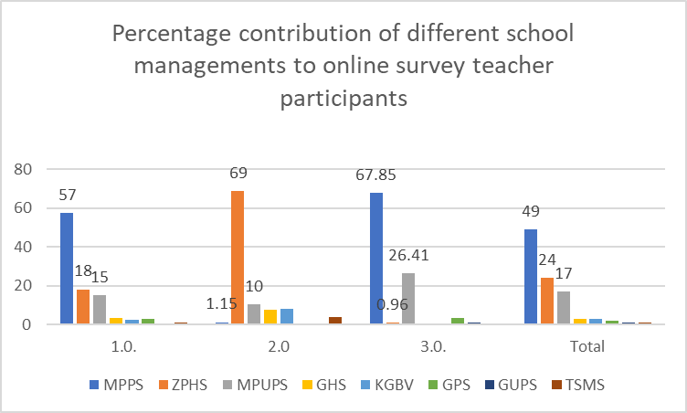
49% of online survey participants are from MPPS, 24% from ZPHS and 17% from MPUPS. There are variations in these proportions across phases;
Figure 9: School Management break-up of online survey participants

In phase 1.0., 57% participants are from MPPS, 18% ZPHS and 15% from MPUPS; in phase 2.0., 69% are from ZPHS, 10% from MPUPS and around 8% each from GHS and KGBVs; in phase 3.0., 68% are from MPPS and 26% from MPUPS.

Designations
Figure 10: Designation break-up of online survey participants

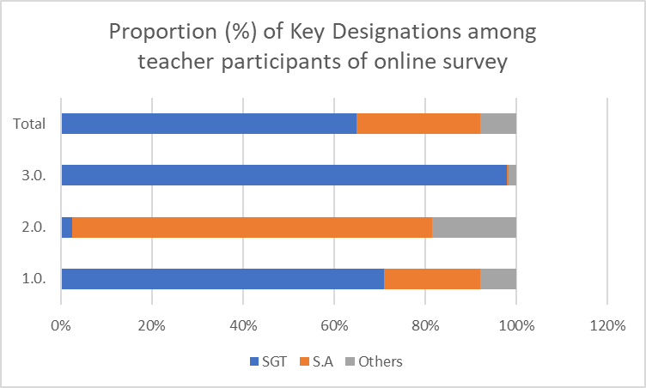
Overall, 65% of teacher participants are SGTs and 27%, School Assistants. The remaining 8% is constituted by Language pandits, PGTs, TGTs, LFL HMs, Special Officers and others. In terms of phase wise proportions, SGTs (71%) and S.A.s(21%) occupy the major proportion in phase 1.0., while 79% of phase 2.0. and 93% of phase 3.0. the teacher participants are SGTs.
In the case of school heads, 53% are SGTs, 26% have identified themselves as HMs/Principals and 9% as S.A.s. 58% of KRPs are S.As and 34%, SGTs. 50% of SRPLs are S.A.s and 29%, SGTs. There are phase-wise variations in these proportions, the details of which can be found in the detailed tables given at Annexure.

Qualifications
46% of teacher participants are graduates while 42% are postgraduates. This overall trend of over 88% of participants being graduates and postgraduates is seen to be applicable to participants of all the 3 individual phases of NISHTHA survey. 43 participants are doctorates. In terms of professional qualifications, 75% of teacher participants are B.Eds and only 4% are M.Eds. Viewed phase wise, the proportion of B.Eds among the teacher participants of phase 1.0. is 74%, that of 2.0. is 81% and that of 3.0. is 70%.
44 % HMs in Phase-I, 60 % in Phase - II, and 36% HMs in Phase - III are post graduate or masters. 72% of KRPs are post graduates and 18% are graduates. Similar trend is seen in respect of SRPLs.
Detailed, stakeholder wise and phase wise tables in this regard are at Annexure.

Teaching Grades
60% of all teacher participants teach 1st to 5th grades. 29% of them teach grades 6th to 10th. In the case of school heads, 66% teach 1st to 5th grades and 22% have selected 6th to 10th grades as their teaching grades. About 3% of school heads of phase 2.0. have opted for ‘I do not teach now’. 61% of KRPs and 71% of SRPLs are 6th to 10th grade teachers. Detailed, stakeholder wise and phase wise tables in this regard are at Annexure.

Teaching Experience
Figure 11: Teaching Experience break-up of online survey participants
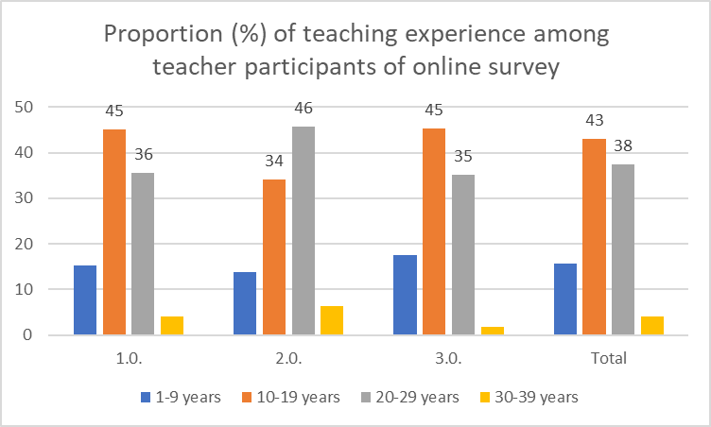
43% of teachers have between 10 and 19 years of teaching experience and 27% have 20 to 29 years of experience. This trend of a higher proportion of teachers in the category of 10 to 19 years of experience is seen for phases 1.0. & 3.0. but is seen to be reversed in the case of phase 2.0. (46% in 20-29 years category & 34% in 10-19 years category). In the case of school heads, 48% are in the 20-29 years category, 18% in the 30-39 years category and 24% in the 10-19 years category. Detailed, stakeholder wise and phase wise tables in this regard are at Annexure.

Chapter 3: Design & Content

About this chapter:
This chapter discusses the design architecture of NISHTHA and presents an analysis of the content of NISHTHA modules.

Design
The importance of the ‘design’ of a CPD program in achieving the ultimate goal of reforming teaching practice, can’t be overstated. The design of these continuous professional development programmes must be informed by an effective needs analysis that culminates from the teachers’ knowledge bases of curricula, instructional, content and pedagogical knowledge (Luneta, 2012). The study therefore begins examining the design from the training needs; investigates design of the curriculum and content, envisaged model of training delivery and the design & effectiveness of system to monitor implementation of the programme.
- Centralized Model: NISHTHA was a completely centralized model of continuous professional development (CPD), with little or no role for states in terms of identifying training needs, designing training curriculum & content, deciding training pedagogy etc. For a state like Telangana, with a dynamic and active SCERT and a proactive and enterprising State Resource Group (SRG) of Teacher Educators having rich experience of conducting large scale CPD programmes, it’s role being limited to implementation, without being able to contribute to the aforementioned broader aspects of the training cycle , as has happened in NISHTHA, was not the most optimal CPD option.
- Choice of courses: Despite the large basket of courses in NISHTHA, all courses were mandatory. It is likely that teachers not interested in or not in need of a course would have had to nevertheless undergo it, even if perfunctorily, yielding low returns to their time on one hand and negligible translation of gains to classroom implementation, on the other. Genuine cases in this category would include, for instance, teachers/school heads desirous of skipping a course because of having already undergone a similar course in the past and/or because of significant classroom/school experience in the course-area.
- Fidelity of NRG-SRG-Participant Model: NISHTHA model was premised on the critical layer of SRG, who after having been trained by the National Resource Group (NRG), were envisaged as training facilitators for the participant teachers and school heads in the State. While this model was followed in Phase -I (face-to-face training), its fidelity was not maintained for Phases II & III (online phases) of NISHTHA, leaving the teachers and school heads without the critical intermediating layer of SRGs.
- App.: The design of NISHTHA and DIKSHA apps, which were the principal vehicles, (esp. DIKSHA) for training during NISHTHA online phases, enable easy navigation. 89% participants in the online survey, conducted as part of this study, found the navigation of NISHTHA App/DIKSHA App. easy. There is however room for improvement, for instance, by way of dispensing with and coming up with an alternative to the requirement of role-based-registration, requiring a teacher/SCERT official playing multiple roles (training participant, course creator etc.) to register separately for each such role.
- Monitoring Mechanism:
  - SCERT was to monitor the district and sub-district level implementation of NISHTHA, through the online monitoring platform developed by NCERT/GoI. The reports generated from this platform only gave district aggregates for course progress by teachers/school heads, without providing for monitoring teacher/school head wise course completion status. As such, SCERT and District Educational Officers could not channelise their monitorial energies in a pointed manner - monitoring NISHTHA Phase II & III entailed reviewing everyone, every time. Being able to selectively monitor teachers/school heads who were yet to complete the courses may have been a more effective use of their time and effort.
(b) NISHTHA online courses were open for enrolment even by teachers in the private sector and from other States. Consequently, the overall enrolment figures went up for Telangana with such private sector teachers’/other state teachers’ enrolment. However, SCERT had no means to follow-up with them – thus, when teachers from these categories did not complete the course, the course completion rate of the state suffered. However, remedying it was not in the hands of SCERT.
- Timing: From the viewpoint that gains from training must be implemented in classroom/school, preferably soon after the training, the timing of a training programme acquires significance. NISHTHA Phases 2.0. and 3.0. were conducted during lockdown – when they were introduced, it was unclear how long it would take before the schools reopened and as it turned out, the schools did not re-open for several months after these trainings; as such the timing of phases 2.0. and 3.0. were not amenable to immediate post-training implementation.

Content Analysis

Abstract of Content Coverage in NISHTHA Courses:

This section presents the abstract of the content of NISHTHA modules, phase-wise.

Table 7: Objectives of NISHTHA

OVERALL OBJECTIVES
- Improvement in learning outcomes of the students.
- Creation of an enabling and enriching inclusive classroom environment.
- Teachers become alert and responsive to the social, emotional and psychological needs of students as first level counsellors.
- Teachers are trained to use Art as pedagogy leading to increased creativity and innovation among students.
- Develop and strengthen personal-social qualities of students for their holistic development.
- Creation of a healthy and safe school environment.
- Integration of ICT in teaching, learning and assessment.
- Developing stress free School Based Assessment focused on development of learning competencies.
- Teachers adopt Activity Based Learning and move away from rote learning to competency based learning.
- Teachers and School heads be sensitized on new initiatives in school education.
- Transformation of the Heads of Schools into providing academic and administrative leadership for the schools for fostering new initiatives

Table 8: Abstract of Content in NISHTHA 1.0.

No | Module Name | Stated Learning Objectives | Key Content
1 | Curriculum, Learner centered Pedagogy, Learning Outcomes and Inclusive Education | - Describe educational policies, National Curriculum Frameworks development, functions and the linkages among intended, transacted and assessed curriculum  - Explain perspectives of the National Curriculum  - Framework-2005 and its translation into syllabi and textbooks  - Develop a richer understanding of diversity and acquire attitudes for promoting inclusive education  - Strengthen existing skills to improve children’s learning outcomes using appropriate pedagogies  - Use and adopt learning activities that foster gender sensitive classroom environment | - National Education Policy (NEP) 2020,  - National Curriculum Framework NCF 2005, Curriculum, Syllabus Textbooks - NCERT , Teacher Support Material , Learning Outcomes  - Pedagogies for achieving learning Outcomes - Inclusive classrooms and Role of Teacher  - Teacher Skills - Accept and address diversity; Gender Sensitive Education; Inclusion in Teaching of Languages, mathematics EVS & Science, Social Sciences ; Assessment for Inclusive Environment
2 | Developing Social - Personal Qualities and Creating Safe and Healthy School Environment | - Build understanding about the personal-social qualities.  - Reflect on personal-social qualities & development of the same in learners.  - Develop qualities and skills required to provide guidance in classroom.  - Create an environment in schools/classrooms where everyone feels accepted, confident, cared and are concerned about each other's well-being. | - Social-Personal qualities  - Nurturing of Social Personal Qualities in Schools  - Understanding Learners  - Qualities and Skills Necessary to Provide a Healthy Environment in School and Classroom - Sensitivity & Care , Trustworthiness, Positive, Attitude towards others & Self ,Effective Communication Skills, Listening and Responding, Empathy, Verbal and Non-verbal Communication of Attentiveness, Pace with student's mode of experience  - Information to Students about Safe and Healthy School Environment
3 | Art Integrated Learning | - Understanding of ‘Arts’ as a pedagogical tool and of its impact on the holistic learning and development of every child.  - Familiarity with art experiences (different art forms) as a medium of exploring his/her creative expression.  - Skill of planning and organizing age-appropriate art experiences to make learning of different subjects appealing. | - About Art-Integrated Learning  - Sessions on art-integrated learning with many activity examples for different subjects
4 | School Based Assessment | - Understand genesis and importance of School Based Assessment,  - Familiarize with learner-centred approaches for assessment,  - Facilitate integration of teaching learning process with assessment procedures,  - Develop context-based exemplars in the relevant subject areas for the purpose of assessment. | - About school-based assessment  - Strategies for school based assessment  - Peer Assessments, Rubrics, Self-assessment  - Examples of school-based assessment tasks in different subjects
5 | Health and Well-being in Schools | - Understand the concept of health and wellness.  - Understand the importance of a healthy environment for children in school.  - Develop an understanding about pedagogical processes to be adopted in order to develop healthy attitudes and behaviors among children.  - Develop life skills for achieving enhanced Learning Outcomes related to health and wellness. | - Health & Wellness  - Physical development - Myths and Misconceptions Related to Growing Up  - Changes in Children  - Developing a good Posture  - Yoga for Holistic Health  - Healthy Habits
6 | Integration of ICT in Teaching-Learning and Assessment | - Explain the meaning of ICT  - Identify appropriate learning resources suitable to the nature of content and teaching-learning strategies  - Explore various eContent, tools, software, hardware for teaching, learning and assessment for different subjects  - Design and implement a teaching-learning plan based on ICT-Content-Pedagogy integration | - Parameters to be considered while integrating ICT - nature of content,context, Methods of teaching-learning, Technology/Tools/eContent  - ICT-Pedagogy-Content integration
7 | Initiatives in School Education | - Get awareness about the recent initiatives of the DoSE&L for school education such as PGI, UDISE+, etc. for implementation in the schools.  - Understand the objectives and provisions under Samagra Shiksha for improving quality of school education  - Take initiatives in schools with regard to promoting reading habits using library books and undertake activities related to sports, kitchen gardens, Youth and Eco Clubs, etc., for providing children experiential learning opportunities and joyful learning | Samagra Shiksha — Integrated Scheme for School Education  Components, features , schemes , innovative programmes
8 | Pedagogy of Environmental Studies (Primary Stage) | - Appreciate EVS as an integrated curricular area at the Primary Stage  - Relate its objectives with the concepts and issues included in the syllabus  - Locate the concepts and issues in textbooks and be aware of different approaches to their transaction in classroom  - Plan and design context and need specific learning experiences for children  - Organise learning opportunities to engage all learners meaningfully.  - Use varied assessment strategies to map the learning progress against learning outcomes in EVS | - Environmental studies as a Curricular Area  - Curricular Expectations and Learning Outcomes in EVS  - Curricular Expectations and Learning Outcomes in EVS  - Scope and Pedagogical Dimensions of the Theme ‘Water’
9 | Pedagogy of Mathematics | - Relate the competencies and skills as given in the Learning outcomes with the state syllabus  - Conduct appropriate pedagogical processes to help children in achieving the class level learning outcomes  - Integrate assessment with pedagogical processes to continuously ensure the progress in learning by all children | - Understanding the nature of Mathematics  - Mathematics at the Primary level  - Mathematics at the Upper Primary Stage  - Pedagogical Processes - Engagement, Observations , Making hypothesis and verifying them, Problem posing, Problem solving, Visualisation and representation, Making connections, Systematic reasoning, Mathematical communication  - Class-wise Learning outcomes  - Assessment — Misconceptions and Support mechanism  - The Upper Primary Stage
10 | Pedagogy of Languages | - Understand the various aspects of language education viz. nature of language learning, role of language in learning, multilingualism as a resource and a strategy, language-in-education policy, objectives of language teaching in Indian contexts, the ideas and philosophy of National Curriculum Framework-2005;  - Familiarise teachers with the approach of integrated skills (LSRW) for literacy and language learning, engaging children in context based activities for developing communicative competence of the children, providing authentic texts and assessment as learning approach;  - be able to chalk out the learning outcomes and pedagogical process for language teaching-learning for different stages;  - Sensitise teachers on using various strategies to language teaching which include language skills - listening and speaking, reading, writing, and teaching of grammar, vocabulary and so on;  - Build an understanding of generic concerns such as knowing the learner, gender issues, special needs, inclusive classroom, school based pre-vocational education and others such pertinent issues;  - Understand the processes and use the strategies for continuous assessment and the reporting of learning outcomes; and  - enable them to build the capacity of teachers in order to achieve learning outcomes stipulated for every class in different subject areas. | - Language and Learning: Language learning situations in India including multilingualism  - Language Across the Curriculum: Promoting Centrality of Language in Learning including, creating language rich environment  - Language and Literacy in early years (with reference to classes 1 & 2)  - Literature for Children  - Language Learning Objectives and Learning Outcomes
11 | Pedagogy of Science (Upper Primary Stage) | - Have basic understanding of science as a subject at upper primary stage  - Have basic understanding of curricular expectations and learning outcomes at upper primary stage  - Apply science as a process of inquiry and knowledge construction  - explain how teacher can facilitate learning  - Integrate content, pedagogy and assessment during teaching-learning process  - Design various learning situations for students to transact concepts | - What is Science?  - Curricular Expectations at the Upper Primary Stage  - Learning Outcomes in Science at the Upper Primary Stage  - Suggestive Pedagogical Processes for Achieving the Learning Outcomes  - Examples from NCERT Science Textbooks — Upper Primary Stage (Classes VI–VIII)
12 | Pedagogy of Social Sciences (Upper Primary Stage) | - Understanding the relevance of Social Sciences in order to appreciate the phenomena of continuity and change.  - Recognising the relevance of the subject in establishing inter linkages with the natural and social environment.  - Appreciating the values enshrined in the Constitution of India such as justice, liberty, equality and fraternity and the unity and integrity of the nation and the building of a socialist, secular and democratic society.  - Classifying and comparing the cause and effect relationship in the context of occurrence of events, natural and social processes and their impact on different sections of society  - Explaining the concepts like unity in diversity, democracy, development, diverse factors and forces that enrich our culture and art.  - Discussing the need for evolving plurality of approaches in understanding natural and social phenomena  - Creating awareness and sensitivity towards diversity, gender disparity, needs of Children With Special Needs (CWSN) and marginalized sections of society. | - Brief Introduction about the Subject Area - Geography, History and Political & Social Life  - Class Specific Learning Outcome in the Subject Area — An Overview  - A Brief on the Pedagogies for Achieving the Learning Outcomes — Class Specific  - Exemplars for Transaction in Social Sciences - Examples Geography - Globe, Latitude and Longitude; History - Sources; Political & Social Life - Livelihoods  - Integrated Exemplar — Mock Parliament/Assembly Activity
13 | School Leadership : Concepts and Application | System level functionaries (CRC/BRC/ABRC/BEO/ABEO/DEO/DPO) would be able to:  - Develop a shared vision on leading clusters, blocks and districts for quality improvement in schools  Head Teachers would be able to:  - Understand and develop a perspective on school leadership with a focus on multiple roles and responsibilities of a school leader  - Develop academic leadership for improving student learning and quality improvement in schools  - Gain knowledge, skills and attitudes to lead the school through building a collaborative learning culture conducive for student learning | - Learning Outcomes for Leadership Development: Knowledge, Skills and Attitudes Framework  - Concept of Leadership  - Academic Leadership for Improving Student Learning - Understanding of Pedagogical-Content Knowledge as a School Head; Supervision  - Creating a Learning Culture in School  School Development Plan  - ICT Initiatives in School Education
14 | Pre-School Education | - Define Preschool education  - Describe the need and importance of preschool education  - Describe the Pedagogy used in preschool education  - Demonstrate an understanding of assessment in the preschool years  - Outline the Role of Parents and Community in promoting preschool education  - Describe how linkages can be made with Primary schools for smooth transition | - Pedagogy in Pre-school Education – How do Children Learn?  - Early Literacy and Numeracy  - Math Readiness or Early Numeracy
15 | Pre-Vocational Education | - Comprehend historical perspectives on work based education in India  - Describe the key features of skill development in India  - Describe the purpose of work experience and pre-vocational education programme.  - Describe the vocationalisation of school education under SamagraShiksha | - Historical Perspectives on Work Based Education in India  - Present Scenario of Skill Development Session  - National Occupation Standards  Vocationalisation of Higher Education  - Work Experience and Pre-Vocational Education Programme  - Vocationalisation of Education under Samagra Shiksha
16 | Relevance of Gender Dimensions in Teaching and Learning Process | - Identify existing gender biased attitudes and behavior among teachers and students  - Develop gender sensitive pedagogical processes in transaction of various disciplines  - Use and adopt learning activities that foster gender sensitive classroom environment | - Pedagogies for Achieving Learning Outcomes  - Integrating Gender Concerns in Transaction of Disciplines - Language, Social Science, Mathematics and Science

Table 9: Abstract of content in NISHTA 2.0 (Secondary Stage)

No | Course Name | Stated Learning Objectives  On completion of the course learners will be able to: | Course Outline
1 | Curriculum and Inclusive Education | - Describe the National Educational Policies, the development of National  - Curriculum Frameworks, functions and the linkages among intended,  - transacted and assessed curriculum  - Explain perspectives of the National Curriculum Framework-2005 and its translation into syllabi and textbooks  - Develop a richer understanding of inclusive education and strategies to  - create inclusive classrooms  - Strengthen existing skills of teachers for inclusion of children with special needs in regular classrooms  - Reflect on addressing concerns and issues related to curriculum and  - inclusive education in extraordinary situations like COVID-19 | - Unpacking Terminologies relating to National Educational  - Policies, Frameworks, Curriculum, Syllabus, Textbooks, Teacher  - Support Material and Learning Outcomes  - Inclusive Classrooms - Legal and Policy Frameworks  - Accepting Diversity in the Classrooms  - Addressing Diversity in the Classrooms  - Suggestions for creating Inclusive Classrooms  - Assessment for Inclusive Environment
2 | ICT in Teaching, Learning and Assessment | - Describe information and communication technology (ICT)  - Explain the benefits of ICT  - Identify and explain the use of various ICT tools in teaching, learning and assessment  - Identify appropriate learning resources suitable to the nature of content  - and teaching- learning strategies  - Design an ICT integrated teaching-learning plan | - Concept of ICT  - Scope of using ICT based on Content, Context and methods  - of Teaching  - Diverse eContent and Technologies available for Teaching -  - Learning - Assessment  - Criteria for selection of eContent and Technology  - ICT Integrated Teaching-Learning Plan
3 | Personal-Social Qualities for Holistic Development | - Build an understanding about the Personal-Social Qualities, PSQs  - Reflect on your own PSQs for the development of the same in your  - learners  - Develop qualities and skills required to provide guidance in the classroom  - Create an environment in schools/classrooms where everyone feels  - accepted, confident, cared for and are concerned about each other’s  - well-being | - Develop understanding – perspective taking, PSQs, opportunities in  - school where PSQs can be nurtured among secondary stage learners and  - understanding the psychological needs of secondary stage learners.  - Qualities and skills for facilitating holistic development of learners – sensitivity  - and care, trustworthiness, positive attitude towards self and others, effective  - communication skills and empathy.
4 | Art Integrated Learning | - Explain what is AIL  - Describe AIL as a pedagogical tool to make learning experiential and joyful in your subject  - Connect with and appreciate regional/ folk arts and explore its potential for making subject learning interesting  - Design and organizing stage-appropriate art experiences and projects to  - make learning of different concepts in your subject/s joyful and experiential  - Use AIL as an assessment tool for measuring competency based learning  - Enjoy art experiences as a medium of exploring your creativity | - What is Art Integrated Learning?  - Art Integrated Learning as Pedagogy  - Designing of Art Integrated Learning activities  - Linking Art Integrated Learning with various subjects and concepts  - Assessment through Art Integrated Learning
5 | Understanding Secondary Stage Learners | - Build their understanding about guidance and counseling approach to  - understand the secondary stage learners  - Recognise the need for guidance and counseling approach while dealing with the students  - Reflect on their personal qualities as a guidance-minded teacher | - Understanding Adolescent Learners (at the secondary stage)  - Need of Guidance in Schools  - Role of Peers  - Role of Teachers as Guidance Functionary  - Guidance: Concept, Process and Types  - Counseling: Concept, Scope and Limitation
6 | Health and Well-being | - Recognize the importance of secondary stage of school education as a  - crucial stage in terms of quality education  - Realize that gender is not a ‘women’s’ issue but a people’s issue and create an understanding on issues related to gender  - Redefine the role of teachers and principals through unlearning of  - gendered and stereotypical attitudes and making the schooling process  - gender inclusive  - Develop gender sensitive pedagogical processes in transaction of various  - disciplines.  - Use and adopt learning activities that foster gender sensitive classroom  - Environment | - Understanding Gender and Gender Inclusion in Schooling Processes  - Secondary Stage and Adolescent Learners  - Adolescence and Importance of Sexuality Education  - Schooling Process and the Hidden Curriculum  - The Role of the Teacher  - Integrating Gender Concerns in Transaction of Disciplines  - Making the School Environment Gender Inclusive
7 | Integrating Gender in Schooling Processes | - Recognize the importance of secondary stage of school education as a  - crucial stage in terms of quality education  - Realize that gender is not a ‘women’s’ issue but a people’s issue and create  - an understanding on issues related to gender  - Redefine the role of teachers and principals through unlearning of  - gendered and stereotypical attitudes and making the schooling process  - gender inclusive  - Develop gender sensitive pedagogical processes in transaction of various  - disciplines.  - Use and adopt learning activities that foster gender sensitive classroom  - environment | - Understanding Gender and Gender Inclusion in Schooling Processes  - Secondary Stage and Adolescent Learners  - Adolescence and Importance of Sexuality Education  - Schooling Process and the Hidden Curriculum  - The Role of the Teacher  - Integrating Gender Concerns in Transaction of Disciplines  - Making the School Environment Gender Inclusive
8 | School Leadership: Concepts and Application | - Understand and develop a perspective on context specific challenges of  - secondary school with a view to lead it towards transformation  - Gain knowledge, skills and attitudes to lead the secondary school  - Develop an understanding on the framework of ‘leadership for learning’ for enhancing teachers’ capacity and improving student learning at secondary level  - Develop School Development Plan considering specific contexts and  - challenges | - Understand and develop a perspective on context specific challenges of  - secondary school with a view to lead it towards transformation  - Gain knowledge, skills and attitudes to lead the secondary school  - Develop an understanding on the framework of ‘leadership for learning’ for  - enhancing teachers’ capacity and improving student learning at secondary  - level  - Develop School Development Plan considering specific contexts and  - Challenges
9 | : Vocational Education | - Explain the meaning of vocationalisation of education  - Describe the historical background and policy recommendations on vocational education in India  - Describe the initiatives taken for integration of vocational education with  - general education  - Comprehend the various components of vocational education for its effective implementation in schools under Samagra Shiksha  - Combine general knowledge subjects with generic skills and occupation-  - specific knowledge, skills, and competences  - Plan and implement vocational courses in schools. | - Introduction to Vocational Education  - Historical Background of Vocational Education in India  - Integrating Vocational Education with Academic Education  - Vocational Education under Samagra Shiksha
10 | School Based Assessment | - Understand the genesis and importance of School Based Assessment  - Familiarize with the strategies of School Based Assessment at the secondary stage  - Facilitate integration of teaching-learning process with assessment practices  - Develop context-based exemplars in the relevant subject areas for the purpose of assessment | - Basics of Assessment  - What is School Based Assessment?  - School Based Assessment Procedures  - Measuring Complex Achievements  - Assessment of Transversal Competencies (TVC)  - Assessment of Vocational Education  - Assessment in Remote Learning  - Reporting and Using Assessment Information
11 | Initiatives in School Education | - Understand the meaning and objectives of centrally sponsored schemes  - Appreciate the initiatives taken by Ministry of Education (MoE) under Samgra Shiksha for quality improvement in school and teacher education  - Understand the objectives, provisions and grants of several initiatives taken under Samagra Shiksha to improve quality of school education  - Prepare, plan and implement initiatives taken under Samagra Shiksha at school level or institution level  - Explore and participate in-service teacher education programmes at DIET, BRC and CRC level and support them for improving the students’ learning outcomes  - Assess the initiatives undertaken by the schools, students, teachers, head teachers and other stakeholders through various online assessment/monitoring tools  - Engage SMC members, community and other stakeholders in the initiatives taken by schools under Samagra Shiksha become aware about the new approaches of and operation of mid-day meal scheme in the country  - Link with details of best practices/innovations, etc. given on various online platforms  - Become aware of new interventions under revamped Samagra Shiksha | - Introduction to Initiatives in School Education  - Samagra Shiksha - Integrated Scheme for School Education  - Components of the Scheme  - Safety and Security in Schools during Covid -19 Situation  - Best Practices in States/UTs  - Mid - Day - Meal: New Approaches
12 | Toy Based Pedagogy | - Explain the concept and features of Toy Based Pedagogy  - Describe Toys and Games as a pedagogical tools to make learning  - experiential and joyful in your subject  - Connect with and appreciate regional/ folk toys and explore their potential for making subject learning interesting  - Design and create stage-appropriate toys and games to make learning  - of different concepts in your subject/s as well as in the area of common  - concerns such as values, inclusion, etc., joyful and experiential, and  - Enjoy toys and games as a medium of exploring creativity | - What is Toy Based Pedagogy?  - Indigenous Toys and Games based pedagogy  - Designing of Toys and Game based activities  - Linking Toys and Games with skills/competencies in different subject/s areas.

Table 10: Abstract of Content in NISHTA 3.0 (Foundational Literacy and Numeracy)

No | Course Name | Stated Learning Objectives  On completion of the course learners will be able to: | Course Outline
1 | Introduction to FLN Mission | - Describe the need and importance of Early Childhood Care and Education (ECCE) as foundation of learning  - Understand the vision of FLN Mission  - Recognize the need for FLN Mission  - Be familiar with the aims and objectives of FLN Mission  - Understand the roles and responsibilities of different stakeholders | - Introduction of FLN Mission  - Early Childhood Care and Education as foundation of learning  - Vision of FLN Mission  - Need for FLN Mission  - Objectives of FLN Mission  - Roles and responsibilities of different stakeholders
2 | Shifting towards competency-based education | - Differentiate between the term ‘Competency’ and ‘Learning Outcomes’.  - Describe the need for shifting towards Competency Based Education.  - Explain the initiatives undertaken in India for shifting towards Competency Based Education.  - Describe the three developmental goals used in the Foundational Literacy and Numeracy (FLN) framework for integrated and holistic development.  - Demonstrate an understanding of codification of learning outcomes in the FLN framework | - Need for Competency Based Education for FLN  - Concept of Competency Based Education  - Learning Outcomes for FLN  - Shifts in Competency Based Education (CBE) Systems  - Towards Competency Based Education in India  - The Foundational Literacy and Numeracy (FLN) Framework  - Goals and Codification of Learning Outcome
3 | Understanding Learners: How Children Learn? | - Explain the ways children learn  - Discuss the different learning abilities among children  - Able to create learning environment  - Describe ways to recognise the learning needs of children  - Describe strategies to promote or address the learning needs of children | - Importance of understanding children and their way of learning  - Ways children learn  - Ways to identify their learning needs  - Creating learning environment  - Strategies to promote learning of children
4 | Involvement of parents and communities for FLN | - Appreciate the need for involvement of parents and community for  - attaining FLN  - Understand the concept of meaningful partnership with parents and  - community  - Discover and develop ways of engagement with parents and community  - Identify FLN related activities, which can be supported by parents/adults  - Understand the role of the teacher in involving parents for enhancing FLN skills in children by creating learning environment at home | - Need and importance of involvement of parents and community in  - preschool education  - What are True Partnerships?  - Why involve parents and community in FLN activities?  - Role of parents, families, community and School Management Committees  - (SMCs)  - Strategies for engaging parents, community and SMCs  - Activities related to FLN and involvement of parents  - Challenges in Eliciting Involvement of Parents and Community
5 | Understanding ‘ Vidya Pravesh’ and ‘Balvatika’ | - Describe the aims and objectives of Vidya Pravesh and Balvatika  - Describe Developmental goals and their interrelatedness  - Describe ways to plan the weekly schedule  - Plan age appropriate activities and experiences for children  - Transact the activities and experiences in a joyful way  - Track the progress of the children to support learning | - Introduction to Vidya Pravesh and Balvatika  - Developmental Goals  - Learning Experiences related to Developmental Goals  - Designing Vidya Pravesh and Balvatika Programme  - Important Considerations for Transacting Learning  - Experiences  - Tracking the Progress of Children
6 | Foundational Language and Literacy | - Understand the various aspects of language education, such as nature of  - language, role of multilingualism as a resource, and a strategy, and the role of language in education policy.  - Familiarize with the strategies to develop foundational literacy amongst  - the learners, for example, the use of a print rich environment, morning  - messages, picture books, story reading, etc.  - Familiarize with the approach of integrated skills for reading and writing as conceptualized under foundational literacy skills.  - Develop sensitivity and bonding with children.  - Understand the processes and the strategies for assessment and achieving the learning outcomes.  - Understand the role of children’s literature in language enhancement. | - Understanding Language and Literacy  - Language – Nature and Functions  - Multilingualism as a Resource  - Language and Language Learning  - Phonological Awareness  - Silent Period  - Engagement with Language and Literacy  - Aspects of Reading  - The Processes and Behaviour Involved in Reading  - Writing as a Thought Process  - Strategies of Writing  - Children’s Literature  - Teaching Learning Process  - Assessment – Understanding Child’s Self-Reading and Writing Efforts
7 | Multilingual Education in Primary Grades | - Describe the nature of multilingualism in the Indian society  - Analyze the language context of children’s education  - Realize the importance of using languages familiar to children in the  - teaching learning process  - Explain the Multilingual Education (MLE) perspective and its importance  - Describe some strategies for including children’s languages in classroom  - learning  - Explain effective strategies for teaching a second language (L2) | - Linguistic fabric of our country  - Learning disadvantage due to the difference between home language  - and school language  - Importance of using languages familiar to children in teaching learning  - processes  - Provisions for the use of children’s mother tongues  - Multilingual Education - Meaning and Importance  - Multilingual Education in Bal Vatikas  - Strategies for implementing Multilingual Education
8 | Learning Assessment | - Define assessment  - Describe the need and importance of assessment for FLN  - Understand the usefulness of observation for assessment and  - methods of observation  - Demonstrate an understanding of effective assessment to improve  - FLN  - Outline the role of parents and families in promoting foundational  - literacy and numeracy | - Need and Importance of Assessment  - What is Assessment for FLN?  - Assessment for Learning: Planning for Pedagogy and Observation  - Learning Environment for Assessment  - Activity Areas: Reading, Writing and Math  - Observing and Assessing Children’s Learning in Various Activities  - Approaches for Developmentally Appropriate Assessment  - The Power of Observation and Types of Observation  - A Sample Checklist for ‘Print Concept’ and ‘Print Awareness’  - Alignment of Learning Outcomes with Pedagogical Practices  - Toy/Game based Pedagogy and Integrating FLN  - Plan for in-built Assessment Techniques along with Pedagogical Processes (Observations across the Developmental Goals)  - Reporting through Holistic Report Card/360 Degree  - Involving Parents and Families in Continuous Assessment in FLN
9 | Foundational Numeracy | - Acquaint yourself with the need for Foundational Mathematics and  - Numeracy among children  - Explain the terminology and skills associated with Foundational  - Mathematics and Numeracy  - Provide appropriate intervention within and outside classrooms to  - help children have a strong Foundation of Mathematics and Numeracy  - Apply assessment tools to continuously understand the learning strengths and gaps (weaknesses) to provide timely help to each child in the class. | - Skills associated with Mathematics and Numeracy: Classification,  - Seriation, One to One Correspondence, Spatial sense, etc.  - Need of Early Mathematical Skills  - Aspects and Components of Foundational Mathematics and  - Numeracy  - Pedagogical Processes to enhance Foundational Mathematical  - (Numeracy) Skills  - Assessment of Foundational Mathematics and Numeracy
10 | School Leadership for Foundational Literacy and Numeracy | - Acquire knowledge, skills, and attitudes to strengthen and lead  - foundational literacy and numeracy among children of 3-9 years of age  - Develop an understanding on pedagogical leadership for enhancing  - teachers’ capacities and improving student learning at foundational stage  - Create a collaborative school development plan for integrating FLN as a  - priority area for school transformation  - Network with parents and community to help build foundational stage of children’s education | - Perspective on school leadership for leading Foundational Literacy and  - Numeracy (FLN)  - Pedagogical leadership for strengthening FLN  - Development of strong networking with community and parents to build  - effective school-community relations  - Preparation of a context specific school development plan  - Implementation of FLN by school heads
11 | Integration of ICT in Teaching, Learning and Assessment | - Describe Information and Communication Technology (ICT)  - Explain the benefits of integrating technology with pedagogy for the development of FLN among students  - Identify and explain the use of various ICT tools in teaching, learning, and assessment  - Identify appropriate learning resources suitable to the nature of content and teaching-learning strategies  - Design a teaching-learning plan based on ICT Content-Pedagogy integration for pre-primary/primary grades  - Exploring multiple ways of developing foundational literacy and numeracy among children using technology | - Concept of ICT  - Scope of using ICT, based on Content, Context, and Methods of  - Teaching  - Diverse Digital Resources and Technologies available for  - Teaching - Learning - Assessment  - Criteria for selection of eContent and Technology  - ICT integrated Teaching-Learning plan
12 | Toy based Pedagogy for Foundational Stage | - Get familiar with Play and Toy Based Pedagogy as an integral part of experiential learning  - Develop skills to integrate TBP across the three developmental goals  - Appreciate how Toys and Play develop as Pedagogy  - Implement TBP at the Foundational and Preparatory Stage  - Map the concepts with toys, games and manipulative material  - Understand role and importance of indigenous and Indian traditional toys  - Promote cultural connect through Toy-based Pedagogy  - Setting up a Toy Area/D-I-Y Area in the classroom  - Create Do it Yourself (D-I-Y) Toys from Low cost/No cost materials/resources  - Learn about Technology aided toys | - Importance of Play and Toy Based Pedagogy (TBP )  - Perception on Toy Based Pedagogy  - Toys, Games as Play-based Pedagogy  - Role of Indigenous and Traditional Toys  - Promoting Cultural Connect through TBP  - Multilingualism and Toy Based Pedagogy  - Toy Based Pedagogy for inclusion  - Setting up Toy Area/D-I-Y Area  - Creating D-I-Y toys using Low Cost /No Cost materials and resources  - Use of Technology supported toys for Learning  - Implementing TBP in classrooms  - Parents and Community participations for TBP

Review/Analysis of Course Content

All course outlines were reviewed. 5 courses, three from NISHTHA 1 and 1 each from NISHTHA 2 and NISHTHA 3 were reviewed in detail. The review does not include assessment of learning objectives as they have been designed and implemented separately. Overall, the findings from the review of the courses show the following:

- Module content is authentic and mainly NCERT documents have been used as references in all the modules
- All modules/courses have clear learning objectives and there is alignment between the content and activities and the learning outcomes.
- An emphasis has been placed on teacher’s understanding of competency based assessment and a focus on linking teaching to student’s learning outcomes.
- There is overall focus on inclusion, creating inclusive learning environments, recognizing diversity in the classroom, teaching-teaching for students with special needs and gender sensitivity
- Most of the modules/courses have a section at the end for the Key Resource Persons on tips on how to facilitate the module with teachers
- While NISHTHA 2 and NISHTHA 3 courses have clearly defined course outlines, this appears to be missing in the initial NISHTHA 1 modules, as they were not designed keeping online learning in mind. Creating an index for the NISHTHA 1.0 modules will make it more readable.
- Research-based literature/s have not been cited as references or provided as additional reading in any of the modules /courses and only a few modules/courses provide additional web-based resources.
- The overall objectives of the modules/courses would provide a broad overview of the topic addressed, in-depth understanding of the topic to transform teacher’s knowledge, attitudes and practice would require engaging with teacher’s attitudes/beliefs, a more practice-based pedagogical approach to teacher education and greater support in schools.
- These modules are developed more like textbooks and not as courseware, much more work that includes discussions, activities, tasks and assessments need to be integrated to develop the NISHTHA modules/courses into courseware that may be run online and facilitated by experts. Developing them into courseware will also ensure coherence and interconnections among sections which is not made very explicit in many of the modules/courses.
- Core theoretical ideas are well presented, however the ideas are very general and the opportunities to connect these ideas to specific contexts, cultures and issues and challenges that arise in teacher’s contexts are very limited. Hence the theory-practice connection which is a core need of teacher professional development is missing, especially in modules that address leadership, guidance and counseling.
- Teacher professional development requires a social learning platform and experience sharing among teachers and educators for transforming practice. Developing the content into courseware and providing a platform (like an online community of practice managed by educators & experts) for experience sharing will enable teachers to link theoretical knowledge with their context and existing practices and beliefs.

Detailed Review of Specific Modules

Table 11: Content Analysis of Module 1 of NISHTHA 1.0

Module Name : NISHTHA 1.0 Module 1 Curriculum, Learner centered Pedagogy, Learning Outcomes and Inclusive Education
- Structure
- The learning objectives are clearly stated.
- The discussion points / activities have been formatted in boxes for easy readability
- The video provided for the module is conversational and helps enhance engagement with the module
- Knowledge/Skills
- The current National Education Policy and National Curriculum Framework are discussed to help situate the teacher and her practice within the broader education system.
- Features of the learner-centered NCERT textbooks reflective of the NCF 2005 educational and pedagogical aims are identified
- The idea and importance of learning outcomes and teaching for achieving learning outcomes for all children
- The need and importance for Inclusive education, inclusive learning learning environments and appreciating diversity

- Pedagogy
- Interesting discussion points are included to enable teachers to understand rationale regarding policy changes
- The self-assessment provided at the end of the module enables teachers to reflect on the learning
- There are activities for teachers to engage in, especially to understand the meaning and need for creating inclusive classrooms
- Gaps to be addressed
- The readability of the text pdf could be enhanced if an index was included.
- Some emphasis on use of teaching-learning resources in this module will help teachers move away from a textbook centered approach
- Reading materials and resources for further engagement will enhance the quality of the module

Table 12: Content Analysis of Module 6 of NISHTHA 1.0
Module Name : NISHTHA 1.0 Module 6 Integration of ICT in Teaching-Learning and Assessment
- Structure
- The learning objectives are clearly stated.
- The examples and activities provided are useful to give head teachers an idea about use of ICT in schools
- Knowledge/Skills
- A broad overview of what ICT means is useful to set the context
- The Parameters to be considered while integrating ICT is a useful introductory concept for teachers to begin thinking about integrating ICT in teaching and learning
- Pedagogy
- The pedagogy is designed to give a broad overview of ICT and Education and its use in the teaching learning process
- Gaps to be addressed
- The integration of ICT into teaching-learning still adopts a view of learner as a consumer of information, rather than a creator of information
- Leveraging the communication aspect of ICTs for teaching and learning is minimal
- It would be important for even headteachers to experience some of the teaching learning tools hands-on and such examples for hands-on activities for teacher development are missing

Table 13: Content Analysis of Module 9 of NISHTHA 1.0
Module Name : NISHTHA 1.0 Module 9 Pedagogy of Mathematics
- Structure
- The learning objectives are clearly stated.
- Many ideas are specified, but the sections are not clearly connected. For example, the nature of mathematics does not connect with the learning outcomes, or the pedagogical processes do not connect with the assessment sections explicitly.
- Knowledge/Skills
- The nature of mathematics is discussed referencing the NCF 2005 to enable teachers and educators to link to discussions in Module 1
- The mathematical processes which are an important aspect of mathematical teaching and learning are missing, they have been briefly stated as pedagogical processes and need much more elaboration. The NCF 2005 concept of mathematisation hinges on teachers being able to transform their teaching from creating procedural activities to activities that involve developing mathematical processes.
- There is an emphasis defining learning outcomes for each grade and a competency-based approach for assessing student’s learning
- The Assessment in Mathematics at the Elementary Stage is explained with a number of activities , however the connection with the pedagogical processes are not made explicit
- Pedagogy
- A large part of the module merely states the learning outcomes for each class.
- The different sections are not explicitly connected, hence the teacher would get a lot of information about mathematics pedagogy, but in a disconnected manner, hence making it difficult to put these learnings into practice.
- Gaps to be addressed
- The module address many aspects of mathematics pedagogy in a superficial manner
- The mathematics teacher would find it difficult to interlink the nature of mathematics, learning outcomes and assessment to inform practice as efforts to interlink these concepts are not made explicit
- Pedagogy courses need to address teacher’s current practices and beliefs much more explicitly to recognise the need for pedagogical change, such activities are missing in the module

Table 14: Content Analysis of Module 13 of NISHTHA 1.0

Module Name : NISHTHA 1.0 Module 13 School Leadership : Concepts and Application
- Structure
- The learning objectives are clearly stated.
- The module is well structured, the topics are interconnected and flow well
- Knowledge/Skills
- The process of moving from an administrator to a manager and becoming a leader are clear and useful as an introductory section.
- The transition to multiple roles and responsibilities of a school leader is good and the content is well formulated. However the section is very theoretical and it would be useful to connect it with the school realities in the Indian context, especially schools located in rural and remote areas.
- The section on Academic Leadership for Improving Student Learning is well structured and provides a clear idea for leaders to implement
- Pedagogy
- More connections to the school realities in the Indian context to connect the theories would be useful. Currently the module is heavily focussed on theoretical ideas of leadership
- The case-study is a useful pedagogical approach
- The references used are not limited to NCERT texts, there are also sufficient video resources and websites listed
- Gaps to be addressed
- Many more cases that focus on the issues and challenges of schools in India, especially in rural and remote areas would help connect the theoretical ideas. For example, a case study on how to maximize challenges of under-resourced schools would be useful, as this is a major challenge many of the school leaders face
- Some activities and tasks to carry out in headteacher / System level functionaries specific contexts and collaborative discussions will make explicit connections between the theoretical ideas and the discussions rich.

Table 15: Content Analysis of Module 5 of NISHTHA 2.0.

Module Name : NISHTHA 2.0 Course 5 Understanding Secondary Stage Learners
- Structure
- The learning objectives are clearly stated.
- The instructions to do the course are clear
- The videos are short and like information bytes, they could be made more engaging with some slides
- The sections of the module are well structured and there is a logical flow from one section to another
- Knowledge/Skills
- The course is aimed to help teachers understand adolescent learners from a guidance and Counseling perspective
- The theoretical topics, Need of Guidance in Schools , Role of Peers ,Role of Teachers as Guidance Functionary ,Guidance: Concept, Process and Types and Counseling: Concept, Scope and Limitation are well presented
- Pedagogy
- The course covers a lot of theoretical ideas in a very generalized manner. Connections to specific Indian contexts and the understanding of the adolescent from a cultural context with specific examples are missing, thus making the theory-practice connect weak
- A case-based approach may be a useful pedagogy to follow, where a variety of specific context cases are presented in the form of issues and challenges for teachers to apply their understanding of ideas
- Gaps to be addressed
- Given the diverse school and student contexts in India and the role of cultural and religious practices that shape adolescents from childhood to adulthood in India, these very generalized theoretical ideas will not equip teachers to be guides and counselors.
- The activities provided do not enable teachers to engage with specific contexts and issues teachers may encounter in their schools.

Table 16: Content Analysis of Module 9 of NISHTHA 3.0.
Module Name : NISHTHA 3.0 Course 9 Foundational Numeracy
- Structure
- The learning objectives are clearly stated.
- The videos are well made, for example the video on concept of numeracy is interactive, uses resources to explain concepts and engages through a question and answer interaction.
- The topics are well connected and build a holistic understanding of numeracy
- Knowledge/Skills
- The concept of numeracy, linkages to language are explained clearly and enable a more nuanced understanding
- Major Aspects and Components of Early Mathematics and Foundational Numeracy such as Number and Number Operations, Shapes and Spatial Understanding , Patterns, Data Handling are covered with appropriate examples.
- Pedagogical Processes to Enhance Foundational Mathematical (Numeracy) Skills are well presented and there is a provision for teachers to share their thoughts.

- Pedagogy
- The activities are well structured and enable teachers to observe the development of number sense among their students
- Having more activities covering different topics will enhance the module
- There is a provision for teachers to share their thoughts on specific topics. The discussions will be more meaningful if it is moderated by an expert/educator
- Gaps to be addressed
- Some more visual representations of the examples provided for the components of Components of Early Mathematics and Foundational Numeracy would enhance understanding of the content
- Some examples of how teachers can connect to specific contexts will be very useful and trigger ideas among teachers
- Many more curated web links may be provided to enhance teacher’s understanding , as ample good quality resources are available
- The portfolio activity should be structured in more detail (for example a more detailed report template to reflect on practice) to link to the numeracy concepts presented

Table 17: Content Analysis of Module 12 of NISHTHA 3.0.
Module Name : NISHTHA 3.0 Course 12 Toy based Pedagogy for Foundational Stage
- Structure
- The learning objectives are clearly stated.
- Videos discussing concepts and practical ideas for implementing toy-based pedagogies are well organized.
- Knowledge/Skills
- There is a balance of conceptual ideas as well as practical suggestions related to toy-based pedagogy
- Pedagogy
- Activities have been created for teachers to explore and observe toys in their lives and surroundings
- Gaps to be addressed
- This course nicely addresses the connection between use of toys and their role in early learning with conceptual clarity and practical implementation strategies and ideas

Chapter 4: Findings on Process and Implementation

About the chapter:
This chapter discusses the various processes involved in the implementation of NISHTHA.

Key findings on Process

Month and Duration of Trainings
Phase: 1 (Face to Face mode)
All the Key Resource Persons (KRPs) and State Resource Persons (SRPs -Leadership) at the State level received initial face-to-face mode training from the National Resource Group (NCERT and NIEPA). The training was held in Hyderabad in August 2019. In this study, KRPs and SRPs only from Schools participated. However, there must be other KRPs and SRPs from DIETs, and other teacher training Institutes but their number was relatively small. These KRPs from schools were selected based on their previous experience in conducting training for teachers. Most of the KRPs and SRPs (leadership) who were interviewed for this study mentioned that ‘they have previously delivered various training for teachers at the District or Mandal level’ and that was the basis of their selection for NISHTHA training. In the online survey, the majority of KRPs, and SRPs reported that they attended face to face training between October -December 2019.

After attending training, KRPs and SRPs translated modules into Telugu language and prepared a training calendar for the Head Teachers’ and Teachers’ training. All the processes were conducted under SCERT’s guidance and supervision. Later, Head Teachers and Teachers’ training were conducted. Most Teachers (81%)' reported that they attended training in the month of December 2019 and January 2020. Whereas the majority of Head Teachers (76%) reported that they attended training in the month of November and December 2020.

Both, KRPs and Teachers reported that they attended 5 days training at their respective Mandal. Whereas SRPs and Head Teachers reported that their training was last in 2 days of the 5-day-training programme.
Phase: 2.0.
Following was the sequence of events conducted in the run-up to introducing NISHTHA 2.0.:
Table 18: Rollout plan of NISHTHA 2.0.
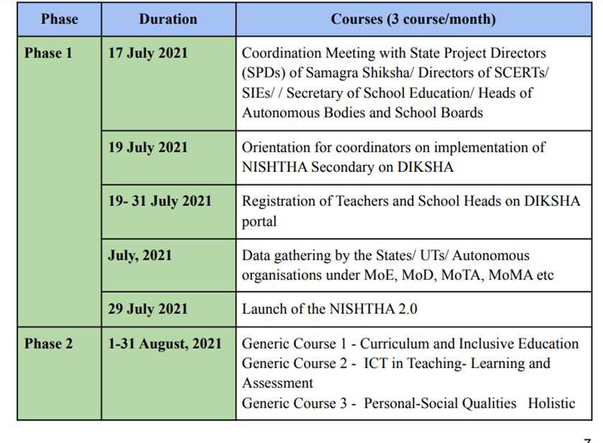
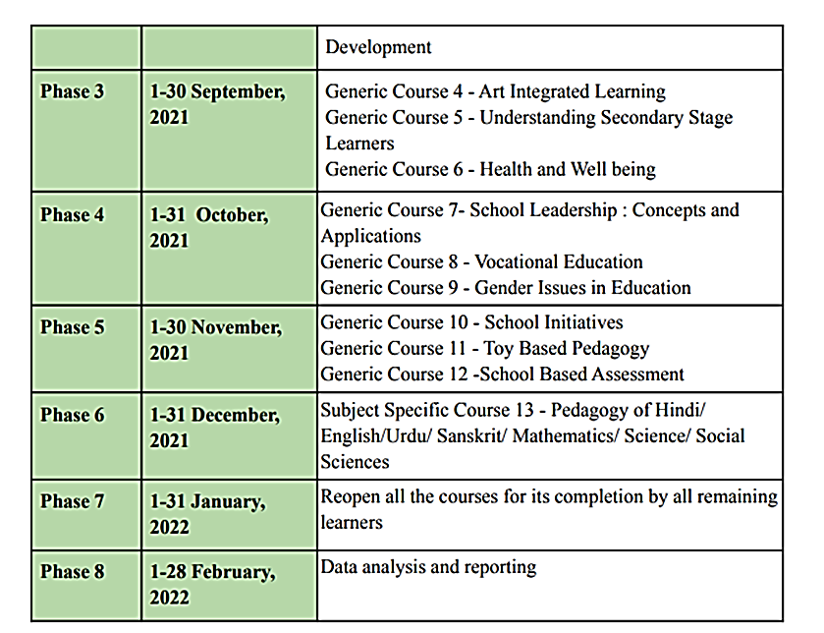
Source: NISHTHA Generic Guidelines for implementation
The Head Teachers and Teachers reported that they attended various NISHTHA Phase 2.0 online courses on the DIKSHA portal in the month of August 2021 to January 2022 in a phase-wise manner. Between August to November 2021 about 85-90% respondent teachers reported that they completed various NISHTHA 2.0. training courses.
Phase: 3
The Head Teachers and Teachers reported that they attended various NISHTHA Phase 3.0 online courses on the DIKSHA portal in the month of October 2021 to May 2022. Between October to March 2022 mostly teachers (82-86%) reported that they completed various NISHTHA 3.0.Courses.

Following matrix presents the phase-wise coverage of NISHTHA in Telangana:
Figure 12: NISHTHA Coverage in Telangana

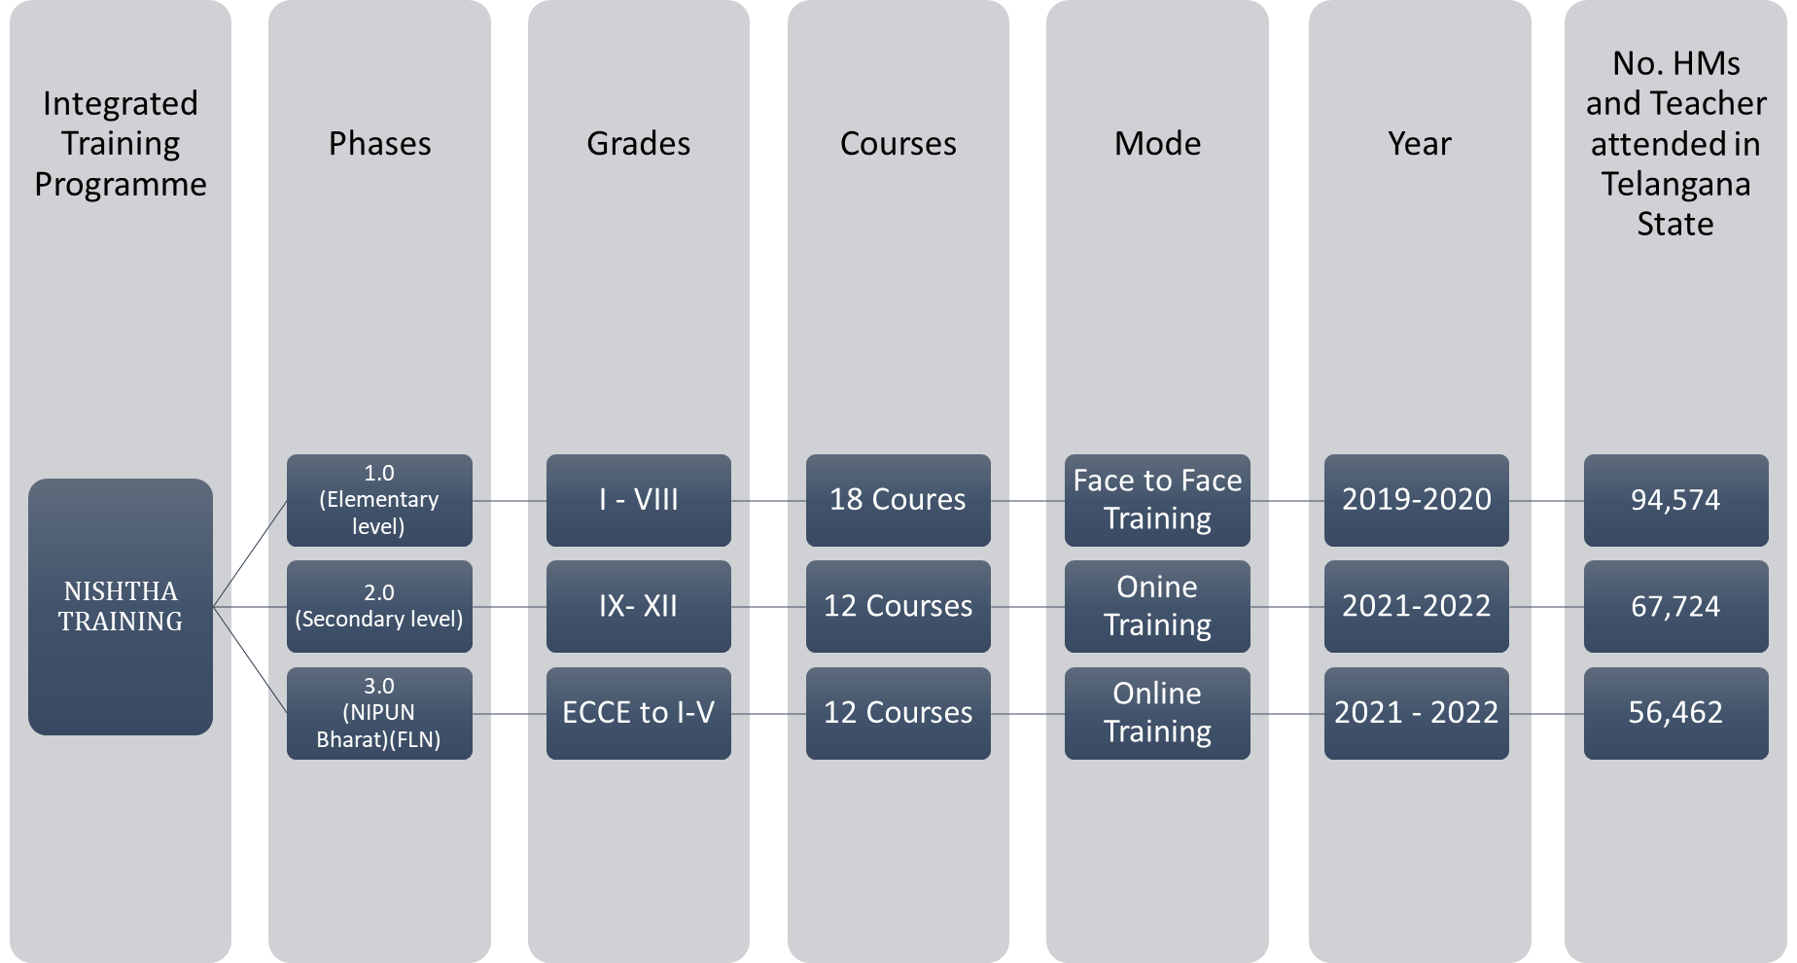
Source: NISHTHA website (https://itpd.ncert.gov.in//) and SCERT, Telangana Data

Teacher – KRP ratio

In the Phase -1 training, KRPs reported that they trained teachers within a broad range of 51 to 1000 within 2-4 batches or more. Out of 187, 45 KRPs reported that they trained 501-1000 teachers in 2-4 or more batches. Male KRPs reported that they trained more teachers in comparison to female KRPs. Only 6 male KRPs reported that they trained 1000 plus teachers in the 2 or above number of batches.

Information about training
Figure 13: KRP/SRPL to Participant Ratio:Phase 1:
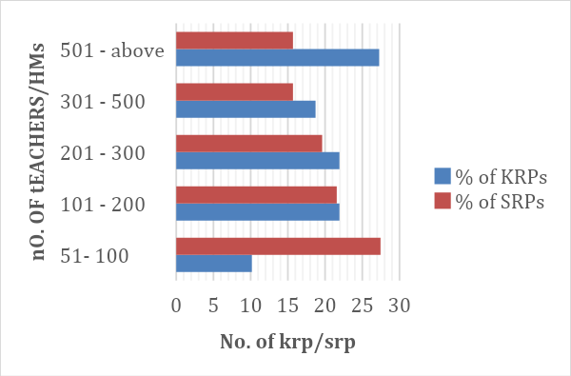
In the face-to-face training, the majority of Head Teachers (84%) and Teachers (62%) reported that they received information about training from District/ Mandal Education Officer. Also, a large number of teachers (32%) received information about this training from their school Head Masters/Teachers. Whereas a small number, about 450 remaining teachers and 131 Head Teachers selected either the District Technical team, DIETs/SCERT staff, or others.
Source: Online Survey for KRPs and SRPs
In districts like Jayashankar Bhupalpally, Mahabubnagar, and Nizamabad about 20-25 teachers (highest among all districts) reported that they received information from District Technical Team. Further, 9 teachers from Karimnagar district (highest among all districts) reported that they received information from DIETs / SCERT. Majority of KRPs and SRPs of phase 1.0. responded that they received information from DEOs or SCERT.

Phase 2: In the online Phase - II training, most Head Teachers (78%) and Teachers (40%) received information from District/ Mandal Education officer. Also, 48% teachers reported that they received information about training from the Head Teachers. The remaining 11% teachers reported that they received training information from District Technical Team, DIETs/SCERT staff, or others.

Phase 3: In the online Phase - III training, most Head Teachers (81%) and Teachers (74%) received information from District/ Mandal Education officer. The remaining 18 -26 % of Head Teachers and Teachers reported that they received information from their fellow colleagues/ Head Teachers in their respective schools, District Technical Team, DIETs/SCERT staff, or others.

Overall, whether it was face-to-face mode training or online mode training, District / Mandal Education office, fellow Head Teachers or Teachers played a key role in circulating the information about training.

Notice about training
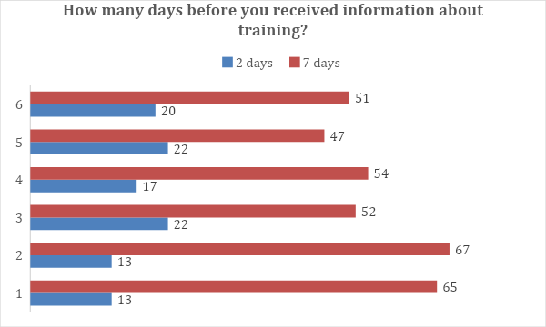
Phase1: Prior information about training is helpful as it gives time to Head Teachers and Teachers for preparations such as delegation of responsibilities and planning lessons accordingly. About 65-67% of Head Teachers and Teachers reported that they received information at least a week before which is a reasonable lead time. But there were about 13% Head Teachers and Teachers who received information just 1-2 days before the trainings. Majority of such head teachers / teachers are from rural schools. High percentage of such teachers who received short notice were seen in districts like Vikarabad and Mahbubnagar district.
When KRPs and SRPs were asked if they received complete information about the training before the shortlisting or selection process, only 47% KRPs and 56% SRPs reported that they received complete information. Remaining 53% KRPs and 44% SRPs reported receiving either partial or no information before training.
Phase 2: About 52-54% Head Teachers and Teachers received information about a week before the start date of the course. Further, there are 17-22 % Head Teachers and Teachers who received information just 1-2 days before the start. And remaining Head Teachers and teachers (26- 28%) reported that they received information 15-30 days’ prior.
Phase 3: About 47-51% of Head Teachers and Teachers received information about a week before the start date of the course. Also, there were 29-30% of head teachers and teachers who received information about the training at least 15 - 30 days before the training. And remaining Head Teachers and teachers (20- 22%) reported that they just received information only 1-2 days before.
Overall, as compared to Phase - 1(face-to-face mode), in the online phase, there were more no. of Head Teachers and Teachers who received information at a short notice.

Training Guidelines
State functionaries / SCERT team was responsible for customizing the training manuals as per the local context, translation in Telugu language, and distribution across all mandals in the state. Distribution of training manuals was required only in phase -1 and not in phases - II and III as the training was completely online. In Phase -II and III, SCERT customized the online content within the short timelines given by NCERT and got the courses uploaded (Telugu version) on the DIKSHA portal. Thereafter, bar codes or web links of different courses were generated by SCERT and shared with all the Head Teachers and Teachers
Phase:1
Figure 14: Dissemination of guidelines
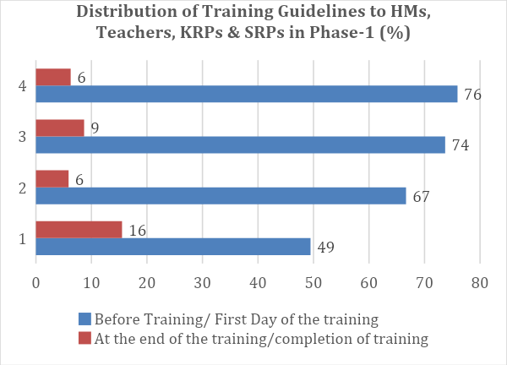
When Head Teachers and Teachers were asked whether they received NISHTHA guidelines, the majority of Head Teachers (74%) and Teachers (76%) reported having received guidelines before the training commenced or on the first day of training. However, only 3-4% of them responded that they didn’t receive a training manual. The district with the highest percentage of teachers who reported ‘No guideline received’ is Wanaparthy district (17%) and in the case of Head Teachers, it is Komaram Bheem Asifabad (13%). Whereas, 49% KRPs and 66% SRPs received training guidelines before or on the first day of training. Remaining KRPs and SRPs received after the training was started or on the last day of training. Source: Head Teacher and Teacher Online Survey Phase -1

Mode of Receiving information or instructions about the Training
Figure 15: Mode of receiving information
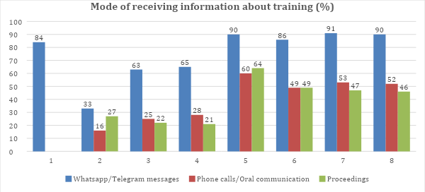
Source: KRPs & SRPs, Head Teacher and Teacher Online Survey across all phases
Phase 1:
When Head Teachers and Teachers were asked how they received information about self-enrollment in the NISHTHA training, the majority 63-65% of them reported that they received information through ‘Whatsapp or Telegram group messages.’ Further, ‘phone calls/ oral communication’ and ‘proceedings’ was also found as the most popular mode of information dissemination. The ‘zoom meetings’, and ‘Emails’ was the least popular response mode of information dissemination. Among KRPs and SRPs ‘WhatsApp or Telegram messages’, ‘State level workshops’ and “Zoom meetings’ were the main media for receiving information.
Phase 2:
In this phase, ‘WhatsApp or Telegram messages’, ‘phone calls/ oral communication’, ‘zoom meetings’, and ‘proceedings’ were the principal media for information dissemination. Only a few participants had received thee information on ‘email’.
Phase 3:
In this phase, similar types of responses (like in phase - 2) were received from Head Teachers and Teachers. ‘Whatsapp or Telegram group messages’ and ‘phone calls/ oral communication’ were found to be the main media through which most participants had received information.

Learning navigation of Online Platform

Figure 16: Using DIKSHA
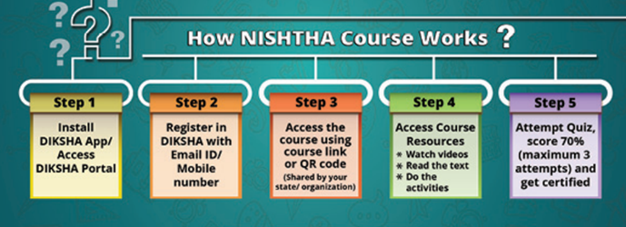
Since Head Teachers and Teachers in Phase 2 and Phase 3 attended completely online training on the DIKSHA Portal, they were asked how they learnt navigating NISHTHA Courses online, especially given that many teachers were exposed to online learning for the first time, especially the ones located in rural areas. In the survey, this question was a multiple choice one and teachers could select more than one response.
Source: NISHTHA Guidelines
Figure 17: Learning navigation of online platform
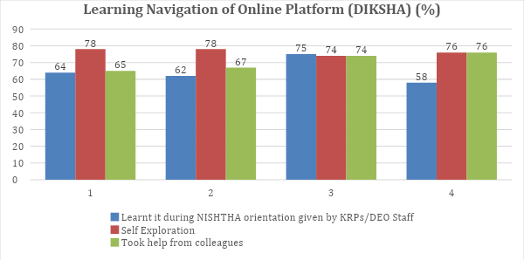
Source: Head Teacher and Teacher Online Survey Phase 2 and Phase 3
Phase 2:
Most teachers and school heads learnt navigating the modules through “Self-Exploration” and “NISHTHA Guidelines /SOP document”. Further, 21-23 % of Head Teachers and Teachers also took support from the members of their family.
About 47-55% Head Teachers and Teachers also reported that they had previously done some course/s / had uploaded material on DIKSHA. These experiences have been of help to them during the online NISHTHA phases.
Phase 3:
In Phase 3, the most popular responses were “Self-Exploration” and “help from colleagues” among Head Teachers and Teachers teaching in the Primary grades. Also, 24-27% of total Head Teachers and Teachers also reported that they learn from family members.
About 48-54% Head Teachers and Teachers also reported that they had done some course/s or previously they had uploaded material on DIKSHA portal. In both the responses, the percentage of teachers is slightly higher than Head Teachers.

Level of Comfort in Online Navigation
Phase 2:
When Head Teachers and Teachers were asked how comfortable they were in accessing online modules, the majority of Head Teachers (66%) reported that it was difficult for them to access courses online throughout whereas Teachers (69%) reported that it was initially difficult for them, but they learnt to navigate eventually.
Figure 18: Comfort in online navigation
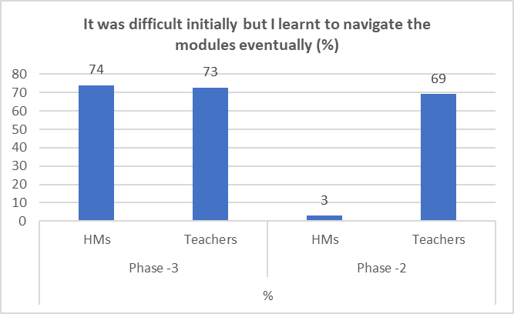
Phase -3
Majority of Head Teachers (74%) and Teachers (73%) reported that it was initially difficult, and that they had learnt navigating the modules eventually. Very few reported that it was difficult throughout all the courses.

Source: Head Teacher and Teacher Online Survey (Phase – 2 & 3)

Devices used for training
In Phase -1, since the training was in face-to-face mode, the usage of devices was limited to self-enrollment and accessing content on the NISHTHA App. Whereas, in Phase-2 and Phase-3, the devices played an important role in accessing online NISHTHA content, as the training was completely online.

Phase-1:
In phase -1, the majority (88-89%) Head Teachers and Teachers reported that they used mobiles for self-enrolment. Moreover, 15-17% Head Teachers and Teachers also reported that they used training center desktops/laptops. Head Teachers and Teachers who reported that they used ‘training center desktops/laptops’ were from different school types such as MPPS, MPUPS and ZPHS.
Figure 19: Devices used for online training
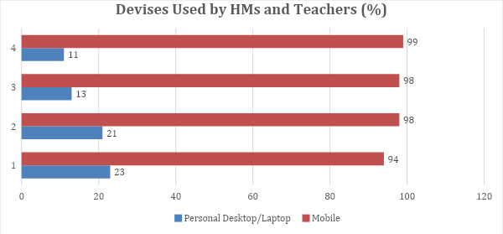
Source: Head Teacher and Teacher Online Survey (Phase – 2 & 3)

Phase 2:
In phase -2, the majority (94-98%) Head Teachers and Teachers reported that they used mobiles for the DIKSHA App/website. The second most used device was personal desktop/laptop. 242 out of 349 Head Teachers and 2054 out of 2684 Teachers reported that they used a single device which is mobile for training purposes. The remaining Head Teachers and Teachers used multiple devices (2 or more devices).
Phase 3:
Most Head Teachers and Teachers (98-99%) reported that they used mobiles for the DIKSHA App/website.

Internet Connectivity
Phase 2:
14-16 % teachers and school heads had fast/extremely fast internet connectivity and 16-17% Head Teachers and Teachers reported that internet connectivity was slow or very slow. Between 64% and 66% of the participants had satisfactory internet connectivity.
Figure 20A: Speed of internet connectivity
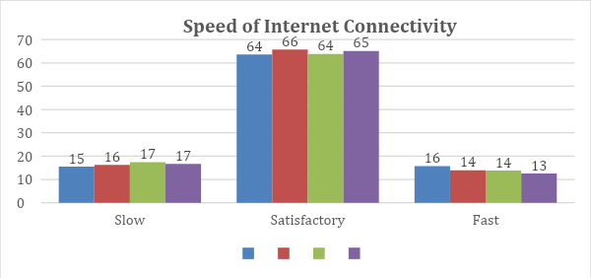
Source: Online Survey of HMs and Teachers (Phase 2 & 3)
Phase 3:
13-14 % participants reported that the internet connectivity was fast/ extremely fast. The percentage of Head Teachers and Teachers who had satisfactory internet speed was high in both online phases.

Number of hours spent to complete an online course
According to NISHTHA Guidelines, each course is to take at least 3-4 hours to complete. In the online survey, when teachers were asked how much time it took to complete one course:

Phase - 2
54% Head Teachers and 48% Teachers reported that they completed each course in 3-4 hours. About 8% teachers took more than 12 hours. Remaining took up to 6-12 hours or more to complete the modules.

Phase 3
54% Head Teachers and 52% Teachers reported that they completed each course in 3-4 hours. About 9% teachers took more than 12 hours. In both phases, teachers spent more time completing each module as compared to the school heads.

Sharing of Weblinks or QR Code (Phase-2 & Phase-3)

Phase -2
About 9% of the total teachers in Phase – 2 and 16% of the total teachers in Phase – 3 received weblink or QR code for the joining the course online after the day of course opening. Its an assumption that if there is delay in receiving the weblink or QR code then there are high chances that a teachers will spend less time on the course completion.
Figure 20B: Timing of disseminating weblink/QR codes
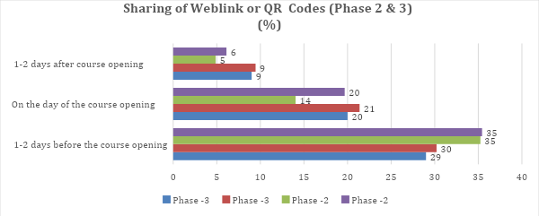
Source: Online Survey of HMs and Teachers (Phase 2 & 3)

When were courses completed?
Most of the teachers 83 -88% reported that they completed training after school hours or on the weekends. Further, 14% of the teachers and 13% HMs in Phase -2 reported that they completed during the school hours.
During the face-to-face interviews in one of the districts in which in-person interviews were conducted, one of the KRP also mentioned that “since teachers have to complete the online courses (2 courses in one month); due to the paucity of time and also it was difficult to use mobile phones for a very long time to attend the training, many teachers quickly skipped the training videos or they left it continuing for some time while they are busy doing other things parallelly. Further, many referred to YouTube and completed the assessment in Phase -2 /Phase 3 courses. On YouTube, there are many videos made by teachers on NISHTHA Trainings assessment and uploaded. Those videos have answers to all the questions asked in the course assessment. By doing all this, many teachers managed to get the certificate of course completion.”

Problems faced during the trainings:
All Head Teachers and Teachers had varied experiences of attending face-to-face training as these trainings were organized at mandal level. KRPs and SRPs who conducted the training had received direct training from NCERT.
Phase 1:
In the online survey, Head Teacher and teachers were asked what problem/s they had faced at the time of the training. Head Teachers and Teachers could select multiple response options.
a. Training venue was located very far away from my residence. Therefore, traveling regularly for 5-days was difficult
b. Training infrastructure (projectors, screen, seating arrangement etc.) was not conducive to training
c. There were too many participants per KRP. Hence, one-to-one interaction between KRP and teachers was not always possible
d. Others

Male teachers reported having faced a greater number of problems (from among those listed in response options) faced during the face-to-face training as compared to women teachers.
More than 50% male teachers reported two kinds of problems faced –
a. Training infrastructure was not conducive to training and
b. There were too many participants per KRP. Hence, one-to-one interaction between KRP and teachers was not always possible as compared to female teachers.
On the other hand, more than 50% women teachers reported that the training venue being located very far away from their residence as a major problem, with a majority of them being teachers of primary grades (I-V grades).
Phase -2 and Phase -3
In the online survey, Head Teachers and teachers were asked what problem/s they faced at the time of the online NISHTHA phases and following options were given. Head Teachers and Teachers could select more than one option.
- I did not have the requisite devices to access the online content (mobile/PC/laptop etc.)
- I did not have good internet connectivity to access/download the online content
Figure 21: Support required in Phase 1.0
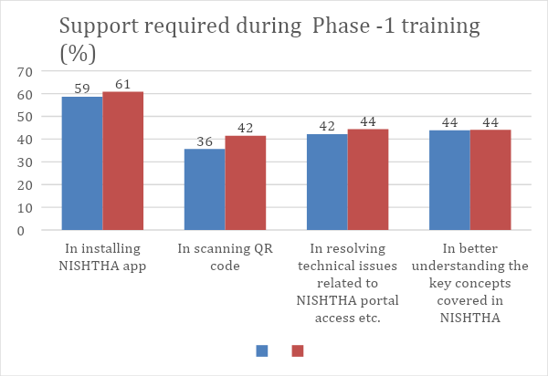
- There were technical issues with the DIKSHA portal because of which online access was not smooth
- I was not acquainted with the steps to be followed for accessing online modules
- I did not get my certificate due to technical issues of DIKSHA portal
Source: Online Survey of HMs and Teachers (Phase 2 & 3)
- Reading the content on mobile phone was difficult
- There was no opportunity to seek clarifications on the concepts covered
- Others
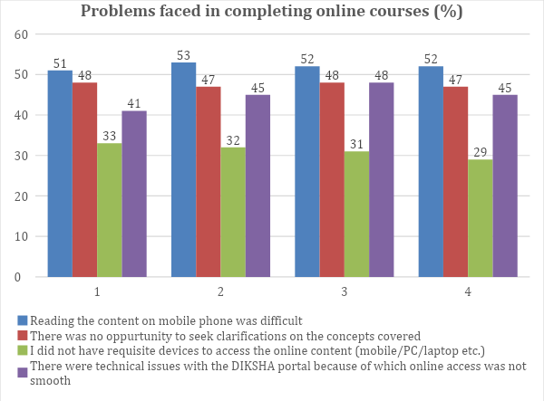
Figure 22: Problems faced during online training
29-33% Head Teachers and Teachers reported that they did not have requisite devices to access the online content.
In both the online phases, many Head Teachers and Teachers (51% and above) reported that reading the content on mobile phone was difficult. Further, since the training was conducted online, many reported ( 44 - 48% Head Teachers and Teachers) that there was no opportunity to seek clarification on the concepts covered.
Source: Online Survey of HMs and Teachers (Phase 1)
With regards to the usage of DIKSHA portal, many reported ( 42-48 % Head Teachers and Teachers) that there were technical issues with the DIKSHA portal because of which online access was not smooth. Also, 29% Teachers in Phase -2 and 28% Teachers in Phase -3 also reported that they faced issues in getting online certificate after the completion of the training on DIKSHA portal.

Support required by HMs and Teachers
Phase 1.0.:
During the training, majority of teachers who took training in the Phase -1 OF NISHTHA sought at least 2 or more types of support. Only 5 out of 818 HMs and only 33 out of 7,569 teachers responded that ‘ they sought help had not received it.’
HMs and Teachers took help in installing NISHTHA App for accessing offline modules content, scanning QR code, in understanding key concepts and resolving technical issues.
Only 2112 out of 7569 teachers (27%) reported that they sought post training support in developing action plan/implementing certain key concepts.
Phase - 2 & 3
In these phases also, HMs and Teachers have sought and received at least 2 different types of support. Support was mostly taken in resolving technical issues as the training was completely online. A high proportion of Head Teachers and Teachers (44-46%) also faced problems in the self-registration on the DIKSHA Portal and accessing online courses.
Figure 23: Support required in Phases 2.0. & 3.0.
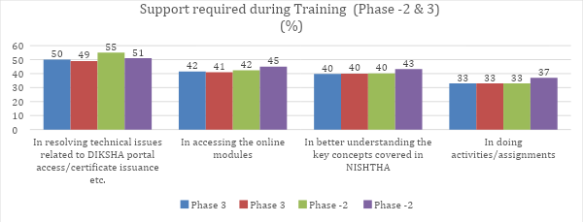
Source: Online Survey of HMs and Teachers (Phase 2 & 3)
Further, post-training support was sought by 24- 26% Head Teachers and Teachers. About 14-18% Head Teachers and Teachers sought support in posting their reflection on a blog.
Mostly HMs and Teachers who completed online training appreciated the support given.
In the online survey, HMs and Teachers reported that their issues were resolved either on the same day or within 1-2 days of the issue being reported.
Very few HMs (1-2%) and Teachers (1%) reported their issues were not resolved.

Who supported Head Teachers and Teachers?
Phase -1
Figure 24: Issue resolution time
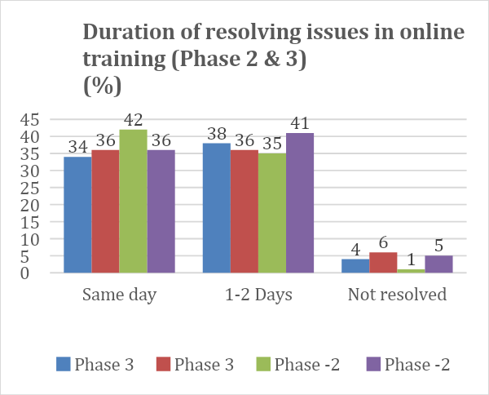
74-75 % of HMs and Teachers in the online survey have reported having received support from Key Resource Persons (KRPs) supported Teachers and State Resource Persons (SRPs) (Leadership). Besides KRPs/SRPs, there were course director, Technical persons, Fellow teachers, and DEO office who supported teachers during the online Face-to-face training.

Phase -2 and Phase -3
In the online phases of NISHTHA, most HMs and Teachers have reported having received support from DEO office, technical person and SCERT team.
Source: Online Survey of HMs and Teachers (Phase 2 & 3)

There were other actors like DIET faculty, School Heads, Fellow Teachers and MEO Office who have actively supported HMs and Teachers during training, but their percentage was comparatively low.

Figure 25: Who supported
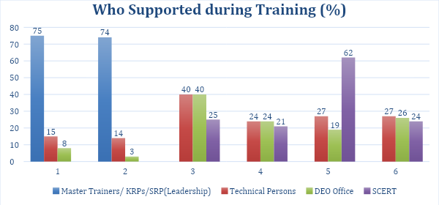
Source: Online Survey of HMs and Teachers across phases

Follow-ups regarding course completion
Majority of Head Teachers and Teachers reported that the follow-up was done. During Phase -1, most of the HMs and Teachers reported that follow-up was done during the 5 -days of the training. A few districts such as Vikarabad, Nizamabad, and Mahabubnagar have a noticeably higher percentage of teachers who said no-follow-up was done.
Whereas, in the Phase -2 and Phase – 3 HMs and Teachers reported follow-ups were done on weekly, fortnightly and once in a month basis.
Highest percentage of HMs and Teachers (13-14%) who attended Phase -3 training mentioned that the no – follow was done.

Chapter 5: Usefulness of NISHTHA Modules as reported by Teachers & School Heads
About the chapter:
This chapter discusses the usefulness of NISHTHA modules as reported by teachers and school heads in the online survey conducted as part of this assessment. The chapter has been organized thematically, with the feedback of teachers and school heads drawn from one or more of NISHTHA phases in which the themes have been covered.

Key findings on modules

Foundational Literacy & Numeracy
Foundational Literacy and Numeracy (FLN) has been given special attention in NISHTHA 3.0., since this phase was meant for teachers & school heads of primary schools. As mentioned in the Participants’ Profile, 3,555 teachers and 802 school heads who have completed NISHTHA 3.0. have participated in the online survey. In this section we focus on the findings of the online survey as it relates to FLN.
Figure 26: Understanding NIPUN BHARAT
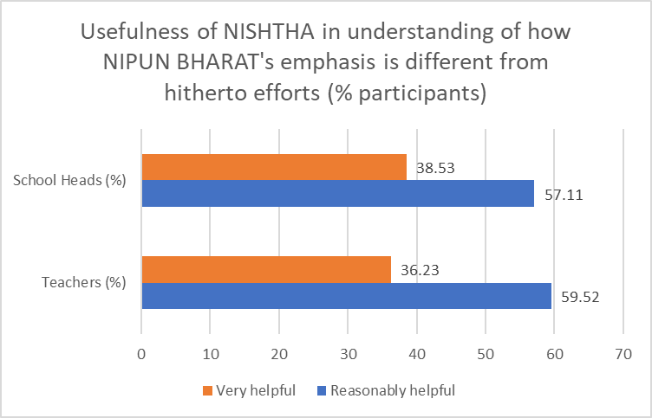
59% of teachers and 57% of school heads think NISHTHA has been ‘reasonably helpful’ in bringing about an understanding of/adding to their understanding of how NIPUN BHARAT’s emphasis on building numeracy and literacy skills is distinct from the hitherto efforts in these directions. 36% teachers and 38% school heads think NISHTHA has been very helpful in this regard.

After completing NISHTHA 3.0., 62% of teachers & 60% of school heads are reasonably clear about the areas they need to focus on, in order to align their teaching with NIPUN Bharat's focus-areas. 30% teachers & 33% school heads are very clear in this regard.

Figure 27: FLN Assessments
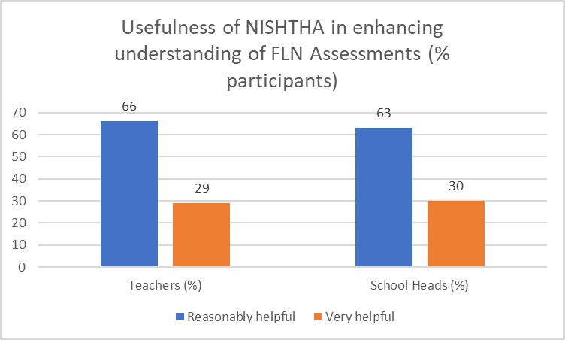
NISHTHA has been able to bring about a good understanding among the teachers & schools of the concept of Balavatika. 58% teachers & 57% schools heads thought NISHTHA has been reasonably helpful in this regard and 38% teachers & 37% school heads think NISHTHA has been very helpful in this regard. Similar positive responses have been received in respect of the concept of Vidya Pravesh.
66% of teachers and 63% of school heads have expressed that their understanding of different types of assessments required for measuring competencies relevant to FLN has been enhanced by NISHTHA to a reasonable extent and 29% teachers & 30% school heads think such an enhancement has been to a significant extent.

NISHTHA discusses the facilitation of activities around children’s literature. This was found to be reasonably useful by 62% teachers and 60% school heads and very useful by 32% teachers and 35% school heads.

In terms of understanding how to involve parents and community to promote FLN, 63% teachers and 59% school heads think NISHTHA has been reasonably useful to them while 33% teachers and 37% school heads have rated this usefulness as being significant.

Considering the centrality of competencies & learning outcomes in FLN, the teachers and school heads were asked about their opinion regarding the extent of flexibility provided for in the list of competencies & learning outcomes.

Figure 28: On following pre-defined Learning Outcomes & Competencies
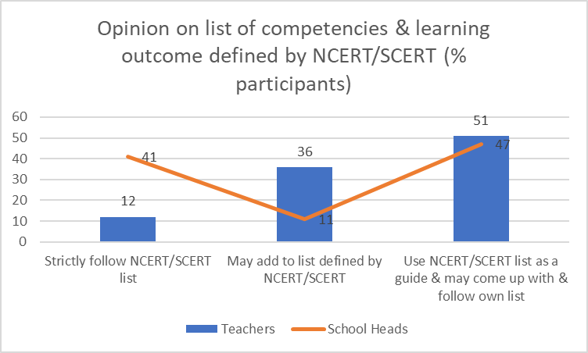
12% teachers thought they are to strictly follow the list of competencies defined by NCERT/SCERT; significantly higher proportion of the school heads (41%) also thought so;
36% teachers thought they may add to the list of competencies defined by SCERT/NCERT, while only 11% of school heads agreed with this proposition;
interestingly, 51% teachers and 47% school heads thought that while using list of competencies/learning outcomes defined by NCERT/SCERT as a guiding framework, teachers/school heads can come up with and follow their own list of competencies/learning outcomes
With reference to play-way-methods emphasized by NISHTHA for promoting FLN:
32.5% teachers and 33% school heads had implemented/had been implementing such methods already
51% teachers and 51% school heads believed they were newer ideas/perspectives in this regard in NISHTHA and that they would implement them, if necessary by raising resources
16% teachers and 14% school heads thought that while there were newer perspectives/ideas they could gain from NISHTHA about the use of these methods, they would be in a position to implement them in their classrooms, provided the requisite resources are made available
There have been discussions around multilingual education in NISHTHA 3.0. 66% teachers and 63% school heads thought this has expanded their understanding of how children engage with language to a reasonable extent. 29.5% teachers and 32% school heads believe their understanding in this regard has been expanded to a significant extent.
Among other things, NISHTHA 3.0. discusses the teaching of pre-number skills like classification, sorting, ordering, one-to-one correspondences etc. 77% teachers and 58% school heads agree with the proposition that NISHTHA has strengthened their knowledge/skills/ideas in this regard. 17% teachers and 38% school heads strongly agree with the proposition.
There are 557 common survey respondents between phase 1.0. and 3.0. Their responses were compared for the following questions:
Phase 1.0.: NISHTHA 1.0. has been useful in strengthening teachers' knowledge/skills/ideas related to teaching pre number skills like classification, sorting, ordering, one-to-one correspondences etc. The response options were on a 6-point-scale, from ‘strongly agree’ to ‘strongly disagree’, including the option of ‘not applicable to my grade/subject’.
Phase 3.0.: How would you rate the usefulness of ideas/concepts related to imparting pre-number skills to students as discussed in NISHTHA 3.0.? The response options were on a 6-point-scale, from ‘very helpful’ to ‘not at all helpful’, including the option of ‘course not done, hence can’t say’
The response pattern of these 557 participants is broadly similar for the aforementioned questions. 95% in phase 1.0. and 96% in phase 3.0. have reported NISHTHA adding value to them in terms of teaching pre-number skills. About 4% participants were not sure of such value addition in both the phases.

Competencies
Competency-based-education has been given central prominence in NISHTHA. We tried to understand how useful NISHTHA has been in enhancing the teachers’ and school heads’ understanding of competencies as a concept.
In phase 1.0., 63% teachers and 62% school heads have reported a reasonable enhancement in this regard. This was sought to be triangulated through the opinions of KRPs and SRPLs, who had trained the teachers and school heads respectively. 51% KRPs and 49% SRPLs believed that upto 70% of teachers/school heads trained by them had understood the concept of competencies and 24% KRPs and 27% SRPLs believe the proportion of this constituency to be greater than 70%.
In phase 3.0., 56% teachers and 54% school heads found NISHTHA to be reasonably helpful in enhancing their understanding of competencies. 40% teachers and 41% school heads believed the training to be very helpful in this regard. Besides the understanding of the competencies as a concept, we tried to gauge the extent to which NISHTHA has been able to help with reference to understanding concrete classroom practices required for imparting competencies in students. 59% teachers & 56% school heads reported the training to be helpful to a reasonable extent while 37% teachers and 39% school heads have reported the training to be significantly helpful in this regard.

Figure 29: Assessments for competency based education
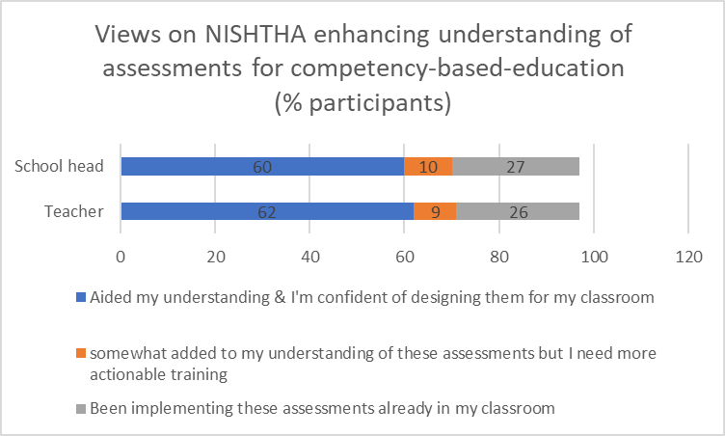
In terms of assessments required for competency-based-education:
62% teachers and 57% school heads believe NISHTHA 3.0. to have aided their understanding of these assessments and that they were now confident of designing them in their classrooms
9% teachers & 10% school heads believe NISHTHA 3.0. to have somewhat added to their understanding of these assessments but have sought more actionable training to implement them in their classrooms
26% teachers & 27% school heads had reported to have already been implementing such assessments & that it was good to see NISHTHA covering them.

Learning Outcomes
Figure 30: Understanding Learning Outcomes
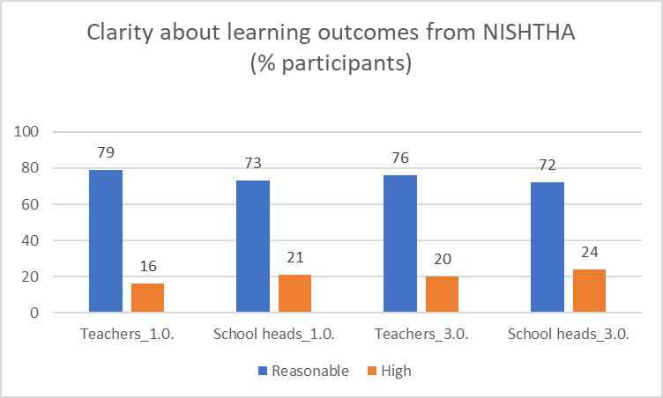
The concept of Learning outcomes (LO) and its relation to various pedagogic aspects have been discussed across several modules across all the phases of NISHTHA. Through the online survey, feedback has been sought from teachers, school heads, KRPs and SRPLs on the extent of value NISHTHA has been able to add with reference to understanding and applying the concept.
In phase 1.0., 79% teachers, 73% school heads, 53% KRPs and 51% SRPLs agree with the proposition that they are clearer about learning outcomes after undergoing NISHTHA 1.0. 16% teachers, 21% school heads, 45% KRPs and 37% SRPLs strongly agree with this proposition.
In phase 3.0., 77% teachers and 72% school heads believe that their understanding of LOs has been enhanced by NISHTHA. A further 20% teachers and 24% school heads strongly agree with this proposition. In respect of the steps to be taken to implement LOs, 72% teachers have reported that they have understood them reasonably well from NISHTHA and a further 23% teachers and 25% school heads have reportedly understood them very well.

Assessments for holistic development
Figure 31: Assessments for holistic development
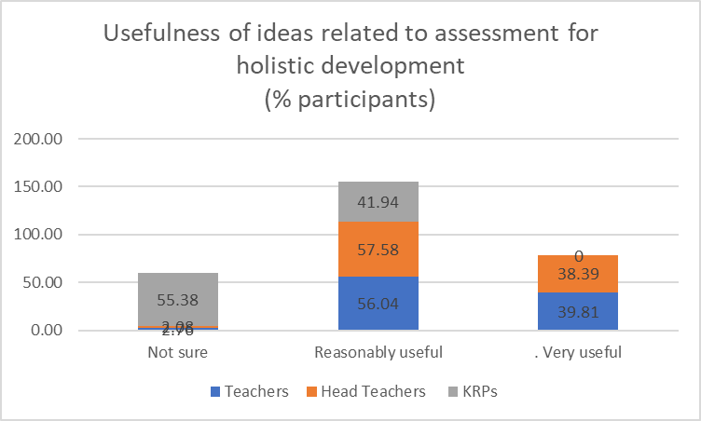
Assessments have been discussed in NISHTHA under specific grade-levels (like assessments for secondary grade students) as well as under specific themes (like assessments for FLN, for competency-based-education etc.). All the 3 phases of the training programme have discussions on assessments.
56% teachers and 58% school heads found the coverage of assessments to measure holistic development of students to be reasonably useful. A further 40% teachers and 39% school heads found them to be very useful. We however get a different picture when KRPs’ responses are examined. While 42% of KRPs found these assessments to be reasonably useful, 55% of them were not sure of the usefulness of the course and 3% did not find them useful.
65% teachers and 60% school heads found the ideas for assessments for secondary grades to be reasonably useful and a further 29% teachers and 34% school heads found them to be very useful.
In terms of the novelty of the ideas related to assessments, 70% teachers and 68% school heads of phase 3.0. thought NISHTHA presented them with newer ideas which they are keen to implement in their schools. 25% teachers and 27% school heads have reported to have been familiar with and having implemented these ideas even before NISHTHA. About 3% of teachers and school heads have reported these ideas as not being relevant to their schools’ contexts.

Subject Pedagogies
Subject pedagogies were covered in phase 1.0. of NISHTHA in the subjects of EVS, social science, mathematics, science and language. Subject wise feedback is as follows:

Pedagogy of EVS
Considering the inter-subject spread of Environment Science (EVS), the participants of phase 1.0. were asked if NISHTHA has been able to enhance their view of EVS as being spread across multiple subjects. 74% teachers and 53% school heads agreed and a further 16% teachers & 37% school heads strongly agreed with this proposition.
73% teachers and 50% KRPs thought they have been able to get newer ideas related to pedagogy of EVS from NISHTHA. A further 14% teachers and 39% KRPs strongly endorsed this view.

Pedagogy of Mathematics
A related aspect on which primary school teachers of phase 1.0. were requested to respond to was the proposition that NISHTHA has been able to present them with newer ideas related to imparting mathematical skills while teaching EVS and languages. 72% teachers and 54% school heads agreed and a further 15% teachers and 36% school heads strongly agreed with this proposition.
72% teachers and 56% KRPs thought they have been able to get newer ideas related to pedagogy of mathematics from NISHTHA. A further 14% teachers and 34% KRPs strongly endorsed this view.

Pedagogy of Language
Figure 32: On Subject Pedagogies
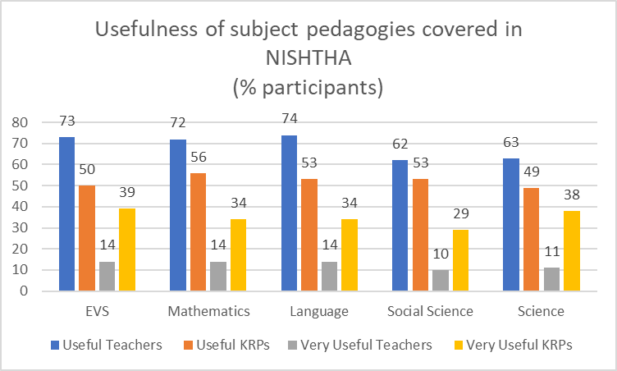
74% teachers and 53% KRPs thought they have been able to get newer ideas related to pedagogy of languages from NISHTHA. A further 14% teachers and 34% KRPs strongly endorsed this view.

Pedagogy of Science
63% teachers and 49% KRPs thought they have been able to get newer ideas related to pedagogy of science from NISHTHA. A further 11% teachers and 38% KRPs strongly endorsed this view.

Pedagogy of Social Science
62% teachers and 53% KRPs thought they have been able to get newer ideas related to pedagogy of social science from NISHTHA. A further 10% teachers and 29% KRPs strongly endorsed this view.

School Leadership
Figure 33: Usefulness of School Leadership Concepts & Applications
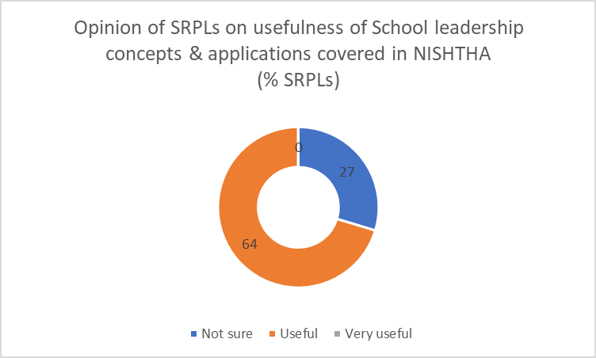
Phase 1.0. has 6 modules dedicated to school leadership. Besides these, the school heads have also undergone generic courses across all the 3 phases of the programme. The feedback from school heads in respect of the latter is being reported in the respective sections. In this section, the feedback being reported is specific to aspects of school leadership.
Since the State Resource Persons (Leadership) (SRPL) received training from NCERT and had in-turn trained the school heads, they were asked about the usefulness of concepts and applications related to school leadership in NISHTHA. While 64% of them found these to be reasonably useful, it is interesting to note that 27% were not sure of the usefulness of concepts and applications, with a further 8% of them reporting them as not being useful.
Figure 34: On pedagogical leadership
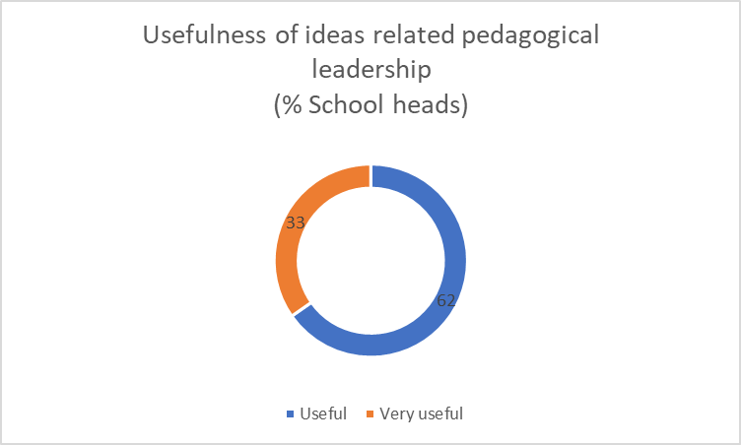
The feedback given by the school heads however is more affirmative in respect of pedagogical leadership, with 63% of them finding NISHTHA to have enhanced their knowledge/skills in this regard to a reasonable extent and 33% of them believing such enhancement to be to a significant extent.
Further, 68% school heads thought NISHTHA has enhanced their confidence with regard to creating school vision and curricular goals. 28% of school heads strongly endorsed this view.

Curriculum and Inclusive Classrooms
Inclusion as a theme has been covered across all Phases of NISHTHA, with emphasis sought to be laid on creating an enabling and enriching inclusive learning classroom environment,
In the online survey, 6772 (out of 7569) teachers and 747 (out of 818) Head Teachers have reported attending the course ‘Curriculum, Learner-Centered Pedagogy, Learning Outcomes, and Inclusive Education’ in the face to face mode of Phase 1.0. This course aims to help the participants understand the diversity in classrooms and adopt pedagogies that are most suitable to making classrooms and teaching-learning processes inclusive.
Figure 35: On enabling learning by CWSN
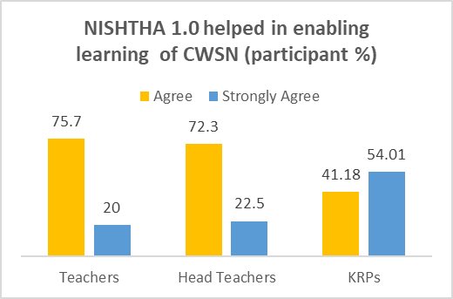
20 % of Teachers and 22% of School Heads ‘Strongly agree’ that this course has enhanced their understanding of how to enable boys as well as girls students to learn, how to enable children from different social & economic backgrounds to learn, and how to enable learning of differently-abled children.CWSN etc. Of the 20% teachers who ‘strongly agree’, 58% are from Primary schools, 23% from Secondary schools, and the remaining 14% from Upper Primary Schools.

Figure 36: On Universal Design for Learning
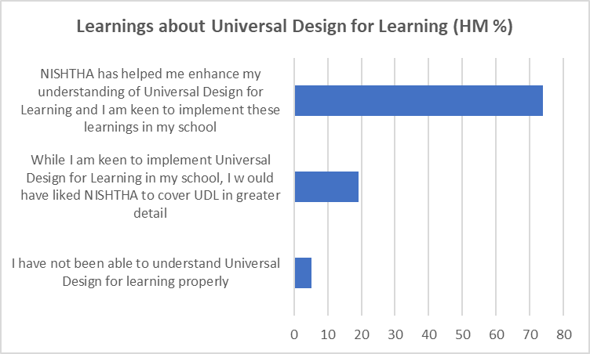
Graph Source: Teachers, Head Teacher and KRPs Online Survey (Phase -1)

Phase-2 included the course ‘Curriculum and Inclusive Classrooms’, which focuses on developing a sharper understanding of the National Education Policies, Frameworks, Curriculum, its transaction, and pedagogies for accepting diversity and creating inclusive classrooms. 2658 (out of 2684) teachers and 341 (out of 349) Head Teachers, in the online survey, have reported attempting this course, online. After completing this course, 52% teachers thought that they have “substantially benefited from NISHTHA as they have learnt newer aspects of managing inclusive classrooms.” A further 44% thought they have ‘somewhat benefited’ from this course.
When Head Teachers (Phase -2) were asked about their learning about ‘Universal Design for Learning (UDL); 73% of them believed the training has helped them enhance their understanding of Universal Design for Learning (UDL) and that they are keen to implement the learning in their schools. Further, 19% Head Teachers have reported being keen on implementing UDL in their schools and that they would like the concept covered in greater detail. 5% Head Teachers could not understand the concept.
The theme of teaching Children with Special Needs (CWSN) /differently-abled children is covered in multiple courses of phase 3.0. 61% Teachers and 59% Head Teachers who completed phase 3.0 courses believe they have gained newer ideas or perspectives related to. teaching Children with Special Needs (CWSN) /differently-abled children to a ‘reasonable extent’. 29% of Teachers and 33% of Head Teachers believe such a gain to be of ‘significant extent’.

Initiatives of School Education
This theme has been covered in phases 1.0. and 2.0. The key focus is on Centrally Sponsored Schemes on School Education run by the Department of School Education and Literacy, Ministry of Education (MoE), Government of India, aimed at generating awareness about these initiatives among teachers and school heads.
Figure 37: On school education initiatives
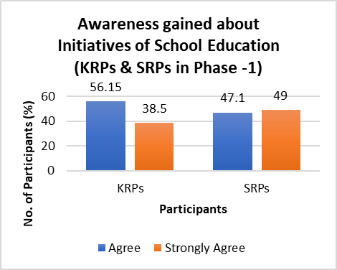
In the Phase -1, 4749 (out of 7569) Teachers and 507 (out of 818) Head Teachers reported that they have attended training on this course. And 161 (out of 187 KRPs) and 36 (out of 51) SRPLs have attended this course during NCERT training. Whereas, in the phase - 2, 2572 Out of 2684 teachers and 324 out of 349 Head Teachers attended this online course. The following is the summary of feedback received about this course:

Graph Source: Teachers, Head Teachers and KRPs Online Survey (Phase -1 and Phase -2)

- 56% KRPs and 47% SRPLs agreed that their awareness had been enhanced and 38% KRPs and 49% SRPs strongly agreed with the proposition.
- About 4% KRPs and SRPLs have reported not being sure about the course having improved their awareness about the initiatives.
- 79% Teachers and 72% Head Teachers agree that they gained awareness about Initiatives of School Education in phase-1.
- 72% Teachers and 74% Head Teachers agree that they gained awareness on the same subject in Phase -2.
- A greater number of teachers (23%) in Phase -2 strongly agree compared to teachers (14%) in Phase -1.
- Also, a greater number of teachers (in both the phases) thought that they are not sure of their gains from the course, as compared to Head Teachers. The gap between Teachers (7%) and Head Teachers (3%) is more in phase 2.

Guidance and Counseling/ Personal Social Skills
Figure 38: On school safety
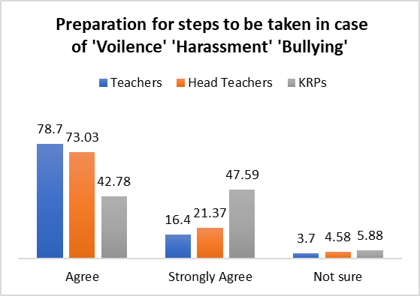
This theme is covered in NISHTHA Phase -1 (Elementary), under the course ‘Developing Social- Personal Qualities and Creating Safe and Healthy School Environment’ and in Phase -2 (Secondary), under the course ‘Personal- Social Qualities for Holistic Development.’ The focus areas are to help teachers develop psychological bases and skills to strengthen personal-social qualities /provide guidance to students for their holistic development, with a view to equipping School Heads
and Teachers to be alert and responsive to the students’ psycho-social needs Graph Source:
and serve as first-level counselors at the school level. In the online survey, 5986 out of 7569 Teachers, 665 out of 818 Head Teachers have reported having completed these courses. 151 out of 187 KRPs and 27 out of 51 SRPs attended the training conducted by NCERT.

In phase 2, 2638 out of 2684 Teachers and 342 out of 349 Head Teachers have reported completed training on the above mentioned course.
When Teachers and Head Teachers were asked if they were able to get newer ideas from this course to prepare students on the steps to take when they encountered 'violence', 'harassment', 'bullying' etc., the following feedback was reported:
79% Teachers and 73% Head Teachers agree that they got newer ideas on preparing students and a further 16% Teachers and 21% Head Teachers strongly agreed with this proposition
The percentage of Head Teachers who were ‘not sure’ of such a gain is more than that of Teachers
About 6% KRPs were ‘Not Sure’ of such a gain.
61% Teachers and 56% Head Teachers of Phase 2.0. found the course useful to a ‘reasonable extent.’
Further, Teachers and Head Teachers in both phase 1 & 2 were asked about their feedback on the extent to which NISHTHA has equipped them with ideas/skills for developing qualities like sensitivity, care, trustworthiness, effective communication skill in their students. In phase -1, 54% KRPs, 25% Teachers and 27% Head Teachers believe that training helped them in this regard to a ‘significant extent.The corresponding figures in phase -2 are 30% for teachers and 66% for Head Teachers.

Art Integrated Learning
Figure 39: On art integrated learning
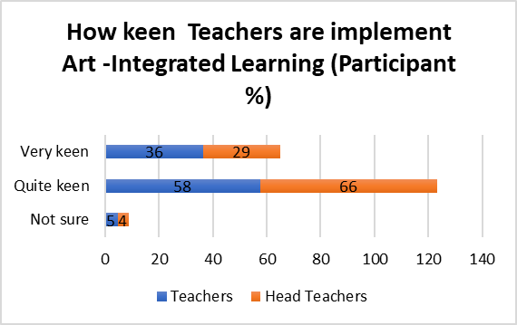
The course “Art Integrated learning” is included Phase -1 and Phase -2. In Phase - I, 5322 Teachers and 548 Head Teachers reported having attended training on this course in face-to-face mode and in Phase -2 2650 Teachers and 340 Head Teachers have reported completing the course online. The overall aim of the course is to provide age appropriate art experiences in order to enhance the creativity in teachers as well as in students, explore integration of Art with other subjects and provide holistic learning experiences.

NISHTHA Phase - I discusses using art forms (like Drawing, drama, role play, theatre, etc.) in subject teaching. When Teachers /Head teachers were asked ‘how keen’ they were to implement these ideas in classroom/school, 58% Teachers and 66% Head Teachers have reported that they are ‘quite keen’. About 5% of both Teachers and Head Teachers have reported ‘not being sure’ of such keenness.
59% of KRPs reported that teachers trained by them were ‘quite keen’ to implement art forms based approaches in their classroom..
When Teachers and Head Teachers who attended NISHTHA Phase- 2 courses were asked whether they learnt to design innovative activities which includes different forms of Art (like Drawing, drama, role play, theatre, etc) for teaching and learning from the Art Integrated course, 69% teachers agreed.

Pre- School Education
Figure 40: On integrating gender with subject teaching
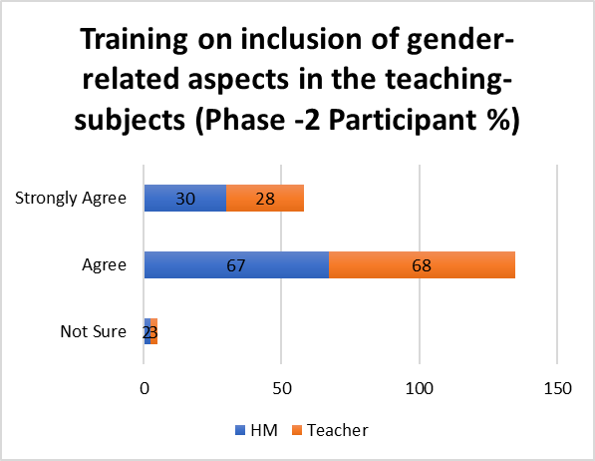
In the Phase -1 training, Pre- School education is one of the courses for School leaders. The aim of this course is to identify the need and importance of pre-school education, linkages that can be made with Primary Schools for smooth transition of children, pedagogy, role of parents and community, etc.
When SRPLs (who delivered face to face Head Teacher trainings) were asked about the extent to which ideas covered under NISHTHA training have enabled them to train School Heads on facilitating effective pre-school education, 39% believed NISHTHA such enablement by NISHTHA to be to a ‘reasonable extent’, 47% to a ‘significant extent’. 8% of KRPs were ‘not sure’ in this regard.

Integrating Gender Concerns:

In general, ideas pertaining to inclusion of gender aspects with curricular subjects were found included in all phases of NISHTHA. Specifically, in the phase - 1 (Elementary) under courses for leadership group, there is a specific course, titled ‘Relevance of Gender Dimensions in Teaching and Learning Processes’ and in Phase -2, titled ‘Integrating Gender in Schooling Processes’. The overall idea was to identify gender biased attitudes and behaviour among Teachers and Head Teachers, trained teachers on sensitive pedagogical processes in various disciplines and also to develop a clear understanding of gender as a social construct and redefines the role of teachers and principals as facilitators who can make positive interventions towards a gender just society. (Source: NISHTHA Course content accessed from the website https://itpd.ncert.gov.in/)

When SRPs (Leadership)’s feedback was sought on the helpfulness of the training (conducted by NCERT) with respect to training school heads on supervising the inclusion of gender concerns in teaching and learning processes, 52% SRPLs were found to believe the training as being useful to ‘significant extent’ and 39% of them believing the training to be useful to a‘ ‘reasonable extent’.

28% teachers and 30 % Head Teachers from among those attending Phase 2.0. ‘strongly agreed’ with the proposition that the course had enhanced their knowledge regarding inclusion of gender-related aspects in their subject teaching.

Revisiting NISHTHA Material
Since NISHTHA Phases 2 (Secondary) and 3 (Primary) courses were to be self-navigated by teachers and school heads online, they were to access course content, reference materials and weblinks on DIKSHA App or website. In Phase-1 as well, which was conducted in face to face mode, Teachers and Head Teachers could access all modules in the offline mode on NISHTHA App.
In the online survey, when Teachers and Head teachers who attended either Phase -2 or Phase -3 trainings were asked if they re-visited the course material after the course completion, the following responses were reported:

Figure 41: Re-visiting course material (2.0.)
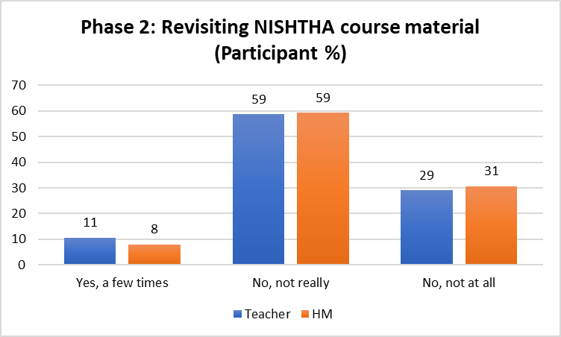
- 29% Teachers and 31% Head Teachers who attended Phase -2 trainings did not revisit course modules.
- Only 11% Teachers and 8% Head Teachers (Phase -2) said that ‘they visited the modules only a few times.’

Figure 42: Re-visiting course material (3.0.)
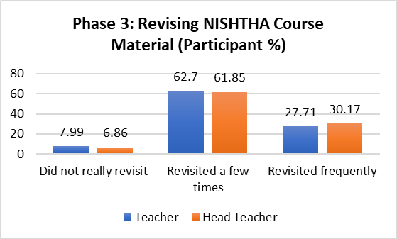

- 62% both Teachers and Head Teacher said that they revisited course material ‘frequently’ course completion.

- Only 8% Teachers and 7% Head Teachers said that they ‘did not really revisit.’

Testing Higher Order Skills
Teachers and Head Teachers who attended Phase - 2 training were asked about the extent to which NISHTHA Training had been able to provide them with newer ideas related to testing of higher order skills like critical thinking, conceptual clarity, analysis etc. 66% Teachers believed NISHTHA being helpful to a ‘reasonable extent’ and 27%, to a ‘significant extent’. 4% Teachers were ‘not sure’.

Reflecting on Teaching-Learning Processes
Teachers and Head Teachers who attended Phase -2 online training were asked if the training helped them reflect/ introspect on their teaching methods:

28% Teachers and 30% Head Teachers said that training has helped to a ‘significant extent’ in this regard.
Figure 43: On vocational education

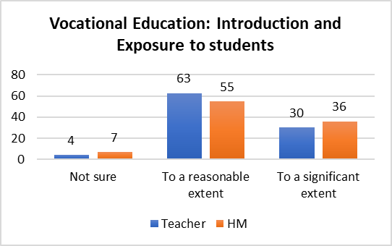
Vocational Education
Different aspects of vocationalisation of school education are covered in Phase-1, under the course ‘Pre-vocational Education’ and in Phase - 2 (Secondary) under the course ‘Vocational Education’.

60% of Head Teachers who attended the Phase -1 training and 59% SRPs who delivered training to Head Teachers believe that NISHTHA has added to their knowledge of implementing pre-vocational education in their respective schools ‘to a reasonable extent’. 7% Head Teachers and 6% SRPs were found being ‘not sure’ in this regard.

In phase- 2, 63% Teachers and 55% Head Teachers were ‘keen’ to introduce and give exposure to students on vocational education.

More percentage of School Heads (36%) were interested in introducing vocational education as a subject in their schools than teachers (30%).

Toy based Pedagogy

Toy based pedagogy is covered in Phase 2, under the course ‘Toy based pedagogy' and in Phase 3., under the course, ‘Toy-based pedagogy for Foundational Stage’. The online survey explored understanding how useful teachers found this module and how keen Head teachers were to practice toy-based pedagogy to promote joyful classroom learning.

58% teachers found this module useful to reasonable extent and 36% to a significant extent. Also, 54% of Head teachers were found ‘reasonably keen’ to used toys in teaching and learning in their school (from phase -2).
Figure 44: On School safety and security

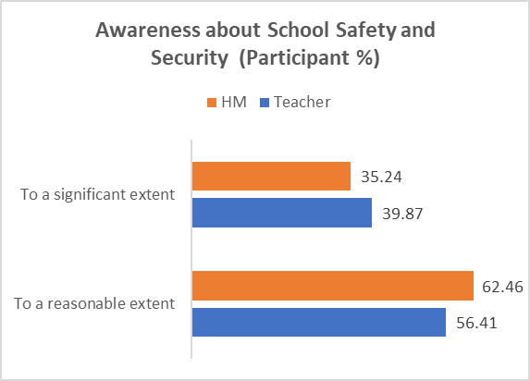
School Safety and Security
This theme is covered in NISHTHA with a view to creating awareness about the importance of school safety and security. 62% of Head Teachers and 56% of Teachers agreed to a ‘reasonable extent’ that NISHTHA has enhanced their awareness or helped them in understanding the steps to be taken w.r.t ensuring children’s safety and security in schools.

    - Training material
As part of the online survey, feedback of the participants of all the 3 phases of NISHTHA was sought on different aspects of training material, including instructions, language, key themes covered in modules, videos, images, activities/assignments and web links and references, blogs etc.

“Instructions were found to be useful by the most number of teachers (97% in each of 1.0., 2.0. and 3.0. ) and school heads(99% in 1.0., 95% in 2.0. & 98% in 3.0.). The aspects found to be useful by a relatively lower proportion of participants are:
- web links & references (Not sure/Not useful: 17% teachers & 13% school heads in phase 1.0.),
- Blog (Not sure/Not useful: 23% teachers & 25% school heads in phase 2.0. & 20% teachers & 19% school heads in phase 3.0.)

Course assessments, introduced in phase 2.0. and continued with in phase 3.0 were generally found useful by participants ( 95% teachers & 92% school heads in phase 2.0. and 95% teachers & school heads in phase 3.0.)

Language of the material was found to be useful by 95% to 97% of the participants across phases and stakeholders.

Between 4% and 10% of participants were either not sure of the usefulness of or had not found the key themes covered in modules to be useful. Phase 1.0. has the highest number of such participants (Not sure/Not useful: 10% of teachers and 7% of school heads).

The following table summarizes the feedback received from teachers of all the 3 phases of the programme on training material:

Table 19: On Training Material

Aspects of training material | Phase 1.0. |  |  | Phase 2.0. |  |  | Phase 3.0
Aspects of training material | Teachers |  |  | Teachers |  |  | Teachers
Aspects of training material | Not Useful | Not Sure % | Useful | Not Useful | Not Sure % | Useful | Not Useful | Not Sure % | Useful
Aspects of training material | % | Not Sure % | % | % | Not Sure % | % | % | Not Sure % | %
Instructions | 1 | 2 | 97 | 1.15 | 1.86 | 96.98 | 1 | 2 | 97
Language | 2 | 2 | 95 | 2.01 | 2.16 | 95.83 | 1 | 2 | 97
Key themes in modules | 4 | 6 | 91 | 1.97 | 2.61 | 95.42 | 2 | 2 | 96
Videos | 4 | 5 | 91 | 2.12 | 2.91 | 94.97 | 2 | 3 | 94
Images | 3 | 4 | 92 | 2.68 | 3.2 | 94.11 | 2 | 2 | 96
Activities/Assignments | 3 | 4 | 93 | 1.94 | 2.5 | 95.57 | 2 | 3 | 95
Blog | N.A. | N.A. | N.A. | 11.25 | 11.66 | 77.09 | 10 | 10 | 80
Assessments | N.A. | N.A. | N.A. | 1.97 | 2.38 | 95.64 | 2 | 2 | 95
Web Links and References | 7 | 10 | 83 | 6.33 | 8.05 | 85.62 | 7 | 8 | 85
 | n=7569 |  |  | n= 2684 |  |  | n= 3555

NISHTHA/DIKSHA App.
In phase 1.0., NISHTHA App. was used by the participants. The course material was available for participants’ access in the offline mode in the app. DIKSHA app was introduced during the online modes of training in phases 2.0. and 3.0. and became the principal medium for accessing the modules, sharing participants' reflections in the blog and taking course assessments. Thus, considering their centrality (especially DIKSHA app) in NISHTHA, the participants' feedback was sought on the ease of using the apps in all the 3 phases of the programme.

Overall aspects of the training programme
In addition to understanding the feedback related to training material and NISHTHA/DIKSHA app, we sought the participants’ feedback on various aspects of the overall programme, across all the 3 phases. Following are the findings in this regard:
Figure 45: Feedback on Training Aspects
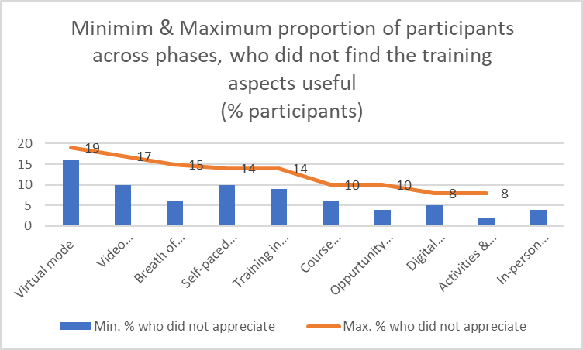
- In-person mode: Between 96% and 100% of teachers, school heads, KRPs and SRPLs found it useful that the programme was conducted in the in-person mode in phase 1.0.
- Virtual mode: That the training was virtual in phase 2.0. and 3.0., obviating the need to travel to the training venue, was found to be useful by between 81% and 84% of the participants.
- Self-paced learning: The feature of self-paced-learning in phases 2.0. and 3.0. was found to be useful by between 86% and 90% of the participants
- Course assessments: Course assessments were a part of phases 2.0. and 3.0. Between 6% and 10% of the participants were either not sure of the usefulness of course assessments or had not found them useful.
- Digital certification: Between 92% and 95% of the participants found the feature of digital certification ( phases 2.0. and 3.0.) as being. useful
- Training in Telugu: The usefulness of the training being in Telugu was asked in phase 1.0. Between 86% and 91% of the participants
- Activities & Assignments: Between 92% and 98% participants found the activities and assessments to be useful.
- Video sessions by NCERT National Resource Group members: Between 83% and 90% participants found it useful that NCERT NRG members’ video sessions were included in the training.
- Wide breath of concepts: Between 85% and 94% participants found the wide breath of concepts covered in the training to be useful.
- Revisiting training material: Between 90% and 96% participants found the opportunity to view/listen to the videos/refer material multiple times as being useful

Inter-sector and inter-school management analysis
In the foregoing sections of this chapter, the findings have been presented across different aspects such as the processes involved in the implementation of NISHTHA in Telangana, the usefulness of the modules and key conclusions and recommendations of the participants for future TPD programmes etc.
An analysis has been carried out to understand if there have been variations in the usefulness of the concepts covered in the programme across teachers from different school managements and sectors ((primary, upper primary and secondary). The findings of this analysis are discussed in this section.
Participants of Phase 1.0., covering teachers from primary, upper primary and secondary schools were given a proposition that NISHTHA has helped them become more acquainted with using ICT for teaching and learning and were asked to convey their agreement with the proposition on a 5-point-scale.
Of the 1,852 teachers from secondary schools, 72% agreed with the proposition and a further 23% strongly agreed with it. Seen across the different school managements in the secondary schools viz., GHS, ZPHS, TSMS and KGBV, a similar response trend is seen, with the proportion of teachers from these schools agreeing with the proposition being between 72% and 75%, while that of teachers strongly agreeing with it being in the range of 22% to 24%.
Of the 1,171 teachers from the upper primary schools, 76% of teachers agreed and a further 19% strongly agreed with the proposition. The cumulative proportion of both these responses is 93% in the case of GUPS and 95% in the case of MPUPS. Between these 2 school managements, MPUPS teachers appear to have found stronger usefulness from the programme, with 19% of them strongly agreeing with the proposition against the corresponding proportion for GUPS being 12%.
Of the 4,546 teachers from the primary schools, 75% agree and 20% strongly agree with the proposition. The proportion of teachers strongly agreeing with the proposition is higher for MPPS (21%) as compared to GPS (18%).
The above analysis has been carried out for a number of other aspects covered in NISHTHA modules. The following table summarizes the findings in this regard:

Table 20: School Management & Sectoral Break-up of Usefulness of Training
Phase | Concept/s imparted | How was it received? | School Management & Sectoral Break-up of usefulness  (% Teachers)
Phase | Concept/s imparted | How was it received? | Primary |  |  | Upper Primary |  |  | Secondary
Phase | Concept/s imparted | How was it received? | G  P  S | M  P  P  S | O  V  E  R  A  L  L | GU  P  S | M  P  U  P  S | O  V  E  R  A  L  L | GH  S | Z  P  H  S | T  SMS | K  G  B  V | O  V  E  R  A  L  L
NISHTHA 1.0. | On preparing students w.r.t steps to encounter 'violence', 'harassment', 'bullying' etc. | Useful | 72 | 70 | 70 | 83 | 71 | 71 | 69 | 72 | 71 | 70 | 71
NISHTHA 1.0. |  | Very Useful | 17 | 20 | 20 | 12 | 19 | 19 | 21 | 19 | 19 | 23 | 20
NISHTHA 1.0. | Clarity about Learning Outcomes | Useful | 80 | 79 | 79 | 86 | 80 | 80 | 77 | 78 | 79 | 77 | 78
NISHTHA 1.0. | Clarity about Learning Outcomes | Very Useful | 15 | 17 | 17 | 12 | 15 | 15 | 18 | 17 | 20 | 21 | 17
NISHTHA 1.0. | Newer ideas w.r.t. pedagogy of Mathematics | Useful | 75 | 77 | 77 | 76 | 76 | 76 | 56 | 58 | 58 | 57 | 57
NISHTHA 1.0. | Newer ideas w.r.t. pedagogy of Mathematics | Very Useful | 15 | 14 | 14 | 5 | 12 | 12 | 16 | 12 | 15 | 15 | 13
NISHTHA 1.0. | Newer ideas w.r.t. pedagogy of Languages | Useful | 75 | 78 | 78 | 86 | 78 | 78 | 60 | 62 | 69 | 67 | 63
NISHTHA 1.0. | Newer ideas w.r.t. pedagogy of Languages | Very Useful | 16 | 14 | 14 | 5 | 14 | 14 | 16 | 13 | 13 | 20 | 14
NISHTHA 2.0. | Inclusive education | Useful | 75 | 48 | 51 | 45 | 50 | 50 | 45 | 45 | 37 | 39 | 44
NISHTHA 2.0. | Inclusive education | Very Useful | 0 | 42 | 37 | 45 | 47 | 47 | 51 | 52 | 61 | 58 | 53
NISHTHA 2.0. | Newer ideas related to testing of higher order skills | Useful | 50 | 6 | 74 | 45 | 71 | 70 | 66 | 66 | 67 | 63 | 65
NISHTHA 2.0. | Newer ideas related to testing of higher order skills | Very Useful | 0 | 6 | 17 | 45 | 22 | 23 | 28 | 28 | 31 | 33 | 28
NISHTHA 2.0. | Difficulty level of course assessments | Easy | 50 | 65 | 63 | 55 | 63 | 63 | 69 | 69 | 70 | 66 | 69
NISHTHA 2.0. | Difficulty level of course assessments | Very Easy | 0 | 10 | 9 | 18 | 13 | 13 | 12 | 9 | 7 | 12 | 10
NISHTHA 3.0. | Alignment of teaching with NIPUN Bharat's focus-areas | Useful | 63 | 62 | 62 | 43 | 62 | 61 | 33 | 68 | 75 | 100 | 70
NISHTHA 3.0. | Alignment of teaching with NIPUN Bharat's focus-areas | Very Useful | 29 | 29 | 29 | 50 | 30 | 31 | 67 | 29 | 25 | 0 | 28
NISHTHA 3.0. | Expanding the understanding of how children engage with language and learning | Useful | 66 | 66 | 66 | 53 | 66 | 65 | 100 | 68 | 100 | 83 | 74
NISHTHA 3.0. |  | Very Useful | 30 | 29 | 29 | 43 | 30 | 30 | 0 | 29 | 0 | 0 | 21
NISHTHA 3.0. | Ideas/concepts related to imparting pre-number skills | Useful | 63 | 63 | 63 | 33 | 62 | 61 | 67 | 56 | 75 | 83 | 62
NISHTHA 3.0. | Ideas/concepts related to imparting pre-number skills | Very Useful | 34 | 34 | 34 | 58 | 35 | 36 | 33 | 35 | 25 | 17 | 32
NISHTHA 3.0. | Difficulty level of course assessments | Very Easy | 9 | 9 | 9 | 13 | 9 | 9 | 0 | 15 | 0 | 0 | 11

Comparison of responses across modules
A comparative picture of responses of teachers and HMs across modules and phases has been in the table below.
Table 21: Comparison of responses across modules
S.  No. | Area | No. of questions |  | N |  | % Participants
S.  No. | Area | No. of questions | Phase | Total | Respondent | Phase -1 | Phase -2 | Phase - 3
1 | Competencies | 2 | 1,3 | Phase -1: 8387, Phase -3: 4357 | Teacher + HMs | Useful - 66%, Very Useful - 34% | NA | Useful- 55%, Very Useful - 40%
2 | Learning Outcomes | 2 | 1,3 | Pase -1: 8387, Phase -3: 4357 | Teacher + HMs | Reasonable Agree - 75%, Strongly agree - 18% | NA | Reasonable Agree - 74%, Strongly agree - 22%
3 | Assessments/ School Based Assessments | 2 | 1,2 | Phase -1 - 8387, Phase -2 – 3033 | Teacher + HMs | Useful - 56%, Very Useful - 39% | Reasonable extent - 62%, Significant extent - 31% | NA
4 | Teaching CWSN/ children from different backgrounds | 2 | 1,3 | Pase -1: 8387, Phase -3: 4357 | Teacher + HMs | Reasonable Agree - 74%, Strongly agree - 21% | NA | Reasonable extent - 60%, Significant extent - 31%
5 | Personal- Social Qualities | 2 | 1,2 | Phase -1 - 8387, Phase -2 - 3033 | Teacher + HMs | Reasonable extent - 66%, Significant extent - 26% | Reasonable extent - 31%, Significant extent - 50% | NA
6 | Intiatives in School Education | 2 | 1,2 | Phase -1 - 8387, Phase -2 - 3033 | Teacher + HMs | Reasonable Agree - 75%, Strongly agree - 17% | Reasonable Agree - 73%, Strongly agree - 20% | NA
7 | Literacy and Numeracy skills | 4 | 3 | 4357 | Teacher + HMs | NA | NA | Useful- 60%, Very Useful - 35%
8 | FLN (Balvatika, Vidya Pravesh, etc) | 4 | 3 | 4357 | Teacher + HMs | NA | NA | Reasonable extent - 53% Significant extent - 33%,
9 | Use of ICT | 1 | 1 | 8387 | Teacher + HMs | Reasonable Agree - 74%, Strongly agree - 20% | NA | NA
10 | Toy based Pedagogy | 1 | 2 | 2684 | Teacher | NA | Reasonable extent - 58%, Significant extent - 36% | NA
11 | Art Integration | 1 | 2 | 2684 | Teacher | NA | Reasonable Agree - 70%, Strongly agree - 22% | NA
12 | Inclusion of Gender Aspects | 1 | 2 | 3033 | Teacher + HMs | NA | Reasonable Agree -67%, Strongly agree - 29% | NA
13 | Leadership skills | 1 | 1 | 818 | HMs | Reasonable extent - 61%, Significant extent - 28% | NA | NA
14 | Teaching Pedgogy of EVS | 1 | 1 | 7569 | Teachers | Reasonable Agree -73, Strongly agree - 14% | NA | NA
15 | Teaching Pedagogy of Maths | 1 | 1 | 7569 | Teachers | Reasonable Agree -72, Strongly agree - 13% | NA | NA
16 | Teaching Pedadgogy of Language | 1 | 1 | 7569 | Teachers | Reasonable Agree -74, Strongly agree - 14% | NA | NA
17 | Teaching Pedagogy of Science | 1 | 1 | 7569 | Teachers | Reasonable Agree -63, Strongly agree - 11% | NA | NA
18 | Teaching Pedagogy of Social Science | 1 | 1 | 7569 | Teachers | Reasonable Agree -62, Strongly agree - 9% | NA | NA

Chapter 6: Insights from Significance Tests
About the chapter
The chapter discusses at length the different attributes of NISHTHA intervention across different phases for each of the stakeholders. It has explored all these dimensions of the intervention from both macro and micro perspectives which ranges from stakeholder specific perspective to that of a district. The objective of this section is to gauge the effectiveness of the overall intervention in each phase. Given the objective, the discussion in this chapter pivots around specific inputs or attributes of the intervention and outputs of the intervention. The current section will summarize the phase 1, 2 and 3 interventions by answering questions like (1) how effective various inputs have been in terms of output generation, (2) which inputs was most effective and (3) what is the scope of improvement for future intervention.

Key aspects of Significance Tests

Inputs and Outputs
In order to summarize the effectiveness of the intervention, the classification of inputs and outputs for each phase is as shown in the table below:
Table: 22: List of inputs and outputs across 3 phases of intervention
Input | (1) internet connectivity, (2) Delay in sharing QR code, (3) medium of instruction, (5) duration of notice , (4) count of information modes,
Output | (1) comfort of using NISHTHA modules, (2) number of navigation means used, (3) courses completed, (4) platform experience, (5) Usefulness of overall aspects of program(6) appreciation for overall aspects of program (8)Problems faced
* Problem faced is an intermediary output which can also affect and get affected in the process of change.

Effectiveness of the intervention attributes are gauged from perspectives of exploratory analysis. Hypothesis underlying such exploration assumes that each attribute of the intervention is likely to produce some positive change in at least one of the expected outcomes. Though "change" per se cannot be ascertained from the type of data available, tests were applied for "association" and "difference between groups". Test of association include both parametric and non-parametric statistics, namely, Pearson correlation, Mann-Whitney and Kruskal Wallis. To test between group difference, ANOVA has been applied for select variables. Individuals who opted for a specific Likert scale as their response have been clubbed together into a specific group. Accordingly, the number of "groups" vary across questions.

Hypotheses
Following were the hypotheses:
A. Delay in sharing QR Code: Advance sharing of QR codes will produce better outputs
If the QR code are received in advance, teachers will start some preparatory work like exploring DIKSHA App/website if doing for the first time, will work on navigation skills, discuss with fellow teachers for gaining better understanding about the course and overall will have better learning experience
B. Count of information modes: Greater the modes of information sharing, better would be the intervention output
C. Follow-up regarding status of course completion: More follow-ups, better is the course completion rate
With more frequent follow-ups, the teachers will try to explore more, report more technical issues, complete more courses, and will be in a better position to critique the overall training aspects.
D. Internet connectivity: Better the connectivity greater would be the intervention output

Phase-wise effectiveness of inputs
Key takeaways within phase 3 are explored only from the perspective of inputs and outputs. Given the hypotheses, effectiveness of inputs is gauged based on the extent of significant relationship each input is found to exhibit vis-a-vis total number of outputs post-intervention. To understand the overall effectiveness of inputs it is important to assess the relationship between inputs and outputs of the intervention. This is discussed in the following section. This is followed by a summary on the effectiveness.

Effectiveness of inputs within phases of intervention:
  - Effectiveness of sharing notice, guidelines and QR code prior to course: Sharing of notices, guidelines and QR codes are important for preparing participants for a course and hence need to be shared in advance. Though the majority of the participants have received these in advance, discussions in previous chapters have shown that there has been variations across phases and stakeholders. The following three tables disintegrate the effect of delay in each of these inputs on various outputs. A delay has been associated with a significant negative effect on the number of courses completed, number of ways of learning navigation, number of material found useful and number of aspects of the intervention found useful. Though the effectiveness varies across phases and stakeholders, timing of sharing of notice, guidelines and QR code tend to have impacted teachers more than the HMs.
  - Timing of sharing critical information emerged significant to very few outputs for HMs, across phases, as compared to Teachers. Timing of sharing notice tends to be as important for teachers as for HMs. In phase 3, delay in sharing of notice implies lesser means of navigation explored by HMs (average of 3.9) than those who received an advance notice (an average of 4.2).
  - On the other hand, in phase 1, delay in sharing of notice has resulted in a lesser number of course completion among HMs (average of 8.2 courses) than those who received an advance notice (average of 9.6 courses). Teachers who received notice in advance, on an average completed significantly more courses (7.3) in phase 1 and explored more ways of learning navigation in both phase 2 (4.1) and 3 (4.1) than those who faced delay in receiving the notice (average of 6.8, 3.9 and 3.9 respectively).
  - Similarly timing of sharing guidelines emerge more effective for teachers than for HMs. Teacher specific outputs are more impacted by timing of receiving guideline than the HM specific outputs. Delay in receiving program guidelines tends to reduce the course completion rate for both teachers and HMs in phase 1. On an average, teachers completed 5.7, 6.5 and 7.2 number of courses when guidelines were not shared/shared after the course completion, in between the course and before the course initiated, respectively. Similarly for HMs the average completion of courses was 6.7, 7.9 and 8.9 respectively.
  - Apart from course completion, teachers in phase 1 tend to appreciate the usefulness of training material and various training aspects with advance sharing of course guidelines. The average number of training material and aspects of the training program found useful by teachers was much higher when the guidelines were shared before the initiation of the course (6.5 and 5.6, respectively) than when the guidelines were shared in the middle of the course (6.3 and 5.4, respectively ) and after the course completion or not shared at all(6 and 5.3 respectively).
With regard to online training (phase 2 and 3), delay in sharing QR codes with participants tends to enhance the number of technical difficulties of accessing the content. On an average technical difficulties perceived by HMs in phase 2 increases from 2.2 to 2.8 with a delay in sharing of QR codes. Similarly, in phase 3, on an average teachers perceive 2.4 and 2.51 difficulties when QR code is shared in advance as against when it was delayed, respectively. On the other hand, teachers on an average in phase 3, tend to explore more ways of learning navigation (4.02) with advance sharing of QR codes than with a delay (3.82). In addition to the results discussed, a chi-square test of independence was calculated comparing experience of liking DIKSHA learning platform between respondents who received QR-code in advance vis-a-vis those who received it late. A significant interaction was found among HMs in phase 2 (χ2(2)=7.02, p<0.05) and among teachers in phase 3 (χ2(2)=21.69, p<0.05). HMs who found the application easy or very easy were more likely to get the QR in advance of at least 15 days (80%) than those who did not (42%).
In phase 3, apart from 806 teachers who reportedly did not find any difficulty with the DIKSHA platform since they were well-versed with online content, majority of the remaining teachers (73 %) learnt to cope with the difficulty of handling online content. The chi-square results show that lack of delay in sharing QR-code can play an important role in helping teachers learn to cope with difficulties of online learning. Teachers who learnt to cope with their online difficulties were more likely to get the QR code prior to the training dates (63%) than those who did not (55%).

Table 23: Variation in outputs by the delay in receiving notice about course
Stakeholder | Notice received about course (Input) | Output | N | Mean* | Output | N | Mean* | Output | N | Mean*
Stakeholder | Notice received about course (Input) | Phase 1 |  |  | Phase 2 |  |  | Phase 3
Teachers | Less than 15 days | Number of courses completed | 5878 | 6.8 | Number of ways of learning navigation | 1970 | 3.9 | Number of ways of learning navigation | 2462 | 3.9
Teachers | at least 15 days | Number of courses completed | 1691 | 7.3 | Number of ways of learning navigation | 714 | 4.1 | Number of ways of learning navigation | 1093 | 4.1
HMs | Less than 15 days | Number of courses completed | 656 | 8.2 |  |  |  | Number of ways of learning navigation | 567 | 3.9
HMs | More than 15 days | Number of courses completed | 162 | 9.6 |  |  |  | Number of ways of learning navigation | 235 | 4.2
*Significant at p=0.05

Table 24: Variation in outputs by delay in receiving guideline about course
Input | Teachers |  |  |  |  | HM
Delay in guideline shared (Input) | Output |  | N | Mean* |  | Output |  | N | Mean*
Delay in guideline shared (Input) | Phase 1
not shared/after course | # training aspects useful | 673 |  |  | 6.005944 | #courses completed | 100 |  |  | 6.7
once started | # training aspects useful | 1148 |  |  | 6.309233 | #courses completed | 115 |  |  | 7.9
shared before course | # training aspects useful | 5748 |  |  | 6.502958 | #courses completed | 603 |  |  | 8.9
not shared/after course | #courses completed | 673 |  |  | 5.690936 | #courses completed |  |  |  | 8.9
once started | #courses completed | 1148 |  |  | 6.516551 | #courses completed |  |  |  | 8.9
shared before course | #courses completed | 5748 |  |  | 7.160926 | #courses completed |  |  |  | 8.9
not shared/after course | # aspects useful (61) | 673 |  |  | 5.31055 | #courses completed |  |  |  | 8.9
after course started | # aspects useful (61) | 1148 |  |  | 5.404181 | #courses completed |  |  |  | 8.9
shared before course | # aspects useful (61) | 5748 |  |  | 5.589248 | #courses completed |  |  |  | 8.9
* Results Significant at p<0.05

Table 25: Variation in outputs by the delay in receiving QR code
Stakeholder | Delay in QR code (Input) | Output |  | N | Mean* |  | Output |  | N | Mean*
Stakeholder | Delay in QR code (Input) | Phase 2 |  |  |  |  | phase 3
HM | QR code received in advance | Technical problems | 270 |  |  | 2.2
HM | Delayed | Technical problems | 79 |  |  | 2.8
Teacher | QR code received in advance | - | - |  |  | - | Technical problems | 2,211.00 |  |  | 2.36
Teacher | Delayed |  |  |  |  |  |  | 1,344.00 |  |  | 2.51
Teacher | QR code received in advance | - | - |  |  | - | Number of ways of learning navigation | 2,211.00 |  |  | 4.02
Teacher | Delayed |  |  |  |  |  |  | 1,344.00 |  |  | 3.82
* Results Significant at p<0.05

- Effectiveness of sharing information through multiple channels: Sharing information through multiple channels acts as multiple reminders to stakeholders. Table below shows the effectiveness of a diverse channel of informing participants in terms of better platform experience and overall feedback. Teachers who found the DIKSHA platform easy or very easy had on an average higher number of communication modes both in phase 2 and in phase 3 (average of 2.8 in each phase) as against those who had a difficult or very difficult experience with the platform (average of 2.5 and 2.6 in phase 2 and 3 respectively). Similarly, for HMs, it is noted that those who had an easy or very easy experience with DIKSHA platform, on an average had significantly greater modes of communication (average of 3.4 and 2.9 in phase and 3 respectively) than those who had a difficult or very difficult experience (average of 2.9 and 23 in phase 2 and 3 respectively). In terms of overall feedback, having a diverse mode of communication emerged significant only for teachers in phase 2 and 3. Teachers with good or very good overall experience had significantly higher means of communication in both phase 2 and 3 (average 2.8 in both phases) as compared to those who had bad or very bad experience (average of 2 and 1.9 in phase 2 and 3 respectively). Mode of communication did not emerge significant for offline mode of training.

Table 26: Variation in outputs by number of different modes of receiving information
Stakeholder | Output | N | Mean* | Output | N | Mean*
Stakeholder | Phase 2 |  |  | Phase 3
HM | Difficult platform experience | 27 | 2.9 | Difficult platform experience | 58 | 2.3
HM | Easy platform experience | 300 | 3.4 | Easy platform experience | 679 | 2.9
Teacher | Difficult platform experience | 158 | 2.5 | Difficult platform experience | 241 | 2.6
Teacher | Easy platform experience | 2358 | 2.8 | Easy platform experience | 3079 | 2.8
* Results Significant at p<0.05

- Follow-up regarding status of completion : The significance of followup has been perceived throughout offline and online modes of training. Table below summarizes the aspects that emerge to have a significant relationship with follow-up. In phase 1, follow-up has emerged to be an important component of training only for teachers. Teachers who reported to have experienced 5-day follow-up, have reportedly, on an average, completed more number of courses (7), found greater aspects of the useful (Q55: 6.4 and Q61: 5.6) as against their counterparts who did not have as frequent a follow-up. It is interesting to note that followup failed to be of any significance for HMs in phase 1. In the online phases, follow-up was more critical for HMs than for teachers. HMs with more frequent follow-ups tend to have explored diverse means of learning about navigation in both phase 2 and 3. In phase 2, HMs with more frequent followups tend to experience more technical problems. This could indicate that owing to frequent follow-ups HMs are better engaged and hence experiencing more problems.
Table 27: Variation in intervention output by follow-up in Phase 1
Stakeholder | 5 day followup (Input) | Output |  | N | Mean*
Stakeholder | 5 day followup (Input) | Phase 1
Teachers | No followup | Course completion | 304 |  |  | 6.1
Teachers | 5 day Followup | Course completion | 7265 |  |  | 7.0
Teachers | No followup | # Usefulness of training material | 304 |  |  | 6.1
Teachers | 5 day Followup | # Usefulness of training material | 7265 |  |  | 6.4
Teachers | No followup | # aspects useful (61) | 304 |  |  | 5.2
Teachers | 5 day Followup | # aspects useful (61) | 7265 |  |  | 5.6
* Results Significant at p<0.05

Table 28: Variation in Intervention output by frequency of follow-ups in Phase 2 and 3
Stakeholder | Frequency of followup (Input) | Output | N | Mean* | Output | N | Mean*
Stakeholder | Frequency of followup (Input) | Phase 2 |  |  | Phase 3
Teacher | no follow-up | # technical problems | 161 | 2.7
Teacher | At least once a month | # technical problems | 768 | 2.5
Teacher | At least once a fortnight | # technical problems | 450 | 2.6
Teacher | Every week | # technical problems | 1305 | 2.3
Teacher | no follow-up | Navigation | 161 | 3.2 | Navigation | 478 | 3.2
Teacher | At least once a month | Navigation | 768 | 3.8 | Navigation | 1474 | 3.9
Teacher | At least once a fortnight | Navigation | 450 | 4.1 | Navigation | 665 | 4.1
Teacher | Every week | Navigation | 1305 | 4.1 | Navigation | 938 | 4.3
HM | no follow-up | # navigation learnt | 13 | 3.5 | # navigation learnt | 116 | 3.5
HM | At least once a month | # navigation learnt | 77 | 3.5 | # navigation learnt | 326 | 3.8
HM | At least once a fortnight | # navigation learnt | 79 | 4.6 | # navigation learnt | 148 | 4
HM | Every week | # navigation learnt | 180 | 4.4 | # navigation learnt | 212 | 4.6
* Results Significant at p<0.05

Internet connectivity: Internet connectivity has emerged to be one of the critical inputs in the successful delivery of the program. Better internet connectivity is associated with lesser technical problems and exploration of diverse means of navigation. In phase 2 and 3 HMs with slow or very slow connection, on an average, experienced 3.6 technical problems while those with fast or very fast internet experienced an average of 1.4 and 1.6 technical problems, respectively. Similarly, teacher in phase 2 and 3 experienced lesser number of problems on average (1.9 and 1.6 respectively) if they had a faster connection than those with slower connectivity (3.5 and 3.6 respectively). Apart from this, teachers from both phase 2 and 3 explored greater numbers of navigation with a faster internet connection (4 and 4.1 respectively) than those without (3.8).

Table 29: Variation in outputs by variation in internet connectivity
Stakeholder | Internet connectivity (Input) | Output |  | N | Mean* |  | Output |  | N | Mean*
Stakeholder | Internet connectivity (Input) | Phase 2 |  |  |  |  | phase 3
HM | Slow | Technical problems | 60 |  |  | 3.6 | Technical problems | 160 |  |  | 3.6
HM | Satisfactory | Technical problems | 222 |  |  | 2.3 | Technical problems | 512 |  |  | 2.3
HM | Fast | Technical problems | 67 |  |  | 1.4 | Technical problems | 130 |  |  | 1.6
Teacher | Slow | Technical problem | 477 |  |  | 3.5 | Tech Problems | 682 |  |  | 3.5
Teacher | Satisfactory | Technical problem | 1765 |  |  | 2.3 | Tech Problems | 2315 |  |  | 2.3
Teacher | Fast | Technical problem | 442 |  |  | 1.9 | Tech Problems | 558 |  |  | 1.7
 | Slow | Navigation | 477 |  |  | 3.7 | Navigation | 682 |  |  | 3.7
 | Satisfactory | Navigation | 1765 |  |  | 4 | Navigation | 2315 |  |  | 4
 | Fast | Navigation | 442 |  |  | 4 | Navigation | 558 |  |  | 4.1
* Results Significant at p<0.05

Table 28 summarizes all the stronger correlations that emerged statistically significant. Course completion emerges to have a significant association with all the select inputs as mentioned in table 28 for both teachers and HMs in all the phases. While all the associations are very weak, the correlation between course completion and types of support received are above 0.3 for both Teachers and HMs in phase 1.
Few correlation that emerge with stronger correlations are those pertaining to the number of navigations learnt by stakeholders. This particular output exhibits strongest correlations with two inputs,namely, modes of information (0.4643 for teachers and 0.5011 for HM in phase 2, & 0.4256 for teachers in phase 3) and number of persons from whom stakeholder received support in the duration of the training (0.4797 and 0.4873 for teachers and HM in phase 2 and 0.4815 and 0.4801 for teachers and HMs in phase 3).
Table 30 : Correlation between various inputs and outputs of NISHTHA across phases
 | Modes of information | # support persons | #types of support
Course completion |  |  | T1- 0.3167  H1- 0.3320
Number of ways of learning navigation | T2- 0.4643  H2- 0.5011  T3- 0.4256 | T2- 0.4797  H2- 0.4873  T3- 0.4815  H3- 0.4801

Effectiveness of intervention across Districts
This section tries to understand the effectiveness of inputs at the district level. The importance of followup by higher officials is extremely important for a successful completion of a state program. In the case of NISHTHA, its importance is perceived not only at the level of stakeholders but also at the level of districts. As seen from table 8, follow-up is the only aspect that emerges significant across stakeholders across phases. Though the results are not generalisable for all stakeholders across phases, it is evident that districts with reportedly more follow-up have also experienced greater average course completion among teachers and HMs. The correlation between the two emerges to be significant (teachers in phase 1: 0.3602, teachers in phase 2: 0.48). Apart from course completion, follow-up has also emerged to be positively associated with overall training experience to be perceived to be atleast good at the level of districts in phase 3. In other words, districts with a greater proportion of HMs receiving a follow-up in phase 3 have witnessed a greater proportion of HMs reportedly finding the NISHTHA experience to be at least good. On the other hand, the districts with lesser number of HMs being given a follow-up in phase 2 , are also the ones which reportedly witnessed more number of technical problems on average among the HMs.
With regard to other inputs, availability of support persons emerge to be significant for course completion at the district level. It has a very strong correlation (0.7876) with the course completion rate. Districts with more people available to support participants , on an average, witnessed higher completion of courses in phase 1. This is followed by the relation between significance of sharing guidelines prior to initiation of the course and technical problems experienced by stakeholder at the district level in phase 1. A strong negative relationship (-0.5112) is witnessed between the two, stating that districts with more persons available to support HMs, are the ones to also witness significantly less average problems. The relationship between fast internet connectivity and technical problems emerge to be strong(-0.4196) for teachers in phase 2. Districts with more teachers having a fast or reasonably fast connection are also the ones to experience lesser problems in completing the courses. On similar lines, delay in sharing QR codes emerged to be negatively correlated with course completion rate (-0.3921) among HMs at the district level in phase 2. Districts which have a greater proportion of HMs with delayed receipt of QR code are the ones to have poor course completion on average.

Table 31: Effectiveness of inputs at the level of districts
 | Stakeholders with followup done | Average support persons available | Stakeholders with guideline in advance | Stakeholders with delayed sharing of QR codes | Stakeholder with fast or reasonably fast internet connection
Average Course completion | T1: 0.3602  T2: 0.48 | T1: 0.7876 |  | H2: -0.3921
Average Technical problems | H2: -0.3673 |  | H1: -0.5112 |  | T2: -0.4196
Overall training experience being good or very good | H3: 0.3666
* Results significant at p<0.05

Chapter 7: NISHTHA Scorecard
About the chapter
Based on the findings and facts of the programme, this chapter presents a scorecard, with ratings being given to various components.
Abstract
Training Aspect | Locus of control | Max. Marks | Marks Awarded
Design | NCERT | 15 | 1.67
Content | NCERT | 15 | 7.5
Training delivery | SCERT | 15 | 11.01
Participants’ self-reported utility | NCERT/SCERT | 15 | 14.01
Implementation of training gains by participants | NCERT/SCERT | 15 | 2.56
Grand Total |  | 75.00 | 36.75

D E S I G N
Indicator | Locus of control | Indicator marks (Max.) | Marks awarded to NISHTHA | Justification/basis for marking
State identifes training needs/State's training needs are factored-in | NCERT | 2 | 0 | State's role was limited to translation and execution. No role for state/no scope for state innovations in the larger training cycle.
State designs/co-designs curriculum & content | NCERT | 2 | 0
State designs/co-designs pedagogy | NCERT | 2 | 0
Teachers/SLs were able to choose courses as per their interest | NCERT | 2 | 0 | All courses of NISHTHA were mandatory
Stipulated KRP-Teacher ratio is practicable | NCERT | 3 | 1 | Stipulated KRP: Teacher ratio was 1:110, which is practicable, allowing each KRP to train approx. 2 batches of 60-70 teachers each. However, this was stipulated only for Phase 1.0., without any role stipulated for KRPs in Phases 2.0. & 3.0. ( 1 mark per NISHTHA phase)
Social learning platform & sharing of substantive experiences related to teaching practice | NCERT | 2 | 0.67 | NISHTHA guidelines for 1.0. suggest mentoring mechanism through whatsapp groups. However this was not stipulated for phases 2.0. & 3.0. (0.67 mark per NISHTHA phase)
Ease of monitoring implementation | NCERT | 2 | 0 | LMS reports did not facilitate ease of monitoring the implementation, as detailed in conclusions note.
Design Subtotal |  | 15 | 1.67

C O N T E N T
Indicator/s to measure parameter | Locus of control | Indicator marks (Max.) | Marks awarded to NISHTHA in Telangana | Justification/basis for marking
Content is authentic | NCERT | 2 | 2 | Module content is authentic as mainly NCERT documents have been used as references in all the modules
Learning objectives are clear | NCERT | 2 | 2 | All modules/courses have clear learning objectives and there is alignment between the content and activities and the learning outcomes
Content, activities & LOs are in alignment | NCERT | 2 | 2
Research-based literature citations/additional readings | NCERT | 2 | 0.5 | Research-based literature/s have not been cited as references or provided as additional reading in any of the modules /courses and only a few modules/courses provide additional web-based resources.
Theory-practice connect | NCERT | 3 | 0 | Opportunities to connect theories with teachers practice are minimal
Platform has features of courseware | NCERT | 2 | 0.5 | The module has very few interactive elements
Activities provide for reflection in local contexts | NCERT | 2 | 0.5 | Implementing in school and understanding theory vis-a-vis the local contexts is minimal
Content Subtotal |  | 15 | 7.5

T R A I N I N G D E L I V E R Y
Indicator/s to measure parameter | Locus of control | Indicator marks (Max.) | Marks awarded to NISHTHA | Justification/basis for marking
Compliance of KRP-Teachers/SLs ratio in Phase -1 as stipulated by NCERT | SCERT | 2 | 2 | NCERT stipulated 110-130 teachers per KRP. Telangana had 887 KRPs for 94,547 teachers, making the ratio 1: 110
Formation/use of WhatsApp/ Telegram Groups for circulating training related information | SCERT | 1 | 1 | Groups formed in all districts (Marks scheme: All districts- 1 marks, Upto 70% districts - 0.7 marks, Upto 50% districts - 0.5 marks, Upto 30% districts - 0.3 marks, Less than 30% - 0)
Experience of using App | SCERT | 3 | 2.67 | 89% teachers and SLs Phase -1, Phase -2 and Phase -3 mentioned that the platform experience was 'Easy' or 'Very Easy'. (Marks scheme: 89% of 3 marks)
Regularity of follow-ups | SCERT | 3 | 2.11 | 36% Teachers and SLs who attended either Phase 2 or Phase -3 have had weekly follow-ups, 17% fortnightly follow-ups, 35% monthly followups & 10% no follow-up. (Marks scheme: Weekly/Fortnightly = 3 marks, Monthly = 1.5, > month = 0.5 , No follow-up=0)
Support provided during training | SCERT | 3 | 2.98 | Only 0.7% teachers and SLs across all phases had not received the support sought. Marks scheme: (>85% = 3 marks, 75%-84% = 2, 50 - 74% = 1, <50% = 0)
Pedagogic discussion and peer learning on social learning platform | NCERT/SCERT | 3 | 0.25 | Evidence (from f2f interviews) of such discussions having happened is not strong. (Marks scheme: 1 per NISHTHA phase)
Training Delivery Subtotal |  | 15 | 11.01

T E A C H E R S' / S L S' S E L F - R E P O R T E D U T I L I T Y F R O M P R O G R A M M E
Indicator/s to measure parameter | Locus of control | Indicator marks (Max.) | Marks awarded to NISHTHA in Telangana | Justification/basis for marking
Teachers'/SLs' self-reported utility from programme | NCERT/SCERT | 15 | 14.01 | 93.4% Teachers and SLs in the online survey found the training at least reasonably useful (Marks scheme: 93.4% of 15 marks)
Self-reported utility Subtotal |  | 15 | 14.01

I M P L E M E N T A T I O N B Y T E A C H E R S OF T R A I N I N G G A I N S
Indicator/s to measure parameter | Locus of control | Indicator marks (Max.) | Marks awarded to NISHTHA in Telangana | Justification/basis for marking
Timing of the online phases of NISHTHA | NCERT | 3.00 | 1.00 | Phases 2.0. and 3.0. were conducted during lockdown - it was unclear how long it would take before the schools reopened & as it turned out, schools did not reopen for several months after the training. As such the timing of phases 2.0. and 3.0. were by design not amenable to immediate post-training implementation. (Marks scheme: 1 mark per NISHTHA phase for timing the training appropriately)
Post-training support | NCERT/SCERT | 6 | 1.56 | 26% of teachers and SLs from all phases have reported having received post-training support. (Marks scheme: 26% of 6 marks)
Implementation by teachers of training gains | NCERT/SCERT/Force Majeure | 6 | 0 | Most teachers we interviewed have said that post training implementation has not been possible because of lockdowns and even after schools reopened, the focus has been on bridging learning loss and as such, they have not been in a position to implement concepts learned in NISHTHA
Implementation by teachers of training gains |  | 15.00 | 2.56
Grand Total |  | 75.00 | 36.75

Chapter 8: Conclusions and Recommendations
About the chapter
This chapter concludes the report and presents the recommendations.

Conclusions & Recommendations on Design
- Centralized Model: NISHTHA was a completely centralized model of continuous professional development (CPD), with little or no role for states in terms of identifying training needs, designing training curriculum & content, deciding training pedagogy etc. For a state like Telangana, with a dynamic and active SCERT and a proactive and enterprising State Resource Group (SRG) of Teacher Educators having rich experience of conducting large scale CPD programmes, it’s role being limited to implementation, without being able to contribute to the aforementioned broader aspects of the training cycle , as has happened in NISHTHA, was not the most optimal CPD option.
- Choice of courses: Despite the large basket of courses in NISHTHA, all courses were mandatory. It is likely that teachers not interested in or not in need of a course would have had to nevertheless undergo it, even if perfunctorily, yielding low returns to their time on one hand and negligible translation of gains to classroom implementation, on the other. Genuine cases in this category would include, for instance, teachers/school heads desirous of skipping a course because of having already undergone a similar course in the past and/or because of significant classroom/school experience in the course-area.
- Fidelity of NRG-SRG-Participant Model: NISHTHA model was premised on the critical layer of SRG, who after having been trained by the National Resource Group (NRG), were envisaged as training facilitators for the participant teachers and school heads in the State. While this model was followed in Phase -I (face-to-face training), its fidelity was not maintained for Phases II & III (online phases) of NISHTHA, leaving the teachers and school heads without the critical intermediating layer of SRGs.
- App.: The design of NISHTHA and DIKSHA apps, which were the principal vehicles, (esp. DIKSHA) for training during NISHTHA online phases, enable easy navigation. 89% participants in the online survey, conducted as part of this study, found the navigation of NISHTHA App/DIKSHA App. easy. There is however room for improvement, for instance, by way of dispensing with and coming up with an alternative to the requirement of role-based-registration, requiring a teacher/SCERT official playing multiple roles (training participant, course creator etc.) to register separately for each such role.

Recommendations on Design:
  - Leaving the teachers and school heads to navigate online courses entirely by themselves, without facilitation by senior teachers/mentors/experts, is not the most effective CPD option. In order for CPD programmes to be effective, it is important to maintain human interaction – both, (a) between facilitators and participants and (b) among the participants.This must be ensured for CPD programmes Telangana will invest in, in the future.
  - In the online survey, 83% of the participant teachers and school heads recommended blended mode (mix of in-person & virtual modes) for CPD programmes to be undertaken in the future. In comparison, face-to-face training mode received recommendation from 70% and completely online training mode, from only 47% of the online survey participants. Telangana may therefore consider blended mode of CPD, going forward.
  - By virtue of the rich in-house professional competence in Telangana, as discussed at para 1 above, the State must invest in such CPD programmes which provide for utilization & further nurturing of State’s CPD expertise, enabling thereby the addressal of contextualized training needs of Telangana teachers and school heads. State must choose to have a say in, actively decide on and contribute to all aspects of CPD - training needs, curriculum, pedagogy etc. so that the State maximizes returns from training investments (financial as well as teachers’ time), by addressing capacity gaps specific to teachers and school heads in Telangana.
  - When a large basket of CPD courses are being offered (like in NISHTHA), it would be useful to provide teachers and school heads with an option to choose the courses they wish to sign-up for, with a minimum number of courses to be taken, stipulated, if necessary. Such a choice-based-approach is more likely to be aligned to addressing the felt-training-needs of the participants as compared to making all courses being offered mandatory. It would be useful to build a competency-based framework for CPD such that educationists choose what competency they would wish to build on and choose appropriate courses that are mapped to those competencies.
  - The road map of career growth (both horizontal and vertical) could also be an added component that would aid informed decision making and improve engagement in the courses. Thus, teachers interested in expanding their roles and responsibilities in their current position such as being a part of the State Resource Group (SRG) or moving up the ladder of hierarchy to becoming HMs or such would pick courses according to the selected career pathway they are interested in.

Conclusions & Recommendations on Content:
- Content authenticity & LOs: Module content is authentic and mainly NCERT documents have been used as references in all the modules. Sample lessons have been given. All modules/courses have clear learning objectives and there is alignment between the content and activities and the learning outcomes. An emphasis has been placed on teacher’s understanding of competency-based assessment and a focus on linking teaching to student’s learning outcomes.
- Inclusion focus: There is overall focus on inclusion, creating inclusive learning environments, recognising diversity in the classroom, teaching-teaching for students with special needs and gender sensitivity
- KRP Section: Most of the modules/courses have a section at the end for the Key Resource Persons on tips on how to facilitate the module with teachers
- Course Outlines: While NISHTHA 2.0. and NISHTHA 3.0. courses have clearly defined course outlines, this appears to be missing in the initial NISHTHA 1 modules, as they were not designed keeping online learning in mind. Creating an index for the NISHTHA 1.0 modules will make it more readable.
- Research-based literature: Research-based literature/s have not been cited as references or provided as additional reading in any of the modules /courses and only a few modules/courses provide additional web-based resources.
- Overview vs. practice-centric approach: The overall objectives of the modules/courses would provide a broad overview of the topic addressed; in-depth understanding of the topic to transform teachers’ knowledge, attitudes and practice would require engaging with teacher’s attitudes/beliefs, a more practice - based pedagogical approach to teacher education and greater support in schools.
- Textbooks vs. Courseware: These modules are developed more like textbooks and not as courseware, many more features leveraging digital technology that includes discussions, activities, tasks and assessments need to be integrated to develop the NISHTHA modules/courses into courseware that may be run online and facilitated by experts, for instance, for doubt solving sessions, an aspect sorely missed by many of the teachers. Developing them into courseware will also ensure coherence and interconnections among sections which is not made very explicit in many of the modules/courses. Infographics connecting units and competencies could have aided comprehension.

- Theory-Practice Connect: Core theoretical ideas are well presented; however the ideas are very general and the opportunities to connect these ideas to specific contexts, cultures and issues and challenges that arise in teacher’s contexts are very limited. Hence the theory-practice connection which is a core need of teacher professional development is missing, especially in modules that address leadership, guidance and counseling. Multilevel, multilingual, multi ability classroom contexts are not addressed adequately in the sample lessons. There is also no space explicitly mentioned for the teachers to reflect on how they could transact such lessons and tweak aspects to suit their own classroom context. While modules cannot address all these issues, the online training with a lack of discussion forum, further divided theory from practice by not facilitating reflections on practice.

Recommendations on content:
  - Research-based literature/s have not been cited as references or provided as additional reading in any of the modules /courses. Theory-practice connection which is a core need of teacher professional development needs underscoring, especially in modules that address leadership, guidance and counseling.
  - Having teachers perform a task using principles/ constructs of a course and share their reflections would have aided theory-practice connect. Such a practice-based approach would aid feedback cycles from peers/mentors either online or in small cluster/complex level groups and enable reflective improvements in practice (Moxley, et al, 2017). While sample lessons were provided, developing case studies either as videos of actual classrooms or demonstration that can act as models for teachers to see implementation of constructs would aid fidelity to programme objectives (Brock & Carter, 2017).
  - Teacher professional development requires a social learning platform and experience sharing among teachers and educators for transforming practice. Developing the content into courseware and providing a platform (like an online community of practice managed by educators & experts) for experience sharing will enable teachers to link theoretical knowledge with their context and existing practices and beliefs.

Conclusions & Recommendations on Training Delivery
- KRP-Teacher Ratio: SCERT have complied with NCERT’s stipulation of 1 KRP/SRPL for every 110-130 teachers/school heads.
- Target vs. Achievement: In phase 1.0., which happened in face-to-face mode, the participants attending the 5-day-training-programme are deemed to have completed the courses. Thus, 94,547 participants (teachers and school heads) completed phase 1.0. courses in Telangana. In phases 2.0. & 3.0., which happened online, against a target of 67,724 and 56,462 respectively, there have been 9,15,231 and 6,59, 086 course enrolments cumulatively for 12 courses in each of these phases viz. 76,269 and 62,178 participants respectively, with course completion rates ( viz. those who gave assessments) of 81.5% and 80.3% and certification rate of 78% and 77% (viz. those who secured 70% or more in assessments) respectively.
- Data management: Phase-wise, district wise data of course enrollment, course completion and certification of government and local body schools has been maintained by SCERT efficiently.
- Follow-up & ensuring participation: SCERT have mobilized teachers and school heads as per the phase-wise-targets. Besides releasing official circulars from time-to-time, SCERT have held several meetings with the district-level-functionaries to review the progress of course enrollment, course completion and certification. Follow-up was critical in the online phases of NISHTHA, especially with reference to course completion. In the online survey, nearly 90% of teachers and school heads have reported having received follow-up calls - 36% on a weekly basis; 17% on a fortnightly basis; 35% on monthly basis.
- Online phases transaction: 90% participants used mobile phones, 98% used personal data, about 65% had satisfactory internet connectivity, about 50% participants spent 3 to 4 hours to complete a course and 80% completed the courses after school hours/weekends.
- Support: SCERT has been able to mobilize the requisite support required for the participants during the training. 99.3% teachers and school heads have, in the online survey, reported having received the support they had sought during online NISHTHA phases, in terms of resolving technical glitches on DIKSHA app, self-registration, better understanding concepts etc.
- WhatsApp Groups: NISHTHA WhatsApp groups were formed in all the districts of Telangana and used mainly for communication of guidelines/instructions and resolution of technical issues.
- These groups however did not function as ‘communities-of-practice’, with pedagogical discussions between facilitators and teachers and peer learning amongst teachers. If teachers needed help, they felt more comfortable asking for this one-on-one with known SRGs/senior peers than in the larger WhatsApp groups. This added to parallel channels of communication hindering monitoring of how much effort was going into scaffolding learning.
- Monitoring Mechanism:
  - SCERT was to monitor the district and sub-district level implementation of NISHTHA, through the online monitoring platform developed by NCERT/GoI. The reports generated from this platform only gave district aggregates for course progress by teachers/school heads, without providing for monitoring teacher/school head wise course completion status. As such, SCERT and District Educational Officers could not channelise their monitorial energies in a pointed manner - monitoring NISHTHA Phase II & III entailed reviewing everyone, every time. Being able to selectively monitor teachers/school heads who were yet to complete the courses may have been a more effective use of their time and effort.
  - NISHTHA online courses were open for enrolment even by teachers in the private sector and from other States. Consequently, the overall enrolment figures went up for Telangana with such private sector teachers’/other state teachers’ enrolment. However, SCERT had no means to follow-up with them – thus, when teachers from these categories did not complete the course, the course completion rate of the state suffered. However, remedying it was not in the hands of SCERT.
- Feedback: While for Phase I, it was envisaged that the KRPs would take teachers’/school heads’ feedback, for Phase II & III, the State’s were to devise their own mechanism to take participants’ feedback. Among other things, the problem of not having individual participant details came in the way of SCERT collecting the feedback.
Recommendations on training delivery:
The problems discussed at para i(i), i(ii) & j could have been resolved with a unique identity being provided to every participant, which was missing in NISHTHA. It is especially important for large scale CPD programs like NISHTHA to have this feature included in the program and provide these to implementing agencies (SCERT), which are tasked with monitoring the roll-out of the program.
- To enable effective monitoring, adequate LMS controls should be vested with the implementing agencies (SCERT, in the case of NISHTHA). They should be able to generate the requisite reports at desired frequency, without having to depend on NCERT/GoI for such reports.
- Reporting mechanisms of help needed, sought and given would aid design, development and delivery of newer teacher development modules.
- Communities of practice, as an ongoing mechanism for peer learning, must be ensured in all CPD programmes. The COPs must be anchored by Teacher Educators/mentors/experts and have a design principle on how to engage teachers and facilitate learning and reflections, how often to post, how to scaffold learning and how to consolidate reflections and ideas shared in the CoP (Wegner et al, 2002, Thirumalai, 2022).
- Given the limitations, the analysis has tried to explore the inputs and outputs which emerged significant for the intervention in various phases. Based on the results the study would recommend that the aspects which emerged significant for a given stakeholder in a given phase, need to be emphasized more to reap greater benefits. As discussed in this chapter, it is evident that there is no standard relationship that an input has exhibited for any given output across stakeholders and/or phases. Based on such results, it is therefore difficult to generalize effectiveness of an input for any given stakeholder across phases or for all stakeholders within a phase. Therefore, recommending a standard mode of implementation, based on the results discussed above, must be avoided. In other words, while the study recommends that future implementation continues to focus on the key significant results as evident from this study, it also suggests that there is need to dwell upon possible reasons for lack of significance of a given relationship across stakeholders.
- Though the findings largely encompass stakeholder-specific and phase-specific significant results, few unique findings stand out for generalisability. For instance ease of accessing content is of utmost importance and the discussion so far points to the same. Ease of access of content, particularly in online mode, is heavily driven by good internet connection. It has emerged to have a strong impact on the overall experience and appreciation for the platform experience both by teachers and HMs. To experience better outcomes, future implementation must focus on enhancing the outreach of the content in terms of device accessibility and internet connectivity. However, with respect to internet connectivity in particular, the study finds its relevance in not only impacting outputs at the level of an individual but also at the level of districts. Hence, future implementation must consider the critical role played by internet connection as part of the design of its intervention.
- Sharing of notice and guidelines in advance of at least 1-2 weeks notice is as important as accessibility of the content. Delay in sharing notices and QR codes must be avoided. This has emerged particularly important for HM in phase 2 at the district level. As an input it is critical to address technical problems faced not only at the level of individual stakeholders but also at the level of a district.
- Role of periodic follow-up, which is well recognised by the NISHTHA program , has also emerged to be of supreme importance at the level of both individual and district. It has not only resulted in reduction of technical problems and greater course completion but has also affected stakeholders' perception about the usefulness of the training materials and the training itself. Regular follow-up will ensure that the learning process remains continuous and handholding of stakeholders carried out at regular intervals.
- Employing diverse channels of information (zoom, proceedings etc) implies multiple reminders for a stakeholder. Such practices need to be promoted to enhance the commitment of a stakeholder towards course completion.
- Last but not the least, the nature of responses show that stakeholders have a tendency to give favourable responses, in general. However, this tendency was stronger among HMs. For example though more than 80% HM completed all the courses in phase 3, their responses fail to identify the inputs that proved a significant role in attainment of such level of completion.

Conclusions & Recommendations on Implementation of training gains
- Survey feedback: Ninety-three point four (93.4) % participants in the online survey have found NISHTHA training at least reasonably useful in terms of the modules/courses covered in the training. These are cumulative responses across all the modules/courses of all the 3 phases of implementation.
- Timing: From the viewpoint that gains from training must be implemented in classroom/school, preferably soon after the training, the timing of a training programme acquires significance. NISHTHA Phases 2.0. and 3.0. were conducted during lockdown – when they were introduced, it was unclear how long it would take before the schools reopened and as it turned out, the schools did not re-open for several months after these trainings; as such the timing of phases 2.0. and 3.0. were not amenable to immediate post-training implementation.
It is thus uncertain whether the gains from the programme, as reported by the teachers and school heads in the online survey, have been converted into improved classroom/school practices.
- Pedagogic discussions and peer learning: Evidence of pedagogic discussions and peer learning having happened on WhatsApp groups created for NISHTHA is not strong.
Recommendations on implementing training gains:
  - Timing of CPD programmes must provide for immediate implementation of training gains in classroom/school.
  - There must be post-training support and supervision at the school level, with continuous feedback loops created between the teachers/school heads and the mentors/teacher educators/experts over a sustained period of time, to ensure implementation of training gains. In fact, 91% of the online survey respondents have sought this support for CPD programmes to be planned in the future.

References:
- Ball, D. L., & Forzani, F. M. (2009). The work of teaching and the challenge for teacher education. Journal of Teacher Education, 60(5), 497–511. https://doi.org/10.1177/ 0022487109348479
- Brock, M. E., & Carter, E. W. (2017). A meta-analysis of educator training to improve implementation of interventions for students with disabilities. Remedial and Special Education, 38, 133–144. https://doi.org/10.1177/0741932516653477
- Brownell, M. T., Benedict, A. E., Leko, M. M., Peyton, D., Pua, D., & Richards-Tutor, C. (2019). A continuum of pedagogies for preparing teachers to use high-leverage practices. Remedial and Special Education, 40(6), 338–355. https://doi.org/10.1177/0741932518824990
- Ericsson, K. A. (2009). Enhancing the development of professional performance: Implications from the study of deliberate practice. In K. A. Ericsson (Ed.), Development of professional expertise: Toward measurement of expert performance and design of optimal learning environments (pp. 449–469). Cambridge University Press. https://doi.org/10.1017/ CBO9780511609817
- Gunn, A. A., Peterson, B. J., & Welsh, J. L. (2015). Designing teaching cases that integrate course content and diversity issues. Teacher Education Quarterly, 42(1), 67–81.
- Mandernach, B. J., Robertson, S. N., & Steele, J. P. (2018). Beyond content: The value of instructor-student connections in the online classroom. Journal of Scholarship of Teaching and Learning, 18(4), 12–17. https://doi.org/10.14434/josotl.v18i4.23430
- Moxley, J. A., Ericsson, K. A., & Tuffiash, M. (2017). Gender differences in SCRABBLE performance and associated engagement in purposeful practice activities. Psychological Research, 83, 1147–1167. https://doi.org/10.1007/s00426-017-0905-3.
- Nagro, S. A., deBettencourt, L. U., Rosenberg, M. S., Carran, D. T., & Weiss, M. P. (2017). The effects of guided video analysis on teacher candidates’ reflective ability and instructional skills. Teacher Education and Special Education, 40, 7–25. https://doi.org/10.1177/ 0888406416680469
- Palloff, R. M., & Pratt, K. (2007). Building online learning communities: Effective strategies for the virtual classroom. John Wiley & Sons.
- Pea, R. D. (2004). The social and technological dimensions of scaffolding and related theoretical concepts for learning, education, and human activity. Journal of the Learning Sciences, 13(3), 423–451. https://doi.org/10.1207/s15327809jls1303_6
- Singh A.K., Rind I.A., Sabur Z. (2020) Continuous Professional Development of School Teachers. In: Sarangapani P.M., Pappu R. (eds) Handbook of Education Systems in South Asia. Global Education Systems. Springer, Singapore.
- Shulman, L. (1992). Toward a pedagogy of cases. In J. Shulman (Ed.), Case methods in teacher education (pp. 1–29). Teachers College Press.
- Thirumalai, B, Ramanathan, A, Charania, A, Stump, G (2019). Designing for Technology Enabled Reflective Practice: Teachers’ Voices on Participating in a Connected Learning Practice. In Teaching and Teacher Education. South Asian Perspective. Setty, R., Iyengar, R., Witenstein, M., Byker, E.J., Kidwai, H. (Eds.), Palgrave Macmillan.
- Thirumalai, B. (2022). A Study of Teachers’ Community of Practice in the Indian Context. Unpublished doctoral dissertation submitted to the Tata Institute of Social Sciences, Mumbai.
- Thirumalai, B & Sarangapani, P.M. (2018). Building Teacher Professional Communities in India: an examination of the APPEP experience of Teacher Centres. Presented in 2018 at CESI, Vadodara, India.
- Wenger, E., McDermott, R.A., Snyder, W. (2002). Cultivating Communities of Practice. Boston, MA: Harvard Business School Press
- Wenger, E. (2000). Communities of practice and social learning systems. Organization, 7: 225-246. 10.1177/135050840072002.
- Wenger, E. (1996). How we learn. Communities of practice. The social fabric of a learning organization. Healthcare Forum Journal, 39: 20-26.

[1] https://itpd.ncert.gov.in/mod/page/view.php?id=504
ELEC stands for English Language Enrichment Course, run by SCERT, Government of Telangana, as part of which a network of teacher & school head mentors and mentees was created.
K. Luneta (2012) Designing continuous professional development programmes for teachers: A literature review, Africa Education Review, 9:2, 360-379, DOI: 10.1080/18146627.2012.722395
NISHTHA Phase -1 was launched on 21st August, 2019
NISHTHA Phase -2 was launched on 29 July, 2021
NISHTHA Phase -3 was launched on 7th August 2021 by NCERT

