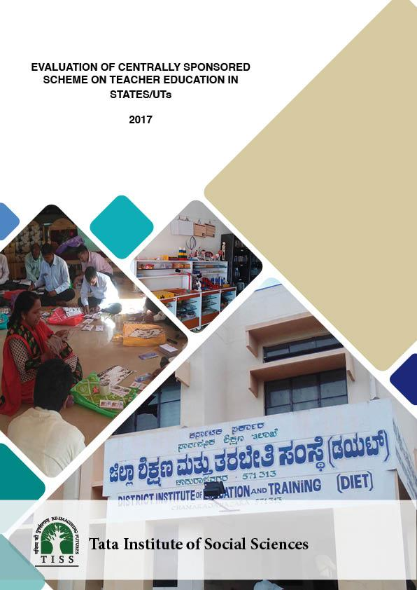

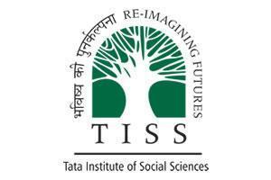
TATA INSTITUTE OF SOCIAL SCIENCES
VN Purav Marg, Deonar, Mumbai

EVALUATION OF CENTRALLY SPONSORED SCHEME
ON TEACHER EDUCATION IN STATES/UTs

Report

October , 2017

Preface

In July 2017, the Ministry of Human Resource Development initiated an evaluation study of the Centrally Sponsored Scheme for Teacher Education (CSSTE) of Government of India that is currently implemented by the Department of School Education and Literacy in 33 States/Union Territories, on a fund sharing pattern between the Centre and the States. With growing concern over the quality of education in schools, it is imperative to prepare the teachers adequately to respond to the students’ educational and emotional needs in an effective and timely manner. The CSSTE forges a Centre-State partnership to promote training of teachers of elementary and secondary education at different stages in their careers. The CSSTE which was launched in the 7th plan, has seen modifications continuously in the 8th, 9th, 10th and 11th Five Year Plans. Following its last revision in 2012 with an approved outlay of INR 6,308 crores for the next five year period, and with the scheme approaching its term completion in 2017, the MHRD sought to gauge the efficacy in the Teacher Education Institutions (TEIs) that are supported by it. The Tata Institute of Social Sciences (TISS), Mumbai took up the study of the scheme as a third party evaluator.

The Objectives and Terms of Reference (MHRD, 2017) shared by the MHRD, outlining the role of TISS as the third party evaluator of the scheme were:
Objectives:
(i) Assess the extent to which Centrally Sponsored Scheme on Teacher Education (CSSTE) has been able to achieve its objective and the factors determining the same.
(ii) Identify the constraints in the implementation of the scheme in the 12th five year plan.
(iii) Suggest revisions in the provisions of the scheme in order to meet the exceptional challenges of the State/UTs and for the effective implementation in the next plan period.
(iv) Analyze the fund flow mechanism and recommend procedures for timely and effective utilization of funds.
(v) Analyze the need to continue the scheme in the existing form or changes required in the norms both programmatic and financial for effective implementation of the scheme.
(vi) Examine the effectiveness of Teacher Education Institutions (TEIs) in terms of its envisioned role and function.
(vii) Study whether Teacher Education Institutions are functioning as per the norms and standards of the NCTE Regulations 2014.
(viii) Analyze whether Teacher Education Institutions are playing complementary and coordinated roles [sic] with other institutions at the State and District levels, for improving the quality of education and teacher education.
(ix) Any other improvements or additions to the scheme that can make it more effective and meet its objectives in today’s society and education system.

Terms of Reference
(i) To analyze extent the improvement in the quality of teacher education since the reorganization and restructuring of the Centrally Sponsored Scheme on Teacher Education in 2012 [sic].
(ii) To analyze Impact and effectiveness of teacher education provided through this scheme.
(iii) To analyze adequacy and timeliness of fund flow and delivery mechanisms.
(iv) To analyze scope of operational guidelines including cost norms and recommend modification, if any;
(v) To assess extent of coverage and linkages with other institutions at the State and district level.
(vi) To analyze effectiveness of Teacher Education Institutions in terms of its envisioned role and functions.
(vii) To justify/recommend about the continuation of the scheme or otherwise.
(viii) To suggest measures for improvement of implementation and monitoring mechanism for the scheme.
Note: Approval of competent authority should be obtained for framing ToR and all order/instructions issued from time to time in respect of ToR may be complied.
- A National field sample survey of minimum 13 States/UTs choosing from all regions of the country viz. North/North Eastern Region/Himalayan States, South, East & West Zones, etc., shall be conducted. During the visit the team shall interact with officials at State & also make visits to SCERT and at least 4 DIETs, 2 CTEs, 1 IASEs and 1 BITE (wherever functional) in the State/UT.
- Information shall be collected to test the various parameters inherent in the objectives. The sampling frame shall include various Teacher Education Institutions (TEIs) like SCERTs, DIETs, BITEs, IASEs and CTEs at State, district and block level. The study shall be able to collect and analyze the data related to capacity and performance of TEIs.
- It shall also brought [sic] out the impact and effectiveness of teacher education provided through this scheme. The study shall also look into the Joint Review Mission Reports, 45 Teacher Education Appraisal Board (TEAB) meeting minutes, NCTE Regulations and Initiatives, Prashikshak Portal (a portal on DIETs) and other research reports etc.
- Review of the various data sources on teacher education to assess the progress over the years and review of quality indicators and financial fund flow for optimal utilization of financial resources shall also be conducted.

Expected tasks to be performed by the selected agency included:
(i) Develop the instruments as agreed in consultation with the Department
(ii) Develop protocols for data collection, entry and cleaning
(iii) Develop the field implementation plan
(iv) Conduct orientation/training for field survey team
(v) Pilot test instruments
(vi) Revise/refine instruments based on learning from pilot
(vii) Prepare progress report on pilot
(viii) Conduct the main survey
(ix) Clean and prepare the data for analysis (in specified formats) along with developing a detailed codebook for data analysis
(x) Prepare and submit technical report highlighting all stages from planning and preparation to completion of data collection.

(From the Request for Proposal for Evaluation of Centrally Sponsored Scheme on Teacher Education, (MHRD, 2017): 42-45)

This report is an outcome of following upon these requirements and presents the findings from the study that was conducted by CEI&AR, TISS, in the months of August and September 2017, as mandated in the time schedule.

The CSSTE, as outlined in the Government of India Guidelines for Implementation of CSSTE (MHRD, 2012), was conceived as a scheme that would support different institutions and academic bodies across the country in improving the quality of teacher education. The figure below indicates the web of relations between the institutions that are the beneficiaries of the CSSTE scheme.

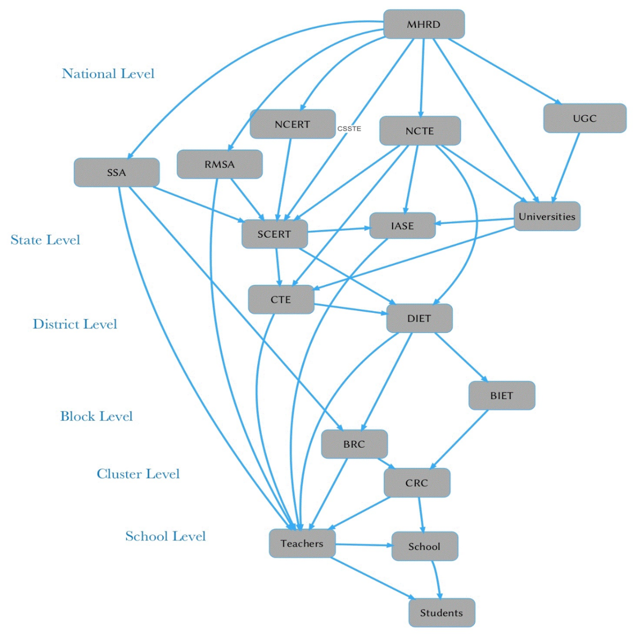
Most of the institutions supported by the CSSTE, namely the SCERTs, the IASEs, the CTEs, the DIETs and the BITEs, occupy liminal positions as nodes that connect blocks and clusters to districts, districts to states, and states to national governing bodies. Relationships between the different bodies, further, are dialogic and multi-directional. Equally complex are the functions of each of these bodies. On the one hand, they are envisioned as institutes that intervene directly in improving the quality of school education. On the other hand, they function as higher education and professional training institutes within the field of education. Mediation of administration, governance, fund flow and academic responsibility becomes some definite challenges that the CSSTE encounters in its disbursement of funds for the activities related to teacher education in the country.

The programs supported by the scheme include pre- and in-service teacher trainings, capacity building and professional development opportunities for school teachers as well as the faculty at the institutions. Other responsibilities include support in research and needs analysis that can guide the development of appropriate training programs, and domain specific research by the faculty of these institutes as part of enhancing subject knowledge.

This study uses the Government of India Guidelines (MHRD, 2012) and the “Terms of Reference” stated above, as the framework for its analysis. The TISS team visited and interacted with officials, key informants, faculty, administrative staff and students in over 90 institutions across 11 states and 2 Union Territories, from August 2017 to September 2017. A variety of tools ranging from observation checklists of institutional infrastructure and classroom practices to interview schedules for key informants, senior officials, faculty and students were developed, piloted and finalised in the two-month period of study, to gauge the functionality of the institutions. Also analysed were documentary evidence of fund flow, vacancies, TEAB minutes, JRM reports of states, syllabi, textbooks and curricular materials gathered from the sampled institutions to understand the different ways and extent to which CSSTE has intervened in the dynamic teacher education system in the country.

This report seeks to present a realistic picture of teacher education as the team encountered in the States and UTs, its reflections on the prevalent conditions and current practices, the gaps and best practices noticed and recommendations based on these findings. It is hoped that these recommendations will enable the Ministry to take an informed decision about the future prospects of the scheme in meeting its goals.

Sd. as under

10th October 2017

Acknowledgements

TISS team acknowledges with deep sense of gratitude all the good things that have contributed towards the conduct of this study. The team solemnly appreciates all the kindness that it received from the host states during the study which facilitated collection of data, allowed space and time for interactions with the members on the faculty as well as the student-teachers and education officials and smoothened visiting team’s local stay and travel. TISS team will remain indebted to the respondents for their enthusiastic participation in the study by sacrificing their time and work. At many instance, the host institutes and departments extended kindest hospitality and care which are much appreciated by the TISS team. This study owes a lot to the local host institutes and their teams.

Special thanks are reserved for the Department of School Education & Literacy, MHRD, New Delhi which facilitated the study and also provided timely and constructive feedback, suggestions and insights towards conducting the study and preparation of this report. Sincere thanks and gratitude are placed for Ms Anita Karwal, Ms Rashi Shrama, of MHRD, Ms Tara Naorem, Ms Swati Chawla and Mr Wamiq Towhid from TSG (TE) and Prof Rajrani from NCERT for their generous feedback and facilitation during field work.

List of Tables

Table 1.1: Number of JRM Reports by year and state
Table 2.1: Inputs-Outputs-Outcomes of CSSTE
Table 2.2: Table 2.2: Research Questions and Indicators
Table 2.3: Summary of Tools
Table 2.4. Sampling of Institutions
Table 2.5: Table 2.5. Sampling of Respondents
Table 3.1: Positions and Vacancy Status in the SCERTS as on 20.9.2017
Table 3.2: Status of SCERTs web site as on Sep 2017
Table 3.3: Curricular Change as per NCFTE 2009
Table 3.4: Revision according to NCF-2005 by SCERT
Table 3.5: Planning Process of CSSTE
Table 4.1: IASE Sanctioned and Functional
Table 4.2: Academic and non-academic posts - filled and vacant
Table 4.3: Consolidated vacancy data
Table 4.4: Faculty Development and Capacity Building
Table 4.5: Trainings and CPD
Table 4.6: Management and different activities
Table 4.7: Infrastructure availability at IASEs
Table 5.1: presents the vacancy scenario in select CTEs across the states
Table 5.2: Infrastructure and Resources in CTEs
Table 5.3: Limitations, Challenges and Remarks for CTEs
Table 6.1: Vacancies in Academic and Non-Academic Posts in DIETs
Table6. 2: Infrastructure and Resources in DIETs
Table 6.3: Limitations, Challenges and Remarks for DIETs
Table 7.1: Status of Functional BITEs at end of 12th Five Year Plan
Table 7.2: Status of Infrastructure at BITEs
Table 7.3: Status of Equipment and Resources at BITEs
Table 9.1: A summary of state of ICTs in education in various states.
Table 10.1: Dates of TEPAB & Release of Minutes
Table 10.2: Fund Flow: Case of 2015-16

Abbreviations

AS | Assam | MZ | Mizoram
AWP | Annual Work Plan | NCERT | National Council of Educational Research and Training
BITE | Block Institute of Teacher Education | NCF | National Curriculum Framework
BH | Bihar | NCFTE | National Curriculum Framework for Teacher Education
BRC | Block Resource Centre | NCTE | National Council of Teacher Education
BTC | Basic Training Centre | NET | National Eligibility Test
CG | Chhattisgarh | NGO | Non Government Organization
CPD | Continuous Professional Development | NPE | National Policy on Education
CRC | Cluster Resource Centre | NUEPA | National University of Educational Planning and Administration
CSSTE | Centrally Sponsored Scheme on Teacher Education | ODL | Open and Distance Learning
CTE | College of Teacher Education | OERs | Open Educational Resources
DIET | District Institute of Education and Training | PAB | Plan Approval Board
DL | Delhi | PAC | Programme Advisory Committee
DPEP | District Primary Education Programme | PPT | Power Point Presentation
DRC | District Resource Centre | PSTE | Pre-Service Teacher Education
DSERT | Department of State Educational Research and Training | RMSA | Rashtriya Madhyamaik Shiksha Abhiyan
HP | Himachal Pradesh | SCERT | State Council of Educational Research and Training
IASE | Institute of Advanced Studies in Education | SM | Social Media
ICT | Information and Communication Technology | SMC | School Management Committee
ISTE | Inservice Teacher Education | SSA | Sarva Shiksha Abhiyan
JRM | Joint Review Mission | TESS | Teacher Education Through School Based Support
KN | Karnataka | TEIs | Teacher Education Institutions
MH | Maharashtra | TET | Teacher Eligibility Test
MIS | Management Information System | TLMs | Teaching Learning Materials
MOOC | Massive Open Online Courses | TS | Telangana
MP | Madhya Pradesh | UPS | Uninterrupted Power Supply

Table of Contents

CHAPTER 1 1
Introduction 1
1.1. Policy Background 3
1.2. The CSSTE 4
1.3. Summary of CSSTE evaluation 2009 and JRM Reports 5
1.4 Structure of the Report 9
CHAPTER 2 11
Operationalising the TOR: Key Questions and Methodology 11
2.1 Components of the scheme, Study Objectives and TOR 11
2.2. Evaluation Questions & Indicators 13
2.3. Methodology: Sampling, Data Collection and Analysis 14
2.4. Limitations 18
CHAPTER 3 20
State Council of Educational Research and Training 20
3.1. The Context: Establishment and Current Scenario 20
3.2. The Role of SCERT 20
3.3. Functions of the SCERTs 21
3.5 Infrastructure and use of technology 24
3.6 Revision of the teacher education curriculum 25
3.7. Revision of School Curriculum and Textbooks. 26
3.8. Research 27
3.9. Planning Process for Teachers’ Education & TE 28
3.10. Collaboration & Network 29
3.11. Scarcity of Fund 30
3.12. Concern for Quality 30
CHAPTER 4 31
Institutes of Advanced Studies in Education 31
4.1. The context 32
4.2. Institution description 32
4.3. Staff and vacancy 34
4.4. IASEs in India: Survey-trends across 13 states 35
4.5. Number of institutions setup as or upgraded to IASE 35
4.6. IASE as a Regional Resource Centre 36
4.7. Summary 44
CHAPTER 5 45
Colleges of Teacher Education 45
5.1 Process and Performance Indicators: Government of India Guidelines, 2012 46
5.2. CTEs in India: A Survey 47
5.3. Observations and Challenges on the Field 54
5.4. Analysis and Insights 56
CHAPTER 6 57
District Institutes of Education and Training 57
6.1. Process and Performance Indicators: Government of India Guidelines, 2012 58
6.2. DIETs the Status in 2017 59
6.3. Observations, Analysis and Insights 69
CHAPTER 7 72
Block Institute of Teacher Education (BITE) 72
7.1. The context 72
7.2 Observations from the Field 73
7.3. Conclusion 78
[CHAPTER 8 79
Teachers’ Professional Development; 79
Modalities for In-service and Pre-service Teachers’ Education 79
8.1. Schemes for Teachers’ Education 80
8.2 Pre-service 82
8.3. Notion of Quality 84
8.4. Moving towards Inservice 85
8.5. Private Teachers Education Institutions 86
8.6. Curricular Change & Capacity Building 86
8.8. Impact of New Reform 87
8.9. Some Concluding Observations 88

CHAPTER 9 90
Technology Use 90
9.1. Expectation of Scheme: Recommendations from the Guidelines 91
9.2. Findings from the Survey 92
9.3. A few examples: Role of Teacher-Educator - consumer or producer 95
9.4. Reflections on the state of ICTs in the TE institutes 97
CHAPTER 10 100
Governance, Program Management & Fund flow 100
10.1. Norms of the Scheme 100
10.2. Inadequacy of Financial Norms and Allocation 100
10.3. Fund Flow 101
10.4. Vision, Planning, Institutional Development Knowledge and Orientation to TE 103
10.5. Conclusion 106
CHAPTER 11 108
Conclusion and Recommendations 108
11.1: Summary of key findings 108
11.2. Key Research Questions 113
11.3 Best Practices 115
11.4 Key Recommendations 117
11.5 Reflections 120
A. REFERENCES 122
B. Annexure Tools 124
C. List of Analytical Tables generated and utilized 155
D. Research Team 156

CHAPTER 1

Introduction
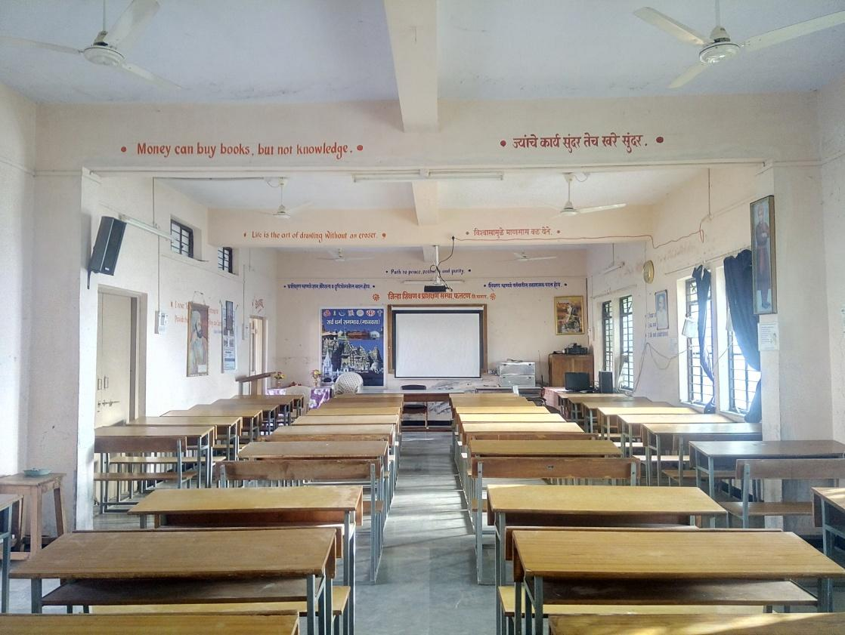
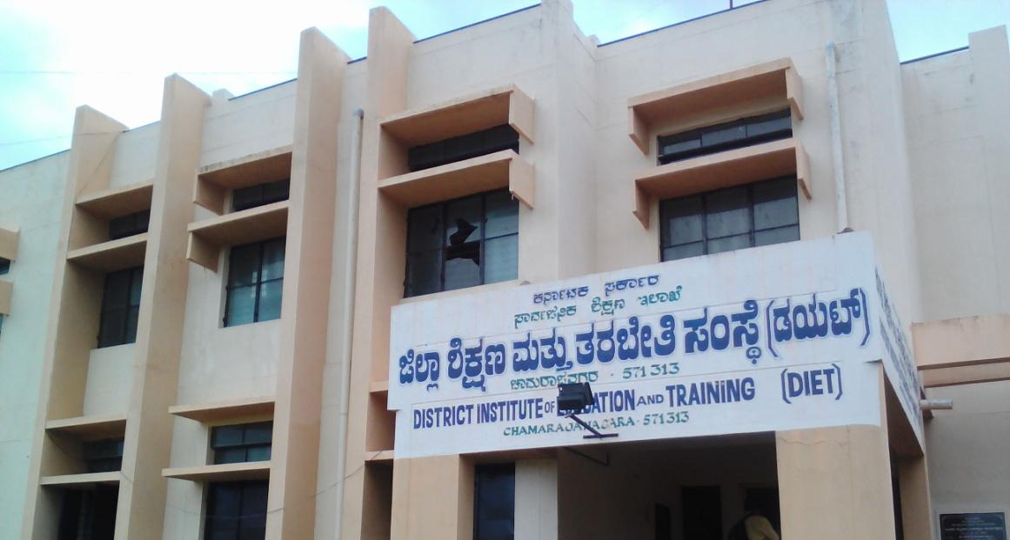
DIET, Phaltan, Maharashtra.

DIET, Chamrajnagar, Karnataka

Karnataka.

CHAPTER 1
Introduction

There is a growing demand for quality elementary and secondary education in the country. The Right to Education is a constitutional guarantee for a quality education as the foundation of human life with dignity. Teachers are central to realising this promise. A strong teacher education programme is a sine qua non for building a system that can deliver on the promise of quality in education for all.

The Centrally Sponsored Scheme on Teacher Education (CSSTE) was a unique contribution of the 7th plan (1985-1992) (Planning Commision, 1985), following the National Policy on Education 1986 (NPE, 1986). The plan and the scheme envisaged extensive development and strengthening of institutions for teacher education and reform of the sector, both pre and inservice as well as for elementary and secondary education. The scheme led to the creation of institutions for teacher education at the District level-the District Institutes of Education and Training as well as strengthening colleges of teacher education and university departments for research and faculty development. The scheme was reviewed and revised in 2012 (MHRD, 2012a). The scheme has been implemented by the Department of School Education & Literacy (DSEL), Ministry of Human Resource Development (MHRD), Government of India (GoI) in States and Union Territories (UTs) on a fund sharing pattern between the Centre and the States.
The main objective of the revised scheme is to strengthen and upgrade Teachers Education through the development of Institutions (TEIs) and through programmes of pre and inservice teacher education, faculty development and research, innovation and field action, to bring about localisation and decentralisation, to strengthen academic resources and support to the District level leading to the enhancement of quality of teachers education at all levels.
The proposed study evaluates the implementation of the CSSTE and its various components/activities across the country through a sample basis. This report of the study carried out between July 2017 and September 2017. The objective of the study is
- To presents a comprehensive picture of CSSTE implementation across the country,
- To understand the extent to which the stated objectives and targets of the scheme have been met,
- To highlight the factors that have helped achievement of the objectives, and the challenges and constraints that have affected the intended course of implementation.

The study also inquires into the governance of the programme in terms of coordination between stakeholders/institutions, convergence, financial allocations, operational guidelines, data management, monitoring and planning processes and finally the meeting of the objectives and vision of teachers’ education under the scheme.
Field visits were carried out to 11 States and 2 Union Territories ( UTs) which included visits to institutions, interviews with respondents in these institutions as well as key respondents in the states and observations and data provided by them. Additionally, reports, minutes of meetings and Management Information System (MIS) data of the programme, budgets, annual work plans were examined and drawn upon. The MHRD also carried out monitoring and review visits to the States between 2012 and 2017, and these reports and observations were also utilised, as well as the monitoring visit reports carried out by teams from the MHRD between 2012 and 2017 were also reviewed and utilised. The primary source of data is field data gathered from sampled State Council of Educational Research and Training (SCERTs)/ District Institute of Education and Training (DIETs)/ Institute of Advanced Study in Education (IASEs)/ College of Teacher Education (CTEs) and key informants in the 11 States and 2 UTs. The study provides recommendations about areas that need to be revised and strengthened under CSSTE, which will serve as an important ingredient for evidence based policy formulation and reform.

1.1. Policy Background
The National Policy on Education (NPE, 1986), which recommended an overhaul of the teacher education system in India, led to the launch of a centrally sponsored scheme of teacher education, incorporating the establishment of DIETs, CTEs and IASEs.
The CSSTE received its first allocation in the Seventh Plan (1985-1990/1990-1992), (Planning Commision, 1985) . This scheme constituted the most important, and till date, the only major institutional development in teacher education. The Seventh Plan emphasised the significance and need for a decentralized system for the professional development of teachers. It was in this context that District Institutes of Education (DIETs), Colleges of Teacher Education (CTEs) and Institutes of Advanced Study in Education (IASEs) were established.
10.22 The Seventh Plan provides for reorientation of the education system so as to prepare the country to meet the challenges of the next century. The main thrust areas in the Seventh Plan would be . . . . (v) provision of facilities for education of high quality and excellence in every district of the country

10.28 The role of the teacher is most crucial in achieving universal elementary education, especially in the motivation of children as well as their parents. They can play a leading role in improving the quality of primary education, bringing in environment and health education and value orientation. In-service training of teachers thus becomes a programme of high priority. The training of teachers will include, apart from pedagogy, the use of mass media, science and technology, planning and curriculum design for local environment-based courses, mobilisation and use of community resources and other relevant subjects. There will also be special emphasis on teaching methods and other measures particularly required for first generation learners and for reducing the number of dropouts. Teacher training institutions will be developed and strengthened accordingly.

10.29 Facilities will have to be created for the training of additional teachers required during the Seventh Plan period. There is as yet no infrastructure in the country for training of teachers in non-formal and early childhood education. Training of such teachers would have to be organised by suitably strengthening the existing teacher training centres.
(Source: http://planningcommission.nic.in/plans/planrel/fiveyr/index7.html accessed on 10 June 2016).

In its review of the NPE 1986, the Acharya Ramamurti Committee (Ramamurti, 1990), while propagating for the adoption of an internship model for teacher training, observed that “the internship model is firmly based on the primary value of actual field experience in a realistic situation, on the development of teaching skills by practice over a period of time”. The Yashpal Committee Report on “Learning without Burden” (Yashpal, 1993) while advising on ways and means to reduce the load on school students at all levels also recommended that the content of teacher preparation programmes should be restructured to ensure its relevance to the changing needs of school education .
Two major initiatives for quality improvement that took place between 1990 and 2010, namely the District Primary Education Programmes (DPEP) and the Sarva Siksha Abhiyan (SSA), infused a focus on in-service teacher education as a modality for strengthening school quality, and thereby created subdistrict institutions and functionaries (Block Resource Centres and Cluster Resource Centres, or BRCs and CRCs, respectively) to strengthen training, school based follow-up for teachers and cluster based teacher meetings. The National Curriculum Framework for Teacher Education (NCFTE, 2009) necessitated an alternate framework for Teacher Education that would be consistent with the changed philosophy of the school curriculum as recommended in the National Curriculum Framework (NCF, 2005) and to achieve the aims of quality education for all as promised by the Right to Education (RTE, 2009).
As per the Twelfth Plan of the Planning Commision and emerging need due to the RTE 2009 Act the CSSTE guideline was reviewed in 2012 (MHRD, 2012). As per this review the TE curriculum was revised to address the needs of RTE Act 2009 and quality of school education.

1.2. The CSSTE
The Teacher Education Scheme and the functioning of its various institutions have been evaluated by independent bodies at various points of time. The National University of Educational Planning and Administration (NUEPA) had evaluated DIETs in 1997 and the NCERT conducted a study on the DIET, CTEs and IASEs in 1999-2000. The Teacher Education Resource Group under the NCTE, was entrusted by the Ministry of Human Resources Development (MHRD) to undertake a mid-term review of the Scheme during the Xth Plan, and submitted its report in 2007. The Scheme was last evaluated in 2008-09 by the NCERT and its findings were reported in 2009. NIAS (2007) conducted a workshop titled “DIETs: Potential and Possibilities” drawing together several issues that were experienced by States in implementing the scheme. In the 12th plan, the Scheme was revised in order to meet the revitalise the scheme and enable teacher education to respond to new challenges and developments in Indian education. exceptional challenges for Teacher Education System.
Under CSSTE, SCERTs are visualized as the lead academic institutions at the state level in matters of education quality of schools and teacher education. They are expected to provide leadership and support to the Colleges of TEacher Education with a focus on secondary school teachers and District Institutes of Education and Training with a focus on elementary school teachers. In the 12th plan, new institutions called Block Institutes of Teacher Education (BITE) were added in blocks which have higher demography of scheduled caste and tribal communities with a view to increase access to teacher education from these communities. The Institutes of Advanced Studies in Education (IASE) was provided to University departments of education to increase opportunities for Masters in Education, research and inservice teacher education. SCERTs were envisaged as functioning along the lines of NCERT at the state level, providing advice to state governments on policy issues, supporting implementation, appraising programmes and undertaking quality improvement programmes in school and teacher education. The RTE 2009 requires that every state identify one of its institutions as its nodal academic agency. In general SCERTs are expected to play this role and be responsible for establishing proper coordination between, and collaboration with various statutory bodies like the Board of Textbooks, the Board of Secondary Education and the Board of Elementary Education.
Post 2012, the revised scheme required that the curriculum of teacher education be revised in the light of the NCFTE 2009, which was developed following the NCF 2005. Areas such as training for educational administrators, including the head teachers has also become important. The SSA and more recently the RMSA also require inservice to be designed by teacher education institutions of the state, under the overall guidance of the SCERT.

1.3. Summary of CSSTE evaluation 2009 and JRM Reports
In 2009, prior to the revision of the scheme in the 12th plan, the NCERT conducted a study of the scheme,Comprehensive Evaluation of Centrally Sponsored Scheme on Restructuring and Reorganization of Teacher Education (NCERT, 2009).After the revised scheme was launched in 2012, the MHRD instituted joint review missions to be conducted to review the status of the scheme. A total of 30 such reports covering 28 States and 1 Union Territory (Delhi) are available on the TE website of the MHRD.
Table 1.1 Number of JRM Reports by year and state
Year | No. of States | States
2013 | 16 | Assam, Bihar, Chhattisgarh, Gujarat, Haryana, Jammu and Kashmir, Jharkhand, Madhya Pradesh, Meghalaya, Mizoram, Odisha, Punjab, Tripura, Uttar Pradesh, Uttarakhand, West Bengal
2014-15 | 5 | Andhra Pradesh, Karnataka, Kerala, Maharashtra, Tamil Nadu
2015-16 | 9 | Rajasthan, Manipur, Sikkim, Telangana, Arunachal Pradesh, Delhi,Goa, Himachal Pradesh, Nagaland
2016-17 | 5 | Assam, Chhattisgarh, Jharkhand, Madhya Pradesh, Uttar Pradesh

The following were noted as key achievements and areas of concern.
1.3.1 Infrastructure and Resources:
The evaluation study (NCERT, 2009) and JRM reports suggest that the infrastructure and resource availability vary between states. Most of the SCERTs do not have adequate rooms for holding meetings, conferences and workshops. Computer laboratories are absent at some places or not fully functional even if they are present. Many SCERTs lack in basic facilities like science laboratories, auditoriums and in some cases libraries too. The libraries have abundant number of books but these were up-to-date nor are they properly maintained. The posts of librarian are lying vacant in almost half of the SCERTs and the libraries are being managed manually making it difficult for faculty to access any material. Infrastructure and physical facilities such as hostels, toilets, etc. are either not available or not sufficient enough to cater to the need. Inadequate utilization of available provisions, facilities and infrastructure, including land resources have been noted. Staff positions in SCERTs/SIEs vary across states. Many SCERTs were found to be inadequately staffed and huge numbers of sanctioned positions were lying vacant. A few SCERTs do not have a separate cadre and faculty is drawn from other institutions / state education service, some of whom are posted on an ad-hoc basis. Weak administrative support is noted while many posts of administrative staff such as administrative officers, stenographers, clerks, accountants and other Group C and D posts have not been filled up. No uniform or concrete policy for faculty recruitment at the BITEs, DIETs and SCERTs was noticed. It was observed that the DIET faculties’ expertise do not always match the skills, understanding and expertise shown by trainers drawn from other contexts. Over the years, academic work has become redundant and clerical work has increased for the faculty of SCERT and DIETs.
JRMs also expressed concern over absence of documents like NCF 2005 and NCFTE 2009 and children’s literature in the libraries. There was a dearth of educational material in local languages throughout the states, even though SCERTs themselves develop modules for teacher educators related to areas like CCE, special education, life skills and so on. In many cases, there is no access to the internet and hence access to online journals is a major problem. Development of ICT resources remains non-existent in most of the states. A common problem observed by the JRMs is the lack of proper hostel and toilet facilities for DIET students, especially for women. These reports also suggested that IASEs be upgraded in terms of their infrastructure and material so that they can work with their full capacity as visioned by the Centrally Sponsored Scheme on Teacher Education.
In the JRMs conducted between 2014 to 2016,it was noted, though overall CSSTE was found to have addressed the institutional infrastructural needs, in some states its quality needed attention.

1.3.2. Faculty and Faculty Development:
Huge vacancies were noted in all institutions of faculty. Moreover a large proportion of faculty appointed in teacher education institutions did not have the requisite NCTE qualifications. Encadrement of teacher educators had not be carried out in most states where the dominant practice was to have education officers move into these positions and high school teachers to be promoted into the faculty positions.
States did not have any systematic mechanism for the professional development of faculty of their teacher education institutes. A few SCERTs were found to conduct sporadic training for DIET faculty. DIET faculty were found to be least exposed to any kind of professional development.
Lack of expertise was also noticed in these institutions in undertaking research or in the utilization of the available research data.
The JRMs conducted between 2014-16 indicated that SCERTs, in some states had developed as nodal point for TEIs in terms of management, fund provision and providing overall direction. DIETs in some states had emerged as key institutions and focal point for teacher education at the district level, despite the absence of adequate resources.

1.3.3. Curriculum and processes:
In several states the SCERTs were found to have initiated changes in school curriculum and teacher education curriculum in the light of NCF 2005 and NCFTE 2009. However teacher education institutions were found to be less in sync with these policy developments and changes.
JRM teams also noted teaching-learning processes and evaluation in teacher education had not been significantly changed nor was there much discussion about the same. Pedagogy continued to be primarily in the lecture-mode, students mainly used guidebooks and there was limited opportunities for interaction among teacher educators and students and use of other resources. Preparation of models and charts continued to be the main TLM; libraries lacked in good textbooks and also the NCERT textbooks and resources. Lack of flexible and adaptive physical infrastructure, inadequate resource material and unpreparedness of teacher educators to adapt to the new ways of teaching were found to be the prominent reasons that restricted the use of any constructivist approach in the teaching-learning process.
Some of the positives noted by the JRMs in 2014-16 include efforts made in some states to design curriculum and syllabus in local languages, attempts at inclusive education, increasein number of trained teachers and teacher educators. It was noted that convergence with Curriculum Framework for teacher education and continuing lack of awareness of needs in this sector An absence of adequate awareness and orientation towards NCFTE 2009 and NCF 2005 noticed. Lack of adequate human resource strength remained a challenge across Teacher Education Institutions
It was observed that disbursement of funds, underutilization of funds, complex processes were concerns related to aspects of funding under the scheme. In some states, in some states it needed further empowerment to take decisions to enable it to provide academic leadership. Mismatch in demand and supply of teachers and underutilization of potential of TEIs due to overall neglect were also areas of concern.

1.3.4. In-Service Teacher Training
The JRMs noted that in all the States Training Management Systems (TMS) and/or a database of teachers in the State at the district level were not being used to plan for and depute teachers.
NCERT evaluation report 2009 and NIAS 2007 observed that SCERTs and DIETs employ a limited convergence with other institutions and organizations like BRCs, CRCs, RMSA/SSA, university departments of education, and so on. Relationship with SSA and RMSA in teachers’ training remains ad-hoc in nature. Alignment of In-Service trainings with identified needs was identified as an area of concern
1.3.5. Collaboration & Innovative Practices:
Innovative practices reported by the JRMs adopted by some states include, use of social media, collaboration with NGOs, setting up of community radios, development of online data management system, student feedback for curriculum and pedagogy, and so on. innovations covering assessments, development of student absenteeism monitoring tools, girls’ education, etc. JRM reports of 2013 indicate that six out of 21 states have claimed nil or negligible collaboration of the state's teacher education institutes with any NGOs. JRM reports of 2014-16 highlighted that greater convergence between universities and TEIS was needed along with inter institution collaborations. Institution spread and provision was another area which needed attention.
1.3.6 Summary of Recommendations
1. Sectoral matters
- There needs to be an overall professionalisation of teacher education
- Interlinkage between elementary teacher education institutions and higher education system need to be strengthened.
- DSERT, DIETs, etc. to have in addition to resources the autonomy to function with capable and stable faculty and leadership
- Vacancies in institutions needs to be filled up
- Technology use needs to be integrated into all aspects of teacher education
- There needs to be periodic academic monitoring of TEIs
- There needs to be overall convergence between various stakeholders of TE
- Curriculum and syllabus of pre-service teacher education courses and programs of TEIs to be aligned with the NCF-2005 and based on NCFTE 2009.
- Measures to Attract good professionals in TEIs: Pay scales of the faculty of TEIs to be upwardly revised and UGC salary and pay scales could be followed along with structures of mobility for career advancement. TEIs’ posts to be en-cadred
- Faculty development opportunities need to be created
- ISTE programmes to be of longer duration and should take into account identified needs of teachers

2. Funding and Fund Sharing Pattern:
- Financial sharing pattern between Centre and States should be in the ratio 75:25 (90:10 for North Eastern states)
- Local necessities to inform funding patterns and allow for regional variations
- Flow of funds to be according to the following pattern:
Center-->State Education Secretaries-->SCERTs-->IASEs/CTEs/DIETs
d) State’s budget heads to maintain State’s share and Central assistance
e) fund flow needs to be timely

3. DIETs:
- Improvement of the existing institutional structure and extending the mandate of in-service training provided to include secondary and senior secondary school teachers.
- Improvements in infrastructure and organizational structure have been suggested.
- DIETs to have linkages with universities, colleges and well established private institutions
- Around 10% of DIETs in the coming years to be considered for upgradation to provide secondary level pre-service training
- Establishment of a DIET in 196 identified districts with minority, SC/ST concentration. In remaining blocks, BITEs to be set up (BRCs to be subsumed within BITEs)

4. CTEs and IASEs
- Strengthening of existing institutions
  - New to be set up based on specific needs of the states

5. SCERTs
- To be re-vitalized
- To be developed as lead state-level academic institutions
- To develop links with Universities
- All existing State Instituted of Education to be upgraded as SCERTs

1.4 Structure of the Report
This first chapter provided the background of the scheme and key findings regarding the status of the scheme from earlier studies and review and monitoring reports. The next chapter engages with the design of the study and breaks down the overarching objective into research questions which the study tried to answer. The sample of the study, process of data gathering, processing and analysis are presented. Key limitations of the study are identified. There are eight Chapters of findings. There are five chapters which present institution wise findings covering the SCERT, IASE, CTE, DIET and BITE. An additional three chapters synthesise findings on three major thematics: inservice and preservice teacher education, use of technology and governance. The final chapter summarises key findings, answers the research questions, highlights best practices and makes recommendations.

CHAPTER 2
Operationalising the TOR: Key Questions and Methodology

CHAPTER 2

Operationalising the TOR: Key Questions and Methodology
The study was mainly guided by the CSSTE goals to enhance quality and access of teachers’ education and responding to the present day challenges of quality education at all levels of schooling through capacity building of teachers. This chapter presents the key issues and questions which the study seeks answer. Based on the components of the scheme, the Objectives and TOR of the study as outlined in the RFP, research questions are identified and relevant indicators suggestion. The sampling and tools that were used is presented and the limitations of the study are summarised.

2.1 Components of the scheme, Study Objectives and TOR
The design of the study was based on the following considerations:
- Components of the scheme
- Objectives of the study, and
- Terms of Reference of the Study
Details of these considerations are as follows
A. The following nine components comprise the design of the scheme. (MHRD, 2012: 24-25).

- Strengthening and up-gradation of State Councils for Educational Research and Training/State Institutes of Education.
- Strengthening of existing Institute of Advanced Studies in Education (IASEs) and up-grading of Department of Education of Universities into IASEs.
- Strengthening of College of Teacher Education (CTEs) and establishment of new CTEs.
- Strengthening of existing District Institutes of Education and Training (DIETs) and extending their mandate for training of teachers at the secondary level.
- Establishment of Block Institutes of Teacher Education (BITEs) in 196 identified SC/ST/Minority concentration districts as elementary pre-service teacher education institutes
- Identification of 50 lead institutions, including Department of Education in Universities, NUEPA, NCERT, Academic Staff Colleges and other Institutions in the non-Government sector to conduct refresher courses for teacher educators.
- Provide hardware support, namely, provisioning of satellite transmission facilities in DIETs and provisioning of software support for developing content for orientation of teacher educators and teachers.
- Giving mandate to SCERTs and DIETs to involve not-for-profit organizations for conducting innovative field based programmes related to teacher education, collaboration in in-service and pre-service teacher education, undertaking impact assessment studies and designing and developing locally relevant material for teachers and student-teachers of teacher education institutions.
- Developing and putting in place a comprehensive monitoring mechanism.

B. Additionally the following nine points were delineated as the objectives of the study:
- Assess the extent to which Centrally Sponsored Scheme on Teacher Education (CSSTE) has been able to achieve its objective and the factors determining the same.
- Identify constraints in the implementation of the scheme in the 12th five year plan.
- Suggest revisions in the provisions of the scheme in order to meet the exceptional challenges of the State/UTs and for the effective implementation in the next plan period.
- Analyze the fund flow mechanism and recommend procedures for timely and effective utilization of funds.
- Analyze the need to continue the scheme in the existing form or changes required in the norms both programmatic and financial for effective implementation of the scheme.
- Examine the effectiveness of Teacher Education Institutions (TEIs) in terms of its envisioned role and function.
- Study whether Teacher Education Institutions are functioning as per the norms and standards of the NCTE Regulations 2014.
- Analyze whether Teacher Education Institutions are playing a complementary and coordinated roles with other institutions at the State and District levels, for improving the quality of education and teacher education.
- Any other improvements or additions to the scheme that can make it more effective and meet its objectives in today’s society and education system.

C. The following eight components were listed as the terms of reference of the study
- To analyze extent the improvement in the quality of teacher education since the reorganization and restructuring of the Centrally Sponsored Scheme on Teacher Education in 2012.
- To analyze Impact and effectiveness of teacher education provided through this scheme.
- To analyze adequacy and timeliness of fund flow and delivery mechanisms.
- To analyze scope of operational guidelines including cost norms and recommend modification, if any;
- To assess extent of coverage and linkages with other institutions at the State and district level.
- To analyze effectiveness of Teacher Education Institutions in terms of its envisioned role and functions.
- To justify/recommend about the continuation of the scheme or otherwise.
- To suggest measures for improvement of implementation and monitoring mechanism for the scheme.

On the basis of above consideration an Input, Output and Outcomes was formulated as below (table 2.1).
Table 2.1: Inputs-Outputs-Outcomes of CSSTE (from Inception Report)
Inputs | Outputs | Outcomes
CSSTE financing for strengthening of SCERT,IASEs CTEs, DIETs,BITEs, and other support for capacity building of states | Improvement in accessibility of pre-service teachers education, strengthen structure of in-service teachers education, increment in proportion of teachers trained, increased proportion of functional DIET with trained faculty available, proportion of DIETs and CTE with upgraded infrastructure (enabling factors), curricular reforms in teachers education carried out, setting up a robust system for monitoring teachers education process. | Increase in trained teachers in system, teacher resource support structures established and strengthened, Improved quality teachers education programs in the states

2.2. Evaluation Questions & Indicators

Based on the above, considerations, the following research questions were identified along with relevant indicators,

Table 2.2: Research Questions and Indicators
Research questions | Indicators
1.Has there been an improvement in Pre-Service Teacher Education and has it contributed towards overall improvement of teacher professional development and school improvement? | - Quality of teachers Education Program,  - Curricular revision  - Class room transaction  - Facility at Pre-service Institution  - Faculties and Expertise
2.Has there been an improvement in In-Service Teacher Education and has it contributed towards overall improvement of teacher professional development and school improvement? | - Quality Training module  - Quality of transection  - Follow up
3.Has there been development of professionalism and capacity of Teacher Educators? | - No. of teacher educators in system  - Activities to prepare teachers educators  - Materials / Module for teachers educators
4.Have strong inter-linkages developed within Teacher education and training sector between the following;  - Existing Departments and Institutions at district level  - Existing Departments and Institutions at state level  - Higher Education Institutions  - Schools  - Non-Government Organizations | - No. and nature of activities to ensure convergence among state level  - No. and nature of activities to ensure convergence among District and sub district level
5.Have institutions at all levels led to the adequate supply and quality of trained teachers at elementary and secondary levels of education? | - Percentage of trained teachers in system
6.Is there in place processes, systems and structures across institutions to ensure planning, monitoring and tracking? | - Process of planning  - Mechanism for Monitoring
7.Has there been an adherence to guidelines related to staffing? | - Vacancies  - Staff qualifications
8.Has there been an adherence to guidelines related to the infrastructure? | - Improved infrastructure
9. Has there been an adherence to guidelines related to the flow of funds? | - Timely fund flow
10.Has there been use of ICT to enhance institutional, instructional and teaching quality across the institutions? | - No. & Quality of Teachers training for ICT  - No. of program in ICT  - Materials developed in ICT
11.To what extent has the academic profile of the institutions been strengthened through the following:  - Research and Publication  - Education Courses for Faculty  - Seminars  - Workshops  - Study Tours | - No. & nature of Publication  - No. and quality of Courses for faculty  - No. & quality of Seminar  - No. and quality of Study
12. Has there been a one-time situation analysis and stock-taking by institutions where mandated?  Has there been a regular and frequent situation analysis by institutions and states where mandated? | - Situation analysis report/s  - Evaluation Study
13. Has the flow of funds affected the quality of implementation of the scheme? | - Fund flow mechanism  - Expenditure per quarter
14. Has there been scope for operational autonomy for institutions under the scheme?  Has there been scope for various actors and institutions to adapt the guidelines and requirements to meet local needs of quality and adequacy? | Innovative use of support available under CSSTE

2.3. Methodology: Sampling, Data Collection and Analysis
The methodology adopted for various aspects of the study viz. selection of institution, selection of beneficiaries, sampling method, source of data collection, its documentation, analysis and interpretation, including time period involved is provided here. The study was based on a mixed methods approach that included quantitative and qualitative data. The study tried to focus on input, output and outcome at different levels of program implementation - starting with central, to state to institutional level.
The study was able to draw on secondary sources of data and information including the minutes of Teacher Education Appraisal Board (TEAB) Meetings, Plan Approval Board (PAB) reports, approvals and appraisal notes, previous Joint Review Mission (JRM) reports, details of Teacher Education Institutions sanctioned per year and details of funds allocated and utilized by the States/UTs. This was supplemented by various guidelines issued by central and state governments to the institutions covered by the scheme. The study tried to examine the impact of planning processes, resources allocation and provisions allotted under CSSTE and fund flow mechanism through analysis of quarterly expenditure report.

2.3.1 Tools
Eight tools consisting of structured and unstructured items were used to generate primary data (see table 2.4). The tools were designed based on the research questions and indicators and additionally other tools used in related studies were also examined. The tools were pilot tested and revised for final use.
Table 2.4 : Summary of Tools
Tool No | Tool Name | Respondent | Details
Tool 1 | Interview Schedule for State Coordinators of TE | State level TE functionaries. | Contains all basic information of state’s teachers education progress, fund flow, coordination annual plan and monitoring of CSSTE for all years pertinent to the study.
Tool 2 | Key Informant Interview Schedule | State Education Secretary, SCERT Director | Gathers perceptions, views, insights, experience and contextual scenario of the state.
Tool 3 | Focus Group Discussion Guide | SCERT faculty | Data on activities under CSSTE- includes training, materials development, capacity building , research etc . and their role in TE.
Tool 4 | Interview Schedule for Head of Institutions | Interview of Institution head | Perception and view about the TE scenario in the state, specific role of their institution and working of the CSSTE.
Tool 5 | Institutional fact sheet | To be filled with help of Principals of DIETs/ BITEs /CTEs /IASE | Collects all basic information of selected institutions and their functioning covered under evaluation study.
Tool 6 A | Faculty Interview Schedule (I) | DIET/BITE/CTE faculty (1 per institution) | Gathers perception, views, experiences, insights into role, challenges and recommendations.
Tool 6 B | Faculty Interview Schedule (I) | IASE faculty  (1 per institution) | Gathers perception, views, and experiences, insights into role, challenges and recommendations.
Tool 7 | Student-Teacher Interview Schedule (I) | Student-teachers from the DIET/BITE/CTE / IASE | Gathers perception, views, experiences, insights, challenges and recommendations.
Tool 8 | Observation Protocol (I) | DIET/BITE/CTE/  IASE | Captures the infrastructure, activities, processes, ethos of the institution.

2.3.2 Sampling
As required under RFP a total of 11 states and 2 UTs were covered for the study:

Table 2.6. Sampling of Institutions
Institutions |  | Secretary Education | SCERT | IASE | CTE | DIET | BITE
East Zone | Assam | 1 | 1 | 1 | 2 | 4 | 1
East Zone | Bihar | 1 | 1 | NA | 2 | 4 | 1
East Zone | Chhattisgarh | X | 1 | 1 | 1 | 5 | NA
East Zone | Mizoram | 1 | 1 | 1 | NA | 4 | NA
West Zone | Madhya Pradesh | 1 | 1 | 2 | 2 | 4 | NA
West Zone | Maharashtra | X | 1 | 2 | 2 | 4 | NA
West Zone | Rajasthan | 1 | 1 | 1 | 2 | 4 | NA
North Zone | Delhi | X | 1 | 2 | NA | 4 | NA
North Zone | Himachal Pradesh | 1* | 1 | NA | 1 | 4 | NA
North Zone | Uttar Pradesh | 1 | 1 | 1 | 2 | 4 | NA
South Zone | Karnataka | 1 | 1 | 1 | 2 | 4 | NA
South Zone | Puducherry | 1 | NA | NA | 1 | 1 | NA
South Zone | Telangana | 1* | 1 | 1 | 2 | 4 | NA

Table 2.7. Sampling of Respondents
 | State | Secretary | CSSTE Incharge | SCERT Head | SCERT Faculty** | TEI*** Head | TEI Faculty | TEI Student-Teachers
East Zone | Bihar | 1 | 1 | 1 | 1 | 7 | 6 | 7
East Zone | Assam | 1 | 1 | 1 | 1 | 9 | 9 | 8
East Zone | Chhattisgarh | X | 1 | 1 | 1 | 6 | 6 | 6
East Zone | Mizoram | 1 | 1 | 1 | 1 | 5 | 7 | 9
West Zone | Madhya Pradesh | 1 | 1 | 1 | 1 | 8 | 8 | 8
West Zone | Maharashtra | X | 1 | 1 | 1 | 5 | 7 | 9
West Zone | Rajasthan | 1 | 1 | 1 | 1 | 5 | 3 | 5
North Zone | Delhi | X | 1 | 1 | 1 | 4 | 5 | 6
North Zone | Himachal Pradesh | 1* | 1 | 1 | 1 | 3 | 4 | 3
North Zone | Uttar Pradesh | 1 | 1 | 1 | 1 | 3 | 9 | 1
South Zone | Karnataka | 1 | 1 | 1 | 1 | 7 | 7 | 7
South Zone | Puducherry | 1 | 1 | X | X | 2 | 8 | 13( FGD)
South Zone | Telangana | 1* | 1 | 1 | 1 | 7 | 12 | 13
Totals |  | 10 | 13 | 12 | 12 | 71 | 91 | 82 (+13 through FGDs)
Notes:
*: Telangana and Himachal Pradesh SPD was interviewed
**: At SCERTs, FGD with faculty was conducted
*** : TEIs includes IASE, CTE, DIET and BITE

States were selected based on a number of considerations including JRM reports, status of TE in the state based on secondary literature, and ease of access and availability of local teams. This final consideration was important given the tight timelines of the study. Broadly the requirement of the RFP sampling was met. The sampling was also verified and approved by the MHRD.
Field visits were to include the following numbers of CSSTE supported institutions: SCERTs and to at least 4 DIETs, 2 CTEs, 1 IASE and 1 BITE (wherever functional). Actual numbers of institutions covered was based on local considerations: smaller units such as Puducherry had fewer number of DIETs. Initially 49 DIETs, 19 CTEs, 13 IASE, 2 BITEs and 12 SCERTs were selected for the study. Institutes selection was carried out in coordination with the nodal officer of the state. Nodal officers were requested to suggest institutions which were representative of what they consider working well and having difficulties and also to include both urban and rural institutions with some considerations for geographical spread. Although visits were planned to BITEs in Bihar, they could not be visited on account of local conditions of floods so data was collected through online. Finally the numbers covered were 50 DIETs, 19 CTEs, 13 IASE, 2 BITEs and 12 SCERTs.
Within institutions,faculty for interview and students for interview were suggested by the head of the institution. A total of 8 Education secretaries, 2 SPDs, 71 heads of TEIs, 91 Faculty and 82 students.
2.3.3. Data Collection, Processing and Analysis
Teams of two to six persons of trained education professionals comprised the teams to undertake field visits and conduct observations and interviews and gather data. Orientation to the use of tools was carried out on 20-21 August 2017. Field visits were carried out in coordination the state nodal officers who facilitated selecting the institutions and informed local personnel so that the visit could be carried out. Field visits lasted about 3 weeks between 23 August 2017 and 8th September 2017.
A facilitative and positive orientation was adopted to the process of interviewing, encouraging respondents to reflect and share what works and what does not in their institutional context and inviting them to think about how they think the scheme could be made to work in their context. This methodology was adopted as it was felt desirable given the largely beleaguered condition of these institutions and the stresses faced by their faculty. It was also felt that while there is an aura of dysfunctionality with which most of these institutions are approached and with which they struggle, nevertheless, there are pockets which are trying to make things work and local innovations and efforts that need to be recognised. Finally care was taken to communicate to the respondents that this was not an evaluation of their work, but of the scheme, so their experiences, positive and negative as well as their reflections on how the scheme can be made to work better to address the local challenges of teacher education, as well as the needs that they experience, are expressed and inform the evaluation and understanding of the evaluation team.
Data was noted in hard copy or typed into soft copy and made available via email to the team responsible for organising data and coordinating the process of processing and analysis. Teams were also required to gather evidence in the form of reports and minutes of meetings, records in registers etc. Some of the interviews were recorded with permission of the informants. Photographs were also taken of the institutes visited.
Analysis was carried out through categorisation and summarisation across tools and themes, and at most simple spreadsheets were used to compile responses and data for different items. These were then summarised and synthesized.

2.4. Limitations
This study is based on fieldwork undertaken at selected sample institutions the selection of which was largely guided by convenience and accessibility, with some minimal considerations of representativeness and regional balance. This was on account of the tight timeline of the study and is an inherent limitation. Again, given the timelines, data gathering was largely based on one day long visits to institutes and hence rely on verbal accounts and basic observation. While attempts were made during interviews to triangulate and to seek evidence, the study does rely on verbal reports and accounts of respondents, and their perceptions. Materials developed, programmes designed ad research conducted were gathered, however, these could not be examined for the quality. Similarly, observations of classroom transaction and interviews with student teachers give only a limited view of the quality of the programmes they are undergoing. We were not able to sample and review any inservice teacher education programme. Moreover it is also need to mention here that initially evaluation team anticipated that selected critical data to verify indicators may available with state government or institutions but eventually team get to know that data are not available in consolidated form so we are not able to verify all indicators as per table 2.2.

CHAPTER 3
State Council of Educational Research and Training

CHAPTER 3

State Council of Educational Research and Training

3.1. The Context: Establishment and Current Scenario

The National Policy on Education 1986 and 1992 recommended the creation of State Council of Educational Research and Training (SCERT) in each state as a measure of providing each state with an academic authority responsible for all aspects of quality education, research and training. More specifically, SCERTs were to be strengthened, supported and in some cases also to be created, under the Centrally Sponsored Scheme of Teacher Education, to support and develop teachers and to provide coordination and leadership in teacher education, in both preservice, in coordination with Universities, and inservice. After the enactment of the RTE 2009, all states with SCERTs were expected to declare this institution as the academic authority of the state under Section 29 of the RTE Act. [An exception to this rule as observed during this study is Puducherry that does not have an SCERT. The role of academic authority is therefore performed currently by the SCERTs of Kerala, Tamil Nadu & Andhra Pradesh.]

3.2. The Role of SCERT

As visualized in the Guidelines for Implementation of CSSTE (MHRD, 2012), the major role of the SCERTs was that of a key academic institute in the field of school education at the State level. Their functions include:
- Curricular reform - development of curriculum, instructional material, textbooks, supplementary materials and development of learners evaluation scheme
- Teachers’ professional development – development of curriculum, syllabus and material for pre-service teachers’ education, modules and framework for in-service teachers. It also includes training of teacher educators to provide effective support to the teachers.
- Research – research for school education includes baseline and state level achievement survey. This also includes evaluation of program in education.
- Support to education department: support to state education department in formulation of government order, policy and rule in development of annual work plan and implementation of new programs in schools
- Network and coordination: work as link between national level organization and states’ institutions. SCERTs are also supposed to coordinate with the university and centers of excellence in the field of school education. They are expected to establish links with civil society and international NGOs.
- Information of teachers & teacher educators: establish MIS system for teacher education in the state as mentioned in the indicators of success in 2012 Guidelines
- Academic authority: SCERTs have been visualised as and are given the responsibility of being the key academic authority in states in the field of education.

3.3. Functions of the SCERTs
During the team’s observation and discussions with SCERT faculties, it appeared that these institutions covered all the significant aspects visualized in their roles, as per the capacity of the institution i.e., development of curriculum, syllabus & textbook, organization of in-service education and extension programs for all categories of educational personnel. It was seen that the SCERTs were also performing other roles of providing support to the government to carry out the certification program on teachers’ education for untrained teachers, as in the cases of Assam, Uttar Pradesh, Bihar & Chhattisgarh.
It is important to note that the SCERTs in all states are doing most of the tasks visualized under CSSTE guidelines. The SCERTs covered under this study were performing their role as academic authority, were involved in curriculum and material development for teaching and learning, conducting in-service teachers training, developing annual work plans & perspective documents and conducting research. However, in terms of influencing policy, some SCERTs such as Delhi, Himachal Pradesh, Mizoram and Rajasthan, were not able to create impact, as indicated by the Directors of the respective SCERTs. Similarly, except Chhattisgarh, Maharashtra and Madhya Pradesh, SCERTs in other states don’t have a system in place to ensure community and children outreach. The SCERTs of Bihar, Chhattisgarh, Karnataka, Madhya Pradesh, Mizoram, Telangana and Uttar Pradesh were involved in interdepartmental coordination for conducting teachers training, research and monitoring.

3.4. Human Resources

3.4.1 Leadership

All the SCERTs, under this survey have directors , however in some cases like Chhattisgarh, Madhya pradesh, Rajasthan and Uttar Pradesh, the directors are in charge of other departments as well as the duties of SCERT Director. Chhattisgarh, Delhi , Madhya Pradesh and Rajasthan have directors from all India services whereas other states have director from education service of the state or an educationist.

3.4.2 Positions and vacancy
As proposed in the 2012 guidelines, a model SCERT should have 45 technical faculty, 4 personnel as librarians, information and documentation staff, 5 technical staff for different departments, 6 project staff and 11 staff in the administrative section. However it appears that the states are not adequately staffed at the SCERTs. The table 3.1 is indicative of the sanctioned and vacant positions at SCERT.

Table 3.1: Positions and Vacancy Status in the SCERTS as on 20.9.2017
Institutes | Academics |  | Total | Others |  | Total
State | Sanctioned | Filled | % filled | Sanctioned | Filled | Sanctioned |  |  | Filled | % filled
Assam | 103 | 16 | 16% | 133 | 83 | 236 |  |  | 99 | 42%
Bihar | 49 | 13 | 27% | 14 | 14 | 63 |  |  | 27 | 43%
Chhattisgarh | 31 | 30 | 97% | 43 | 27 | 74 |  |  | 57 | 77%
Delhi | 46 | 25 | 54% | 148 | 93 | 194 |  |  | 119 | 61%
Himachal | 19 | 18 | 95% | 21 | 10 | 40 |  |  | 28 | 70%
Karnataka | 21 | 20 | 95% | 100 | 68 | 121 |  |  | 88 | 73%
Maharashtra | 114 | 46 | 40% | 96 | 48 | 210 |  |  | 94 | 45%
Mizoram | 52 | 41 | 79% | 126 | 94 | 178 |  |  | 135 | 76%
Madhya Pradesh | 47 | 36 | 77% | 55 | 42 | 105 |  |  | 78 | 74%
Puducherry | Not applicable please see note(11) below
Rajasthan | 56 | 35 | 63% | 91 | 59 |  | 147 | 94 |  | 64%
Telangana | 25 | 21 | 84% | 30 | 11 |  | 55 | 32 |  | 58%
UP | 25 | 23 | 92% | 38 | 22 |  | 63 | 45 |  | 71%
Total | 539 | 311 | 58% | 881 | 557 |  | 1423 | 869 |  | 61%
% filled |  | 58% |  |  | 63% |  |  | 61%
 | Note (1) Puducherry State Training Centre (STC) has a faculty of 3 members, a part of the Department of School Education, who manage coordination functions. Their salaries are met from the CSSTE.

In addition to the academic faculty and education officers and administration and accounts, a few SCERTs were also found to have additional experts and researchers from NGOs ( as in the states of Bihar, Chhattisgarh ) and consultants.

As can be seen from table 3.1, overall status of faculty and other support staff appointments in the SCERT is low. An average of 58% of the academic positions, 63% of the non academic support positions (total of 61%) are filled. There is considerable variation between states as far as filling of positions is concerned (both academic and total). Assam lags with only 16% of the academic positions and total 42% filled, followed by Maharashtra, where only 40% of the academic positions and overall 45% positions are filled, and Delhi with 54% of the academic positions and 61% of the total positions. The states of Chhattisgarh, Himachal, Karnataka and Up have over 90%of the faculty positions in place, with Telangana at 84%--however these states have also not filled their non academic support positions so that the state average positions filled in the SCERTS are between 71 and 77% with Telangana at 58%. This suggests a severe shortage of support staff, raising concern regarding the ability of these institutions to meet their stated goals, the administrative pressures on faculty and the likely dilution in their academic role on account of having to manage administration. In the case of ASsam recruitments, which are through the Assam Public Service Commission, 149 posts have been advertised and a recruitment is underway.

The PAB minutes of 2013 cite the problems of recruitment in Jharkhand (not a part of our sample). The SSA PAB sanctioned positions of consultants to be appointed/deputed to the SCERT as an intermediary measure. The SCERT was not able to discharge its academic responsibilities and decided to adopt NCERT textbooks as it did not have faculty to develop textbooks, and for which the State had to pay large royalties to the NCERT.

The SCERT in Karnataka is a part of the Directorate of Education and they are charged with additional administrative tasks over and above what other SCERTs are required to do. The MHRD guidelines on faculty size was indicative and was to be adapted and localised as per state requirements. States however had not undertaken any detailed exercise to determine the roles and functions of the SCERT and map requisite faculty against this.

3.4.3 Capacity building

During the period 2012-2017, there were a few opportunities and facilities available for these staff for their capacity building. These trainings were mostly conducted by NCERT, NUEPA and MHRD through the Technical Support Group (TSG) of Teacher Education. Most faculty during FGDs could not cite many opportunities available to them for capacity building. Gap or need analysis, or choice of courses to attend for development were limited, and those who attended mainly did so as they were nominated by their line managers. The norms for travel were found to be problematic, particularly for capacity building of functionaries from the North Eastern and from smaller states. Where there are direct recruitments to the SCERT, senior faculty felt that new recruits should have field exposure after which they can receive induction training.

There were a few programmes offered through international collaboration through TESS--in which the British Council and UK Open University. USAID supported a large scale fellowship programme to Arizona State University (2013-2014) in which faculty of SCERTs and DIETs participated. Faculty found the programme enriching and interesting, although a few faced some difficulties with English. The exposure was a good experience. Most faculty said that they did not have opportunities to use what they had learnt after returning. There seems to have been insufficient planning to utilise their enhanced knowledge and skills.

NUEPA has been providing training to selected key resource persons from SCERTs for capacity building in school leadership of head teachers. The uniformity of the module across states in these trainings, however was a drawback. Chhattisgarh state had tried to localise these training for their own specific needs. The work of the TSG (TE) was found to be useful in pacity building of states by planning focused programs for teachers’ education each year. The TSG orients and handholds states on the norms of central government. It also identifies regular issues in planning and implementation and addresses them in collaboration with the states. This process seems educative in nature, by orienting SCERT functionaries, particularly the new ones, in planning tasks as per the government norms and policy.

3.5 Infrastructure and use of technology

Each SCERT has a library. While most of the libraries have a good number of titles, which are mostly textbooks and reference books, very few new titles have been added recently. Only in SCERT Chhattisgarh, faculty were seen to be using the library frequently, unlike in other states, where libraries were not spaces that were used much. None of the libraries have access to inflibnet or any other online journal repository.

The SCERTs had provided laptops to select faculty and functionaries on a case to case basis. The provision is not available for all faculty. Faculty and functionaries, however, did not perceive this as a problem.

All faculty seemed to have reasonable working conditions, including office work space.

Most SCERTs were found to have websites which provided varying amounts of detail and information on the organisation. Delhi, Chhatisgarh and Karnataka websites were found to be rich and informative.

Table 3.2 : Status of SCERTs web site as on Sep 2017
Sl. No | States | Status of Web site | Good | Average-poorly managed | Limited or absent
1. | Assam | Only information about D.Ed admission is available. |  | P
2. | Bihar | Website is functional but information is outdated and poorly managed |  | P
3. | Chhattisgarh | Rich Website , adequately updated | G
4. | Delhi | Rich Website , adequately managed | G
5. | Himachal Pradesh | Website is poorly managed. |  | P
6. | Karnataka | Rich website with a lot of information including textbooks and training modules | G
7. | Madhya Pradesh | Only teacher portal is available |  |  | Teacher portal
8. | Maharashtra | There is only teacher learning portal under the MSCERT website |  |  | Teacher portal
9. | Mizoram | Not accessible during study |  |  | Not accessible
10. | Puducherry | Not applicable |  |  | Not applicable
11. | Rajasthan | Website is functional with very limited information |  | limited
12. | Telangana | Website is functional and good but information is limited | G
13. | Uttar Pradesh | Website is functional but information is outdated |  | P
 |  |  | 4 | 5 | 3+1

3.6 Revision of the teacher education curriculum

All the 13 States and UTs had undertaken TE curriculum revision for DElEd in the light of the NCFTE 2009. Karnataka State had revised the curriculum with considerable input and coordination with state NGOs and had even produced a faculty handbook and resources to support the transaction. Chhatisgarh state had also developed a well worked out curriculum and resources for D.El.Ed. Bihar has developed curriculum for D.El.Ed in 2009 and again revised it in 2013 with help of UNICEF, selected researchers and consultant. This exercise was followed by selection and writing of course materials for D.El.Ed students and training of teachers educators from 33 DIETs. It is important to note TESS india has also contributed a number of open education resources for teacher education through help of respective state resource group of Bihar, Madhya Pradesh, Uttar Pradesh, Odisha, Karnataka, Assam and West Bengal.

Despite the remarkable work in the development of D.El.Ed curriculum, only 33% of the states and UTs were able to achieve this for BEd curriculum revision. The main reason cited for this was that B.Ed. is a part of the Higher Education system and there is no systematic coordination between the SCERT and collegiate education. Karnataka State was an exception for this. In Karnataka the state nodal officer for TE, who is also a part of the SCERT, is a formal member of the collegiate education cell for teacher education and convenes that group. Difficulties in coordination between school and higher education is an area which requires structural attention and solution.

Table 3.3: Curricular Change as per NCFTE 2009
State | Assam | Bihar | Chhattisgarh | Delhi | Himachal Pradesh | Karnataka | Madhya Pradesh | Maharashtra | Mizoram | Puducherry | Rajasthan | Telangana | Uttar Pradesh
B.Ed. | Yes | No | Yes | No | No | No | No | No | Yes | NA | No | Yes | No
D.Ed. | Yes | Yes | Yes | Yes | Yes | Yes | Yes | Yes | Yes | NA | Yes | Yes | Yes
66% no, 33% yes

3.7. Revision of School Curriculum and Textbooks.

All states were found to have revised and reformed school education curriculum in the light of the NCF 2005, and the SCERTs had played a significant role in curriculum, syllabus development and textbook as well as materials design. In light of CCE of the RtE, SCERTs had played an important role in development of practices for assessment and evaluation.

Table 3.4 : Revision according to NCF-2005 by SCERT
Sl. No. | State | Curricular revision | Status of Curriculum Renewal Process with respect to NCF-2005
1. | Assam | Revised | Revised syllabus and textbooks. NCERT textbooks for Science and Mathematics being adapted. (Maths Science, English, Hindi textbooks of NCERT were adapted to the local context)
2. | Bihar | Revised | SCF- 2006 revised in 2007. Textbook renewal completed in 2013.
3. | Chhattisgarh | Revised | Curriculum, Syllabus and Textbooks revised.
4. | Delhi | NCERT | Follows NCERT textbooks.
5. | Himachal Pradesh | Revised At PS, UPS-NCERT | Revision of curriculum, Syllabus and textbook under process. For PS, revision has been completed at UPS level, NCERT textbooks are being utilized
6. | Karnataka | Revised | Curriculum, syllabus and textbooks revised.
7. | Madhya Pradesh | Revised | Curriculum cum syllabus document prepared by SCERT as per NCF 2005 and accordingly textbooks are revised.
8. | Maharashtra | In Process | Curriculum, syllabus and textbooks revised.
9. | Mizoram | Revised | For the Mizo medium, Mizoram Board of School Education adapted and revised the NCERT textbooks in the year 2007.  For the English medium schools, the state mainly gets textbooks from private publishers and provides some NCERT textbooks.
10. | Puducherry | Tamilnadu, Kerala & AP | Pondicherry and Karaikal adopt curriculum and syllabus of the “Samacheer Kalvi Thittam” followed in Tamilnadu. Mahe and Yanam follow the text books prescribed by the State Boards of Kerala and Andhra Pradesh respectively.
11. | Rajasthan | Revised | Revised as per NCF 2005, some portion of NCERT textbook are adopted
12. | Telangana | Revised | State Curriculum Framework, Syllabus & Textbooks revised by SCERT
13. | Uttar Pradesh | Revised | Curriculum, syllabus and textbooks revised.
Most of the textbook development was carried out by SCERT drawing on external experts and a network of writers and illustrators. Timelines for textbook development are often very short leading to ad hoc and inadequately researched materials. Faculty also need to be introduced and exposed to textbook writing and resource development so that the process can be managed more effectively and with appropriate academic coordination provided.

3.8. Research
One of the mandates of the SCERTs is to promote educational research. However, when asked, few faculty responded to this question. Even in the cases of those who responded, research seemed low on their priority and agenda. (Refer -Annexure II) . Questions on the number of publications authored by SCERT faculty – conference/seminar presentations, reports, newspaper/journal articles, books etc. - were not answered. This suggests that even research being undertaken was perhaps not disseminated.
Some SCERTs said that they provide topics for action research to faculty of DIETs. Some were found to be coordinating with DIETs particularly for data collection. A few of the states conducted and implemented ‘learning surveys’ in the state to assess learning outcomes in schools. These states were Assam, Bihar and Chhattisgarh and Uttar Pradesh.
While SCERT and various other CSSTE institutions cited carrying out research, there seemed to be no forum or mechanism for sharing this work with eachother, formally or informally. . Even within the institute, there were no well placed mechanisms or database for earlier researches done by the SCERTs or other institutes under SCERT like DIETs and IASEs that could be readily accessed. The SCERT library did not have a data base or copies of all these researches carried out. A mechanism for dissemination of the research work done to other institutes was currently present. Setting up a pre-print server to create an online repository for collating research from different areas for wider dissemination could be one solution to address this gap. In the absence of any access to e-journal repositories also it is a question how research was being conducted and what relevant literature review was possible.
Many institutes pointed to action research, but could not give a detailed description of the nature of research and its implications. The utility of these researches in class room transactions could not be gauged.

3.9. Planning Process for Teachers’ Education & TE

It seems that to a great extent, planning of teacher education is the responsibility of a few individuals at the SCERT. With the exception of Karnataka which said that they had constituted an advisory board on teacher education, no other state sought such advisory guidance in planning for the sector. Though each SCERT has their own process and steps for planning and also demands input from district level institutions, the process largely was found to take a centralized and norm driven form, rather than being geared for addressing the issues and needs of the state. District level officials stated that they participate in the process but can’t do much with regard to the planning, as the final decision lies with the SCERT. SCERT functionaries, in turn, were of the view that they cannot do much as things are directed and decided by norms and fund flow from MHRD. The planning process mentioned by each of the states is as follows. By and large it was an exercise of fulfilling the budget requirements of the CSSTE rather than being seen as a way of converging various teacher education relation opportunities of the state, coordinating and leveraging sources of funds in order to achieve objectives for the sector as a whole.

Table 3.5: Planning Process of CSSTE
State | Planning Process | SCERT role
Assam | Coordinated by SCERT. The plan is prepared and the AWP and budget is approved in PAC before submission to TEAB. | SCERT coordination
Bihar | Plan prepared by Directorate of Training , faculty provide support | SCERT
Chhattisgarh | Plan prepared by SCERT | SCERT
Delhi | By SCERT (but restructuring is under process) | SCERT
Himachal | SCERT- The faculty members submit their respective proposals and the consolidated plan is submitted to the MHRD; DIET- Consolidated plan of all the DIETs are prepared and sent to SCERT; CTE- The principal makes the plan and submits it to the SCERT. | Consolidated by SCERT
Karnataka | DIETs share their plans and DSERT takes a call on the proposed plan after workshop discussions. IASEs are neither monitored nor supported by DSERT. | Consolidated by SCERT
Maharashtra | Plan prepared by SCERT | SCERT
Mizoram | DIET and IASE prepare the plan and send it to SCERT. SCERT accordingly plans in workshop mode according to the format specified by MHRD. | SCERT coordination
Madhya Pradesh | SCERT- As per MHRD guidelines; DIET- Based on SSA guidelines and they prepare their own annual plan; IASE - Prepare their own plan with the help of DIETs. | Consolidated by SCERT
Puducherry | Plan was prepared by DIET | Consolidated by SCERT
Rajasthan | Plan was prepared By SCERT | SCERT
Telangana | SCERT- dept prepares a consolidated proposal which is included in AWP and Budget for MHRD’s approval; DIET - Individual proposals are submitted to the director; IASE- Proposal submitted is finalised by the IASE in the workshop with DIET and finally submitted to MHRD | Consolidated by SCERT
UP | Plan was prepared in workshop mode , where representatives of selected DIETs and CTEs participate. | Coordinated by SCERT

In five of the states/UTs, SCERT centrally prepared the plan. In another five states and UTs the SCERT consolidated plans individually prepared by constituted institutions--this function seems to be one of aggregating and formatting rather than common visioning--Karnataka SCERT did not coordinate with the IASE at all. In three cases, there was evidence of greater role of the SCERT in coordinating between institutions and developing a holistic plan.

3.10. Collaboration & Network

All SCERTs were found to have strong connections with SSA & RMSA. Indeed, in most cases, they carried out the designing teachers training programs approved under and conducted by the SSA & RMSA. SCERTs developed a range of modules for training and also were responsible for the training of key resource persons. The SCERTs were also found to be designing and implementing program for quality education.

The SCERTs were seen to mobilize the service of experts and other agencies in these task. The SCERTs in Bihar & Chhattisgarh, for instance, had sought help from Eklavya and Vidya Bhawan Society to develop their textbook. The SCERT in UP, similarly, has completed the achievement survey with the help of Education Initiatives. According to the Director, SCERT Telangana, “This sector is open for everyone – Government, Private and NGOs etc., the role we can play across the central, state, district and sub-district level is a very healthy one. Yes, we are collaborating with many NGOs. PRATHAM, SAVE THE CHILDREN etc., are the NGOs who are working along with government. They are involved in mostly in research and bring back the reality and flavor directly from the field.”

3.11. Scarcity of Fund

The evaluation report of NCERT (2009) indicated that “The provision of two crores as matching grant on 50:50 basis was made for strengthening SCERT during Tenth Five Year Plan, which was not availed by many states and union territories due to their financial constraints” ( pp 50). This continued into the eleventh five year plan. States are not able to nurture SCERT as an academic authority and academic leader under the RTE act to address the overall domain of school education. Senior officials indicate that funds are not sufficient and the pattern of the norms are unclear.

3.12. Concern for Quality

Most of the SCERTs have a bureaucratic vision to address quality. These reflect primarily in their management activities through enhanced monitoring mechanism. However, it seems that some of the SCERTs were focusing on an inclusive, decentralized planning, as indicated by the Director of Chhattisgarh, while others felt that online monitoring systems will enhance quality. They are also beginning to realize that “We have leveraged ICT to great extent.” The SCERT Director, Udaipur, for example, shared her views regarding the quality of teacher training. She felt that teacher training is now more activity based and effective, with the focus shifting from content in textbooks to methodology of teaching. This method seems to have impacted trainings at the state level, but doesn’t appear to have reached the district or block levels as yet. Taking anonymous feedback from teachers is also a new practice that SIERT, Rajasthan has started. Taking biometric attendance at in-service trainings further seems to have enhanced attendance.

CHAPTER 4

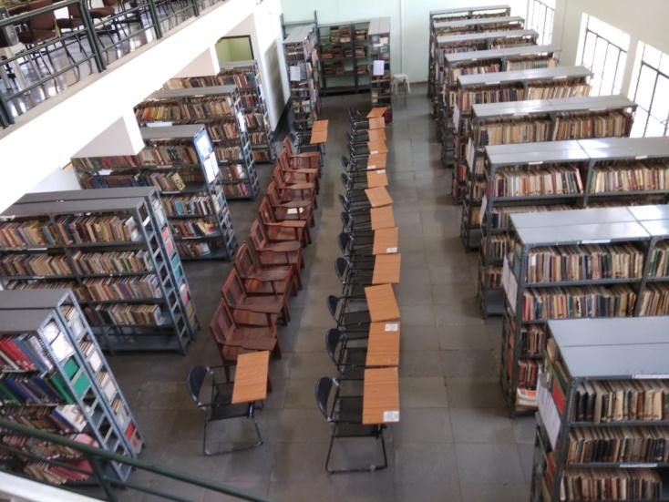
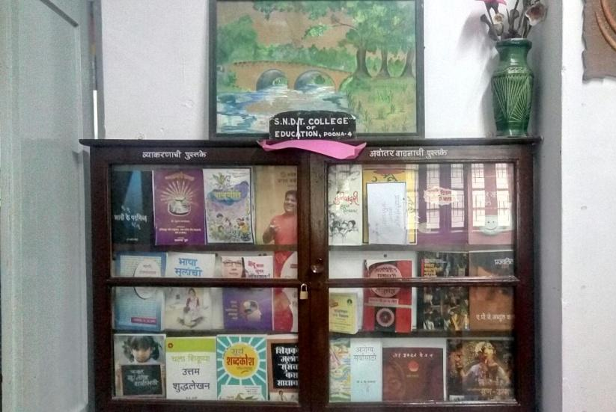
Institutes of Advanced Studies in Education

RVTEC Karnataka and SNDT Maharashtra
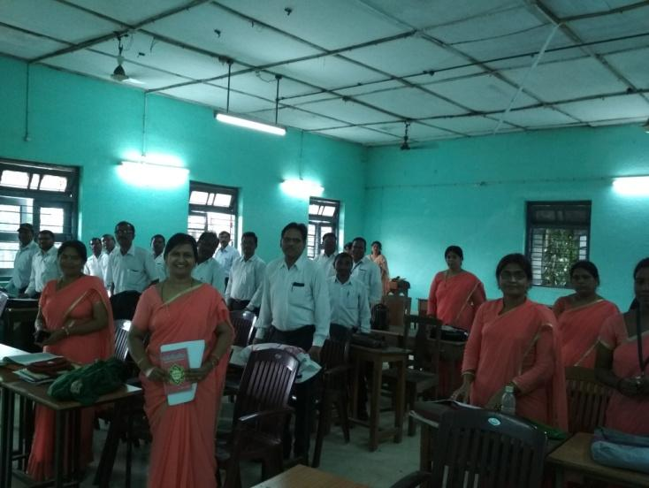
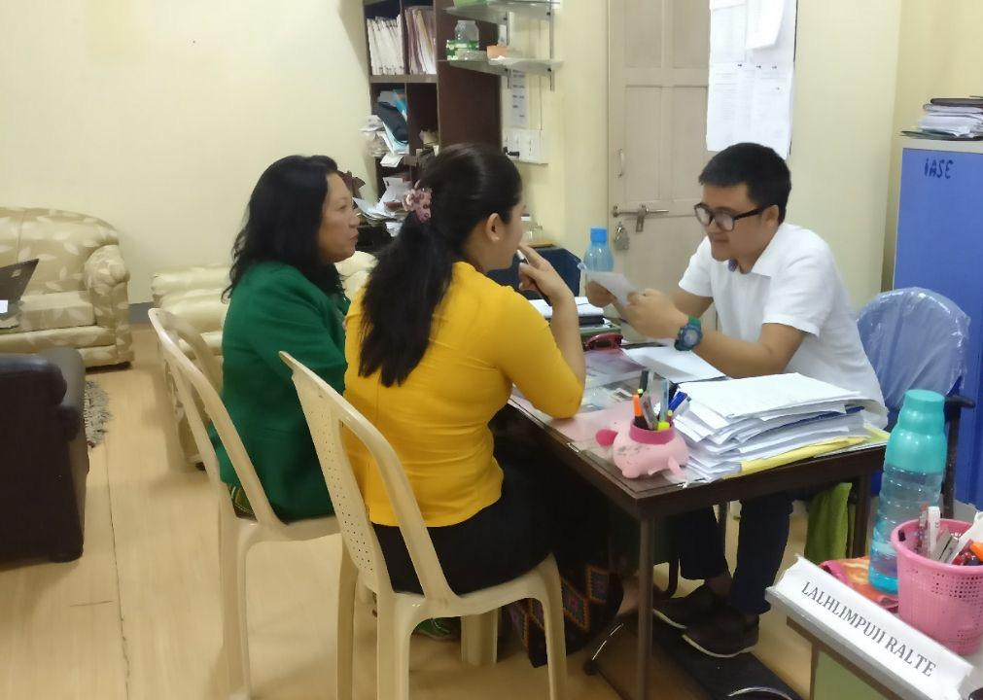
IASE, Bilaspur, Chattisgarh; IASE, Aizawl, Mizoram.

CHAPTER 4
Institutes of Advanced Studies in Education (IASE)

4.1. The context

Institutes of Advanced Studies in Education (IASE) were conceptualised to create an ecosystem for incubating excellence in the professional development of teacher educators. This vision emerged as a result of the concern which National Policy of Education 1986 (MHRD, 1986) raised about the quality of teacher education in India. It was therefore envisaged to develop IASEs into centres of excellence and research into innovations in teaching practice (MHRD, 2012). The NCERT evaluation (NCERT, 2009) of the Centrally Sponsored Scheme (CSS) on Restructuring and Reorganization of Teacher Education envisaged a guiding role of IASEs as regional resource hubs providing academic support to CTEs, DIETs and BITEs, and establishing strong linkages with BRCs and CRCs.

Key components visualised in the functioning of IASEs are as under:
- Empowering TEIs in respective states to engage in research study and in the improvement in educational methods and in curricula
- Functioning as a regional resource centre for teacher education

Primary objectives and functions of IASEs

- To work and make an impact in the field of elementary and secondary teacher education – both in pre-service as well as in in-service,
- Bear responsibility of conducting M.Ed, M.Phil and Ph.D programmes for the preparation of teacher educators,
- Integrating teacher education at all levels of school education with overall education development in states,
- Conceptualising and developing innovative courses and materials for teacher educators and conduct sustained programmes,
- To leverage education technology for effective coordination and to generate quality research output,
- To create a forum for incubating a synergy between higher education institutes, DRT and SCERT, CTEs, DIETs and BITEs

4.2. Institution description

As described above, an important academic role has been envisaged for IASEs in the domain of teacher education (MHRD, 2012). The organogram of IASEs proposed in CSSTE Guidelines 2012 (MHRD, 2012) is for a minimum of 15 academic posts and only Madhya Pradesh, Mizoram and Telangana fulfill this criterion (among the the 13 states/UTs that the TISS team visited for this evaluation study). IASE in Delhi (which is a part of the Delhi University) also fulfills this norm but it has staff from University cadre and there is no separate wing or cadre dedicated for IASE activities. IASE Aurangabad which has been upgraded from a CTE has not earmarked any academic or non-academic posts so far.

During the Evaluation Study it was noticed that a few states like Arunachal Pradesh, Bihar, Himachal Pradesh, Jharkhand, Manipur, Nagaland and union territories like Puducherry do not yet have an IASE. The CSSTE Guidelines 2012 envisaged establishment of IASEs by upgrading Departments of Education of Universities (MHRD, 2012) p.24 and even though there has been a recommendation (JRM, 2013, p6) to upgrade the Department of Education of Patna University into an IASE, and to “provide all necessary support to at least four more universities of the state for creating and developing 4 full-fledged Departments of Education under capable academic leadership, even if this means making a search at an all-India level”(op.cit.). the same has neither been sanctioned nor has it been established till date.

There are not many IASEs which function as centres situated in a university. Many IASEs rather function as independent entities affiliated to a university. Some of the better performing IASEs in the country are of this kind. For example, IASE Aizawl was upgraded from CTE (erstwhile Mizoram Institute of Education) in 2005 which was initially affiliated to North Eastern Hill University (NEHU), Shillong and subsequently got affiliation from Mizoram University. IASE Jabalpur is the new avatar of one of the oldest teacher training institutes of India established in 1889. It is now affiliated to Rani Durgawati Vishwavidyalaya, Jabalpur. On the other hand, both the IASEs in Delhi are University Departments of Education (Delhi University and Jamia Milia Islamia University). Similarly, IASE Pune is a University Department of Education, while SNDT University is approved but not fully functional as yet.

Table 4.1 below presents a picture about the sanctioned and functional IASEs in the 13 states/UTs which the TISS team visited during this study.

Table 4.1: IASE Sanctioned and Functional
Sr No. | State/UT | Number of IASEs sanctioned  (as per CSSTE Guidelines, 2012) | Number of IASEs functional (observed by TISS team, Aug-Sept, 2017)
1. | Assam | 2 | 2
2. | Bihar | 0 | 0
3. | Chhattisgarh | 1 | 1
4. | Delhi | 2 | 2
5. | Himachal Pradesh | 0 | 0
6. | Karnataka | 2 | 1
7. | Madhya Pradesh | 3 | 2
8. | Maharashtra | 2 | 2**
9. | Mizoram | 1 | 1
10. | Puducherry | 0 | 0
11. | Rajasthan | 2 | 2
12. | Telangana | 2*  (*for erstwhile Andhra Pradesh) | 1
13. | Uttar Pradesh | 3 | 1
** One IASE not fully functional - student enrolment yet to start

4.3. Staff and vacancy
As conceptualised in the CSSTE Guidelines 2012 (MHRD, 2012), a minimum of 15 faculty positions were earmarked for smooth functioning of IASEs (MHRD, 2012, p.115, Annexure VI). A variation in staff recruitment was noticed in many IASEs. Examples of transfer cases (e.g., IASE, Ajmer), and instances of deputation are widely prevalent in many IASEs (e.g., IASE, Guwahati). Encadrement of teacher educator has not been achieved in most states that the TISS team visited. Table 2 below presents data about the vacant academic and non-academic posts vis-a-vis filled ones.

Table 4.2: Academic and non-academic posts - filled and vacant
Sr No. | State/UT | Filled academic posts | Vacant academic posts | Filled non-academic posts | Vacant non-academic posts
1. | Assam | 9 | 4 | 13 | 3
2. | Bihar | -- | -- | -- | --
3. | Chhattisgarh | 12 | 3 | 16 | 18
4. | Delhi | Merged with University cadre, 1 faculty works for IASE (CIE, DU);  Data Not provided (JMI) | N.A.  Data Not provided (JMI) | Merged with University cadre (CIE, DU)  Data Not provided (JMI) | Merged with University cadre (CIE, DU)  Data Not provided (JMI)
5. | Himachal Pradesh | -- | -- | -- | --
6. | Karnataka | 10 | 0 | 13 | 0
7. | Madhya Pradesh | 19 (Bhopal) + 19 (Jabalpur) | 12 (Bhopal) +  4 (Jabalpur) | 12 (Bhopal) +  27 (Jabalpur) | 05 (Bhopal) + 09 (Jabalpur)
8. | Maharashtra | 4 (Pune) +  Not filled (Aurangabad) | 1 (Pune) +  Not filled (Aurangabad) | 0 (Pune) +  Not filled (Aurangabad) | 2 (Pune, temporary, contractual) + Not filled (Aurangabad)
9. | Mizoram | 19 | 9 | 17 | 4
10. | Puducherry | -- | -- | -- | --
11. | Rajasthan | Data not supplied as on 20 Sept 2017 | Data not supplied as on 20 Sept 2017 | Data not supplied as on 20 Sept 2017 | Data not supplied as on 20 Sept 2017
12. | Telangana | 16 | 14 | 18 | 7
13. | Uttar Pradesh | 9 | 18 | 32 | 11

Table 4.3: Consolidated vacancy data

Type of Post | % vacancy across  IASEs observed
Academic | 35.7%
Non-academic | 28.5%

4.4. IASEs in India: Survey-trends across 13 states
With respect to IASEs, the observations are summarised as under:

- Not all states have established IASE even though recommendations were made for establishment of the same (for example, Bihar, recommended in (JRM, 2013), p. 6),
- A few states have more than one IASE (for example, Delhi, Madhya Pradesh, Karnataka, Rajasthan), while a few IASEs are non functional for paucity of funds despite being upgraded from CTEs (for example, Aurangabad IASE in Maharashtra). Similar observation was made in NCERT Evaluation Study of CSSTE done in 2009 (NCERT, 2009).
- Growing use of ICT was noticed in the functioning of all IASEs. However, internet connectivity was not good at all places. A few IASEs like Aizawl and Bangalore make use of ICT in their in-service programmes for teacher educators and for other innovative practices while similar efforts were found to be less in other IASEs.

4.5. Number of institutions setup as or upgraded to IASE

In XII Plan, a select number of CTEs or GCTEs were upgraded to IASEs additionally, new IASEs were established (numbers have not been ascertained).

Table 4.4: Faculty Development and Capacity Building
States | Institutions | Faculty Development Programmes | ICT compliance & use of laptop/computer | Exposure visits undertaken/conducted | Training for New Curricula
Assam | IASE | Yes | Yes | Yes | No (one day orientation)
Bihar | IASE | -- | -- | -- | --
Chhattisgarh | IASE | Yes | Yes | Yes | Yes
Delhi | IASE 1 (CIE, DU) | Yes | Yes | Yes | No
Delhi | IASE 2 (JMI) | Yes | Yes | Yes | No
Himachal | IASE | -- | -- | -- | --
Karnataka | IASE | Yes | Yes | Yes | No
Maharashtra | IASE 1 (SNDT, Pune) | Yes | Yes | Yes | No
Maharashtra | IASE 2  (Aurangabad) | No | No | No | No
Mizoram | IASE | Yes | Yes | Yes | Yes  (also runs multi-mode progamme in BEd)
Madhya Pradesh | IASE 1  (Jabalpur) | Yes | Yes | Yes | No
Madhya Pradesh | IASE 2  (Bhopal) | Yes | Yes | Yes | No
Puducherry | -- | -- | -- | -- | --
Rajasthan | IASE | Data not provided as on 20 Sept 2017 | Data not provided as on 20 Sept 2017 | Data not provided as on 20 Sept 2017 | Data not provided as on 20 Sept 2017
Telangana | IASE | Yes | Yes | Yes | No
UP | IASE | No | No | Yes | No

All the IASEs are affiliated to some universities of their respective states and governed by the requirements of the respective universities, which include following the prescribed curricula and syllabi, examinations, and so on.

IASE Guwahati faculty members have undergone trainings conducted by IGNOU and workshop by SCERT on inclusive education. Some of these programmes were conducted through video conferencing. IASE Bilaspur faculty members talked about the workshop on research methodology which they attended at RIE Bhopal and at APF Bangalore. These events indicate the inter-sharing of ideas and interactions, although these are only in the form of trainings and not in terms of collaborations. Similar responses came from the faculty-members of IASE Hyderabad and Aizawl who spoke about refresher course on women studies and leadership training. There were however no similar evidence received from IASEs in Madhya Pradesh, Karnataka and Uttar Pradesh.

4.6. IASE as a Regional Resource Centre
As envisaged in the CSSTE Guidelines 2012, IASEs are deemed to function as an academic resource centre in the area/region where they are located. Many IASEs such as Aizawl, Bilaspur, Jabalpur are functioning as such centres. The following are the features that were noticed during the evaluation study:

4.6.1. Maintaining database of TEIs and teacher educators
A gross variation was noticed in the functioning of IASEs in their interaction with other stakeholders in their areas. While the objective is to establish a coordinated system of academic interaction and support for the CTEs, DIETs, CRCs and BRCs in their respective areas, evidence of no such interaction emerged from IASE Bhopal. On the other hand, IASE Jabalpur has charted out detailed “organisational responsibilities to coordinate with the CTEs and DIETs for implementation of the Teacher-Education Programme” (IASE, 2017). IASE Aizawl and IASE Bilaspur showed similar interactions. A few other IASEs indicated a lot of dependency on SCERT. Though IASE Jabalpur has a good interaction with CTEs, DIETs, CRCs and BRCs, they do not have academic autonomy. All the training requirements, schedule and places are decided at the SCERT, mostly not in consultation with IASEs. IASEs follow instructions received from the top. This top down approach is uni-directional and therefore a hindrance to a system of full synergy that CSSTE Guidelines 2012 (MHRD, 2012) and NCFTE 2009 visualise for teacher education programmes.

4.6.2. Training need analysis

Almost all IASEs reported that they do not conduct any need analysis for teacher educators. Rather they are directed by the SCERT or DRT or both (whichever the case may be) to schedule, plan and implement the training programmes.

4.6.3. Special courses and innovation for teacher educators
IASE Aizawl runs a 2-year B.Ed. Multimode Programme that it has developed on the recommendation of the Educational Reforms Commission Mizoram 2010 to clear the backlog of teachers without professional qualification or “untrained” in-service teachers. The intake capacity is 100 per study centre - IASE study centre and CTE study centre. This course is same as the regular B.Ed course offered by Mizoram University. This multimode B.Ed programme uses blended mode in the form of contact period (coincidently when the TISS visited IASE Aizawl, their 30-days contact classes were on) and online period. The online period is heavily ICT-dependent.

4.6.4. Modules created / materials developed for teacher educators
Most IASEs have procured books of late, many of which are written by the respective local authors. A few IASEs did not have copies of NCF-2005 and NCFTE-2009. Catalogue system in many IASEs is still maintained manually. A few journals were available (including NCERT journal) in the library. Most IASE libraries did not have textbooks of primary or middle grades since they believed the student-teachers were doing B.Ed or M.Ed and therefore only needed high school textbooks. Most IASEs do not have access to electronic journals.

4.6.5. IASE interaction with other stakeholders (SSA, RMSA, DIETs, CTEs, SCERT)
There is an evident lack of synergy between IASEs and other TEIs like SCERT, CTEs, DIETs, BITEs, CRCs and BRCs. Some IASEs like Aizawl, Jabalpur had strong connections with DIETS, BITEs, CRCs and BRCs, a few others like IASE Bhopal does not have meetings/connections with these. IASE Bilaspur takes part in the monthly meeting that SCERT conducts to assess progress of individual institutions. However, there is a lack of a platform/forum for convergence of all the institutions and structures (including SSA and RMSA) of teacher education within states.

Reports from IASE Guwahati indicated that there is a coordination mechanism in place and the stakeholders meet in forums to discuss work at least four times a year. Many other IASEs showed a synergy between CTEs, DIETs, CRCs and BRCs and not so much with SCERT, for example IASE Pune where last meeting with SCERT was held in 2012 when it was a CTE. The purpose then was to prepare a perspective plan for overall teacher education scenario in the state. It has been reported to the TISS team that the DIETs were looked down upon as it was felt that DIETs were concerned only with the primary education and therefore CTE had no role or business there. IASE Bangalore reported that there were more meetings when the funding came from the state. Meetings then were called at DSERT. IASE Jabalpur reported that there was a lack of platform for convergence, for example, one of the duties of IASE is to perform training for RMSA but this has not been given to IASE. Mizoram has two different directorates which lack in creating synergy between all the stakeholders and could not create a platform/forum to bring all the stakeholders together. Other states like Telangana and Uttar Pradesh indicated similar state of affairs.

Table 4.5 below maps the training programmes for pre-service and in-service untrained teachers and the continuous professional development (CPD) programmes conducted by different IASEs.

Table 4.5:Trainings and CPD
States | Institution | Pre-service for fresh graduates | In-service for untrained teachers | In-service CPD (SSA/RMSA/CSSTE)
Assam | IASE | Yes | Yes | Yes
Bihar | IASE | -- | -- | --
Chhattisgarh | IASE | No | Yes | Yes
Delhi | IASE 1 (CIE, DU) | Yes | No | No
Delhi | IASE 2 (JMI) | Yes | No | No
Himachal | IASE | -- | -- | --
Karnataka | IASE | Yes | Yes | No
Maharashtra | IASE 1 (SNDT, Pune) | No | No | No
Maharashtra | IASE 2 (Aurangabad) | No | No | No
Mizoram | IASE | Yes | Yes | Yes (CSSTE)
Madhya Pradesh | IASE 1 (Jabalpur) | Yes | Yes | No
Madhya Pradesh | IASE 2 (Bhopal) | Yes | Yes | No
Puducherry | IASE | -- | -- | --
Rajasthan | IASE | Data not provided as on 20 Sept 2017 | Data not provided as on 20 Sept 2017 | Data not provided as on 20 Sept 2017
Telangana | IASE | Yes | Yes | No
UP | IASE | No | No | No

Table 4.6 below presents training management system usage data and research activities and their outcomes details.
Table 4.6: Management and different activities
States | Institution | Use of training management system | Research studies conducted (by student-teachers) | Research studies conducted (by faculty-members) | Number of publication by faculty-members (conference/seminar presentations, reports, newspaper/journal articles, books etc)
Assam | IASE | No | Yes | Yes | 4
Bihar | IASE | -- | -- | -- | --
Chhattisgarh | IASE | No | Yes (only action research) | Yes (only action research) | 6
Delhi | IASE 1 (CIE, DU) | No Data | Yes | Yes | No Data
Delhi | IASE 2 (JMI) | No Data | Yes | Yes | No Data
Himachal | IASE | -- | -- | -- | --
Karnataka | IASE | No | No | Yes (only action research) | 2
Maharashtra | IASE 1  (SNDT, Pune) | No | No | No | N.A.**
Maharashtra | IASE 2 (Aurangabad) | No | No | No | N.A.**
Mizoram | IASE | Yes | Yes (UGC-funded minor project) | Yes | 20
Madhya Pradesh | IASE1 (Jabalpur) | No | Yes (only action research) | Yes (only action research) | 3
Madhya Pradesh | IASE 2  (Bhopal) | No | Yes (only action research) | Yes (only action research) | No data
Puducherry | IASE | -- | -- | -- | --
Rajasthan | IASE | No data | No data | No data | No data
Telangana | IASE | No data | No data | No data | 0
UP | IASE | No | No | No | 0
** upgraded from CTE to IASE recently, publication not as IASE faculty so far

A few members on the faculty mentioned that they were not aware of what a Training Management System (TMS) was. Staff of IASE Pune was not clear, either, about TMS. The only training management system that they have is the yearly update that they are expected to send to the UGC. This particular update requires the teacher educators to fill in their qualifications and the details of the training programmes that they attended, the programmes that they conducted in the IASE, feedback from the students and feedback from the Principal.

4.6.6. Narratives about most ‘talked-about’ process improvement in IASE (past one year)

There have been several narratives about the initiatives that happened due to CSSTE funds. Here are some narratives from a few states:

Assam:
1. Number of trained teachers have increased.
2. We have good expertise as we directly deal with teachers.

Chattisgarh: Teachers’ qualification are seen as a boon among teachers. So teachers who wanted to pursue higher education are moving in that direction. A lot of change in quality of discussion regarding pedagogy and transaction.

Karnataka: RTE has been useful, earlier there were some problems which have reduced. Public have started accepting it. Also there were reports on difference shown by institute. Quality of education has improved because student activity is more instead of teacher dominant activity. This is based on classroom. Student teachers are very interactive compared to earlier years.

Madhya Pradesh:
1) Curriculum reforms of DElEd, BEd MEd courses
2) Text books at elementary and secondary level have been made according to NCF 2005
3) Development of TMS

Mizoram: More structured, much attributed to NCTE. Pre 2012 there was nothing much but compliance. State plans helped in establishing TE centers, DIETs.

Telangana: Digitalization of textbook content, coordinated presentation of lessons through satellite, to promulgate the RTE

There has however been no feedback on the in-service programmes by secondary school teachers or no records thereof.
4.6.7. Funds flow
Fund flow under the CSSTE has been instrumental in the functioning of several TEIs including IASEs. This was evident from the functioning and infrastructural facilities available at some of the IASEs that the TISS team visited. However, there are instances of hindrances due of lack of funds flow that emerged from the field. The box below presents such one such narrative:

IASE Pune is situated in SNDT University that is in a sense resource rich, also evident in the infrastructure available to them and middle class background of the teacher educators. Most notable though is the way the Principal and teacher educators ‘view’ the role of IASE. IASE was upgraded from a B. Ed college which was set up in 1962 and which was later converted into a University Department of Education in 2013. It established a College of Education (CTE) which offered both M. Ed. and B. Ed. As per the government’s recommendation this CTE was then upgraded into an IASE and funds were sanctioned. Funds were received only once under the IASE upgradation. After the fund flow stopped, the College doesn’t see itself doing any of the IASE duties that it was mandated to do, namely, conducting in-service teacher training for secondary school teachers or senior secondary school teachers. Neither does it collaborate with CTEs in any capacity, though there are 6 CTEs under each IASE. It collaborated once with the CTE and SCERT when it was to prepare a perspective plan and a budget in the year 2012. This separation of IASE and the University Department, due to lack of funds, is a major source of discomfort for Principal and the faculty in responding to any questions related to CSSTE scheme as they were not doing any activity related to the IASE part of their functioning.

4.6.8. Infrastructure and facilities

Most IASEs visited by the TISS team meet the MHRD guidelines for infrastructural facilities. Most IASEs have their own buildings although a few of these need immediate renovation and facelift, for example, IASE Hyderabad and Bhopal. Interestingly, this same observation was reported in the NCERT Evaluation Report of CSSTE in 2009 but evidently not much has happened in this context since then. There are examples of space crunch as was noticed in IASE Aizawl, in spite of which it showcases features of a model IASE in the country.

Table 4.7 Infrastructure availability at IASEs
Infrastructure | Availability of infrastructural facility in IASE*  *(No data from IASE Pune, Lucknow & Ajmer) | Number of IASEs* with this facility  *(No data for IASE Pune, Lucknow & Ajmer)
Room for Head/Principal | Yes | 10
Staff room | Yes | 10
Classrooms | Yes | 10
Multipurpose hall | Many IASEs use multipurpose halls as regular classrooms | 10
Library | Yes | 10
Resource room | Most of IASEs have resource room except for IASE Bangalore, Bhopal and Hyderabad.  IASE Aurangabad has a resource room but it is not functional. | 9
Laboratories | Except for IASE Aurangabad, all other IASEs have laboratories. | 9
Storerooms | Except for IASE Hyderabad, all other IASEs have store room. | 9
Seminar Rooms | Except for IASE Hyderabad, all other IASEs have Seminar Rooms. | 9
Auditorium (if separate from multipurpose hall) | No, only IASE Bilaspur, Bangalore, Bhopal, and Jabalpur have an auditorium. | 4
ICT lab | Yes | 10
Separate toilets for men and women (staff) | Except for IASE CIE Delhi, all of them have a separate toilet for men and women | 9
Separate toilets for me and women (students) | Yes | 10
Auditorium | No, only IASE Bilaspur, Bangalore, Bhopal, Jamia Milia Islamia and Jabalpur have an auditorium. | 5
Hostels for men | Except for IASE Hyderabad all other have., but existing hostel facilities are poor (not maintained, no drinking water, etc.). New construction is in progress | 10
Hostel for women | Except for IASE Aurangabad, Guwahati and Hyderabad, all other IASEs have hostel facilities for women. IASE Guwahati has a hostel but not functional yet. | 7
Drinking water facility | No, IASE Aurangabad does not have drinking water facility. | 9
Staff Quarters | No, IASE Bangalore, Bhopal, Aurangabad, Aizwal and Hyderabad has not staff quarters. | 5
Office administration room | Yes | 10
Electricity (on day of Visit) | Yes | 10
Generator Backup | No, IASE Bilaspur, Jabalpur and Hyderabad does not have a generator backup.  All other IASEs have either a generator or a Inverter. | 7
Internet Connection | Yes | 10
Website | Yes | 10
Boundary Wall | Yes, IASE Bhopal shares the wall with other institutions. | 10
Playground | No, IASE Guwahati, Bhopal, Aurangabad and Hyderabad has either no playground or is not proper. | 6

4.6.9. Computer centre/lab
Computer and ICT use was noticed in all the IASEs visited by TISS team. Number of computers, printers, internet facility and availability of other accessories varied between institutions. In some IASEs, internet connectivity was not uninterrupted and computer labs in all IASEs were not fully functional. None of the IASEs seemed to be having add-on computer facilities for the physically challenged persons.

4.6.10. Use of ICT during in-service training programmes
It was noticed that use of ICT has remained restricted to use of presentations during teaching (most IASEs reported this), use of smart classrooms, and use of online admission process (most IASEs). Leveraging technology through its innovative use was not evident in most IASEs. A few exceptions were IASE Hyderabad that uses MOOCs in their courses, and IASE Aizawl that runs a multi-mode B.Ed. in-service programme for regular untrained teachers. IASE Lucknow reported that due to poor availability of electricity, use of technology remains restricted.
Another exception are the IASEs in Maharashtra - Aurangabad and Pune - that are still not fully functional, and reported that in-service training programmes are not happening due to lack of funds. Faculty-members spend time drawing students from different B.Ed colleges for their M.Ed programme.

4.6.11. Library and reading room
All the IASEs visited have a library with reading rooms and sufficient number of books as per MHRD guidelines, but in many institutions latest publications were not available. Important curricular documents like copies of NCF 2005, NCFTE 2009 could not be found in a few IASEs. In a few cases, the space available for the library and the reading room were found to be inadequate. An interaction with the pre-service student-teachers also revealed the same fact. In a few IASEs, the post of librarian lay vacant.

4.6.12. Laboratories
Almost all IASEs visited by the TISS team had a functional computer lab with varying degree of internet connectivity and computer availability. Some IASEs like Aurangabad in Maharashtra, however, do not have a designated science laboratory. Though IASE Guwahati has designated one room as a science lab, it is used as a regular classroom. Many IASEs do not have a language laboratory.

4.7. Summary

There is a variation in terms of resource allocation, infrastructure availability and functioning of IASEs in India. While a few IASEs are better resourced and executing their roles as “regional resource centres” and “academic mentors” to other stakeholders, there are IASEs which are waiting for both academic and non-academic posts or struggling due to lack of funds. A lack of synergy was noticed in most states due to the presence of two different academic heads which lead to non-consultation on training requirements and duplication of trainings. Areas of improvement can be focussed on systematic and effective leverage of ICT in the routine functioning of IASEs and not just limited to use of classroom presentations and admission processes. Similarly, research work only leading to use of action research as a methodology needs to be discussed and thought about. Major focus and emphasis is required towards well planned research studies conducted by faculty-members which are qualitatively effective than research conducted just for the sake of doing them. Annual conferences for teacher educators and the larger teacher community can provide a platform for further deliberation.

CHAPTER 5

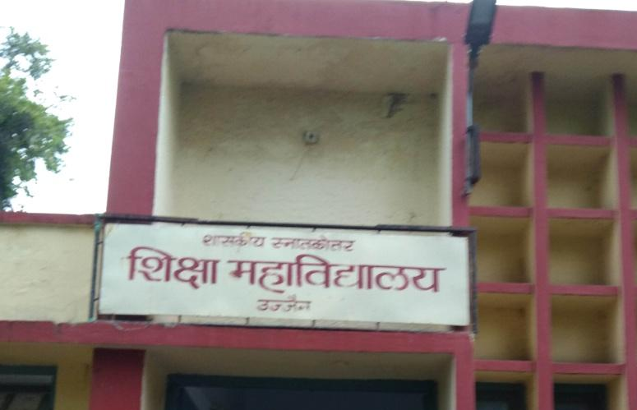
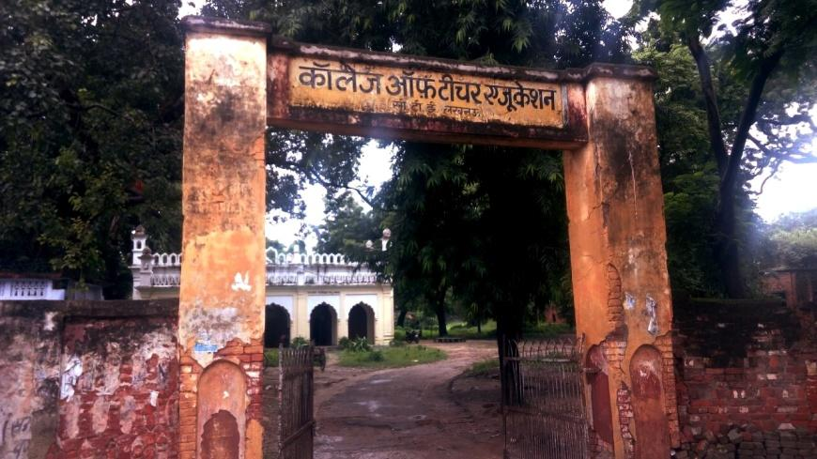
Colleges of Teacher Education

CTE, Ujjain: Madhya Pradesh and CTE, Lucknow: Uttar Pradesh
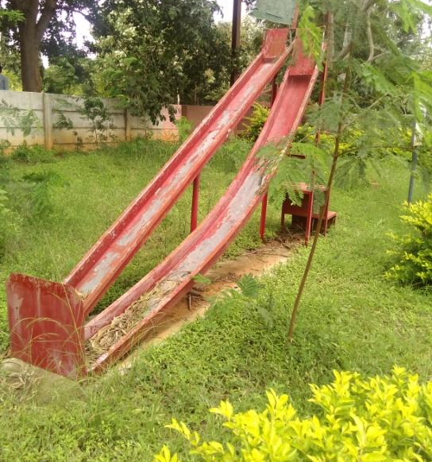
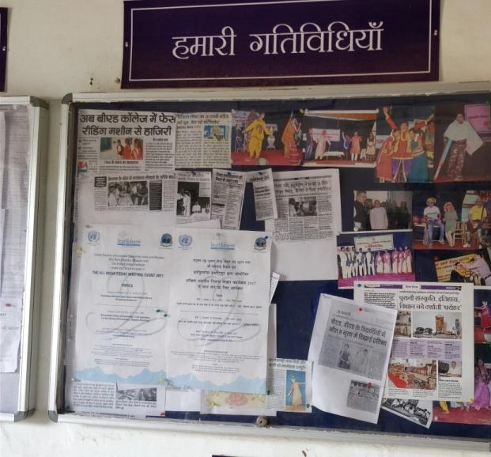
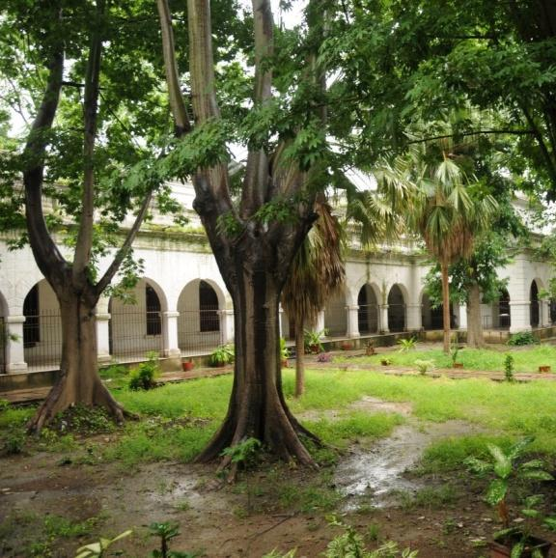
From Left: CTE and IASE, Jabalpur: Madhya Pradesh
CTE Raipur, Chhattisgarh and CTE Science Park, Mysore: Karnataka

CHAPTER 5
College of Teacher Education (CTE)

The Colleges of Teacher Education (CTEs) offer in-service training to secondary and higher secondary teachers and teacher educators. Following the Right to Education Act (RTE, 2009), it was imperative to take steps to equip teachers with the capacity to achieve the vision of providing free and compulsory education to children between 6 to 14 years. The CTEs were therefore assigned the responsibilities of pre- and in-service training for secondary and higher secondary school teachers. It was envisioned that the CTEs will coordinate with the District Education Officers regarding the short-term and long-term needs of secondary school teachers, particularly under the RMSA plans. Meticulous planning for subject-specific in-service training was required alongside the preparation of handbooks for teachers. The CTEs were expected to develop perspective plans and annual work plans that included plans for infrastructure development, financial planning and budgeting, projection of expenditure and sources of income to meet the institute goals (MHRD, 2012). Annual work plans were expected to present details of CTEs’ performance against identified indicators.

Primary functions of CTEs
- Perform needs analysis and conduct baseline surveys to design appropriate trainings materials
- Prepare implementation guidelines for planning and executing training activities and projects
- Conduct impact studies to examine classroom processes
- Study learning outcomes after training programs for impact
- Maintain updated database of secondary schools and teachers

5.1 Process and Performance Indicators: Government of India Guidelines, 2012

In order to achieve the goals for excellence in teacher training, the CTEs are expected to collaborate with other academic institutions like the IASEs to work towards capacity building of CTE faculties in academic and research domains. CTE as an institution is expected have adequate infrastructure availability to support these activities with an intake of 100 students for a B.Ed. course, and an academic staff of 1 principal, 3 readers and 13 lecturers (total of 17). It must have an academic area of about 5 acres with sufficient number of rooms and an administrative wing to support its activities. A library equipped with about 10,000 books, at least 10 professional journals and a seating capacity of 50 students has been envisaged in the CSSTE Guidelines 2012 (MHRD, 2012). Necessary audio-visual (AV) and computer equipment must be present and actively used in the teaching-learning process. It is also desirable to have separate hostels for men and women in every CTE with a minimum capacity of 150 each at a given time, with adequate provision for recreation like availability of playgrounds for games, athletics and physical activities. The CSSTE Guidelines 2012 has emphasised on increased use of technology and integrating it with education (MHRD, 2012).

CTEs are also expected to follow the 1989 guidelines for the number of trainings to be conducted and the number of teachers to be trained under ISTE. Subject-based courses are to be of 3-4 week long duration, while theme based courses must be 3-10 days long. The institutions are required to view their PSTE and ISTE activities as a continuum, and institutionalise a training management system to track the number of teachers trained, their training needs and their professional and educational qualifications. An annual in-service training planned in coordination with RMSA is desirable. Further, their vision for the trainings are required to align with the NCFTE 2009, with an extensive use of ICT.

PSTE is a required as part of CTEs’ Annual Work Plan (AWP). The CTEs must maintain records of the feedback to the course, the number of secondary teachers qualified through the institution, their success ratio in the pre-service examination and the percentage of CTE students who have cleared the Teacher Eligibility Test (TET). Alongside conducting subject- and theme-based workshops, CTEs must take cognisance of the percentage of faculty participants attending them. They are also required to conduct faculty development and research workshops, facilitate workshop series in coordination with the centre and state that engages experts as participants. ICT must also be actively incorporated for the professional development of faculty.

Networking and collaborations with other academic institutions like SSA, RMSA, IASEs, DIETs and SCERTs comprise part of CTE responsibilities. This involves not just professional development of faculty but also linkages with schools. Areas where support can be provided include creating supplementary materials and teaching aids, as well as addressing issues on pedagogy, assessments, aims of education and schools and society, among others.

Research studies are a critical facet of CTEs’ responsibilities to ensure quality education in schools. CTEs must identify experimental schools to conduct pilot research and studies. Field visits must be planned and conducted systematically with 2-3 subject experts to study the impact of the in-service trainings. Individual research must also be conducted on children’s understanding of concepts, on child development, review of textbooks and educational materials. CTEs are expected to conduct workshops on research methodology and guide school teachers in conducting action research in their classrooms.

5.2. CTEs in India: A Survey

As mentioned before, this study covers select CTEs across 13 states in India. A variety of tools, both quantitative as well as qualitative, were used to study the role of the CTE in teacher education, their existing infrastructure, faculty contribution to teaching and research, fund flow and staffing, and their collaborations with other educational bodies, among others, to gauge their ability and performance to meet the CSSTE guidelines.

The selected components of observation and analysis in this study are
● Vacancies of academic and non-academic staff
● Faculty development and capacity building
● Pre- and In-service training and continuous professional development
● Research, publications and materials development
● Interaction and collaboration
● Infrastructure and CTE resources

Other indicators included in the study are the perceptions of faculty, students and institutional heads of the challenges faced and possible measures that would help them function more effectively. The sections below present the key findings from this study.

5.2.1. Faculty Profile and Vacancies
As the core component of teaching, faculty qualifications are often equated with their ability to teach effectively. Current norms under the NCTE require a post-graduate degree in Education and a NET/TET in Education as eligibility criteria for teaching in CTEs. There is a necessity of a sufficient number of faculty in each CTE for the institute to efficiently function.

Table 5.1 presents the vacancy scenario in select CTEs across the states
Number of CTEs reporting vacancies
State | Total Institutions Covered | Academic Vacancies |  |  |  |  | Non-Academic Vacancies
State | Total Institutions Covered | Filled | <25% | 25%-50% | 50-75% | >75% | Filled | <25% | 25%-50% | 50-75% | >75%
Assam | 2 |  |  | 1 |  | 1 |  |  | 2
Bihar | 2 | 1 |  |  | 1 |  |  | 1 |  | 1
Chhattisgarh | 1 |  |  |  | 1 |  |  |  | 1
Delhi | 0
Himachal Pradesh | 1 |  |  | 1 |  |  |  |  | 1
Karnataka | 2 |  |  |  | 1 | 1 |  |  |  |  | 1
Madhya Pradesh | 2 |  |  | 1 | 1 |  |  | 1 | 1
Maharashtra | 2 |  |  |  | 2 |  |  |  | 2
Mizoram | 0
Puducherry | 1 |  |  |  | 1 |  |  |  | 1
Rajasthan | 2 |  |  | 1 | 1 |  |  | 2
Telangana | 2 |  |  | 1
Uttar Pradesh | 2 |  |  | 1 | 1 |  |  |  | 2

The table shows that with the exception of Bihar, all the states and institutions visited have vacant academic and non-academic posts. The percentages of vacancies vary between 25-75% with 2 CTEs having more than 75% vacancy (one each in Assam and Karnataka). Most noticeable is the complete absence of CTEs that have filled all their non-academic positions. Vacancies therein implies that faculty and the employed staff have to work harder to reach the institution’s set goals. Equally worrisome are the high number of institutions that have vacant academic positions. It is evident that these vacancies will have a negative impact on the execution of academic responsibilities.

5.2.2. Faculty Development and Capacity Building

Continuous professional development and capacity building become necessary to ensure consistency and quality in pedagogic and content knowledge. It is also necessary to align these with the recommendations of NCF 2005 and NCFTE 2009. It was observed that faculty belonged to one of three broad categories:
- Administrative officers who do not contribute much to teaching and research
- Fresh faculty in need of training and teaching experience
- Seasoned academicians who focus principally on teaching and research
The challenges herein are to identify and offer relevant capacity building programs to update faculty knowledge. Also problematic are the constant shifting of faculty between the academic and administrative domains. This leads to fragmented visions in training and diluting of capabilities and calls for the need to retain faculty in a given position for a sustained period of time. Some questions to consider are how to reconcile the needs and capabilities of these different kinds of practitioners towards quality teacher education programs. How can teacher education draw on individual expertise in a timely and systematic manner to meet the larger vision of the CSSTE?

Table 5.2 presents responses by faculty to different aspects that can enhance their productivity as teacher educators. Provision of personal computers and laptops in the workspace can aid, simultaneously, in integrating ICT into their work and help in individual and institutional research. Exposure visits to other institutions contribute towards understanding best practices as well as creation of learning communities and peer interaction to face challenges in the workplace. Training in the new curriculum is necessary not simply to meet immediate requirements of the classroom but also to orient the faculty to the pedagogies of NCFTE (NCTE, 2009).

Table 5.2: Faculty Development and Capacity Building in CTEs
States |  | Faculty Development Programs | Laptop / Computers | Exposure visit | Training for New Curricula
Assam | CTE 1 | F1: Y (2013-14) | F1: No | F1: No | F1: No
Bihar | CTE 1 | F1: Y | F1: Y | F1: Y | F1: No
Chhattisgarh | CTE 1 | F1: No | F1: No, but has personal one | F1: Y, for consultancy | -
Himachal | CTE 1 | F1: Y | F1 : No | F1 : No | F1: No
Karnataka | CTE 1 | F1: Y | F1: Y | F1: Y | F1: Y, but not effective
Karnataka | CTE 2 | F1: Y | F1: Y | F1: F1: Y | -
Maharashtra | CTE 1 | F1: After 2009, no | F1: No | F1: No | F1: Y
Maharashtra | CTE 2 | F1: Y  F2: Y | F1: Y  F2: Y | F1: Y, for exam visit; F2: No | F1: Y  F2: No resp
Mizoram | No CTEs | NA | NA | NA | NA
Madhya Pradesh | CTE 1 | F1: No  F2: Y | F1: Y  F2: No | F1: No  F2: Y | F1: No (Sr)  F2: Y (Jr)
Puducherry | CTE 1 | Y | Y | - | Y
Rajasthan | CTE 1 | Y | Y | No | No
Telangana | CTE 1 | F1: No  F2: No | F1: No  F2: No | F1: No  F2: No | F1: No  F2: No resp.
Telangana | CTE 2 | F1: Y  F2: No | F1: Y  F2: No | F1: Y  F2: No | F1: Y  F2: No
*F1, F2 … refer to number of faculty interviewed | CTE 1, CTE 2 … refer to CTEs visited per state

Most noticeable in the responses to the items is the faculties’ lack of orientation into the new curriculum, with a large majority providing negative response. Access to computers and laptop with an internet connection is also not uniform. In most institutes, these are available on a shared basis. Most of the work on computers is restricted to administrative tasks like entering attendance and marks. Very few instances were observed of the faculty using computers for research. Exposure visits also appear sporadic and unstructured. A large number of faculty remarked across states that they felt intellectually isolated, suggesting that the visits that are occurring are not adequately contributing to knowledge building.

5.2.3. Pre- and In-Service Trainings and Continuous Professional Development

CTEs are mandated to engage in different kinds of teacher training activities. Apart from the pre-service training of fresh graduates, faculty at CTEs must conduct in-service training programs and attend continuous professional development workshops themselves. Faculties’ perception of these trainings and their use in the teaching profession, the positioning of policies with respect to training and professional development programmes, its translation into action and the positioning of funds affect teacher education programs to varying extents. One important aspect of this study is to capture the faculties’ notion of quality, their perception of teaching as a profession and their responses’ proximity to progressive thought. How do these perceptions relate to the different trainings they participate in and conduct? Annexure IV indicates the pre-service, in-service and professional trainings undertaken by the faculty in the last 3 years.

A large proportion of work by faculty is channeled towards pre-service training of fresh graduates. A large number of the training programmes were conducted with outsourced resource persons, with the CTEs functioning only as the coordinating agencies. Another problematic situation is the nature of continuous professional development programmes attended by the faculty-members. A few faculty-members stated in their discussions and interviews with the TISS team that lack of information about training programmes prevent them from participating more actively in the programmes. Yet another deterrent is the inadequate funds to support their engagement in these programmes. It was also remarked by some faculty-members that there was a need to have better training for ICT that is currently lacking.

On the other hand, in most CTEs, in-service trainings are not as frequent. One common reason given was limited faculty and vacant positions that restricted CTEs from engaging more fully with training programmes. A few exceptions are CTE Chhapra in Bihar and CTE Lucknow in UP. While CTE Chhapra is currently focussing only on ISTE to clear the backlog of large scale newly recruited untrained teachers, CTE Lucknow is neither engaged in PSTE nor in ISTE.

5.2.4. Research, Publications and Material Development
Faculties’ responses across states on their research activities have been varied (refer to Annexure V). A major gap perceived has been in research that underlies meaningful training programmes. There seems to be a dearth of structured study into the needs of teachers and subsequent follow-ups to determine the impact of trainings conducted. Research in baseline, impact studies and learner outcomes, which are outlined by the CSSTE as necessary research that CTEs must conduct in schools, appear missing. In some cases, they are sporadic. Lack of a systematic and sustained research in CTEs is, however, an overall gap perceived across states. Also noteworthy is the inconsistency of responses of CTEs to the same item within the same state. For instance, while one faculty at one CTE in Telangana (Warangal) displayed ignorance of training programs, other faculty at Mahbubnagar have actively pursued trainings and materials development.

Individual research and publications are inconsistent across states. CTEs in Puducherry, Chhattisgarh and Karnataka, for instance, have motivated and intellectually active faculty who pursue research and publish their works. Telangana and Uttar Pradesh, by contrast, do not show active research. CTEs within a state presented different academic scenario, for instance being the two CTEs visited in Bihar (Chhapra and Turki). While CTE Turki appeared to be active in research, no similar evidence was visible in CTE Chhapra. It is possible to link research output to infrastructure support and opportunities for academic collaborations. States where faculty have greater autonomy and access to internet and computers display greater academic initiatives than states without this support.

Developing curricular materials to support schools in their vicinity is an identified role that a CTE must play as per CSSTE norms. Material development must happen based on needs analysis and surveys. Other materials developed can be Teaching and Learning Materials (TLMs) deployed in the CTE classrooms to teach pre- and in-service teachers. Questions on materials development yielded interesting responses. While some faculty initially stated in FGDs that they had not developed any materials, further probing revealed that they had, indeed, worked on textbook developments, lesson plans and teaching learning materials for their classes that went beyond the regular textbooks. This could suggest that faculty view textbook based activities as separate from materials development. It also indicates lack of clarity on their academic and institutional roles in their organisation.

5.2.5. Interaction and Collaboration

Interaction with other educational institutions remains sporadic. The interactions can be classified into two broad kinds.
- Interaction with DIETs, IASEs and SCERTs for purposes of training and outreach of the faculty of these institutions.
- Interaction with schools, monitoring activities, impact of teacher training programs and classroom processes in schools.

There is a high level of negative response for interactions with BRCs and CRCs in the CTEs visited for this study . The larger trend of responses indicates that in the CTEs that have adopted curricular changes in pursuant of the NCFTE 2009, supervision of student-teacher internships are the primary points of active collaboration with schools. The increase in course duration of the B.Ed. to two years seems to have aided this interaction because of the longer duration of internship. Other collaborative activities that pertain to research or publications, exposure visits, exchange programs and impact studies are largely absent. Several heads of CTEs, in effect, requested for such measures and communication of information that will help them send their faculty for interactions with their peers in other organisations. One principal expressed the need for an online portal that involves all teacher training institutes in a district, which can help convey information and encourage further interactions between peers. A major gap seemed to be disrupted flow of information about workshops and training programs, which translates into lack of opportunities for teachers. Another challenge articulated was lack of funds to sponsor faculty for conferences.
Interviews with faculty members and principals in CTEs revealed details of academic interactions and collaborations. All CTEs except for one each in Assam and Chhattisgarh reported that they do not have any academic interaction with BRCs and CRCs. Academic interactions reported by Assam and Chhattisgarh CTEs are limited to conducting training and capacity building programmes. Similarly no CTE reported academic interaction with SCERT and only three CTEs (one each in Assam, Madhya Pradesh and Rajasthan) informed about occasional interaction with IASE for training programmes. Every CTE, except Madhya Pradesh, indicated that they are attached with a school nearby for internship of their students. However, many CTEs namely, Bihar, Chhattisgarh, Karnataka, Maharashtra, Madhya Pradesh and Puducherry, reported about their collaboration and interaction with NGOs.

In some states, collaborative work with some NGOs was noticed, but none of these were formalised. Also evident was the sporadic, and in some states, almost no instances of visits by senior officials from the SCERT, SSA, RMSA and IASEs to the institutes. However there are evidence where CTE are visited by SCERT faculty however 33% of CTE are not visited by SCERT faculty. .

5.2.6. Infrastructure and CTE Resources

Interviews with faculty and heads of CTEs on the availability of resources and required infrastructure were supplemented by observations at the sites.

The table below illustrates the availability of infrastructure and its use in the CTEs visited.

Table 5.3: Infrastructure and Resources in CTEs
 | Number of CTEs recording 'Yes' as response
State | Assam | Bihar | Chhattisgarh | Delhi | Himachal Pradesh | Karnataka | Madhya Pradesh | Maharashtra | Mizoram | Puducherry | Rajasthan | Telangana | Uttar Pradesh
Total Covered (N) | 2 | 2 | 1 |  | 1 | 2 | 2 |  |  | 1 |  | 2 | 2
Room for head/principal | 2 | 2 | 1 |  |  | 2 | 2 |  |  | 1 |  | 2 | 2
Staff room | 2 | 1 | 1 |  | 1 | 2 | 2 |  |  | 1 |  | 2 | 2
Classrooms | 2 | 2 | 1 |  | 1 | 2 | 2 |  |  | 1 |  | 2
Multipurpose hall |  | 1 | 1 |  | 1 | 2 | 2 |  |  | 1 |  | 2 | 2
Library | 2 | 2 | 1 |  | 1 | 2 | 2 |  |  | 1 |  | 2 | 2
Resource room |  | 1 | 1 |  |  | 1 | 1 |  |  |  |  | 1 | 1
Labs | 1 | 2 | 1 |  |  | 2 | 2 |  |  | 1 |  | 2
Storerooms | 2 | 2 | 1 |  | 1 | 2 | 2 |  |  |  |  | 2 | 1
Seminar Rooms |  |  | 1 |  | 1 | 1 | 2 |  |  |  |  | 1 | 1
Auditorium (if separate from multipurpose hall) |  |  |  |  | 1 | 2 | 1 |  |  | 1
ICT lab | 2 |  | 1 |  | 1 | 2 | 2 |  |  | 1 |  | 2
Separate toilets for men and women (staff) | 2 | 1 |  |  | 1 | 2 | 2 |  |  | 1 |  | 2 | 1
Separate toilets for men and women (students) | 2 | 2 | 1 |  | 1 | 2 | 1 |  |  | 1 |  | 1 | 1
Hostels for men | 1 |  |  |  |  |  | 1 |  |  |  |  |  | 1
Hostel for women |  |  | 1 |  | 1 | 1 | 1 |  |  |  |  |  | 1
Drinking water facility | 2 | 2 | 1 |  | 1 | 2 | 2 |  |  | 1 |  | 1 | 2
Canteen | 1 |  | 1 |  |  |  | 2 |  |  |  |  |  | 1
Staff Quarters | 1 | 1 | 1 |  | 1 |  | 1 |  |  |  |  | 1 | 1
Office administration room | 2 | 2 | 1 |  |  | 2 | 2 |  |  | 1 |  | 2 | 1
AV Equipment | 1 | 1 | 1 |  |  | 2 | 2 |  |  | 1 |  | 1
Computer Equipment in lab for students | 2 | 1 | 1 |  |  | 2 | 2 |  |  |  |  | 2
ICT in principal room | 1 | 1 | 1 |  |  | 1 | 2 |  |  | 1 |  | 1
ICT in staff room |  | 1 | 1 |  | 1 | 1 | 2 |  |  | 1
ICT for administration room | 2 | 2 | 1 |  | 1 | 2 | 2 |  |  | 1 |  | 1 | 1
Recreational equipment | 1 |  | 1 |  | 1 | 1 | 2 |  |  | 1 |  | 1
Resources and TLMs | 2 | 1 | 1 |  | 1 | 1 | 2 |  |  |  |  | 1
Lab equipment | 2 | 2 | 1 |  | 1 | 1 | 1 |  |  | 1 |  | 1
Library books: | 2 | 2 | 1 |  | 1 | 1 | 2 |  |  | 1 |  | 2 | 2
Does the institution have electricity? | 2 | 2 | 1 |  | 1 | 2 | 2 |  |  | 1 |  | 2 | 2
Does it have backup generator? | 1 | 1 |  |  |  | 2 | 1 |  |  | 1
Does it have well ventilated rooms and fans? | 2 | 1 | 1 |  | 1 | 2 | 2 |  |  | 1 |  | 1 | 2
Does it have internet connection? | 2 | 2 | 1 |  | 1 | 1 | 2 |  |  | 1 |  | 2 | 1
Was the internet working on the day of your visit? | 2 |  | 1 |  | 1 | 2 | 2 |  |  | 1 |  | 1 | 1
Was there electricity on the day of your visit? | 2 | 1 | 1 |  | 1 | 1 | 2 |  |  | 1 |  | 2 | 2
Does the institute have a website? | 2 | 2 | 1 |  | 1 | 1 | 2 |  |  | 1 |  | 2
What is on the website? |  |  |  |  |  | 1
Boundary wall | 2 |  |  |  | 1 | 2 | 2 |  |  | 1 |  | 1 | 2
Surroundings
Playgrounds |  |  | 1 |  | 1 | 1 | 1 |  |  |  |  | 2 | 1
Accessibility (please also note the transport used to reach by students and staff and teachers) | 1 | 2 | 1 |  | 1 | 2 | 1 |  |  | 1 |  | 1 | 2
There was no common trend in infrastructure observed across the states. Some CTEs were functional with open, well ventilated brick buildings and classrooms. Others, by contrast, were dingy with an over-growth of plants and vegetation, for instance, CTE Lucknow and Chhapra. TISS team was informed that a major portion of the land of CTE Chhapra was “usurped” by the railways which has constructed a museum and the CTE is functioning in the old, dilapidated building with no staff quarter or hostel for students. A common complaint across CTEs however, was lack of funds for their maintenance. Computer and ICT labs in most states did not have internet connections for every machine. Some were intentionally not provided since the institute felt that students do not need internet for preparing presentations or writing reports. They could take turns on machines that had internet, based on need and availability. The same practice was extended to faculty who, in a majority of colleges, do not have a dedicated work space computer with internet, but work on and with shared resources. Few libraries were functional, and none had the required numbers of books (10,000) and journals, as stipulated in the CSSTE. Most libraries did not have copies of NCF 2005 and NCFTE 2009.

5.3. Observations and Challenges on the Field

At a CTE in Jabalpur, a faculty opined that the role of teachers must be clearly defined and fixed. This comment is relevant in light of the findings in this study. From lack of clarity of their responsibilities to ignorance of relevant subject knowledge, teacher education faces multiple challenges. A faculty member in CTE Chhapra in Bihar stated that they get into diverse non-academic work that hinders their routine. Many faculty-members are not clear of the three broad kinds of research they are required to conduct as part of their institutional roles:

- Needs analysis, impact and learner outcomes studies for in-service teacher training programs,
- Research as providers of content and pedagogical support to schools and
- Individualised subject-specialisation research as academicians in their own rights.

This study reveals that there is negligible research on the needs of school teachers and impact or learner outcome studies leading to the future design of appropriate training workshops. The faculty development workshops attended by the faculty are also sporadic and unstructured, with lack of clarity on its goal or use. One reason for this arises from the faculty’s confusion over their roles and responsibilities in their institutions. It is also evident that faculty across the CTEs are over-burdened through straddling multiple academic and administrative responsibilities.

In their general awareness of policies, faculty across most states displayed rudimentary knowledge of the Right to Education Act, the no-detention policy, the National Curriculum Framework 2005 (NCF, 2005), the National Curriculum Framework for Teacher Education 2009 (NCFTE, 2009), the programs running in government schools and constructivist theories of learning. In those institutes that had a new curriculum for their B.Ed. programs, awareness of policies was better. This stems in most instances from faculty who have a) been stationed at the same CTE for a sustained duration and b) who have been involved in teaching the courses over the years. Knowledge of these acts and policies seem contingent, on the whole, on their inclusion in the syllabus as primary reading texts and were restricted to their verbatim repetition. Opinions and discussions were however forthcoming from faculty who were self-motivated and read without relying solely on prescribed syllabi. These appear, however, to be a minority. The faculty and student-teachers were unable to engage in discussions on the rationale and implications of no-detention, for instance. This also seems to agree with the (majority of) negative responses in the faculty questionnaires to the item on their training in the new curriculum. It should be noted that there is a direct correspondence between faculty and student knowledge of policies and school room practices. It is necessary to ensure therefore that the faculty possess the necessary knowledge and qualification to educate the student-teachers adeptly.

The faculty and heads of institutes were unanimous in stating that there was shortage of funds and insufficient infrastructure. Lack of ICT facilities, interactions and faculty exchange between institutions as well as learning communities seem to contribute to dearth of ideas. These were presented as some challenges in teacher education. Another challenge pertained broadly to the quality of teachers leaving the CTEs. On the one hand, faculty felt that student-teachers who join CTEs do so as a last resort. Very few view teaching as a worthwhile profession, which affects the extent of learning. On the other hand, ensuring quality of subject teachers in PSTE becomes a challenge since CTEs impart pedagogical knowledge at the expense of content knowledge. In Puducherry, for instance, where the CTE had active and motivated teachers, the faculty felt that the many students who join the B.Ed. course after their undergraduate degree do not possess adequate subject knowledge. The faculty opined that an integrated B.A./B.Sc.-B.Ed. will help the CTEs ensure that adequate content and pedagogic knowledge is imparted. This, they felt, will establish the quality of teachers better since the CTE faculty can take an active part in the teaching-learning process. This suggestion is, of course, contingent on the presence of well-qualified and motivated faculty in the CTEs.

A recurrent negative response was given by faculty across institutions when asked whether the CTE monitored private teacher education institutes. It was felt that a mushrooming of private education bodies was diluting the quality of teacher education. Further, no checks were in place to ensure that the training imparted in the CTEs was translated into practice in schools after the student-teachers graduated. These comments agree with the analysis earlier on research practices by faculty, which reveals that there are very few research studies being conducted in schools to gauge impact of training and learning outcomes. Yet another refrain was that in-service trainings should be done by the CTEs and not the DIETs. There are, however, financial constraints that prevent the CTEs from carrying out these trainings.

Another identified challenge was the TET examination that the student-teachers find increasingly difficult to clear. More than 50% CTEs remarked that they conducted “coaching” classes in TET above their existing workload to help the students clear the exam. Also noted was hesitation on the part of a few senior faculty to attempt the NET since they were closer to retirement.
The table below summarises some of the key limitations, challenges and recommendations offered by faculty and heads of CTEs across the states.

Table 5.4: Limitations, Challenges and Remarks for CTEs

Limitations | Challenges | Remarks
- Inadequate infrastructure  - Inadequate funds  - Inadequate faculty  - Demotivated student-teachers  - Lack of clarity in roles and responsibilities of CTE faculty and staff  - Absence of research studies on needs and impact analysis | - Monitoring quality of teacher training  - Monitoring private institutes’ teacher training  - CTET examination  - Training in (philosophy of) new curriculum  - School monitoring through studies in learner outcomes and impact of training | - Online portal for communication of information  - Greater interaction exchange between faculty across the country to share concerns and best practices  - Better training in use of ICT by subject experts

5.4. Analysis and Insights

Following are some insights emerging from the current study.
- A clear demarcation of academic and administrative responsibilities taken up by the faculty at CTEs is currently missing. A proportionate distribution of workload would help in enhancing the productivity of these institutions.
- The CTEs find it difficult to prioritise their various roles in the education sector. A ranking of necessary activities to be performed by individual institutes and its faculty based on local context and need is necessary.
- Granting academic autonomy can aid many of these institutes in bettering their current performance.
- Interconnectivity between different CTEs is currently lacking. Harnessing the potential of technology to establish this connection between CTEs across the country will greatly aid cross-pollination of idea, abilities and expertise.
- A training management system both at the institute and the state level will enable better load sharing and easier dissemination of knowledge by tracing and tracking teachers who need to attend faculty development programs.
- There is a need to better regulate fund flow and infrastructure development to support the activities of the CTEs.
- Performance based incentives can be implemented with greater rigour to encourage and motivate capable faculty to contribute to teacher education and nation building.

CHAPTER 6

District Institutes of Education and Training
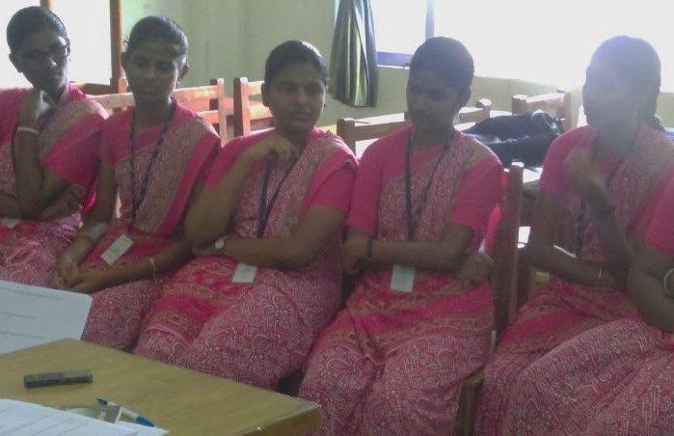
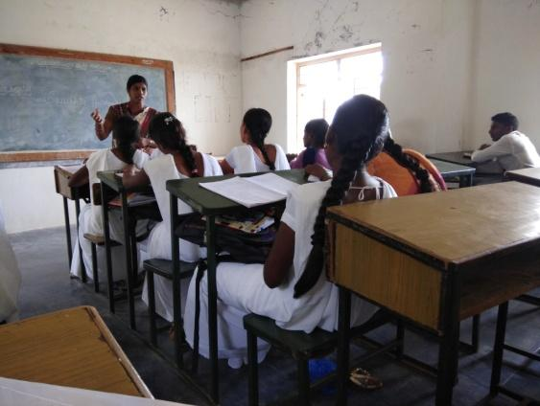

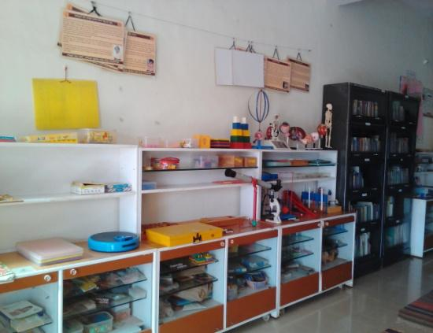
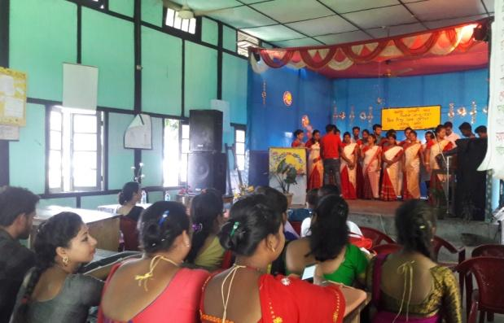
DIET Resource Centre, Chamrajanagar: Karnataka
DIE Nagaon, Assam
DIET Yadgir, Karnataka
DIET Puducherry

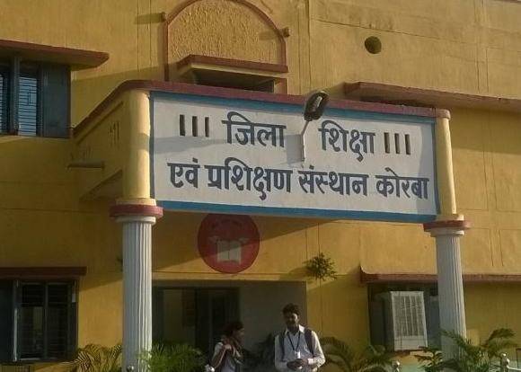

DIET Korba, Chhattisgarh

CHAPTER 6
District Institutes of Education and Training (DIETs)

The District Institutes of Education and Training (DIETs) are nodal agencies entrusted with the responsibility of providing academic and resource support at the district and grassroot levels for the success of strategies and programmes implemented in elementary schools. DIETs, post National Policy on Education (MHRD, 1986), and with the support of the central government, functioned to ensure percolation of their vision of education to the schools.

Some functions of DIETs

● Revise D.El.Ed. curriculum
● Play active role in the conduct of pre- and in-service teacher education programmes
● Monitor schools through direct intervention
● Conduct studies on education
● Develop and function as resource centres for the entire district
● Organise forums of interactions with teachers, teacher educators and provide academic support to CRCs and BRCs in the district
● Engage in academic review and planning
● Provide capacity building support to faculty members and teacher educators
● Conduct inclusive education and special focus group programmes
● Establish educational resource and documentation centres

DIETs are required to have an academic staff comprising a principal, a vice-principal, lecturers and senior lecturers, work experience or work education teachers, a librarian, ICT support staff, statisticians, office superintendents, lab assistants for the different laboratories, personal assistants to the principal, typists, data entry operators, accountants and maintenance support staff, belonging to the Group D cadre.

DIETs also require to have a Programme Advisory Committee (PAC) comprising a chairman who is either the district magistrate, the district collector or the CEO of the zilla parishad; the district education officer; the district project coordinator of SSA or RMSA; 02 senior faculty of the DIET, 02 school headmasters, 01 representative each from the tribal welfare department, the social welfare department, the minorities department, and the women and child welfare department. The committee should also have on its board 01 BRC and 01 CRC coordinator, 01 principal from a private un/aided teacher education college, principals from an IASE and CTE, a representative from the SCERT director and an NGO that is working in the field of teacher education and 02 students from a pre-service course, one from each year of the course. The convener of this committee is the principal of the DIET and it is recommended that the PAC meet at least twice a year. The annual plan prepared by the DIETs are to be collated at the state level to prepare a state plan.

6.1. Process and Performance Indicators: Government of India Guidelines, 2012

The process indicators put forth in the CSSTE Guidelines (MHRD, 2012) trace functionalities of DIETs in the country, as the institutes that are mandated to maintain detailed database of the schools, BRCs and CRCs in the districts that they served. Frequent minuted faculty meetings as well as records of the most talked about improvement processes in the DIET for the year are desired practices that are envisaged. The recommended process for achieving the goals of DIETs is similar to those of CTEs, involving needs analysis of teachers in schools, in coordination with SCERTs and state pedagogic units to develop modules for teacher training, assessing infrastructural gaps and developing modules and trainings for educational administrators.

Action research remains an important task component of DIETs. This comprises research on teacher educators in the respective districts as well as publications and research in their subject areas through conferences, seminars, articles in journals, newspapers, magazines etc. Periodic school-based studies on aspects of pedagogic practices, developing materials for pre-service programs and initiating reform recommendations to the SCERT based on the studies are some identified functions of the DIETs. Faculty are also supposed to be deputed for conferences, study leaves and exposure visits.

Another critical role of the DIET involves conducting professional development and in-service training programs in coordination with SCERT. Records of feedback from the teachers are to be maintained about the nature of trainings and the in-service programs. A training management system is therefore a requisite for DIETs. Responsibilities of DIETs differ from those of CTEs however in their focus on elementary education in schools and their not being perceived as institutes of higher education. Some identified challenges outlined in the guidelines are given below.

Identified Challenges (MHRD, 2012) p.21

- Enabling teachers in all schools to be qualified as per requirements of the RTE Act
- Reforming and renewing curricula for Pre-Service Teacher Education (PSTE) at the elementary and secondary education levels
- Regulating the quality of PSTE in all institutions
- Improving the quality of In-Service Teacher Education (ISTE) and directing it towards overall teacher professional development and school improvement
- Overseeing the quality of school education to support equity and encourage community involvement
- Developing the professionalism and capacity of teacher educators
- Reforming school curricula, pedagogy, assessment and examination
- Developing inter-linkages across departments and institutions engaged in teacher education and teacher training at the State and sub-State level.

6.2. DIETs the Status in 2017

This chapter surveys the functioning of the DIETs, the roles they play and the challenges they face, in 13 states, when mapped against the roles identified by the CSSTE. With their focus on training teachers of elementary schools, DIETs have a significant role to play in the Indian education scenario. This is of particular relevance in light of the RTE that aims to provide free and compulsory education to children under 14 years of age. The Guidelines sketch the structure of DIETs as an higher education academic body with focus on teaching and research. In the following sections, we examine the work ethos observed in select DIETs spread across the 13 states in the country along the following rubrics:

● Faculty profile and vacancy
● Faculty development and capacity building
● Pre- and in-service training and continuous professional development
● Research, publications and materials development
● Infrastructure and DIET resources

6.2.1. Faculty Profile and Vacancies

The guidelines for the CSSTE assert that DIETs are located at “an important point of decentralization - the District” (MHRD, 2012). This indicates that the DIETs are direct meeting points of several stakeholders in the elementary educational system. With the RTE Act, further, their role and capability in influencing education becomes even more critical. The DIETs are entrusted primarily with the task of continual professional development of teachers in schools and therefore active collaboration with schools and teachers in the district. In-service training comprises a major component of their work.

Learners who come to DIETs are primarily aspiring teachers who see in the course opportunities for a safe job. Pre-service student teachers come from wide educational backgrounds, which range from higher secondary students to graduates and, in some instances (as observed in this study), even postgraduates and professional degree holders. The study revealed that the conception of the student-teacher in a DIET as either an already serving teacher or a young student from school is limited. The DIETs, it was observed, offered a space of study, doubled as resource centres in some states, and presented opportunities for professional advancement and financial independence for many students who chose to do the diploma course in education. Students’ perception in many states also indicated that they looked upon teaching as a safe option offering professional growth and career advancement. Maintaining a vibrant DIET can greatly further the educational health of the districts. Acquiring and nurturing adequate qualified faculty is therefore a pressing necessity.

Table 6. 1: Vacancies in Academic and Non-Academic Posts in DIETs
Number of DIETs reporting vacancies
State | Total Institutions Covered | Academic Vacancies |  |  |  |  | Non-Academic Vacancies
State | Total Institutions Covered | Filled | <25% | 25-50% | 50-75% | >75% | Filled | <25% | 25-50% | 50-75% | >75%
Assam | 4 |  | 1 |  | 2 | 1 | 2
Bihar | 4 |  |  | 4 |  |  | 1 | 1 |  | 1
Chhattisgarh | 5 |  | 1 | 1 | 1 |  |  |  |  | 2 | 1
Delhi | 4 |  | 2 |  |  |  |  |  | 2
Himachal Pradesh | 4 | 1 |  | 1 |  |  |  |  | 2
Karnataka | 4 |  | 4 |  |  |  |  | 2 | 2
Madhya Pradesh | 4 | 2 | 1 | 1 |  |  |  | 2 | 2
Maharashtra | 4
Mizoram | 4 |  |  | 4 |  |  | 1 | 1 | 2 | 1
Puducherry | 1
Rajasthan | 4
Telangana | 4 |  |  |  |  | 4 |  | 1 | 1 | 2
Uttar Pradesh | 4 |  | 1 |  | 2 |  |  | 1 | 2

A survey of the faculty strength across the selected states shows a vacancy scenario of 25-75%. This is a case for academic and non-academic positions alike that stretches the capacity of the DIETs’ faculty in performing more efficiently. Most faculty were unanimous in stating in interviews, for instance, that while the DIETs are capable of taking on the responsibility of secondary education, they will need adequate staff to do so. The vacancy scenario appears a deterrent to the DIETs’ functionality. The DIETs in Rajasthan for instance have a noticeably acute shortage of staff that adds significantly to the workload of faculty. Similar trends were observed in Assam as well. It was heartening to note however that, despite the severe shortage and delays of funds and faculty, the Assam DIETs emerged as thriving educational centres.

6.2.2. Faculty Development and Capacity Building

As in CTEs, IASEs and other institutes, building on the pedagogic and content knowledge of DIET faculty is necessary for them to function effectively as teacher educators. How often do the faculty participate in such programs? Have they been resource persons for other training programs? Have they gone on exposure visits that can help them discuss and share best practices with their peers? What is the nature of research and publication they conduct?
For the items in the questionnaire on faculty development programs, exposure visits and provision of laptops and computers to faculty, more than 75% faculty stated that they have attended faculty development programs. No common trend in themes was observed in the the nature of these programs. The topics varied from action research to orientation in the new curriculum. Most faculty replied in the negative to the question of whether they were provided with a laptop. Faculty had access to computers but in most cases they were not exclusively for their use. The machines were shared resources in labs, often used by students, staff and faculty alike. Exposure visits also appeared infrequent. With the exception of Chhattisgarh and Mizoram where every single faculty interviewed claimed to have gone on an exposure visit, responses from faculty at the other DIETs were mostly in the negative. They were also not very clear about what these visits entailed.
There were mixed responses by faculty to questions on faculty development and exposure visits. While no clear trend emerges, lack of knowledge of training and opportunities to attend them appear as constant reasons for a non-interactive academic community. Most faculty are not provided with personal laptops but share common resources in the institutes. It was noticed that a) not all computers had internet connectivity; b) computers were used on rotational basis in labs by faculty and students; and c) use of the computers were made most frequently for administrative activities like entering attendance and marks. Erratic internet on limited machines made a truly integral use of ICT in planning and executing lessons difficult.

On a positive note, several DIETs had smart boards, CPUs and projectors in their classrooms that, the students and teachers claimed, were actively used in the teaching learning process. The DIET at Puducherry is one such example. Similarly the DIETs in Karnataka, Mizoram and Chhattisgarh are cases in point of faculty who, without having received a formal training in the use of computers, actively integrate technology as teaching learning aids in their classrooms. Powerpoints are encouraged in seminar presentations. Students are required to search the internet for relevant materials to prepare for their classes and assignments. Some institutes required students to prepare portfolios of all the TLMs prepared by them during the academic year. This again requires active and intensive use of computers.

6.2.3. Pre- and In-Service Trainings and Continuous Professional Development

The CSSTE guidelines stipulate that the responsibility for offering continuous professional development programs as well as conducting pre- and in-service training programs rests with the faculty of DIETs. These activities must be conducted in coordination with the SCERTs that will help with module and material development as well as curricular changes.

Majority of faculty at the DIETs are intensely involved in pre-service training. There were mixed responses for in-service training of teachers, with only Uttar Pradesh, Mizoram, Maharashtra and Karnataka stating that they have been conducting in-service training in a sustained manner. All the faculty interviewed in seven out of the 13 states responded positively to having been involved in CPD trainings for untrained teachers.

An overwhelming number of positive responses are indicated against the pre-service teaching role played by the DIETs. These are primarily D.El.Ed. and serve to provide elementary school teachers to the educational community. Faculty development programs for the DIET faculty also seems active. Interviews with faculty suggest however that the programs are not systematic or well-organised. One head of DIET observed that there was an “uncoordinated overdose of training” (transcribed from interview with head of DIET, Udaipur, Rajasthan). Information about ongoing programs does not reach faculty in a timely manner. It was remarked in some DIETs that better resource persons for trainings are required in use of ICT in the classroom.

Few DIETs used an active training management system. Some DIETs also stated that most of their in-service trainings are conducted by resource persons sourced from outside their DIETs. The reason given was lack of faculty to shoulder the responsibility of continuous in-service training of teachers on a regular basis. This corroborates with the data on vacancies, seen in Table 1. In such cases, the DIETs largely function as coordinating agents in order to meet the growing demands of teacher training.

6.2.4. Research, Publications and Material Development

There are two broad categories of research that faculty of the DIETs are required to perform in their institutional roles as teacher educators.

● Action research studies in schools on various aspects like pedagogic practices, needs analysis of teachers that will guide the in-service training designs, impact analysis to determine the effect of training in learner outcomes and training effectiveness and identifying areas and themes for administrators to run institutions better.
● Individual research in content and pedagogy as part of continuous professional development to constantly update their knowledge as academicians..

Limited opportunities and lack of financial support act as yet another deterrent for research and presentation of their work in national and international fora. A case in point is the faculty of the DIET at Puducherry. The faculty displayed, during this team’s visit, a series of research articles published in journals, including one in Elsevier. They told us that yet another paper had been accepted for presentation at a national seminar in Mizoram, organised by NUEPA. They were, however, unable to attend it because they were not entitled to air travel and reaching Mizoram would take several days from Puducherry. They had to, subsequently, withdraw their paper. Such instances are, however, not singular ones.
There has been an overwhelming negative response by faculty for questions on the research conducted. Similarly, faculty in a majority of states indicated that they had not published any article in the last 2-3 years. In those cases where faculty claimed publications, the works were either articles in college magazines or newspaper articles. Academic journals were never mentioned as sites of publication, except in rare instances like Puducherry where the faculty displayed copies of their research articles published in Elsevier. A majority of faculty across the states have replied in negative to publications. Research activities also do not register a constant trend across states. These are predominantly in the form of individual, domain specific research that does not account for action research in schools. A similar negative characterises the trend of responses for material development as well.
Design and development of curriculum and materials based on teachers’ needs is one of the roles assigned to DIETs. This relates to their larger role as researchers and teacher educators. It is envisioned that the faculty establish connections and interact actively with schools in their district to identify gaps and challenges faced by the school teachers. These are subsequently addressed as they provide support to the teachers in the functioning of the schools.

There is a need to put an emphasis on foundational concepts in subject areas, particularly those which are taken as rules or axioms at the school level. For instance, during an interaction with student-teachers (D.El.Ed. first year students) in DIET Serchhip in Mizoram, TISS team felt that a few students were yearning for clarity of basic mathematical ideas and concepts and craved to gain more understanding of basic concepts that they claimed they could not find in the books in library or from other sources. One such question was why does a natural number when raised to zero produce one. Is it an axiom or can it be proved? Such deep engagement with basic concepts require a few more years of engagement with the core subject matter and interaction with equally qualified teachers for suitable guidance.

It was observed that most of the materials developed by the faculty in the DIETs were principally teaching learning materials for the pre- and in-service trainings. Very little role was played in curriculum (re)design and development which could inculcate critical thinking and make students learn to ask questions. Interactions with schools was also based solely on internship visits. A few instances of teaching-learning support extended directly to schools were, however, seen in states like Assam both through interaction with schools and with respect to lesson planning. A predominant reason provided for this was lack of funds, resources and staff to carry out the responsibilities assigned to the DIETs.

Some instances were seen of DIETs developing and adapting existing resources to suit the needs of their students. The DIET in Puducherry is a case in point. Though the current faculty team at this DIET is on deputation for 5 years, they have translated the textbooks for their D.El.Ed. curriculum from Tamil to English so that students are provided greater exposure to the language. The translation and printing was undertaken as an extra task by the DIET faculty, drawing upon their personal time and DIET funds, with no external aid. Ironically, they did not see it as a mentionable activity and were mute about this initiative, until probed further. Once again, this is not a singular instance of initiatives taken by the DIETs and improvisations made to meet their immediate and individual needs as academic bodies.

6.2.5. Interaction and Collaboration

Based on their responsibilities, DIETs’ collaborations with other (educational) organisations are envisioned at multiple levels. Interaction with schools involve, as already mentioned, research and support in teaching and learning. Coordination with SCERTs, IASEs and CTEs help in faculty development, PSTE and ISTE. Other interactions also happen with NGOs for a variety of purposes.
Faculty and senior officials were asked about collaborations with NGOs, visits to BRCs and CRCs, SCERTs and IASEs and school visits. Responses were varied. Most states stated with unanimity that visits to the SCERTs and IASEs were negligible. NGO presence and collaborations seem high and active in most states. The most frequently cited NGOs were Pratham, Eklavya and Azim Premji. None of these collaborations were however formal. It appeared that some of the DIET faculty helped NGOs conduct their studies and research activities after their regular work hours. Visits to BRCs and CRCs seem to be taking place more frequently. At least 50% of the faculty interviewed in each state said they visited BRCs and CRCs. The only exceptions were Rajasthan and Puducherry. In the case of Puducherry, it was discovered that there were no functional BRCs in the neighbourhood.[
Questions on school monitoring received an overwhelmingly positive response. Every state had active collaboration with the schools. It was discovered that the extended duration of the new D.El.Ed. and B.Ed. curriculum had led to greater collaborations between DIETs and the schools due to internships. Faculty were therefore spending more time in monitoring pre-service trainings. It was however also noted that this was the only activity that most faculty did during their school visits. With the exception of Chattisgarh where the faculty also visited schools for impact studies and needs analysis research apart from monitoring trainings, none of the other faculty spoke of classroom based research and learning. Contrary to other states, Chattisgarh faculty also stated that they were paid TA/DA for these school visits.

Discussion with the faculty and institution heads at the DIETs regarding visits to the institutes by SCERT faculty and officials like education secretaries and directors yielded indecisive answers. Most DIETs have seen visits by SCERT faculty. The visits by senior officials, secretaries and directors are, however, sporadic and infrequent. Some DIETs have not been visited by senior officials for more than 2 years as of the date of this study. Also problematic was that the responses by different faculty in the same institutes were sometimes not consistent. Apart from some who stated that they didn’t know of any visit or couldn’t remember one, there were DIETs in Himachal Pradesh and Maharashtra, for instance, where two faculty gave opposite responses. It is difficult to trace a trend of visits to the DIETs by senior officials based on these responses.

It appeared in interviews with the faculty, and the junior faculty in particular, that there was ambiguity in their understanding of their responsibilities. Apart from a heavy and multi-dimensional workload, the faculty were also not very clear of their academic and administrative responsibilities in the DIETs. Several faculty, especially in Karnataka, complained that they were unable to carry out their academic responsibilities or see through any task to its completion because they were performing many, unrelated tasks. This reflects in the lack of research and publications from the DIETs as well, as they lack the time and resources to pursue structured and systematic study as required by the Guidelines 2012.

6.2.6. Infrastructure and DIET Resources

Availability of suitable infrastructure is critical for effective functioning of institutions. Apart from ICT resources and audio-visual equipments in classrooms that will aid a seamless movement into digital learning, access to internet for faculty and students in preparation of TLMs, well-equipped and updated libraries and independent research that can aid making innovative lesson plans and publications, clean and functional toilets, well ventilated classrooms, drinking water facilities, recreational spaces for students and faculty, canteens and hostels for men and women become instrumental in creating a healthy learning environment.

Table 6. 2: Infrastructure and Resources in DIETs
 | Number of DIETs recording 'Yes' as response
State | Assam | Bihar | Chhattisgarh | Delhi | Himachal Pradesh | Karnataka | Madhya Pradesh | Maharashtra | Mizoram | Puducherry | Rajasthan | Telangana | Uttar Pradesh
Total DIETs Covered (N) | 4 | 4 | 4 | 4 | 2 | 4 | 4 | 2 | 4 | 1 | 4 | 4 | 3
Room for head/principal | 4 | 4 | 4 | 4 | 2 | 4 | 4 | 2 | 3 | 1 | 4 | 1 | 3
Staff room | 4 | 4 | 4 | 2 | 1 | 4 | 4 | 2 | 3 | 1 | 4 | 4 | 3
Classrooms | 4 | 4 | 4 | 4 | 2 | 4 | 4 | 2 | 3 | 1 | 4 | 4 | 2
Multipurpose hall | 3 | 3 | 3 | 4 | 1 | 3 | 4 | 2 | 3 | 1 | 3 | 3 | 3
Library | 4 | 4 | 4 | 3 | 2 | 3 | 4 | 2 | 3 | 1 | 4 | 4 | 3
Resource room | 4 | 1 | 3 | 2 | 1 | 1 | 4 |  | 1 |  | 3 | 1 | 2
Labs | 4 | 4 | 3 | 2 | 1 | 2 | 4 | 1 | 3 | 1 | 3 | 3 | 1
Storerooms | 4 | 3 | 4 | 2 |  | 3 | 3 | 2 | 3 | 1 | 3 | 3 | 2
Seminar Rooms | 2 | 2 | 2 | 2 | 2 | 1 | 4 |  | 2 |  | 3 | 1 | 2
Auditorium (if separate from multipurpose hall) | 0 | 2 | 2 | 2 |  | 2 | 3 |  | 1 | 1 |  |  | 2
ICT lab | 4 | 4 | 3 | 3 | 2 | 4 | 4 | 2 | 2 | 1 | 2 | 4 | 1
Separate toilets for men and women (staff) | 4 | 2 | 3 | 2 | 2 | 3 | 4 | 1 | 3 | 1 | 4 | 3 | 3
Separate toilets for men and women (students) | 4 | 3 | 3 | 3 | 2 | 2 | 4 | 1 | 3 | 1 | 3 | 4 | 3
Hostels for men | 3 | 2 | 2 |  |  | 2 | 4 |  | 2 |  | 1 | 4 | 2
Hostel for women | 3* | 3 | 3 |  | 2 | 2 | 3 |  | 2 |  | 1 | 3 | 1
Drinking water facility | 4 | 4 | 4 | 2 | 2 | 3 | 4 | 2 | 3 | 1 | 4 | 4 | 3
Canteen | 2 | 1 |  | 2 | 1 |  |  |  | 3 |  |  |  | 1
Staff Quarters | 3 |  | 3 | 1 |  | 2 | 3 | 1 | 3 |  | 2
Office administration room | 4 | 4 | 4 | 3 | 1 | 4 | 4 | 2 | 3 | 1 | 4 | 4 | 2
AV Equipment | 4 | 4 | 3 | 3 | 2 | 2 | 3 |  | 3 | 1 | 3 | 4 | 1
Computer Equipment in lab for students | 4 | 4 | 4 | 3 | 2 | 3 | 3 | 2 | 1 | 1 | 2 | 4 | 1
ICT in principal room | 2 | 1 | 3 | 2 | 2 | 3 | 3 | 2 | 3 | 1 | 1 | 3 | 3
ICT in staff room | 1 |  | 3 |  |  | 2 | 3 |  | 2 |  | 1 |  | 1
ICT for administration room | 3 | 3 | 4 | 3 | 2 | 4 | 3 | 2 | 2 | 1 | 3 | 3 | 3
Recreational equipment | 4 |  | 2 | 3 | 2 |  | 3 | 1 | 2 |  | 2 | 3
Resources and TLMs | 4 | 1 | 4 | 3 | 1 | 3 | 3 |  | 3 | 1 | 2 | 4 | 3
Lab equipment | 4 | 4 | 4 | 2 | 1 | 2 | 3 |  | 2 | 1 | 1 | 4 | 1
Library books: | 4 | 4 | 4 | 2 | 2 | 3 | 3 | 1 | 3 | 1 | 4 | 4 | 3
Does the institution have electricity? | 4 | 4 | 4 | 3 | 2 | 4 | 3 | 2 | 3 | 1 | 3 | 4 | 3
Does it have backup generator? | 2 |  |  | 1 |  | 4 | 2 |  | 3 |  | 3 | 2 | 3
Does it have well ventilated rooms and fans? | 4 | 4 | 3 | 3 | 2 | 4 | 3 | 2 | 3 | 1 | 3 | 3 | 3
Does it have internet connection? | 4 | 4 | 4 | 3 | 2 | 4 | 2 | 1 | 3 | 1 | 4 | 4 | 2
Was the internet working on the day of your visit? | 4 | 1 | 3 | 3 | 2 | 2 | 1 | 1 | 2 | 1 | 3 | 4 | 2
Was there electricity on the day of your visit? | 4 | 4 | 4 | 2 | 2 | 4 | 2 | 1 | 2 | 1 | 4 | 4 | 3
Does the institute have a website? | 3 | 4 | 1 | 1 | 2 |  | 2 |  | 2 | 1 | 4 | 4 | 3
What is on the website? |  |  |  |  | 2 |  |  |  |  |  |  | 1
Boundary wall | 2 | 1 | 3 | 4 | 2 | 3 | 4 | 2 | 2 |  | 2 | 4 | 3
Surroundings
Playgrounds | 2 | 1 | 4 | 3 | 2 | 2 |  | 1 | 3 |  | 3 | 4 | 1
Accessibility (please also note the transport used to reach by students and staff teachers | 3 | 4 | 3 | 4 |  | 3 | 4 | 1 | 2 | 1 | 2 | 4 | 3

Most of the DIETs visited had adequate numbers of functional classrooms, ICT labs with computers, Principal’s room, staff and administrative rooms and library. Several DIETs however lacked an auditorium and seminar rooms that could facilitate discussions and presentations. Also lacking were working internet connections. It was observed during the visits that while the DIETs were provided with computers, not all of them had internet connectivity. Faculty and students stated that they took turns on the machines with internet connection. Partial provisioning of facilities is problematic in light of ICT policies that promote use of technology in teaching and learning. Uninterrupted supply of electricity was also an issue observed during the visits. Only a few DIETs had a back-up generator.

Most noticeable in the institutes were (lack of) boundary walls, physically demarcated spaces and the condition of surrounding areas that can often make the DIET unwelcoming. DIET Dighi in Vaishali district of Bihar, for instance is situated at a prime location between two important railway tracks and with broken boundary walls. The trespassing has become so rampant that a public pathway cutting through DIET campus grounds has emerged to connect two adjoining colonies. One portion of the DIET land has been given away to KVS and a KV school runs in the same premises. Similar is the situation with DIET Sonepur in Bihar which has no boundary wall while DIET Bikram in Patna district has lost big pieces of land to JNV, Kasturba School hostel and a BRC opened in its campus. A DIET in Uttar Pradesh, for instance, was overgrown with vegetation due to lack of funds for maintenance of the institute. Interestingly, however, it continued to see active teaching practice with students visiting the buildings for classes. It is necessary to factor the gap between available resources and faculty and learner commitments towards keeping these institutions active learning centres. An identifiable challenge herein is to find a sustainable way of nurturing the intellectual life of these institutions to make them vibrant and welcoming learning spaces.

Another noticeable infrastructural gap was hostels and accommodation for students and faculty. This was remarked on as a challenge facing teacher education by a faculty in Assam. The faculty reasoned that lack of accommodation on campus fails to create a collegiate atmosphere, dissuades students from joining the institution and, in many instances, even restricts inter-institutional exchange. While the case is particularly relevant for Assam, a similar instance was noticed in Puducherry as well, where connectivity becomes a problem. In such cases, motivated faculty and vibrant academic spaces become out of reach for many aspiring students. Suggestions were put forth by faculty in Assam and Bihar, in the context of student exchange initiatives, that there can be programs that involve students visiting DIETs in different parts of the country, as in the case of faculty as well. This can encourage cross-pollination of ideas, learning cultures and pedagogies. For this to happen, however, infrastructural frameworks must be robust and functional.

6.2.7. Library and Reading Room facilities in DIETs

Most DIETs have functional libraries with varying number of books. However, many DIETs did not have a copy of the National Curriculum Framework (NCF, 2005) or National Curriculum Framework for Teacher Education (NCTE, 2009). Most DIETs did not have a functional reading hall for its students and faculty members to read and work silently in the library. A few DIETs (for example, DIETs in Serchhip, Bikram) have newly built buildings and space earmarked for library and reading rooms, but infrastructural facilities for reading rooms are not yet in place. The DIET at Chamarajanagar had a well functioning resource centre equipped with relevant books and teaching learning materials and also ICT access for teachers. This resource centre was developed with the assistance of the National Institute of Advanced Studies (NIAS) and with support from the Tata Trusts.

6.2.8. Use of ICT as a Resource

Most DIETs displayed a skewed interpretation of ICT use as a resource. Many faculty members and principals in DIETs relegated use of ICT to the use of power-point presentation during lessons. Only a few DIETs for instance Nalanda, Bikram in Bihar cited use of internet for material search and use of online resources for lessons. Faculty members of DIET Nalanda showed examples of the videos of student-teachers’ project based activities that they have uploaded on YouTube for use as OER. Use of ICT reflected from their proto-research too.

Not many DIETs could show evidence of using ICT for purposes other than administrative purposes such as online admission system and declaration of results and so on. DIET Serchhip in Mizoram displayed an indigenous Training Management System (TMS) which one of their faculty-members who is conversant in digital technology has developed to maintain a database of training requirement of teachers in the district and trainings conducted and attended by teachers subject-wise and school-wise. Serchhip district is the highest literate district in India. Karnataka has developed a training management system but is yet to put it into widespread use.

6.3. Observations, Analysis and Insights

The challenges faced by the DIETs are various and varied. As critical points of “decentralization” in the Indian elementary educational system, the DIETs possess a liminal and fluid identity of being simultaneously a body of higher education for student-teachers as well as fluent in the pedagogy of elementary education. Their primary challenge is, therefore, at the level of self-definition. Apart from teaching and conducting in-service trainings for teachers, DIETs are (like the CTEs) also stipulated to conduct research and contribute to pedagogical and content knowledge in their relevant areas. This perception is, currently, lacking. It can be argued that the lack of clear identity affects and demotivates faculty from performing effectively. Another trend that emerges from the study is that the active and functional DIETs are located close to big cities and in well connected areas, the DIETs in Karnataka offering instructive examples of vibrant and rich learning spaces. Institutes in second- and third-tier cities face greater challenges ranging from insufficient funds to vacancies, de/motivated faculty and students and fewer opportunities for faculty development programs.

A greater challenge for DIETs is monitoring the spread of schools covered under each district. As institutes responsible for ensuring quality of elementary school teachers, DIETs’ volume of work is high that they thereby require greater number of faculty. The vacancies present in the existing DIETs is affecting a smooth functioning of these institutes. Current lack of opportunities also seem to have a demotivating effect on the DIETs. An overwhelming majority of faculty stated that DIETs should, and are academically positioned, to assume the responsibility of secondary school (teacher) education. They were also unanimous in stating, though, that this was contingent on receiving the necessary funds, resources and infrastructure on a timely basis. Encadrement was seen as another possible incentive to motivate faculty to perform better.

Table 6.3: Limitations, Challenges and Remarks for DIETs
Limitations | Challenges | Remarks
- Inadequate infrastructure  - Inadequate funds  - Inadequate faculty  - Demotivated student-teachers  - Absence of systematic research studies on needs and impact analysis of trainings and learner outcomes in schools  - Lack of a training management system in most institutions | - Monitoring quality of teacher training in schools  - Monitoring private institutes’ teacher training is lacking  - CTET examination  - Training in (philosophy of) new curriculum  - School monitoring through studies in learner outcomes and impact of training | - Online portal for communication of information  - Greater interaction and exchange between faculty across the country to share concerns and best practices  - Better training in use of ICT by subject experts  - Encadrement desirable to motivate faculty

The following are some insights from this study:

● Greater awareness needs to be built among the faculty at DIETs regarding their academic and administrative responsibilities.
● Like the CTEs, a prioritisation of tasks is required at, equally, the academic and administrative levels for a more efficient work distribution and functioning of the institutes.
● Greater academic and financial autonomy can help the DIETs address the specific needs of their local communities more effectively. This pertains to administrative and pedagogic roles in the education ecosystem.
● An interconnection between DIETs can help cross-pollination of ideas, research and collaborative studies on best practices. It will also enable sharing of responsibilities at the level of materials design and curriculum development by creating communities of practice.
● Having a centralised training management system will aid in further cementing collaborations between the different DIETs in the state, not simply through faculty exchange and exposure visits but also by harnessing the affordances of technology to trace and track the needs of teachers in schools and address them effectively.
● A more transparent, regulated and timely flow of funds is desirable.
● Performance based incentives when introduced with greater rigour can act as motivating factors for faculty to deliver efficiently and effectively in their duties. The notion of encadrement is quite welcome, in this regard.
● There is a need to view a courses in elementary education as a professionally viable degrees. It was suggested at some DIETs that the course be renamed a Bachelor in Elementary Education, which can cause a change in expectations of faculty and students and cause greater number of registrants.

CHAPTER 7
Block Institute of Teacher Education (BITE)

CHAPTER 7

Block Institute of Teacher Education (BITE)

7.1. The context
[
The 12th Five Year Plan (GoI, 2012) emphasised the need to advance the cause of the minorities and focus on their educational advancement as a part of the Multi-sectoral Development Programme (MsDP), (GoI, 2012a). This led to a restructuring of several schemes wherein the the Block replaced District as the unit of planning for implementation. The government identified several districts and towns across India with a high minority population based on the census 2001 data. Major initiatives were launched to ensure the advancement of minorities as part of the MsDP.

One such proposed initiative was to set up Block Institutes of Teacher Education (BITEs) under the CSSTE Scheme in high minority concentration districts or in districts or towns with a high SC/ST population. The establishment of these institutes would ensure access to good quality teacher education facilities for rural and remote areas and facilitate the entry of talented persons, particularly persons from SC/ST and Minority concentration areas, into the teaching profession. This would help not only ensure the participation of SC/ST and minority groups in the teaching profession but also overcome the shortage of locally based teachers in elementary schools in these areas (MHRD, 2012).

The 2009 NCERT Evaluation Report of the CSSTE (NCERT, 2009) recommended that block level teacher education institutes be created to meet the academic and curricular needs of teachers at the block level. It was proposed that additional DIETs be set up in 196 identified districts and that BITEs be established in the remaining 5804 blocks that have a high concentration of SC/ST and minorities. The primary function of BITEs was to improve the in-service training of teachers from the pre-primary to the senior secondary level to create a pool of trained teachers from the local community who would be aware of and sensitive to the local realities and needs of their students. The existing BRCs were to be subsumed into the BITEs.

The Press Information Bureau, Govt. of India released the following in 2013 from the MHRD that announced the approval of setting up BITEs the 196 identified districts stated “More than 690 crore rupees have been approved with 1/3rd of this investment being made in 8 high deficit states of Uttar Pradesh, Bihar, West Bengal, Assam, Odisha, Chhattisgarh, Jharkhand and Madhya Pradesh. Over Rs. 6300 crores are earmarked in the 12th Five Year Plan for training of untrained teachers” (PIB, 2013).

However, the impact of this plan is not seen in reality as shown in the table below depicting the status of functional BITEs across India at the end of the 12th Five Year Plan in selected states/ UTs covered under this study.

Table 7.1 Status of Functional BITEs at end of 12th Five Year Plan

State | Assam | Bihar | Chhattisgarh | Delhi | Himachal Pradesh | Karnataka | Madhya Pradesh | Maharashtra | Mizoram | Puducherry | Rajasthan | Telangana | Uttar Pradesh
Proposed BITEs | 14 | 8 | 6 | 1 | 8 | 3 | 6 | 4 | 10 | - | 4 | - | 38
Functional BITEs* | 1 | 4 | 0 | 0 | 0 | 0 | 0 | 0 | 0 | - |  |  | 0
*information as reported by State Nodal Officers

This study covers two BITEs, BITE Rangia in Assam, and BITE Dariyapur in East Champaran, Bihar. BITE Dariyapur was a Primary Teachers Education College (PTEC) which was established in 1956. It was recently upgraded to a BITE under the scheme. The Basic Training Center (BTC) in Rangia, Kamrup district of Assam has been designated and functioning as a BITE under this scheme.

In Bihar, no fund outlay was released after 2014-15 due to ‘paucity of funds’. Proposals for 4 new BITEs that were recommended by the TEAB minutes were also cancelled for the same reason (8th TEAB meeting minutes, 2015-16). In 2015-16, sanction for 4 new BITEs was cancelled in spite of recommendation from earlier TEAB minutes. It was suggested that the existing 4 BITEs would be the only ones in the state. 14 BITEs have been proposed in Assam, out of which 7 have been sanctioned. Central assistance however, have been released for only one BITE in 2014-15 (5th TEAB meeting minutes, 2014-15). It seems evident from the above data that the BITEs have not been established with the urgency warranted at the beginning of the 12th Five Year Plan.

7.2 Observations from the Field

Both the BITEs covered during the study are located in Minority Concentration Districts (MCDs) with low performance on education indicators (GoI, 2001; GoI, 2011). Poor educational attainment levels translate into lower work status and low quality of life. The challenges of a teacher education institute in such regions are high as they have to equip the trainee teachers with the appropriate knowledge, skills and attitudes to navigate through the multiple challenges of multilingualism, minority conflict and other socio- political issues that emerge in a heterogeneous classroom.

For Rangia, the transition from BTC to BITE is still in progress. The Annual Report 2015-16 of SCERT (SCERT Assam, 2016), Assam acknowledges the Govt. of India guidelines that non-recurring central assistance will be made available for civil works for construction of BITE based on NCTE norms for a D Ed. Institution, based on the state government’s sanction of land earmarked for BITE. Accordingly, BTC Rangia was identified, and civil works were undertaken to ensure the repair and renovation of the building. As per tender No. 30 CE (BD) of 2013-14 (see annexure), the construction of a 2 storeyed building, repair and renovation of office and hostel, boundary wall, gate and deep tube well installation has been completed under the CSSTE. It has taken three years for the civil works to be completed and handed over. It is interesting to note that the signboard of the institution still says BTC Rangia, and the principal and faculty members are not aware of the details what entails in restructuring of the BTC to a BITE.
7.2.1. Infrastructure

Table 7.2: Status of Infrastructure at BITEs
Infrastructure | Status for BITE, Rangia | Status for BITE, Dariyapur
Room for head/principal | Yes | Yes
Staff room | Yes | Yes
Classrooms | 2 sufficiently large and airy classrooms | 3
Multipurpose hall | No. The classroom also serves the purpose of a hall | Yes
Library | Room of 797.32 sq. ft. consisting of a few almirahs holding around 400 books. The same space also serves the purpose of ICT resource room and resource centre. There is no seating arrangement for a reading room. | Yes
Resource room | No. Staff room is also the art and craft resource centre according to the institution website | Yes
Labs | Not functional. Tables with Math and Science equipment on it serve the purpose of the lab. | Yes
Storerooms | No | Yes
Seminar Rooms | No | No
Auditorium (if separate from multipurpose hall) | No | No
ICT lab | Not functional as the entire institution has only 1 working computer. Not for student access. | No
Separate toilets for men and women (staff) | Yes | No
Separate toilets for men and women (students) | Yes | No
Auditorium | No | No
Hostels for men | Yes, but existing hostel facilities are poor (not maintained, no drinking water, etc.). New construction is in progress | No
Hostel for women | No | No
Drinking water facility | 2 deep tube wells have been constructed recently under the central assistance for BITE | 4 hand pumps
Staff Quarters | Yes. | No
Office administration room | Yes | Yes
Electricity (on day of Visit) | Yes | Yes
Generator Backup | No | No
Internet Connection | No | No
Website | Yes, but as BTC Rangia | Institution has a moderately active face book page. Last t post was in July this year
Boundary Wall | Yes | No
Playground | Yes, but covered with stagnant water due to heavy rains. Can be used only during dry season. | Yes

BITE, Rangia functions in an old Assam style building (traditionally made of bamboo and clay), which houses around three rooms for the official staff (principal’s room, administrative office, and a fairly large staff room for faculty). There are two large and airy classrooms, which also serve the purpose of a multipurpose hall. There are no meeting rooms, seminar rooms or auditorium. The hostel facility for men is not functional. There is a deep tube well from which drinking water is sourced. There are separate toilets for men and women, and for use by the staff. We were able to get a glimpse of the students’ toilets, but they were not well maintained or clean. There is a small courtyard which functions as the playground, but this was full of stagnant water due to the heavy rains. Water-logging is a standard problem in the institution every year, and the principal showed us a picture in her room from a few years back when the BITE was waist deep in water due to heavy flooding. The lack of a proper drainage mechanism to flush out the stagnant water in this BITE is a pressing issue.

The infrastructural facilities of BITE Dariyapur seemed quite far from the standard norms. The building is old, with not very well ventilated classrooms. The area has no boundary wall. The lack of toilet facilities in the premises is a hindrance. The institute was not well maintained, and cleanliness and hygiene emerged as major issues.

Table 7.3: Status of Equipment and Resources at BITEs
Equipments and Resources | Status for BITE, Rangia | Status for BITE, Dariyapur
AV Equipment | No | No
Computer Equipment in lab for students | No | Only 2 working computers available
ICT in principal room | One computer | No
ICT in staff room | No | No
ICT for administration room | No. Computer in principal’s room used for administrative purposes | No
Lab equipment | Two tables with math and science equipment | Yes
Library books | 400, mainly dictionaries and old reference books. Not many textbooks or reference materials of contemporary relevance. | Around 2100 books, mostly for general reference. No school textbooks available.

The faculty responsible for teaching the ICT course in BITE Rangia shared that ICT is taught theoretically, and he sometimes brings his personal laptop to demonstrate, as there is no ICT lab. The students are not allowed to access the only computer on the premises. They usually use a cyber café in the nearby Rangia town or their own smartphones to access the internet for resources. No ICT facilities are available in Dariyapur either, and the student interviewed for the study responded that the course is not taught at all.

The BITE Rangia library houses around 400 books, with dictionaries and reference books, but it is clearly not enough to meet the needs of the students. A student shared that the library has very few resources that they can use for their course, and they rely more on their teachers’ notes and on guidebooks and study materials available in the market. The study material from Krishna Kanta Handiqui State Open University (KKHS Open University) in Guwahati has an in-service course, which is, according to the students and teachers, very similar to their own course and quite popular among the students. In contrast, the library in BITE, Dariyapur had a wider collection of books, but a major drawback was that it did not stock school textbooks.

7.2.2. Faculty

The data from BITE, Dariyapur indicates a significant shortage of faculty members. Only six out of the sanctioned ten posts for faculty have been filled (including the principal, and currently a faculty member is the acting head). The faculty members do not fulfill the NCTE norms for TEIs.

There are no vacant faculty or non faculty positions in BITE Rangia as per the BTC pattern. However, on its restructuring into a BITE, new regulations will come into effect and more faculty members are to be recruited. At present, the existing six faculty members struggle to address the needs of over 200 students. There is no faculty for English, or for regional languages like Bodo, though there are a substantial number of students who opt for the Bodo Method. Later discussion revealed that each faculty member would often have to take more than three courses to adjust for the lack of adequate teachers. From the current year, there are two more attached members to the institution, so this partly eases the burden for the faculty, and classes for each course are also held regularly. The faculty norms are different from the NCTE and faculty members have a designation of ‘teacher educator’. Most of them possess a B.Ed degree. It is observed that despite the up gradation of the institute to a BITE, the faculties in either of these institutions have not been upgraded. New faculty has not yet been recruited.

7.2.3. Student Profiles

The student teachers in the BITEs are primarily freshers who have come to the institute to fulfill the NCTE norms of trained teachers. Some are graduate students who have registered for this course to fulfill the eligibility criteria for B. Ed. The students come from the local community and aspire to become teachers in the government lower primary and upper primary schools in the locality. They have enrolled for the D.El.Ed. course in the hope that this will help them to get a secure job as a teacher. A significant proportion of the students belong to the SC/ST or minority community. However, the exact figures were not readily available when the field visit took place.
7.2.4. Teaching Learning Process
The classes seem fairly traditional. Subjects are taught theoretically, with little help of teaching aids. There is no facility to teach concepts through audio visual aids. The lab is seldom used by students for demonstration purposes. However, classes are held more or less regularly, and the students seemed comfortable with their teachers.
On talking to the students in Rangia, we realized that they were quite satisfied with the faculty and their teaching. The students talked about the need for faculty to receive more capacity building though, and on the need for the library to be more effective. They shared how their teachers were extremely approachable and helpful, and also regular with their classes.
The students are mostly very comfortable with the internet, and they often use it for developing their lesson plans, and are encouraged to do so by their teachers. The only handicap is that since the medium of instruction is the local language for most of these students, language becomes a hindrance to navigate through these online resources. There are hardly any students who have opted for the course in English.

7.3. Conclusion
The study reveals a shortage of faculty, inadequate infrastructure and other facilities (e.g. a well equipped library or lab) that arise from the lack of adequate and timely funding. This adversely affects the quality of teaching learning offered in the institution.
Most of the teacher educators in the BITEs do not fulfill the NCTE norms, and have not received adequate capacity building to meet the needs of the trainee teachers sufficiently. The linkages with SCERT, DIETs and other teacher education institutions at the state and district level are not very strong, with visits reduced to procedural work rather than actual handholding support. There is a significant number of faculty members who have not attended even a single capacity building programme organized by the SCERT, despite many years of service. A proper monitoring and support mechanism needs to be urgently developed to ensure that the BITE can serve its intended purpose.

Though the BITEs have been proposed and sanctioned in many MCDs across India in the 12th Five Year Plan, only five are functional so far. The TEAB minutes of the states over the past five years (2012-17) reveal administrative logjams and financial roadblocks that have led to several revisions and re-examining of the sanctioning of the proposed BITEs. The faculty members of the BITEs seem largely unaware of the welfare agenda with which it was envisaged.

The BITEs have been envisaged as a powerful medium to reach the goal of quality and contextually relevant elementary education by ensuring the participation of local youth in the teaching profession. It has the potential to bring about a positive change in the classrooms through the creation of a dynamic group of trained professionals who are aware of the local realities and are well equipped to meet its challenges. There seems to be a major gap in communication of the vision, mission and aims of this institution among all the stakeholders involved, which perhaps hinders the implementation of the scheme in its original spirit.

[CHAPTER 8

Teachers’ Professional Development;

Modalities for In-service and Pre-service Teachers’ Education
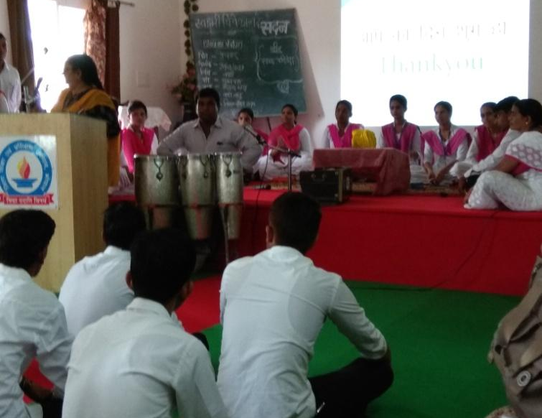
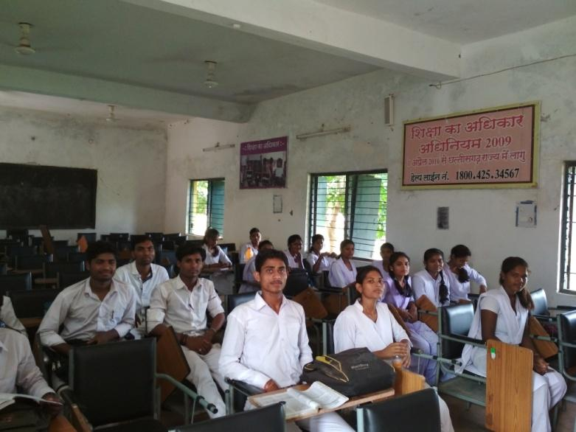
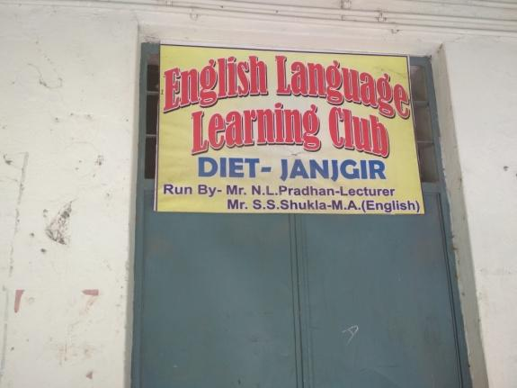
DIET Kabirdham, Chhattisgarh
DIET Bhopal, Madhyapradesh

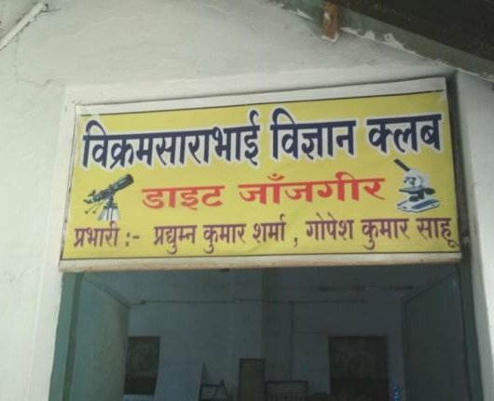

DIET Janjgir, Chhattisgarh Language and Science Lab

DIET Janjgir, Chhattisgarh Language and Science Lab

CHAPTER 8
Teachers’ Professional Development:
Modalities for In-service and Pre-service Teachers’ Education
This chapter explores various modalities of in-service teachers’ training and the role of SCERTs and other TEIs including IASE, CTE, DIET and BITE in these trainings.
A primary agenda of the CSSTE is the capacity building of teachers, teacher educators and teacher education institutions to support and enable quality education at government schools. This visualization is based on a notion of teacher education that has been articulated in policy documents such as NCF 2005 and NCFTE 2009. Moreover, the RTE Act mandates the professional training of teachers, which adds to the responsibilities of teacher education institutions to train untrained teachers.

8.1. Schemes for Teachers’ Education
The Government of India has three different schemes for supporting school and teachers’ education, namely, the SSA, RMSA and CSSTE. While the three schemes have significant components for in-service teacher education, the CSSTE has a pre-service component as well, embedded in it. The modalities of in-service training is dependent on the structure of the policy and scheme under which these trainings are usually funded and conducted within the state structures. The TISS evaluation team had specific and categorical discussions with all levels of functionaries regarding the roles of the SCERT and TEIs in teachers’ professional development.
Sarva Shiksha Abhiyan
Sarva Shiksha Abhiyan (SSA) is the flagship programme of the Government of India for universalisation of Elementary Education. It is visualized as the primary vehicle to implement the Right to Education Act for free and compulsory education for children between 6-14 years of age. Ensuring education of satisfactory quality is the key SSA goal, for which a major emphasis is teachers training. It is worth noting at this point that all quality reforms are contingent on teachers training. With regard to raising the standard of teaching by building capacity of teachers through regular training programmes, the Scheme provides support for three kinds of training: i) annual in-service teachers’ training for up to 20 days, ii) 30-days induction training for newly recruited teachers, and iii) training for professionally untrained teachers for two consecutive years. One of the major current contributions of SSA is its visualization and execution of a sub-district structure of BRC/CRC for teachers’ support and teachers training. SSA also provides support for head teachers training and training of resource persons.Rashtriya Madhyamik Shiksha Abhiyan
Rashtriya Madhyamik Shiksha Abhiyan (RMSA) is another flagship programme of the Government of India, which provides support for the training of secondary school teachers. Under this scheme, provision is available for in-service training of secondary school teachers, induction training for newly recruited teachers and training of head teachers on school leadership.
Within CSSTE, a support mechanism is available for SCERTs, IASEs, CTEs and DIETs for conducting teachers training for different categories of teachers and teacher educators. Most of the states organize teachers training with the help of SCERTs, DIETs, CTEs and BRCs/CRCs. IASEs also train selected number of teachers and teacher educators. Select states take help from NGOs and in a few cases, universities, to achieve their training targets.
It is important to note that RMSA has no formal structure for providing regular training to in-service teachers. Therefore, RMSA either approaches NGOs, works with ad-hoc structures or transfers the trainings to SCERTs and DIETs.Considering the limitations of BRCs and CRCs, some states directly approach SCERTs and DIETs. This leads to a situation of duplication of training programmes.
These kinds of ad-hoc measures also lead to loss of expertise. A case in point is Rajasthan. In 2010-11, an MoU was executed with the national level trainer’s team, which was facilitated by UNICEF. A team of 140 trainers at the state level was selected through screening workshops. This team was given intensive training in five workshops (of five days each). The training modules evolved during these workshops were field tested with the teachers to identify the responses of teachers during their trainings. This team of trainers was referred as Key Resource Persons (KRPs). With the help of these KRPs similar selection and screening workshops were organised at the district level to identify potential Master Trainers (MT). Approximately 750 MTs were selected. These MTs were trained in three workshops by the KRPs. MTs conducted the training for 25,000 head teachers of Upper Primary Schools. After two years, however, all the resource persons disappeared. They were in the system but not necessarily providing support to teachers.
The case of Rajasthan seems to suggest an overall need to merge various in-service teachers training programs and activities provided for by different schemes, so that the activities could be focused and have the impact intended. Senior officers and functionaries are of the view that it is important to merge all centrally sponsored teachers trainings, including the CSSTE, RMSA, SSA and other schemes as well.
There are instances of parallel activities occurring due to non-coordination among the various schemes. For example, under CSSTE, the central government provides a regular budget to improve the quality of training of in-service teachers. DIETs are supposed to conduct selected in-service teachers training under CSSTE. In some states like Uttar Pradesh and Chhattisgarh, DIETs are also supposed to conduct teachers training for SSA from the budget allocated under the SSA, and in some cases, the RMSA.
SCERTs and DIETs are to fulfill the RTE Act mandates of regular training and capacity building of all teachers at the elementary level. However, primary surveys indicate some concerns on the quality of in-service teacher training/education. There have been varying degrees of success and failure of in-service teachers training in terms of motivating teachers to alter and develop their classroom practice in ways that improve students’ learning and provide educationally rich experiences to them. In any case, there is no robust mechanism or conceptual planning to track and trace how in-service teacher education translates into and makes an impact in the classroom.
There is a large institutional network along with financial provisions (however shrinking) for in-service teacher education under various policy and schemes of government. There is also an expectation that in-service teachers’ education will lead to improved learning outcomes in the classroom. However, these activities are not yet linked to or supported by a model that can be executed. All seniors officers were of the unanimous view that there is need for linking BRCs to DIETs and develop BRCs as full-fledged residential training institutions for in-service training. Furthermore, none of the states (with the exception of Mizoram) were found to be using a training management system to rationalize, plan, track and maintain records of various trainings being offered, the teachers nominated for various trainings etc.
Education secretaries from 9 states and directors of 12 SCERTs were of the opinion that all teachers’ training of SSA and RMSA should be merged with CSSTE. Since SSA and RMSA are not academic bodies and they are primarily function through an ad-hoc structure, it would be better to transfer all trainings to the SCERTs through CSSTE.
Some of the problems that were highlighted by SCERT and DIET faculty-members regarding in-service teacher trainings were:
1) A single uniform module cannot be applicable for all teachers of the state. There is a need to prepare different sets of module based on actual analysis of the situation. Secondly, delivery of training was resource person dependent with training modules as the main material. The resource persons remain unaware of other materials that could be used. Since the resource personnel are not being shortlisted by a rigorous process, they are unable to use various teacher training materials including reading materials for teachers and ICT/audio-visual resources, self-learning material/teacher manuals etc.
2) Not only should the SCERT and other institutions such as IASEs, CTEs, and DIETs involve in the process at the institutional level, but should own and implement all trainings. However, without full faculty strength, technical upgradations of SCERTs, DIETs and CTEs, and any institutional base, it is difficult to conduct large scale teachers training.
3) Training management systems are not in place.
4) Without BRC-CRC linkages, school based support, supervision and monitoring for the trainings cannot be possible.
5) ICT is not yet being used in any significant way in inservice training or supporting inservice training that can translate into practice in schools.
6) Quality and relevance of training content also needs to be reviewed and strengthened.

8.2 Pre-service
In some cases, the state has reported that teachers, head teachers and the community are motivated to send teachers away from school for long trainings. States need to consider ways of managing this expectation by ensuring that there are Cluster Development Plans so that clusters of schools and teachers are able to attend specific trainings based on their need and new developments in their concerned fields.
It is important to understand that in-service training is a sequel to pre-service training. DIETs can thus be a link between BRCs and CRCs to maintain such a continuity. Moreover, pre-service teacher education is not a barrier in conducting in-service teacher education at the DIETs. For example, in case of Bihar, the state government has rejuvenated around 30 DIETs during 2009-2010. It was observed that while the DIETs’ functionaries were not getting involved in in-service training before 2008, there is sufficient evidence of the DIETs’ faculty involvement in in-service training post 2009.
Some critical issues that can have an impact on the quality of teachers’ in-service education need focus and deliberation. Transferability of what is learned during training programs (both pre-service and in-service) into actual classroom transaction is still very much an area of concern. There is a need to develop organic linkages between the training institution/agencies and teachers by associating a particular DIET faculty to a group of teachers so that there is clarity on every aspect of the group’s calibre. But this can happen only if we visualize links and continuity between pre-service and in-service training. The current approach is focused more on the individual teacher with very limited inputs both in terms of technical skills or exploring potentials for creativity. Further, these inputs are present in a very fragmented manner. Training at one centralized place is the primary approach for in-service training. For professional development and training of teachers, there is a need to evolve school based training approach and this can be achieved only through sub-district level structure. Effectiveness of DIET training programmes could be further enhanced through proper planning of the DIET curricula/syllabi and strengthening of the existing linkages with BRCs and CRCs at the sub-district level.
Existing structures could work together towards a more holistic and integrated approach for strengthening the existing teacher support mechanisms as well as providing wholesome professional development of teachers. Continuous professional development of DIET faculty could be made a prerequisite for improving the quality of the existing cadre of teacher educators. The capacity of DIETs to support and shape educational development across the district depends heavily on their relationship with Cluster Resource Centers and the District Education Office. The policy should therefore provide space for these convergences.

8.2.1. Pre Service: Selected Cases
A major aspect of the CSSTE is to extend support for pre-service programme. It seems that there are a range of successes and issues in pre-service components. Major activities under pre-service and in-service teachers’ education programme for untrained teachers in selected states and UTs covered under CSSTE are as follows:
S.No | State | Activities
1. | Assam | Pre-service at IASEs, CTEs, DIETs, BITEs and in-service training for untrained teachers from Krishna Kanta Handique State Open University (KKHSOU) and National Institute for Open Schooling (NIOS).
2. | Bihar | In-service for untrained teachers through multiple channels, including DIETs.
3. | Chhattisgarh | Pre-service at DIETs and CTEs and in-service for untrained teachers through multiple channels.
4. | Delhi | Pre-service through DIETs and IASE
5. | Himachal | Pre-service through DIETs and IASE
6. | Karnataka | Pre-service through DIETs and IASE
7. | Mizoram | Pre service through DIETs and in-service for untrained teachers
8. | Maharashtra | Pre service through DIETs while CTEs are reluctant to take admissions
9. | Madhya Pradesh | In-service for untrained teachers through multiple channels, including DIETs
10 | Puducherry | Pre-service through DIET and CTE
11. | Rajasthan | Pre-service through DIET and CTE
12. | Telangana | Pre-service through DIET, CTEs and IASE
13. | UP | Pre-service through DIETs

8.3. Notion of Quality
According to state officials, the Lucknow DIET is considered one of the best and vibrant DIETs in the state. There are about 350 pre-service students studying in the BTC (Basic Teaching Certificate) course. A few clear positives are that there is relatively better faculty strength, student teachers engage in project work, take their internships seriously and write their exams at a different center. However, the idea of quality itself is simplistic. Students have a limited sense of (or access to) good reading materials for the course content they study. Key books written by commercial printers just to pass the examination are used as primary resource material. The quality of infrastructure is bad. A single batch of 150 students sit together in one class and teachers conduct their classes for the whole set of 150 students together. There is hardly any scope for a thorough classroom discussion or an effort to delve deep into the subject. Simply put, the notion of quality in the minds of the students is not aligned to the idea envisioned in NCF 2005 and NCFTE 2009.

Equally problematic is the lack of engagement with pedagogical and content knowledge that emerged during student and faculty interviews. In most cases, the students interviewed at the CTEs and DIETs revealed rudimentary knowledge of the latest policies. In institutions that had a revised syllabus and curriculum incorporating the NCF 2005 and NCFTE 2009 in their reading, students showed familiarity with the terms. This was, however, restricted to a verbatim repetition of the policies without an in-depth understanding of its implications. Ironically, a similar trend was observed among faculty as well. While faculty at DIETs in Karnataka such as Mysuru and rural Bangalore displayed deep knowledge and opinions about the latest developments in education, which in turn were imparted to the students, other DIETs displayed rudimentary knowledge. If the quality of education of students depends on teachers and student-teachers, this gap needs concerted attention.

8.4. Moving towards Inservice
In the last 3-4 four years, there has been a major gap in D.El.Ed due to non-recruitment of faculty by the government, leading to a change in perception of parents and students to the course. The declining number of enrolment in D.El.Ed. courses has, consequently, shifted the focus of DIET faculties from pre-service to in-service teacher training, resulting, in many cases, in the negligence by the Principals and DIET faculties towards the D.El.Ed. course. In some DIETs, the faculty were seen to work towards in-service training, while the D.El.Ed. students are taught by deputed primary teachers. Several institutes have rich infrastructure but these are poorly managed. Teachers are not regular. A few upset students remarked that “often times we don’t get a single lecture in a day, teachers always give excuse us by saying other reasons like DIECPD training work”.

Vacancies in faculty positions and in-service and pre-service trainings become critical issues to factor in when we consider the quality of teacher education in India today. It was observed that several institutions, due to paucity of faculty, resort to outsourcing the training responsibilities. Who are the agencies selected? What are their credentials? Are they aware of and agree with the national policies on school and teacher education like the NCF 2005 and NCFTE 2009? Who monitors these trainings administered to in-service teachers? These are some critical questions to consider in the current scenario. They also need to be factored into future courses of action if scarcity of faculty and vacancies continue, since they will directly affect the quality of teacher training programs.
A predominant opinion from the institutes visited was that the training of teachers conducted by the government is more effective and reliable than those by private institutions. An indiscriminate increase in the number of private institutes without focus on quality or expertise of the faculty, and commercialisation of education were compromising on the quality of the training programs. It was felt that all trainings should remain in the hands of the government to retain accountability and ensure quality. This is, however, a far-from-simple exercise when we consider the resource and financial constraints faced by the DIETs. It was recounted by an informant that in the previous year, a few faculty members in DIET Vaijapur had forced students to change their admissions to a nearby private D.Ed. college. However, after protests from parents, they agreed to start it again with temporary teachers allotted from outside. A similar practice of sending students to private colleges was also observed in DIET Nagpur.
Many principals of TEIs are of the strong view that pre-service should not be discontinued, since it is a main source of energy, and institutes garner deeper engagement with in-service programmes only by conducting pre-service programmes. While, on the whole, they did not have a problem with the discontinuation of the D.El.Ed program, they were all united in suggesting that this function should then be taken up by the university and not be left to the private institutions.
It was also highlighted that 70% of the private institutes were fraudulent and students would not get a proper education under them. The key positive outcome they perceived for the DIETs in case of discontinuation of the PSTE program was that they would get more time to focus on monitoring schools and dedicated time for ISTE activities. One major concern that emerged over the prospect of closing pre-service at DIETs is that the beneficiaries students of these institutes who come from the lower strata of the Indian caste system, girls and other marginalised categories of candidates will be rendered fewer opportunities in employment and social mobility.
Students recounted during interviews, in this respect, that they favoured the longer duration of internships because it offered them a space to experience classroom practices first-hand before entering the education system. They also saw this as a professional degree that would provide them with a secure job. This was articulated particularly by women candidates in the DIET at Puducherry for instance, who saw in the course scope for not just financial independence but also further studies. The subsidised fees structure and training by qualified teachers remain key attractions of a government institution that needs continued support to ensure that quality teachers enter the education system.

8.5. Private Teachers Education Institutions
The mushrooming of private teacher training institutes is a major challenge reported by the CTE head and faculty in selected states, which include Uttar Pradesh, Telengana, Rajasthan, Karnataka and Maharashtra. These institutes provide relaxation of attendance to students, allowing them to only pay fee and appear for the examinations. These provisions suit students who are ready to pay extra fees and do not wish to partake of any coursework. As the sole criteria for teacher recruitment is to clear the entrance examination, students from private colleges get an edge over government colleges as they only focus on preparing for such examinations, while the latter spend their time and energy doing coursework and fieldwork.
With a total absence of monitoring of these institutions, as recounted by faculty in interviews, there is no check on the faculty or student-teacher quality. The high fee structure acts as a further roadblock for aspiring student-teachers. Student-teachers stated on this point that most of them could not afford the fees demanded by the private teacher training colleges. The lack of regular classes at the private institutes, further, gives those student-teachers the time to prepare for the TET exam. Students who are trained in the regular DIETs, therefore, find themselves at a disadvantage despite having received formal training since they have to compete in ‘cracking the TET exam’ with the students of private colleges. A result of this is that there are a number of teachers in schools who clear the TET, but who may not have received adequate formal training in the profession.

8.6. Curricular Change & Capacity Building
As discussed earlier, DIETs are entrusted with the dual responsibility of conducting the Pre-Service Teacher Education course (D.El.Ed) and In-Service Teacher Trainings for elementary school teachers. During visits to DIETs in Madhya Pradesh, it was felt that although the faculty members are enthusiastic about teaching the D.El.Ed. course, organising the ISTE trainings takes a lot of their time and effort, resulting in lack of focus in classroom teaching. However, the faculty states that they like visiting schools for monitoring and providing academic support. A common concern raised by faculty from the DIETs, CTEs and IASEs was the need to receive regular orientations on the curriculum and research aspects of teaching at the PSTE level. In most institutions visited, the D.El.Ed. curriculum was revised post NCFTE 2009 and the State is currently working towards integrating the changes in accordance to the directives of the NCTE 2014 Guidelines. However, the revision of B.Ed. curriculum has been left to the respective universities. There was a certain level of discomfort because of frequent revisions in textbooks and teaching methods. Also discomfiting was the lack of concrete guidelines for implementing the changes and rejecting select approaches during teacher trainings (For example, the DIET in Madhya Pradesh had trained elementary teachers for ABL. However, by the time it got integrated in the teachers’ regular pedagogy, they were asked not to practice it any more).
It was noticed in interviews with faculty and student-teachers at the CTEs and DIETs across the states that a majority remained bound by textbook knowledge. Views and knowledge about NCF 2005, NCFTE 2009, RTE and no detention policies were known to the interviewees cursorily. In those states where curricular reform had happened and these policies were explicit inclusions in their syllabus, their knowledge appeared better. Understanding of the implications of these policies and their applicant remained negligible. There is a need to build the capacity of faculty and student-teachers alike in this area.
8.7. Problem of Untrained Teachers
It was observed in a few selected states under the study like Bihar, Uttar Pradesh, Chhattisgarh, Assam, Mizoram, the machinery for teacher education is struggling to train untrained teachers even with the help of NIOS. It was decided by the central government that the training of untrained teachers will be taken care of by the MHRD. These trainings will be conducted under the NIOS. The difficulty herein is that the resource persons identified for evaluation come from the pool of untrained teachers, which defeats the purpose of training in new pedagogies. SCERTs are skeptical of this process, and opined that if there is no support from the Centre or State, the entire process and effort of training becomes infeasible.
What is evident in these cases is the mismatch of the bureaucratic and the pedagogic imaginations. With fund flow and systemic processes being managed by officers with an administrative background, the content and pedagogical demands and necessities that should comprise the heart of educational systems are de-prioritised.

8.8. Impact of New Reform
In the light of NCF 2005 and NCFTE 2009, states are at varied stages of incorporating reforms into their curriculum and pedagogical practices. The variations were most noticeable in their pre-service programs.
Bihar for instance claims to have incorporated all these, including RTE. Other states claimed to have incorporated the visions built over the last few years. The TISS Evaluation team also came across the use of new vocabulary and ideas in the interaction with faculty and students and observations of classroom practices. Most faculty and student-teachers initially appeared conversant with ideas of constructivism and its use in the classroom. Knowledge and opinions on the NCF 2005 and NCFTE 2009 were, however, restricted to those institutions that had revised curriculum and that had these policy documents included in their syllabus. Even so, considered opinions on the implications of these ideas were not forthcoming but limited to a verbatim repetition of the ideas in the policies. This was observed in faculty and students alike, indicating that transference of knowledge was not happening effectively, and was limited, in a majority of the cases, to the faculty’s own knowledge of a topic. One of the causes can be attributed to inadequate training in the new curricular reforms.
A noticeable lag was noticed in trainings imparted towards use of ICT and communication courses. While the latter, it emerged, were largely repetitive with minor variations in content, the trainings in ICT were inadequate. Faculty at a few DIETs observed that there was a pressing need to review the contents of the ICT training modules currently in use and engage people competent in these topics to conduct the trainings. Most evident in interactions with faculty and students alike were their lack of knowledge of what ICT entails, apart from the use of spreadsheets and MS Office. The faculty at the DIETs and CTEs in Madhya Pradesh stated, for instance, that they have informal collaborations with a neighbouring Microsoft Office that trains them. This alone comprised their understanding of ICT. The possibility of using technology innovatively to teach and learn did not even occur to them. This gap in knowledge, while understandable given the relatively recent emphasis on ICT as a field, is still troubling and needs immediate attention.
The team’s experience also signposts the need for a deeper study of recent reform in teacher education at state levels.

8.9. Some Concluding Observations
An emerging trend across the institutions seems to be a disconnect between policies, their intent and their impact on the key stakeholders of the education system - the teachers and students. This reinforces the gap, mentioned earlier in this chapter, between the bureaucratic and the pedagogic imagination.

Fund allocations to institutes and their lack of timely release is another common thread underlying the narratives. Late release of funds, and the amount being lesser than that requested prevent institutions from carrying out their stipulated work plans. Their inability to deliver due to these factors becomes the reason for non-allocation of funds for the next year. This directly affects training schedules. There is a need to break this cycle on a case by case basis to ensure timely release of funds and monitor their use systematically to ensure they abide by the institutions’ AWP.

From the perspective of student-teachers, mixed responses were observed to the teaching programs. Students in Puducherry and Ujjain DIETs, for instance, appreciated the changes in duration and intensity of the pre-service courses and internship periods, notably B.Ed. They felt that it gave them greater exposure to the classroom environment and strengthened their pedagogic and content knowledge. They viewed these as professional courses that can lead to potential job opportunities in the government sector. The teaching profession was described in many instances as a “safe job”, particularly for women. A major hurdle, however, is the CTET that is seen as difficult to clear. In many states, choice of English and/or Hindi language poses a barrier to attempting and clearing this exam.

The shift in alignment of syllabi from the state to the NCERT boards was also the cause of some initial discomfort. It was felt, however, that the move is desirable in standardising learning and pedagogies across the country.
- There is a need to streamline the idea of continuous professional development. Training should be needs and demands based, deriving from research of classroom practices and impact of trainings imparted earlier.
- Current training programs are scattered and unsystematic. There is a need for a merger of schemes so they are aligned towards the larger common goals of teacher training. This can even be brought under the direct perusal of the cabinet committee. The current approach focuses more on the individual teacher with very limited inputs forthcoming terms of technical skills or exploring potentials for creativity. Further, these inputs are presented in a fragmented manner. Training at one centralized place is the sole approach for achieving quality in in-service training.
- Absence of rigorous long term planning was observed during the study. A large number of trainings seemed to address immediate needs of teachers, rather than also factor in sustained and sustainable teaching modules. There is a need to plan pre- and in-service trainings with a long term perspective that can better address the changing needs of the education system.
- In continuation of the earlier point of long term planning, there is a need to link pre- and in-service trainings to maintain continuity in content and pedagogic knowledge dissemination on a sustained basis. Organic linkages must develop between the training institutions and teachers by associating a particular DIET faculty to a group of teachers so that there is clarity on every aspect of the caliber of the group. But this can happen only if we visualize links and continuity between pre-service and in-service training.
- Existing structures should adopt a holistic and integrated approach for strengthening the existing teacher support mechanisms as well as providing wholesome professional development of teachers. Continuous professional development of DIET faculty can improve the quality of the existing cadre of teacher educators. Also desirable are relationships with Cluster Resource Centers and the District Education Office. The policy should provide space for such convergences.
- Encadrement practices seemed, on the whole, to be received favourably. They presented prospects for upward mobility and promotions and could thereby act as motivation for faculty to update their skills and competencies.

CHAPTER 9

Technology Use
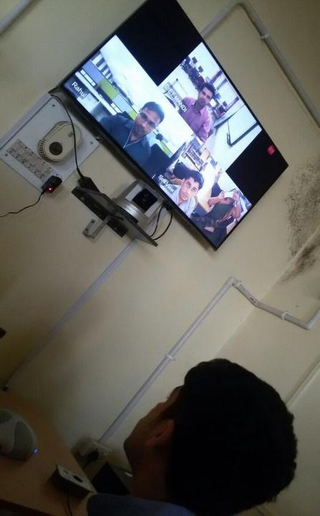
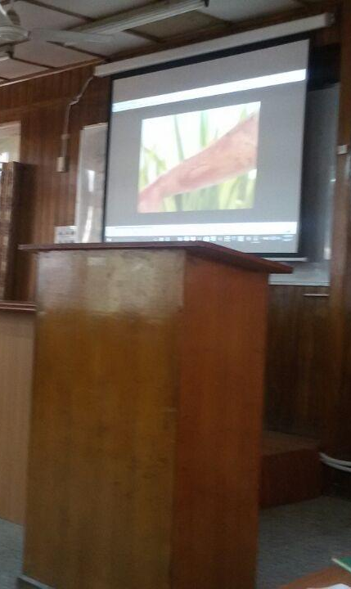
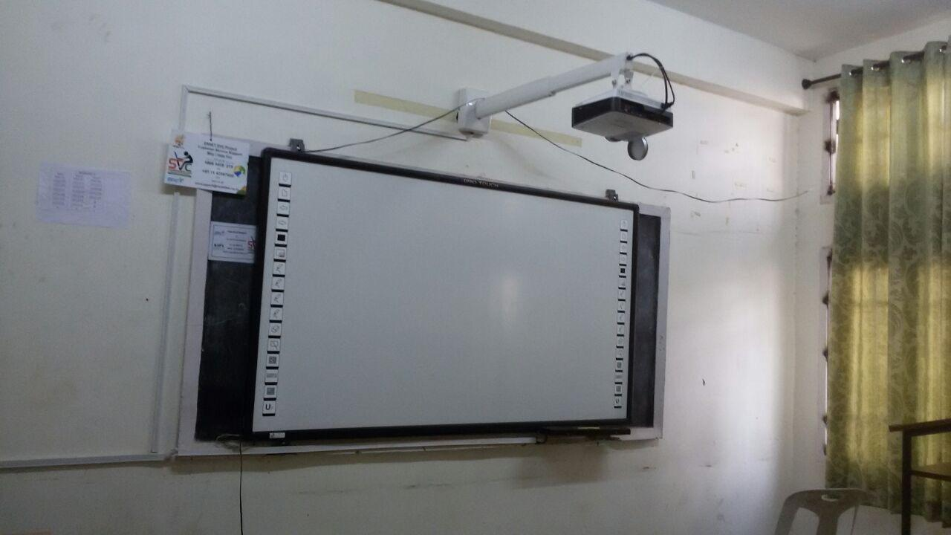
L to R: DIET, Dharmshala, Himachal Pradesh; DIET and SCERT Solan, Himachal Pradesh.
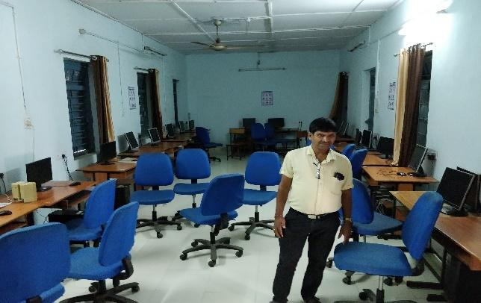
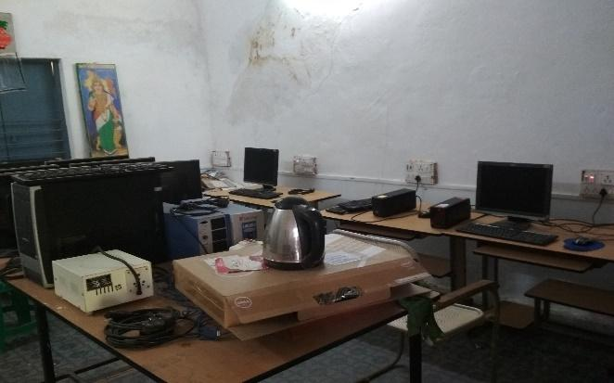

LtoR: CTE Raipur and DIET Kabirdham, Chhattisgarh

CHAPTER 9
Technology Use

In his book The Children’s Machine: Rethinking Education in the Age of Computers, Seymour Papert (Papert, 1991) gives a parable of time-travellers. He asks us to imagine a set of surgeons and school teachers, let us say from a hundred years back, travelling to the current age. The surgeons from the bygone era would be mostly unable to determine what was happening and what the devices are in a modern operation room. This is because there has been a mega-change in the field of medicine by use of technology. Contrast to this the school teachers from the bygone era would be perfectly in-tune, barring some strange devices in the classroom, regarding what was being taught and might be even able to take over the teaching in the class. With this parable Papert asks the question: Why, through a period when so much human activity has been revolutionised (by use of computers) have we not seen comparable change in the way we help our children learn? (p. 2) This question raiser here is relevant for teachers as well.

9.1. Expectation of Scheme: Recommendations from the Guidelines
The penetration of Information and Communication Technologies (ICTs) in the field has happened in varied ways. The CSSTE Guidelines for Implementation (MHRD, 2012) provides a basic framework to integrate ICTs with teacher education (Ch. IX, pp 80-85). Though ICTs have impacted all aspects of life and administrative and bureaucratic matters in general, yet no fundamental changes are seen that have happened in the use of ICT in the way our teachers develop professionally and personally. In looking at the ICT use in teacher education there are parallels to the parable from Papert. The children in this case are our teachers who are undergoing either pre-service or in-service training.
The four major recommendations from the guideline are taken as a starting point to look at the current scenario regarding the usage of ICT across the field.
According to the guideline the main goal of ICT literacy should be:
"... to expose teachers to a wide variety of ICT resources – hardware, software as well as digital learning resources. This requires an emphasis on using available free / public digital resources. Teachers must not treat ICTs as a black box – they should be taught to install even the operating system, open up hardware to study components.'' (p. 80)
Another aspect of ICTs is the integration of ICTs into subject teaching-learning. The guideline notes that:
“The biggest drawback so far in ICTs has been to treat it as a stand-alone subject. However, ICT is a new and powerful method for mediating teaching - restricted to the classroom and virtual learning spaces allow for greater one-to-one interactions, at space and time convenient to the teacher-educators and student teachers. (p. 80-81)”
The guideline also provides a list of softwares resources that could be possibly used for integrating ICTs into the subject teaching-learning that can enhance the quality of learning experience. (p. 81)
Finally, another major theme that is discussed in the guideline use of blended learning models in teacher education. Various online modes of conducting the course like Moodle are discussed. Though there is no mention of Massive Open Online Courses (MOOCs), a trend towards them can be sensed. Another aspect that has emerged since the guidelines were published is the rise in the ownership of a smartphone. The presence of a smartphone has become ubiquitous across all sections of the respondents in the survey.
One major recommendation in the guideline is the use of Free/Public software (sometimes also called as F/LOSS Free/Libre Open Source Software) which includes various free licenses for both software and content.
“...allowing for use of privatized digital learning processes (in the form of proprietary software or content) would be detrimental to education and the public education system should use only publicly owned curricular resources.” (p. 82)
The guideline particularly notes the reasons for using Free software when teaching-learning process is involved. The recommendation of Free software for teaching-learning processes has strong pedagogical, social, political and philosophical basis. Apart from these four points, the survey looks at the varied ways in which ICTs have impacted and can impact the future of teacher education and professional development.

9.2. Findings from the Survey
In this section the responses from the institutes and individuals covered in the survey with these four major themes are presented. A general observation is that though ICTs have made impressive inroads in administrative and bureaucratic matters, the academic and pedagogical matters remain largely untouched at the core.

9.2.1. Administrative and Bureaucratic Matters
There are two major areas in which ICT has made inroads in teacher education. The first one is regarding administrative matters and the second one is in the area of academics. The mode of access, that is the devices used to access is also another important area that is touched upon.

Email Usage: The formal mode of communication between various institutes has shifted to e-mails and use of online portals. The online portals (Table 9.1) in various states have the required information for the schools and the state. Each school has login to this portal where the information regarding the schools is maintained in form of an online database (Education portal).

Satellite Communication: Satellite technology was also used for video conferencing with other officials and teachers. But in many places this has fallen in use after some technical or maintenance issues. EduSat where functional is used for ISTE and PSTE. In case of Chhattisgarh the SCERT has a vibrant ICT department which has produced numerous videos on several topics pertaining to the curriculum. The EduSat is used to disseminate this to the schools and to teachers during scheduled meetings. These meetings happen at the cluster level in the schools where such video conferencing facilities are provided.
In Telangana State MANA TV is being used for broadcasting content in form of video lectures. In case of Himachal Pradesh and Delhi, ERNET is supporting simultaneous video Virtual Classrooms to all DIETs of the state to overcome faculty shortage.
Social Media Platforms: Another powerful mode of communication that has evolved is use of Social Media (SM) platforms like Whatsapp (a proprietary software, alternative Free software is Telegram). Almost all teachers (both in-service, and pre-service), principals, government officials have access to a smartphone. The social and peer pressure to be on the SM platforms is immense. Most of the notifications regarding Government orders, circulars, official visits, trainings, leaves are given using the SM platforms. Also the faculty of the TE institutes interact with higher authorities, teachers and teacher-students via the SM platforms. Each faculty/student member of the institutes visited are part of many groups with specific purposes. Groups were created for a given class of MEd or BEd, or for teachers of a particular block or a subject. For faculties this was an easy way to reach their students. Sharing of information, videos and resources seems to be major usage of SM platform. The nature of interactivity in these groups is not known, but the potential to use them for continuous interaction with teachers should be focused upon in the future.
The use of SM platforms allows rapid spread of information across groups. Though this has mostly positive advantages, this also allows for absent teachers to make amends during school monitoring. In Nagpur a special App was created for monitoring the school visits and school teachers. In Nandurbar CTE an App was developed to help the teacher-students and keep track of their progress.

Monitoring within campus - CCTV Cameras and Biometrics: Also in some institutes CCTV have been installed across the campus. The purpose behind these installations seems to be monitoring of the institutes and their functioning. The heads of the institutes tell us that after the installations of CCTVs attendance in trainings has increased dramatically and teachers don't tend to go away half-way through the trainings. Some institutes have biometric attendance system.

Institutional Websites: Institutional websites are an indicator of online presence of the institute, its people and programs. The range of responses for this was varied. Few institutes (51/72) have a functional website. In some cases, the sites were built some time back and were cracked and were non-functional. In one particular case the respondent confused the website with email address. The content of the websites could not surveyed in detail for quality and quantity.

ICT Labs: Most institutes from reported the existence of an ICT lab (51/68). But the actual state of the labs showed a stark variation. In some cases the labs were well maintained and all the computers were operational. In some cases only few of the computers were operational, some were very outdated. In some cases the labs were barely functional and not maintained at all.

9.2.2. Faculty Usage
While most of the faculties did have some training in the use of ICT, some of the faculties had undergone no training. Most of the faculties across the institutes reviewed were not supplied with an individual computer by the institute (54/92). Typically they used common computers or computers in the lab and the classroom. Typical computer usage that were reported by the faculties were:
- Typing and creating documents (text and spreadsheets)
- Making and showing presentations (PPTs)
- Showing films, websites in the classes
- Searching the internet for TLMs, resources
- Searching for information and materials for the courses they teach
- Checking emails
- Smartboard usage
- KYAN projector and MANA TV (in TS)
Some of the faculties did undergo a training course in basic digital literacy (39/77). This was mostly modeled on the use of Office software and introduction to browsers (Microsoft based). In many places Microsoft provides the training and syllabus for such a course. Typically this course doesn't have any softwares which are specific to subject pedagogy like mathematics and science or languages. This severely restricts the imagination of use of computers in the teaching-learning process. Teachers should be exposed to the exemplars of use of ICT in subjects. Also prevalence of proprietary softwares usage, restricts ICT resources further as licensing fees take up a large amount of funds. The computer labs in many institutes are present (50/67) with varying degree of functionality. The main purpose of such labs is to give basic training in digital literacy, based on the office software suite.
Some of the respondents were aware of the idea of Massive Open Online Courses (MOOCs). TESS India conducted MOOC courses for faculty of many institutes, but most of them could not extend this to the idea that these could be used for the trainings that they undertake. The idea that they can be creators of such course was not seen. This is an untapped potential to reach to more teachers in an efficient way.
For the MOOCs to function efficiently the trainees to have access to internet via their own individual devices. But this also allows the trainings to be extended, continuous and more interactive than only a face-to-face training for limited time.

9.2.3. Teacher-Student Usage
Most of the student-teachers from the sample to had access to a smartphone (68/88). The smartphone was the primary device for accessing the internet. Though in some cases the institute provided a wireless access to the internet, most of the students also had a personal access also. The primary usage of student-teachers was being part of various SM groups and browsing the internet for information. Most students, where computers were available, reported that the teachers use ICTs in the classroom. Teachers used computers mostly for showing PPTs and videos.
The student-teachers have ICT as topic in both MEd, BEd and DEd programs. How can teacher students cope with this subject in absence of the labs as reported earlier? The syllabus seems to be mostly theoretical with focus mostly on basics of operating system and focus on the office suite, (see the box item below). Little scope is present for hands-on experience for integrating ICTs in the classroom as suggested in the guidelines by using applications that were specifically designed for learning. Such syllabi are promoted by industry with aim to sell their products which are not designed for to help teaching-learning processes. Most of the times this is the only exposure the student-teachers and the faculties get to use of ICTs, it severely limits the use of appropriate applications in the classroom teaching-learning processes.
This problem has several dimensions. One of the factors for this problem is the availability and continued access to the ICT devices. This is directly dependent on creation and maintenance of computer labs, which are not functional or maintained in many places. The second aspect of this problem is availability to various platforms and subject specific applications to the teacher students. This is also compounded by the fact that the faculties at these institutes themselves are not aware of the availability of various applications and their potential use in the classroom. Finally, to get a good conceptual understanding of an application and its usage one needs to spend some time with the application, to practice with it. Only under these situations one can expect the student-teachers to get the mastery of the application and confidence to take this to the classroom as envisioned in the guideline document.

9.2.4. Perceived Problems from respondents
The main roadblocks that were perceived regarding widespread use and adoption of ICTs that emerged from the interactions with heads of the institutes are:
- Grants should be made available on time
- More, well equipped and maintained labs needed including hi-speed internet and backup UPS
- Resource persons required for trainings not available
- Lab technicians and programmers for various tasks not available
- No continuous engagements for teachers or teacher trainers
- Lack of initiatives from the concerned faculties
- Teachers not being enthusiastic or comfortable in adopting technology
Most of the issues raised are regarding the infrastructure or human resources. But there is hardly any mention of the issues regarding the nature and the content of the trainings. The accepted norm seems to be that ICT training is limited to office suite.

9.3. A few examples: Role of Teacher-Educator - consumer or producer
In this section a couple of examples where the institutes have taken interest in developing the capacity in context of ICTs are seen. Almost all the respondents looked at ICTs in a very positive light. This positive intent was shared across the spectrum by directors, institute heads, faculties and teacher-students. A positive attitude though is essential in adopting ICTs, it is not sufficient. ICTs can be used in ways which expensive and restrictive without achieving the best of the possible outcomes. In such a case learners are looked at as passive recipients of the content. On the other hand there is an example where ICTs inclusion happens right from the ground level and teachers are producers of a variety of materials.

9.3.1. Technology for administration and delivery/consumption of content

In SISE-CTE Jabalpur the present Principal has a very positive attitude towards technology. He has used it to automate various aspects of the administrative work in the institue. The institute has a well maintained computer lab of about 30 terminals based on the N-computing model. The computer lab is used for training on basic office suite comprising of document writing, slide presentation, spreadsheets and basic internet browsing. There was no software used in the training that linked to the subject teaching. The emphasis was on possible use of computers in administrative matters, like writing letters, reports etc. The only possible use of this training in the classroom is making slide based presentations. Other uses were finding information from the internet in form of notes, TLMs or video lectures.
At the institute level there is an effort to create 3-D videos for various topics in science. There is an excellent silver-screen theater in an auditorium with Dolby-Digital surround sound to watch these films with 3-D goggles. These films require a proprietary plugin to run. The films were in accented in American English, and it was noted that efforts are on to create Hindi and other local dialect versions. The films themselves were copyright by the company which provided them, their copyright text running through the length of the video. This is perhaps a very good example of limitation of pedagogical imagination in the context of education in general and use of ICTs in education in particular. Though showing such a video in context of a training can lead to some interesting discussions, this is a very restrictive use of ICTs.

The very idea that ICTs can be used to create knowledge by learners themselves by hands-on practice are not part of this approach. All the effort in this case has been to recreate the old model of dissemination of knowledge in a digital way. This is against the guidelines of CSSTE and also against the spirit of constructivism as elaborated in NCF 2005. Furthermore, the creation (this set of videos had cost several lakhs) and more importantly dissemination of such videos is not scalable due to both hardware and copyright restrictions.

9.3.2. ICTs for Production
In contrast to this the model in Karnataka a vibrant movement has developed around the effective use of ICTs in the classroom teaching-learning processes. A NGO IT for Change has been central for bringing about this change in the state. There is a very active and collaborative platform of Karnataka OER (KOER) maintained by IT for Change. The KOER platform has open content created by teachers across the state and has various features like Lesson of the Week, Online Courses, Videos and Interactives, Question Banks etc. This has resulted in grass-root level participation of teachers making this movement sustainable. A typical curriculum for ICT courses here focuses on use of ICTs in communicating the subject matter via a hands-on experience with various applications designed for teaching and learning (see box below). Assessments in this course are mostly in form of Digital Portfolios and discussions in the online forums. This approach is along the guidelines of CSSTE for ICT training and integration with teaching-learning process.
Even with this approach not all institutes in the state could have excellent or sufficient infrastructure or provide an integrated approach to teaching-learning with ICTs.

OER Usage in other states: Apart from Karnataka, four other states in the survey were using OER materials and innovative use of ICTs in teacher education and classroom interventions in form of the Connected Learning Initiative (CLIx) project from Tata Institute of Social Sciences.

9.3.3. Use of smartphones as production devices

One positive outcome of penetration of smartphones with cameras has been their use in recording, collecting and sharing of data. There are several instances where photos from the school are used regularly for monitoring or updating purposes. An interesting episode use of smartphones came from a group of pre-service teachers in . The students while interning at the school video recorded their teaching sessions. These videos were then uploaded on the internet (Youtube) to get feedback from the faculty mentors. Though this is not advocated as a replacement for on-site support, the idea of video-recording of a classroom session opens up many possibilities. The use of smartphone in the classroom as a recording or data collection can lead to potential research opportunities for the teachers. Even for analysis of their own teaching and discussions about it with peers and mentors can be immensely enriching for the in-service and pre-service teachers alike.
Though the smartphone has its own uses, for certain operations a computer is much better suited. Especially when it needs more computing power or larger screen space. Also certain applications, as of now, are available only on computers.

Table 9.1: A summary of state of ICTs in education in various states.

State/UT | State of ICT Labs (functional/  total institutes) | Websites across institutes | Education Portal | Computer access | ICT Training for Faculties statewise
Assam | 5 / 8 present | 7/8 | online.assam.gov.in/web/guest/education-in-assam | 2/8 | 3/8
Bihar | 3/6 | 7/7 | http://www.educationbihar.gov.in/ | 4/7 | 0
Chhattisgarh | 6/6 | 4/6 | http://eduportal.cg.nic.in/Login.aspx | 5/6 | 4/6
Delhi | 7/7 | 3/6 | http://www.edudel.nic.in/ | 2/4 | 2/4
Himachal Pradesh | 3/3 | 3/3 | NA | 0/3 | 0/3
Karnataka | 3/4 | 4/7 | http://karnatakaeducation.gov.in/ | 5/8 | NA
Madhya Pradesh | 6/8 | 6/7 | http://www.educationportal.mp.gov.in/ | 9/12 | 12/12
Maharashtra | 4/6 | 2/5 | https://education.maharashtra.gov.in/ | 9/11 | 7//11
Mizoram | 2/4 | 5/5 | https://schooleducation.mizoram.gov.in/ | 7/7 | 6/7
Puducherry | 2/2 | 2/2 | http://schooledn.puducherry.gov.in/ | 3/3 | 0/3
Rajasthan | 2/4 | 4/5 | http://education.rajasthan.gov.in/ | 3/3 | 0/3
Telangana | 6/7 | 7/7 | http://ssa.tg.nic.in/ (not functional) | 3/12 | 4/12
Uttar Pradesh | 1/2 | 2/9 | http://www.upefa.com/upefaweb/ | 2/8 | 5/8

9.4. Reflections on the state of ICTs in the TE institutes

The TE institutes across various states reveal a contrasting picture in terms of ICT use and adoption. In certain states the overall infrastructure seems to be much better than other states. But even within a given state the conditions are quite varied. Some institutes have functional ICT labs, while some have a barely functional lab, while others don’t have one. In some cases the students report that almost all faculties use computers (mostly in form of slide-shows) for their classes, while in other cases the faculty don’t use a computer at all. In general, as the availability of computers increases the academic usage also increases. When the number of computers are less, they are mostly used for administrative and bureaucratic functions. Only when the computers are present in sufficient numbers, they are utilised for academic purposes. This reflects the priority that the system gives for using the computers. The familiarity with computers through practice is essential if they are to be integrated as per the guideline. The same pattern is also reflected in usage of computers in the schools.
As far as the four points discussed in the first section, most of them are not achieved. The hope that teachers should not treat the computer as a black-box and should master both hardware and software is not achieved. The second point regarding ICTs should not be considered stand alone subjects is negated by the presence of ICT curricula which are based only on the office suite. The third point regarding the use of online platforms for teacher training, again no exemplary evidence was found in this survey. The fourth point regarding use of Free/Public software is again not seen in practice. Except, perhaps in Karnataka, proprietary software was used for both administrative and academic purpose. For a deeper understanding of the issues perhaps a more substantive and comprehensive survey with focus on ICT is needed.

CHAPTER 10
Governance, Program Management & Fund flow

CHAPTER 10

Governance, Program Management & Fund flow

It is important to understand the overall governance and support structure in CSSTE. Being a central government scheme, the major source of funding for this scheme is through government of India supported by the states’ share. In a way, the MHRD has done a wonderful job by establishing the program and supporting the states in implementation of program. Referring back to 2012, it seems that there are significant improvements in terms of planning, implementation, governance and record keeping of the scheme. Clear and thorough development is visible in timeliness and approval, particularly with respect to the scenario before 2012. MHRD had established a Technical Support Group (TSG) in 2012-13 and this group has been doing impressive work since 2013-14.
There are many institutions that are involved and are impacted by the scheme, directly and indirectly. The functioning of state level teacher education institutions, including SCERTs, IASEs, CTEs, DIETs and BITEs, are directly impacted by this scheme while other institutes and schemes such as SSA, RMSA, BRC, CRC, Directorate of School Education (Elementary & Secondary) are indirectly impacted by CSSTE.
Despite significant change and directed effort in approach to the scheme, there are certain issues that need to be addressed.

10.1. Norms of the Scheme
At the central government level, the program norms are reviewed and suggested by the MHRD. However, they are finalized and decided by the Cabinet Committee. The norms were last revised in 2012. It is important to note that norms are indicative of the upper limit of funding while in practice the allocation does not happen to that extent. The following concerns have come to the fore during our interactions with the state level functionaries.
- Norms are uniform and standardised across the country. They are fixed for selected activities, with no flexibility in accordance with the diverse needs of different institutes.
- The norms are old, and due to inflation it is difficult to manage activities under the stipulated constraints.
- There is also expectation of some kind of convergence among different schemes of the government of India.

10.2. Inadequacy of Financial Norms and Allocation
The norms related to monetary allocation were decided in 2012 and despite inflation, the same are being used currently (in 2017). Moreover, the present approach to financial norms does not support diversity. States are not happy that MHRD has a blanket approach - deciding uniform and same standards for varying levels of training needs for different geographies, institutions, target groups and training deficits. It was also found that there was slashing of funds under different heads related to functioning of teacher education. For example, the SSA funds meant for research and evaluation were cut off. What is even more challenging is that there is inordinate delay with respect to the salary disbursement of the DIET faculty – sometimes DIET faculty are not paid timely salaries for a stretch of 6 month durations. Indeed, one of the DIET staff had casually remarked that in teaching circles it is understood that “if you have got a posting in DIET, it means that from now on you won’t get salary”. This, the respondent stated, is a serious deterrent for people to join as DIET staff.
A major concern of states was that of norms and approval. Mid-level functionaries have expressed that given the setting of current norms of CSSTE, if the MHRD cuts down the fund allocation for any particular head or item, the state government too is given to make a proportionate cut. In other words, any slashing of funds at the centre has twice the impact. One suggestion that has come from one of SCERT directors is that “the norms need to be revised every year or fixed at par with inflation. Our teachers too deserve quality training in good environments.’’

10.3. Fund Flow
It seems that over the years there has been a lot of improvement in timeliness of budget approval and release. The following table about the dates of TPAB meetings and release of minutes indicates the categorical improvements.
Table 10.1: Dates of TEPAB & Release of Minutes
States | 2015-2016 |  | 2016-2017 |  | 2017-2018
 | Meeting Date | Meeting Minutes Date | Meeting Date | Meeting Minutes Date | Meeting Date | Meeting Minutes Date
Assam | 05/03/15 | 08/06/15 | 04/03/16 | 10/03/16 | 22/02/17 | 18/04/17
Bihar | 27/03/15 | 13/04/15 | 29/04/16 | 24/05/16 | 08/03/17 | 18/04/17
Chhattisgarh | 27/03/15 | 13/04/15 | 10/03/16 | 05/04/16 | 08/03/17 | 18/04/17
Delhi | 13/03/15 | 21/04/15 | 21/04/16 | 11/05/16 | 10/03/17 | 18/04/17
Himachal Pradesh | 10/04/15 | 23/04/15 | 08/04/16 | 25/04/16 | 02/02/17 | 18/04/17
Jharkhand | 10/04/15 | 23/04/15 | 18/03/16 | 05/04/16 | 10/03/17 | 18/04/17
Karnataka | 06/02/15 | 17/03/15 | 05/02/16 | 19/02/16 | 15/02/17 | 18/04/17
Madhya Pradesh | 20/03/15 | 06/04/15 | 18/03/16 | 05/04/16 | 02/03/17 | 18/04/17
Maharashtra | 13/03/15 | 21/04/15 | NA | 25/04/16 | 09/02/17 | 18/04/17
Mizoram | 20/02/15 | 10/03/15 | 26/02/16 | 04/03/16 | 23/02/17 | 18/04/17
Puducherry | 10/04/15 | 23/04/15 | 12/06/16 | 26/02/16 | 01/03/17 | 18/04/17
Rajasthan | 27/03/15 | 13/04/15 | 08/04/16 | 25/04/16 | 17/02/17 | 18/04/17
Telangana | 06/02/15 | 17/03/15 | 19/02/16 | 01/03/16 | 01/03/17 | 18/04/17
Uttar Pradesh | 20/03/15 | 06/04/15 | 21/04/16 | 11/05/16 | 27/03/17 | 18/04/17

As per the information provided by the selected state, status of fund flow are as follows.
Table 10.2: Fund Flow: Case of 2015-16
State | Fund proposed | Funds Allocated | Fund received (in lakh) | Date of Receipt of fund- please indicate each installment
Assam | 18609.00 | 5202.82 | 198.68 (1st) NR  139.00 (2nd)  2142.59 (1st) R  225.475 (2nd) R  245.33 (2nd) | 05-10-16  05-10-16  27-06-16  31-03-17  21-03-17
Bihar | NA | NA | 114.345 | NA
Chhattisgarh | NA | 1196.58 | 717.95 | May 2015 and March 2016
Chhattisgarh | NA | 1523.80 | 819.56 | May 2016 and March 2017
Delhi | 4576.36 | 1842.87 | 1049.86 | 1st - 29.07.2015  2nd- 26.02.2016  3rd-29.07.2016
Delhi | 3428.00 | 2076.06 | 2076.06 | 1st- 20.06.2016  2nd-30.03.2017
Himachal Pradesh | 2362.94 | 2082.60 | 270.00 | 2/11/2015
Himachal Pradesh | 3811.19 | 2222.51 | 1000.13 | 10/02/2017
Karnataka | 4637.31 | 3477.98 | 1738.99* | 03-11-2015
Karnataka | 4395.39 | 2637.24 | 1318.62  559.31 | 22-07-2016  31-03-2017
Maharashtra | 15211.17 | 3710.47 | 1391.43  370.21 | 10.7.2015 8.8.2016
Maharashtra | 16096.66 | 3915.72 | 1174.71  522.10 | 8.8.2016  6.3.2017
Mizoram | 5136.25 | 1766.13 | 2574.02 | F. 44-8/2015-EE.9  Dt. 23.7.2015 &  Dt. 23.2.2016
Mizoram | 5230.78 | 1246.22 | 1246.22 | F. 44-6/2016-EE.9  Dt. 30.12.2016
Madhya Pradesh | 6022.35 | 2638.43 | 1118.85 | F.44-23/2016-EE.9 dt 18.01.2017
Madhya Pradesh | 6,313.14 | 2,237.70 | 1,118.85 | F.44-23/2016-EE.9 dt 18.01.2017
Puducherry | 252.2 | 172.75 | 80.79 | July, 2015
Puducherry | 289.2 | 245.2 | 139.44 | June, 2016
Rajasthan |  | 6918 | 52222.29 | 22-07-2015  28/01/2016
Rajasthan |  | 7830.37 | 5044.02 | 18-07-16  30-12-2016  27-02-17
Telangana |  | 863.03 | 80.00 | 03/11/2015
Telangana | 4711.37 | 983.91 | 295.17 | 28/02/2017
UP | 19346.60 | 5247.05 | 5247.05 | 10-07-15(I1), 08-03-16(I2)
UP | 15408.02 | 5681.27 | 4260.95 | 21-07-16(I1), 03-03-17(I2)
* Only one instalment was received. There was no second instalment.,
During discussions with lower level functionaries, it emerged that they were not happy with the timeliness of the fund allocation. Further discussion revealed that the fund receipt typically happens in August-September and that they start scheduling for the trainings in about a fortnight thence, till end-march. In other words, the actual training window of the teachers is limited to only 5-6 months in a year. IASE Faculty at Hyderabad informed us that funds reach the institute at the end of the year and it is very difficult to use them in the available time frame. Instead of sanctioning the fund at the end of the year, it will be more worthwhile, meaningful and beneficial, if the same is given at the beginning of the respective year. One important suggestion that emerged during field work was that to avoid this challenge, MHRD may release 25% of the budget early, right at beginning of year on the basis of advance calculations.

10.4. Vision, Planning, Institutional Development Knowledge and Orientation to TE
There is a need of separate cadres for Academic, Educational Administration and Technical faculty at SCERTs, CTEs and DIETs. The gap related to education and training was apparent during the discussions. The creation of an academic cadre does not seem to have taken place. During the interview with state level functionaries it appeared that administrators have very simplistic ideas about some issues in education. In the overall hierarchical structure, academic and technical faculty are not in a position to register their voice and ideas vis-a-vis administrative officers. It was found that the officials had varying backgrounds and hence varying levels of understanding of the teaching-learning scenario. While they were confident of their understanding and perceptions, it seems that there is lack of awareness among very senior bureaucrats as well as lower level functionaries about the teaching-learning process. The activity of teaching-learning is widely considered to be something simple and is common knowledge. Knowledge with respect to TE is limited to those activities to which funds are allocated and for which there are government orders. It is important that all key officers handling CSSTE need to be thoroughly oriented before joining the position. The orientation should be supplemented with frequent subsequent orientations. Faculty who are appointed to various posts by and large learn on the job and there is no induction. There are also no systematic provisions of faculty development for the faculty of the institutions.
10.4.1. Planning
The approach to planning is a decentralized one. However, the norms do not seem to allow for it. They are at the very least perceived as fixed and not adaptable to local requirements. Moreover, the process of planning itself is creating a huge constraint. States are struggling with uniform and centralized norms. Its impact is obvious throughout the system. Ground level functionaries are of the view that those DIETs with good infrastructure and full faculty strength should continue with pre-service training but if infrastructure and faculty strength are not well provided for, pre-service may be revisited.
10.4.2. Technical Support to State
During discussions with state officials, it emerged that they require more and frequent support for capacity building of state level functionaries. The NCERT structure and capacity do not allow them sustainable and continuous work with state and district level officers. Moreover, NCERT is also not in close touch with the reality of states. Given this, strengthening of TSG is required for regular support and capacity building of states.
10.4.3. Crunch of Experts and Trained Teacher Educators
This is a multifold problem which includes large number of vacancies, putting admin officers in the role of DIET /CTE faculty. It also creates a long list of expectations on these faculty. IASE Faculty at Hyderabad informed that “in this institute we have very less number of faculty and these faculties are called to work at SSA, RMSA and SCERT all the time as there is less number of staff in those institutions”. State has introduced English medium in most of the district colleges, without appointing the necessary faculty. For SCERT Telangana, there are only two staff members at the Assistant Professor level who understandably have inordinate levels of work. As mentioned earlier, there seems to be a certain lack of alacrity in filling all the posts in the institutions. Furthermore, even with regard to the existing faculty, there is a great need for their capacity building. As the Secretary, Uttar Pradesh has indicated, “training and learning of developed word would not work, we need socially and culturally rooted ideas and training materials in indigenous language”.
10.4.4. Inter departmental coordination
Education institutes at both state and district level have reported that there is lack of coordination among education institutes and other offices like SSA and RMSA. Though SCERT is the nodal institute for academic matters and development work, it is reported that very often in-service teacher trainings are organized by RMSA, SSA or the department of school education without consultation with state or district academic institutions. Due to this lack of coordination, teachers attend multiple, sometimes similar, trainings organized by different departments. It is highly recommended that for all the trainings pertaining to state teachers, SCERT should be consulted and trainings be conducted by state or district institutes. It is also important to develop an e-governance for teacher education and coordination among various departments.
10.4.5. TSG
In the last couple of years (post 2013), the TSG has done some remarkable work in the space of teacher education. TSG’s work is apparent from testimonies like its previous minutes, its coordination with State, its defining of norms for teacher education institution, and its orientation of state academic groups on various academic/administration disciplines. The TSG also reported supporting state resource person for visits to Arizona State University for capacity building programs and get exposed with new techniques through TESS.

TSG WORKSHOP
The National Consultation Workshop to discuss the Evaluation of Centrally Sponsored Scheme on Teacher Education (CSSTE) was held at Mirza Ghalib Hall, Scope Convention Centre, Scope Complex, New Delhi, on 25th August, 2017. Some major points of discussion were Improvement in Physical Infrastructure, Incentivizing Teacher Education, Redefining the role of SCERT, Teacher Education Institutions (TEIs) as Registered Societies Convergence of TEIs, Up gradation of existing resource material, Open Educational Resources (GROER), Professional Development of Teacher Educators, Strengthening of linkage between states and UTs, Use of ICT, SCERT as the nodal authority for Teacher Training, Replacement of 2-year D.El.Ed. Course, Supervision and monitoring, Quality of Teaching learning materials, Real time monitoring through Mobile App, DIETs as nodal institution of the district, Redefining the role of SCERT, Funds for training, Replacement of 2-year D.El.Ed. Course with 3-year or 4-year integrated teacher education courses, Single hierarchy system Self-Financing Autonomous Model of DIETs.

In the recent past, however, the role of TSG with respect to state participation has tremendously decreased, being restricted to a few core areas like the formulation of training, curriculum reforms and development in the planning phase of States. Due to limited budget availability, the TSG’s role has been bound by select areas of expertise like planning, appraisal and monitoring. Further, there is a need to build the capacity of the TSG in other core competencies areas, such as Teacher Education Design, supporting the state in modules and curriculum development, addressing issues of quality in the landscape of teacher and school education.

NCERT
The nature of contributions and responsibilities of NCERT emerge principally from academic necessity rather than field requirement and through the work of a few senior functionaries who can enrich state capacity. According to the SCERT functionaries, the younger faculty require capacity building, of which monitoring is a strong component.

10.5. Conclusion
There is a strong need to restructure the scheme of CSSTE. Doing so will enable the central government to help the states. It is desirable that teacher trainings under SSA and RMSA be transferred to the CSSTE. Since SSA and RMSA are mostly administrative bodies, it will be a help to the state as well to transfer the funds for research on school education to the SCERT through CSSTE scheme.
Fund allocations to institutes and their lack of timely release is another common thread underlying the narratives. Late release of funds, and the amount being lesser than that requested prevent institutions from carrying out their stipulated work plans. Their inability to deliver due to these factors that are beyond their control becomes the reason for non-allocation of funds for the next year. There is a need to
this cycle on a case by case basis to ensure timely release of funds and monitor their use systematically to ensure they abide by the institutions’ AWP.
One emerging trend across the institutions seems to be a disconnect between policies, their intent and their impact on the key stakeholders of the education system - the teachers and students. In some states, infrastructure and funds pose barriers to teachers to achieve their full potential. Motivation and inherent zeal seems to be the key factors driving programs in many states.
There is a need for better coordination among state education institutes and other scheme offices (SSA, RMSA). State level SCERTs need to be strengthened adequately to coordinate among different department of education and primarily be involved in planning teacher education at district levels. All resource persons or technical faculties at BRC/ CRC should be directly linked with the DIET and come under direct supervision of the SCERT and DIET. There is need as well to develop e-governance for teacher education to efficiently plan resources and implement various teacher education programmes

CHAPTER 11
Conclusion and Recommendations

CHAPTER 11

Conclusion and Recommendations

The TISS team visited 11 states and two union territories, and collected data from,50 DIETs, 19 CTEs, 13 IASE, 2 BITEs and 12 SCERTs, and met 8 Education secretaries, 2 SPDs,12 SCERT Directors, 71 heads of TEIs, 91 Faculty and 82 students.

In this final chapter, we present our conclusion and recommendations. In part 1, the key findings from the five types of institutions and three thematic areas are summarised. In part 2, we summarise our findings with reference to the key research questions. Part 3 is devoted to best practices that were noted. Part 4 provides a summary of key recommendations.

11.1: Summary of key findings

11.1.1 SCERT

SCERTs were found to be mostly carrying out all of their core functions. The evaluation team found that all SCERTs are declared as an academic authority under section 29 of RTE act for their respective state. SCERTs were performing a range of tasks to meet the requirement of RTE act which includes curriculum reform, development of school curriculum, syllabus and textbooks as per NCF 2005. It was observed that SCERTs engage in curriculum, module and material development for pre-service and in-service teachers training, as well as perform research in the domain of school education. SCERTs were also involved in conducting achievement surveys to understand the learning level of the children as per their grade and age.
There are certain critical issues as well. First, it was observed that due to a bureaucratic structure, the SCERTs were able to influence state level policy to a limited extent, in most cases they act as advisory body. Secondly, the lack of in-house capability for necessary pedagogical process, in particular, curriculum development for school, teacher development and research are under question due to vacancy and other administrative load on existing faculties. There is an apprehension that this institution may turn out into an administrative body than academic one. Faculties of the SCERT have limited chances for their own capability building. Thirdly, components of rigorous vetting and review of existing curricular and material development process is missing. This has a significant impact on the quality of development work and research.
To meet the constitutional mandate, it is important that every SCERT has sufficient faculty as per the guidelines of CSSTE and the respective states have plans and budget for nurturing this institution.

11.1.2 IASE

There is a variation in terms of resource allocation, infrastructure availability and functioning of IASEs in different states. Encadrement of teacher educators is absent in most states. Appointment of many members on the teaching faculty is co-terminus with the CSSTE scheme which is a cause of great anxiety and concern for the employees. While a few IASEs are better resourced and executing their roles as “regional resource centres” and “academic mentors” to other stakeholders, there are IASEs which are waiting for both academic and non-academic posts or struggling due to lack of funds. A lack of synergy was noticed in most states due to the presence of two different academic heads which lead to non-consultation on training requirements and duplication of trainings. Libraries in many IASEs are not rich enough and few have access to e-resources. A few IASEs did not even have curricular documents currently in use such as NCF-2005, NCFTE and so on. Subscription to international journals, e-journals is missing in most IASEs and so are subscription to academic magazines. Latest publications were not available. Reading halls are insufficient in size in many IASEs. Full time librarian not appointed in many IASEs. No evidence of effectively leveraging of ICT in the routine functioning of IASEs was noticed. Use of ICT is limited to use of classroom presentations and admission processes.Research work only leading to use of action research as a methodology needs to be discussed and thought about. Major focus and emphasis is required towards well planned research studies conducted by faculty-members which are qualitatively effective than research conducted just for the sake of doing them. Annual conferences for teacher educators and the larger teacher community can provide a platform for further deliberation

11.1.3 CTE

The study revealed that at the level of academic work, faculty are not clear about their teaching and research responsibilities. There is negligible research on the needs of school teachers and impact or learner outcome studies leading to the future design of appropriate training workshops. The faculty development workshops attended by the faculty are also sporadic and unstructured, with lack of clarity on its goal or use. It is also evident that faculty across the CTEs are over-burdened through straddling multiple academic and administrative responsibilities. Knowledge of latest policies and their implications for teaching in the classroom was also limited among faculty and students. It was more prevalent in institutes that had incorporated the policies into their curriculum. The knowledge was however restricted to a verbatim repetition of the terms rather than considered understanding of what the terms meant. The faculty and heads of institutes were unanimous in stating that there was shortage of funds and insufficient infrastructure. Lack of ICT facilities, interactions and faculty exchange between institutions as well as learning communities seem to contribute to dearth of ideas. These were presented as some challenges in teacher education. Another challenge pertained broadly to the quality of teachers leaving the CTEs. On the one hand, faculty felt that student-teachers who join CTEs do so as a last resort. Very few view teaching as a worthwhile profession, which affects the extent of learning. On the other hand, ensuring quality of subject teachers in PSTE becomes a challenge since CTEs impart pedagogical knowledge at the expense of content knowledge. Some CTEs felt that floating an integrated B.A./B.Sc.-B.Ed. program will fill this gap since the faculty can then impart content and pedagogical knowledge alike to the students and ensure quality. The increase in the number of private institutions was seen as a challenge since the quality of teachers produced by these institutions are suspect. Further, no checks were in place to ensure that the training imparted in the CTEs was translated into practice in schools after the student-teachers graduated. These comments agree with the data that reveals that there are very few research studies being conducted in schools to gauge impact of training and learning outcomes. Yet another refrain was that in-service trainings should be done by the CTEs and not the DIETs. There are, however, financial constraints that prevent the CTEs from carrying out these trainings.
Another identified challenge was the TET examination that the student-teachers find increasingly difficult to clear. More than 50% CTEs remarked that they conducted “coaching” classes in TET above their existing workload to help the students clear the exam. Also noted was hesitation on the part of a few senior faculty to attempt the NET since they were closer to retirement.

11.1.4 DIETS
The challenges faced by the DIETs are various and varied. Apart from teaching and conducting in-service trainings for teachers, DIETs are also stipulated to conduct research and contribute to pedagogical and content knowledge in their relevant areas. This perception is, currently, lacking since the faculty appear unclear about their roles and responsibilities in the institutes, apart from teaching and administrative work. Research activities pertaining to domains were a little more than impact and needs analysis in schools. In most institutes, publication of works were restricted to college magazines and local dailies. Very few DIET faculty had written for academic journals. Another trend that emerges from the study is that the active and functional DIETs are located close to big cities and in well-connected areas, while the DIETs in second- and third-tier cities face greater challenges ranging from insufficient funds to vacancies, de/motivated faculty and students and fewer opportunities for faculty development programs. Lack of functional online portals communicating information of training programs etc. contributed to limited exposure opportunities to faculty. Most faculty also expressed diffidence in clearing the CTET and felt it was crippling career advancement for fresh and seasoned teachers, alike.
Another challenge for DIETs is monitoring the spread of schools covered under each district. As institutes responsible for ensuring quality of elementary school teachers, DIETs’ volume of work is high and they thereby require greater number of faculty. The vacancies present in the existing DIETs is affecting smooth functioning of these institutes. Current lack of opportunities also seem to have a demotivating effect on the DIET faculty. An overwhelming majority of faculty stated that DIETs should, and are academically positioned, to assume the responsibility of secondary school (teacher) education. They were also unanimous in stating, though, that this was contingent on receiving the necessary funds, resources and infrastructure on a timely basis. Encadrement was seen as a possible incentive to motivate faculty to perform better.

11.1.5 BITEs
Of 102 approved BITEs (the sanctioned ones as per TEAB minutes are almost half) only 05 are functional. It is noted that the teacher strength is very poor in the observed BITEs and in one of them the existing faculty were not even aware of the transformation processes involved in converting their BTC to a BITE. The "paucity of funds" repeatedly argued in the TEAB meetings that reduce the number of sanctioned BITEs are a sad state of affairs. Furthermore, the purpose of establishing even these sanctioned BITEs to both build capacity at the local level to both improve the pupil-to-teacher ratio and enhance sensitisation of teachers to local needs has not been at all met in the current implementation cycle.
11.1.6 Infrastructure and governance

Lack of infrastructure and facilities to faculty such as computers at desks were found to be problems. Libraries were found to be poorly equipped in all but few Institutions. The Resource Centre at Chamarajanar, Karnataka, and IASE Jabalpur were notable exceptions. There were no effectively functioning internal forum for faculty discussions, reviews of work etc, most work planning was carried out but in a ‘line department’ manner with the institution head responsible for assigning tasks. Most institutions conducted weekly or daily meetings but no instances of yearly review were cited. Faculty were found to have limited opportunity to interact with experts and no opportunities for faculty development. Although all SCERTS had constituted Programme Advisory Committees, there were very few which met systematically to review and contribute to the process.
Impact of CSSTE is visible in various aspect of teacher education in order to ensure quality of school education. It has the most potential scheme of government of India to address quality components of RTE act 2009. As of now the scheme is mostly governed through SCERT at state level. However, there are exceptions as in case of Bihar where scheme is governed through Directorate of Training. It seems that despite of inadequate funding as per approval of PAB and norms under CSSTE guideline, scheme is able to spread across the 13 states/UTs which were covered under the study.

The Evaluation team observed that from 2012 onwards there has been more regularity in conducting TE PAB, release of minutes and fund. MHRD, through TSG (TE) is able to establish a coherent mechanism of release of funds and monitoring through frequent JRMs. TSG plays a significant role in supporting the capacity building of state government functionaries for planning and implementation of CSSTE. TSG (TE) and teachers’ education department of NCERT should work together to provide technical support to state government. MHRD should focus on capacity building of TSG (TE) functionaries.
It is important to note that there are frequent transfers, posting and deputation of administrative officers on academic positions such as SCERT director. It was observed by the Evaluation Team that some senior level functionaries have little knowledge on teachers’ education and school education. CSSTE should work in coordination with Lal Bahadur Shastri National Academy of Administration or other institutes of reputation to develop a course for Senior officers.

Moreover, the website of the institutions should be functional and monitored on a quarterly basis.

11.1.7 PSTE and ISTE
Most states had revised their curriculum and there were concerted efforts to improve the quality of the programme and the use of specially developed modules and technology for students (as seen in Bihar, Karnataka, Chhatisgarh and Himachal Pradesh and Mizoram).There were also improvements on student admission. Students were found to be enthusiastic about and responding well to the new curriculum. The introduction of M.Ed. into IASE (Mizoram) was cited as important to address shortages of faculty for TEIs. DIETs were perceived as good institutions by student-teachers. However in some states, dealing with large enrolments was a problem particularly in view of vacancies. However, overall interest from students to opt for teacher education programmes was found to be lagging since teacher recruitment in most states was increasingly irregular, and private employment was not found to be remunerative. The BEd programmes now becoming two years duration was also found to affect student interest. It was also felt that centralised admission processes needed streamlining as delays are affecting quality (Karnataka). TET was being implemented in all states. However there was a feeling that TET based on only written test was not sufficient and an interview component should be included in teacher selection.
DIETs in some states (like Bihar) were found to be catering only to the need of completing the training of untrained in-service teachers, rather than new teachers. There were cases of in-service teachers holding B.Ed and even M.Ed but deemed as “untrained” to teach at the primary level of school education since they did not have a D.El.Ed/D.Ed. In a few states, such as Mizoram, on account of inadequate BEd colleges, students with Bachelors and Masters degrees were opting for D.El.Ed/D.Ed course in DIETs.

Training management systems are not in place in most TEIs. BRCs and CRCs are still not formally linked to DIET--without these linkages support for training, supervision and monitoring, as well as responding to local needs is limited. There were no assessments of quality and efficacy of ISTE. There were also few instances of convergence and coordinated planning and strategy of ISTE. Each state has done significant and massive work in-service teachers education and although they have a good repository of such training modules, these are often scattered. Currently, they can offer a list of options to teachers to choose as per their requirements and the state of Karnataka is providing the same to its teachers.

Contrary to the general perception of quality under government sector it is important to note that all the stakeholders (bureaucrats, faculties and students) are in the view that the pre-service teachers’ trainings of government institutions are much better than private sector. This was noted that quality of the process and output was much better in the Government run institutes. All the states have reformed their curriculum of Diploma in Elementary Education (D.El.Ed) and are now struggling with the development of reading materials in the local languages.

One of the most critical observation that emerged during the field work was the need for merger of different teachers’ training program and activities. This will result in it being focused and can have the intended impact. Senior officers and functionaries are of the view that it is important to merge all centrally sponsored teacher trainings into CSSTE including the trainings under RMSA and SSA. Funding under several schemes creates a problem of duplication of efforts at many levels.

11.1.8 Use of Technology
Technology was being used in administration. Most heads felt that institutions need technical assistance. ICT labs were under development but their establishment was uneven. It was observed in most institutions that faculty were not provided with personal computers or laptops. The extent of computer literacy among faculty of different states varied. Some states had progressed far beyond others in terms of ICT infrastructure (Maharashtra, Puducherry). Some states were seen using online student admission etc (Bihar, Mizoram). However, ICT was not being used to manage the TE programmes nor were students receiving much exposure to ICT use. ICT was also not being used in any significant way in the in-service professional development programmes, through the use of training management systems or in ICT and multimedia based training was seen at times. The Karnataka subject teachers’ forum was found to be a notable exception, this was now being tried out in a few other states such as Telangana. In a few states teachers were involved in the creation of OERs (Karnataka, Telangana), and were beginning training in ICT integration into the classroom (Assam, UP). There were a few cases of use of ICT for school support to teachers, with the exception of a few states were teacher telephonic help lines had been made available. While whats-app groups was increasingly common, there were no systematic strategies for providing inservice support through social media. The use of Free Software for both administrative and academic purposes should be encouraged and supported, currently proprietary softwares are the norm in most places with exception of Karnataka.

11.1.9. Vision for the TE sector and CSSTE

In most states there was a feeling of lack of a coherent vision for the sector. Where private colleges proliferated, it was felt that this was having a distorting effect on teacher preparation. There was little coordination between institutions and stakeholders. While most institutions seemed to be preparing Annual Work Plans for the scheme, however, there was generally a low level of awareness of a state perspective plan on TE under the CSSTE (the exceptions to this being Chhatisgarh, Karnataka). Even where there was awareness of such a plan, the stakeholder institutions were not aware of it. None of them had seen or referred to the CSSTE plan guidelines, even for the purpose of preparing their own AWP. There was a feeling that on the whole the CSSTE scheme has been neglected (exceptions being Bihar, Mizoram), with resources at best being used for salaries, but with no coherent vision being implemented through the scheme. Monitoring of institutions and the scheme seemed to be routinized and limited. Teacher Educator encadrement was found only in few states like Karnataka and Delhi.

In most states, SCERT was the single point for dealing across institutions. In Bihar and Mizoram, however, there is also a Directorate of Research and Training (DRT), thereby making two authorities who plan TE programmes in their respective states. There seemed to be no platform of convergence. Annual audits, report submissions, and data gathered on formats were cited as the monitoring tools. Only a few DIETs (Bihar, Chhatisgarh and Mizoram) cited visits from Education officers, SCERT director or senior faculty to their institution. Bihar and Mizoram cited the creation of a DIET principals’ Whatsapp group to share information. Delhi cited coordination by SCERT.
Almost all the states cited problem of vacancies which are not being filled.

11.2. Key Research Questions
In this section we take up the key research questions that were formulated to guide the study and review the evidence in order to try to answer these questions.
- Has there been an improvement in Pre-Service Teacher Education and has it contributed towards overall improvement of teacher professional development and school improvement? Has there been improvement in accessibility of PSTE? Have resources been developed?
There has been an improvement in pre-service teacher education at the very least because the curriculum for PSTE has been revised in all the states and UTs in the light of the NCFTE 2009. A few states have also developed handbooks and support resources for PSTE.

- Has there been an improvement in In-Service Teacher Education and has it contributed towards overall improvement of teacher professional development and school improvement? Have structures for inservcice been strengthened? Have resources been developed?
None of the states had revised their approach to inservice education or made investments towards improving its quality. Only one state was found to be using a training management system. One state was found to be moving towards a choice based system for ISTE. There were a few individual cases of modules being designed at local or decentralised levels (mainly DIET) to address local needs and based on local talent in the faculty. Most training designs were centrally prepared and focussed on meeting training targets of SSA and RMSA. There was no convergence of various schemes and activities in ISTE.
- Has there been development of professionalism and capacity of Teacher Educators?
There have been few systematic efforts to improve professionalism and capacity of teacher education. By and large this sector remains neglected. There are also very few opportunities being provided to them.
- Have strong inter-linkages developed within Teacher education and training sector between the following: Existing Departments and Institutions at district level; Existing Departments and Institutions at state level; Higher Education Institutions; Schools; Non-Government Organizations.
There are evidences of Non-Government involvement in teacher training sector in most states. There is coordination between SCERTs, RMSA and SSA at the State level. However at the District level, there is mostly limited interaction between them. CTEs and IASEs are not systematically integrated or interacted with in almost all contexts. Integration of IASEs and their contribution to overall state teacher education revitalisation is in particular weak.
- Have institutions at all levels led to the adequate supply and quality of trained teachers at elementary and secondary levels of education?
All institutions at all levels are making meaningful contribution to PSTE, however their role and contribution is affected by in all cases by inadequate faculty (in-spite of which many institutions carry out their activities with diligence) and in some states by the presence of aided and private institutions leading to oversupply of PSTE opportunities and distortions with the system of seat allocation. Students cited preference for DIETs and government TEIs on counts of quality and cost. Further states are found not to keep detailed data on subject teacher requirement and deployment, hence there is no overall human resource planning in place.
- Is there in place processes, systems and structures across institutions to ensure planning, monitoring and tracking?
There are almost no systems of tracking in place internal to the states or between the centre and the states. The platform PRASHIKSHAK, which has recently been introduced by the MHRD (in early 2017) is only partially useful and up to date.
- Has there been an adherence to guidelines related to staffing?
Positions are vacant. Recruitment is either via internal transfer without care being taken to ensure that qualifications meet NCTE requirements, or recruitment is through state public service commission and delayed. There are huge variations in between states on adequacy of staffing, and further there are also transfers taking place during the academic sessions, disrupting the academic cycle for students.
- Has there been an adherence to guidelines related to the infrastructure?
Yes.
- Has there been an adherence to guidelines related to the flow of funds?
Yes, states are following guideline for fund flow.
- Has there been use of ICT to enhance institutional, instructional and teaching quality across the institutions?
The use of ICT on the whole has been found to be limited. Only in SCERTS do faculty have access to ICT for their office work. Most staff have received ICT related training, but the use of ICT is not an integral part of their functions and role. Websites in all but four places were found to be of poor quality and with limited information.
- To what extent has the academic profile of the institutions been strengthened through the following: Research and Publication, Education Courses for Faculty, Seminars, Workshops, Study Tours. Is there an enabling environment of governance, and are the institutions able to network and collaborate? To what extent are the institutions able to work in a convergent manner?
In only a few cases have such academic activities been undertaken systematically to strengthen the institute's academic profile. On the whole these area is neglected with poor inter institutional functioning and profiling. Most institutions with few exceptions have resource centres or libraries that are up-to-date.
- Has there been a one-time situation analysis and stock-taking by institutions where mandated? Has there been a regular and frequent situation analysis by institutions and states where mandated? Is there regular monitoring
With one exception, there has been no situation analysis and stock taking. Most states do not have
- Has the flow of funds affected the quality of implementation of the scheme? Are there avenues for new funding available?
Yes, the fund flow has affected the quality of implementation. It has been observed that there is a gap between the state proposal and fund approved by the PAB, and a further gap between funds approved and funds released by MHRD. States are taking limited support from NGOs and Trusts for implementations of selected programmes. As of now there are very limited non-Government sources available for funding.
- Has there been scope for operational autonomy for institutions under the scheme?
Yes and No. Planning has largely adhered to meeting programme targets and applying norms with little evidence of any attempt to ‘develop’ the institutions to play a significant role in TE in their area. SCERT

11.3 Best Practices

Faculty Capacity building
- Special courses and innovation for teacher educators- IASE Aizawl runs a 2-year B.Ed. Multimode Programme that it has developed on the recommendation of the Educational Reforms Commission Mizoram 2010 to clear the backlog of teachers without professional qualification or “untrained” in-service teachers. The intake capacity is 100 per study centre - IASE study centre and CTE study centre. This course is same as the regular B.Ed course offered by Mizoram University. This multimode B.Ed programme uses blended mode in the form of contact period (coincidently when the TISS visited IASE Aizawl, their 30-days contact classes were on) and online period. The online period is heavily ICT-dependent.

- Utilization of Learnings from Exposure Visits by Teacher Educators-At DIET Bhopal, the training received at Arizona University was used to shape the internship programme at D.El.Ed. level and the innovation of internship evaluation diary by faculty member.
- At DIET Puducherry, several faculty have been building on the existing outdated curriculum to impart to students additional knowledge of subjects. This is based on their own research initiatives and experience as domain expert

11.3.1 Research, Development and Innovation

- Encouraging proto research- DIET Nalanda Principal mentioned about her academically useful visit to Arizona, USA in 2013-14, which was a huge moral booster - she realised that “one can carry out small scale observation and research and publish them”. She mentioned that we need to go beyond only action research and adopt methods. She has encouraged other faculty-members in DIET Nalanda to make TLMs using ICT and such videos have been uploaded on YouTube for larger usage.
- Outside the walls innovation- DIET Bilaspur (rural) in HP, though under resourced, has developed a botanical garden and installations for experiments with sound and light. They also had a science activity lab, developed in partnership with an NGO, which had a number of models to support textbook experiments.
- Inclusive education & research curriculum- IASE , Delhi , in partnership with SCERT has developed and implemented curriculum across ISTE/PSTE on research for school teachers and inclusive education.
- DIET Bangalore (rural) is involved in creating awareness among SDMC members regarding their roles and responsibilities through ‘SAMAGRA’ magazine, which is used by the school HMs during SDMC meetings.
- Development of local language dictionary- At DIET Ujjain, with the initiative of the Principal, a Malvi-Hindi dictionary is being developed to be used as a resource, across the district, for teaching Hindi in schools.

Teacher Education practices
- Mixed ISTE-PSTE classes- SCERT is engaged in textbook development , projects for out of school children and online learning options called ‘Chalklit’ in partnership with other organisations. SCERT also runs mixed classes for ISTE /PSTE students which may be of interest to research learning processes and impacts.
- Resource materials for students: At DIET Puducherry, the faculty depends on Tamil Nadu SCERT for its D.El.Ed. curriculum and textbooks that are in Tamil. The faculty therefore voluntarily translated all the textbooks into English themselves and printed limited numbers of books, in-house, for their students, using DIET funds. This was to ensure that the students get exposure to English language in an education system that was primarily Tamil medium.
- Dynamic Monitoring- A Monitoring systems for students activities and teachers projects through software based monitoring system at HP SPD-SSA/RMSA is promising to be scalable, though trainings planned on these outputs is mandated to be carried out by SCERT-HP.
- Morning Assembly and story-telling- Across all the TEIs visited in Bihar and Madhya Pradesh, the morning assembly was an essential part of the time table. It was also an allotted time for developing presentation skills and building confidence among the students by encouraging them to present on different topics. Story-telling is an important component of the morning assembly at many places. It is seen as a simple step towards motivating the teacher-students for self-study and also for handling different situations in their work domain.
- Training Management System- DIET Serchhip in Mizoram maintains a well functional Training Management System. A lecturer in DIET maintains this facility, which helps in mapping profiles of entire teacher cadre in the district, professional development they have received and need for future professional development. Mapping is also done school-wise and subject-wise.
- Inspiring Award for the Students- DIET Rural facilitates Inspiring award, NTSC, NMMS (National Means Merit scholarship] for the students through MHRD.
- Volunteers’ role in teaching- Provision has been given to volunteers to teach on the weekends at rural schools by registering online, specifying the school name and subject they are teaching and volunteers can teach the students with specific skills also.
- ‘Odu Karnataka’ – a remedial program is being conducted at DIET Mysore, in collaboration with an NGO, for training teachers of class 4 and 5 to improve learning among children lagging behind in these classes.
- To promote culture in classroom activity, DIET Rural, Bangalore is sending specified number of teachers from each taluka to CCERT [Centre for Cultural Resource and Training] and also monitoring the statistics on number of teachers sent.
- Stress Management Module for teachers (SANMARGA DARSHANA)- DIET Bangalore (rural) is working on the module of teachers.

11.3.2 Infrastructure, Resources and Library
- Digitization of library- work in progress, and science centre, technology lab -annex buildings established with CSSTE support is an effective benefit for CTE Dharamshala. Centrally enabled ERNET from DIET Dharamshala connects to 12 other DIETs and is used to enable students in far off areas in connecting and accessing virtual classroom.
- Use of Science laboratory- At DIET Indore, with the support and initiative of the Principal, the DIET was able to set up 3 separate sections within the science lab for physics, chemistry and biology-with the resources of each.
- Resource Centre: DIET Chamarajanagar has developed a well-equipped and well- maintained teacher resource centre with resource materials and books, textbooks and reference materials, which is used by school teachers, student teachers, school students and faculty of TEIs. The main problem however is that this resource centre has been dependent on external support for its HR as the department has not made appointments of librarians/resource centre in charge.

Key Recommendations

- Continuation of the CSSTE Scheme: The CSSTE Scheme should be continued to meet constitutional mandate of the RTE Act 2009. This scheme has a huge potential to ensure the improvement in the quality of school education.

- Visioning and planning for the sector of teacher education is essential in order to benefit from the scheme effectively. There is need for states to vision and plan their approach to the sector as a whole for better governance of teachers, including regular recruitment, and for reacher requirements to be managed effectively, and guiding intake in TEIs. Human resource planning for the sector is also necessary to guide approach to PD and CPD, however most states are found not to have reliable data on teacher requirement and subject teacher requirement. The CSSTE scheme need to be actively and strategically leveraged used by states rather than mechanically oriented only to utilising funds allocated under prescribed activities. Towards this the MHRD must consider having visioning and planning workshops for regions/state wise, with the involvement of research institutions and NGOs who have been active in the sector. The plan could incentivise evidence being shown of how the scheme is being adapted to meet local challenges and requirements. The sector could replace the concept of ‘teacher training’ with ‘teacher professional development’.

- Staff vacancies must be filled--both academic and administrative staff must be provided in full complement and appointments must be carried out in a timely manner. Institution heads must have autonomy to make ad hoc appointments while tenure appointments are under process.

- Faculty for TEIs under the CSSTE. There is a need of a separation of academic and administrative cadres in the States and a focus on nurturing academic faculty to carry out the core education, research and training activities of the institutions of TE under the CSSTE. Linkages for upward mobility within the cadre, opportunities for school teachers to acquire additional qualifications to become faculty, as well as circulation and infusion of external views from other Departments and Colleges of Education of the Higher Education system is desirable. States must be incentivised to achieve encadrement which is often resisted by departments who fear that this will limit mobility. The lack of academic cadre being separated from administration however leads to compromising the knowledge and practice of teacher education.

- Strengthening the scheme requires that all key officers those who handling CSSTE need to be thoroughly oriented before joining the position. They must also have opportunities for exposure visits to other states and internationally to understand how this scheme could be leveraged to strengthen the teachers and teacher professional development as a whole. They should also be oriented to developing appropriate information systems to manage to sector. Strengthening of TSG is required for regular support and capacity building of states. Capacity building opportunities for state level functionaries provided by NCERT,NUEPA and other universities is desirable.

- Faculty development is essential for the strengthening of the sector. There is need for a range of faculty development opportunities including courses, fellowships and deputations, collaborative teaching and research that need to be developed and offered to faculty at these institutions. Faculty who are appointed to various posts require induction to orient them to their roles. This is necessary to renew the knowledge base of teacher education consistent with the NCF 2005 and as elaborated in the NCFTE 2009. International exposure is also valuable input for faculty development. Care could be taken to enable faculty who have acquired new skills and perspectives to make use of this when they return, by giving due consideration to their role and responsibilities. Faculty exchange and interaction should also be enabled not only between CSSTE institutions but also with other higher education institutions and NGOs working in the sector.
- Consolidation of TEIs: DIETs must continue to provide preservice teacher education as they are by and large of better quality and attract good students. DIETs may be upgraded to also address inservice teacher education needs of secondary schools as they are located in each Districts. Colleges of Teacher Education and DIETs could be consolidated into a single entity, thereby increasing faculty size, increasing study body, and allowing for greater options and specialisations to be made available i a single unified approach to pre and inservice teacher education for the school sector. The possibility of specialised teachers being developed at DIETS and CTEs, such as physical education, special education and art education, needs to be considered and planned for. Integrating and bringing these institutions under the umbrella of higher education will also need to be planned for.

- Inservice teacher professional development needs to be addressed for quality and effectiveness. States must adopt training managements systems and learning management systems to plan, organise, and manage inservice trainings and professional development. A system of reviewing and including inservice programmes on offer from other institutions, university departments and NGOs could aso be developed so that they can all be provided on a common platform and teachers enabled to register for approved programmes based on their interest and need. The integration of continuous professional development with new ICT enabled opportunities also needs to be developed and the use of new platforms such as the national teachers platform need to be explored and developed. Inservice training being offered across different schemes must be rationalised and consolidated for better impact and management. This will require SSA RMSA and the CSSTE plans for inservice to be converged and conceptualised within a common framework. Trainings provided by other agencies should also be brought under a common framework so that there is synergy and consolidation possible. Quality of inservice training must be reviewed and ensured. Support for teachers to improve their classroom practice should be provided.

- Structural linkages between DIETs, BRCs and CRCs need to be developed. There needs to be structural relationships and work integration between the IASEs, CTEs and DIETs. The current hierarchical, supervisory and monitoring (line management) relationships are inappropriate and not meaningful for the roles and responsibilities given to these institutions. Instead there needs to be coordination and collaborative work: research, teaching in pre and inservice, material development, and supervision of quality of teacher education institutions in the area, faculty development, and district level academic seminars and interactions, teacher education festivals, etc, are some of the areas in which a meaningful collaboration and coordination can be achieved.

- Resource Centres and Libraries with relevant and updated print, multimedia and teacher learning resources need to be developed in all institutions. These will serve both the students of the institution as well as teachers in the District.

- ICT use for academic and administrative matters needs to be systematically provided for. There must be provisioning of computing for each faculty as well as access to data/internet throughout the institution. Use of ICT and ICT based resources needs to be promoted systematically. These should favour interactive resources and open education resources. MOOCs and other such resources on Swayam and Diksha will be increasingly available and should be drawn upon by faculty and students to improve the quality of instruction. The use of social media platforms for developing communities of practice and outreach also need to be developed and used by faculty for CPD and to work and mentor student teaches. CIET and other higher education institutions and NGOs with relevant experience and knowledge would need to lead by offering a range of courses and orientation programmes to faculty on resources, and pedagogies for this space. The scheme will also need to be revised to ensure that the appointment of suitable IT professionals to manage these resources in the institute is made possible. (systems administrators, etc). In future institutions may also be provided with studio facilities to produce multimedia resources.

- Resources and funding: Funds should reach institutions at the start of the session and be released in a timely manner. Funding could be managed institute wise so that individual noncompliant institutions do not lead to the entire state’s TE budget releases being affected. There will also need to be greater flexibility with regards norms. There are some critical challenges that should be addressed to further extend the scheme. MHRD needs to think about uniform funding pattern under CSSTE. Funding should be ensured as per the laid out norms. It is extremely difficult for state functionaries to demand budget from the state governments under the same head as CSSTE. Delay of funds can be addressed through release of 25% of estimated budget at beginning of the year.

- Merger of Different Teachers Training Programmes: It is critical juncture to merge and consolidate all kind of in-service teacher training provided under different schemes. It will be good if Government of India takes steps to converge all in-service teacher trainings provided under different flagship schemes.

- SCERT should be nurtured as an independent academic body with appropriate funding provision to serve as an academic authority under Section 29 of the RTE Act 2009.higher education

11.5 Reflections

The CSSTE is a unique wholly indigenous effort to strengthen the teacher education sector. This sector is core to quality in education. The scheme and its intent is therefore central to the foundations of universalisation of quality school education. However, the scheme has not been high profile as it has not enjoyed the attention of multilateral agencies or funding, and has often also had to work at cross purposes with or being ignored by high profile missions. The work of teacher preparation is also complex and requiring attention to detail--it is core academic work, carried out in classrooms and in research and teaching processes, and not a visible administrative matter. Teacher professional development needs to work in tandem with school administrators who are employers of teachers and are concerned with teachers’ ability to deliver quality. The scheme’s effectiveness has therefore been limited as it is an academic programme, ideally suited to higher education, but located and administered within school education which is the sector it serves.

At this juncture, of the development of the Indian education system, teacher education has assumed centrestage, on account of the shift from access to quality overall. Moreover, the state is now looking at school education comprehensively--bringing about a shift in the overall approach to preservice teacher preparation towards parity between elementary and secondary teachers, as well as a comprehensive view of inservice teacher education. There are significant developments in the sectoral approach to inservice and also new possibilities being opened up through the introduction and use of ICT. The need to take measures that will enhance status of the profession as well as quality of teacher education is now a part of the national agenda.

In this context, the CSSTE scheme needs to rise to new ambitions and achieve new visions and goals for the sector. States and the centre need to be encouraged to review and renew their approach to the sector as a whole and to see how the scheme can best be leveraged to meet the sectoral goals, rather than simple routinised ‘implementation’ of the scheme.

REFERENCES

Government of India (1985) Seventh five year plan. New Delhi: Planning Commission.
(1987). Centrally sponsored scheme for Strengthening and Reorganization of Teacher Education. http://pibmumbai.gov.in/English/PDF/E0000_H119.PDF Accessed 13 September 2017, 1118 IST

(1993). Learning without Burden: Report of the National Advisory Committee Appointed by the Ministry of Human Resource Development (The Yashpal Committe Report). New Delhi: Government of India.
http://www.teindia.nic.in/Files/Reports/CCR/Yash%20Pal_committe_report_lwb.pdf
Accessed 26 July 2017, 19:30 IST.

(2001). Census 2001. New Delhi: Government of India. http://www.censusindia.gov.in/2011-common/census_data_2001.html Accessed on
10 June 2016.

(2011). Census 2011. New Delhi: Government of India. http://www.censusindia.gov.in/2011-Common/CensusData2011.html Accessed on 10 June 2016.

(2012) Twelfth five year plan. New Delhi: Planning Commission.

(2012a) Guidelines for Implementation of Multi-sectoral Development Programme during the 12th Five Year Plan. http://www.minorityaffairs.gov.in/schemesperformance/multi-sectoral-development-programme

IASE, 2017 IASE, Jabalpur (2017). About IASE. http://iasejabalpur.org/site/about Accessed 16 September 2017 1855 IST.

(JRM, 2014a) . Andhra Pradesh Joint Review Mission on Teacher Education.Ministry of Human Resources and Development New Delhi: Government of India.

(JRM, 2014b) Joint Review Mission on Teacher Education in Karnataka. Ministry of Human Resources and Development .New Delhi: Government of India.

(JRM, 2014c) Joint Review Mission on Teacher Education Maharashtra. Ministry of Human Resources and Development. New Delhi: Government of India.

(JRM, 2014d) Joint Review Mission Report on Teacher Education Tamil Nadu. Ministry of Human Resources and Development. New Delhi: Government of India.

(JRM, 2016) Ministry of Human Resources and Development ( August 2016). Report of the Joint Review Mission On the Centrally Sponsored Scheme of Teacher Education (CSSTE). Ministry of Human Resources and Development (June 2017).New Delhi: Government of India.

Ministry of Human Resource Development (1986). National policy on education - 1986.
New Delhi: Government of India

(2012). CSSTE Guidelines for Implementation: Restructuring and Reorganization of the Centrally Sponsored Scheme on Teacher Education.

(2017) Request for Proposal for Evaluation of Centrally Sponsored Scheme on Teacher Education. New Delhi: Government of India.

National Council for Educational Research and Training (NCF, 2005). National curriculum framework. New Delhi: NCERT.

National Council for Teacher Education (NCFTE, 2009). National curriculum framework for Teacher Education: towards preparing professional and humane teachers. New Delhi: NCTE.

National Council of Educational Research and Training NCERT (2009). Comprehensive Evaluation of Centrally Sponsored Scheme on Restructuring and Reorganization of Teacher Education. A Report. New Delhi: NCERT.

National Institute of Advanced Studies (2007). DIETS: Potential and Possibilities.
Papert, S. (1993). The children's machine: Rethinking school in the age of the computer. BasicBooks, New York,.

Press Information Bureau [PIB]. (2013). Block Institutes of Teachers Education to be Established in 196 SC/ST/Minority Concentrated Districts. New Delhi: Ministry of Human Resource Development. Retrieved from http://www.pib.nic.in/newsite/mbErel.aspx?relid=96200

Ramamurti, A. (1990). Report of the Review Committee on the National Policy on Education 1986. New Delhi: Govt. of India. RNM/DS/HKJ/Teacher Education/24/5/2013 sourced from http://www.pib.nic.in/newsite/mbErel.aspx?relid=9620

RTE, 2009; Government of India (2009). Right to Free and Compulsory Education Act 2009. New Delhi: Government of India.

SCERT Assam, 2016, Assam Annual Report 2015-16.

List of Teacher Education Appraisal Board Minutes accessed and used:
1. Teacher Education Appraisal Board (5th TEAB) Minutes 2014-15
2. Teacher Education Appraisal Board (8th TEAB) Minutes 2015-16

B. Annexure Tools

TOOL 1: Interview with Education Secretary:
A: Overall Teacher Education Sector in the state
- What is the teacher education scenario in the state?
- How is teacher education organized in the state?
- What is the state’s vision for teacher education?
a) How has the state’s vision evolved in light of the NCFTE 2009 and RTE 2009?
- What are the key achievements of the state in the field of teacher education?
- What major changes have you made recently in the structure and functioning of TE?
- What according to you are the challenges of teacher education sector in the state?
- How has the state been able to identify and deal with the challenges?
- What are the roles and contributions of the central government, state government, private actors, NGOs in teacher education? How do these stakeholders interact with each other?
- What are the measures for enhancing quality of teacher education in the state?

B: CSSTE in the State
- How has the state’s approach towards teacher education changed post 2012?
- Has the state prepared a perspective plan for teacher education under the CSSTE? Could you mention some of the salient features of this plan?
- To what extent does this plan address the aims and objectives of NCFTE 2009 and RTE 2009?
- What has been the extent to which the CSSTE has been able to strengthen the institutions of teacher education in the state?
- What are the processes to monitor the institutions of teacher education within the state? How have they changed post CSSTE?
- Has the state been able to create a platform/forum for convergence of all the institutions and structures (including SSA and RMSA) of teacher education within the state? Can you highlight major achievements of this forum?
- Under the CSSTE how has the flow of funds to the states been? Were the funds received adequate? What were the timelines of receipt of the same? If there were bottlenecks how were these resolved?
- Has there been a assessment of the needs of training for teachers?
- What were the major findings of this evaluation? How have these findings impacted training content and processes?
- What could be the changes to the scheme to ensure goals of teacher education within the state are met?

C: Technology Use

- Is technology being used for administration and coordination?
- Could you elaborate through specific examples?
- What are the types and kind of technology being used for Teacher Education in the SCERT/DIETs/ IASE/ CTEs ?
- What are the ways in which currently ICT is being used in the process of training and material development? Which areas do you think can improve substantially when ICT is used?
- What kind of capacity building in human resources with regards to ICT do you envision? What are your plans for improving ICT infrastructure in classrooms and trainings?
- How do you see ICT impacting teaching-learning process in the classroom? What are your views about MOOCs? Do you think this model can be used in your training programmes?
- What are major roadblocks according to you for implementing large-scale use of ICT during trainings?
- Which areas do you think will remain largely unaffected by use of ICT?

E: Additional Questions

- What are the ongoing activities for the SCERT as a leading academic institution at the state level providing support to DIETs, CTEs ( college of teachers education) , IASEs ( Institute of Advanced Study in Education) and at the same time engaging in educational research and training; providing advice to state governments on policy issues; quality improvement in school education; and teacher education?
- What are the ongoing activities for revision/development of curriculum and syllabus of the teacher education courses viz-a-viz National Curriculum Framework (NCF–2005) and the National Curriculum Framework for Teacher Education (NCFTE)?What are the ongoing activities of the SCERT under the preparation of prototype teaching learning material other than textbooks for elementary school education;
- What are the strategies with respect to Pre-service and In-service training of teachers/ Education (particularly for the elementary school level)?
· Long term strategy
· On Going program
· Collaboration with SSA/ RMSA etc
- What are the steps for the professional development of education administrators and head teachers?

- What kind of training is required for Professional Development of Teacher Educators for DIETs & SCERTs?

- Role of SCERT as envisaged by 2012 CSSTE Guidelines
Role | Yes/No | If Yes, specify details of the activities
1.Has the SCERT been declared as an academic authority as mandated under the RTE?
2. Does the SCERT play a role in policy matters?
3.Is the SCERT involved in curriculum development?
4. Is the SCERT involved in material development?
5. Does the SCERT conduct in-service training activities? |  | For whom?
6. Does the SCERT have in place a system to ensure community and children’s outreach?
7. HAs the SCERT initiated interdisciplinary coordination?
8. Does the SCERT have an organizational structure as mandated by the guidelines?
9. Is there a Program Advisory Committee, which meets regularly as mandated by the guidelines?
10. Does the SCERT have Annual plan and perspective plan documents?
11. Has the SCERT introduced any innovations in its roles/ IS the SCERT performing in roles which are not directly specified in the Guidelines?

- What are the major gaps of teacher education institutions (SCERTs, DIETs, CTEs, BITEs) in terms of human resources, facilities and functionalities?
- How can the present institutional capacity be enhanced to ensure adequate supply of trained teachers for elementary school education? And / or continuous professional development of teachers?
- According to you, what are the ways for optimum utilization of existing structures for pre-service as well as in-service training of the existing cadre of teachers at all levels?
- Are private Teachers training institutions are helpful?

- Please suggest ways for enhancing the quality of;
  - Pre-service
  - Curricular reform at school level:
  - In- Service
  - Monitoring & Support for enhancing quality of School Education
39. Organizational Structures of SCERT:
a. Has Needs assessment of the following been done? When?
- Faculty and infrastructure
- Departments and Staffing
- Adequacy of Faculty positions
- Adequacy of technical and support staff

40. Nature of Duties performed by SCERT: (Yes/No, If yes, in details)
Role | Yes/No | If Yes, specify details of the activities
1.Has the SCERT been notified as an academic authority as mandated under the state rules under RTE?
2. Does the SCERT play a role in policy matters? |  | Has it developed textbooks?  Has it conducted evaluations?
3.Is the SCERT involved in curriculum development? |  | Which level(s)? Examples post-2012?  For which grades?
4. Is the SCERT involved in material development? |  | What kind of material is developed?  Is ICT used in material development?
5. Does the SCERT conduct in-service training activities? |  | - For whom?  - How frequently?  - Which subjects?  - Where do experts come from?  - Any pool of identified experts?  - Help from NGOs?
6. Does the SCERT have in place a system to ensure community and children’s outreach?
7. Has the SCERT initiated interdisciplinary coordination? |  | Faculty Coordination  Curriculum development
8. Does the SCERT have an organizational structure as mandated by the guidelines? |  | What is the organizational structure of SCERT? (Diagram/Flow Chart)
9. Is there a Program Advisory Committee?
10. Does the PAC meet regularly as mandated by the guidelines?
11. Does the SCERT have Annual plan and perspective plan documents? |  | Annual plans since when?  Collect copies of plans  Who makes the plans?
12. Has the SCERT introduced any innovations in its roles/ Is the SCERT performing activities which are not directly specified in the Guidelines?

5. Have the duties of the SCERT changed after RTE? If yes, how?
6. Planning process of CSSTE
- How are the plans made?
- Who makes the plans?
- What is the database used for planning?

7. Issues in planning process

TISS Evaluation of the CSSTE, August-September 2017 |  | Tool 2 | State CSSTE Nodal Officer
Instructions State Level Schedule – This schedule will contain all the basic information of the state’s teachers education progress, especially under the CSSTE implementation, for all years covered under the evaluation study. It is to be filled with the support of State level officers for year 2012 onwards. This schedule can be shared with the SCERT Planning coordinators in advance and will be collected along with other documents from them. If Planning coordinator is not available, any person/official in charge of planning at state level to be interviewed.
State |  | District/Place
Name of institution

Researcher name |  | Date of visit
Respondent name |  | Designation

A: Overall Teacher Education Sector in the state
- What is the teacher education scenario in the state?
- How is teacher education organized in the state?
- What is the state’s vision for teacher education?
- How has the state’s vision evolved in light of the NCFTE 2009 and RTE 2009?
- What are the key achievements of the state in the field of teacher education?
- What according to you are the challenges of teacher education sector in the state?
- How has the state been able to identify and deal with the challenges?
- What are the roles and contributions of the central government, state government, private actors, NGOs in teacher education? How do these stakeholders interact with each other?
- What are the measures for enhancing quality of teacher education in the state?
- How often does SCERT meet DIETs and CTEs? What is the purpose and function of these meetings?
- What are the challenges faced within the SCERT?
B: CSSTE in the State
- How has the state’s approach towards teacher education changed post 2012?
- Has the state prepared a perspective plan for teacher education under the CSSTE? Could you mention some of the salient features of this plan?
- To what extent does this plan address the aims and objectives of NCFTE 2009 and RTE 2009?
- What has been the extent to which the CSSTE has been able to strengthen the institutions of teacher education in the state?
- What are the processes to monitor the institutions of teacher education within the state? How have they changed post CSSTE?

17. Schedule 1- General (Data may be available with SCERT – in Annual Work Plan document)
1. (A) Govt. Teacher Education Institutions:
 | Institution Type | Number |  |  |  |  |  |  |  | No. of Institutions Supported
 |  | Center |  |  |  | State |  |  |  | CSSTE | Any Other
 |  | Before 2012 |  | 2012-2016 |  | Before 2012 |  | 2012-2016
 |  | Sanctioned | Functional | Sanctioned | Functional | Sanctioned | Functional | Sanctioned | Functional
1 | IASE
2 | CTE
3 | DIET
4 | BITE
5 | SIE
6 | DRC
7 | BTC
8 | Pre-Primary Tr Train. Center
9 | Any other

18. Location Details of TEIs
S.No. | Institution Name | Location
1 | IASE
2 | CTE
3 | DIET
4 | BITE
5 | SIE
6 | DRC
7 | BTC
8 | Pre-Primary Tr Train. Center
9 | Any other
19. Academic and Non-academic posts vacant in SCERT: State & CSSTE
Type of Post | Number
 | Center |  |  |  |  |  |  |  | State
 | Before 2012 |  |  |  | 2012-2016 |  |  |  | Before 2012 |  |  |  | 2012-2016
 | Sanctioned | Filled | Vacant | Subjects | Sanctioned | Filled | Vacant | Subjects | Sanctioned | Filled | Vacant | Subjects | Sanctioned | Filled | Vacant | Subjects
Academic
Non-Academic
Total

20. Filled post in DIETs - both States and Under CSSTE
Type of Post | Number
 | Center |  |  |  |  |  |  |  | State
 | Before 2012 |  |  |  | 2012-2016 |  |  |  | Before 2012 |  |  |  | 2012-2016
 | Sanctioned | Filled | Vacant | Subjects | Sanctioned | Filled | Vacant | Subjects | Sanctioned | Filled | Vacant | Subjects | Sanctioned | Filled | Vacant | Subjects
Academic
Non-Academic
Total

21. filled post in BITEs ( if any )
Type of Post | Number
 | Center |  |  |  |  |  |  |  | State
 | Before 2012 |  |  |  | 2012-2016 |  |  |  | Before 2012 |  |  |  | 2012-2016
 | Sanctioned | Filled | Vacant | Subjects | Sanctioned | Filled | Vacant | Subjects | Sanctioned | Filled | Vacant | Subjects | Sanctioned | Filled | Vacant | Subjects
Academic
Non-Academic
Total

22. filled posts in CTEs ( if any )
Type of Post | Number
 |  | Center |  |  |  |  |  |  |  | State
 |  | Before 2012 |  |  |  | 2012-2016 |  |  |  | Before 2012 |  |  |  | 2012-2016
 |  | Sanctioned | Filled | Vacant | Subjects | Sanctioned | Filled | Vacant | Subjects | Sanctioned | Filled | Vacant | Subjects | Sanctioned | Filled | Vacant | Subjects
Academic
Non-Academic
Total

23. Planning process of CSSTE
- How are the plans made?
- Who makes the plans?
- What is the database used for planning?

24. What are the issues in planning process
25. Funds received and utilized

S.No. | Year | Fund proposed | Funds Allocated | Fund received | Date of Receipt of funds - please indicate each installment | Fund utilized | If there was any additional (apart from what was received from the Centre as per guidelines) source of funding? Please mention (Private, grants, etc.)
1 | 2011-12
2 | 2012-13
3 | 2013-14
4 | 2014-15
5 | 2015-16
6 | 2016-17

26. . Details of fund flow – centre to state & state to institution and Issue in funding under CSSTE
- Time Cycle
- Quantum
- Financial Norms
- Absorption of funds
- Timeliness

27. Major activities – pedagogical in nature in last 10 years ( collect documents )
- Curriculum and Material Development
- Text book
- Trainings package
- E-materials
- State Curriculum Framework
- Assessments and Evaluations
- Continuous Comprehensive Evaluation
- Learning Outcomes
- Measures

28. Major highlights/Achievements?

Note Collection of Documents – Diploma in education (please collect documents, if possible in English version), syllabus/curriculum and annual work plan, perspective plan and budget if any.
29. Information on Recruitments for SCERTs, CTEs, and DIETs
- -What is the process of recruitment
- what are the Qualification
- -what is the Frequency of Recruitments (when was the last recruitment done? What is the existing backlog?)
- Level of entry
- Pay and Grades
30. Qualification at Entry level:
 | Entry level qualification | Pay | Grades
DIETs
BIETs
CTEs
SCERTs
IASE

TISS Evaluation of the CSSTE, August-September 2017 |  | Tool 3 | SCERT-faculty FGD
Instructions: This FGD will include 3 to 4 faculties / sr functionaries (Assistant professor and above), organization / members associated with SCERT such as NGOs/ INGOs/ Institutions etc.
The FGD will take about an hour. Kindly record the conversation with all the nuances. If material is available in soft copy then copy it in pen drive as well as laptop , you can also collect soft copy
State |  | District/Place
Name of institution

Researcher name |  | Date of visit
Respondent name |  | Designation

1. About Major activities under CSSTE - What are the major activities conducted under CSSTE programmes during 2012-2017 in particular and since inception of scheme in general. (please collect relevant materials such as information sheet, training module, CDs , manuals, annual work plan, evaluation report etc , of different programe implemented under CSSTE, )

2. About Teachers Education - What kind of change we are approaching for Teachers education in the state/ UTs ? Upto what extent you are able meet expectation and requirement for teachers education ? what are major challenges? Efforts/ steps taken to ensure that trainings/courses translate into classroom practices based upon the vision of NCF2005? ( collect vision document and Teachers training modules ),

3. Collaboration & Networking - To what extent has the SCERT been able to collaborate with other institutions(DIETs, IASE, BITE, CTEs, Private institutions) of education in the state?

4. Curriculum development - What is SCERT role in curriculum, syllabus and textbook development , if it has been declared as an academic authority?

5. Research : what is the major research that SCERT has completed during 2012-17 in particular and since inception of scheme in general. What guides you to formulate a particular research. How is this research disseminated and used? (please collect copy of research if possible in soft copy )

6. Implementation of specialized programe for school education : What is the role of SCERT in planning & execution of education program , experience with planning (as envisioned in the NCFTE)?

7. Monitoring and support mechanism: What are mechanism to support district and subdistrict level TE organisation includes DIETs , BIETs , BRC, CRC . What are are monitoring mechanism for execution and implementation of education program for school structure (please write link if it is online)
8. Policy: Has the SCERT been able to engage with policy matters?
9. Which are the key NGOs in the state? What are your interactions with them? Which setors are they currently contributing to?
10. As faculty what are the key areas of reform that you seek?
11. What faculty development opportunities have been provided to you?
12.To what extent do you use technology and for what purpose? Have you all been provided with computers? Have you had training in the use of computers?
13. What are the various schemes under which your activities are currently taking place? What is the synergy between these schemes?
14. To what extent do you think the CSSTE scheme for DIET, CTE and IASE has been reorganized to meet the needs of the state? What are the areas for improvement?
9. Fund provision and Fund Flow: Any observations and suggestions on use of fund under CSSTE
10. Governance : Any observations and suggestions on recruitment posting, managing program under CSSTE and technical support that SCERT required
11. Any other highlights/achievements/to-dos?
12. What are the improvements and changes needed in the CSSTE scheme?

TISS Evaluation of the CSSTE, August-September 2017 |  | Tool 4 | Institution head interview at IASE, CTE, DIET and BITE
Instructions Please ill up the basic information about the institution, with the help of interview of the institution head. General (Data may available with CTE / DIET / BITE – In Annual work plan Document – 5 year trend)
State |  | District/Place
Name of institution

Researcher name |  | Date of visit
Respondent name |  | Designation

A: Overall Teacher Education Sector in the state
- What is the teacher education scenario in the state?
- How is teacher education organized in the state? What are the key challenges
- What is the state’s vision for teacher education?
- How has the state’s vision evolved in light of the NCFTE 2009 and RTE 2009?
- What are the key achievements of the state in the field of teacher education? What is the state doing to meet the challenges of the sector?
- What major changes in the structure and functioning of TE in the state?
- What are the roles and contributions of the central government, state government, private actors, NGOs in teacher education? How do these stakeholders interact with each other?
- What are the measures for enhancing quality of teacher education in the state?

B: CSSTE in the State
- How has the state’s approach towards teacher education changed post 2012?
- Has the state prepared a perspective plan for teacher education under the CSSTE? Could you mention some of the salient features of this plan?
- To what extent does this plan address the aims and objectives of NCFTE 2009 and RTE 2009?
- According the perspective plan of the state? What is the key contribution that is expected from your institution?
- Have you seen to the 12th plan guidelines for the CSSTE scheme? To what extent has the state been able to support your institution in achieving the proposed vision in the 12th plan scheme of the guidelines?
- What are the processes to monitor your institution’s work? How is this monitoring carried out?
- Has the state been able to create a platform/forum for convergence of all the institutions and structures (including SSA and RMSA) of teacher education within the state? Can you highlight major achievements of this forum?
- Under the CSSTE how has the flow of funds to your institution been? ere the funds received adequate? What were the timelines of receipt of the same? If there were bottlenecks how were these resolved?

C: Technology Use

- Is technology being used for administration and coordination?
- Has satellite technology been provided to your institution? What is it used for? Have you paticipated in any meetings using satellite conferencing?
- Could you elaborate through specific examples?
- What are the types and kind of technology being used for Teacher Education in the SCERT/DIETs/ IASE/ CTEs ?
- What are the ways in which currently ICT is being used in the process of training and material development? Which areas do you think can improve substantially when ICT is used?
- What kind of capacity building in human resources with regards to ICT do you envision? What are your plans for improving ICT infrastructure in classrooms and trainings?
- How do you see ICT impacting teaching-learning process in the classroom? What are your views about MOOCs? Do you think this model can be used in your training programmes?
- What are major roadblocks according to you for implementing large-scale use of ICT during trainings?
- Which areas do you think will remain largely unaffected by use of ICT?
- Do you own a smart phone? Are you a part of any whats app or telegram groups? Which ones? What is the main communication taking place through whatsapp.

E: Additional Questions

- What are the major gaps of teacher education institutions (SCERTs, DIETs, CTEs, BITEs) that you are facing in your institute?
- What fora do you use to communicate and interact with your faculty?( topic or issues of discussion )
- Has your institute been visited by state secretary/SPD-SSA or RMSA? When? For what purpose?
- Has your institute been visited by SCERT faculty recently? When? For what purpose?
- What are the innovations that your institute has been able to achieve?
- In your view, should DIETs be given the responsibility to conduct secondary teacher training in the state? If yes, what changes or support will be required? If no, why not?
- What are the key duties which the institution is expected to perform and which are performed within the current constraints of resources? (note expected duties and actually performed duties)
- Has there been any recent major revision of the duties and functions of the institute? After RtE? After CSSTE 12th plan?
- When did these take place? And why? ( who has occasioned them? For what reasons? Etc)
- Was there any revisioning exercise based on which these changes were made?
- Have there been any major restructuring of the institution? Why? How does the present structure compare with the earlier structure? Better/ more problems etc.
- Which are the key non government organisations with whom you have interacted and collaborated in the last 3 years for TE, and what has been the nature of the collaboration?
- Has your institution been given any key responsibility by the state? What?
- How do you monitor the work of your faculty and staff?
- How does the state monitor the work of your institution?
- What are the areas in which the CSSTE scheme can be changed so that it is able to help you work more effectively?
- What are the areas in the CSSTE scheme which are working well?
- Do you think any of the norms of the CSSTE scheme need to be changed?
TISS Evaluation of the CSSTE, August-September 2017 |  | Tool 5 | Institution fact sheet for IASE, CTE, DIET and BITE
Instructions Please ill up the basic information about the institution, with the help of interview of the institution head. General (Data may available with CTE / DIET / BITE – In Annual work plan Document – 5 year trend)
State |  | District/Place
Name of institution

Researcher name |  | Date of visit
Respondent name |  | Designation

- When was the institution established? Was it upgraded from some earlier institution? What was its earlier form?
- Organizational Structures (organogram) today.
- Academic posts vacancy (note vacancies and transfers over the last five years)
- Non academic posts (note vacancies and transfers over the last five years)
- What are the key duties which the institution is expected to perform and which are performed within the current constraints of resources? (note expected duties and actually performed duties
- Has there been any recent major revision of the duties and functions of the institute? After RtE? After CSSTE 12th plan?
- When did these take place? And why? ( who has occasioned them? For what reasons? Etc)
- Was there any revisioning exercise based on which these changes were made?
- Have there been any major restructuring of the institution? Why? How does the present structure compare with the earlier structure? Better/ more problems etc.
- Collection of related Documents –Syllabus of ongoing courses (Pre-service) and Annual work plan/budget (if any)

- Which of the following activities of the DIET are currently taking place (as envisioned in the 2012 guidelines):
Role | Yes/No
1. Has the DIET been conducting ISTE programs? |  | No. of Master resource persons prepared, no.of courses designed, school follow up and documentation
2. Has the DIET planned for direct school intervention and improvement? |  | How Many interventions planned and What kind of interventions?
3. Has the DIET developed as a resource centre? |  | What kind of resources? How many? Who uses the resource centre
4. Has the DIET organized forums? |  | How many conducted? How many participants were there? On what were the forums conducted?
5. Has the DIET organized co-curricular activities? |  | How many? On what? And for whom were these conducted?
6. Has the DIET followed the staffing guidelines?
7. Does the DIET have a PAC? |  | If yes, is the composition as per suggested norms? How many times have they met? Are there any minutes of meetings? Collect if any?
8. Are the infrastructure facilities at the DIET as per the guidelines? (use guidelines to expand and check against each) |  | - Classrooms  - Seminar rooms  - Special rooms  - Staff rooms  - Library  - Hostels  - Canteen / Dining Hall
9. Has the DIET established systemic linkages with other institutions? |  | Details of linkages/interactions with SSA, RMSA, CTE, SCERT, NGOs, Higher education institutions, others. What is the nature of / operational form of these linkages and meetings?
10. Does the DIET conduct any programs/ activities for faculty development and capacity building? |  | How many in the last five years, topics, number of participants?
11. Is the DIET involved in research activities? |  | -Areas of research covered  -No. Of publications
12. Has the DIET prepared the perspective plan? |  | How is it prepared?
13. Has the DIET prepared its annual plans? |  | How are these prepared?
14. Has the DIET introduced any innovation in the role it plays ? |  | Details of innovative programs? Who has funded them?

12. CTEs
12.1. Role as envisaged under 2012 CSSTE Guidelines
Role | Yes/No | If yes, details | Remarks
1.Has the CTE played a role in development of excellence in secondary teacher education? |  | -Needs analysis surveys for trainings conducted  -Creation of context specific handbooks  -maintenance of detailed database on secondary schools and secondary school teachers  -other activities
2. Have new CTEs been set up wherever a need was identified?
3. Has the CTE developed collaboration with IASEs? |  | -Capacity development of CTEs  - Capacity development for handling research
4. Has the CTE developed collaborations with SCERT? |  | -Facilitating collaborations with other state agencies  - Support provided to the CTE’s PAC
5. Has the CTE used ICT effectively? |  | -Adherence to NCFTE 2009 norms  -Retention of institutional memory  -Institutional Development  -Development of institutional links  -Development of locally relevant teacher education modules  -Development of COPs
6. Has the PSTE programme been implemented? |  | How many students have completed the PSTE?
7. Has the mandated process of tracking and monitoring been followed?
8. Does professional development of TEs form a part of the CTEs activities? |  | In what way?
9. Has the ISTE program been implemented? |  | How many participants in 5 years?
10. Has the CTE provided extension and resource support to secondary schools? |  | How many schools? What kind of support has been provided?
11. Has the CTE provided resource support to DIETs? |  | How many? When? What support was provided?
12. Has the CTE established linkages with other education institutions?
13. Has the CTE undertaken research? |  | Number of research studies? What were the topics? How were these disseminated or used?
14. Has material development taken place? |  | What kind of material? How many resources were used? Where is this material available?
15. Is the organisational structure and personnel as per the given norms? |  |  | If these are not followed, why not?
16. Are the 1989 infrastructure guidelines followed? |  |  | If these are not followed, why not?
17. Is the annual work plan prepared? |  |  | If this is not prepared, why not?
18. Are there annual reports prepared? |  |  | If this is not prepared, why not?
19. Does the CTE have a perspective plan prepared? |  |  | If this is not prepared, why not?
20. What innovations have been introduced by the CTE in its role?

9. Academic and non-academic posts vacant as of August/Sept 2017:

 | sanctioned | Post filled | Permanent / Contractual | Innovations/ Measures to deal with vacancies | Any Litigation for not filling up vacancies
Academic
Non-academic
Total

9 Faculty Profile < THIS IS NOT GOING TO BE ENOUGH SPACE DO WE REALLY NEED TO HAVE ALL THESE DETAILS?>

Is there an appointed head or acting head?
What is the total faculty senior

What is the total faculty-junior

How many faculty fulfil the NCTE qualificaitons>
Which subject specialisations do faculty have?
Science, maths, language (of the state/region), English, social sciences, work experience art, physical education, education foundations including psychology and history.

Name | Age | Sex | Qualification & Designation | Subject expertise | Years of Service in DIET
- How may inservice programme were conducted under the CSSTE scheme?

 | For teachers | For MRPs/KRPs | For teacher educators/TEIs | School heads
2011-2012

2012-2013

2013-2014

2014-2015

2015-2016

2016-2017

- How many inservice programmes were conducted under other schemes? (SSA/RMSA/other state funds)

 | For teachers | For MRPs/KRPs | For teacher educators/TEIs | School heads
2011-2012

2012-2013

2013-2014

2014-2015

2015-2016

2016-2017

1. Student Profile
Course Name | No. of Students | No. of Girls | No. of SC Students | No. of ST students | No. of students from under Rs. 1 lakh annual family income

11. Funds received and utilized by DIET/CTE/BITE Under the CSSTE scheme

S.No. | Year | Fund proposed (in Lakhs) | Fund sanctioned (in Lakhs) | Fund received (in Lakhs) | Date on which funds received | Fund utilized (in Lakhs) | If there was any additional (apart from what was received from the Centre as per guidelines) source of funding please mention
1 | 2011-12
2 | 2012-13
3 | 2013-14
4 | 2014-15
5 | 2015-16
6 | 2016-17

12. What were the other sources from which funds were received? (please include also funds raised by the institution locally.
S.No. | Year | Source/  scheme | Amount (in lakhs) | purpose | Date on which funds received | Fund utilized (in Lakhs) | achievements
1 | 2011-12
2 | 2012-13
3 | 2013-14
4 | 2014-15
5 | 2015-16
6 | 2016-17

TISS Evaluation of the CSSTE, August-September 2017 |  | Tool 6 | Interview of faculty of DIET
Instructions: Please select and interview at least two faculty member from the institution. One must be a senior lecturer and one must be a junior lecturer involved with PSTE in the DIET

State |  | District/Place
Name of institution

Researcher name |  | Date of visit
Respondent name |  | Designation

SELF
- When did you join this DIET? What were you doing before this? What posting are you likely to get after this?
- What are your qualifications?
- Have you taught in schools? What grades and what subjects?
- (based on whether the state has undertaken encadrement, modify/adapt the question). Do you think encadrement is desirable and has/can produce improvement of academic quality?
- Which wing do you belong to? What were three of the key activities that you conducted as a member of this wing last year?
- What are your own responsibilities in the DIET? What are the key activities you have been doing in the last three months?
- What kind of faculty development programmes did you attend in the last year?
- Have you been provided with a computer? Can you use a computer? For what? (have you used a computer in teaching or in a workshop with teachers?) Have you received any computer/ICT training?
- Have you gone on any exposure visits to other institutions etc.?
- Were you a resource person for the state? What kind of work did you do? How many days were you away from this DIET for this purpose?
- What are the three main activities you did last year which in your view are not actually meant to be activities of the DIET, and you wish you did not have to do them?
- What are the three main activities you did which contributed to the role of the DIET?
- Do you visit schools on a regular basis? Since when? What is the purpose of these visits? What follows after you hve made a school visit? When did you last visit a school and what did you do during this visit? Do you receive TA/DA reimbursements for these visits?
Institutional functioning
- How often do all the faculty of the DIET meet? When did you meet last and what did you discuss at this meeting?
- How many members are there in your unit/wing/department?
- How often do the faculty of your wing meet? When did you meet last and what did you discuss at that meeting?
- How stable has the faculty of the DIET been in the last year?
- When was the annual work plan prepared for last year? What were the key elements of the plan? What was your contribution to the plan?
- Was the structure of the DIET changed in the 12th plan? Do you think there is need for any improvemetnsin the structure? What are these changes that are needed?
- Do you think you have autonomy in academic matters?
- Do you think you have autonomy in financial matters?
- Academic functioning
- Were you involved with any inservice teacher training? Which one? And what was your contribution? Was this under SSA or RMSA or CSSTE or other programmes?
- Do you use a training management system?
- Do you have adequate non-academic staff to coordinate trainings?
- Have you conducted any research in the last year? What was the research you conducted?
- Have you written any article last year? What are the details?
- Have you carried out any innovation or developed materials or resources? Can you share an example of what you have done? (please note details)
- Have you had any interactions or visits to BRCs and CRCs?
- Have you had any interactions or visits to IASEs or CTEs?
- Have you had any interactions with NGOs in the district?
- Are any NGOs involved or collaborating with you at the DIET?
- Preservice teacher education
- What are the key challenges of teacher education in the District/State?
- Is there adequate supply of trained teachers/elementary teachers?
- What are the numbers of private, aided and government institutions working in the district and what is the rough estimate of their intake?
- Does the DIET/CTE/IASE/BITE have any formal role vis a vis these institutions? If so what? How much of your time was spent in such monitoring work?
- Who are the students who apply to you for admission? Has the demand for teacher training changed in the last few years?
- Has your curriculum been reformed in the light of NCFTE? Have there been changes in the length of the programme or internship in the last few years? Have these changes impacted on the student intake or admission process in any way? Have these changes impacted on the students coming to your institution?
- What is the admission process followed? What type of screening is adopted to select students?
- Which are the papers you teach in the PSTE?
- What books do you use to teach these papers?
- How do you find the examinations?
- Have there been any changes after NCFTE? Are these changes good/bad/useful/useless?
- What subjects do students find most difficult and which ones do they enjoy the most?
- Have you had orientation and training to teach the new curriculum?
- Does your district have a BITE? Where has it been established?
- What is the role of the BITE?
- Do you think it is serving its purpose?
- Knowledge of recent education policy matters
- What is the RTE 2009?

- What is the no-detention policy?

- What is constructivism?

- What is NCF 2005?

- What is NCFTE 2009?

- What are the main government programmes running in schools of your state?

valuation of the CSSTE, August-September 2017 |  | Tool 6B | Interview of faculty of IASE
Instructions: Please select and interview at least two faculty member from the institution. One must be a senior lecturer and one must be a junior lecturer involved with PSTE in the DIET

State |  | District/Place
Name of institution

Researcher name |  | Date of visit
Respondent name |  | Designation

SELF
- When did you join the IASE? What were you doing before this? What posting are you likely to get after this?
- What are your qualifications?
- Have you taught in schools? What grades and what subjects?
- What are your own responsibilities in the IASE? What are the key activities you have been doing in the last three months?
- What kind of faculty development programmes did you attend in the last year?
- Have you been provided with a computer? Can you use a computer? For what? (have you used a computer in teaching or in a workshop with teachers?) Have you received any computer/ICT training?
- Have you gone on any exposure visits to other institutions etc.?
- Were you involved in any work last year which you feel is not a part of the main role and funcitons of the IASE?
- Do you visit schools on a regular basis? Since when? What is the purpose of these visits? What follows after you hve made a school visit? When did you last visit a school and what did you do during this visit? Do you receive TA/DA reimbursements for these visits?

Institutional functioning
- How often do all the faculty of the IASE meet? When did you meet last and what did you discuss at this meeting?
- How stable has the faculty of the IASE been in the last year? Are there any vacancies?
- When was the annual work plan prepared for last year? What were the key elements of the plan? What was your contribution to the plan?
- Was the structure of the IASE changed in the 12th plan? Do you think there is need for any improvemetns in the structure? What are these changes that are needed?
- What is your relationship with the University(in case the IASE is not a part of the university)
- How do you interact with ad contribute to the planning of the state government?
- How have you interacted with SSA or RMSA?
- How have you interacted with DIETs and CTEs?
- Do you think you have autonomy in academic matters?
- Do you think you have autonomy in financial matters?

Academic functioning
- Were you involved with any inservice teacher training? Which one? And what was your contribution? Was this under SSA or RMSA or CSSTE or other programmes?
- Do you use a training management system?
- Do you have adequate non-academic staff to coordinate trainings?
- Have you conducted any research in the last year? What was the research you conducted?
- Have you written any article last year? What are the details?
- Have you attended ad participated in any conference or seminar in the last year?
- Have you carried out any innovation or developed materials or resources? Can you share an example of what you have done? (please note details)
- Have you had any interactions or visits to BRCs and CRCs?
- Have you had any interactions or visits to DIETs or CTEs?
- Have you had any interactions with NGOs in the district?
- Are any NGOs involved or collaborating with you?
- Have you designed and conducted any faculty development programmes for faculty of TEIs, DIETs, CTEs?
- Have you developed any resources to be used in schools?
- Have you developed and conducted any programme for school administrators or for school leadership last year?
Preservice teacher education
- What are the key challenges of teacher education in the District/State?
- Is there adequate supply of trained teachers/elementary teachers?
- What are the numbers of private, aided and government institutions working in the district and what is the rough estimate of their intake?
- Does the DIET/CTE/IASE/BITE have any formal role vis a vis these institutions? If so what? How much of your time was spent in such monitoring work?
- Who are the students who apply to you for admission? Has the demand for teacher training changed in the last few years?
- Has your curriculum been reformed in the light of NCFTE? Have there been changes in the length of the programme or internship in the last few years? Have these changes impacted on the student intake or admission process in any way? Have these changes impacted on the students coming to your institution?
- What is the admission process followed? What type of screening is adopted to select students?
- Which are the papers you teach in the PSTE?
- What books do you use to teach these papers?
- How do you find the examinations?
- Have there been any changes after NCFTE? Are these changes good/bad/useful/useless?
- What subjects do students find most difficult and which ones do they enjoy the most?
- Have you had orientation and training to teach the new curriculum?
- Does your district have a BITE? Where has it been established?
- What is the role of the BITE?
- Do you think it is serving its purpose?
Knowledge of recent education policy matters
- What is the RTE 2009?
- What is the no-detention policy?
- What is constructivism?
- What is NCF 2005?
- What is NCFTE 2009?
- What are the main government programmes running in schools of your state?
TISS Evaluation of the CSSTE, August-September 2017 |  | Tool 6B | Interview of faculty of IASE
Instructions: Please select and interview at least two faculty member from the institution. One must be a senior lecturer and one must be a junior lecturer involved with PSTE in the DIET

State |  | District/Place
Name of institution

Researcher name |  | Date of visit
Respondent name |  | Designation
SELF
- When did you join the IASE? What were you doing before this? What posting are you likely to get after this?
- What are your qualifications?
- Have you taught in schools? What grades and what subjects?
- What are your own responsibilities in the IASE? What are the key activities you have been doing in the last three months?
- What kind of faculty development programmes did you attend in the last year?
- Have you been provided with a computer? Can you use a computer? For what? (have you used a computer in teaching or in a workshop with teachers?) Have you received any computer/ICT training?
- Have you gone on any exposure visits to other institutions etc.?
- Were you involved in any work last year which you feel is not a part of the main role and funcitons of the IASE?
- Do you visit schools on a regular basis? Since when? What is the purpose of these visits? What follows after you hve made a school visit? When did you last visit a school and what did you do during this visit? Do you receive TA/DA reimbursements for these visits?
Institutional functioning
- How often do all the faculty of the IASE meet? When did you meet last and what did you discuss at this meeting?
- How stable has the faculty of the IASE been in the last year? Are there any vacancies?
- When was the annual work plan prepared for last year? What were the key elements of the plan? What was your contribution to the plan?
- Was the structure of the IASE changed in the 12th plan? Do you think there is need for any improvemetns in the structure? What are these changes that are needed?
- What is your relationship with the University(in case the IASE is not a part of the university)
- How do you interact with ad contribute to the planning of the state government?
- How have you interacted with SSA or RMSA?
- How have you interacted with DIETs and CTEs?
- Do you think you have autonomy in academic matters?
- Do you think you have autonomy in financial matters?
Academic functioning
- Were you involved with any inservice teacher training? Which one? And what was your contribution? Was this under SSA or RMSA or CSSTE or other programmes?
- Do you use a training management system?
- Do you have adequate non-academic staff to coordinate trainings?
- Have you conducted any research in the last year? What was the research you conducted?
- Have you written any article last year? What are the details?
- Have you attended ad participated in any conference or seminar in the last year?
- Have you carried out any innovation or developed materials or resources? Can you share an example of what you have done? (please note details)
- Have you had any interactions or visits to BRCs and CRCs?
- Have you had any interactions or visits to DIETs or CTEs?
- Have you had any interactions with NGOs in the district?
- Are any NGOs involved or collaborating with you?
- Have you designed and conducted any faculty development programmes for faculty of TEIs, DIETs, CTEs?
- Have you developed any resources to be used in schools?
- Have you developed and conducted any programme for school administrators or for school leadership last year?
Preservice teacher education
- What are the key challenges of teacher education in the District/State?
- Is there adequate supply of trained teachers/elementary teachers?
- What are the numbers of private, aided and government institutions working in the district and what is the rough estimate of their intake?
- Does the DIET/CTE/IASE/BITE have any formal role vis a vis these institutions? If so what? How much of your time was spent in such monitoring work?
- Who are the students who apply to you for admission? Has the demand for teacher training changed in the last few years?
- Has your curriculum been reformed in the light of NCFTE? Have there been changes in the length of the programme or internship in the last few years? Have these changes impacted on the student intake or admission process in any way? Have these changes impacted on the students coming to your institution?
- What is the admission process followed? What type of screening is adopted to select students?
- Which are the papers you teach in the PSTE?
- What books do you use to teach these papers?
- How do you find the examinations?
- Have there been any changes after NCFTE? Are these changes good/bad/useful/useless?
- What subjects do students find most difficult and which ones do they enjoy the most?
- Have you had orientation and training to teach the new curriculum?
- Does your district have a BITE? Where has it been established?
- What is the role of the BITE?
- Do you think it is serving its purpose?
Knowledge of recent education policy matters
- What is the RTE 2009?
- What is the no-detention policy?
- What is constructivism?
- What is NCF 2005?
- What is NCFTE 2009?
- What are the main government programmes running in schools of your state?

TISS Evaluation of the CSSTE, August-September 2017 |  | Tool 8 | Observation DIETs, CTEs, IASEs and BITEs
State |  | District/Place
Name of institution

Researcher name |  | Date of visit
Respondent name |  | Designation

- Type of building
- State of the garden and surrounding
- Cleanliness and ventilation
- Boundary wall
- Surroundings
- playgrounds
- Accessibility (please also note the transport used to reach by students and staff and teachers)
- Rooms
 | Y/N and number | Functional/being used and maintained | Remarks
Room for head/principle
Staff room
Classrooms
Multipurpose hall
Library
Resource room
labs
storerooms
Seminar Rooms
Auditorium (if separate from multipurpose hall)
ICT lab
Separate toilets for men and women (staff)
Separate toilets for me and women (students)
Auditorium
Hostels for me
Hostel for women
Drinking water facility
Canteen
Staff Quarters
Office administration room

- Equipment and resources
AV Equipment
Computer Equipment in lab for students
ICT in principel room
ICT in staff room
ICT for administration room
Recreational equipment
Resources and TLMs
Lab equipment
Library books:
General reference
Textbooks
School textbooks
Magazines
newspaper

- Does the institution have electricity?
- Does it have backup generator?
- Does it have well ventilated rooms and fans?
- Does it have internet connection?
- Was the internet working on the day of your visit?
- Was there electricity on the day of your visit?
- Does the institute have a website?
- What is on the website?
- Other observations about infrastructure, facilities and resources
- Classroom observation. Please sit in and observe the transaction in a class and note the following. Is the teaching learning process interactive? What kinds of questions are asked by teachers and by the student-teachers? Do student teachers seem to be involved? Does the teacher seem to be prepared?

C. List of Analytical Tables generated and utilized

1. Role & Function of SCERT in last 5 years.
2. Response of SCERT faculty on ‘Research study conducted by SCERT faculty’.
3. Trainings and CPD in CTEs.
4. Research, Publications and Materials Development in CTEs.
5. Interaction and Collaboration in CTEs.
6. Institute Visits by Officials in CTEs.
7. Faculty Development and Capacity Building in DIETs.
8. Trainings and CPD at DIET.
9. Research, Publications and Materials Development at DIET.
10. Interaction and Collaboration at DIET.
11. Institute Visits by Officials at DIET.
12. Funding Norms Under Centrally Sponsored Scheme of Teacher Education - Components of Central Assistance to be provided to SCERTs.
13. Components of Central Assistance to be provided to IASEs.
14. Components of Central Assistance to be provided to CTEs.
15. Components of Central Assistance to be provided to DIETs.
16. Components of Central Assistance to be provided to BITEs.

Research Team

Assam  - Dr. Amina Charania  - Ms. Chinju Mathew  - Ms. Shinjini Sanyal  - Mr. Vijay Jathore  - Mr. Utpal Medhi  Bihar  - Mr. Ajay Kumar Singh  - Mr. Amol Gopnarayan  - Dr. Arindam Bose  - Mr. Nilesh Gourkhede  - Mr. Varun Kumar  Chhattisgarh  - Mr.Ajay Kumar Singh  - Ms. Anusha Ramanathan  - Mr. Dipankar Roy  - Mr. Hari Mishra  - Mr. Omkar Balli  - Mr. Saurav Mohanty  - Mr. Vikram Chourey  Delhi  - Mr. Abdul Basit  - Ms. Namrata Singh  - Dr. Nutan Bharti  - Ms. Parul Kalra  - Ms. Tanushree Dutta  Himachal Pradesh  - Dr. Nutan Bharti  - Mr. Saurabh Khanna  Karnataka  - Ms. Anusha Gajinkar  - Dr. Padma M. Sarangapani  - Ms. R. K. Latha  - Mr. Rajasekhar Satyavada  - Ms. Sumana Srikanth  Madhya Pradesh  - Dr. Disha Nawani  - Mr. Amit Dhakulkar  - Ms. Ananya Chatterji  - Ms. Aditi Desai | Maharashtra  - Mr. Amit Dhakulkar  - Ms. Nisha Ramachandran  - Ms. Sahana V.P.  - Mr. Shrikant Kalokhe  - Mr. Shiva Thorat  Mizoram  - Dr. Arindam Bose  - Dr. Lalbiakdiki Hnamte  - Mr. Lalhmachhuana  - Ms.Prasanna M Sangma  - Mr. Vanlalruatfela Hlondo  Puducherry  - Dr. Nishevita Jayendran  - Mr. Ramjee Swaminathan  Rajasthan  - Mr. Ankit Dwivedi  - Mr. Kushal Suthar  - Dr. Nagendra Nagpal  - Mr. Premsagar Raju  - Ms. Surbhi Nagpal  Telangana  - Mr. Praveen Allamsetti  - Ms. Radhika Ajit  - Ms. Spoorthi Nidhuram  - Mr. Shashank Parimi  Uttar Pradesh  - Mr. Ajay Kumar Singh  - Mr. Brij K Singh  - Mr. Amitabh Anand  - Mr. Rajasekhar Satyavada  Data Consolidation and entry  - Mr. Amol Gopnarayan  - Ms. Ananya Chatterji  - Ms. Anusha Gajinkar  - Mr. Arun K.P.  - Mr. Rajasekhar Satyavada  - Ms. Sahana V.P.  - Mr. Shrikant Kalokhe  - Ms. Sumana Srikanth  - Mr. Sumegh Paltiwale

Report Writing & Editing Team: Prof Padma M. Sarangapani, Mr Ajay Kumar Singh , Dr Arindam Bose , Dr. Nishevita Jayendran, Mr. Amit Dhakulkar, Ms.Aditi Desai , Ms. Sumana Srikanth, Ms Shinjini Sanyal, Ms. Anusha Ramanathan. Mr Omkar Balli, Dr Nutan Bharti,Mr. Premsagar Raju.
Cover: Mr. Shiva Thorat , Ms. Aditi Desai.

