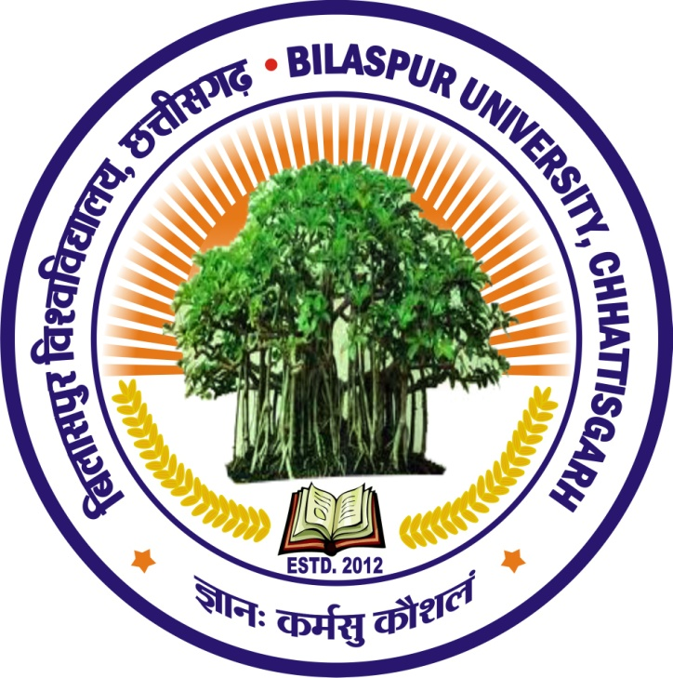
TWO-YEAR B.ED. PROGRAMME

BILASPUR UNIVERSITY, BILASPUR CHHATTISGARH

