Regular salary/wage distribution of school teachers
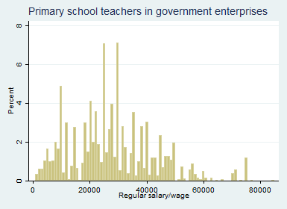
N= 8777906
minimum=900
max=85000

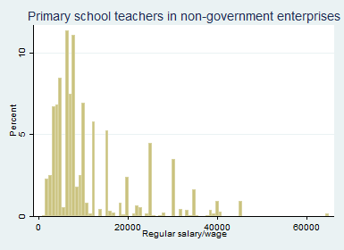

N=8194230
minimum= 2000
max= 112000

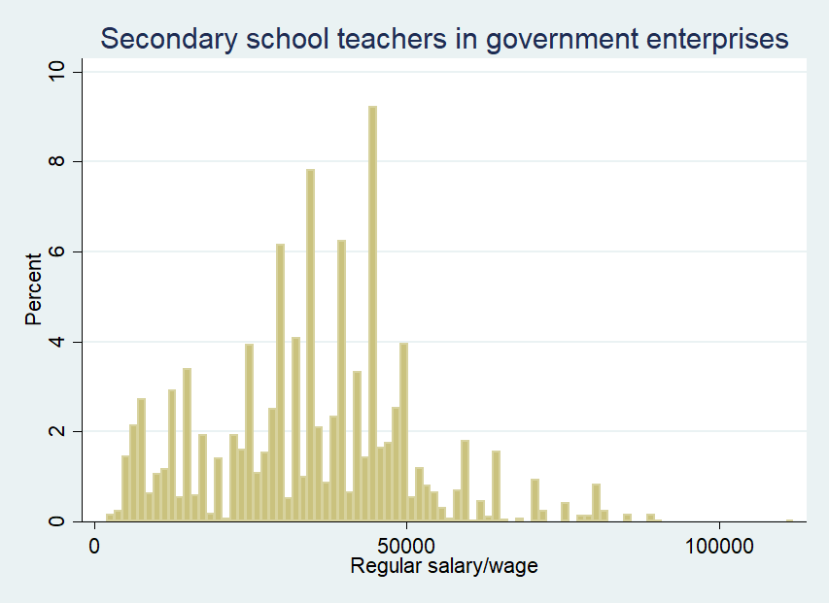
N= 4675699
minimum=700
max= 65000

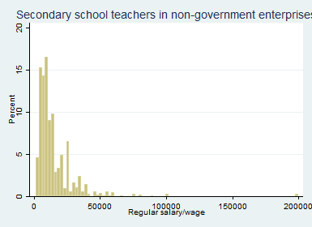
N= 5798356
minimum=1500
max= 200000

=================================================================
New alternatives- 1
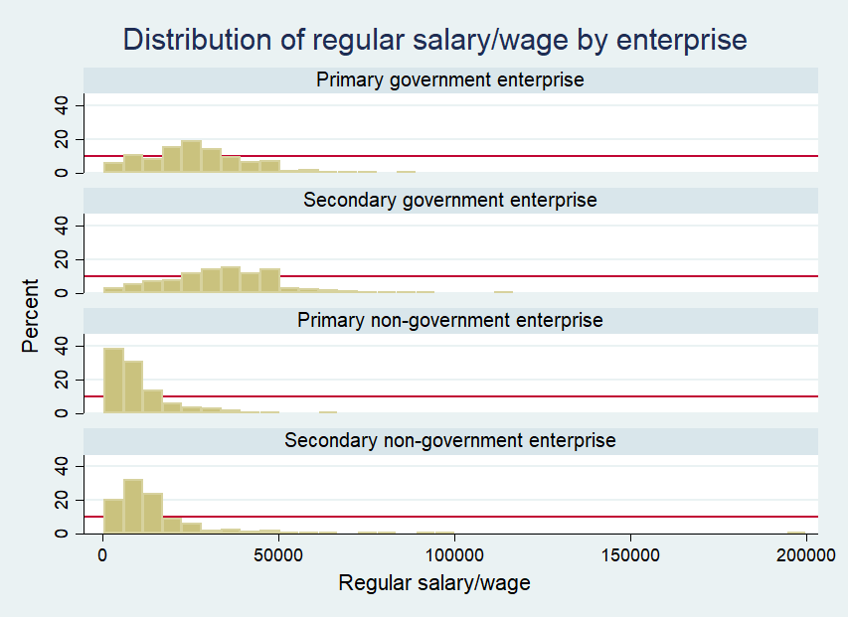

New alternative- 2
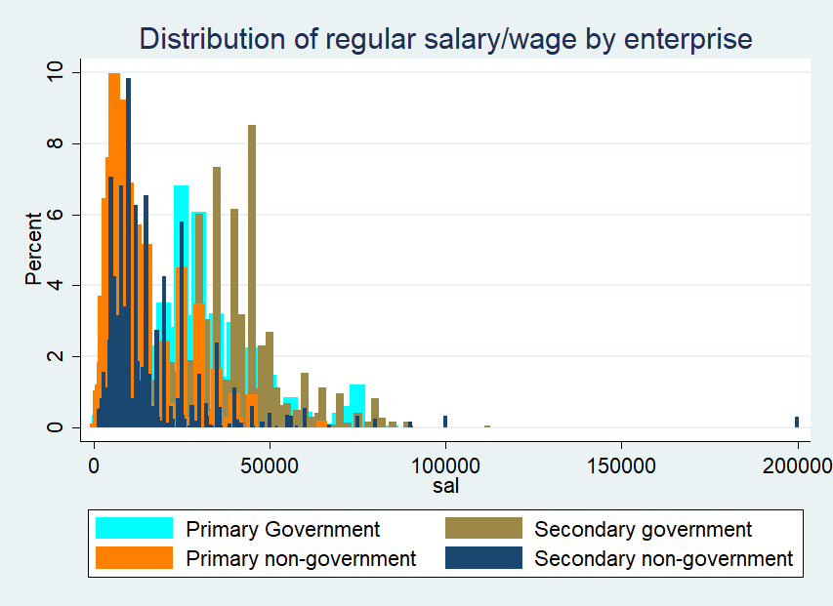

Final Graph
